**Q'orianka Kilcher**

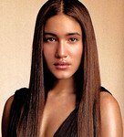

Charities & foundations supported

* ALS Association
* Global Green
* Greenpeace
* United Global Shift

Causes supported

* Animals,
* Conservation,
* Environment,
* Health, Peace,
* Philanthropy,
* Physical Challenges,
* Poverty,
* Water

# Queen

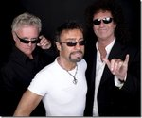

Charities & foundations supported

* 46664
* ChildLine
* Prince's Trust

Causes supported

* Abuse,
* AIDS & HIV,
* At-Risk/Disadvantaged Youths,
* Children,
* Depression and Suicide,
* Education

# Queen Latifah

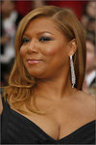

Charities & foundations supported

* 46664
* Boys & Girls Clubs of America
* Citymeals On Wheels
* Common Ground Foundation
* FFAWN
* Generosity Water
* Harry Holmberg Memorial Foundation
* Keep A Child Alive
* Starlight Children's Foundation

Causes supported

* AIDS & HIV,
* At-Risk/Disadvantaged Youths,
* Cancer, Children,
* Education, Family/Parent Support,
* Gay/Lesbian Support,
* Health, Hunger,
* Literacy, Senior Citizen Support
* , Unemployment/Career Support,
* Veteran/Service Member Support,
* Water,
* Women

# Queen Noor of Jordan

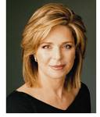

Charities & foundations supported

* American Cancer Society
* Conservation International
* Free The Children
* Mineseeker Foundation
* Nuclear Age Peace Foundation
* Save the Children
* SOS Children's Villages
* Survivor Corps
* Tahirih Justice Center
* United Nations Foundation
* WWF

Causes supported

* Abuse,
* Adoption,
* Fostering,
* Orphans,
* AIDS & HIV,
* Animals, Cancer,
* Children,
* Conservation, Creative Arts,
* Disaster Relief,
* Education, Environment, Health,
* Homelessness, Human Rights,
* Hunger
* , Miscellaneous,
* Peace, Poverty,
* Refugees,
* eapons Reduction,
* Women

Queen Pen

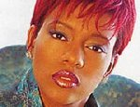

### Causes supported

* Abuse

# Queen Rania Al Abdullah

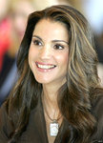

Charities & foundations supported

* Clinton Foundation
* Clinton Global Initiative
* FINCA
* Tony Blair Faith Foundation
* UNICEF
* United Nations Foundation

Causes supported

* AIDS & HIV,
* Children,
* Economic/Business Support
* , Education,
* Environment,
* Health, Human Rights,
* Miscellaneous,
* Peace,
* Poverty,
* Women

# Queensryche

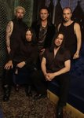

Charities & foundations supported

* Save The Music Foundation

Causes supported

* Children,
* Creative Arts,
* Education

# Quentin Blake

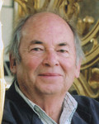

Charities & foundations supported

* Eastside Educational Trust
* PACT
* The Children's Trust, Tadworth

Causes supported

* Children,
* Creative Arts,
* Education,
* Family/Parent Support,
* Health,
* Mental Challenges,
* Physical Challenges

# Quentin Tarantino

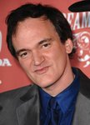

Charities & foundations supported

* The Art of Elysium
* UNICEF

Causes supported

* AIDS & HIV,
* Cancer,
* Children,
* Health,
* Human Rights,
* Poverty

# Quincy Jones

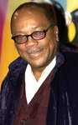

Charities & foundations supported

* American Foundation for AIDS Research
* Andrea Bocelli Foundation
* Artists for a New South Africa
* Barbara Davis Center for Childhood Diabetes
* Children Mending Hearts
* GLAAD
* Jazz Foundation of America
* Keep Memory Alive
* MusiCares
* Nelson Mandela Foundation
* Rape Foundation
* Usher's New Look Foundation
* We Are The World Foundation

Causes supported

* Abuse,
* AIDS & HIV,
* At-Risk/Disadvantaged Youths,
* Children, Creative Arts,
* Disaster Relief,
* Education, Gay/Lesbian Support,
* Health, Human Rights,
* Mental Challenges,
* Miscellaneous, Peace,
* Physical Challenges,
* Poverty,
* Rape/Sexual Abuse,
* Sports,
* Unemployment/Career Support

# Quinton Aaron

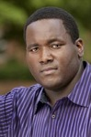

Charities & foundations supported

* Find A Dream
* K.I.S. Foundation

Causes supported

* At-Risk/Disadvantaged Youths,
* Children,
* Education,
* Health