**Rachael Flatt**



**Charities & foundations supported**

* Reading is Fundamental

**Causes supported**

* [Literacy](http://www.looktothestars.org/cause/literacy)

**Rachael Harris**

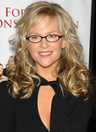

**Charities & foundations supported**

* [Oceana](http://www.looktothestars.org/charity/oceana)

**Causes supported**

* Animals,
* Conservation
* Environment
* Oceans
* Water

**Rachael Leigh Cook**



**Charities & foundations supported**

* DoSomething.org
* Farm Sanctuary

**Causes supported**

* Animals
* Philanthropy

**Rachael Ray**



**Charities & foundations supported**

* American Association of Retired Persons
* ASPCA
* Blue Planet Run Foundation
* Centre For Environmental Education
* Clothes Off Our Back
* Feeding America
* Food Bank For New York City
* Heifer International
* Hope North
* Keep A Child Alive
* Mayor's Fund to Advance New York City
* Robert F Kennedy Memorial
* Share Our Strength
* Soles4Souls
* The Art of Elysium
* The Heart Truth
* The Lunchbox Fund
* Tuberous Sclerosis Alliance
* Yum-o!

### Causes supported

* Abuse
* Adoption
* Fostering
* Orphans
* AIDS & HIV
* Animals
* At-Risk/Disadvantaged Youths
* Cancer
* Children
* Disaster Relief
* [Education](http://www.looktothestars.org/cause/education)
* Environment
* Family/Parent Support
* Health
* Human Rights
* Hunger
* Miscellaneous
* Poverty
* Refugees
* Water
* Women

**Rachel Bilson**



**Charities & foundations supported**

* Artists for Peace and Justice
* Cancer Research UK
* Candie's Foundation
* DoSomething.org
* Invisible Children
* Rape, Abuse & Incest National Network
* Skin Cancer Foundation
* The Art of Elysium

### Causes supported

* AIDS & HIV
* At-Risk/Disadvantaged Youths
* Cancer
* Children
* Disaster Relief
* Health
* Human Rights
* Miscellaneous
* Peace
* Philanthropy
* Poverty
* Rape/Sexual Abuse
* Women

# Rachele Brooke Smith

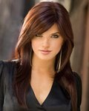

**Charities & foundations supported**

* 1736 Family Crisis Center
* In A Perfect World

### Causes supported

* Abuse
* Children
* Family/Parent Support
* Homelessness
* Women

**Rachel Hunter**

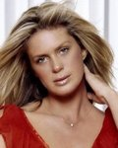

**Charities & foundations supported**

* Born Free Foundation
* Hillsides
* Storylines Trust

**Causes supported**

* Animals
* Children
* Education
* Rape/Sexual Abuse

**Rachelle Lefevre**



**Charities & foundations supported**

* Red Cross

**Causes supported**

* AIDS & HIV,
* Disaster Relief,
* Human Rights

**Rachel Miner**



**Charities & foundations supported**

* Best Friends Animal Society
* Kiva
* PETA
* The Humane Society
* Water.org

### Causes supported

* Animals
* Economic/Business Support
* Water

**Rachel Shenton**



**Causes supported**

* Children
* Physical Challenges

**Rachel Weisz**

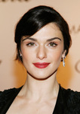

**Charities & foundations supported**

* African Rainforest Conservancy
* Cancer Research UK
* Constant Gardener Trust
* Only Make Believe
* Pediatric Epilepsy Project
* Worldwide Orphans Foundation

Causes supported

* Adoption
* Fostering
* Orphans
* AIDS & HIV
* Cancer
* Children
* Conservation
* Creative Arts
* Environment
* Health
* Poverty

**Rachel Zeskind**



**Charities & foundations supported**

* AmberWatch Foundation
* Food for the Hungry
* L.A. GOAL
* Mercy Ministries
* Smile Train
* Watoto

### Causes supported

* Abuse
* Adoption
* Fostering
* Orphans
* At-Risk/Disadvantaged Youths
* Children
* Depression and Suicide
* Disaster Relief
* Family/Parent Support
* Health
* Hunger
* Mental Challenges
* Miscellaneous
* Missing Children
* Poverty
* Substance Abuse
* Women

**Radiohead**

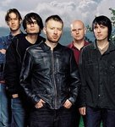

Charities & foundations supported

* Amnesty International
* Fair Trade Resource Network
* Friends of the Earth
* Missing People
* Pablove Foundation
* Witness

### Causes supported

* At-Risk/Disadvantaged Youths
* Cancer
* Children
* Conservation
* Creative Arts, [Education](http://www.looktothestars.org/cause/education)
* Environment
* Fair Trade
* Grief Support
* Health
* Human Rights
* Missing Children
* Voter Education

# Rafael Nadal



**Charities & foundations supported**

* City Harvest
* Laureus Sport for Good Foundation

**Causes supported**

* At-Risk/Disadvantaged Youths
* Hunger
* Sports

**Ragan Brooks**



**Charities & foundations supported**

* Animal Advocates Alliance
* Home For Life
* Lange Foundation
* Los Angeles Mission

**Causes supported**

* Animals
* Homelessness

# Rage Against The Machine

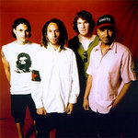

**Charities & foundations supported**

* [Los Angeles Youth Network](http://www.looktothestars.org/charity/los-angeles-youth-network)
* [Shelter](http://www.looktothestars.org/charity/shelter)
* [Youth Music](http://www.looktothestars.org/charity/youth-music)

**Causes supported**

* At-Risk/Disadvantaged Youths
* Creative Arts
* Homelessness
* Unemployment/Career Support

**Rahul Khanna**



**Charities & foundations supported**

* PETA

**Causes supported**

* Animals

**Raine Maida**



**Charities & foundations supported**

* War Child

**Causes supported**

* Children
* Disaster Relief
* Peace

**Rainn Wilson**



**Charities & foundations supported**

* Artists for Peace and Justice
* J/P Haitian Relief Organization
* Milk+Bookies
* Mona Foundation
* Project HOME
* Tahirih Justice Center

### Causes supported

* Children
* Disaster Relief
* Education
* Homelessness
* Human Rights
* Literacy
* Miscellaneous
* Philanthropy
* Poverty
* Women

**Ralph Fiennes**



**Charities & foundations supported**

* ACAP
* Artists Against Racism
* Constant Gardener Trust
* Environmental Investigation Agency
* Raisa Gorbachev Foundation
* UNICEF
* WildAid

### Causes supported

* Animals
* Cancer
* Children
* Conservation
* Environment
* Health
* Human Rights
* Miscellaneous
* Poverty

**Ralph Lauren**

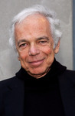

**Charities & foundations supported**

* Breakthrough Breast Cancer
* Memorial Sloan-Kettering

Causes supported

* Cancer
* Conservation
* Education

**Randy Couture**

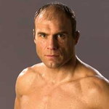

**Causes supported**

* Veteran/Service Member Support

**Randy Foye**

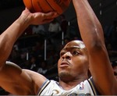

**Charities & foundations supported**

* Randy Foye Foundation

**Causes supported**

* At-Risk/Disadvantaged Youths
* Children

**Randy Jackson**

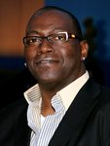

**Charities & foundations supported**

* Aviation Angels
* Barbara Davis Center for Childhood Diabetes
* Believe in Dreams
* Dream Foundation
* Guitar Center Music Foundation
* Lili Claire Foundation
* Music Rising
* Red Cross
* Right Action for Women
* Save the Children
* Soles4Souls

### Causes supported

* Abuse
* AIDS & HIV
* At-Risk/Disadvantaged Youths
* Cancer
* Children
* Creative Arts
* Disaster Relief
* Education
* Family/Parent Support
* Health
* Human Rights
* Mental Challenges
* Poverty
* Refugees
* Unemployment/Career Support
* Women

# Randy Travis



**Charities & foundations supported**

* Child Safety Network
* Damon and Stella Foundation
* Hollywood Charity Horse Show
* Operation Smile
* Project Clean Water

### Causes supported

* Abuse
* Children
* Depression and Suicide
* Health
* Mental Challenges
* Missing Children
* Physical Challenges
* Water

**Rankin**



**Charities & foundations supported**

* Oxfam
* Prince's Trust

### Causes supported

* At-Risk/Disadvantaged Youths
* Children
* Disaster Relief
* Education
* Human Rights
* Poverty

# Ranulph Fiennes



**Charities & foundations supported**

* CHICKS
* Elton John AIDS Foundation
* Marie Curie Cancer Care

### Causes supported

* AIDS & HIV
* At-Risk/Disadvantaged Youths
* Cancer
* Children
* Health

# Rascal Flatts

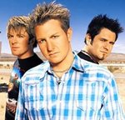

**Charities & foundations supported**

* City of Hope
* Clothes Off Our Back
* Feeding America
* Fisher House Foundation
* GRAMMY Foundation
* Jason Foundation
* Make-A-Wish Foundation
* Monroe Carell Jr. Children's Hospital at Vanderbilt
* MusiCares
* Red Cross

### Causes supported

* AIDS & HIV
* At-Risk/Disadvantaged Youths
* Cancer
* Children
* Creative Arts
* Disaster Relief
* Health
* Human Rights
* Hunger
* Unemployment/Career Support
* Veteran/Service Member Support

# Rashida Jones



**Charities & foundations supported**

* EB Medical Research Foundation
* International Rescue Committee
* Peace First
* The Art of Elysium

### Causes supported

* AIDS & HIV
* Cancer
* Children
* Disaster Relief
* Health
* Human Rights
* Peace
* Refugees
* Women  
  Raul Julia-Levy

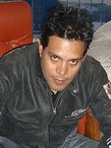

**Charities & foundations supported**

* Children's Hospital Los Angeles
* Elton John AIDS Foundation
* Make-A-Wish Foundation
* Michael J. Fox Foundation
* The Humane Society

### Causes supported

* AIDS & HIV
* Animals
* Cancer
* Children
* Health

# Raven Symone



**Charities & foundations supported**

* Children's Miracle Network Hospitals
* Give Back Hollywood Foundation
* Red Cross
* Variety Power Of Youth
* Women Alive Coalition
* Young Storytellers Foundation

### Causes supported

* AIDS & HIV
* Children
* Disaster Relief
* Education
* Health
* Human Rights
* Literacy
* Philanthropy
* Women

# Ray Charles

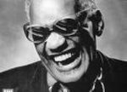

**Charities & foundations supported**

* Aid Still Required
* Ray Charles Robinson Foundation

### Causes supported

* Children
* Creative Arts
* Disaster Relief
* Literacy
* Physical Challenges

# Ray Lewis

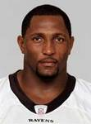

**Charities & foundations supported**

* USAID

**Causes supported**

* Disaster Relief
* Economic/Business Support
* Education
* Health
* Human Rights
* Hunger
* Poverty
* Rape/Sexual Abuse
* Women

**Ray Romano**



### Charities & foundations supported

* AmberWatch Foundation
* Andre Agassi Foundation for Education
* Ante Up For Africa
* Barbara Davis Center for Childhood Diabetes
* Children Affected by AIDS Foundation
* Comic Relief
* ENOUGH Project
* Muscular Dystrophy Association
* Not On Our Watch
* Vine Group
* Watering Seeds Organization

### Causes supported

* AIDS & HIV
* At-Risk/Disadvantaged Youths
* Children
* Disaster Relief
* Education
* Health
* Homelessness
* Human Rights
* Missing Children
* Peace
* Physical Challenges
* Poverty
* Rape/Sexual Abuse
* Refugees

# Ray Winstone

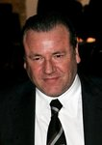

**Charities & foundations supported**

* Haven House Children’s Hospice
* Talk... Don't Walk

### Causes supported

* At-Risk/Disadvantaged Youths
* Cancer
* Children
* Family/Parent Support
* Grief Support
* Health

# Razorlight



**Charities & foundations supported**

* 46664
* Children in Need
* Friends of the Earth
* Live Earth
* Make Poverty History
* Nordoff Robbins
* Stand Up To Cancer
* Willow Foundation

### Causes supported

* Abuse
* AIDS & HIV
* Cancer
* Children
* Conservation
* Environment
* Health
* Homelessness
* Mental Challenges
* Miscellaneous
* Physical Challenges
* Poverty
* Substance Abuse

**Reba McEntire**

  
Charities & foundations supported

* Celebrity Fight Night Foundation
* City of Hope
* David Foster Foundation
* Fisher House Foundation
* Hero in Heels
* Mary Kay Ash Charitable Foundation
* Monroe Carell Jr. Children's Hospital at Vanderbilt
* Muhammad Ali Parkinson Center
* MusiCares
* Operation Once in a Lifetime
* Smile Train
* Soles4Souls
* SOS Children's Villages
* Wish Upon A Hero Foundation

### Causes supported

* Abuse
* Adoption
* Fostering
* Orphans
* AIDS & HIV
* Cancer
* Children
* Creative Arts
* Disaster Relief
* Family/Parent Support
* Health
* Homelessness
* Human Rights
* Miscellaneous
* Philanthropy
* Poverty
* Refugees
* Unemployment/Career Support
* Veteran/Service Member Support
* Women

# Rebecca Breeds

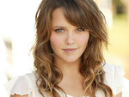

### Causes supported

* Adoption
* Fostering
* Orphans
* Children

**Rebecca Budig**

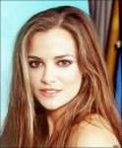

**Charities & foundations supported**

* Love Our Children USA
* STOMP Out Bullying
* The NephCure Foundation

### Causes supported

* Abuse
* At-Risk/Disadvantaged Youths
* Children
* Family/Parent Support
* Health

**Rebecca Gayheart-Dane**



**Charities & foundations supported**

* Chrysalis
* March Of Dimes
* The Art of Elysium

### Causes supported

* AIDS & HIV
* Cancer
* Children
* Health
* Homelessness

**Rebecca Gibney**

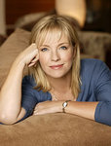

**Charities & foundations supported**

* World Vision

**Causes supported**

* Adoption
* Fostering
* Orphans
* AIDS & HIV
* Children
* Poverty

# Rebecca Mader

### Rebecca Mader

### Charities & foundations supported

* Reality Cares
* UNICEF

### Causes supported

* Children
* Health
* Human Rights
* Miscellaneous
* Poverty

**Rebecca Romijn**



**Charities & foundations supported**

* Feeding America
* Point Foundation

### Causes supported

* Gay/Lesbian Support
* Hunger

**Red Hot Chili Peppers**

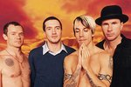

**Charities & foundations supported**

* Artists for Peace and Justice
* Bridge School
* Chandler Sky Foundation
* Greenpeace
* LIFEbeat
* Live Earth
* Peace Alliance
* Sea Shepherd Conservation Society
* Silverlake Conservatory of Music
* Surfrider Foundation
* Sweet Relief Musicians Fund
* Unite The United

### Causes supported

* Abuse
* Adoption
* Fostering
* Orphans
* AIDS & HIV
* Animals
* At-Risk/Disadvantaged Youths
* Children
* Conservation
* Creative Arts
* Disaster Relief
* Economic/Business Support
* Environment
* Miscellaneous
* Oceans
* Peace
* Physical Challenges
* Poverty
* Substance Abuse
* Unemployment/Career Support
* Women

# Red Jumpsuit Apparatus

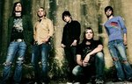

**Charities & foundations supported**

* Boost Mobile RockCorps
* DoSomething.org
* The Red Jumpsuit Alliance

### Causes supported

* Abuse
* At-Risk/Disadvantaged Youths
* Creative Arts
* Environment
* Health
* Homelessness
* Hunger
* Philanthropy
* Poverty
* Unemployment/Career Support

**Reese Witherspoon**

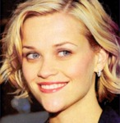

**Charities & foundations supported**

* Afghanistan Relief Organization
* American Humane Association
* Avon Foundation
* Children's Defense Fund
* Declare Yourself
* Film Foundation
* Food Bank For New York City
* March Of Dimes
* Refuge
* Safety Harbor Kids
* The Lunchbox Fund
* Toy Mountain Campaign
* UNIFEM
* Vital Voices

### Causes supported

* Abuse
* Adoption
* Fostering
* Orphans
* Animals
* At-Risk/Disadvantaged Youths
* Cancer
* Children
* Creative Arts, Disaster Relief
* Economic/Business Support
* Education
* Family/Parent Support
* Health
* Human Rights
* Hunger
* Mental Challenges
* Physical Challenges
* Poverty
* Rape/Sexual Abuse
* Voter Education
* Women

**Regina King**



**Charities & foundations supported**

* Coalition of Skin Diseases

**Causes supported**

* Cancer
* Health
* Voter Education

**Regina Spektor**

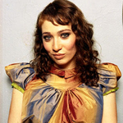

### Charities & foundations supported

* Amnesty International
* Doctors Without Borders

### Causes supported

* Disaster Relief
* Health
* Human Rights

# Regis Philbin

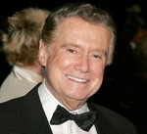

**Charities & foundations supported**

* Bob Woodruff Foundation
* Robert F Kennedy Memorial
* STOMP Out Bullying
* The Doe Fund

### Causes supported

* Abuse
* Children
* Family/Parent Support
* Homelessness
* Human Rights
* Veteran/Service Member Support

**Relient K**

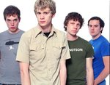

**Charities & foundations supported**

* Children's Hospital Los Angeles
* [TJ Martell Foundation](http://www.looktothestars.org/charity/tj-martell-foundation)

### Causes supported

* AIDS & HIV
* Cancer
* Children
* Health

**R.E.M.**

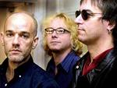

**Charities & foundations supported**

* Amnesty International

**Causes supported**

* Human Rights

**Rene Auberjonois**

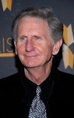

**Charities & foundations supported**

* Amnesty International
* Doctors Without Borders
* Heifer International

### Causes supported

* AIDS & HIV
* Animals
* Children
* Disaster Relief
* Health
* Human Rights
* Hunger
* Poverty

**Renee Zellweger**



**Charities & foundations supported**

* Bony Pony Ranch
* United Service Organization

### Causes supported

* At-Risk/Disadvantaged Youths
* Children
* Creative Arts
* Education
* Veteran/Service Member Support

# REO Speedwagon

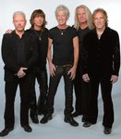

**Charities & foundations supported**

* Bear Necessities Pediatric Cancer Foundation
* City of Hope
* MusiCares
* Project Clean Water

### Causes supported

* AIDS & HIV
* Cancer
* Children
* Creative Arts
* Health
* Unemployment/Career Support
* Water

**Rev. Jesse Jackson**

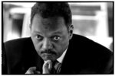

**Charities & foundations supported**

* 46664
* The HollyRod Foundation

### Causes supported

* AIDS & HIV
* Family/Parent Support
* Health
* Physical Challenges

**Rhea Perlman**



**Charities & foundations supported**

* Operation USA
* Solar Neighbors Program

### Causes supported

* Disaster Relief
* Environment
* Poverty

**RhonaMitra**



**Charities & foundations supported**

* Global Green

**Causes supported**

* Environment
* Health
* Peace
* Poverty
* Water

**Rib Hillis**



**Charities & foundations supported**

* Be The Match
* Reality Cares
* Red Cross
* The Thirst Project

### Causes supported

* AIDS & HIV
* Blood, Marrow & Organ Donation
* Disaster Relief
* Human Rights
* Miscellaneous
* Water

**Richard Branson**



**Charities & foundations supported**

* 21st Century Leaders
* 46664
* Aegis Trust
* Avoided Deforestation Partners
* Cancer Research UK
* Caudwell Children
* charity:water
* Children with AIDS
* Free The Children
* Girls Not Brides
* Greenpeace
* Heavens Angels
* International Rescue Corps
* Kids Company
* Life College
* Make A Child Smile Appeal
* Marie Keating Foundation
* Mineseeker Foundation
* Peace One Day
* ROTA
* Starfish Greathearts Foundation
* Strike a Chord for Cancer Foundation
* Swan Lifeline
* The Elders
* Virgin Unite
* Whatever It Takes
* WildAid

### Causes supported

* Abuse,
* Adoption,
* Fostering,
* Orphans,
* AIDS & HIV,
* Animals,
* At-Risk/Disadvantaged Youths,
* Cancer,
* Children,
* Conservation,
* Disaster Relief,
* Education,
* Environment,
* Family/Parent Support,
* Health,
* Homelessness,
* Human Rights,
* Hunger,
* Literacy,
* Mental Challenges,
* Miscellaneous,
* Peace,
* Physical Challenges,
* Poverty,
* Water,
* Weapons Reduction,
* Women

**Richard Curtis**



**Charities & foundations supported**

* Comic Relief
* Live 8
* Make Poverty History
* Mo Farah Foundation

### Causes supported

* Adoption,
* Fostering,
* Orphans,
* AIDS & HIV,
* Children,
* Disaster Relief,
* Health,
* Homelessness,
* Human Rights,
* Hunger,
* Poverty

**Richard Dawkins**

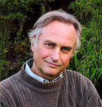

### Charities & foundations supported

* British Humanist Association
* Doctors Without Borders
* Richard Dawkins Foundation
* Save the Rhino

### Causes supported

* Conservation
* Disaster Relief
* Education
* Health
* Philanthropy

**Richard Dean Anderson**

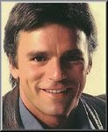

**Charities & foundations supported**

* Sea Shepherd Conservation Society
* Waterkeeper Alliance

### Causes supported

* Animals
* Environment
* Oceans
* Water

# Richard Dreyfuss

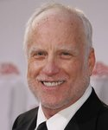

### Charities & foundations supported

* National Parks Conservation Association
* Paralyzed Veterans of America

Causes supported

* Conservation
* Environment
* Physical Challenges
* Veteran/Service Member Support
* Voter Education

# Richard E. Grant

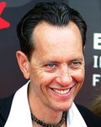

### Charities & foundations supported

* Eastside Educational Trust
* Prince's Trust
* Soil Association

### Causes supported

* At-Risk/Disadvantaged Youths
* Children
* Conservation
* Creative Arts
* Education
* Environment

# Richard Gere

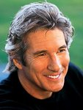  
Charities & foundations supported

* Afghanistan Relief Organization
* American Foundation for AIDS Research
* American India Foundation
* Amnesty International
* Barbara Davis Center for Childhood Diabetes
* Cinema For Peace
* Druk White Lotus School
* Elizabeth Glaser Pediatric AIDS Foundation
* Free The Children
* Free Tibet Campaign
* Gere Foundation
* Healing the Divide
* Heroes Project
* International Campaign for Tibet
* Meals On Wheels
* Robert F Kennedy Memorial
* Society for Animal Protective Legislation
* Stand Up and Take Action
* Survival International

### Causes supported

* AIDS & HIV
* Animals
* Children
* Disaster Relief
* Economic/Business Support
* Education
* Environment
* Family/Parent Support
* Health
* Human Rights
* Hunger
* Peace
* Poverty
* Senior Citizen Support
* Women

**Richard Hammond**

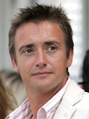

### Charities & foundations supported

* Children in Need
* Sophie's Gift
* Sport Relief
* The Children's Trust, Tadworth

### Causes supported

* Abuse
* AIDS & HIV
* Cancer
* Children
* Conservation
* Education
* Environment
* Fair Trade
* Health
* Homelessness
* Human Rights
* Hunger
* Literacy
* Mental Challenges
* Miscellaneous
* Physical Challenges
* Poverty
* Substance Abuse

# Richard Karn

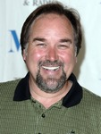

**Charities & foundations supported**

* National Center for Missing and Exploited Children
* Screen Actors Guild Foundation

Causes supported

* Cancer
* Children
* Creative Arts
* Family/Parent Support
* Missing Children
* Rape/Sexual Abuse

# Richard Marx

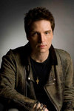

**Charities & foundations supported**

* American Cancer Society
* Cystic Fibrosis Foundation
* Make-A-Wish Foundation
* Special Olympics
* Toys for Tots

### Causes supported

* At-Risk/Disadvantaged Youths
* Cancer
* Children
* Health
* Mental Challenges
* Physical Challenges

# Richard Quest



### Charities & foundations supported

* ROTA
* UNICEF

### Causes supported

* Children
* Education
* Health
* Human Rights
* Poverty

# Richard Thomas



**Causes supported**

* Health

**Rich Eckhardt**

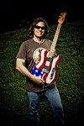

**Charities & foundations supported**

* Little Kids Rock

### Causes supported

* At-Risk/Disadvantaged Youths
* Children
* Creative Arts

**Richie Sambora**



### Charities & foundations supported

* City Hearts: Kids Say Yes to the Arts
* Clothes Off Our Back
* Dream Foundation
* Elevate Hope Foundation
* Feeding America
* MusiCares
* Precious Paws
* Stand Up For A Cure

### Causes supported

* Abuse
* Animals
* At-Risk/Disadvantaged Youths
* Cancer
* Children
* Creative Arts
* Education
* Family/Parent Support
* Health
* Hunger
* Poverty
* Unemployment/Career Support

**Rick Allen**

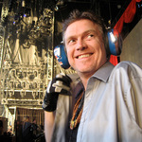

**Charities & foundations supported**

* Raven Drum Foundation

### Causes supported

* Veteran/Service Member Support

**Rick Fox**

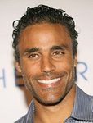

**Charities & foundations supported**

* Collaboration Foundation
* Global Fund for Women
* Keep A Child Alive
* The HollyRod Foundation

### Causes supported

* AIDS & HIV
* Children
* Creative Arts
* Economic/Business Support
* Family/Parent Support
* Health
* Human Rights
* Physical Challenges
* Women

**Rick Hearst**

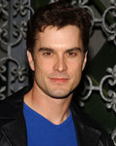

**Charities & foundations supported**

* HARK
* St. Jude Children's Research Hospital

### Causes supported

* Children
* Creative Arts
* Health

**Ricki Lake**



**Charities & foundations supported**

* Chrysalis
* Vine Group

### Causes supported

* Cancer
* Children
* Education
* Homelessness
* Women

**Rick Mercer**

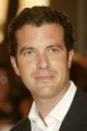

**Charities & foundations supported**

* ONEXONE
* Spread the Net
* UNICEF

### Causes supported

* Children
* Health
* Human Rights
* Hunger
* Poverty

**Rick Schroder**

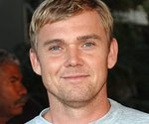

### Charities & foundations supported

* Racing for Kids
* Vijay Amritraj Foundation

### Causes supported

* Adoption,
* Fostering,
* Orphans,
* AIDS & HIV,
* Children,
* Mental Challenges,
* Miscellaneous,
* Physical Challenges,
* Women

**Rick Springfield**

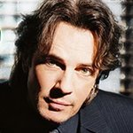

**Charities & foundations supported**

* A Star For The Nigh

### Causes supported

* Children

**Ricky Gervais**

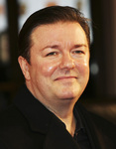

**Charities & foundations supported**

* Autism Speaks
* Bob Woodruff Foundation
* British Union for the Abolition of Vivisection
* Comic Relief
* Cool Earth
* Dorset Wildlife Trust
* Great Ormond Street Hospital
* Hauser Bears
* Humane Society International
* Macmillan Cancer Support
* PETA
* Roy Castle Lung Cancer Foundation
* Soles4Souls
* Starlight Children's Foundation
* Teenage Cancer Trust
* TigerTime
* Variety Club
* Willow Foundation
* World Society for the Protection of Animals

### Causes supported

* AIDS & HIV
* Animals
* At-Risk/Disadvantaged Youths
* Cancer
* Children
* Conservation
* Disaster Relief
* Environment
* Health
* Homelessness
* Human Rights
* Mental Challenges
* Physical Challenges
* Poverty
* Refugees
* Veteran/Service Member Support

# Ricky Martin

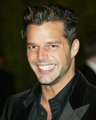

**Charities & foundations supported**

* ALAS
* American Foundation for AIDS Research
* Barbara Davis Center for Childhood Diabetes
* Habitat For Humanity
* International Organization for Migration
* Music for Relief
* Ricky Martin Foundation
* YoAmo America Campaign

### Causes supported

* AIDS & HIV
* Children
* Disaster Relief
* Environment
* Health
* Homelessness
* Human Rights
* Hunger
* Poverty

**Ricky Ponting**

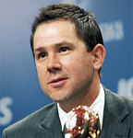

**Charities & foundations supported**

* Children's Cancer Institute Australia

### Causes supported

* Cancer
* Children
* Health

**Rihanna**

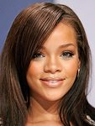

**Charities & foundations supported**

* Bear Necessities Pediatric Cancer Foundation
* Believe Foundation
* BID 2 BEAT AIDS
* City of Hope
* Designers Against AIDS
* DKMS
* DoSomething.org
* Feeding America
* GRAMMY Foundation
* Kids Wish Network
* Live Earth
* Mission Australia
* MusiCares
* Raising Malawi
* Red Cross
* Shriners Hospitals for Children
* Stand Up To Cancer
* UNICEF

### Causes supported

* Adoption
* Fostering
* Orphans
* AIDS & HIV
* At-Risk/Disadvantaged Youths
* Blood, Marrow & Organ Donation
* Cancer
* Children
* Creative Arts
* Disaster Relief
* Environment
* Family/Parent Support
* Grief Support
* Health
* Homelessness
* Human Rights
* Hunger
* Philanthropy
* Poverty
* Unemployment/Career Support

**Ringo Starr**

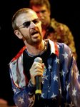

**Charities & foundations supported**

* 21st Century Leaders
* American Foundation for AIDS Research
* David Lynch Foundation
* Elevate Hope Foundation
* GRAMMY Foundation
* Lotus Outreach
* Mines Advisory Group
* Whatever It Takes

### Causes supported

* Abuse
* AIDS & HIV
* Children
* Creative Arts
* Education
* Health
* Human Rights
* Miscellaneous
* Poverty
* Rape/Sexual Abuse
* Weapons Reduction

**Rise Against**

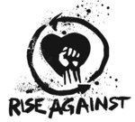

**Charities & foundations supported**

* Amnesty International
* PETA

### Causes supported

* Animals,
* Human Rights

**Rita Moreno**



**Charities & foundations supported**

* Jackie Robinson Foundation

### Causes supported

* Education

**Rita Rudner**



**Charities & foundations supported**

* Children's Hospital Los Angeles
* Kiss For A Cause Foundation

### Causes supported

* Adoption
* Fostering
* Orphans
* Children
* Health

**Robbie Coltrane**



**Charities & foundations supported**

* Amnesty International
* Book Aid International
* Greenpeace

### Causes supported

* Animals
* Children
* Conservation
* Education
* Environment, Human Rights
* Refugees

# Robbie Williams

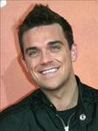

### Charities & foundations supported

* 21st Century Leaders
* Caudwell Children
* ChildLine
* Comic Relief
* Give It Sum
* Help for Heroes
* Jeans for Genes
* National Society for the Prevention of Cruelty to Children
* Scope
* Sport Relief
* UNICEF
* WAVE Trauma Centre
* Whatever It Takes

### Causes supported

* Abuse
* AIDS & HIV
* Cancer
* Children
* Conservation
* Depression and Suicide
* Disaster Relief
* Education
* Environment
* Fair Trade
* Family/Parent Support
* Grief Support
* Health
* Homelessness
* Human Rights
* Hunger
* Literacy
* Mental Challenges
* Miscellaneous
* Physical Challenges
* Poverty
* Veteran/Service Member Support

**Rob Brydon**

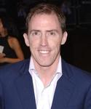

**Charities & foundations supported**

* CARE
* Children in Need
* Comic Relief
* Great Ormond Street Hospital
* Oxfam
* Prince's Trust
* Willow Foundation

### Causes supported

* Abuse
* AIDS & HIV
* At-Risk/Disadvantaged Youths
* Cancer
* Children
* Disaster Relief
* Education
* Environment
* Health
* Homelessness
* Human Rights
* Mental Challenges
* Physical Challenges
* Poverty
* Substance Abuse
* Women

# Robert Adamson



### Charities & foundations supported

* National Kidney Foundation

### Causes supported

* Blood, Marrow & Organ Donation
* Health

**Roberta Flack**



**Charities & foundations supported**

* Keep America Beautiful

### Causes supported

* Conservation
* Environment
* Water

**Robert Davi**

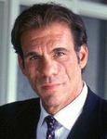

**Charities & foundations supported**

* The Salvation Army

### Causes supported

* Abuse
* At-Risk/Disadvantaged Youths
* Disaster Relief
* Family/Parent Support
* Grief Support
* Homelessness
* Senior Citizen Support

**Robert De Niro**

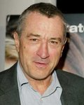

**Charities & foundations supported**

* 46664
* Artists for Peace and Justice
* Barbara Davis Center for Childhood Diabetes
* FilmAid International
* Film Foundation
* HEART
* Hearts of Gold
* Robert F Kennedy Memorial
* STILLERSTRONG

### Causes supported

* Adoption
* Fostering
* Orphan
* AIDS & HIV
* Animals
* At-Risk/Disadvantaged Youths
* Children
* Creative Arts
* Disaster Relief
* Education
* Environment
* Health
* Homelessness
* Human Rights
* Miscellaneous
* Peace
* Poverty
* Senior Citizen Support
* Women

# Robert Downey Jr

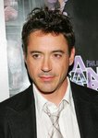

**Charities & foundations supported**

* Clothes Off Our Back
* Midnight Mission
* Orca Network

### Causes supported

* Animals
* Children
* Conservation
* Homelessness

**Robert Duvall**

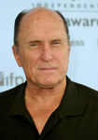

**Charities & foundations supported**

* Pro Mujer
* Robert Duvall Children's Fund
* SixDegrees.org

### Causes supported

* Economic/Business Support
* Health
* Philanthropy
* Poverty
* Women

**Robert Mirabal**

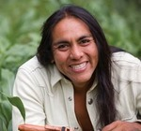

**Charities & foundations supported**

* Middle Road Foundation
* Peacing It Together Foundation

### Causes supported

* Children
* Education
* Peace

# Roberto Manrique

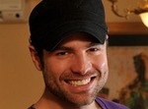

**Charities & foundations supported**

* UNHCR

### Causes supported

* Human Rights
* Refugees

**Robert Pattinson**



### Charities & foundations supported

* American Foundation for AIDS Research
* GO Campaign
* Midnight Mission
* PACT

### Causes supported

* Adoption
* Fostering
* Orphans
* AIDS & HIV
* Children
* Family/Parent Support
* Health
* Homelessness
* Mental Challenges
* Physical Challenges
* Poverty

**Robert Picardo**

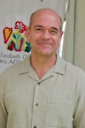

Charities & foundations supported

* Elizabeth Glaser Pediatric AIDS Foundation
* Toteman Epilepsy Awareness Project

### Causes supported

* AIDS & HIV
* Children
* Family/Parent Support
* Health

**Robert Plant**

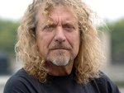

### Charities & foundations supported

* AhmetErtegun Education Fund
* GRAMMY Foundation
* K9 Connection
* Killing Cancer
* Mount Sinai Hospital
* MusiCares
* Nordoff Robbins
* Racehorse Sanctuary
* Teen Cancer America

### Causes supported

* Animals
* At-Risk/Disadvantaged Youths
* Cancer
* Creative Arts
* Education
* Health
* Miscellaneous
* Unemployment/Career Support

**Robert Redford**



**Charities & foundations supported**

* American Wild Horse Preservation Campaign
* Greenpeace
* James Redford Institute for Transplant Awareness
* Sundance Institute

### Causes supported

* Animals
* Blood, Marrow & Organ Donation
* Conservation
* Creative Arts
* Environment

**Robert Vaughn**



**Charities & foundations supported**

* Feed the Children

### Causes supported

* Abuse
* Adoption
* Fostering
* Orphans
* Children
* Disaster Relief
* Hunger
* Poverty

**Robin Gibb**

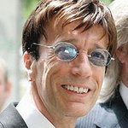

**Charities & foundations supported**

* Caudwell Children
* Comic Relief
* The Royal British Legion

### Causes supported

* Children
* Disaster Relief
* Health,
* Homelessness
* Human Rights
* Poverty
* Veteran/Service Member Support

# Robin Leach



### Charities & foundations supported

* Keep Memory Alive
* TJ Martell Foundation

### Causes supported

* AIDS & HIV
* Cancer
* Children
* Health

# Robin Quivers



**Charities & foundations supported**

* 15 Foundation

### Causes supported

* Philanthropy

**Robinson Cano**

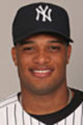

**Charities & foundations supported**

* Red Cross
* Soles4Souls

### Causes supported

* AIDS & HIV
* Disaster Relief
* Human Rights
* Poverty
* Refugees

# Robin Thicke

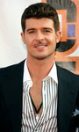

**Charities & foundations supported**

* Save The Music Foundation

### Causes supported

* Children
* Creative Arts
* Education

**Robin Williams**

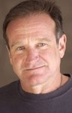

### Charities & foundations supported

* American Foundation for AIDS Research
* Amnesty International
* Andre Agassi Foundation for Education
* Augie's Quest
* Christopher & Dana Reeve Foundation
* Comic Relief
* David Foster Foundation
* Doctors Without Borders
* Dogs Deserve Better
* Dream Foundation
* Heifer International
* International Medical Corps
* Keep Memory Alive
* LIVESTRONG
* Love Our Children USA
* Luke Neuhedel Foundation
* Muhammad Ali Parkinson Center
* MusiCares
* Prince's Trust
* Robert F Kennedy Memorial
* Smile Train
* St. Jude Children's Research Hospital
* UNICEF

### Causes supported

* Abuse
* AIDS & HIV
* Animals
* At-Risk/Disadvantaged Youths
* Cancer
* Children
* Creative Arts
* Disaster Relief
* Education
* Family/Parent Support
* Health
* Homelessness
* Human Rights
* Hunger
* Miscellaneous
* Physical Challenges
* Poverty
* Unemployment/Career Support

# Robin Wright



Charities & foundations supported

* 21st Century Leaders
* American Foundation for AIDS Research
* ENOUGH Project
* The Art of Elysium
* The Nature Conservancy
* Whatever It Takes

### Causes supported

* AIDS & HIV
* Cancer
* Children
* Environment
* Health
* Human Rights
* Miscellaneous
* Peace
* Rape/Sexual Abuse
* Refugee

# Rob Lowe

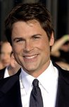

**Charities & foundations supported**

* Believe in Dreams
* Dream Foundation
* Last Chance for Animals
* Live Earth
* Parkinson Society Maritime Region
* Stand Up To Cancer

### Causes supported

* Animals
* Cancer
* Children
* Environment
* Family/Parent Support
* Health

**Rob Machado**

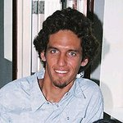

**Charities & foundations supported**

* Chill Foundation
* SurfAid

### Causes supported

* At-Risk/Disadvantaged Youths
* Health
* Miscellaneous

# Rob Reiner

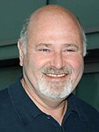

**Charities & foundations supported**

* Alliance For Climate Protection
* American Foundation for Equal Rights
* American Wild Horse Preservation Campaign
* Parents Action For Children

### Causes supported

* Animals
* Children
* Environment
* Gay/Lesbian Support
* Health

# Rob Thomas

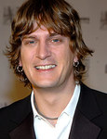

**Charities & foundations supported**

* Alzheimer's Association
* Andre Agassi Foundation for Education
* Live Earth
* Sidewalk Angels Foundation

### Causes supported

* Animals
* At-Risk/Disadvantaged Youths
* Children
* Creative Arts
* Education
* Environment
* Health
* Homelessness
* Poverty

# Rodney Atkins



### Charities & foundations supported

* Fisher House Foundation
* Mary Kay Ash Charitable Foundation

### Causes supported

* Abuse
* Cancer
* Veteran/Service Member Support
* Women

**Rodney Peete**



### Charities & foundations supported

* ACT Today!
* A Place Called Home
* Artists for a New South Africa
* A Star For The Night
* Champions for Children
* Elevate Hope Foundation
* Honey Shine Foundation
* Mama na Dada
* The HollyRod Foundation

### Causes supported

* Abuse
* AIDS & HIV
* At-Risk/Disadvantaged Youths
* Children
* Creative Arts
* Education
* Family/Parent Support
* Health
* Mental Challenges
* Physical Challenges
* Poverty
* Women

**Rod Stewart**



### Charities & foundations supported

* Andre Agassi Foundation for Education
* Barbara Davis Center for Childhood Diabetes
* Caudwell Children
* Dream Foundation
* Hear The World
* Hillsides
* Lowe Syndrome Trust
* MusiCares
* Red Cross
* Starkey Hearing Foundation
* STOMP Out Bullying

### Causes supported

* Abuse
* AIDS & HIV
* At-Risk/Disadvantaged Youths
* Children
* Creative Arts
* Disaster Relief
* Education
* Family/Parent Support
* Health
* Human Rights
* Rape/Sexual Abuse
* Unemployment/Career Support

# Roger Daltrey

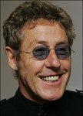

**Charities & foundations supported**

* Bridge School
* Killing Cancer
* Live 8
* Macmillan Cancer Support
* Nordoff Robbins
* Norwood
* PETA
* Prince's Trust
* Robin Hood
* Teenage Cancer Trust
* Teen Cancer America
* Willow Foundation

### Causes supported

* Adoption
* Fostering
* Orphans
* AIDS & HIV
* Animals
* At-Risk/Disadvantaged Youths
* Cancer
* Children
* Economic/Business Support
* Education
* Health
* Literacy
* Mental Challenges
* Miscellaneous
* Physical Challenges
* Poverty

**Roger Federer**

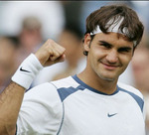

### Charities & foundations supported

* Humpty Dumpty Foundation
* Roger Federer Foundation

### Causes supported

* Children
* Education
* Health
* Sports

**Roger Moore**

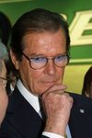

### Charities & foundations supported

* 21st Century Leaders
* Children in Need
* Epilepsy Action
* Feed the Children
* Neurofibromatosis Association
* PACT
* Passage
* PETA
* Prince's Trust
* TigerTime
* UNICEF
* Whatever It Takes

### Causes supported

* Abuse
* Adoption
* Fostering
* Orphans
* Animals
* At-Risk/Disadvantaged Youths
* Children
* Conservation
* Disaster Relief
* Education
* Family/Parent Support
* Health
* Homelessness
* Human Rights
* Hunger
* Mental Challenges
* Miscellaneous
* Physical Challenges
* Poverty
* Substance Abuse

**Roland Williams**

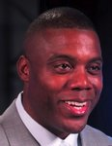

**Charities & foundations supported**

* Youth Lifeline America

### Causes supported

* At-Risk/Disadvantaged Youths
* Children
* Education
* Sports

# Rolf Harris

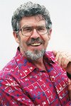

**Charities & foundations supported**

* Elton John AIDS Foundation
* Epilepsy Action
* Neurofibromatosis Association
* Prince's Trust

### Causes supported

* AIDS & HIV
* At-Risk/Disadvantaged Youths
* Children
* Education
* Health

**Roman Harper**

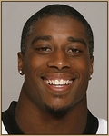

**Charities & foundations supported**

* Boys & Girls Clubs of America
* Harper's Hope 4*1 Foundation
* United Way

### Causes supported

* At-Risk/Disadvantaged Youths
* Children
* Education
* Family/Parent Support
* Health
* Miscellaneous
* Poverty

**Romeo**



**Charities & foundations supported**

* Food on Foot
* It's Time Kids

### Causes supported

* Adoption
* Fostering
* Orphans
* At-Risk/Disadvantaged Youths
* Children
* Creative Arts
* Disaster Relief
* Education
* Health
* Homelessness
* Hunger
* Literacy
* Peace
* Sports

# Romero Britto



**Charities & foundations supported**

* ABC Trust
* Andre Agassi Foundation for Education
* Best Buddies International
* BrazilFoundation
* Britto Foundation
* Keep Memory Alive
* St. Jude Children's Research Hospital

### Causes supported

* At-Risk/Disadvantaged Youths
* Children
* Creative Arts
* Education
* Health
* Human Rights
* Literacy
* Mental Challenges
* Poverty

**Romi Dames**



**Charities & foundations supported**

* ALS Association
* Believe in Dreams
* Rock the Vote
* Starlight Children's Foundation

### Causes supported

* AIDS & HIV
* Cancer
* Children
* Family/Parent Support
* Health
* Physical Challenges
* Voter Education

# Ronaldinho

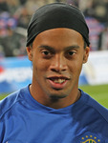

**Charities & foundations supported**

* UNAIDS

### Causes supported

* AIDS & HIV

**Ronaldo**

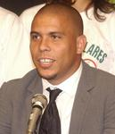

**Charities & foundations supported**

* United Nations Development Programme

### Causes supported

* Economic/Business Support
* Education
* Poverty

# Ronan Keating



**Charities & foundations supported**

* Cancer Research UK
* Children in Need
* Christian Aid
* Comic Relief
* FAO
* Fifteen Foundation
* Leukaemia and Lymphoma Research
* Marie Keating Foundation
* Nordoff Robbins
* Prince's Trust
* Sport Relief

### Causes supported

* Abuse
* AIDS & HIV
* At-Risk/Disadvantaged Youths
* Cancer
* Children
* Conservation
* Disaster Relief
* Education
* Environment
* Fair Trade
* Health
* Homelessness
* Human Rights
* Hunger
* Literacy
* Mental Challenges
* Miscellaneous
* Peace
* Physical Challenges
* Poverty
* Substance Abuse
* Women

**Ron Artest**

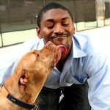

**Charities & foundations supported**

* PETA

### Causes supported

* Animals
* Mental Challenges

**Ron Howard**

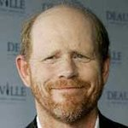

**Charities & foundations supported**

* Boys & Girls Clubs of America
* Bring Change 2 Mind
* The Hollywood Cookbook

### Causes supported

* AIDS & HIV
* At-Risk/Disadvantaged Youths
* Children
* Disaster Relief
* Education
* Health
* Homelessness
* Mental Challenges
* Women

**Ron Livingston**



### Charities & foundations supported

* Redlight Children Campaign
* Somaly Mam Foundation

### Causes supported

* Children
* Human Rights
* Rape/Sexual Abuse
* Women

**Ronnie Corbett**

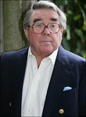

### Charities & foundations supported

* Cats Protection
* Comic Relief
* Norwood
* Royal National Lifeboat Institution

### Causes supported

* Animals
* Children
* Disaster Relief
* Education
* Emergency services
* Homelessness
* Human Rights
* Literacy
* Mental Challenges
* Poverty

# Ronnie Wood

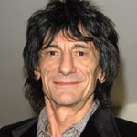

**Charities & foundations supported**

* Nordoff Robbins

### Causes supported

* Miscellaneous

**Ron Perlman**

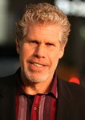

**Charities & foundations supported**

* Make-A-Wish Foundation

### Causes supported

* Cancer
* Children
* Health

# RoopashreeJeevaji



**Charities & foundations supported**

* The Trevor Project

### Causes supported

* Children
* Depression and Suicide
* Gay/Lesbian Support

**Rory Bremner**

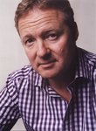

**Charities & foundations supported**

* Comic Relief
* Environmental Investigation Agency

### Causes supported

* Animal
* Conservation
* Disaster Relief
* Environment
* Homelessness
* Human Rights
* Poverty

# Rory McIlroy

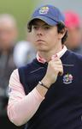

**Charities & foundations supported**

* Laureus Sport for Good Foundation
* UNICEF

### Causes supported

* At-Risk/Disadvantaged Youths
* Children
* Health
* Human Rights
* Poverty
* Sports

# Rosanna Arquette



**Charities & foundations supported**

* Amazon Watch
* Bicycle For A Day
* Plastic Pollution Coalition
* The Art of Elysium

### Causes supported

* AIDS & HIV
* Cancer
* Children
* Conservation
* Environment
* Health
* Human Rights
* Oceans
* Water

**Rosario Dawson**



**Charities & foundations supported**

* Amnesty International
* Artists for Peace and Justice
* Declare Yourself
* DoSomething.org
* Global Cool
* International Rescue Committee
* Lower East Side Girls Club
* Make-A-Wish Foundation
* ONE Campaign
* Oxfam
* Parents, Families, and Friends of Lesbians and Gays
* Peace Over Violence
* V-Day
* Voto Latino

### Causes supported

* Abuse
* AIDS & HIV
* Cancer
* Children
* Disaster Relief
* Education
* Environment
* Family/Parent Support
* Gay/Lesbian Support
* Health
* Human Rights
* Miscellaneous
* Philanthropy
* Poverty
* Rape/Sexual Abuse
* Refugees
* Voter Education
* Women

**Roseanne Barr**



**Charities & foundations supported**

* ACORN
* Comic Relief
* The Trevor Project

### Causes supported

* Children
* Depression and Suicide
* Disaster Relief
* Gay/Lesbian Support
* Homelessness
* Human Rights
* Miscellaneous
* Poverty

**Rose McGowan**



**Charities & foundations supported**

* Aids Life
* Artists for Peace and Justice
* The Art of Elysium

### Causes supported

* AIDS & HIV
* Animals
* Cancer
* Children
* Disaster Relief
* Health
* Miscellaneous
* Poverty

**Rosie O'Donnell**



### Charities & foundations supported

* Autism Speaks
* Blue Planet Run Foundation
* Gloria Estefan Foundation
* Heifer International
* Human Rights Campaign
* Rosie's Broadway Kids
* Rosie's For All Kids Foundation
* SixDegrees.org
* St. Francis Food Pantries and Shelters

### Causes supported

* AIDS & HIV
* Animals
* At-Risk/Disadvantaged Youths
* Blood, Marrow & Organ Donation
* Children
* Education
* Gay/Lesbian Support
* Health
* Hunger
* Mental Challenges
* Philanthropy
* Poverty
* Water
* Women

# Ross Brawn



**Charities & foundations supported**

* Royal National Lifeboat Institution

### Causes supported

* Emergency services

**Ross Thomas**

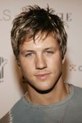

**Charities & foundations supported**

* Amazon Watch
* Survival International

### Causes supported

* Conservation,
* Environment,
* Human Rights,
* Water

**Rowan Atkinson**

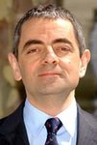

**Charities & foundations supported**

* Amnesty International
* CAFOD
* Charity Projects Entertainment Fund
* Comic Relief
* Kids Company
* Prince's Trust
* Save the Children
* UNICEF

### Causes supported

* Abuse
* Addiction
* AIDS & HIV
* At-Risk/Disadvantaged Youths
* Children
* Disaster Relief
* Economic/Business Support
* Education
* Environment
* Health
* Homelessness
* Human Rights
* Hunger
* Miscellaneous
* Poverty

**Roy Jones JR**

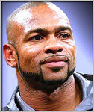

**Causes supported**

* Disaster Relief

**Roz Savage**



**Causes supported**

* Conservation
* Environment
* Water

**Ruben Studdard**

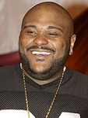

### Causes supported

* Children
* Health

**Ruby Wax**

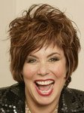

**Charities & foundations supported**

* Kids Company
* Mind
* Oxfam
* Refuge
* Rethink

### Causes supported

* Abuse
* At-Risk/Disadvantaged Youths
* Children
* Disaster Relief
* Education
* Human Rights
* Mental Challenges
* Poverty
* Women

**Rudy Ruettiger**

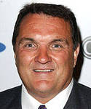

**Causes supported**

* Education
* Sports

**Rue McClanahan**

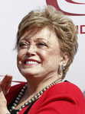

**Charities & foundations supported**

* Farm Sanctuary
* Neurofibromatosis, Inc.
* PETA

### Causes supported

* Animals
* Health

**Run DMC**

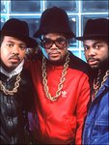

**Charities & foundations supported**

* Children's Hospital Los Angeles
* CLIC Sargent
* Josh Beckett Foundation

### Causes supported

* At-Risk/Disadvantaged Youths
* Cancer
* Children
* Family/Parent Support
* Grief Support
* Health

**Rupert Grint**



**Charities & foundations supported**

* Great Ormond Street Hospital
* Keech Hospice Care
* Sense

### Causes supported

* Children
* Family/Parent Support
* Health
* Physical Challenges

**Rush**

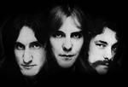

**Charities & foundations supported**

* Little Kids Rock
* UNICEF

### Causes supported

* At-Risk/Disadvantaged Youths
* Children
* Creative Arts
* Disaster Relief
* Environment
* Health
* Human Rights
* Poverty

**Russell Brand**

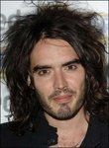

**Charities & foundations supported**

* Hillsborough Family Support Group
* Noreen Fraser Foundation

### Causes supported

* Cancer
* Family/Parent Support
* Grief Support
* Health
* Women

**Russell Crowe**



**Charities & foundations supported**

* Artists for Peace and Justice
* Keep A Child Alive
* Locks Of Love
* Red Cross
* Robert F Kennedy Memoria

### Causes supported

* AIDS & HIV
* Cancer
* Children
* Disaster Relief
* Family/Parent Support
* Health
* Human Rights
* Miscellaneous
* Poverty

**Russell Simmons**

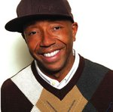

**Charities & foundations supported**

* ACE Programs for the Homeless
* Champions for Children
* Diamond Empowerment Fund
* Earth Day Network
* Farm Sanctuary
* Get Schooled Foundation
* Hip-Hop Summit Action Network
* Lisa Lopes Foundation
* PETA
* (RED)
* Rush Philanthropic Arts Foundation
* The Doe Fund
* The Humane Society
* US Doctors for Africa

### Causes supported

* Abuse
* Adoption
* Fostering
* Orphans
* AIDS & HIV
* Animals
* At-Risk/Disadvantaged Youths
* Children
* Creative Arts
* Education
* Environment
* Health
* Homelessness
* Miscellaneous
* Poverty
* Voter Education
* Women

**Russell Watson**

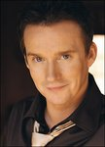

**Charities & foundations supported**

* Children in Need

### Causes supported

* Abuse
* Children
* Health
* Homelessness
* Mental Challenges
* Physical Challenges
* Substance Abuse

**Ruth Riley**

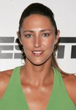

**Charities & foundations supported**

* Share Our Strength
* United Nations Foundation

### Causes supported

* AIDS & HIV,
* Children,
* Environment,
* Health,
* Human Rights,
* Hunger,
* Peace,
* Women

# Ryan Adams

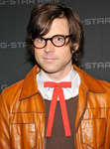

**Charities & foundations supported**

* Save The Music Foundation

### Causes supported

* AIDS & HIV
* Children
* Creative Arts
* Education
* Homelessness

**RyanDan**

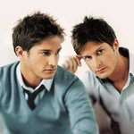

**Charities & foundations supported**

* BeatBullying
* b.r.a.i.n.child
* Sunnybrook Foundation
* [Tal Doron Memorial Fund](http://www.looktothestars.org/charity/tal-doron-memorial-fund)

### Causes supported

* Cancer
* Children
* Health
* Human Rights

**Ryan Gosling**

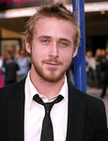

### Charities & foundations supported

* Invisible Children
* PETA
* SickKids Foundation
* Silverlake Conservatory of Music

### Causes supported

* Animals
* Children
* Creative Arts
* Health
* Human Rights
* Peace

**Ryan Kwanten**

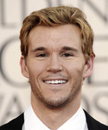

**Charities & foundations supported**

* City of Hope

### Causes supported

* AIDS & HIV
* Cancer

# Ryan Reynolds

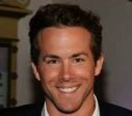

### Charities & foundations supported

* Michael J. Fox Foundation

### Causes supported

* Health

**Ryan Seacrest**



**Charities & foundations supported**

* CHOC Children's
* Clothes Off Our Back
* Dogs In Danger
* DoSomething.org
* Feeding America
* Keep A Child Alive
* LA's Promise
* Malaria No More
* Noreen Fraser Foundation
* Operation Once in a Lifetime
* Reality Cares
* Red Cross
* Ryan Seacrest Foundation
* Soles4Souls
* STILLERSTRONG
* The Art of Elysium

### Causes supported

* AIDS & HIV
* Animals
* At-Risk/Disadvantaged Youths
* Cancer
* Children
* Disaster Relief
* Education
* Family/Parent Support
* Health
* Human Rights
* Hunger
* Miscellaneous
* Philanthropy
* Poverty
* Refugees
* Veteran/Service Member Support
* Women

**Ryan Sheckler**

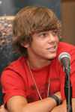

**Charities & foundations supported**

* Children's Cancer Research Fund
* Kids Wish Network
* Sheckler Foundation
* Tony Hawk Foundation

### Causes supported

* At-Risk/Disadvantaged Youths
* Cancer
* Children
* Grief Support
* Health
* Sports

# Ryan Star

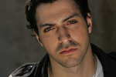

### Charities & foundations supported

* rock CAN roll

Causes supported

* Hunger