**Taboo**



**Charities & foundations supported**

* i.am scholarship Fund
* The Black Eyed Peas Foundation
* We Are The World Foundation

**Causes supported**

* Adoption,
* Fostering
* Orphans
* AIDS & HIV
* At-Risk/Disadvantaged Youths
* Children
* Disaster Relief
* Education
* Family/Parent Support
* Peace

**Taio Cruz**

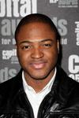

**Charities & foundations supported**

* Big Brothers Big Sisters
* Help a London Child
* Little Kids Rock
* Musicians on Call

### Causes supported

* At-Risk/Disadvantaged Youths
* Children
* Creative Arts
* Health
* Poverty

**Take That**



**Charities & foundations supported**

* Children in Need
* Comic Relief
* Help for Heroes
* Nordoff Robbins

Causes supported

* Abuse
* Children
* Disaster Relief
* Health
* Homelessness
* Human Rights
* Mental Challenges
* Miscellaneous
* Physical Challenges
* Poverty
* Substance Abuse
* Veteran/Service Member Support

# TalibKweli

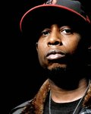

**Charities & foundations supported**

* Chris Webber Foundation
* Common Ground Foundation
* Make-A-Wish Foundation

Causes supported

* At-Risk/Disadvantaged Youths
* Cancer
* Children
* Education
* Health
* Literacy

**Tali Lennox**

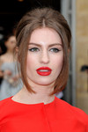

**Charities & foundations supported**

* [Christian Aid](http://www.looktothestars.org/charity/christian-aid)

### Causes supported

* Human Rights
* Peace
* Poverty
* Women

**Tamara Tunie**



**Charities & foundations supported**

* Children's Aid Society
* Figure Skating in Harlem
* Hearts of Gold
* Soles4Souls

**Causes supported**

* At-Risk/Disadvantaged Youths
* Children
* Disaster Relief
* Family/Parent Support
* Homelessness
* Poverty
* Refugees
* Senior Citizen Support
* Sports

**Tamia**



**Charities & foundations supported**

* Ronald McDonald House Charities

### Causes supported

* Children
* Family/Parent Support

**TanithBelbin& Ben Agosto**



**Charities & foundations supported**

* American Cancer Society
* Red Cross

**Causes supported**

* AIDS & HIV
* Cancer
* Disaster Relief
* Health
* Human Rights

**Tanja Maritsa**

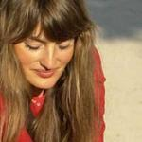

**Causes supported**

* Children
* Human Rights

**Tanya Donelly**



**Charities & foundations supported**

* Casting For Recovery
* MoveOn
* ONE Campaign
* Plan International USA

**Causes supported**

* AIDS & HIV
* At-Risk/Disadvantaged Youths
* Cancer
* Children
* Education
* Family/Parent Support
* Health
* Human Rights
* Poverty
* Voter Education
* Women

**Taraji P. Henson**



**Charities & foundations supported**

* A Place Called Home
* The Heart Truth

**Causes supported**

* At-Risk/Disadvantaged Youths
* Health
* Women

# Tara Palmer Tomkinson



**Charities & foundations supported**

* Mind
* Save the Children

**Causes supported**

* Abuse
* AIDS & HIV
* Children
* Disaster Relief
* Education
* Mental Challenges
* Poverty

**Tate Donovan**

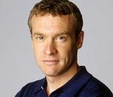

**Charities & foundations supported**

* Children's Cancer Research Fund
* Global Green
* Young Storytellers Foundation

**Causes supported**

* Cancer
* Children
* Education
* Environment
* Health
* Literacy
* Peace
* Poverty
* Water

# TatjanaPatitz



**Charities & foundations supported**

* Farm Sanctuary
* Return To Freedom

**Causes supported**

* Animals
* Environment

**Tatyana Ali**



**Charities & foundations supported**

* Aviva
* Barbara Davis Center for Childhood Diabetes
* Believe in Dreams
* Declare Yourself

**Causes supported**

* Adoption
* Fostering
* Orphans
* At-Risk/Disadvantaged Youths
* Children
* Education
* Family/Parent Support
* Health
* Voter Education

**Taye Diggs**

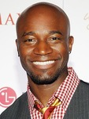

**Charities & foundations supported**

* American Cancer Society

**Causes supported**

* Cancer
* Health

**Taylor Barton**

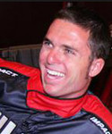

**Charities & foundations supported**

* Boys & Girls Clubs of America
* Children Mending Hearts
* Feed the Children
* Taylor Barton Foundation

**Causes supported**

* Abuse
* Adoption
* Fostering
* Orphans
* At-Risk/Disadvantaged Youths
* Children
* Disaster Relief
* Hunger
* Poverty

**Taylor Dayne**



**Charities & foundations supported**

* Dream Foundation
* Global Green
* Muscular Dystrophy Association
* Nancy Davis Foundation for Multiple Sclerosis
* Operation Doggy Drop
* Project Angel Food

**Causes supported**

* AIDS & HIV
* Animals
* Cancer
* Children
* Environment
* Family/Parent Support
* Health
* Peace
* Poverty
* Water

**Taylor Lautner**

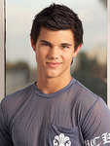

**Charities & foundations supported**

* Lollipop Theater Network

**Causes supported**

* Children
* Health

**Taylor Swift**

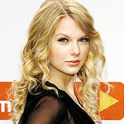

**Charities & foundations supported**

* Children in Need
* Clothes Off Our Back
* DonateMyDress.org
* Family Health International
* Feeding America
* GRAMMY Foundation
* Habitat For Humanity
* Hands On Nashville
* Hero in Heels
* MusiCares
* Music for Relief
* PROJECT ZAMBI
* Red Cross
* Save The Music Foundation
* Shoe Revolt
* Shriners Hospitals for Children
* Soles4Souls
* Tug McGraw Foundation
* UNICEF
* Victory Junction Gang
* Wish Upon A Hero Foundation

**Causes supported**

* Abuse
* Adoption
* Fostering
* Orphans
* AIDS & HIV
* At-Risk/Disadvantaged Youths
* Cancer
* Children
* Creative Arts
* Disaster Relief
* Education
* Environment
* Family/Parent Support
* Health
* Homelessness
* Human Rights, [Hunger](http://www.looktothestars.org/cause/hunger)
* Mental Challenges
* Philanthropy
* Physical Challenges
* Poverty
* Rape/Sexual Abuse
* Refugees
* Substance Abuse
* Unemployment/Career Support
* Women

**Tea Leoni**



**Charities & foundations supported**

* Much Love Animal Rescue
* Raising Malawi
* Tuberous Sclerosis Alliance
* UNICEF

**Causes supported**

* Adoption
* Fostering
* Orphans
* AIDS & HIV
* Animals
* Children
* Health
* Human Rights
* Poverty

**Ted Danson**

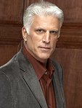

**Charities & foundations supported**

* ASPCA
* Heifer International
* Malaria No More
* Oceana
* Young Storytellers Foundation

**Causes supported**

* AIDS & HIV
* Animals
* Children
* Conservation
* Education
* Environment
* Health
* Hunger
* Literacy
* Oceans
* Poverty
* Water

**Ted Turner**

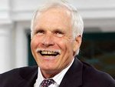

**Charities & foundations supported**

* Avoided Deforestation Partners
* Captain Planet Foundation
* Children's Cancer & Blood Foundation
* Children with AIDS
* Nothing But Nets
* Nuclear Age Peace Foundation
* United Nations Foundation

**Causes supported**

* AIDS & HIV
* Cancer
* Children
* Conservation
* Environment
* Family/Parent Support
* Health
* Human Rights
* Peace
* Weapons Reduction
* Women

**TenleyMolzahn**

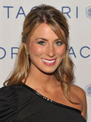

**Charities & foundations supported**

* Give Back Hollywood Foundation

### Causes supported

* Philanthropy

# Terence Newman

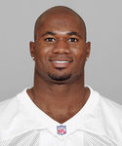

**Charities & foundations supported**

* Rising Stars Foundation

### Causes supported

* Education
* Sports

**Teri Hatcher**

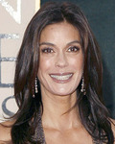

**Charities & foundations supported**

* AmberWatch Foundation
* AmericaShare
* Aviva
* Band From TV Global Charity Trust
* CARE
* Charity Projects Entertainment Fund
* Chrysalis
* Clothes Off Our Back
* Dress for Success
* Keep Memory Alive
* Make-A-Wish Foundation
* Nevada Cancer Institute
* Save the Children
* Starlight Children's Foundation
* The Humane Society
* Tiger Woods Learning Center
* Tuberous Sclerosis Alliance
* UNICEF
* V-Day

**Causes supported**

* Abuse
* Adoption
* Fostering
* Orphans
* AIDS & HIV
* Animals
* At-Risk/Disadvantaged Youths
* Cancer
* Children
* Conservation
* Disaster Relief
* Education
* Environment
* Family/Parent Support
* Health
* Homelessness
* Human Rights
* Miscellaneous
* Missing Children
* Poverty
* Rape/Sexual Abuse
* Women

**Teri Polo**

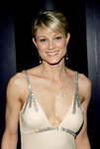

**Charities & foundations supported**

* We Promise Foundation

### Causes supported

* Children
* Health

**Terra Naomi**

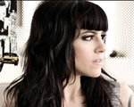

**Charities & foundations supported**

* Doctors Without Borders
* Human Rights Watch
* Live Earth
* Save Darfur Coalition
* Stop Global Warming

**Causes supported**

* Disaster Relief
* Environment
* Health
* Human Rights

**Terrell Owens**

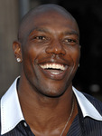

**Charities & foundations supported**

* Alzheimer's Association
* Andy Roddick Foundation
* Elton John AIDS Foundation
* Leeza's Place
* Stand Up To Cancer

**Causes supported**

* Abuse
* AIDS & HIV
* At-Risk/Disadvantaged Youths
* Cancer
* Children
* Health

**Terrence Howard**



**Charities & foundations supported**

* Children's Hospital Los Angeles
* Clothes Off Our Back
* Entertainment Industry Foundation
* Feeding America
* Padres Contra el Cancer
* SickKids Foundation

**Causes supported**

* Cancer
* Children
* Creative Arts
* Education
* Family/Parent Support
* Health
* Hunger
* Poverty

**Terri Irwin**



**Charities & foundations supported**

* Wildlife Warriors Worldwide

### Causes supported

* Animals,
* Environment

**Terri Nunn**

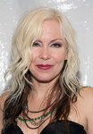

**Charities & foundations supported**

* United Way

**Causes supported**

* Education
* Health
* Miscellaneous
* Poverty

**Terry Crews**

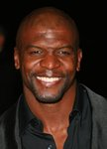

**Charities & foundations supported**

* A Place Called Home
* Celebrity Fight Night Foundation
* Muhammad Ali Parkinson Center
* Padres Contra el Cancer

**Causes supported**

* At-Risk/Disadvantaged Youths
* Cancer
* Children
* Family/Parent Support
* Health

**Terry George**



**Charities & foundations supported**

* charity:water

### Causes supported

* Poverty
* Water

**Terry Gibbs**

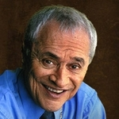

**Charities & foundations supported**

* California Jazz Foundation

Causes supported

* Creative Arts,
* Unemployment/Career Support

**Terry Jones**



**Charities & foundations supported**

* Amnesty International
* National Literacy Trust
* Willow Foundation

**Causes supported**

* Cancer
* Health
* Human Rights
* Literacy

**Terry Pratchett**

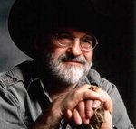

**Charities & foundations supported**

* Alzheimer's Research UK
* British Humanist Association
* Children with AIDS
* Dignity in Dying

**Causes supported**

* AIDS & HIV, [Children](http://www.looktothestars.org/cause/children)
* Education
* Family/Parent Support
* Health
* Human Rights
* Philanthropy
* Physical Challenges

**Terry Venables**

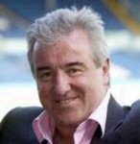

### Charities & foundations supported

* Macmillan Cancer Support
* UNICEF

### Causes supported

* Cancer
* Children, [Health](http://www.looktothestars.org/cause/health)
* Human Rights
* Poverty

**Terry Wogan**



### Charities & foundations supported

* Children in Need
* Children with AIDS

**Causes supported**

* Abuse
* AIDS & HIV
* Children
* Family/Parent Support
* Health
* Homelessness
* Mental Challenges
* Physical Challenges
* Substance Abuse

**Tess Daly**



**Charities & foundations supported**

* Age Concern
* Age UK
* Children in Need
* Children with AIDS
* Great Ormond Street Hospital
* Wellbeing of Women

**Causes supported**

* Abuse
* AIDS & HIV
* Cancer
* Children
* Family/Parent Support
* Health
* Homelessness
* Mental Challenges
* Miscellaneous
* Physical Challenges
* Senior Citizen Support
* Substance Abuse
* Women

**Thandie Newton**

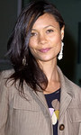

**Charities & foundations supported**

* Artists for Peace and Justice
* Breast Cancer Care
* Greenpeace

**Causes supported**

* Animals
* Cancer
* Conservation
* Disaster Relief
* Environment
* Miscellaneous
* Poverty
* Women

**The Academy Is**

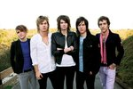

**Charities & foundations supported**

* Children's Hospital Los Angeles
* Memorial Sloan-Kettering
* TJ Martell Foundation

**Causes supported**

* AIDS & HIV
* Cancer
* Children
* Health

**The Band Perry**

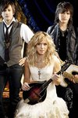

**Charities & foundations supported**

* Save The Music Foundation

**Causes supported**

* Children
* Creative Arts
* Education

**The Cure**

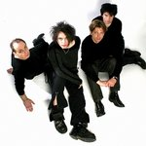

**Charities & foundations supported**

* CAFOD
* Teenage Cancer Trust

**Causes supported**

* Abuse
* Addiction
* At-Risk/Disadvantaged Youths
* Cancer
* Children
* Disaster Relief
* Economic/Business Support
* Environment
* Health
* Homelessness
* Human Rights
* Hunger
* Miscellaneous
* Poverty

**The Dandy Warhols**

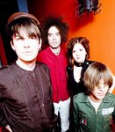

### Charities & foundations supported

* Three Rivers Land Conservancy

### Causes supported

* Conservation

**The Edge**

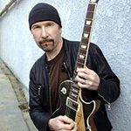

**Charities & foundations supported**

* 21st Century Leaders
* 46664
* DATA
* Food Bank For New York City
* Greenpeace
* Live 8
* Make Poverty History
* Mencap
* MusiCares
* Music Rising
* Whatever It Takes

**Causes supported**

* Adoption
* Fostering
* Orphans
* AIDS & HIV
* Animals
* Children
* Conservation
* Creative Arts
* Disaster Relief
* Environment
* Fair Trade
* Hunger
* Literacy
* Mental Challenges
* Miscellaneous
* Poverty
* Unemployment/Career Support

**The Guncles**

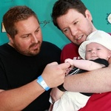

**Causes supported**

* Family/Parent Support
* Gay/Lesbian Support
* Hunger

**The Killers**

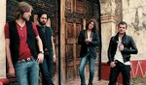

**Charities & foundations supported**

* Aid Still Required
* Andre Agassi Foundation for Education
* (RED)
* UNICEF
* USAID

**Causes supported**

* AIDS & HIV
* At-Risk/Disadvantaged Youths
* Children
* Disaster Relief
* Economic/Business Support
* Education
* Health
* Human Rights
* Hunger
* Poverty
* Rape/Sexual Abuse
* Women

# Theo Fleury

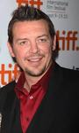

### Charities & foundations supported

* 1in6
* Crohn's and Colitis Foundation of Canada
* The Men's Project

**Causes supported**

* Abuse
* Health
* Rape/Sexual Abuse
* Sports
* Substance Abuse

**Theo Rossi**



**Charities & foundations supported**

* Boot Campaign

**Causes supported**

* Veteran/Service Member Support

**The Police**



**Charities & foundations supported**

* Live Earth
* MusiCares
* Rainforest Foundation Fund
* Unitus

Causes supported

* Creative Arts
* Environment
* Human Rights
* Poverty
* Unemployment/Career Support

**The Proclaimers**



**Charities & foundations supported**

* Comic Relief
* Lighthouse Foundation

**Causes supported**

* Addiction
* Children
* Disaster Relief
* Family/Parent Support
* Homelessness
* Human Rights
* Poverty

**The Saturdays**



**Charities & foundations supported**

* Comic Relief
* Elton John AIDS Foundation
* Help a London Child
* Help for Heroes
* Sport Relief
* Variety Club
* Variety - The Children's Charity

**Causes supported**

* AIDS & HIV
* At-Risk/Disadvantaged Youths
* Cancer
* Children
* Conservation
* Disaster Relief
* Education
* Environment
* Fair Trade
* Health
* Homelessness
* Human Rights
* Hunger
* Literacy
* Miscellaneous
* Physical Challenges
* Poverty
* Veteran/Service Member Support

**The Temper Trap**

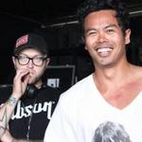

**Charities & foundations supported**

* Little Kids Rock

**Causes supported**

* At-Risk/Disadvantaged Youths
* Children
* Conservation
* Creative Arts
* Environment

**The Veronicas**

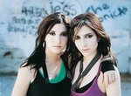

**Charities & foundations supported**

* Redkite
* Wildlife Warriors Worldwide

**Causes supported**

* Animals
* Cancer
* Children
* Environment

**The Wanted**

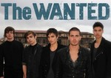

**Charities & foundations supported**

* Comic Relief
* Help for Heroes
* Nordoff Robbins

Causes supported

* Disaster Relief
* Homelessness
* Human Rights
* Miscellaneous
* Poverty
* Veteran/Service Member Support

# The Who

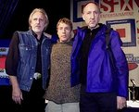

**Charities & foundations supported**

* K9 Connection
* Starlight Children's Foundation
* Teenage Cancer Trust

**Causes supported**

* AIDS & HIV
* Animals
* At-Risk/Disadvantaged Youths
* Cancer
* Children
* Health

**The Wiggles**

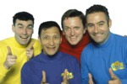

**Charities & foundations supported**

* UNICEF

**Causes supported**

* Children
* Health
* Human Rights
* Poverty

**The Yes Men**

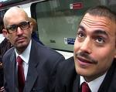

**Causes supported**

* Conservation
* Environment
* Human Rights
* Water

**Thierry Henry**

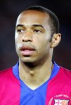

**Charities & foundations supported**

* Cystic Fibrosis Foundation
* Cystic Fibrosis Trust
* Elton John AIDS Foundation
* UNICEF

**Causes supported**

* AIDS & HIV
* Children
* Health
* Human Rights
* Poverty

**Third Day**

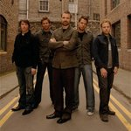

**Charities & foundations supported**

* Habitat For Humanity
* Kids Wish Network

**Causes supported**

* Children
* Disaster Relief
* Grief Support
* Health
* Homelessness

**Third Eye Blind**

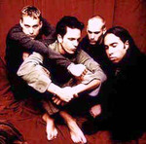

**Charities & foundations supported**

* KickStart
* Rush Philanthropic Arts Foundation
* Sea Shepherd Conservation Society
* Tiger Woods Foundation

**Causes supported**

* Animals
* At-Risk/Disadvantaged Youths
* Children
* Creative Arts
* Environment
* Family/Parent Support
* Oceans
* Poverty
* Water

**Thom Fitzgerald**



**Charities & foundations supported**

* Boston Living Center
* Nova Scotia-Gambia Association

**Causes supported**

* AIDS & HIV
* Health

**Thora Birch**

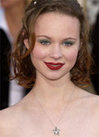

**Charities & foundations supported**

* Barbara Davis Center for Childhood Diabetes
* Best Buddies International
* Elizabeth Glaser Pediatric AIDS Foundation
* The Hollywood Cookbook
* **Causes supported**
* AIDS & HIV
* At-Risk/Disadvantaged Youths
* Children
* Disaster Relief
* Family/Parent Support
* Health
* Homelessness
* Mental Challenges
* Women

# Thurman Thomas

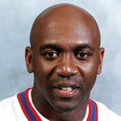

**Causes supported**

* Children
* Sports

**T.I.**

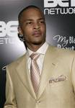

**Charities & foundations supported**

* For The Love Of Our Fathers

**Causes supported**

* Health
* Mental Challenges

**Tia Carrere**



**Charities & foundations supported**

* Ante Up For Africa
* Children's Tumor Foundation
* Global Green
* Global Green Plan
* Vine Group
* Wyland Foundation

**Causes supported**

* Children
* Conservation
* Education
* Environment
* Health
* Human Rights
* Peace
* Poverty
* Refugees
* Water

**Tichina Arnold**



**Charities & foundations supported**

* First Star

**Causes supported**

* Abuse
* At-Risk/Disadvantaged Youths
* Children

**Tico Torres**

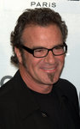

**Charities & foundations supported**

* Tico Torres Children Foundation

### Causes supported

* Children

**Tiffani Thiessen**



**Charities & foundations supported**

* Baby Buggy
* Children's Hospital Los Angeles
* Entertainment Industry Foundation
* March Of Dimes
* World Society for the Protection of Animals

**Causes supported**

* Animals
* Cancer
* Children
* Creative Arts
* Education
* Family/Parent Support
* Health
* Hunger
* Poverty

**Tiger Woods**

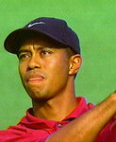

**Charities & foundations supported**

* Caddy for a Cure
* Rainforest Foundation Fund
* Shriners Hospitals for Children
* Tiger Woods Foundation
* Tiger Woods Learning Center

**Causes supported**

* Cancer
* Children
* Education
* Environment
* Family/Parent Support
* Health
* Human Rights
* Miscellaneous

**Tiki Barber**

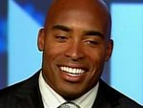

**Charities & foundations supported**

* Children's Cancer & Blood Foundation
* National Black Leadership Commission on AIDS, Inc.
* Opportunity League

**Causes supported**

* AIDS & HIV
* Cancer
* Children
* Health
* Mental Challenges
* Physical Challenges
* Sports

**TildaSwinton**

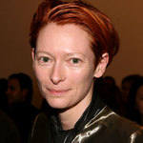

**Causes supported**

* Conservation
* Creative Arts
* Education

**Tim Allen**

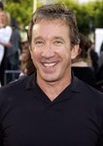

**Charities & foundations supported**

* Big Brothers Big Sisters
* Elton John AIDS Foundation
* Habitat For Humanity
* Neurofibromatosis, Inc.
* Red Cross
* Special Olympics
* St. Jude Children's Research Hospital
* St. Vincent's HealthCare
* Toys for Tots
* Wheels for Humanity

**Causes supported**

* AIDS & HIV
* At-Risk/Disadvantaged Youths
* Children
* Disaster Relief
* Health
* Homelessness
* Human Rights
* Mental Challenges
* Physical Challenges

**Timbaland**

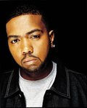

**Charities & foundations supported**

* Designers Against AIDS
* Raising Malawi
* Stand Up To Cancer
* The Gentlemen's Fund
* UNICEF

**Causes supported**

* Adoption
* Fostering
* Orphans
* AIDS & HIV
* Cancer
* Children
* Economic/Business Support
* Education
* Environment
* Health
* Human Rights
* Poverty

**Tim Daly**

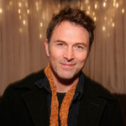

**Charities & foundations supported**

* Creative Coalition
* Entertainment Industry Foundation

**Causes supported**

* Cancer
* Children
* Creative Arts
* Education
* Health
* Hunger
* Miscellaneous
* Poverty

**Tim Duncan**

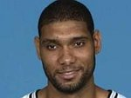

**Charities & foundations supported**

* American Cancer Society
* Tim Duncan Foundation

**Causes supported**

* Cancer
* Children
* Education
* Health
* Sports

**Tim Gunn**

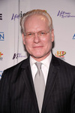

**Charities & foundations supported**

* American Association of Retired Persons
* It Gets Better Project
* PETA
* The Trevor Project

**Causes supported**

* Animals
* Children
* Depression and Suicide
* Gay/Lesbian Support
* Miscellaneous

**Tim Kang**

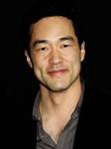

**Charities & foundations supported**

* National Center for Missing and Exploited Children

**Causes supported**

* Children
* Family/Parent Support
* Missing Children
* Rape/Sexual Abuse

**Tim Kring**

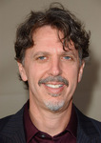

### Charities & foundations supported

* Pearson Foundation
* Room to Read

### Causes supported

* Education

**Tim McGraw**

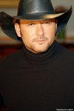

**Charities & foundations supported**

* Aid Still Required
* Andre Agassi Foundation for Education
* Angelwear
* ASPCA
* David Foster Foundation
* Elevate Hope Foundation
* End Hunger Network
* Heifer International
* James Redford Institute for Transplant Awareness
* K9 Connection
* Kids Wish Network
* Live 8
* Monroe Carell Jr. Children's Hospital at Vanderbilt
* Muhammad Ali Parkinson Center
* MusiCares
* Musicians on Call
* Navy-Marine Corps Relief Society
* Neighbor's Keeper Foundation
* Operation Homefront
* Red Cross
* St. Jude Children's Research Hospital
* TJ Martell Foundation
* Tug McGraw Foundation

**Causes supported**

* Abuse
* Adoption
* Fostering
* Orphans
* AIDS & HIV
* Animals
* At-Risk/Disadvantaged Youths
* Blood, Marrow & Organ Donation
* Cancer
* Children
* Creative Arts
* Disaster Relief
* Education
* Family/Parent Support
* Grief Support
* Health
* Homelessness
* Human Rights
* Hunger
* Mental Challenges
* Physical Challenges
* Poverty
* Unemployment/Career Support
* Veteran/Service Member Support

**Timmy Curran**

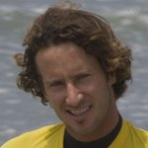

**Charities & foundations supported**

* Chill Foundation
* Heifer International
* Surfrider Foundation

**Causes supported**

* AIDS & HIV
* Animals, [At-Risk/Disadvantaged Youths](http://www.looktothestars.org/cause/at-risk-disadvantaged-youths)
* Children
* Environment
* Hunger
* Oceans
* Poverty

**Tim Robbins**

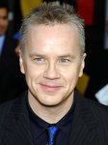

**Charities & foundations supported**

* Cinema For Peace
* Plastic Pollution Coalition
* Right To Play

**Causes supported**

* At-Risk/Disadvantaged Youths
* Children
* Environment
* Oceans
* Peace

**Tina Fey**



**Charities & foundations supported**

* Alzheimer's Association
* Autism Speaks
* Clothes Off Our Back
* Dress for Success
* Jumpstart
* Love Our Children USA
* Stand Up To Cancer
* Worldwide Orphans Foundation

### Causes supported

* Abuse
* Adoption
* Fostering
* Orphans
* AIDS & HIV
* At-Risk/Disadvantaged Youths
* Cancer
* Children
* Education
* Family/Parent Support
* Health
* Literacy
* Mental Challenges
* Poverty
* Women

**Tina Turner**



**Charities & foundations supported**

* Caudwell Children
* Prince's Trust
* United Service Organization

### Causes supported

* At-Risk/Disadvantaged Youths
* Children
* Education
* Health
* Veteran/Service Member Support

**TinchyStryder**

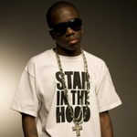

**Charities & foundations supported**

* Help a London Child
* Keep A Child Alive
* Sport Relief
* War Child

### Causes supported

* AIDS & HIV
* At-Risk/Disadvantaged Youths
* Cancer
* Children
* Conservation
* Disaster Relief
* Education
* Environment
* Fair Trade
* Family/Parent Support
* Health
* Human Rights
* Hunger
* Literacy
* Miscellaneous
* Peace
* Poverty

**Tinsel Korey**

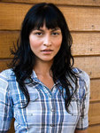

**Charities & foundations supported**

* ACT Today!
* City Hearts: Kids Say Yes to the Arts
* Entertainment Industry Foundation
* Hollywood Arts Council
* TACA

### Causes supported

* Abuse
* At-Risk/Disadvantaged Youths
* Cancer
* Children
* Creative Arts
* Education
* Health
* Hunger
* Mental Challenges
* Physical Challenges
* Poverty

**TippiHedren**



**Charities & foundations supported**

* American Wild Horse Preservation Campaign
* In Defense of Animals
* Shambala Preserve
* Society for Animal Protective Legislation
* The Humane Society

### Causes supported

* Animals

**Tisha Campbell**



**Charities & foundations supported**

* Will and Jada Smith Family Foundation

### Causes supported

* At-Risk/Disadvantaged Youths
* Children
* Family/Parent Support

**Tito Ortiz**

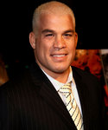

### Charities & foundations supported

* Give Back Hollywood Foundation
* Racing for Kids
* St. Jude Children's Research Hospital

### Causes supported

* Children
* Health
* Philanthropy

**Tobey Maguire**



**Charities & foundations supported**

* Declare Yourself
* Feeding America
* Healthy Child Healthy World
* LIFEbeat
* Skid Row Housing Trust
* Stand Up To Cancer
* The Art of Elysium

### Causes supported

* Addiction
* AIDS & HIV
* Cancer
* Children
* Environment
* Health
* Homelessness
* Hunger
* Poverty
* Voter Education

**Toby Keith**

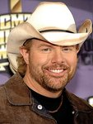

**Charities & foundations supported**

* Ally's House
* Feeding America
* Make-A-Wish Foundation
* Nevada Cancer Institute
* Starlight Children's Foundation

### Causes supported

* AIDS & HIV
* Cancer
* Children
* Health
* Hunger

**Todd Lodwick**

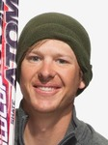

**Charities & foundations supported**

* Citizens United for Research in Epilepsy

### Causes supported

* Health

**TolulaAdeyemi**



**Charities & foundations supported**

* Mind
* Save the Children

### Causes supported

* Abuse
* AIDS & HIV
* Children
* Disaster Relief
* Education
* Mental Challenges
* Poverty

**Tom Arnold**



**Charities & foundations supported**

* After-School All-Stars
* Bony Pony Ranch
* Camp del Corazon
* Collaboration Foundation
* Comic Relief
* First Chance Scholarship Program
* Global Fund for Women
* Love Our Children USA
* Make-A-Wish Foundation
* Nancy Davis Foundation for Multiple Sclerosis
* Operation Homefront
* Professional Baseball Scouts Foundation

### Causes supported

* Abuse
* At-Risk/Disadvantaged Youths
* Cancer
* Children
* Creative Arts
* Disaster Relief
* Economic/Business Support
* Education
* Family/Parent Support
* Health
* Homelessness
* Human Rights
* Poverty
* Unemployment/Career Support
* Veteran/Service Member Support
* Women

**Tomas Berdych**



### Charities & foundations supported

* Laureus Sport for Good Foundation

### Causes supported

* At-Risk/Disadvantaged Youths
* Sports

# Tom Bergeron

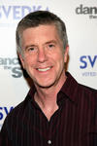

**Charities & foundations supported**

* ACT Today!
* Muscular Dystrophy Association
* STOMP Out Bullying
* UNICEF

### Causes supported

* Abuse
* Children
* Family/Parent Support
* Health
* Human Rights
* Mental Challenges
* Physical Challenges
* Poverty

**Tom Brady**

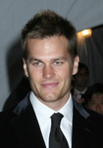

**Charities & foundations supported**

* Best Buddies International

### Causes supported

* Mental Challenges

# Tom Brokaw

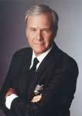

**Charities & foundations supported**

* Robin Hood
* Smile Train
* Soles4Souls

### Causes supported

* Children
* Disaster Relief
* Economic/Business Support
* Education
* Health
* Miscellaneous
* Poverty
* Refugees

**Tom Cochrane**



**Charities & foundations supported**

* Colon Cancer Canada
* Live Earth
* Make Poverty History
* War Child
* World Society for the Protection of Animals
* World Vision
* World Vision Canada

### Causes supported

* Adoption
* Fostering
* Orphans
* AIDS & HIV
* Animals
* Cancer
* Children
* Disaster Relief
* Environment
* Health
* Human Rights
* Miscellaneous
* Peace
* Poverty

**Tom Colicchio**

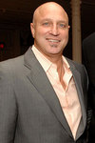

**Charities & foundations supported**

* Elizabeth Glaser Pediatric AIDS Foundation
* Feeding America
* FINCA
* Food Bank For New York City
* Human Rights Campaign
* Keep Memory Alive
* Rush Philanthropic Arts Foundation
* Screen Actors Guild Foundation
* The Lunchbox Fund

### Causes supported

* AIDS & HIV
* At-Risk/Disadvantaged Youths
* Children
* Creative Arts
* Economic/Business Support
* Family/Parent Support
* Gay/Lesbian Support
* Health
* Hunger
* Poverty

**Tom Cruise**

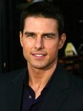

**Charities & foundations supported**

* Barbara Davis Center for Childhood Diabetes
* Children's Hospice & Palliative Care Coalition
* Elizabeth Glaser Pediatric AIDS Foundation
* H.E.L.P.
* Jackie Chan Charitable Foundation
* Mentor LA
* Raising Malawi
* Stockings With Care
* UNICEF

### Causes supported

* Adoption
* Fostering
* Orphans
* AIDS & HIV
* Children
* Disaster Relief
* Education
* Family/Parent Support
* Grief Support
* Health
* Human Rights
* Literacy
* Poverty

**Tom Dreesen**

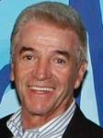

**Charities & foundations supported**

* Hey U.G.L.Y.

### Causes supported

* Children
* Miscellaneous

**Tom Felton**



**Charities & foundations supported**

* Global Network

### Causes supported

* Health

**Tom Hanks**

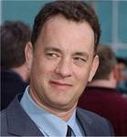

**Charities & foundations supported**

* Barbara Davis Center for Childhood Diabetes
* BID 2 BEAT AIDS
* Elevate Hope Foundation
* Elizabeth Glaser Pediatric AIDS Foundation
* Healthy Child Healthy World
* Hole in the Wall Gang
* K9 Connection
* Lifeline Energy
* Madison Foundation
* National Space Society
* ONE Campaign
* Parkinson Society Maritime Region
* Pearl Harbor Memorial Fund
* Red Cross
* Surfrider Foundation
* UNICEF

### Causes supported

* Abuse
* AIDS & HIV
* Animals
* At-Risk/Disadvantaged Youths
* Cancer
* Children
* Creative Arts
* Disaster Relief
* Education
* Environment
* Family/Parent Support
* Grief Support
* Health
* Human Rights
* Literacy
* Miscellaneous
* Oceans
* Poverty
* Refugees
* Veteran/Service Member Support

**Tom Hardy**

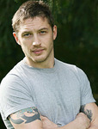

**Charities & foundations supported**

* Bowel Cancer UK

### Causes supported

* Cancer

**Tomiko**



**Charities & foundations supported**

* Be-Do-Have Foundation
* Lupus Foundation of America
* Tomiko Fraser Goddess Gathering
* Will and Jada Smith Family Foundation

**Causes supported**

* Abuse
* Addiction
* Adoption
* Fostering
* Orphans
* At-Risk/Disadvantaged Youths
* Children
* Family/Parent Support
* Health
* Miscellaneous
* Women

**Tom Jones**

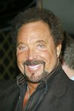

### Charities & foundations supported

* Comic Relief
* Elton John AIDS Foundation
* GRAMMY Foundation
* Help for Heroes
* MusiCares
* Nordoff Robbins
* Prince's Trust

### Causes supported

* AIDS & HIV
* At-Risk/Disadvantaged Youths
* Children
* Creative Arts
* Disaster Relief
* Education
* Health
* Homelessness
* Human Rights
* Miscellaneous
* Poverty
* Unemployment/Career Support
* Veteran/Service Member Support

**Tom Kane**

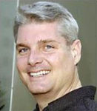

**Charities & foundations supported**

* Toteman Epilepsy Awareness Project

### Causes supported

* Health

**Tom Morello**

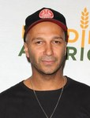

**Charities & foundations supported**

* Aid Still Required
* Amnesty International
* Feeding America
* Los Angeles Youth Network
* Reprieve
* Shelter
* Youth Music

### Causes supported

* At-Risk/Disadvantaged Youths
* Creative Arts
* Disaster Relief
* Homelessness
* Human Rights
* Hunger
* Unemployment/Career Support

**Tommy Haas**

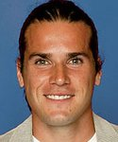

**Charities & foundations supported**

* City Harvest
* Laureus Sport for Good Foundation

### Causes supported

* At-Risk/Disadvantaged Youths
* Hunger
* Sports

**Tommy Hilfiger**

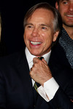

### Charities & foundations supported

* Elephant Family
* Make-A-Wish Foundation
* Nancy Davis Foundation for Multiple Sclerosis

### Causes supported

* Animals
* Cancer
* Children
* Health

**Tommy John**

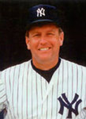

**Causes supported**

* At-Risk/Disadvantaged Youths
* Miscellaneous

**Tommy Lee**

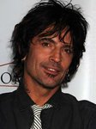

**Charities & foundations supported**

* Music for Relief
* PETA
* Project HOME
* St. Francis Food Pantries and Shelters

### Causes supported

* Animals
* Disaster Relief
* Environment
* Homelessness
* Hunger

**Tommy Lee Jones**



**Charities & foundations supported**

* Buoniconti Fund To Cure Paralysis
* The Miami Project

### Causes supported

* Physical Challenges

**Tom Petty**

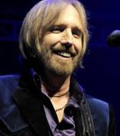

**Charities & foundations supported**

* Midnight Mission
* Safety Harbor Kids

### Causes supported

* Adoption
* Fostering
* Orphans
* At-Risk/Disadvantaged Youths
* Children
* Homelessness

**Tom Schanley**

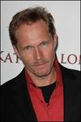

**Charities & foundations supported**

* Los Angeles Mission

### Causes supported

* Homelessness

**Tom Selleck**

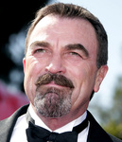

**Charities & foundations supported**

* Entertainment Industry Foundation
* Revlon Run/Walk For Women

### Causes supported

* Cancer
* Children
* Creative Arts
* Education
* Health
* Hunger
* Poverty
* Voter Education
* Women

**Tom Skerritt**



**Charities & foundations supported**

* Borgen Project

### Causes supported

* Poverty

**Tom Waits**



**Charities & foundations supported**

* Bridge School

### Causes supported

* Children
* Health
* Peace
* Physical Challenges
* Women

**Tom Wolfe**



**Charities & foundations supported**

* Raisa Gorbachev Foundation

### Causes supported

* Cancer
* Children

**Toni Braxton**



**Charities & foundations supported**

* Children's Cancer & Blood Foundation
* Lupus LA
* The Help Group

### Causes supported

* AIDS & HIV
* Cancer
* Children
* Health

**Toni Collette**



**Charities & foundations supported**

* 21st Century Leaders
* Amnesty International
* Clothes Off Our Back
* Doctors Without Borders
* Feeding America
* GetUp!
* Greenpeace
* Live Earth
* PETA
* UNICEF
* Whatever It Takes

### Causes supported

* Animals
* Children
* Conservation
* Disaster Relief
* Environment
* Health
* Human Rights
* Hunger
* Miscellaneous
* Poverty
* Voter Education

**Tony Bennett**

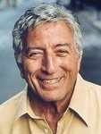

**Charities & foundations supported**

* American Cancer Society
* Andre Agassi Foundation for Education
* Exploring The Arts
* Griffith Park Recovery Fund
* MusiCares
* Neurofibromatosis, Inc.
* Starkey Hearing Foundation

### Causes supported

* At-Risk/Disadvantaged Youths
* Cancer
* Children
* Creative Arts
* Education
* Health
* Miscellaneous
* Unemployment/Career Support

# Tony Blair

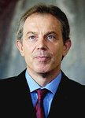

### Charities & foundations supported

* Comic Relief
* Disasters Emergency Committee
* Tony Blair Faith Foundation
* UNICEF

### Causes supported

* Children
* Disaster Relief
* Health
* Homelessness
* Human Rights
* Miscellaneous
* Poverty

**Tony Hadley**

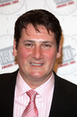

**Charities & foundations supported**

* Lowe Syndrome Trust
* The Hunger Project

### Causes supported

* Health
* Hunger

**Tony Hawk**

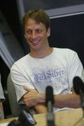

### Charities & foundations supported

* ACT Today!
* Athletes For Hope
* BID 2 BEAT AIDS
* Celebrity Fight Night Foundation
* Children's Hospital Los Angeles
* Jeff Gordon Children's Foundation
* Mia Hamm Foundation
* Muhammad Ali Parkinson Center
* Racing for Kids
* Red Cross
* Robert F Kennedy Memorial
* Seany Foundation
* Stop Global Warming
* Tony Hawk Foundation
* Until There's a Cure

### Causes supported

* AIDS & HIV
* At-Risk/Disadvantaged Youths
* Cancer
* Children
* Disaster Relief
* Environment
* Health
* Human Rights
* Mental Challenges
* Miscellaneous
* Physical Challenges
* Sports

**Tony Horton**

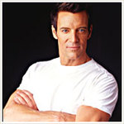

**Charities & foundations supported**

* GO Campaign

### Causes supported

* Adoption
* Fostering
* Orphans
* Children
* Health,
* Poverty

**Tony Parker**

### Tony Parker Charities & foundations supported

* Eva's Heroes
* Keep America Beautiful
* Padres Contra el Cancer

### Causes supported

* Cancer
* Children
* Conservation
* Environment
* Family/Parent Support
* Mental Challenges
* Physical Challenges
* Water

**Tony Robinson**



**Charities & foundations supported**

* Action on Elder Abuse
* Age Concern
* Age UK
* Alzheimer's Society
* Cats Protection
* Dorset Wildlife Trust
* Make Poverty History
* Street Child Africa
* Variety Club

### Causes supported

* Abuse
* Animals
* At-Risk/Disadvantaged Youths
* Children
* Conservation
* Environment
* Health
* Miscellaneous
* Physical Challenges
* Poverty
* Senior Citizen Support

**Tony Sirico**

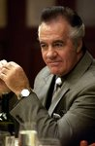

**Charities & foundations supported**

* Wounded Warrior Project

### Causes supported

* Veteran/Service Member Support

**Tori Amos**



**Charities & foundations supported**

* Rape, Abuse & Incest National Network

### Causes supported

* Rape/Sexual Abuse

**Tori Spelling**

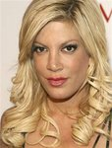

**Charities & foundations supported**

* Best Friends Animal Society
* BID 2 BEAT AIDS
* Children's Hospital Los Angeles
* Children's Miracle Network Hospitals
* CJ Foundation for SIDS
* Clothes Off Our Back
* Feeding America
* K9 Connection
* March Of Dimes
* Much Love Animal Rescue
* Screen Actors Guild Foundation
* spcaLA
* Susan G. Komen for the Cure
* The Heart Truth

### Causes supported

* AIDS & HIV
* Animals
* At-Risk/Disadvantaged Youths
* Cancer
* Children
* Creative Arts
* Health
* Hunger
* Women

**Torrey DeVitto**



**Charities & foundations supported**

* The Humane Society

### Causes supported

* Animals

**Trace Adkins**

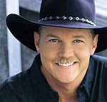

**Charities & foundations supported**

* Animal Rescue Foundation
* Barbara Davis Center for Childhood Diabetes
* Fisher House Foundation
* Food Allergy and Anaphylaxis Network
* GRAMMY Foundation
* Monroe Carell Jr. Children's Hospital at Vanderbilt
* MusiCares
* Musicians on Call
* Project Clean Water
* Red Cross
* Wounded Warrior Project

### Causes supported

* AIDS & HIV
* Animals
* Children
* Creative Arts
* Disaster Relief
* Health
* Human Rights
* Unemployment/Career Support
* Veteran/Service Member Support
* Water

**Tracey Emin**

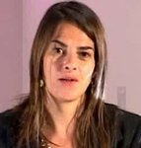

**Charities & foundations supported**

* ARK
* Dorset Wildlife Trust
* Elton John AIDS Foundation
* National Society for the Prevention of Cruelty to Children
* Terrence Higgins Trust

**Causes supported**

* Abuse
* AIDS & HIV
* Children
* Conservation
* Environment
* Health

**Tracy Austin**



**Charities & foundations supported**

* American Lung Association
* Great Ormond Street Hospital

### Causes supported

* Cancer
* Children
* Health

**Tracy Byrd**



**Charities & foundations supported**

* Children's Miracle Network Hospitals
* Fourth and Goal
* March Of Dimes
* Monroe Carell Jr. Children's Hospital at Vanderbilt
* TJ Martell Foundation

### Causes supported

* AIDS & HIV
* Cancer
* Children
* Health
* Sports

**Tracy Lawrence**



**Charities & foundations supported**

* Better Life Foundation
* Fourth and Goal

### Causes supported

* Children
* Disaster Relief
* Miscellaneous
* Sports

**Tracy McGrady**

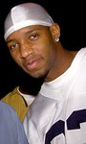

**Charities & foundations supported**

* Boys & Girls Clubs of America
* Tracy McGrady Foundation

### Causes supported

* At-Risk/Disadvantaged Youths
* Children
* Education
* Peace

**Tracy Pollan**



**Charities & foundations supported**

* Michael J. Fox Foundation
* The Hollywood Cookbook

### Causes supported

* AIDS & HIV
* At-Risk/Disadvantaged Youths
* Children
* Disaster Relief
* Health
* Homelessness
* Women

**Train**

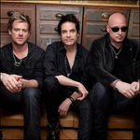

**Charities & foundations supported**

* Andre Agassi Foundation for Education
* Family House
* Operation Homefront
* rock CAN roll
* Save The Music Foundation
* WhyHunger

### Causes supported

* At-Risk/Disadvantaged Youths
* Children
* Creative Arts
* Economic/Business Support
* Education
* Family/Parent Support
* Hunger
* Poverty
* Veteran/Service Member Support

**Trans-Siberian Orchestra**

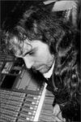

**Charities & foundations supported**

* Children's Miracle Network Hospitals
* Little Kids Rock
* The Salvation Army
* Toys for Tots

### Causes supported

* Abuse
* Adoption
* Fostering
* Orphans
* At-Risk/Disadvantaged Youths
* Children
* Creative Arts
* Disaster Relief
* Family/Parent Support
* Grief Support
* Health
* Homelessness
* Senior Citizen Support

**Travis**

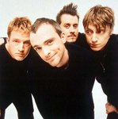

**Charities & foundations supported**

* Versus Cancer

### Causes supported

* Cancer

**Travis McCoy**



**Charities & foundations supported**

* Children's Hospital Los Angeles
* Memorial Sloan-Kettering
* Staying Alive Foundation
* TJ Martell Foundation

### Causes supported

* AIDS & HIV
* Cancer
* Children
* Health

**Travis Tritt**

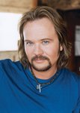

**Charities & foundations supported**

* Lili Claire Foundation

### Causes supported

* Children
* Family/Parent Support
* Mental Challenges

**Treach**

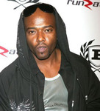

**Causes supported**

* At-Risk/Disadvantaged Youths

**Treat Williams**



**Charities & foundations supported**

* Save the Children
* The Hollywood Cookbook

### Causes supported

* Abuse
* AIDS & HIV, [At-Risk/Disadvantaged Youths](http://www.looktothestars.org/cause/at-risk-disadvantaged-youths)
* Children
* Disaster Relief
* Education
* Health
* Homelessness
* Poverty
* Women

**Trent Reznor**

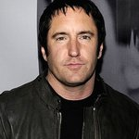

**Charities & foundations supported**

* PETA

### Causes supported

* Animals

# Trent Tucker

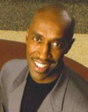

**Charities & foundations supported**

* Max Cure Foundation
* Susan G. Komen for the Cure
* Trent Tucker Youth Program

### Causes supported

* At-Risk/Disadvantaged Youths
* Cancer
* Children

**Treva Etienne**

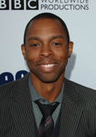

**Charities & foundations supported**

* 21st Century Leaders
* Hollywood Unites For Haiti
* Whatever It Takes

### Causes supported

* At-Risk/Disadvantaged Youths
* Children
* Creative Arts
* Education
* Miscellaneous
* Sports

**Trevor Donovan**

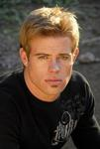

**Charities & foundations supported**

* Habitat For Humanity
* Young Storytellers Foundation

### Causes supported

* Disaster Relief
* Education
* Homelessness
* Literacy

**Trey Morgan**

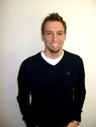

**Charities & foundations supported**

* Habitat For Humanity
* JDRF
* Muscular Dystrophy Association
* Musicians on Call
* Rosie's Broadway Kids

### Causes supported

* Children
* Disaster Relief
* Education
* Health
* Homelessness

**Trey Parker**



**Charities & foundations supported**

* Declare Yourself

### Causes supported

* Voter Education

**Tricia Helfer**



### Charities & foundations supported

* Clothes Off Our Back
* Kitten Rescue

### Causes supported

* Animals
* Children

**Trisha Yearwood**

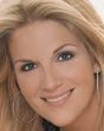

**Charities & foundations supported**

* Habitat For Humanity
* Make-A-Wish Foundation
* National Woman's History Museum
* Sears' Heroes at Home
* Starkey Hearing Foundation
* Susan G. Komen for the Cure
* Teammates for Kids Foundation

**Causes supported**

* Cancer
* Children
* Disaster Relief
* Education
* Health
* Homelessness
* Human Rights
* Veteran/Service Member Support
* Women

**Tristan Wilds**

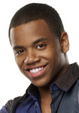

**Charities & foundations supported**

* Habitat For Humanity
* ONE Campaign
* Yéle Haiti Foundation

### Causes supported

* AIDS & HIV
* Disaster Relief
* Economic/Business Support
* Environment
* Homelessness
* Hunger
* Poverty

**TR Knight**

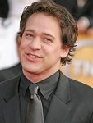

### Charities & foundations supported

* Elizabeth Glaser Pediatric AIDS Foundation

**Causes supported**

* AIDS & HIV
* Children
* Family/Parent Support
* Health

**Troy Polamalu**

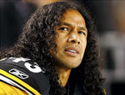

**Charities & foundations supported**

* Operation Once in a Lifetime

**Causes supported**

* Family/Parent Support
* Veteran/Service Member Support

# Trudie Goodwin



**Charities & foundations supported**

* CBM
* National Osteoporosis Society

### Causes supported

* Health
* Physical Challenges

**TrudieStyler**



**Charities & foundations supported**

* Rainforest Foundation Fund
* Soil Association
* The Rainforest Foundation

### Causes supported

* Conservation
* Environment
* Human Rights

**Twiggy**



**Charities & foundations supported**

* Book Aid International
* Breakthrough Breast Cancer
* Environmental Investigation Agency
* Epilepsy Action
* Neurofibromatosis Association

**Causes supported**

* Animals
* Cancer
* Children
* Conservation
* Education
* Environment
* Health
* Refugees

**Twisted Sister**



**Charities & foundations supported**

* Charity Navigator
* March Of Dimes

### Causes supported

* Children
* Health
* Philanthropy

**Ty Burrell**

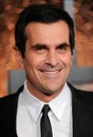

**Charities & foundations supported**

* GO Campaign

**Causes supported**

* Adoption
* Fostering
* Orphans
* Children
* Health
* Poverty

**Tyler Perry**

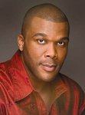

**Charities & foundations supported**

* Covenant House
* Keep A Child Alive
* MaleSurvior

### Causes supported

* AIDS & HIV
* At-Risk/Disadvantaged Youths
* Children
* Family/Parent Support
* Health
* Homelessness
* Rape/Sexual Abuse

**Ty Pennington**

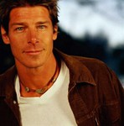

### Charities & foundations supported

* Entertainment Industry Foundation
* United Service Organization

**Causes supported**

* Cancer
* Children
* Creative Arts
* Education
* Health
* Hunger
* Poverty
* Veteran/Service Member Support

**Tyra Banks**



**Charities & foundations supported**

* Dream Foundation
* Get Schooled Foundation
* TZONE
* Yéle Haiti Foundation

**Causes supported**

* At-Risk/Disadvantaged Youths
* Children
* Economic/Business Support
* Education
* Environment
* Family/Parent Support
* Health
* Hunger
* Poverty

**Tyrone Wells**

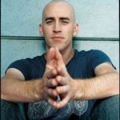

**Charities & foundations supported**

* Invisible Children

**Causes supported**

* Children
* Human Rights
* Peace