**U2**

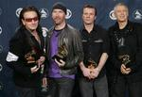

Charities & foundations supported

* 46664
* Amnesty International
* Comic Relief
* DATA
* GRAMMY Foundation
* Greenpeace
* Habitat For Humanity
* Live 8
* Make Poverty History
* Mencap
* MusiCares
* Music for Relief
* Music Rising
* ONE Campaign
* (RED)
* The HollyRod Foundation

Causes supported

* Adoption,
* Fostering,
* Orphans,
* AIDS & HIV,
* Animals,
* Children, Conservation,
* Creative Arts,
* Disaster Relief, Environment,
* Fair Trade,
* Family/Parent Support,
* Health, Homelessness,
* Human Rights,
* Literacy, Mental Challenges,
* Physical Challenges,
* Poverty,
* Unemployment/Career Support,
* Women

# Uma Thurman



Charities & foundations supported

* ARK
* Children's Defense Fund
* Project HOME
* Room to Grow
* USAID

Causes supported

* Children, Disaster Relief
* , Economic/Business Support,
* Education,
* Family/Parent Support,
* Health, Homelessness,
* Human Rights, Hunger,
* Mental Challenges,
* Physical Challenges
* , Poverty,
* Rape/Sexual Abuse,
* Women

# Union Station

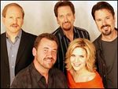

Charities & foundations supported

* National Parks Conservation Association

Causes supported

* Conservation,
* Environment

# Usain Bolt

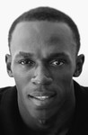

Charities & foundations supported

* Usain Bolt Foundation

Usher

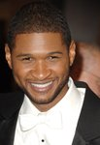

Charities & foundations supported

* Aid Still Required
* Barbara Davis Center for Childhood Diabetes
* Candie's Foundation
* LIFEbeat
* Red Cross
* Stand Up To Cancer
* The Gentlemen's Fund
* Usher's New Look Foundation

Causes supported

* AIDS & HIV,
* At-Risk/Disadvantaged Youths,
* Cancer,
* Children,
* Disaster Relief,
* Economic/Business Support,
* Education,
* Environment,
* Health,
* Human Rights,
* Miscellaneous,
* Sports,
* Women