**Valerie Bertinelli**



Charities & foundations supported

* Cedars-Sinai Medical Center

Causes supported

* Health

# Valery Ortiz

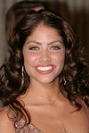

Charities & foundations supported

* Children's Hospital Los Angeles
* NALIP
* The Trevor Project

Causes supported

* Cancer,
* Children,
* Creative Arts,
* Depression and Suicide,
* Gay/Lesbian Support,
* Health

# Val Kilmer

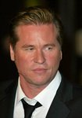

Charities & foundations supported

* First Star
* Global Green
* LIFEbeat
* V-Day

Causes supported

* Abuse,
* AIDS & HIV,
* Animals,
* At-Risk/Disadvantaged Youths,
* Children, Conservation,
* Disaster Relief,
* Environment, Health,
* Human Rights,
* Peace, Poverty,
* Rape/Sexual Abuse,
* Water,
* Women

# Vanessa A. Williams

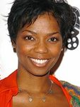

Charities & foundations supported

* A Call To Men
* Jackson Memorial Foundation

Causes supported

* Cancer,
* Health,
* Miscellaneous,
* Women

# Vanessa Carlton



Charities & foundations supported

* GRAMMY Foundation
* Musicians on Call
* Save The Music Foundation

Causes supported

* Children,
* Creative Arts,
* Education,
* Health

# Vanessa Hudgens

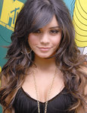

Charities & foundations supported

* Habitat For Humanity
* Keep A Child Alive
* Make-A-Wish Foundation
* Susan G. Komen for the Cure

Causes supported

* AIDS & HIV,
* Cancer,
* Children,
* Disaster Relief,
* Family/Parent Support,
* Health,
* Homelessness

# Vanessa Lachey

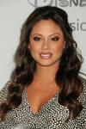

Charities & foundations supported

* Operation Smile

Causes supported

* Children,
* Health

Vanessa Redgrave

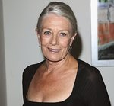

Charities & foundations supported

* American Foundation for AIDS Research
* UNICEF

Causes supported

* AIDS & HIV,
* Children,
* Health,
* Human Rights,
* Poverty

# Vanessa Simmons



Charities & foundations supported

* Children's Miracle Network Hospitals

Causes supported

* Children,
* Health

Vanessa Williams

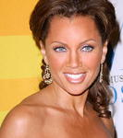

Charities & foundations supported

* Broadway Cares/Equity Fights AIDS
* Get Schooled Foundation
* Healthy Child Healthy World
* Hearts of Gold
* Hollywood Arts Council
* iwantpeace.com
* Rush Philanthropic Arts Foundation
* SOS Children's Villages

Causes supported

* Adoption,
* Fostering,
* Orphans,
* AIDS & HIV,
* At-Risk/Disadvantaged Youths,
* Cancer,
* Children,
* Creative Arts
* Disaster Relief,
* Education,
* Environment,
* Homelessness,
* Human Rights,
* Peace, Poverty,
* Senior Citizen Support,
* Women

# Venus Williams



Charities & foundations supported

* Elton John AIDS Foundation
* Great Ormond Street Hospital
* Save The Music Foundation
* The Heart Truth

Causes supported

* AIDS & HIV,
* Children,
* Creative Arts, Education,
* Health, Women

Vera Lynn

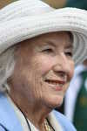

Charities & foundations supported

* ABF The Soldiers' Charity
* Cats Protection
* PETA
* The Royal British Legion

Causes supported

* Animals,
* Veteran/Service Member Support

**Vernon Kay**



Charities & foundations supported

* Great Ormond Street Hospital
* Willow Foundation

Causes supported

* Cancer
* , Children,
* Health

**Victoria Beckham**

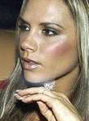

Charities & foundations supported

* BeatBullying
* Cancer Research UK
* Children in Need
* Comic Relief
* Elton John AIDS Foundation
* Love Our Children USA
* Malaria No More
* National Society for the Prevention of Cruelty to Children
* Prince's Trust
* Sport Relief
* UNICEF
* Victoria and David Beckham Charitable Trust

Causes supported

* Abuse, AIDS & HIV
* , At-Risk/Disadvantaged Youths,
* Cancer, Children,
* Conservation, Disaster Relief,
* Education, Environment,
* Fair Trade, Family/Parent Support,
* Health, Homelessness,
* Human Rights, Hunger,
* Literacy, Mental Challenges, Miscellaneous
* , Physical Challenges,
* Poverty,
* Substance Abuse

**Victoria Justice**



Charities & foundations supported

* Aid Still Required
* United Nations Foundation

Causes supported

* AIDS & HIV,
* Children,
* Disaster Relief,
* Environment,
* Health,
* Human Rights,
* Peace,
* Women

**Victoria Pratt**



Charities & foundations supported

* Lili Claire Foundation

Causes supported

* Children,
* Family/Parent Support,
* Mental Challenges

**Victoria Principal**

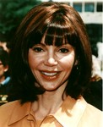

Charities & foundations supported

* TreePeople

Causes supported

* Environment

**Victoria Rowell**



Charities & foundations supported

* Foster Children Positive Plan

Causes supported

* Adoption,
* Fostering,
* Orphans,
* Children

**Victoria Wood**

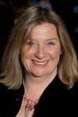

Charities & foundations supported

* Mines Advisory Group

Causes supported

* Weapons Reduction

**Victor Wooten**

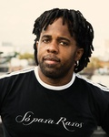

Charities & foundations supported

* Little Kids Rock

Causes supported

* At-Risk/Disadvantaged Youths,
* Children
* , Creative Arts

**Vida Guerra**



Charities & foundations supported

* American Diabetes Association
* Susan G. Komen for the Cure

Causes supported

* Cancer,
* Health

**Viggo Mortensen**



Charities & foundations supported

* American Wild Horse Preservation Campaign
* Return To Freedom
* Save the Chimps
* Spirit Riders Foundation
* The Children's Clinic

Causes supported

* Animals,
* Children,
* Environment,
* Health,
* Miscellaneous

**Vijay Amritraj**

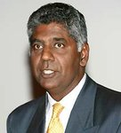

Charities & foundations supported

* Vijay Amritraj Foundation

Causes supported

* Adoption,
* Fostering,
* Orphans,
* AIDS & HIV,
* Children, Mental Challenges,
* Miscellaneous,
* Peace,
* Physical Challenges, Women

**Vijay Singh**

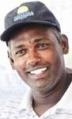

Charities & foundations supported

* Caddy for a Cure
* St. Jude Children's Research Hospital

Causes supported

* Children,
* Health,
* Miscellaneous

**Vince Gill**

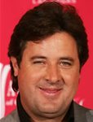

Charities & foundations supported

* City of Hope
* Colon Cancer Alliance
* Creative Recovery Communities
* Crossroads Centre
* Kiss For A Cause Foundation
* Operation Once in a Lifetime
* Soles4Souls
* Tuberous Sclerosis Alliance

Causes supported

* Addiction, Adoption,
* Fostering, Orphans,
* AIDS & HIV, Cancer,
* Children, Disaster Relief,
* Family/Parent Support,
* Health, Poverty,
* Refugees, Substance Abuse,
* Veteran/Service Member Support

**Vince Neil**

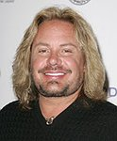

Charities & foundations supported

* Pablove Foundation
* Skylar Neil Memorial Foundation
* TJ Martell Foundation

Causes supported

* AIDS & HIV,
* At-Risk/Disadvantaged Youths,
* Cancer, Children,
* Creative Arts, Education,
* Grief Support, Health

**Vincent Irizarry**

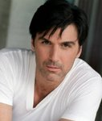

Charities & foundations supported

* Kiva

Causes supported

* Economic/Business Support

**Vince Vaughn**

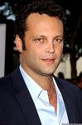

Charities & foundations supported

* Army Emergency Relief
* Declare Yourself
* Jumpstart

Causes supported

* Education,
* Literacy,
* Veteran/Service Member Support,
* Voter Education

**Viola Davis**

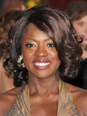

Charities & foundations supported

* Friendly House
* Soles4Souls

Causes supported

* Disaster Relief,
* Health, Poverty,
* Refugees,
* Substance Abuse,
* Women

**Vítor Baía**

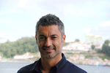

Charities & foundations supported

* Vitor Baia Foundation

Causes supported

* At-Risk/Disadvantaged Youths,
* Children,
* Education,
* Sports

Vivian Campbell

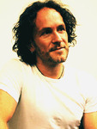

Charities & foundations supported

* Create Now
* Hands On Nashville
* Precious Paws
* Raven Drum Foundation
* Red Cross
* The Salvation Army

Causes supported

* Abuse, AIDS & HIV,
* Animals, At-Risk/Disadvantaged Youths,
* Creative Arts, Disaster Relief,
* Family/Parent Support, Grief Support,
* Homelessness, Human Rights,
* Philanthropy, Senior Citizen Support,
* Veteran/Service Member Support

**Vivica Fox**



Charities & foundations supported

* Gibson Girl Foundation
* Jackson Memorial Foundation
* The Heart Truth

Causes supported

* AIDS & HIV,
* Cancer,
* Creative Arts,
* Health, Women

**Vivienne Westwood**

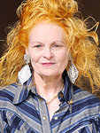

Charities & foundations supported

* 21st Century Leaders
* Cool Earth
* Greenpeace
* Oxfam
* PETA
* Whatever It Takes

Causes supported

* Animals,
* Conservation,
* Disaster Relief, Environment,
* Human Rights, Miscellaneous, Poverty

**Vondie Curtis Hall**

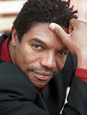

Charities & foundations supported

* The Salvation Army

Causes supported

* Abuse,
* At-Risk/Disadvantaged Youths,
* Disaster Relief,
* Family/Parent Support,
* Grief Support,
* Homelessness,
* Senior Citizen Support