**Walter Cronkite**

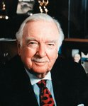

Charities & foundations supported

* Free The Children
* Heifer International
* National Parks Conservation Association
* Peace Alliance
* Realizing the Dream
* Smile Train
* Stop Global Warming

Causes supported

* AIDS & HIV,
* Animals,
* Children,
* Conservation,
* Environment, Health,
* Human Rights,
* Hunger, Miscellaneous,
* Peace, Poverty

# Wanda Sykes

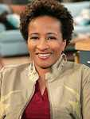

Charities & foundations supported

* American Cancer Society
* GLAAD
* Soles4Souls
* The Trevor Project
* True Colors Fund

Causes supported

* Cancer,
* Children,
* Depression and Suicide,
* Disaster Relief,
* Gay/Lesbian Support,
* Health, Poverty,
* Refugees

# Warrant

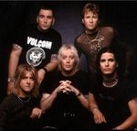

Charities & foundations supported

* ACT Today!
* The HollyRod Foundation

Causes supported

* Family/Parent Support,
* Health,
* Mental Challenges,
* Physical Challenges

# Warren Buffett



Charities & foundations supported

* Animal Rescue Foundation
* Bill and Melinda Gates Foundation
* Girls Inc.
* Glide
* James Redford Institute for Transplant Awareness
* Make-A-Wish Foundation
* Music Rising
* NoVo Foundation
* Smile Train

Causes supported

* Animals,
* At-Risk/Disadvantaged Youths,
* Blood, Marrow & Organ Donation,
* Cancer, Children, Creative Arts,
* Disaster Relief, Education,
* Family/Parent Support, Health,
* Homelessness, Human Rights,
* Miscellaneous,
* Poverty,
* Unemployment/Career Support,
* Women

# Warrick Dunn

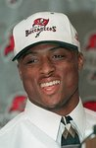

Charities & foundations supported

* Athletes For Hope
* Jeff Gordon Children's Foundation
* Warrick Dunn Family Foundation

Causes supported

* Cancer,
* Children,
* Family/Parent Support,
* Homelessness,
* Miscellaneous,
* Sports

# Warwick Davis

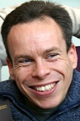

Charities & foundations supported

* Make-A-Wish Foundation

Causes supported

* Cancer,
* Children,
* Health

# Wayne Brady

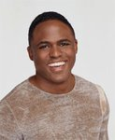

Charities & foundations supported

* Comic Relief
* K.I.S. Foundation
* Point Foundation
* Ronald McDonald House Charities
* UNICEF
* United Negro College Fund

Causes supported

* Children,
* Disaster Relief, Education,
* Family/Parent Support,
* Gay/Lesbian Support,
* Health,
* Homelessness,
* Human Rights,
* Poverty

# Wayne Gretzky



Charities & foundations supported

* Bone Marrow Foundation
* Casey Lee Ball Foundation
* Los Angeles Police Memorial Foundation
* Make-A-Wish Foundation
* MedicAlert Foundation
* Nevada Cancer Institute
* Oxfam
* Soles4Souls
* Starkey Hearing Foundation
* Watering Seeds Organization
* Wayne Gretzky Foundation

Causes supported

* Adoption, Fostering,
* Orphans, At-Risk/Disadvantaged Youths,
* Blood, Marrow & Organ Donation,
* Cancer, Children, Disaster Relief,
* Emergency services,
* Family/Parent Support,
* Health, Human Rights,
* Literacy,
* Physical Challenges,
* Poverty, Refugees

# Wayne Rooney

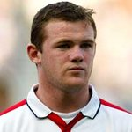

Charities & foundations supported

* SOS Children's Villages
* UNICEF
* Willow Foundation

Causes supported

* Adoption,
* Fostering, Orphans,
* AIDS & HIV, Cancer,
* Children, Disaster Relief
* Health, Homelessness,
* Human Rights, Poverty

# Weird Al Yankovic

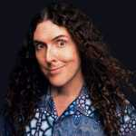

Charities & foundations supported

* Human Rights Campaign

Causes supported

* Gay/Lesbian Support

# Wendy Davis

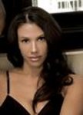

Charities & foundations supported

* Warriors in Pink

Causes supported

* Cancer

**Wendy Richard**



**Charities & foundations supported**

* **Variety Club**
* **Willow Foundation**

**Causes supported**

* **At-Risk/Disadvantaged Youths,**
* **Cancer, Children,**
* **Health, Physical Challenges**

**Whitney Houston**

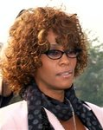

**Charities & foundations supported**

* **Caudwell Children**
* **Celebrity Fight Night Foundation**
* **Children's Defense Fund**
* **Muhammad Ali Parkinson Center**
* **Red Cross**
* **United Negro College Fund**
* **United Service Organization**

**Causes supported**

* **AIDS & HIV, Children,**
* **Disaster Relief, Education,**
* **Family/Parent Support,**
* **Health, Human Rights,**
* **Mental Challenges,**
* **Physical Challenges,**
* **Veteran/Service Member Support**

**Whitney Port**



**Charities & foundations supported**

* **American Cancer Society**
* **Autism Speaks**
* **DKMS**
* **FACE Africa**
* **Reality Cares**

**Causes supported**

* **Blood, Marrow & Organ Donation,**
* **Cancer, Education,**
* **Health, Mental Challenges,**
* **Miscellaneous,**
* **Water,**
* **Women**

**Whoopi Goldberg**

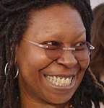

**Charities & foundations supported**

* **21st Century Leaders**
* **American Humane Association**
* **American Wild Horse Preservation Campaign**
* **Bob Woodruff Foundation**
* **Broadway Cares/Equity Fights AIDS**
* **Comic Relief**
* **Declare Yourself**
* **Elevate Hope Foundation**
* **Exploring The Arts**
* **FilmAid International**
* **Garden of Dreams**
* **Human Rights Campaign**
* **New York Cares**
* **Peace Over Violence**
* **Society for Animal Protective Legislation**
* **St. Jude Children's Research Hospital**
* **True Colors Fund**
* **V-Day**
* **Whatever It Takes**

**Causes supported**

* **Abuse, Adoption,**
* **Fostering, Orphans,**
* **AIDS & HIV, Animals,**
* **At-Risk/Disadvantaged Youths,**
* **Children, Creative Arts,**
* **Disaster Relief,**
* **Education, Gay/Lesbian Support,**
* **Health, Homelessness,**
* **Human Rights, Miscellaneous,**
* **Peace, Poverty,**
* **Rape/Sexual Abuse,**
* **Veteran/Service Member Support,**
* **Voter Education,**
* **Women**

**Willard Scott**

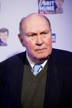

**Charities & foundations supported**

* **Meals On Wheels**

**Causes supported**

* **Health,**
* **Hunger,**
* **Poverty,**
* **Senior Citizen Support**

**Will Ferrell**

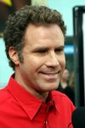

**Charities & foundations supported**

* **Afghanistan Relief Organization**
* **Artists for Peace and Justice**
* **Barbara Davis Center for Childhood Diabetes**
* **BID 2 BEAT AIDS**
* **Cancer For College**
* **Charlize Theron Africa Outreach Project**
* **Milk+Bookies**
* **MoveOn**
* **Music for Relief**
* **Room to Read**
* **Stephen J Wampler Foundation**
* **UNICEF**
* **US Campaign for Burma**
* **Variety - The Children's Charity**

**Causes supported**

* **AIDS & HIV,**
* **Cancer, Children,**
* **Disaster Relief,**
* **Education, Environment,**
* **Health, Human Rights,**
* **Literacy,**
* **Miscellaneous,**
* **Peace, Philanthropy,**
* **Physical Challenges,**
* **Poverty, Voter Education**

**will.i.am**

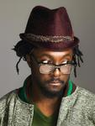

**Charities & foundations supported**

* **Common Ground Foundation**
* **GRAMMY Foundation**
* **Green For All**
* **i.am.home Fund**
* **i.am scholarship Fund**
* **League of Conservation Voters**
* **MASSIVEGOOD**
* **Mercy Corps**
* **Music Rising**
* **RETHINK Fabrics**
* **Shriners Hospitals for Children**
* **The Black Eyed Peas Foundation**

**Causes supported**

* **Adoption,**
* **Fostering,**
* **Orphans, AIDS & HIV,**
* **At-Risk/Disadvantaged Youths,**
* **Cancer, Children,**
* **Conservation,**
* **Creative Arts, Disaster Relief,**
* **Economic/Business Support,**
* **Education, Environment,**
* **Family/Parent Support,**
* **Health, Homelessness,**
* **Human Rights, Literacy,**
* **Peace, Poverty,**
* **Unemployment/Career Support,**
* **Voter Education**

**William H. Macy**

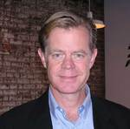

**Charities & foundations supported**

* **Alzheimer's Association**
* **Homeless Not Toothless**
* **United Cerebral Palsy**

**Causes supported**

* **Adoption,**
* **Fostering,**
* **Orphans,**
* **Health**

**William Shatner**

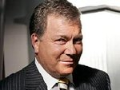

**Charities & foundations supported**

* **Ahead With Horses**
* **Aid Still Required**
* **American Cancer Society**
* **Camp Max Straus**
* **Canadian Intensive Care Foundation Of Calgary**
* **Clothes Off Our Back**
* **Friendly House**
* **Habitat For Humanity**
* **Hollywood Charity Horse Show**
* **Parkinson Society Maritime Region**
* **Red Cross**
* **Screen Actors Guild Foundation**

**Causes supported**

* **AIDS & HIV, Cancer,**
* **Children, Creative Arts,**
* **Disaster Relief,**
* **Health, Homelessness,**
* **Human Rights,**
* **Mental Challenges,**
* **Physical Challenges,**
* **Substance Abuse,**
* **Women**

**Willie Garson**

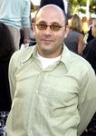

**Charities & foundations supported**

* **Ante Up For Africa**
* **Chrysalis**
* **Kiva**

**Causes supported**

* **Economic/Business Support,**
* **Homelessness,**
* **Human Rights,**
* **Refugees**

**Willie Nelson**

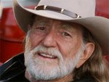

**Charities & foundations supported**

* **AetheriA Foundation**
* **American Wild Horse Preservation Campaign**
* **Best Friends Animal Society**
* **Crossroads Centre**
* **Farm Aid**
* **Feeding America**
* **Green Music Group**
* **Green Treks**
* **Monroe Carell Jr. Children's Hospital at Vanderbilt**
* **Peace Alliance**
* **Red Cross**
* **Society for Animal Protective Legislation**
* **TJ Martell Foundation**

**Causes supported**

* **Addiction,**
* **AIDS & HIV, Animals,**
* **Cancer, Children,**
* **Creative Arts,**
* **Disaster Relief,**
* **Economic/Business Support,**
* **Education, Environment,**
* **Family/Parent Support,**
* **Health, Human Rights,**
* **Hunger,**
* **Miscellaneous,**
* **Peace,**
* **Substance Abuse**

**Will Smith**

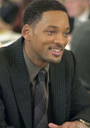

**Charities & foundations supported**

* **46664**
* **Dream Foundation**
* **Feeding America**
* **Florida Marlins Community Foundation**
* **LIVESTRONG**
* **Living Classrooms Foundation**
* **Miami Children's Hospital Foundation**
* **PACT**
* **Red Cross**
* **Will and Jada Smith Family Foundation**
* **Youth Health Empowerment**

**Causes supported**

* **AIDS & HIV,**
* **At-Risk/Disadvantaged Youths,**
* **Cancer, Children,**
* **Disaster Relief, Education,**
* **Family/Parent Support, Health,**
* **Human Rights, Hunger,**
* **Mental Challenges,**
* **Physical Challenges**

**Wilmer Valderrama**



**Charities & foundations supported**

* **Los Angeles Mission**
* **NALIP**

**Causes supported**

* **Creative Arts,**
* **Homelessness**

**Wladimir Klitschko**

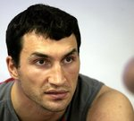

**Charities & foundations supported**

* **Laureus Sport for Good Foundation**
* **UNESCO**

**Causes supported**

* **At-Risk/Disadvantaged Youths,**
* **Children, Education,**
* **Human Rights,**
* **Literacy,**
* **Poverty,**
* **Sports**

**Woody Allen**

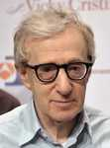

**Charities & foundations supported**

* **St. Francis Food Pantries and Shelters**
* **The Doe Fund**

**Causes supported**

* **Homelessness,**
* **Hunger**

**Woody Harrelson**

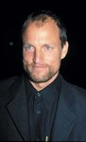

**Charities & foundations supported**

* **Chandler Sky Foundation**
* **Collaboration Foundation**
* **Focus the Nation**
* **Global Fund for Women**
* **Greenpeace**
* **Grenada Relief Fund**
* **Oasis Preserve International**
* **PETA**
* **Racing for Kids**
* **Rainforest Action Network**
* **Red Cross**
* **Silverlake Conservatory of Music**
* **Surfrider Foundation**
* **UNICEF**
* **US Campaign for Burma**
* **Voice Yourself**

**Causes supported**

* **Adoption,**
* **Fostering, Orphans,**
* **AIDS & HIV, Animals**
* **, Children,**
* **Conservation, Creative Arts,**
* **Disaster Relief,**
* **Economic/Business Support, Environment,**
* **Health,**
* **Human Rights,**
* **Oceans, Peace,**
* **Poverty, Women**

**Wyclef Jean**



**Charities & foundations supported**

* **46664**
* **ALAS**
* **Carma Foundation**
* **Clothes Off Our Back**
* **Feeding America**
* **ONEXONE**
* **Pan American Development Foundation**
* **Phoenix House**
* **Rays of Sunshine**
* **Red Cross**
* **Together for Haiti**
* **Urban Zen Foundation**
* **Walkabout Foundation**
* **World Food Programme**
* **Yéle Haiti Foundation**

**Causes supported**

* **Addiction,**
* **AIDS & HIV,**
* **Children, Conservation,**
* **Disaster Relief**
* **, Economic/Business Support,**
* **Environment, Health,**
* **Human Rights, Hunger,**
* **Physical Challenges,**
* **Poverty, Women**

**Wyland**

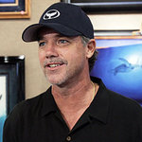

**Charities & foundations supported**

* **Wyland Foundation**

**Causes supported**

* **Conservation,**
* **Environment,**
* **Water**

**Wynonna**



**Charities & foundations supported**

* **Child Safety Network**
* **Mary Kay Ash Charitable Foundation**
* **Metro Christmas Basket Charities**
* **Monroe Carell Jr. Children's Hospital at Vanderbilt**
* **Population Services International**
* **YouthAIDS**

**Causes supported**

* **Abuse,**
* **AIDS & HIV,**
* **Cancer, Children,**
* **Health, Hunger,**
* **Missing Children,**
* **Poverty,**
* **Women**

**Wynton Marsalis**



**Charities & foundations supported**

* **Music For Tomorrow**

**Causes supported**

* **Creative Arts**