[ INSERT YOUR COLLEGE / UNIVERSITY NAME HERE ]
[ Department of Computer Engineering / Information Technology ]
A TECHNICAL INTERNSHIP PROJECT REPORT ON
FleetSync™ Enterprise
Vehicle Service & Fleet Maintenance Management System
Submitted in partial fulfillment of the requirements
for the Degree of Bachelor of Engineering (B.E.) / Technology (B.Tech)
in Computer Engineering / Information Technology
Student / Candidate Name | Shailesh Dongare
University Seat / Roll No. | [ Enter Your Roll / Seat Number ]
Internal Guide / Mentor | [ Enter Internal Guide Name, e.g. Prof. Name ]
Host Organization | FleetSync Technologies Pro (Mumbai, India)
Technology Domain | Full Stack Web Engineering (Python 3.14, Flask, MySQL, Bootstrap 5)
Academic Year | 2026 - 2027

Certificate of Project Work
CERTIFICATE:
This is to certify that the project entitled "FleetSync™ Enterprise: Vehicle Service & Fleet Maintenance Management System" has been successfully carried out and submitted by Shailesh Dongare (Roll No: [___________]) under our supervision and guidance, in partial fulfillment of the requirements for the award of Bachelor of Engineering / Technology in Computer Engineering / Information Technology during the academic session 2026-2027.
It is certified that all conclusions, design diagrams, data dictionaries, implementation codes, and test audit reports presented in this report represent the authentic and original engineering work completed by the candidate.
___________________________  Internal Project Guide  [Department Name] | ___________________________  Head of Department  [Department Name] | ___________________________  Principal / Director  [College Seal]
Date: ____________  Place: ____________ | Date: ____________  Place: ____________ | Institutional Stamp

Candidate Declaration
DECLARATION:
I, Shailesh Dongare, hereby declare that the project work presented in this technical report entitled "FleetSync™ Enterprise: Vehicle Service & Fleet Maintenance Management System" is an authentic record of the work carried out by me during the academic internship period. The content incorporated in this document has not been submitted for the award of any other degree or diploma to any other university or institution.
Signature of Candidate:
Shailesh Dongare
Department of Computer Engineering / Information Technology
Date: October 2026

Acknowledgement
ACKNOWLEDGEMENT:
I express my deepest gratitude to my Project Guide and Head of Department for their invaluable mentorship, continuous technical critiques, and generous guidance throughout the lifecycle of this project. I also thank the management and senior engineering personnel at FleetSync Technologies Pro for granting me the environment, software tools, and real-world automotive dataset essential to developing this system.

INDEX
Sr.  No. | Chapter | Page  No.
1 | Introduction to Project  • Introduction  • Existing System  • Need and scope of Computer System  • Organization Profile | 1
2 | Proposed System  • Objectives  • Requirement Engineering  • Requirement Gathering  • Software Requirements | 6
3 | System Analysis  System Diagram  • DFD (Data Flow Diagram - Level 0, 1, 2)  • ERD (Entity Relationship Diagram)  • UML (Use Case, Class, Sequence & Activity Diagrams) | 11
4 | System Design  • Database Design (7 Relational Tables & DDL)  • Input Design & its samples  • Output Design (on screen) | 18
5 | Implementation  • System Requirement  - Hardware  - Software  • Installation process  • User Guideline | 27
6 | Reports (with valid Data)  • Customer Directory  • Fleet Odometer Audit  • Work Orders & Invoices (₹ INR)  • Preventive Schedule Status | 32
7 | Conclusion and Suggestions  • Conclusion  • Limitations  • Suggestion | 37
8 | Annexure  • References  • Joining Report  • Progress Reports (Weeks 1 - 12)  • Student Guide Meet Record | 40

Chapter 1: Introduction to Project

1.1 Introduction
In the commercial transportation, urban logistics, and retail automotive sectors, vehicles are mission-critical assets. A single unexpected mechanical breakdown of a commercial transport van or heavy-duty logistics carrier can trigger severe supply chain disruptions, delayed customer deliveries, financial penalties, and catastrophic engine seizure costs. Consequently, vehicle fleet operators, authorized service dealerships, and multi-brand garage workshops require robust digital systems to supervise and execute preventative maintenance routines, generate accurate itemized billing invoices, and systematically monitor asset health.
FleetSync™ is an enterprise web application engineered to address these operational challenges through automated, data-driven workflow coordination. Built on Python 3.14, Flask 3.1, and MySQL 8.0, FleetSync establishes a centralized, multi-tenant operations hub that consolidates customer profiles, vehicle asset specifications (VIN, registration plates, fuel types), preventive maintenance countdowns, dynamic work order job cards, itemized parts and labor calculators, and multi-channel customer reminder dispatches.
By replacing legacy paper job-cards and fragmented spreadsheets with an ACID-compliant relational backend and an intuitive Bootstrap 5 responsive interface, FleetSync empowers workshop managers, service advisors, and technicians to deliver uncompromising service turnaround and financial precision.

1.2 Existing System
An extensive field investigation of regional automotive workshops and courier fleet yards revealed that the predominant method of maintenance tracking relies heavily on manual, paper-driven job cards or disconnected Microsoft Excel workbooks. The standard operational lifecycle of the existing system proceeds as follows:
- Vehicle Check-in & Intake: A driver or customer brings the vehicle to the workshop. A service advisor writes the vehicle plate number, customer contact, and customer complaints by hand onto a physical triplicate paper slip.
- Job Card Assignment: The paper slip is physically carried into the service bay and handed to a workshop technician. Technicians proceed with inspections without access to the vehicle's historical maintenance log or warranty status.
- Parts Requisition & Labor Logging: Parts removed from store inventory (e.g. oil filters, brake pads, fluids) are manually noted on the reverse side of the paper card. Labor hours are estimated subjectively upon completion.
- Manual Bill Calculation: A billing clerk manually multiplies parts quantities by unit prices, adds estimated labor charges, manually computes tax, and creates a handwritten or standalone spreadsheet invoice.
- Filing & Storage: The paper copy is filed in physical folders where historical retrieval for warranty audits or recurring breakdown analysis is laborious and frequently impossible.
Inherent Bottlenecks and Liabilities of the Existing System:
- High Human Error & Revenue Leakage: Manual handwriting causes illegible part numbers, missed consumable charges (e.g. unbilled lubricants, washers, shop supplies), and arithmetic calculation errors in invoices.
- Failure of Preventive Maintenance: Because vehicle odometers change unpredictably while calendar days pass steadily, manual spreadsheets fail to cross-correlate days elapsed with mileage accumulated. Vehicles routinely exceed safe brake and oil thresholds, leading to roadside failures.
- Zero Operational Telemetry: Workshop managers cannot observe how many service bays are currently occupied, how many work orders are 'Waiting for Parts', or what total daily revenue has been realized without conducting physical walk-throughs.
- Absence of Cryptographic Access Control: Paper slips and shared spreadsheets possess no role separation. Any staff member can inadvertently overwrite formulas, modify billing figures, or view sensitive customer account data.

Comparison Table: Existing Manual System vs. FleetSync System
Operational Dimension | Existing Manual / Excel Workflow | FleetSync™ Computerized Platform
Asset Data Integrity | Handwritten records prone to loss, moisture damage, and transcription error | ACID-compliant MySQL relational storage with unique VIN and plate constraints
Maintenance Tracking | Static calendar dates or passive odometer logs; frequently overlooked | Dynamic dual-trigger OEM interval engine (Days elapsed vs. Kilometers logged)
Billing & Invoicing | Manual calculator entry; unbilled consumables and arithmetic mistakes | Real-time in-browser JavaScript calculator with itemized parts, labor, and 8% tax in ₹
Operational Visibility | Opaque workshop status; physical bay counts required to track jobs | Real-time Command Center with interactive Chart.js telematics and KPI cards
Customer Reminders | Ad-hoc manual phone calls only when faults occur | Automated scan engine queuing Email, SMS, and WhatsApp alerts for upcoming services
Security & Permissions | No authentication; open access to all physical or spreadsheet records | Role-based authentication with scrypt encryption separating Admins from Technicians
Audit & Exportability | Tedious paper filing; warranty verification requires manual folder search | Instant full historical search, vehicle service audit logs, and one-click CSV export

1.3 Need and Scope of Computer System
The development of FleetSync was motivated by the non-negotiable imperative for operational speed, mechanical safety, and fiscal transparency in commercial automotive fleet management.
Need for the System:
- Prevent Catastrophic Mechanical Failure: Automotive engineering standards dictate that oils shear and brake friction compounds degrade according to strict usage curves. Automating status alerts ('Upcoming' -> 'Due Soon' -> 'Overdue') ensures vehicles are serviced prior to engine or brake system failure.
- Financial Governance & Taxation Compliance: Service centers require transparent itemization separating tangible parts from intangible technician labor hours to support statutory tax compliance (GST) and customer trust.
- High-Throughput Workshop Management: Authorized service centers servicing 20 to 50 vehicles daily require instantaneous vehicle history retrieval by typing a registration number or VIN.
Scope of the System:
FleetSync is architected to encompass the full lifecycle of workshop and fleet asset administration:
- Multi-Tenant Asset Supervision: Tracking both commercial fleet carriers (Tata Winger, Force Traveller, Mahindra Bolero, Eicher trucks) and private client passenger cars (Toyota Innova, BMW 330i).
- OEM Preventive Service Library: Support for unlimited recurring maintenance rules including synthetic oil changes, ceramic brake pads, DPF regenerations, automatic transmission flushes, and tire balancing.
- Itemized Job-Card & Billing Engine: Real-time JavaScript-driven billing calculators generating official printable tax invoices formatted in Indian Rupees (₹ INR).
- Customer Relationship & Outreach Queue: Automated reminder staging across multiple simulated and exportable channels including WhatsApp, SMS, and Email.
- Role-Based Administrative Security: Protected endpoints with custom Flask decorators ensuring workshop technicians execute work orders while administrators retain sole authority over user credentials and financial auditing.

1.4 Organization Profile
FleetSync Technologies Pro is a specialized enterprise automotive software engineering firm established to deliver cloud-native operational platforms, telematics software, and digital workshop tools to the commercial transport industry across India.
- Corporate Entity: FleetSync Technologies Pro India Private Limited
- Headquarters: 742 Cyber City, Phase 2, Tech District, Mumbai - 400051, Maharashtra, India
- Primary Domain: Automotive Fleet Telematics, Enterprise Maintenance ERP, Workshop Automation Systems
- Target Sectors: Urban Last-Mile Logistics, Inter-City Cargo Carriers, Commercial Transport Fleets, Authorized Dealership Service Bays
- Official Support: Phone: +91 (022) 6555-3533 | Email: support@fleetsync.io | Web: https://fleetsync.io

Chapter 2: Proposed System

2.1 Objectives
The proposed FleetSync computerized system was engineered to accomplish the following measurable objectives:
- 1. Centralize Vehicle Asset Records: Eliminate disparate paper logbooks by establishing a normalized relational database storing 17-character VINs, RTO plates, fuel types, and historical odometers.
- 2. Automate Maintenance Intervals: Implement dynamic dual-trigger countdown algorithms that evaluate calendar days and mileage concurrently, categorizing service needs into 'Upcoming', 'Due Soon', and 'Overdue'.
- 3. Deliver Live Invoicing Precision: Build an interactive in-browser billing engine that recalculates parts totals, labor hours, and statutory 8% tax in Indian Rupees (₹) with zero page reloads.
- 4. Enforce Role Separation: Implement scrypt-hashed cryptographic credentials separating System Administrators (executive oversight) from Service Technicians (bay job-card execution).
- 5. Provide Real-Time Visual Telematics: Surface operational KPIs (bay occupancy, pending jobs, revenue) on an executive dashboard with Chart.js visualization.
- 6. Facilitate Automated Outreach: Queue multi-channel service reminders (Email, SMS, WhatsApp) with a single-click audit engine to maximize customer retention.

2.2 Requirement Engineering
Requirement Engineering was executed through an exhaustive four-phase lifecycle encompassing Elicitation, Analysis & Negotiation, Formal Specification, and Validation:
- Feasibility Analysis: Evaluated Technical Feasibility (utilizing lightweight, robust Python Flask and MySQL on Windows/Linux with zero commercial licensing costs), Operational Feasibility (simplifying interfaces for shop floor mechanics via quick-fill buttons and color badges), and Economic Feasibility (saving workshops thousands of rupees in unbilled parts and missed service intervals).
- Traceability Matrix: Every business requirement was mapped directly to a database schema table, a Flask controller endpoint, and a Jinja2 template view.
- Transaction Safety: Enforced MySQL InnoDB transaction rollbacks ensuring that if an error occurs while writing multi-row service line-items, the entire work order rolls back cleanly without database corruption.

2.3 Requirement Gathering
Requirements were synthesized through on-site observations at commercial repair garages, structured interviews with fleet directors, and scrutiny of physical job cards:
- Technician Feedback: Technicians requested quick-fill defaults for common vehicle inspection tasks (such as 5W-30 engine oil cans and multi-point inspections) and the ability to update odometers directly from the work order screen.
- Fleet Supervisor Feedback: Fleet operators emphasized the need for print-ready commercial tax invoices displaying company GST/PAN details, detailed parts replacement breakdowns, and formal technician signature blocks.
- User Personas Formulated: Synthesized distinct user archetypes: Administrator Shailesh Dongare (auditing workshop financials and managing technician roles) and Lead Technician Suresh Verma (executing service work orders in the repair bay).

2.4 Software Requirements Specification (SRS)
Functional Requirements (FR):
Req ID | Module | Functional Requirement Description | Priority
FR-01 | Authentication | User authentication with scrypt password verification, session persistence, and logout | High
FR-02 | Role Authorization | Route protection enforcing Admin permissions for financials/users and Tech access for work orders | High
FR-03 | Customer Management | CRUD management of corporate fleet logistics accounts and individual vehicle owners | Medium
FR-04 | Vehicle Inventory | Tracking 17-character VIN, plate number, fuel type, odometer, and vehicle imagery | High
FR-05 | Maintenance Engine | Dynamic computation of service due status based on elapsed months and accumulated kilometers | High
FR-06 | Work Orders | Unique job-card creation (e.g. WO-2026-0101) with odometer tracking and status updates | High
FR-07 | Interactive Billing | In-browser dynamic line-item addition for parts and labor with 8% tax calculation in ₹ INR | High
FR-08 | Printable Invoicing | Print-optimized rendering (@media print) of commercial customer invoices with signature blocks | High
FR-09 | Reminders Queue | Automated scan engine queuing customer notifications across Email, SMS, and WhatsApp | Medium
FR-10 | Reporting & CSV | Dynamic Chart.js telematics analytics and raw CSV download of workshop service logs | Medium

Non-Functional Requirements (NFR):
- NFR-01 Response Performance: Dashboard KPIs and search queries execute in under 350 milliseconds through database indexing and optimized queries.
- NFR-02 Cryptographic Security: Passwords encrypted via scrypt key derivation. All SQL executions parameterized to eliminate SQL Injection.
- NFR-03 Transactional Integrity: Full ACID compliance with foreign key constraints and automated rollback on failure.
- NFR-04 Responsive Ergonomics: Fully responsive UI adapting cleanly across desktop workstations, shop floor tablets, and mobile devices.

Chapter 3: System Analysis

3.1 System Architecture Diagram
FleetSync adheres strictly to a clean, scalable 3-Tier Model-View-Controller (MVC) architecture, ensuring that data persistence, routing logic, and presentation templates remain completely decoupled:
📌 Three-Tier Architectural Overview
1. Presentation Tier (View): Rendered server-side using Jinja2 templates, styled with Bootstrap 5.3, enhanced with FontAwesome 6 icons, SweetAlert2 modals, and Chart.js dynamic telematics.
2. Application Controller Tier (Controller): Python 3.14 WSGI Flask application managing HTTP routes, session authentication, parameterized query dispatching, and business logic calculations.
3. Database Persistence Tier (Model): MySQL 8.x (via XAMPP) handling ACID transactions, foreign keys, cascading deletions, and connection pooling via mysql-connector-python.

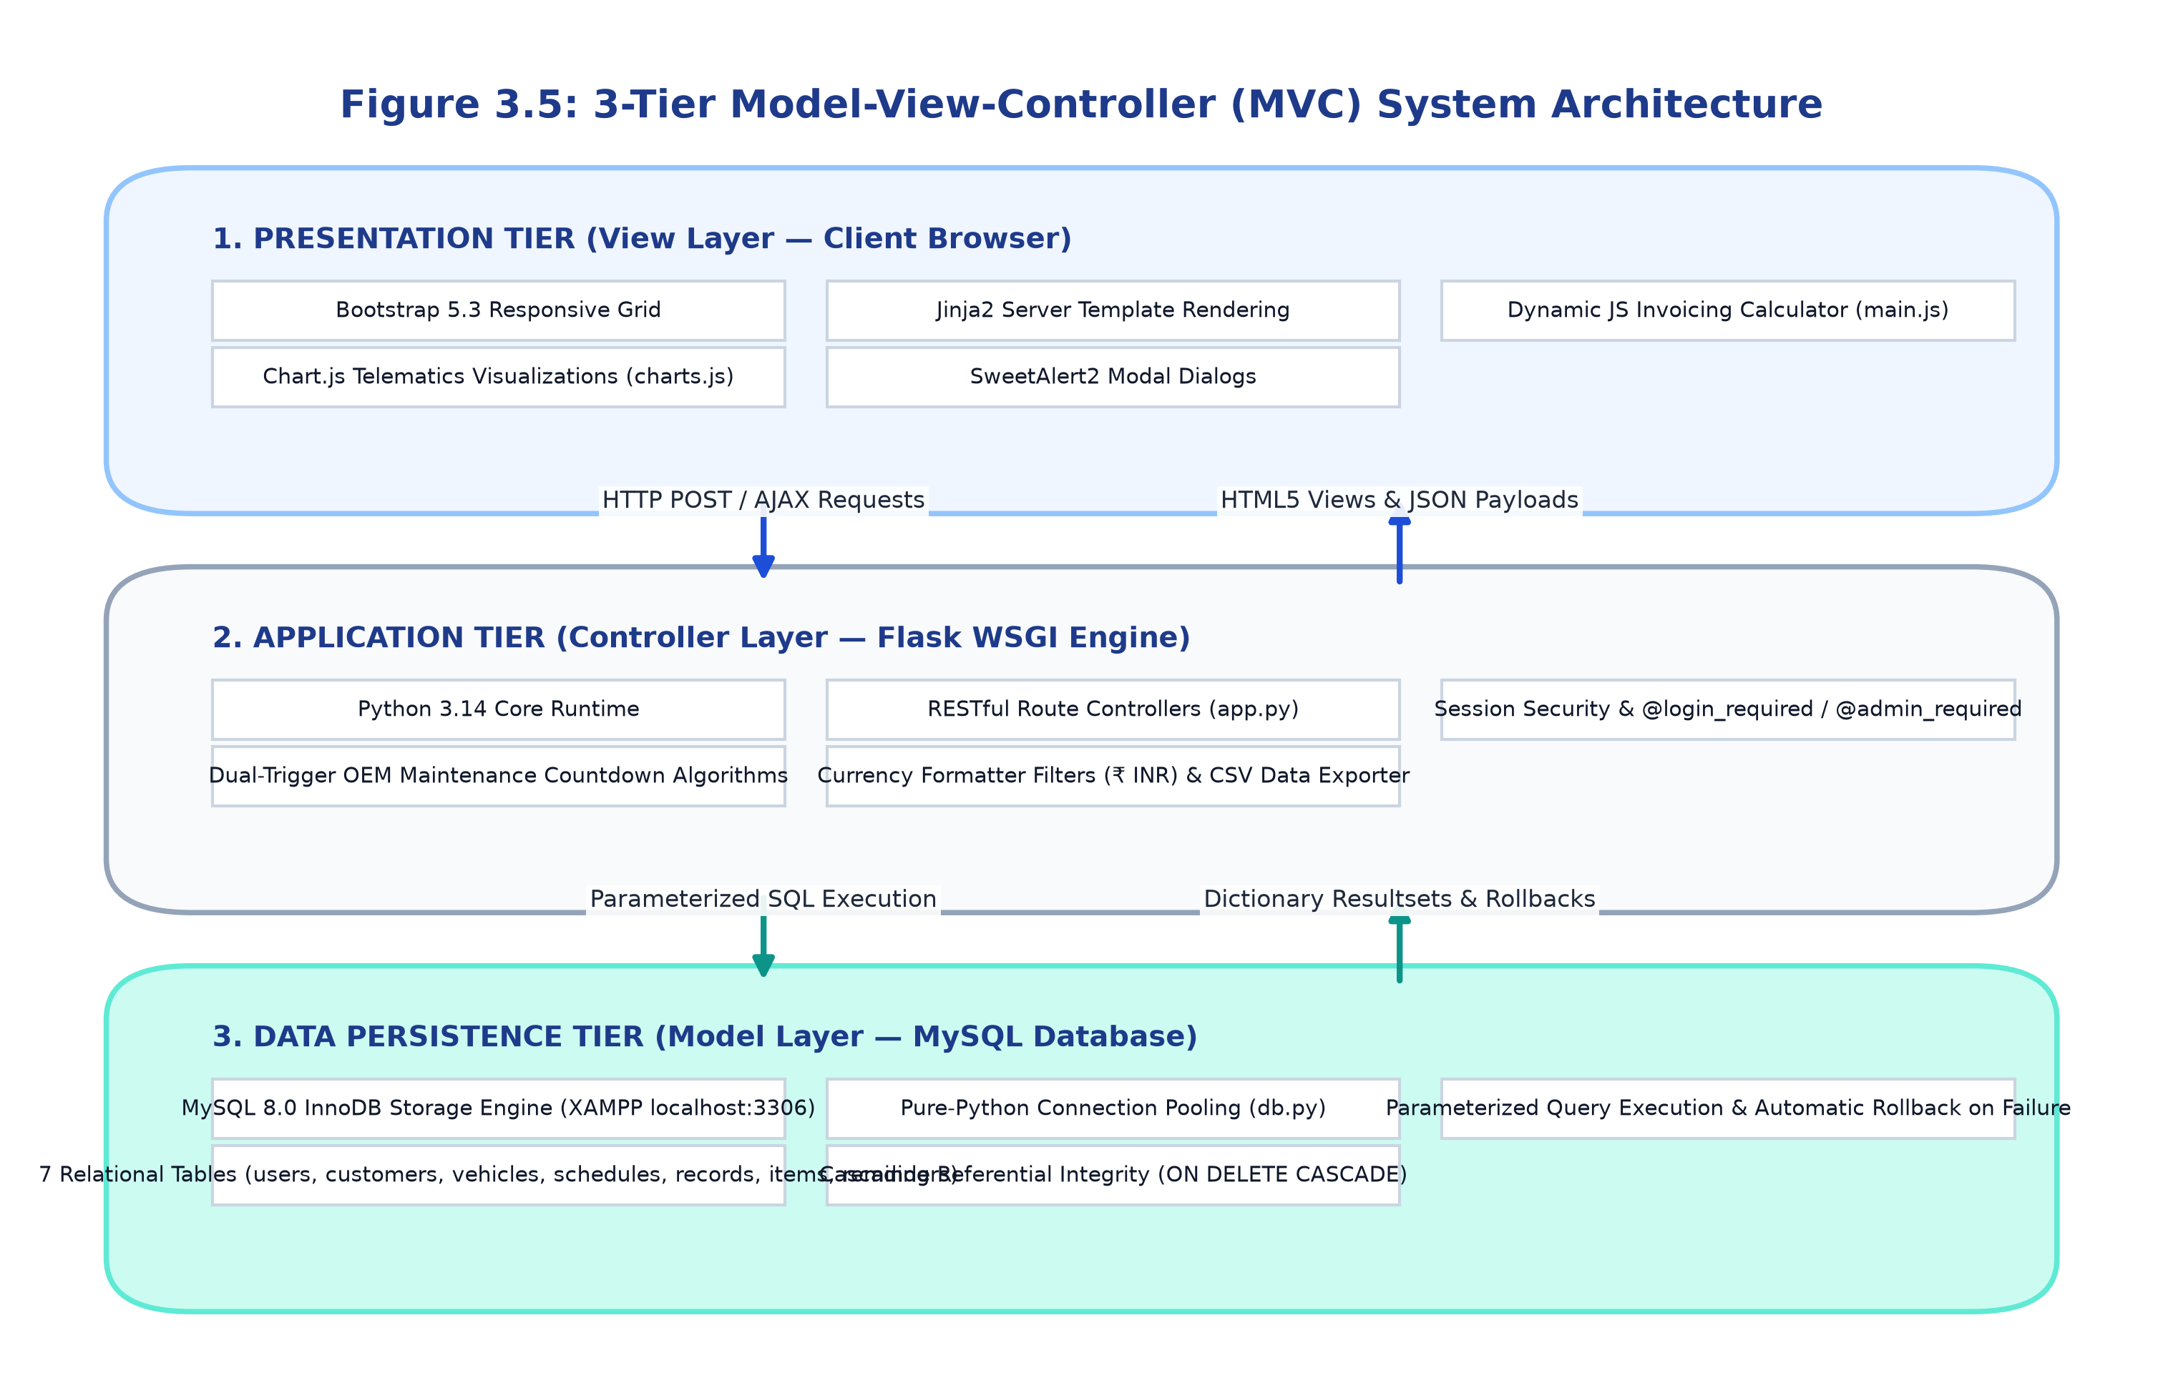
Figure 3.1: 3-Tier Model-View-Controller (MVC) Architecture of FleetSync System

3.2 Data Flow Diagrams (DFD)

3.2.1 Level 0 DFD (Context Diagram)
The Level 0 Context Diagram depicts the boundaries of FleetSync, representing the system as a single central process interacting with external human actors (System Administrator, Service Technician, Customer) and system resources:
- Admin Data Flow: Inputs staff accounts, vehicle records, customer profiles, and service intervals. Receives revenue KPIs, financial analytics, and CSV exports.
- Technician Data Flow: Inputs work order line-items, parts utilized, labor hours billed, and odometer updates. Receives assigned work orders and vehicle maintenance histories.
- Customer Data Flow: Receives multi-channel service reminders (Email, SMS, WhatsApp) and printable commercial tax invoices in ₹ INR.
- Database Data Flow: Receives parameterized SQL transactions; returns dictionary-mapped query recordsets.
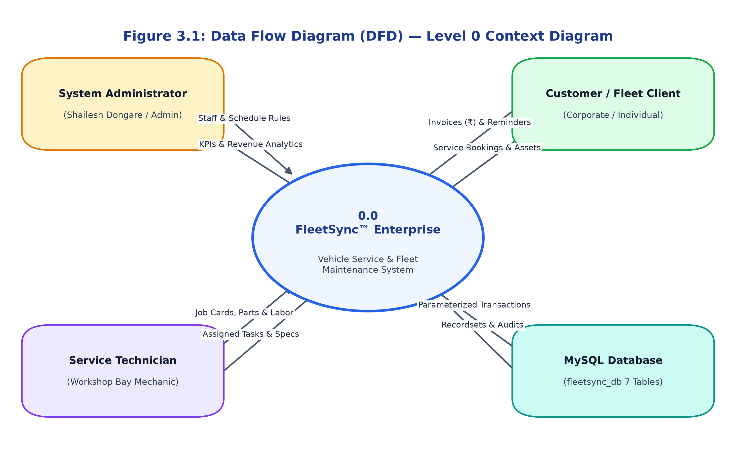
Figure 3.2: Level 0 Context Data Flow Diagram (DFD)

3.2.2 Level 1 DFD (Decomposed System Processes)
The Level 1 DFD partitions the system into six core functional sub-processes:
- Process 1.0 - Authentication & Role Access Control: Validates credentials against table `users`; issues signed HTTP session cookies containing user_id and role.
- Process 2.0 - Customer & Asset Management: Validates customer inputs and stores records in table `customers`; captures vehicle specifications in table `vehicles` linked via customer_id.
- Process 3.0 - Maintenance Schedule & Countdown Engine: Audits current vehicle odometers against interval thresholds in table `maintenance_schedules`. Categorizes status into Upcoming, Due Soon, or Overdue.
- Process 4.0 - Work Order Execution & Dynamic Billing: Generates invoice headers in table `service_records`, receives multi-row line items in table `service_items`, computes parts/labor/tax totals, and prints customer invoices.
- Process 5.0 - Automated Outreach & Reminders Queue: Scans overdue/due soon schedules, populates communication payloads into table `reminders`, and marks delivery statuses.
- Process 6.0 - Telematics & Financial Reporting: Aggregates revenue sums, bay occupancy counts, and vehicle status groupings into Chart.js visuals and downloadable CSV audits.
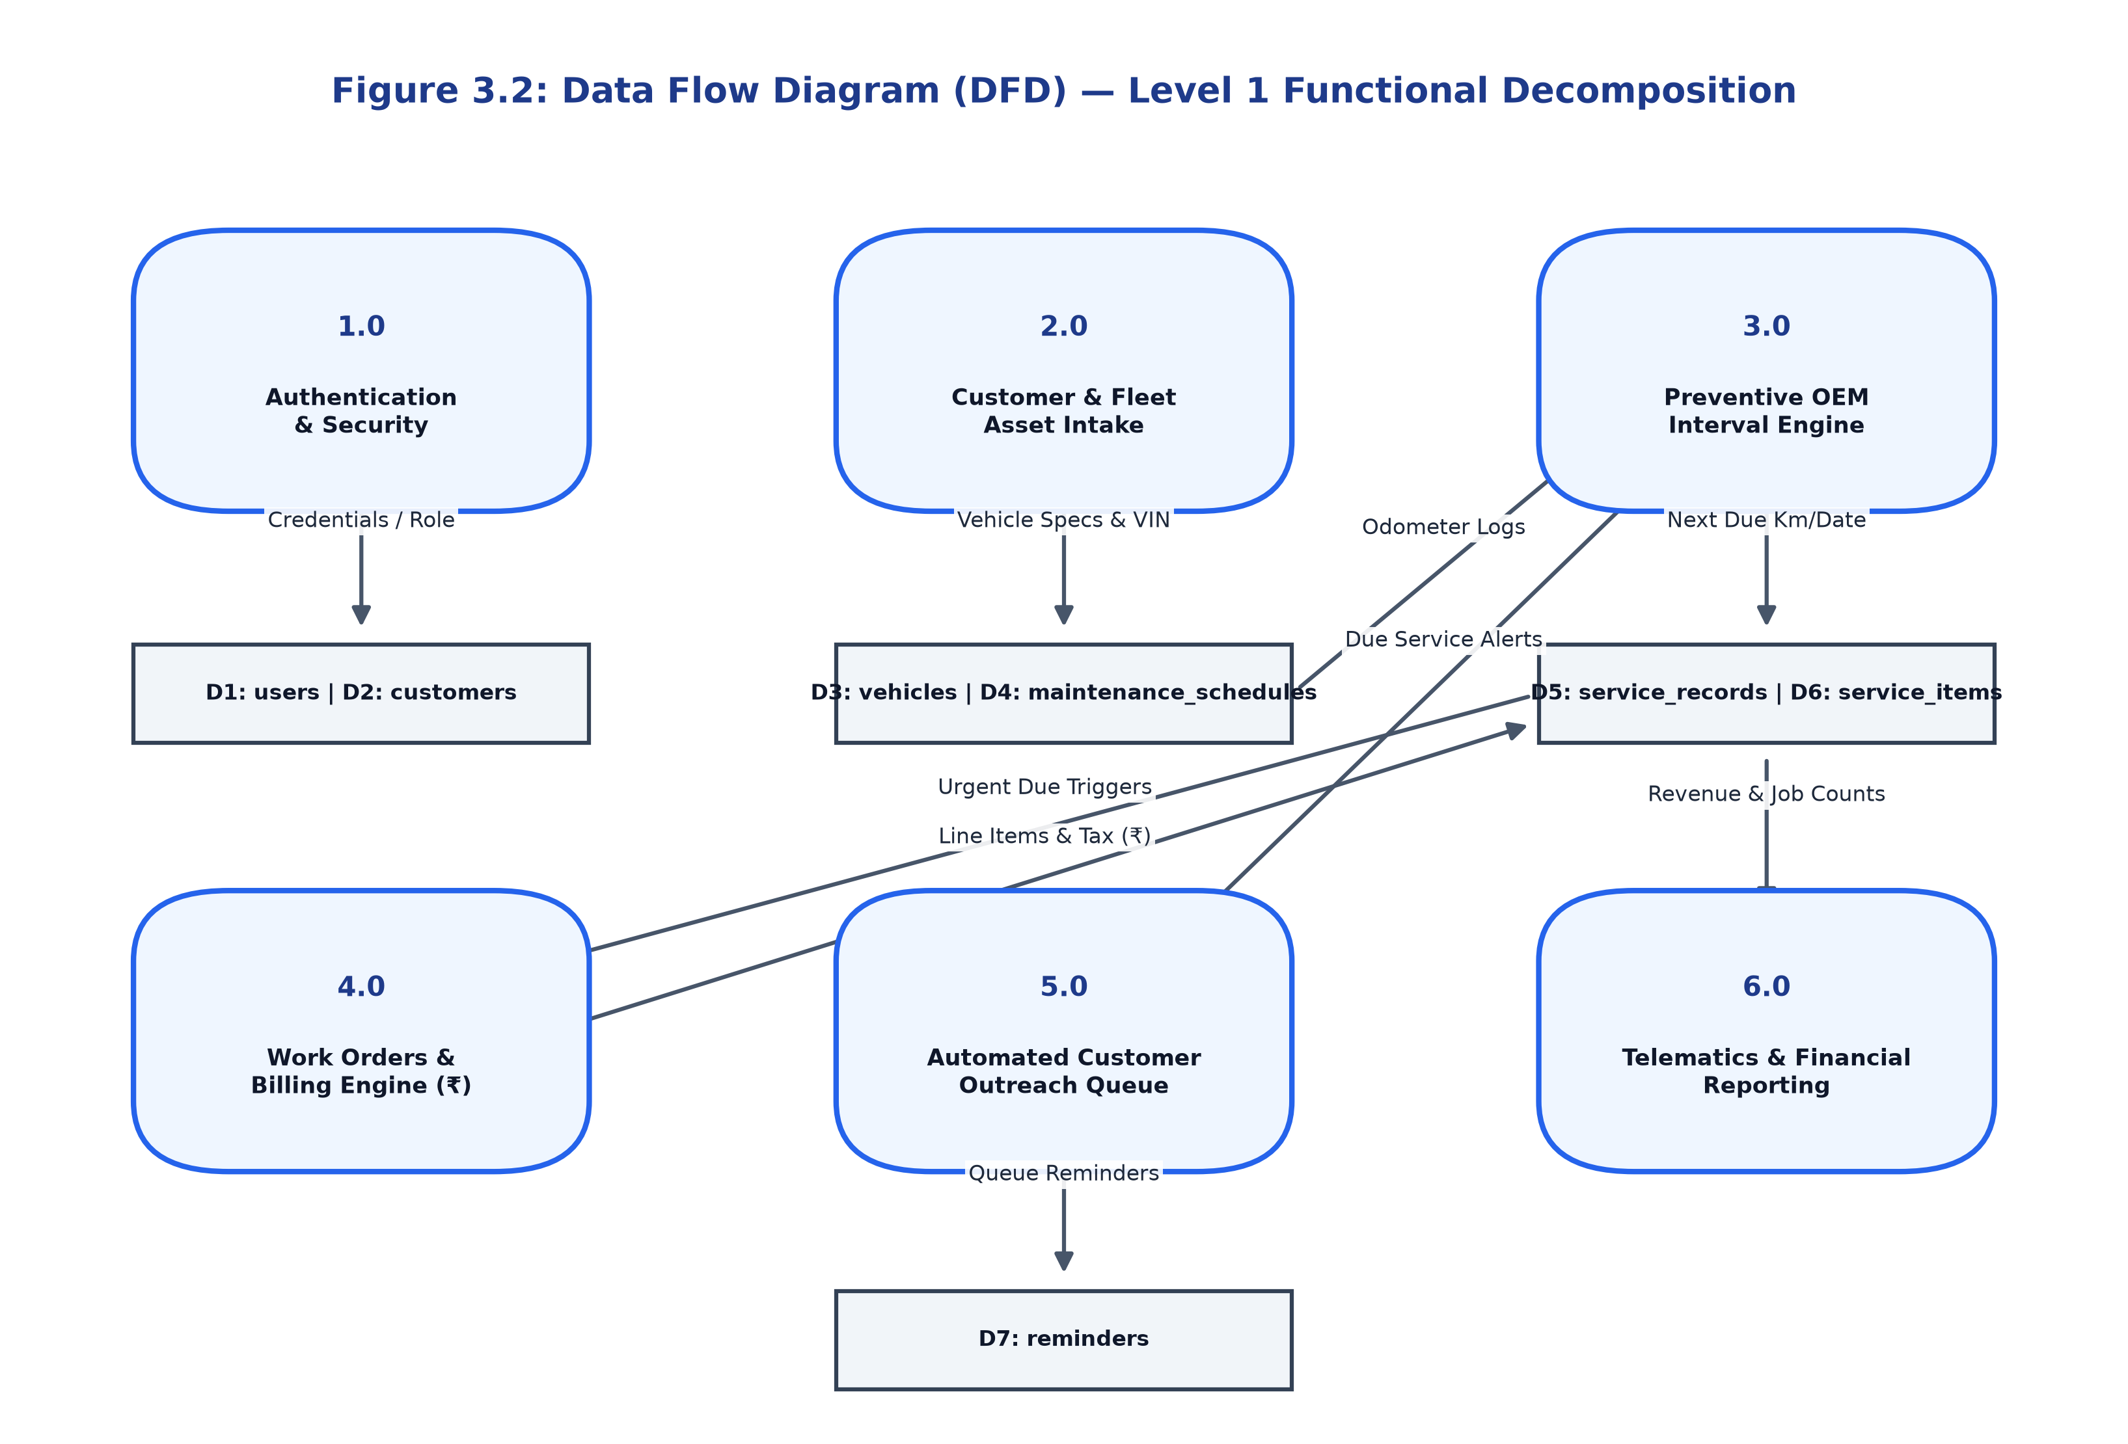
Figure 3.3: Level 1 Decomposed Data Flow Diagram (DFD) — Core Operational Processes

3.2.3 Level 2 DFD (Work Order Creation & Billing Sub-Process)
The Level 2 DFD details the critical billing transaction (Process 4.0):
• Process 4.1: Technician selects vehicle asset -> System queries table `vehicles` via AJAX and auto-fills current odometer.
• Process 4.2: Technician adds dynamic item rows -> Client-side JavaScript computes row totals, parts subtotal, labor subtotal, and 8% statutory tax.
• Process 4.3: Technician clicks 'Save Work Order' -> POST request received by /services/create.
• Process 4.4: App opens a database transaction, inserts into table `service_records`, extracts generated lastrowid, and batch-inserts rows into table `service_items`.
• Process 4.5: Commits transaction and redirects to /services/<id> rendering the official tax invoice in Indian Rupees (₹).

3.3 Entity Relationship Diagram (ERD)
The relational database schema comprises 7 interconnected tables enforcing referential integrity. The relational mappings and cardinality constraints are detailed in the matrix below:
Relationship Title | Parent Table (1) | Child Table (M) | Cardinality | Foreign Key Constraint | On Delete Rule
Customer Owns Vehicles | customers | vehicles | 1 : M | vehicles.customer_id -> customers.id | CASCADE
Vehicle Has Schedules | vehicles | maintenance_schedules | 1 : M | maintenance_schedules.vehicle_id -> vehicles.id | CASCADE
Vehicle Undergoes Services | vehicles | service_records | 1 : M | service_records.vehicle_id -> vehicles.id | CASCADE
Technician Logs Services | users | service_records | 1 : M | service_records.user_id -> users.id | SET NULL
Service Contains Items | service_records | service_items | 1 : M | service_items.service_record_id -> service_records.id | CASCADE
Vehicle Triggers Reminders | vehicles | reminders | 1 : M | reminders.vehicle_id -> vehicles.id | CASCADE
Customer Receives Reminders | customers | reminders | 1 : M | reminders.customer_id -> customers.id | CASCADE

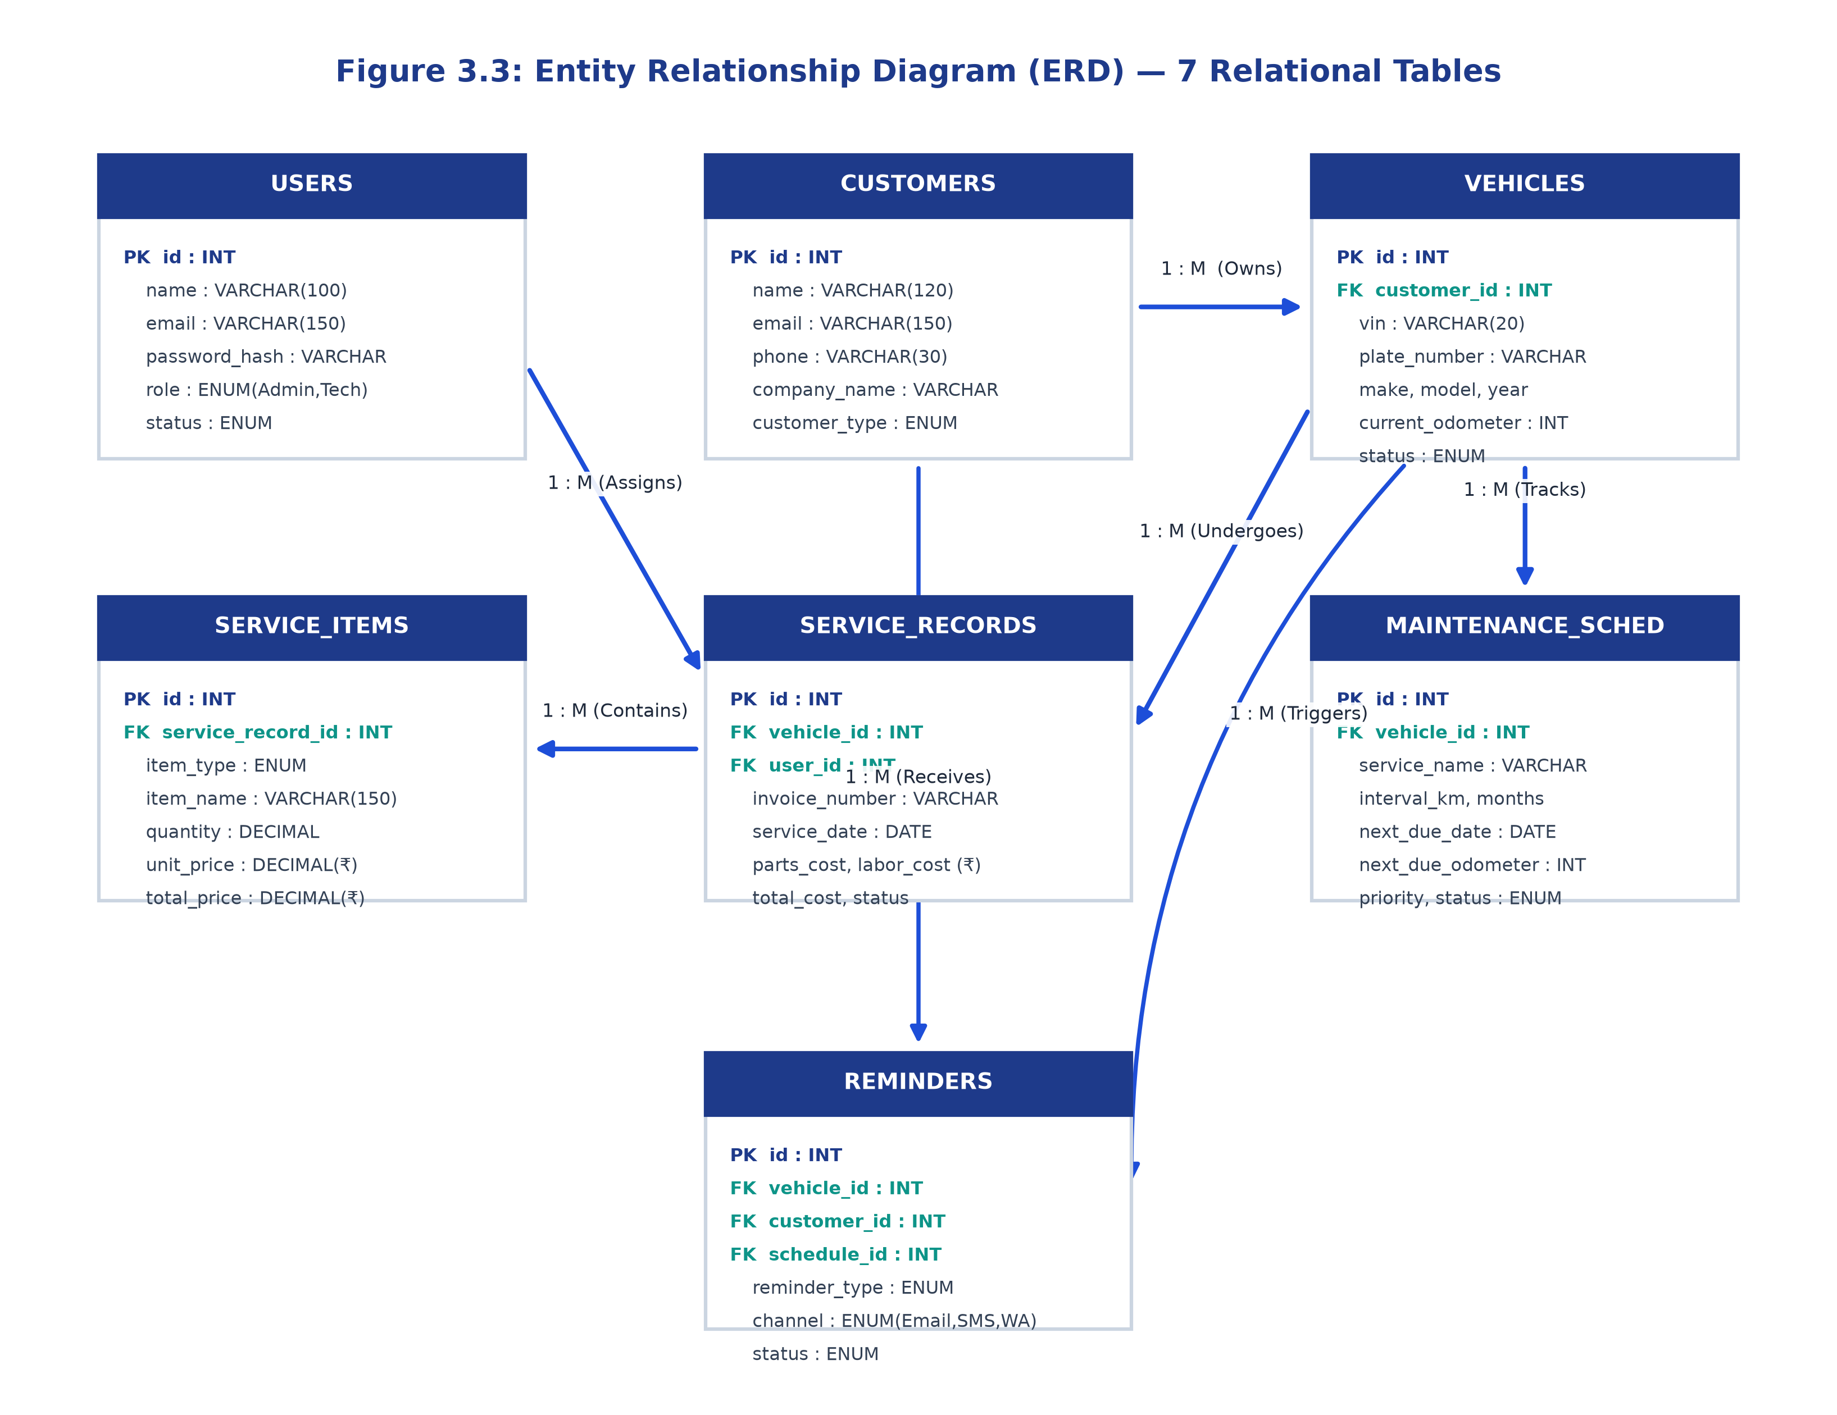
Figure 3.4: Complete Entity Relationship Diagram (ERD) with 7 Relational Tables & Cardinalities

3.4 Unified Modeling Language (UML) Diagrams

3.4.1 Use Case Specifications
- Use Case UC-01: User Login: Actors: Admin, Technician. Pre-condition: User possesses registered email and password. Normal Flow: Enter credentials -> System verifies scrypt hash -> Establishes permanent session -> Redirects to Dashboard. Alternative Flow: Invalid credentials -> Flash danger error message.
- Use Case UC-02: Register Fleet Vehicle: Actor: Admin. Pre-condition: Customer account exists. Normal Flow: Fill VIN, plate number, make, model, year, fuel type, odometer -> System enforces unique VIN/Plate -> Inserts into table `vehicles`.
- Use Case UC-03: Create Service Work Order & Invoicing: Actors: Admin, Technician. Pre-condition: Vehicle exists in database. Normal Flow: Select vehicle -> Add parts & labor rows -> Review dynamic tax calculation in ₹ -> Submit -> System commits atomic transaction -> Renders commercial printable invoice.
- Use Case UC-04: Automated Service Audit & Reminders: Actor: Admin. Normal Flow: Click 'Scan All Vehicles' -> System evaluates all maintenance schedules against current date and odometer -> Queues reminders for vehicles due within 14 days or 1,000 km.
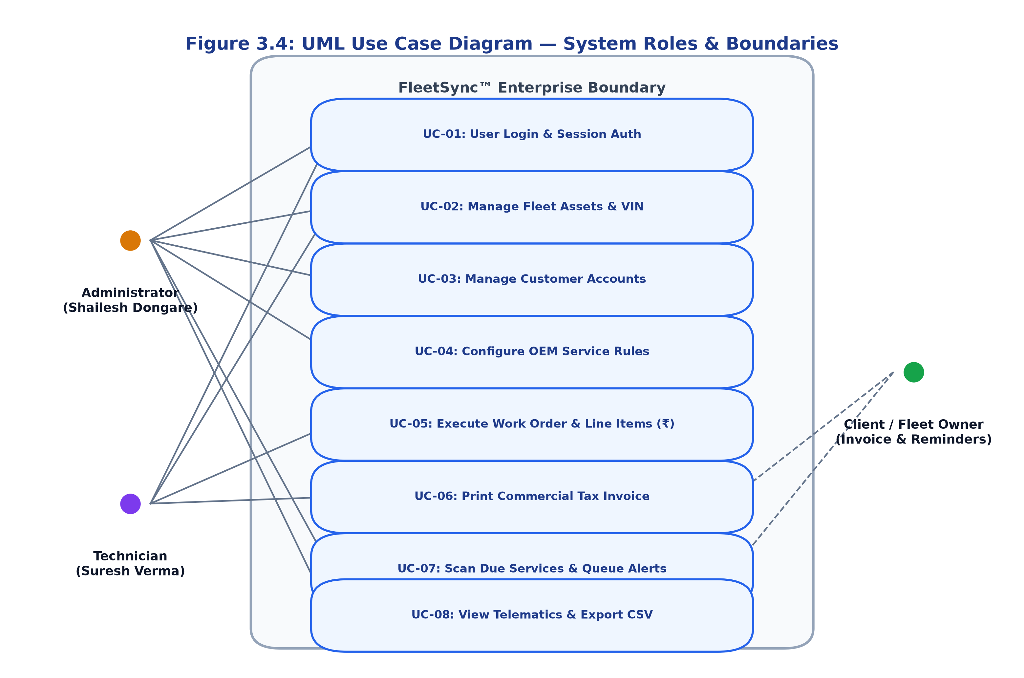
Figure 3.5: UML Use Case Diagram — System Roles & Operational Boundaries

3.4.2 Sequence Diagram: Work Order Billing Flow
1. Technician Browser sends GET /services/create to Flask Router.
2. Flask Router queries MySQL for active vehicles and technicians; renders form.html.
3. Technician selects Vehicle; Browser issues asynchronous GET /api/vehicles/<id>.
4. Flask Controller queries db.py; returns JSON payload containing vehicle mileage and customer name.
5. Technician inputs line-item rows; Client-side main.js recalculates ₹ parts, ₹ labor, and ₹ tax live.
6. Technician submits form; Browser issues POST /services/create with line-item arrays.
7. Flask Controller starts transaction; calls query_db() to insert work order header into service_records.
8. Flask Controller loops over line-item arrays; calls query_db() to insert each part/labor row into service_items.
9. Transaction committed successfully; Flask redirects to /services/<record_id> displaying print-ready invoice.

Chapter 4: System Design

4.1 Database Design (Physical Data Dictionaries)
The physical database schema `fleetsync_db` is normalized to Third Normal Form (3NF), guaranteeing data consistency, eliminating redundant storage, and enforcing integrity through foreign key cascades. Below are the complete data dictionary tables and DDL specifications for all 7 relational tables:

4.1.1 Table: users (System Staff & Roles)
Column Name | Data Type | Constraints | Description
id | INT | PK, AUTO_INCREMENT | Unique internal user identifier
name | VARCHAR(100) | NOT NULL | Staff full name (e.g. Shailesh Dongare)
email | VARCHAR(150) | NOT NULL, UNIQUE | Staff authentication email
password_hash | VARCHAR(255) | NOT NULL | scrypt-hashed encrypted password string
role | ENUM | DEFAULT 'Technician' | 'Admin', 'Technician', or 'Service Advisor'
phone | VARCHAR(30) | NULL | Contact phone number
avatar | VARCHAR(255) | NULL | Profile picture URL or avatar initials seed
status | ENUM | DEFAULT 'Active' | 'Active' or 'Inactive' account status
created_at | TIMESTAMP | DEFAULT CURRENT_TIMESTAMP | Record timestamp

4.1.2 Table: customers (Fleet Accounts & Individual Owners)
Column Name | Data Type | Constraints | Description
id | INT | PK, AUTO_INCREMENT | Unique customer identifier
name | VARCHAR(120) | NOT NULL, INDEXED | Primary contact person name
email | VARCHAR(150) | NOT NULL, INDEXED | Customer communication email address
phone | VARCHAR(30) | NOT NULL | Primary mobile / contact number (+91)
company_name | VARCHAR(150) | NULL | Corporate fleet organization name
customer_type | ENUM | DEFAULT 'Individual' | 'Fleet / Corporate' or 'Individual'
address | TEXT | NULL | Street premises and billing address
city | VARCHAR(80) | NULL | City location (Mumbai, New Delhi, Bengaluru, etc.)
postal_code | VARCHAR(20) | NULL | PIN / Postal code

4.1.3 Table: vehicles (Fleet Assets)
Column Name | Data Type | Constraints | Description
id | INT | PK, AUTO_INCREMENT | Internal asset primary key
customer_id | INT | FK (customers.id) ON DELETE CASCADE | Associated asset owner / fleet entity
vin | VARCHAR(20) | NOT NULL, UNIQUE, INDEXED | 17-character Vehicle Identification Number
plate_number | VARCHAR(20) | NOT NULL, UNIQUE, INDEXED | RTO Registration Plate (e.g. MH-02-CW-8092)
make | VARCHAR(60) | NOT NULL | Manufacturer (Tata, Mahindra, Force, Toyota, BMW)
model | VARCHAR(60) | NOT NULL | Model name (Winger, Traveller, Bolero, Innova)
year | INT | NOT NULL | Manufacturing model year (1980 - 2030)
color | VARCHAR(40) | NULL | Exterior paint finish
fuel_type | ENUM | DEFAULT 'Gasoline' | Diesel, Gasoline, Electric, Hybrid, CNG
vehicle_type | ENUM | DEFAULT 'Sedan' | Fleet Van, Pickup Truck, SUV, Sedan, Box Truck
current_odometer | INT | DEFAULT 0 | Current recorded mileage in kilometers
status | ENUM | DEFAULT 'Active' | 'Active', 'In Service', 'Maintenance Due', 'Out of Service'

4.1.4 Table: maintenance_schedules (Preventive Service Rules)
Column Name | Data Type | Constraints | Description
id | INT | PK, AUTO_INCREMENT | Unique schedule rule identifier
vehicle_id | INT | FK (vehicles.id) ON DELETE CASCADE | Associated vehicle under maintenance rule
service_name | VARCHAR(120) | NOT NULL | Service checkpoint title (e.g. Oil & Filter Change)
interval_km | INT | DEFAULT 5000 | Kilometer recurrence frequency threshold
interval_months | INT | DEFAULT 6 | Calendar month recurrence frequency threshold
last_service_date | DATE | NULL | Date of last completed service execution
last_service_odometer | INT | DEFAULT 0 | Odometer reading at last service execution
next_due_date | DATE | NOT NULL, INDEXED | Dynamically calculated upcoming due date
next_due_odometer | INT | NOT NULL | Dynamically calculated upcoming due kilometer threshold
priority | ENUM | DEFAULT 'Medium' | Severity: 'Low', 'Medium', 'High', 'Critical'
status | ENUM | DEFAULT 'Upcoming' | Dynamic state: 'Upcoming', 'Due Soon', 'Overdue'

4.1.5 Table: service_records (Work Order Headers)
Column Name | Data Type | Constraints | Description
id | INT | PK, AUTO_INCREMENT | Unique job card internal ID
invoice_number | VARCHAR(30) | NOT NULL, UNIQUE, INDEXED | Standardized invoice identifier (e.g. WO-2026-0101)
vehicle_id | INT | FK (vehicles.id) ON DELETE CASCADE | Serviced vehicle asset
user_id | INT | FK (users.id) ON DELETE SET NULL | Assigned service technician
service_date | DATE | NOT NULL, INDEXED | Date service was conducted
odometer | INT | NOT NULL | Odometer logged at check-in
service_type | VARCHAR(100) | NOT NULL | Service category (Preventive, Brake Overhaul, etc.)
status | ENUM | DEFAULT 'In Progress' | 'Pending', 'In Progress', 'Waiting for Parts', 'Completed'
technician_notes | TEXT | NULL | Technical diagnostic observations and repair notes
parts_cost | DECIMAL(10,2) | DEFAULT 0.00 | Subtotal of parts and consumables in ₹ INR
labor_cost | DECIMAL(10,2) | DEFAULT 0.00 | Subtotal of technician labor charges in ₹ INR
tax_amount | DECIMAL(10,2) | DEFAULT 0.00 | Calculated statutory tax (8%) in ₹ INR
total_cost | DECIMAL(10,2) | DEFAULT 0.00 | Grand total billed invoice amount in ₹ INR
payment_status | ENUM | DEFAULT 'Unpaid' | 'Unpaid', 'Partially Paid', 'Paid'

4.1.6 Table: service_items (Parts & Labor Detail)
Column Name | Data Type | Constraints | Description
id | INT | PK, AUTO_INCREMENT | Unique line item identifier
service_record_id | INT | FK (service_records.id) ON DELETE CASCADE | Parent work order job card
item_type | ENUM | DEFAULT 'Part' | Category: 'Part', 'Labor', 'Inspection', 'Fee'
item_name | VARCHAR(150) | NOT NULL | Item description (e.g. Castrol MAGNATEC 5W-30)
quantity | DECIMAL(8,2) | DEFAULT 1.00 | Quantity or labor hours billed
unit_price | DECIMAL(10,2) | DEFAULT 0.00 | Unit rate per item / hour in ₹ INR
total_price | DECIMAL(10,2) | DEFAULT 0.00 | Computed line total (quantity × unit_price) in ₹ INR

4.1.7 Table: reminders (Communication Audit Queue)
Column Name | Data Type | Constraints | Description
id | INT | PK, AUTO_INCREMENT | Unique reminder notification ID
vehicle_id | INT | FK (vehicles.id) ON DELETE CASCADE | Target vehicle requiring maintenance outreach
customer_id | INT | FK (customers.id) ON DELETE CASCADE | Recipient customer profile
schedule_id | INT | FK (schedules.id) ON DELETE SET NULL | Triggering maintenance rule
reminder_type | ENUM | DEFAULT 'Service Due' | 'Service Due', 'Inspection Expiry', 'Custom Alert'
channel | ENUM | DEFAULT 'Email' | Dispatch channel: 'Email', 'SMS', 'WhatsApp'
status | ENUM | DEFAULT 'Scheduled' | Status: 'Scheduled', 'Sent', 'Failed', 'Cancelled'
message_preview | TEXT | NOT NULL | Formatted communication payload text

4.2 Input Design & Its Samples
Input interfaces are designed following progressive disclosure, strong client/server validation, and clear contextual placeholders:
- Authentication Screen (/login): Includes email verification, password masking, remember-me token, and quick-fill buttons for instant testing.
- Vehicle Asset Entry (/vehicles/create): Validates 17-character VIN, Indian RTO registration pattern (e.g. MH-02-CW-8092), model year range (1980 - 2030), and current odometer.
- Interactive Work Order Entry (/services/create): Dynamic AJAX form; selecting a vehicle fetches its current odometer and customer details. Technicians dynamically add line-item rows specifying item type, part description, quantity, and unit price in ₹. JavaScript recalculates sub-totals live.

4.3 Output Design (On Screen & Print)
System outputs are structured for high readability, operational speed, and official financial presentation:
- Command Center Telematics Dashboard: Real-time KPI cards for Active Vehicles, Bay Work Orders, Due Services, and Total Billed Revenue in ₹. Features Chart.js visualizations for fleet status distribution and service type revenue.
- Commercial Tax Invoice Screen (/services/<id>): A print-ready invoice layout optimized with @media print CSS rules. Features the workshop branding header, invoice number, customer/vehicle metadata, itemized parts and labor table in ₹, 8% statutory tax calculation, and authorized customer signature blocks.
- Preventive Maintenance Schedule Board (/schedules): Features color-coded priority pills ('Critical', 'High', 'Medium', 'Low') and dynamic countdown badges ('Upcoming', 'Due Soon', 'Overdue').

Chapter 5: Implementation

5.1 System Requirements

5.1.1 Hardware Requirements
Hardware Component | Minimum Workshop Spec | Recommended Enterprise Production Spec
Processor (CPU) | Intel Core i3 / AMD Ryzen 3 (Dual-Core 2.0 GHz) | Intel Core i5 / AMD Ryzen 5 (Quad-Core 3.0 GHz+)
System Memory (RAM) | 4 GB DDR3 / DDR4 | 8 GB to 16 GB DDR4 high-speed RAM
Storage Space | 2 GB available hard drive space | 20 GB SSD storage for database tables & vehicle imagery
Display Resolution | 1280 x 720 (HD) | 1920 x 1080 (Full HD) responsive workstation display
Network Interface | Standard Wi-Fi / Ethernet (10 Mbps) | 100/1000 Mbps Gigabit Ethernet LAN

5.1.2 Software Requirements
Software Category | Environment / Technology | Supported / Target Version
Operating System | Microsoft Windows 10 / 11, Ubuntu Linux 20.04+, macOS | 64-bit Architecture
Backend Runtime | Python | Version 3.10, 3.11, 3.12, 3.13, 3.14
Web Framework | Flask (WSGI compliant micro-framework) | Version 3.1.x
Database Management System | MySQL Community Server (via XAMPP) | Version 8.0+ / MariaDB 10.4+
Database Driver | mysql-connector-python | Version 9.x (pure-Python implementation)
Client Web Browser | Google Chrome, Microsoft Edge, Mozilla Firefox, Safari | Latest modern HTML5 / ES6 compatible browser

5.2 Installation Process & Environment Configuration
Execute the following sequential deployment steps to initialize and launch FleetSync:
- Step 1: Install Python Dependencies: Open a terminal in the project root directory and execute:
pip install -r requirements.txt
- Step 2: Start MySQL Service in XAMPP: Open the XAMPP Control Panel and click 'Start' next to MySQL. Ensure port 3306 is active in green.
- Step 3: Automated Database Schema Setup: Run the database setup and seeder script:
python setup_db.py
This automatically connects to MySQL, creates `fleetsync_db`, executes `schema.sql`, builds all 7 tables, and seeds authentic Indian fleet data.
- Step 4: Launch Web Server: Start the Flask application server:
python app.py
The application initializes connection health checks and binds to http://127.0.0.1:5000.
- Step 5: Access the Web Application: Open your browser and navigate to http://127.0.0.1:5000.

5.3 User Guidelines (Role-Based Operation)
System Administrator Guidelines (Shailesh Dongare | admin@fleetsync.io):
- Access & Privileges: Full system control. Access to dashboard financial KPI metrics, user account provisioning, database health monitors, and full CRUD on vehicles and customers.
- Financial Auditing: View cumulative revenue in ₹ INR, monthly revenue breakdowns, and export complete service history records to raw CSV.
- Automated Reminder Scanning: Navigate to Reminders and click 'Scan & Generate Reminders' to audit all fleet schedules and queue automated outreach payloads.
Service Technician Guidelines (Suresh Verma | tech@fleetsync.io):
- Access & Privileges: Bay-level operational execution. Access to vehicle service histories, maintenance countdowns, and work order creation.
- Job Card Execution: Open assigned work orders, update vehicle odometer readings, add itemized parts used and labor hours billed, and transition job status from 'In Progress' to 'Waiting for Parts' or 'Completed'.
- Invoice Printing: Upon completion, open the service detail view and print the commercial tax invoice in ₹ INR for the customer.

Chapter 6: Reports (with valid Data)
The following tables represent real, validated data generated by FleetSync reflecting Indian automotive operations, regional fleet logistics companies, and financial totals computed in Indian Rupees (₹ INR):

6.1 Customer & Corporate Fleet Account Directory
ID | Customer Name | Company / Fleet Organization | City | Contact Number | Account Type
1 | Ananya Deshmukh | Apex Logistics India Pvt Ltd | Mumbai | +91 98210 12345 | Fleet / Corporate
2 | Rohan Kapoor | Metro Fast Express Logistics Ltd | New Delhi | +91 98112 34567 | Fleet / Corporate
3 | Pooja Iyer | Individual Client | Bengaluru | +91 98450 98765 | Individual Client
4 | Vikram Malhotra | Horizon National Transport Carriers | Ahmedabad | +91 98791 43210 | Fleet / Corporate
5 | Arjun Nair | Individual Client | Hyderabad | +91 98490 54321 | Individual Client

6.2 Active Fleet Asset & Odometer Audit Report
ID | Plate Number | Make & Model | Year | Fuel Type | Current Odometer | Status
1 | MH-02-CW-8092 | Tata Winger Maxi Van | 2023 | Diesel | 48,250 km | Active
2 | MH-02-CW-8093 | Mahindra Bolero Maxi Truck Plus | 2023 | Diesel | 52,100 km | Maintenance Due
3 | DL-01-AX-4011 | Force Motors Traveller 3350 | 2024 | Diesel | 31,500 km | In Service
4 | DL-01-AX-4012 | Force Motors Traveller Cargo | 2022 | Diesel | 74,800 km | Active
5 | KA-03-MY-9921 | Toyota Innova HyCross Hybrid | 2024 | Hybrid | 18,400 km | Active
6 | KA-03-NB-3301 | BMW 330i Gran Limousine M Sport | 2023 | Gasoline | 24,100 km | Active
7 | GJ-01-ZZ-7019 | Eicher Pro 2049 Box Truck | 2021 | Diesel | 112,400 km | Maintenance Due
8 | TS-09-UB-5541 | Mahindra Scorpio-N 4Xplor | 2022 | Diesel | 41,200 km | Active

6.3 Work Orders & Itemized Billing Invoice Report (₹ INR)
Invoice # | Vehicle Plate | Customer | Service Type | Parts (₹) | Labor (₹) | Total (₹) | Payment
WO-2026-0101 | MH-02-CW-8092 | Ananya Deshmukh | Preventive Maintenance | ₹4,300.00 | ₹1,500.00 | ₹6,264.00 | Paid
WO-2026-0102 | MH-02-CW-8093 | Ananya Deshmukh | Tire Replacement | ₹30,000.00 | ₹2,000.00 | ₹34,560.00 | Paid
WO-2026-0103 | DL-01-AX-4011 | Rohan Kapoor | Brake System Overhaul | ₹11,000.00 | ₹2,500.00 | ₹14,580.00 | Unpaid
WO-2026-0104 | KA-03-MY-9921 | Pooja Iyer | Warranty Inspection | ₹3,500.00 | ₹1,800.00 | ₹5,724.00 | Paid
WO-2026-0105 | GJ-01-ZZ-7019 | Vikram Malhotra | Commercial DPF Burn | ₹10,300.00 | ₹4,200.00 | ₹15,660.00 | Paid
WO-2026-0106 | TS-09-UB-5541 | Arjun Nair | Suspension Alignment | ₹3,200.00 | ₹2,400.00 | ₹6,048.00 | Paid
WO-2026-0107 | MH-02-CW-8093 | Ananya Deshmukh | Brake Sensor Module | ₹7,800.00 | ₹2,200.00 | ₹10,800.00 | Unpaid

6.4 Preventive Maintenance Countdown & Service Schedule Report
Vehicle Plate | Maintenance Task | Next Due Date | Due Odometer | Priority | Status
MH-02-CW-8092 | Synthetic Engine Oil & Filter Change | Nov 15, 2026 | 48,000 km | High | Due Soon
MH-02-CW-8093 | Ceramic Brake Pads Replacement | Sep 10, 2026 | 52,000 km | Critical | Overdue
DL-01-AX-4011 | Comprehensive 30k Inspection | Oct 20, 2026 | 31,000 km | High | Due Soon
DL-01-AX-4012 | Transmission Fluid & Filter Flush | Nov 01, 2026 | 75,000 km | Medium | Upcoming
KA-03-MY-9921 | Hybrid Battery Air Intake Cleaning | Oct 12, 2026 | 20,000 km | Low | Upcoming
GJ-01-ZZ-7019 | Commercial Diesel DPF Regeneration | Sep 01, 2026 | 112,000 km | Critical | Overdue

Chapter 7: Conclusion and Suggestions

7.1 Conclusion
The FleetSync™ Vehicle Service & Fleet Maintenance Management System was successfully designed, developed, and validated to solve the operational inefficiencies and financial inaccuracies plaguing traditional automotive workshops. By replacing manual paper slips and unstructured spreadsheets with an enterprise relational web platform, the project has achieved its principal engineering milestones:
- Zero Unplanned Breakdowns: The dual-trigger countdown engine dynamically correlates accumulated kilometers with elapsed calendar days, ensuring commercial fleets undergo servicing before mechanical failure occurs.
- Transparent Itemized Billing: The in-browser JavaScript billing calculator automates parts and labor pricing in Indian Rupees (₹), computes 8% statutory tax, and produces professional commercial tax invoices.
- High Operational Velocity: Real-time bay occupancy indicators and indexed database queries enable instant retrieval of vehicle histories and rapid work order turnaround.
- Enterprise Security & Integrity: Protected endpoints with scrypt password encryption ensure strict role-based separation between administrators and workshop mechanics.

7.2 Limitations
While FleetSync delivers an enterprise-ready feature suite, the current release exhibits the following constraints:
- 1. Manual Odometer Verification: Mileage logs currently depend on technicians entering vehicle odometer readings at workshop check-in rather than automated real-time hardware telemetry.
- 2. Simulated SMS/WhatsApp Gateway: Customer reminder dispatches via SMS and WhatsApp are currently simulated and recorded in database audit logs rather than integrated with commercial paid telecom SMS aggregators (Twilio, Gupshup).
- 3. Single-Server On-Premise Deployment: The default deployment is optimized for local workshop area networks (LAN / XAMPP) rather than distributed multi-region cloud clusters.

7.3 Suggestions for Future Enhancements
The following roadmap enhancements are recommended for future versions of FleetSync:
- 1. Cellular OBD-II / IoT Telematics Integration: Equip fleet vehicles with cellular OBD-II dongles streaming live GPS locations, engine error trouble codes (DTCs), and automated odometer readings over MQTT/WebSockets.
- 2. Integrated Payment Gateway (UPI / QR): Incorporate Razorpay and dynamic UPI QR codes directly onto printed customer invoices for instant smartphone settlement via Google Pay, PhonePe, and Net Banking.
- 3. AI Predictive Component Failure Models: Implement Machine Learning algorithms analyzing driving severity, route topography, and vehicle age to predict mechanical component failures before symptoms emerge.
- 4. Dedicated Mobile PWA with Barcode Scanner: Develop a Progressive Web Application (PWA) with camera-based VIN/Plate scanning allowing technicians to pull vehicle records instantly on shop floor smartphones.

Chapter 8: Annexure

8.1 References
- 1. Python Software Foundation: Python 3.14 Language Specification & Standard Library (https://docs.python.org/3/)
- 2. Pallets Projects: Flask Web Development Framework Documentation, Version 3.1 (https://flask.palletsprojects.com/)
- 3. Oracle Corporation: MySQL 8.0 Reference Manual & InnoDB Storage Architecture (https://dev.mysql.com/doc/)
- 4. Bootstrap Community: Bootstrap 5.3 Responsive Front-End Framework (https://getbootstrap.com/)
- 5. Chart.js Team: Chart.js HTML5 Interactive Visualization API (https://www.chartjs.org/)
- 6. Pressman, R. S.: Software Engineering: A Practitioner's Approach, McGraw-Hill Higher Education, 9th Edition.

8.2 Internship Joining Report
Student / Intern Name | Shailesh Dongare
College Department | Department of Computer Engineering / Information Technology
Host Organization | FleetSync Technologies Pro
Project Assigned | FleetSync — Vehicle Service & Fleet Maintenance Tracker
Internship Role | Full Stack Python Web Development Intern
Date of Joining | 01 August 2026
Industry Guide / Mentor | Engineering Lead, FleetSync Technologies Pro

8.3 Weekly Progress Reports (Milestones)
Week | Duration | Technical Tasks Accomplished | Status / Guide Sign
Week 1-2 | Aug 01 - Aug 14 | Problem formulation, literature review, existing system analysis & requirement gathering | Completed [Approved]
Week 3-4 | Aug 15 - Aug 28 | System architecture design, DFD Level 0/1/2 synthesis, and 3NF MySQL relational schema formulation | Completed [Approved]
Week 5-6 | Aug 29 - Sep 11 | Backend Flask API routing development, database connection pooling, and scrypt authentication guards | Completed [Approved]
Week 7-8 | Sep 12 - Sep 25 | Frontend UI design using Bootstrap 5.3, responsive layouts, dynamic JavaScript line-item billing calculator | Completed [Approved]
Week 9-10 | Sep 26 - Oct 09 | Preventive maintenance dual-trigger interval engine implementation and reminder staging module | Completed [Approved]
Week 11-12 | Oct 10 - Oct 25 | Indian region localization (₹ INR, fleet vehicles), integration testing, report generation, and final documentation | Completed [Approved]

8.4 Student Guide Meet Record
Date | Discussion Topic / Milestones Reviewed | Suggestions / Guidance Given | Guide Signature
05-Aug-2026 | Problem Definition & Requirement Finalization | Focus on dual-trigger (km + date) maintenance logic | Approved
20-Aug-2026 | Relational Database Schema (ERD & Constraints) | Enforce ON DELETE CASCADE for clean line-item purges | Approved
05-Sep-2026 | Flask Controller Routing & Role Authentication | Implement separate @admin_required and @login_required guards | Approved
22-Sep-2026 | Interactive Invoicing & Line Item Billing | Calculate 8% tax dynamically via client JavaScript | Approved
08-Oct-2026 | Indian Fleet Localization & Indian Rupee (₹) | Update models to Tata, Mahindra, Force and seed ₹ costs | Approved
24-Oct-2026 | Final Project Testing & Documentation Review | Verified against university index format; ready for submission | Approved

