DIRISA Student Datathon Challenge 2026
Hung Council Watch
Project and dashboard guide

Forecasting which South African municipalities could lose their governing majority in the 4 November 2026 Local Government Elections, and a plain-language guide to the interactive dashboard we built to explore it.
Team Eduvos
Live dashboard: https://eduvos-hung-councils.netlify.app
September 2026

How to use this guide
This guide explains our project and our dashboard for readers who are not data scientists. You do not need any background in statistics or coding to follow it. Technical terms are explained the first time they appear, and there is a glossary at the end.
If you only have five minutes, read Section 1 (The project at a glance) and then open the dashboard and follow the demonstration walk-through in Section 7.6.

Contents
- The project at a glance
- The problem we set out to solve
- How the project developed
- The data we used
- Key ideas explained simply
- The model in plain language
- A tour of the dashboard
- Why we built it this way
- What to keep in mind (limitations)
- Looking after the dashboard
- Glossary

1. The project at a glance
South African local politics has changed dramatically over the last two decades. In 2000, most municipalities were run by one party with a comfortable majority. By 2021, far more councils were split between several parties, and 72 councils ended up "hung", meaning no party won a majority on its own and a coalition had to be formed.
Our project asks a practical question ahead of the next local elections on 4 November 2026:
Our research question
Which South African municipalities are most likely to experience a hung council after the 2026 Local Government Elections, and how can two decades of political fragmentation data be used to forecast where coalition government will be needed?
To answer it, we cleaned and combined official election results for all five local elections from 2000 to 2021, measured how competitive each municipality has become, trained and tested a forecasting model, and published everything in a free, public, interactive dashboard.

Key results
What | Result
Elections analysed | 2000, 2006, 2011, 2016 and 2021: every one of today's 213 municipalities
Hung councils after each election | 23 (2000), 30 (2006), 33 (2011), 27 (2016), then 72 (2021)
Model accuracy on an election it had never seen (2021) | Correctly flagged 62 of the 72 councils that became hung
Expected hung councils in 2026 | About 77, with 61 councils at high risk
If leading parties lose another 6 points, as happened between 2016 and 2021 | About 100 hung councils
Provinces with the highest average risk | Gauteng, Western Cape, Northern Cape and KwaZulu-Natal

Everything can be explored live at https://eduvos-hung-councils.netlify.app.

2. The problem we set out to solve

What is a hung council?
In local government elections, voters choose councillors, and the council then elects a mayor and passes the budget. If one party wins more than half of the vote, it can govern alone. If no party wins more than half, the council is "hung": parties must negotiate a coalition to govern.
A simple example
In one municipality, Party A wins 45% of the vote, Party B wins 30% and Party C wins 25%.
Party A is the biggest, but it does not have a majority. To pass a budget or elect a mayor, it needs support from B or C. That council is hung.
In this project, we treat a council as hung when the leading party wins less than 50% of the PR vote (the party vote explained in Section 4). This closely matches whether a party has a majority of seats.

Why it matters
Coalitions are not bad in themselves, but in several South African municipalities, including large metros, they have been linked to unstable administrations, frequent changes of mayor, delayed budgets and disrupted service delivery. Knowing in advance where coalitions are likely allows people to prepare instead of reacting after the results.

Who it is for
Audience | How our work helps them
Voters | See whether the result in their municipality could change who governs
Journalists and civil society | Know which councils to watch and scrutinise closely
Political parties | Anticipate where coalition negotiations are likely to be needed
The Electoral Commission (IEC) and government | Prepare support for councils most at risk of coalition instability
Researchers | Use a cleaned, linked dataset covering 21 years of local elections

3. How the project developed
Good research does not always end where it starts. Our project changed direction once the data told us something important, and we think that is one of its strengths.

Our first idea: turnout and competition
We began with a theory about voter turnout (the percentage of registered voters who actually vote). We expected turnout to follow an inverted U shape:
- Low in one-party "safe towns", where voters feel the result is already decided.
- High in competitive "battleground" municipalities, where every vote counts.
- Low again in very fragmented councils, where unstable coalitions wear voters down.

What we found
We tested this carefully across all five elections, using statistical tests designed specifically for U-shapes, and by following the same municipality over time. The theory did not hold. Turnout rises and falls mainly with national mood from one election to the next, and with long-standing regional differences, not with how competitive a municipality is. Competition explained less than 1% of changes in turnout.
Interestingly, an early version of our analysis did find the U-shape in 2021. When we discovered that most Western Cape municipalities were missing from that file and restored them, the pattern disappeared. This showed us how incomplete data can create a pattern that is not really there.

What the data did show
While testing, one pattern was impossible to miss: one-party dominance collapsed. The share of municipalities dominated by one party fell from 70% in 2000 to 16% in 2021, and hung councils more than doubled in a single election. That is the change most likely to affect how municipalities are governed after 2026, so it became our main question.
Why changing direction is a strength
We tested our first idea honestly, reported that it failed, and let the evidence lead us to a more useful question. This is how good research is meant to work.

4. The data we used

Where it comes from
All election data comes from the Electoral Commission of South Africa (IEC), which publishes official results for every local government election at results.elections.org.za. We used the results for 2000, 2006, 2011, 2016 and 2021. The map in the dashboard uses official municipal boundaries from the Municipal Demarcation Board.
For each election, the files tell us how many votes every party received in every municipality. For 2021, the data goes down to individual voting districts (roughly, each voting station's area), including how many people were registered and how many ballots were spoilt.

Which vote we used
In local elections, many voters receive more than one ballot: a ward ballot for their local councillor, a PR (proportional representation) ballot for a party, and in some areas a third ballot for the district council. We used the PR ballot, because it is the party vote that decides how many seats each party gets on the council. It is therefore the best measure of whether a party has a majority.

Problems we found and fixed
Real-world data is rarely clean. Before analysing anything, we checked every election file and recorded every fix in a cleaning log, so that anyone can see exactly what was changed and why.
Problem found | What we did | Why it mattered
The 2021 file had been combined in Excel, which can only hold about one million rows. Most Western Cape municipalities were silently cut off. | Rebuilt the 2021 data in code from the nine original provincial IEC files | Without it, 22 municipalities would have been missing and one of our early findings turned out to be false
The 2016 turnout column measured only the leading party's votes as a share of registered voters, not all votes cast (Johannesburg showed 25% instead of the true 57%) | Proved it by working the calculation backwards, then excluded 2016 turnout (2016 vote counts were still used) | Turnout for 2016 looked far lower than it really was, which would have distorted any turnout analysis
Johannesburg's 2006 turnout showed 7,387% | Marked as missing | Turnout above 100% is impossible
Nature reserves and parks were listed as municipalities, some with 0% turnout | Removed | They are not normal councils and have almost no voters
The Democratic Alliance appeared under two different names | Combined under one name | Needed to track which party leads each council over time
Municipal boundaries and codes changed in 2006, 2011 and 2016 | Linked municipalities across elections by name and code | Lets us follow each council's history over 21 years (263 units linked; 188 appear in all five elections)

5. Key ideas explained simply

Leading party's share of the vote
The percentage of PR votes won by the biggest party in a municipality. If it is above 50%, the party has a majority. This turned out to be the single most important number in our whole project.

Winning margin
The gap between the first and second party. A party on 55% with the next party on 20% has a margin of 35 points: a comfortable lead. A margin of 3 points is a close race.

Effective Number of Parties (our fragmentation index)
Counting how many parties are on the ballot is misleading: a council can have 20 parties on the ballot while one party wins 90% of the vote. The Effective Number of Parties (ENP) counts parties by their size instead. It is a standard measure in political science (Laakso and Taagepera, 1979).
Situation | Effective Number of Parties
One party wins everything | 1.0
One party wins 90%, two small parties share the rest | About 1.2 (effectively a one-party council)
Two parties split the vote 50/50 | 2.0
Three equal parties | 3.0 (a fragmented council)

Across South Africa, the typical municipality went from about 1.8 effective parties in 2000 to about 2.6 in 2021.

Turnout
The percentage of registered voters who cast a ballot. Median municipal turnout was about 53% in 2000 and 2006, peaked at 60% in 2011 and fell to 48% in 2021.

Risk (probability)
The dashboard shows each council's chance of being hung as a percentage. A 45% risk means that among councils in a similar position, roughly 45 out of 100 would be expected to end up hung. It is a measure of likelihood, not a certainty: a council with a 30% risk can still become hung, and one with a 70% risk can still keep its majority.

6. The model in plain language
Our analysis uses two different techniques, each with its own job. This is deliberate: an earlier prototype used one technique to create labels and the other to predict those same labels, which made it look 99% accurate while actually learning nothing new. Giving each technique a separate job fixed that.

6.1 Grouping municipalities into types (KMeans clustering)
Imagine being handed a pile of unlabelled fruit and asked to sort it into three baskets. You would naturally put similar pieces together, without anyone telling you the categories in advance. KMeans does the same with municipalities: it looks at each council's number of effective parties, the leading party's share and the winning margin, and groups similar councils together.
It found three clear groups, which we named by what they have in common:
Group | Typical effective parties | Typical leading-party share | In plain words
Dominant | 1.46 | 82% | One party wins easily
Competitive | 1.96 | 67% | One party leads, but with real opposition
Fragmented | 2.52 | 51% | The vote is split and the leader is on the majority line

The Fragmented group sits right on the 50% line, which is why it is so closely tied to hung councils. It grew from 25% of municipalities in 2000 to 62% in 2021.

6.2 Predicting the next election
To forecast, the model learns from history. Each training example is a pair: what a municipality looked like at one election, and whether its council was hung at the next election. It learns patterns such as "when the leading party is only just above 50%, the council often ends up hung next time".
Pair | What the model sees | What it tries to predict | Used for
1 | 2000 results | Hung in 2006? | Learning
2 | 2006 results | Hung in 2011? | Learning
3 | 2011 results | Hung in 2016? | Learning
4 | 2016 results | Hung in 2021? | Final test (kept hidden)
Forecast | 2021 results | Hung in 2026? | The prediction

6.3 Testing it fairly
We tested the model the way a teacher sets an exam: the model studied 2000 to 2016, and we hid the 2021 results from it completely. We then asked it to predict 2021 from each municipality's 2016 position and marked its answers against what really happened. This mimics exactly what we do for 2026: predict an election the model has not seen.
We also checked the models in time order while choosing between them: to judge a model on 2011, it was only allowed to learn from 2000 to 2006, and so on. This matters because a model that is allowed to learn from later elections to predict earlier ones can look better than it really is.

6.4 Four approaches compared
Approach | What it does, simply | Result on the hidden 2021 election
Baseline (no learning) | Ranks councils by how close the leading party is to 50% | Very strong ranking, but gives no probabilities
Simple logistic regression (chosen) | Turns the leading party's share into a probability, learned from history | Best: 62 of 72 hung councils flagged; accuracy score 0.88
Full logistic regression | Also uses trends, province, size and other features | Weaker (score 0.72)
XGBoost | An advanced method that builds hundreds of decision rules | Weaker (score 0.79)

The accuracy score here is the ROC-AUC: it measures how well the model puts councils that became hung ahead of councils that did not. A score of 0.5 is guessing, and 1.0 is perfect; 0.88 is strong.
Why the simple model won
XGBoost looked best in ordinary testing, but when we tested in time order it did not carry over from one election to the next. It had learned patterns specific to each period, such as which provinces behaved in certain ways, that stopped being true.
The simplest signal, how close the leading party is to 50% today, held up in every election. Choosing the simpler model because it forecasts the future better is a deliberate, evidence-based decision.

6.5 How the risk is calculated
The chosen model turns the leading party's current share into a risk of being hung at the next election:
Leading party's share now | 80% | 70% | 60% | 55% | 50% | 45% | 40%
Risk of a hung council | 3% | 10% | 24% | 34% | 45% | 58% | 69%

From this, the dashboard sorts councils into three zones: Safe (risk below 25%, leading party on about 59.3% or more), Battleground (risk 25–50%, leading party between about 48.1% and 59.3%) and Likely hung (risk 50% or more, leading party below about 48.1%).

6.6 What the model forecasts for 2026
- About 77 hung councils are expected across the 213 municipalities, compared with 72 after 2021.
- 61 councils are at high risk (50% or more), 72 are battlegrounds and 80 are safe.
- If every leading party loses another 6 points, about 100 councils would be expected to be hung.
- Councils that kept a majority in 2021 but are closest to losing it include Tsantsabane, Lesedi, Sol Plaatje, Hessequa, Emalahleni and Mangaung.

7. A tour of the dashboard
The dashboard is a public website where anyone can explore the forecast, test scenarios and see the evidence behind it. No login or installation is needed.
Address: https://eduvos-hung-councils.netlify.app

The basics
- Five tabs across the top: 2026 forecast, Election-day simulator, How we got here, The model, and Data and method.
- Light or dark mode: the round button in the top-right corner switches between them.
- Works on phones: the layout rearranges itself for small screens.
- Works offline: the single file index.html can be opened in any browser without internet, which is useful for presentations.
- Hover over any municipality on a map to see its name and key numbers; click it to see its full profile.

7.1 Tab 1: 2026 forecast
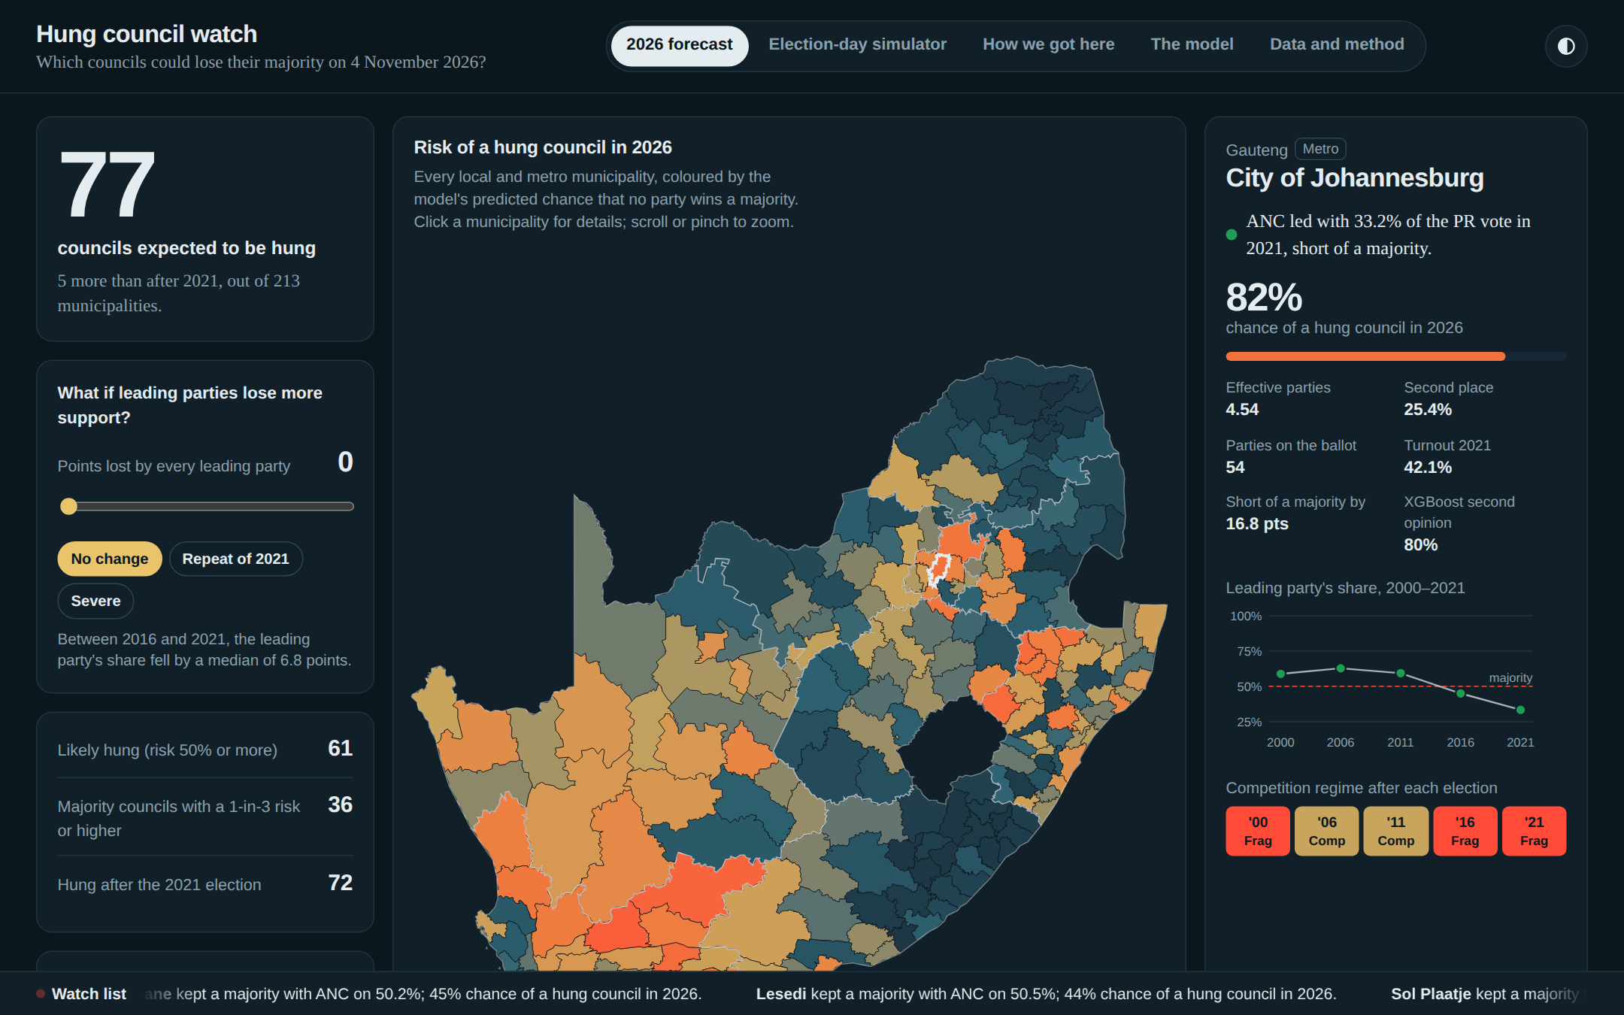
Figure 1. The 2026 forecast tab, with the City of Johannesburg selected

What you see
- The big number (left, top): how many councils the model expects to be hung in 2026 (77), compared with after 2021.
- The swing panel: a slider that asks "what if every leading party loses more support?". Move it and every number, colour and chart on the page updates instantly. The buttons give quick presets: No change, Repeat of 2021 (a 6.8-point drop, the typical drop between 2016 and 2021) and Severe.
- Three key counts: councils likely to be hung (risk 50% or more), councils that still have a majority but face a one-in-three risk or higher, and councils hung after 2021.
- Province and search: choose a province to zoom the map in and filter every number, or type a municipality's name to jump to it.
- The map (centre): every municipality coloured from dark blue (low risk) through sand to red (high risk). Scroll or pinch to zoom, and drag to move around.
- The municipality panel (right): the selected council's leading party and its 2021 share, its risk, how far it is above or below the majority line, a chart of the leading party's share from 2000 to 2021, and its group (Dominant, Competitive or Fragmented) after each election. It also shows XGBoost's estimate as a "second opinion".
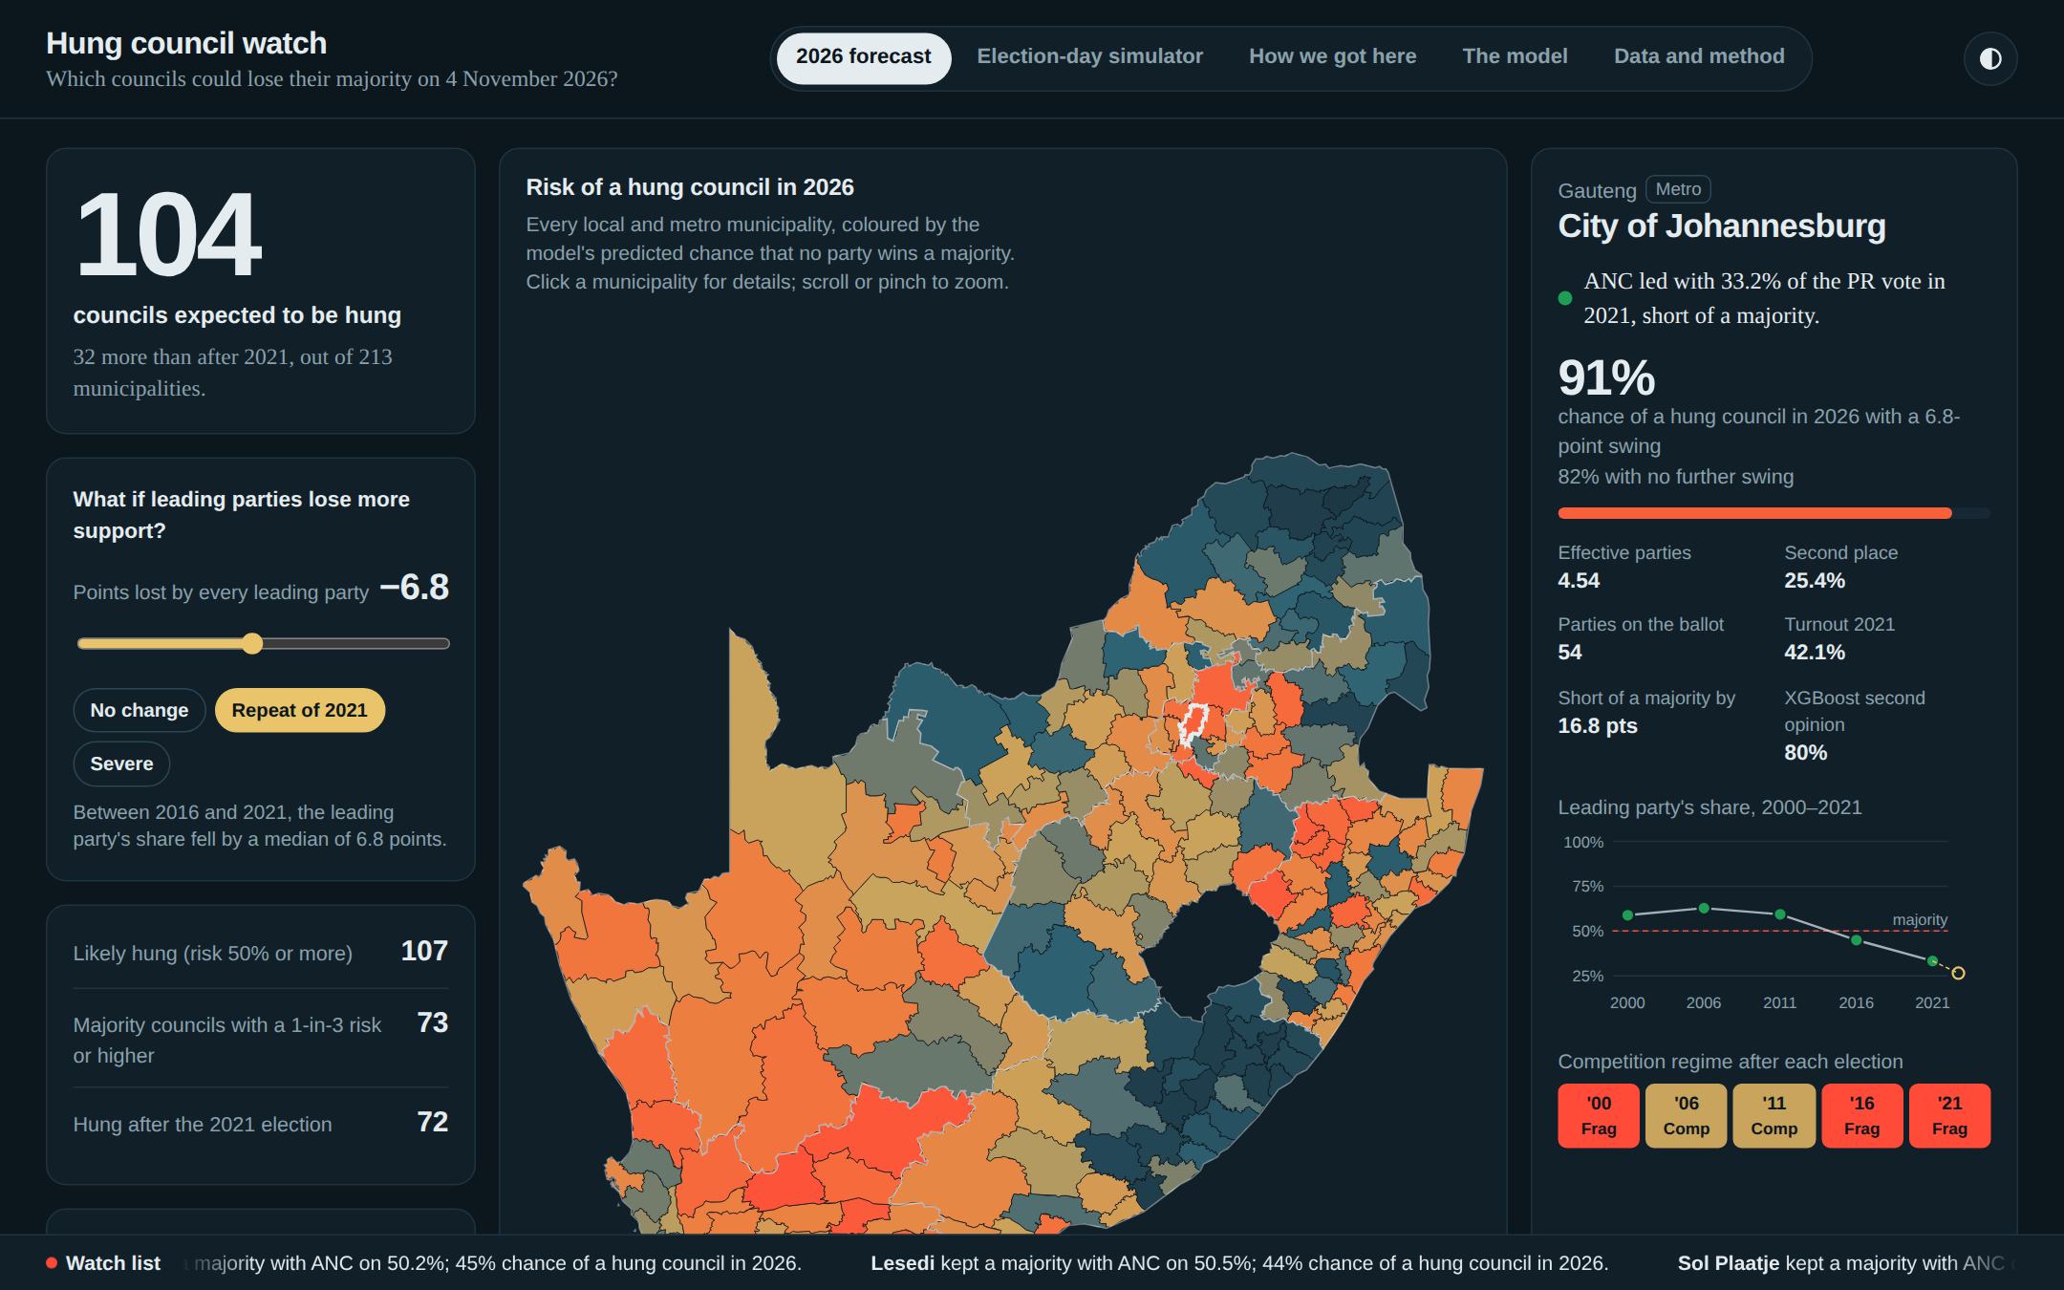
Figure 2. The same tab after pressing "Repeat of 2021": expected hung councils rise from 77 to about 104 and the map turns redder
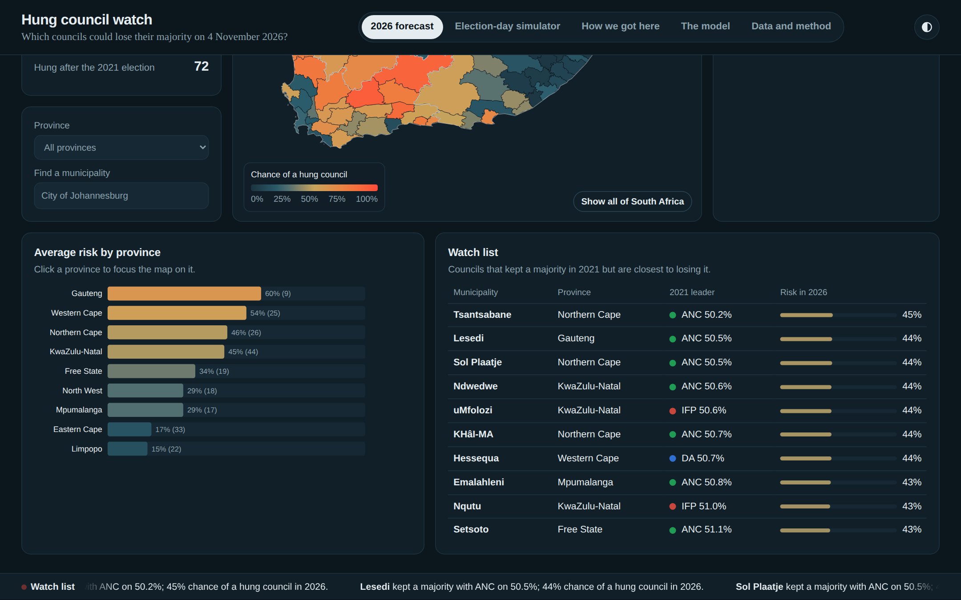
Figure 3. Lower on the page: average risk by province, and the watch list of majority councils closest to losing it

Further down the page
- Average risk by province: a bar for each province. Click a bar to focus the map and the watch list on that province.
- Watch list: councils that kept a majority in 2021 but are closest to losing it. These are the councils most likely to change who governs, and the most useful list for journalists. Click a name to open its profile.
- The moving ticker (bottom): a rolling summary of watch-list councils and metros. Hover over it to pause.

7.2 Tab 2: Election-day simulator
This tab lets you test what could happen on election day in any single municipality, and see the result instantly.
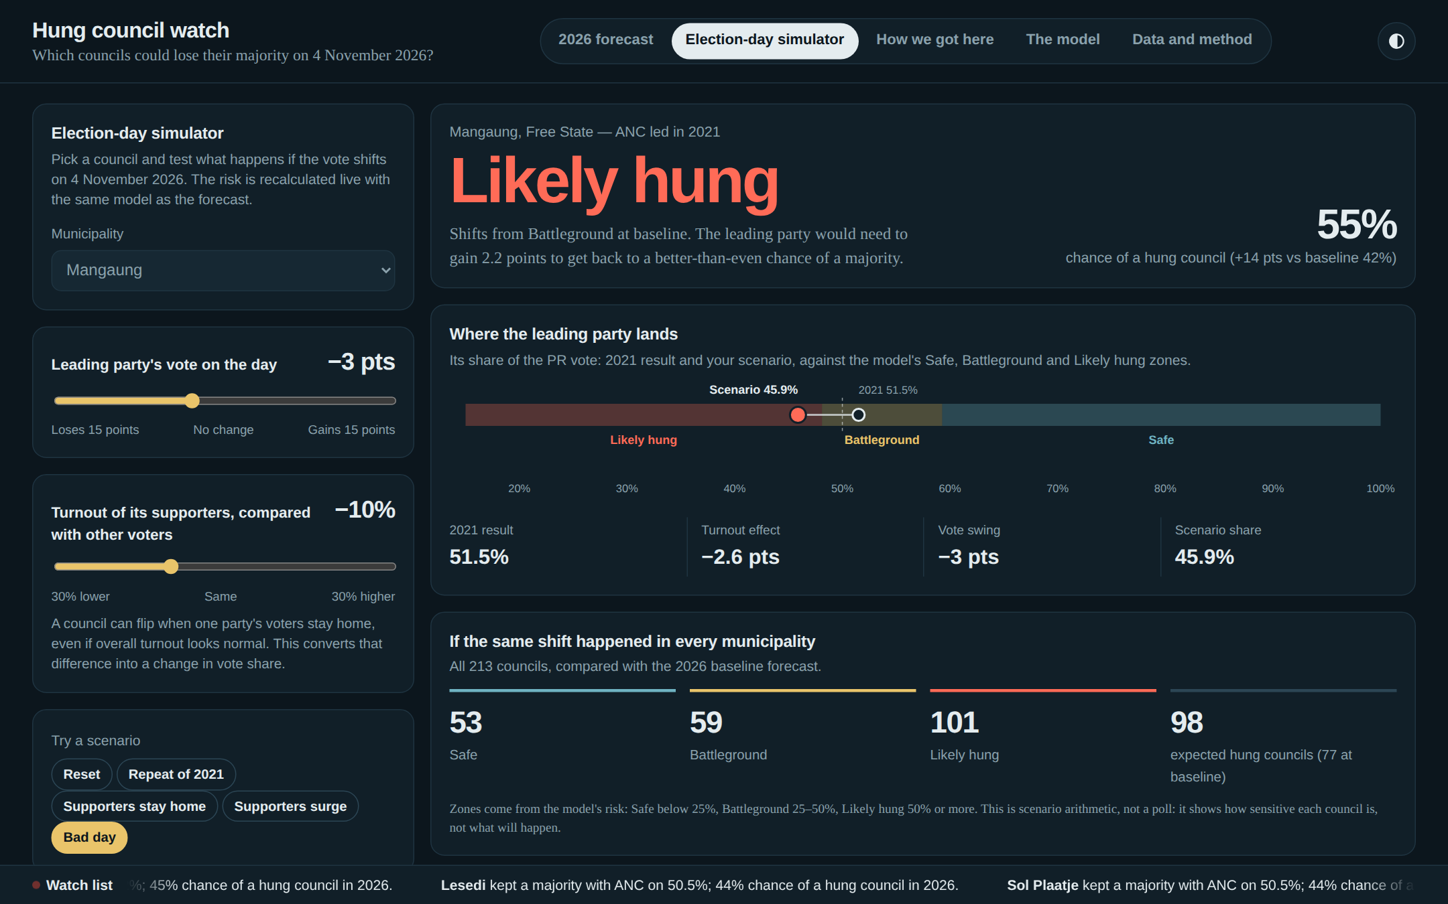
Figure 4. The simulator with Mangaung selected and the "Bad day" scenario applied

The controls
- Municipality: choose any of the 213 councils. It stays in sync with the forecast map.
- Leading party's vote on the day: the leading party gains or loses up to 15 percentage points.
- Turnout of its supporters, compared with other voters: what if the leading party's supporters turn out more or less than everyone else? This is explained below.
- Scenario buttons: Reset, Repeat of 2021, Supporters stay home, Supporters surge and Bad day (loses 3 points and its supporters turn out 10% less).

Why the turnout slider works the way it does
Overall turnout on its own does not decide who wins. If turnout falls by the same amount for every party, the result stays the same. What changes results is who stays home. The slider therefore asks how much more or less the leading party's own supporters turn out than other voters, and converts that into a change in vote share, which is then fed into the model.
Worked example: Mangaung
In 2021, the leading party won 51.5% of the vote: a narrow majority, so the council is a Battleground with a 42% risk.
If its supporters turn out 10% less than other voters, its share falls to about 48.9% (the "turnout effect" of about −2.6 points).
If it also loses 3 points of support, its share lands on 45.9%, below the majority line.
The verdict changes to Likely hung, with a 55% risk. If the same happened everywhere, expected hung councils nationally would rise from 77 to 98.

What the results show
- The verdict: Safe, Battleground or Likely hung, in large coloured text, with the risk percentage and how it compares with the baseline.
- The tipping point: a sentence explaining how many more points the leading party can lose before the council moves into the next zone, or how many it must gain to move back.
- Where the leading party lands: a bar showing the three zones, the 2021 result (hollow circle) and your scenario (solid circle), with a step-by-step breakdown: 2021 share, turnout effect, vote swing and final share.
- If the same shift happened in every municipality: how many of the 213 councils would be Safe, Battleground or Likely hung, and the expected number of hung councils.
The simulator is scenario arithmetic, not a poll. It shows how sensitive each council is to changes on the day, not what will happen.

7.3 Tab 3: How we got here
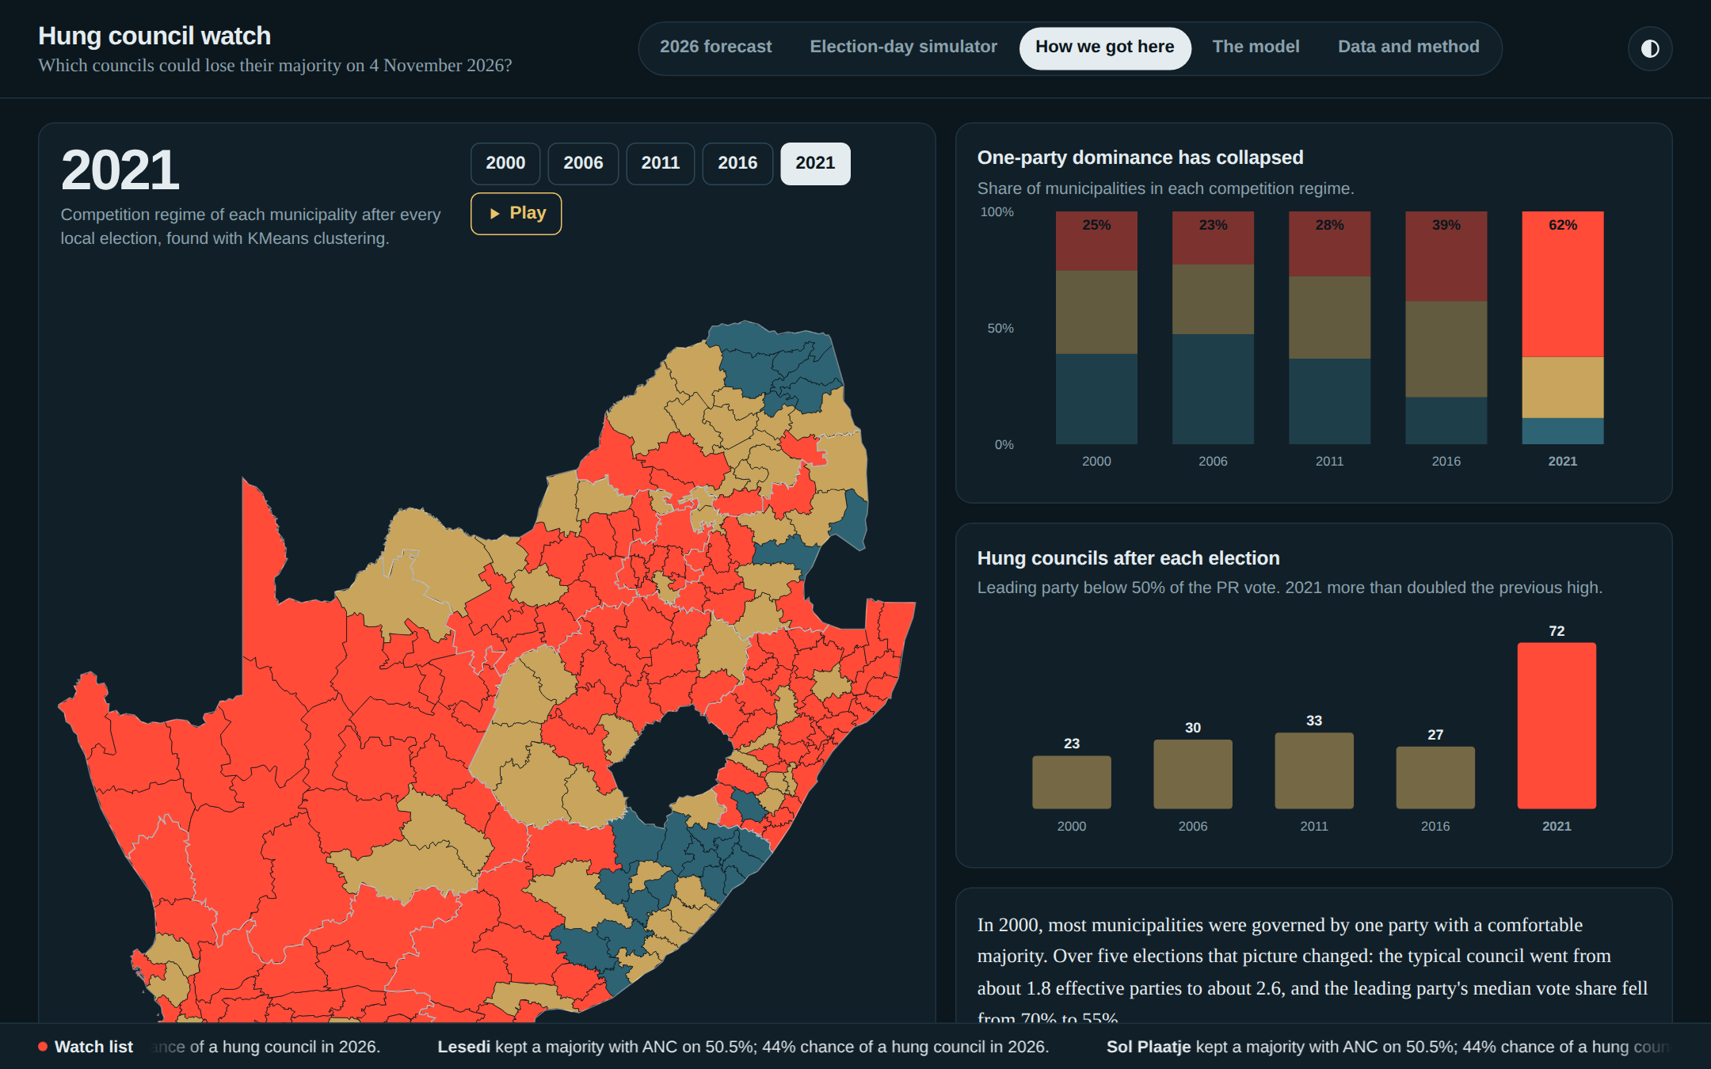
Figure 5. The history tab: the map by election year, the rise of fragmentation and hung councils after each election
- The history map colours each municipality by its group (Dominant, Competitive or Fragmented) for the chosen election. Press Play to watch 2000 to 2021 unfold, or click a year.
- One-party dominance has collapsed: the share of municipalities in each group per election.
- Hung councils after each election: 23, 30, 33, 27, then 72 in 2021.
- Hatched areas on the map are municipalities that could not be matched to that year's records because of boundary changes.

7.4 Tab 4: The model
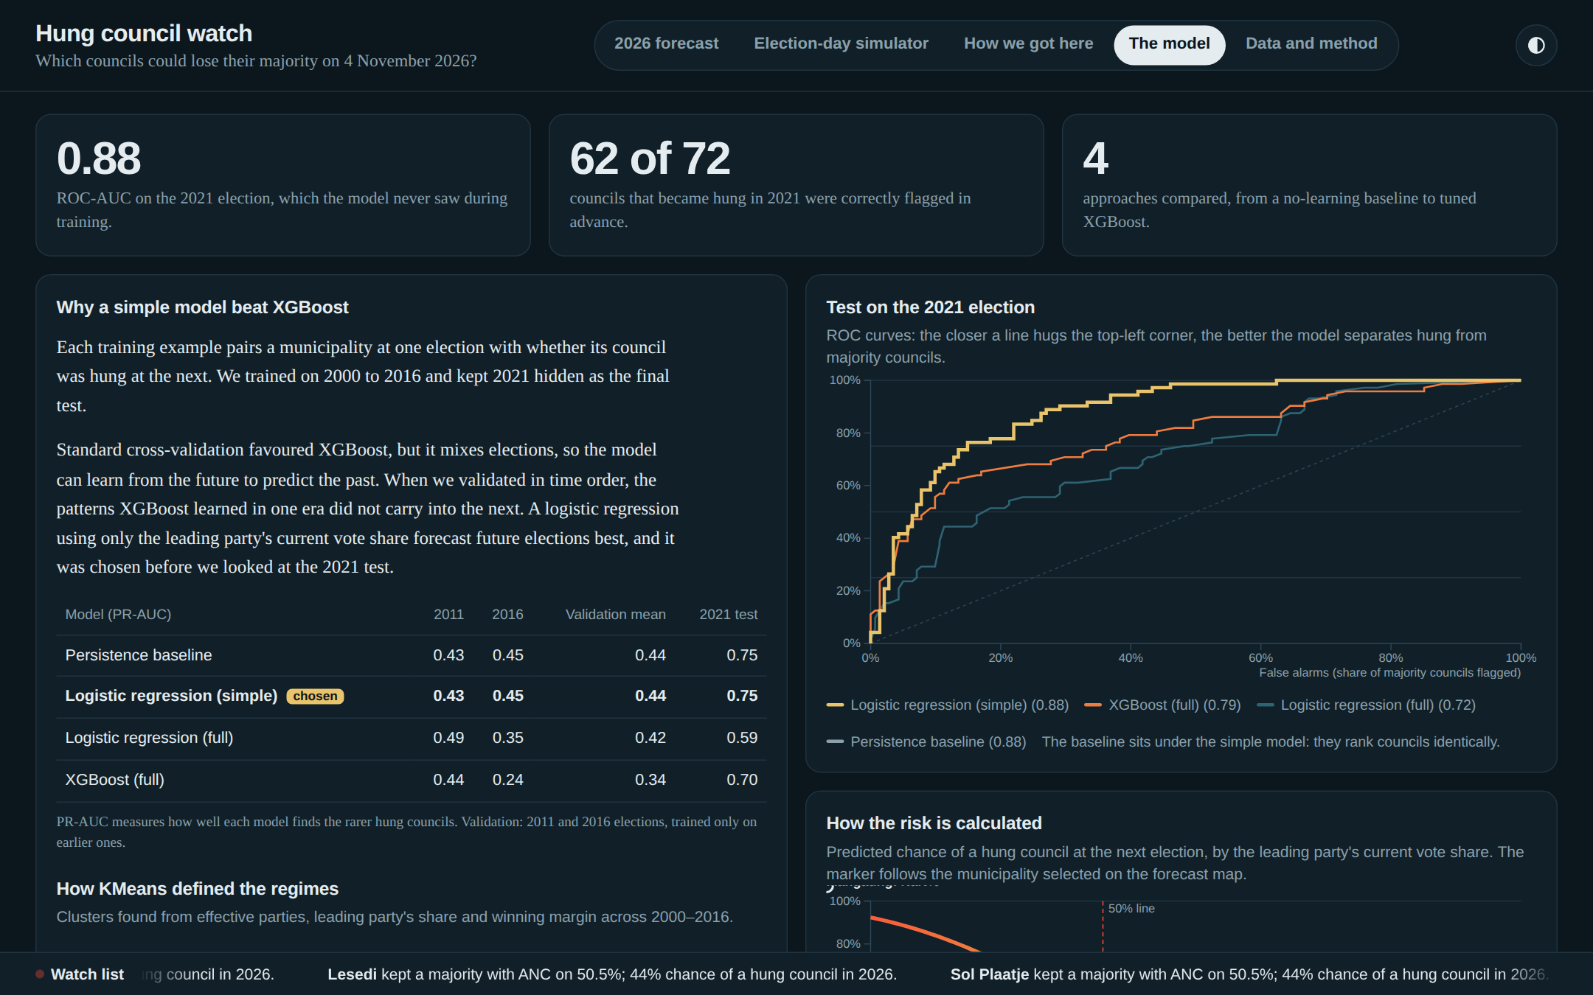
Figure 6. The model tab: headline results, the comparison of approaches and how the risk is calculated
- Headline results: the 0.88 score on the hidden 2021 election and the 62 of 72 hung councils flagged.
- Why a simple model beat XGBoost: the explanation from Section 6.4, with a table comparing all four approaches. The chosen model is marked.
- Test on the 2021 election: ROC curves. The closer a line hugs the top-left corner, the better that model separates hung councils from majority councils.
- How the risk is calculated: the risk curve from Section 6.5. The marker follows the municipality selected on the forecast map.
- How KMeans defined the groups: the table from Section 6.1.

7.5 Tab 5: Data and method
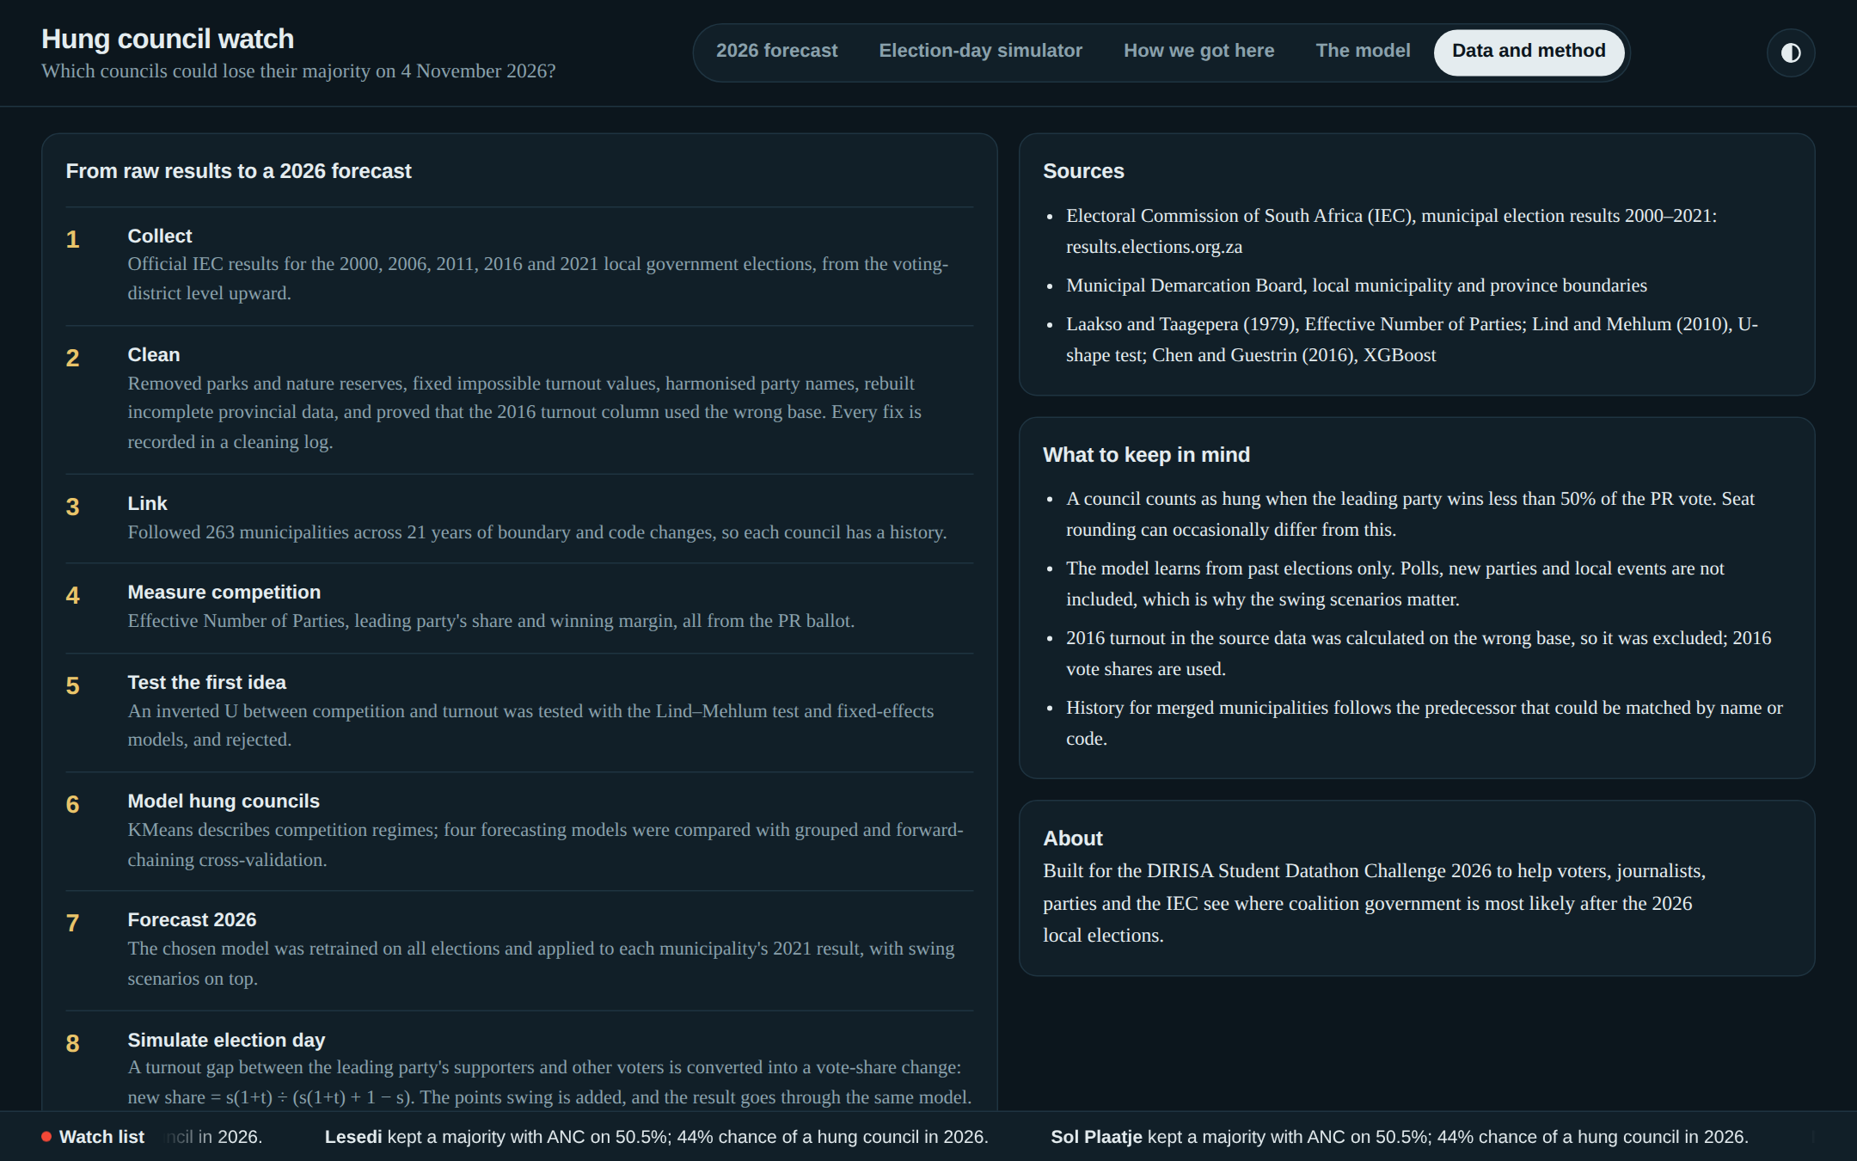
Figure 7. The data and method tab
A short summary of each step from raw results to the forecast, the data sources, the main limitations, and what the project is for.

7.6 Demonstration walk-through (for presentations)
- Open the dashboard and point out the big number: 77 councils expected to be hung.
- Press Repeat of 2021 and watch the map redden and the number rise to about 104. Press No change to return.
- Scroll to the watch list and click Mangaung; show its profile on the right.
- Open the Election-day simulator, which now shows Mangaung. Press Bad day and show it moving from Battleground (42%) to Likely hung (55%).
- Open How we got here and press Play to show fragmentation spreading from 2000 to 2021.
- Finish on The model tab: the model correctly flagged 62 of 72 hung councils in an election it had never seen.

8. Why we built it this way
Every design choice was made for a reason. These are the main ones, explained simply.
Decision | Why we made it
A single web page file, rather than an app that needs a server | It loads instantly, cannot "fall asleep" like free app servers do, costs nothing to host and even works without internet. The data, the map and the model are all packed into one file.
The model runs inside the page | Every time you move a slider, your own browser recalculates each council's risk using the real model's numbers. There is no delay and nothing extra to maintain.
Hosting on Netlify | A free, reliable hosting service: we upload the file and it is live within seconds at a clean public address. Updating is a matter of dragging in a new file.
Official IEC data and Municipal Demarcation Board boundaries | Using official sources means anyone can check our numbers, and the map matches real council boundaries.
Forecasting hung councils rather than turnout | Our analysis showed turnout is not driven by competition, while vote shares are reliable across all five elections and directly determine whether a council is hung.
Choosing the simple model over XGBoost | It predicted future elections better when tested fairly. A model is judged on how well it forecasts, not on how complex it is.
No plain "overall turnout" slider | Overall turnout does not change who wins on its own, and our model does not use it. A slider that seemed to change the result would have been misleading. The relative-turnout slider captures what actually matters: who stays home.
No external embedded tools (for example a Hugging Face iframe) | An embedded tool would add a second system that can go offline or show a loading screen during a presentation. Keeping everything in one page is more reliable.
Every number traceable to the notebooks | The dashboard uses the exact results of our analysis notebooks, so the website, the code, the slides and the video all tell the same story.

9. What to keep in mind (limitations)
Being honest about limitations is part of good analysis. These are the main ones:
- Hung is measured by vote share. We count a council as hung when the leading party wins less than 50% of the PR vote. Seat rounding can occasionally give a party a majority of seats with slightly under 50% of the vote.
- The model only knows past elections. It does not include opinion polls, new parties, candidates, scandals or local events. That is exactly why the dashboard includes scenarios: to show what happens if things change.
- Only four election-to-election steps. Five elections give the model four examples of change to learn from, which is limited. The 2021 shift was sharper than anything before it.
- Boundaries changed over time. Some municipalities were merged or redrawn in 2006, 2011 and 2016, so a council's history may partly cover a slightly different area.
- 2016 turnout was excluded, because the cleaned turnout column counted only the leading party's votes; 2016 vote shares are still used. Recalculating it from the raw data is future work.
- Risk is not certainty. A 45% risk means "quite possible", not "will happen".

10. Looking after the dashboard
The dashboard's source code is kept in the folder hung-council-watch-dashboard. It is organised so that changes are safe and simple.
Part | What it is
src/template.html | The page itself: layout, wording, colours and behaviour. This is the only file to edit.
data/ | The forecast numbers and map boundaries, exported from our notebooks. Change only if the analysis is rerun.
build_dashboard.py | Combines everything into one finished file.
dist/index.html | The finished dashboard that gets published.

To update the live site
- Edit src/template.html (for example, to change wording or colours).
- Run build_dashboard.py to rebuild the finished file.
- Open dist/index.html in a browser and check it: both colour modes, all five tabs and a phone.
- In Netlify, open the project eduvos-hung-councils, go to Deploys, and drag the dist folder into the upload box. The address stays the same.
Important
Do not change the risk calculation. It uses the exact numbers from our trained model; changing it would make the dashboard disagree with the analysis, the slides and the video.

11. Glossary
Term | Meaning
Battleground | A council where the leading party is close to the majority line, with a 25–50% risk of being hung
Coalition | An agreement between two or more parties to govern together when none has a majority
Effective Number of Parties (ENP) | A count of parties weighted by their size; our measure of fragmentation
Fragmentation | How much the vote is split between several parties rather than concentrated in one
Hung council | A council where no party wins a majority; in this project, the leading party wins less than 50% of the PR vote
IEC | Electoral Commission of South Africa, which runs elections and publishes official results
KMeans clustering | A method that sorts items into groups of similar items without being told the groups in advance
Logistic regression | A standard statistical method that turns one or more numbers into a probability
PR ballot | The proportional representation ballot: a vote for a party, which decides each party's share of council seats
Risk / probability | How likely something is, from 0% (will not happen) to 100% (certain)
ROC-AUC | A score from 0.5 (guessing) to 1.0 (perfect) for how well a model separates two outcomes
Safe | A council where the leading party is comfortably ahead, with a risk below 25%
Swing | A change in a party's share of the vote between elections, measured in percentage points
Turnout | The percentage of registered voters who cast a ballot
XGBoost | An advanced machine-learning method that combines many decision rules; tested but not chosen

Sources
- Electoral Commission of South Africa (IEC), municipal election results 2000–2021: results.elections.org.za
- Municipal Demarcation Board, municipal and provincial boundaries
- Laakso, M. and Taagepera, R. (1979). "Effective" number of parties. Comparative Political Studies, 12(1), 3–27.
- Lind, J. T. and Mehlum, H. (2010). With or without U? Oxford Bulletin of Economics and Statistics, 72(1), 109–118.
- Chen, T. and Guestrin, C. (2016). XGBoost: a scalable tree boosting system. Proceedings of KDD 2016, 785–794.

