Load Shedding's Economic Ripple Effect
Quantifying the Relationship Between Eskom's Manual Load Reduction and South African Retail Trade Sales
Thabang Manyama • Portfolio Research Report, BSc IT (Data Science) • July 2026

Abstract
This report investigates whether the severity of Eskom's electricity load shedding, measured through Manual Load Reduction (MLR) in megawatts, is associated with changes in South African retail trade sales. Using 49 months of matched official data (April 2022 – April 2026) from the Eskom Data Portal and Statistics South Africa (StatsSA), the analysis finds a statistically significant negative relationship between load shedding intensity and retail trade sales growth (r = -0.649, p < 0.0001, 95% CI: -0.786 to -0.450). The relationship persists in an OLS regression that controls for the underlying time trend, with an estimated 6.0 percentage-point difference in retail growth between South Africa's calmest and most severe load shedding months (95% CI: 3.0 to 9.1 points). The report also identifies an important structural feature of the data — a marked shift between sustained load shedding in 2022–2023 and its near-complete cessation from 2024 onward — that should temper causal interpretation of these results, and discusses this alongside other limitations.

1. Introduction
Between 2022 and 2023, South Africa experienced some of the most severe electricity load shedding in Eskom's history, with rolling power cuts frequently reaching Stage 6 or beyond. Load shedding is widely assumed to carry a significant economic cost — disrupting operating hours, damaging equipment, raising costs through diesel generation, and depressing consumer spending — yet this cost is rarely quantified for South Africa specifically using official data and formal statistical methods.
This report addresses a single, specific research question: does the severity of Eskom's load shedding measurably move South African retail trade sales, and by how much, with what time lag? It does so using Eskom's own Manual Load Reduction (MLR) figures — the official megawatt figure ordered by the National Control Centre, representing the actual electrical deficit rather than the more commonly cited but coarser “stage” system — matched against StatsSA's official retail trade sales index.

2. Data and Methodology

2.1 Data Sources
Dataset | Source | Variable Used | Granularity
Manual Load Reduction (MLR) | Eskom Data Portal (official) | Load reduction, MW | Hourly → monthly average
Retail Trade Sales (P6242.1) | Statistics South Africa | Total retail trade sales, constant 2019 prices, actual values | Monthly

2.2 Data Preparation
Eskom's hourly MLR readings were aggregated into monthly averages (ls_intensity). Rows beyond the last date with a genuine recorded value were excluded, since the raw file also contains forward-looking forecast figures that had not yet occurred at the time of analysis. StatsSA's retail sales figures, originally published in a wide format with one column per month, were reshaped into a standard monthly time series, and year-on-year percentage growth was calculated directly from the underlying Rand values. The two series were merged on a common year-month key, retaining only months present in both sources.
The resulting dataset spans 49 consecutive months, from April 2022 to April 2026, with no gaps — every month in that window has a matched observation on both sides.

2.3 Analytical Approach
Three complementary methods were used. First, the Pearson correlation coefficient between load shedding intensity and retail sales growth was calculated, together with a 95% confidence interval derived via the Fisher z-transformation. Second, a distributed lag analysis re-ran this correlation at lags of 0 to 4 months, testing whether a severe load shedding month predicts a retail dip in subsequent months rather than only the same month. Third, an ordinary least squares (OLS) regression of retail growth on load shedding intensity, controlling for a linear time trend, was estimated to isolate the effect of load shedding from the broader upward drift in retail sales observed over the sample period.

3. Results

3.1 Descriptive Overview
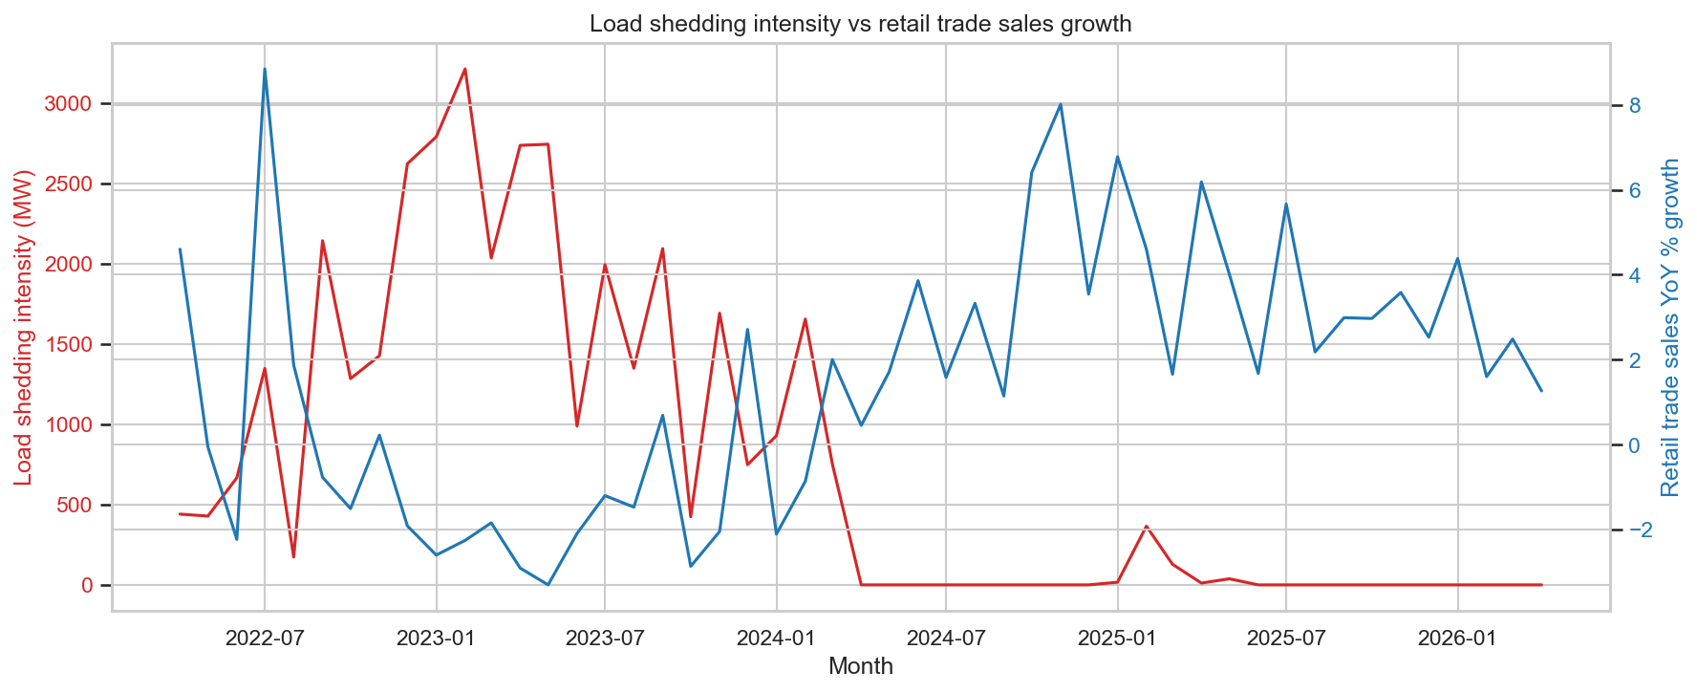
Figure 1. Load shedding intensity (MW, red, left axis) vs. retail trade sales year-on-year growth (%, blue, right axis), April 2022 – April 2026.
The chart shows two visually distinct periods. Through 2022 and 2023, load shedding intensity was frequently severe — peaking at 3,213 MW of average monthly manual load reduction in February 2023 — while retail growth remained weak and volatile, often dipping into negative territory. From early 2024 onward, manual load reduction falls to near zero and stays there for most of the remaining sample, coinciding with a period of consistently stronger retail growth. A brief, modest return of load shedding in early 2025 (peaking around 370 MW) shows no visible corresponding dip in retail growth, a point returned to in the Limitations section.

3.2 Contemporaneous Correlation
The Pearson correlation between load shedding intensity and retail sales growth in the same month was r = -0.649 (p < 0.0001, n = 49, 95% CI: -0.786 to -0.450). This represents a strong, statistically significant negative relationship: months with heavier average load reduction were reliably associated with weaker retail sales growth that same month.

3.3 Lag Analysis
Table 1 shows the correlation re-tested at lags of 0 to 4 months, asking whether load shedding severity in one month predicts retail performance in a later month.
Lag (months) | n | r | p-value | 95% CI
0 | 49 | -0.649 | < 0.0001 | -0.786 to -0.450
1 | 48 | -0.661 | < 0.0001 | -0.796 to -0.465
2 | 47 | -0.695 | < 0.0001 | -0.819 to -0.510
3 | 46 | -0.698 | < 0.0001 | -0.821 to -0.511
4 | 45 | -0.665 | < 0.0001 | -0.802 to -0.461
Table 1. Pearson correlation between load shedding intensity and retail sales growth at lags of 0–4 months.
The relationship remains statistically significant at every lag tested, with correlation strength ranging narrowly between -0.649 and -0.698. Notably, the strength of the relationship does not decay as the lag increases, which would be the expected pattern if load shedding produced a short-lived shock that faded over subsequent months. Instead, this flat pattern most likely reflects the two-era structure visible in Figure 1: shifting a data point by one to four months rarely moves it across the 2023/2024 dividing line, so lags close to zero and lags of several months tell a similar story rather than revealing a specific transmission delay.

3.4 Regression Analysis
To separate the effect of load shedding intensity from the broader upward trend in retail sales over the sample period, retail YoY growth was regressed on load shedding intensity and a linear time index.
Variable | Coefficient | Std. Error | p-value | 95% CI
Intercept | 2.513 | 1.095 | 0.026 | 0.309 to 4.718
Load shedding intensity (MW) | -0.00188 | 0.00047 | < 0.001 | -0.00283 to -0.00094
Time trend | 0.0174 | 0.0321 | 0.590 | -0.047 to 0.082
Table 2. OLS regression of retail trade sales YoY growth on load shedding intensity, controlling for a linear time trend. R² = 0.425, Adjusted R² = 0.400, F(2,46) = 16.97, p < 0.0001, n = 49.
Load shedding intensity remains a statistically significant predictor of retail growth (p < 0.001) even after accounting for the time trend, while the time trend itself is not significant on its own (p = 0.590). This indicates that load shedding intensity — not simply the passage of time — is doing the explanatory work in this model.
Translated into real-world terms: the full observed range of monthly load reduction intensity — from 0 MW in the calmest months to 3,213 MW in the most severe month (February 2023) — is associated with an estimated 6.0 percentage-point swing in retail trade sales growth (95% CI: 3.0 to 9.1 percentage points).

4. Discussion
All three analytical approaches — the contemporaneous correlation, the lag analysis, and the trend-controlled regression — point in the same direction and agree closely in magnitude: heavier load shedding is associated with weaker retail trade sales growth, and this relationship is not simply an artifact of both series moving over time. The estimated real-world scale, a 3.0 to 9.1 percentage-point swing between calm and severe conditions, is economically meaningful given that South African retail growth over this period has generally ranged between roughly -2% and 8% year-on-year.
At the same time, the flat lag structure and the regression's high condition number both point toward a more structural explanation than a precise, predictable month-to-month transmission mechanism: much of the estimated effect likely reflects two broad economic eras — severe, sustained load shedding through 2022–2023 giving way to its near-disappearance from 2024 — rather than a fine-grained “a bad month causes a bad month” dynamic. This distinction matters for how the finding should be read: the qualitative conclusion (load shedding measurably hurts retail sales) is well supported, while the precise timing and month-by-month causal pathway is less certain.

5. Limitations
- Correlation ≠ causation. Load shedding intensity co-moves with the broader business cycle, and this analysis cannot on its own establish a causal mechanism.
- Confounding macroeconomic conditions. South Africa's 2022–2023 interest rate hiking cycle, elevated fuel and consumer price inflation, and the continuing post-pandemic economic recovery all unfolded over the same period as the load shedding crisis and cannot be fully separated from the estimated relationship here.
- Regime shift. Sustained load shedding largely ended in 2024, meaning the informative variance in this dataset sits disproportionately in the 2022–2023 period.
- Multicollinearity. Load shedding intensity and the passage of time are closely related in this dataset (the regression's condition number was approximately 3,950), making it difficult to fully isolate the effect of reduced load shedding from the effect of time passing. The regression coefficient should be read as indicative of magnitude rather than a precise, fully isolated causal estimate.
- Flat lag structure. Correlation strength did not meaningfully decay across lags of 0–4 months, unlike a classic “shock that fades” pattern — more consistent with the regime shift described above than with a specific transmission delay.
- Residual non-normality. Regression residuals show notable positive skew, likely driven by a small number of extreme months (e.g. July 2022); reported p-values should be read as solid estimates rather than exact.
- Sample size. At monthly granularity, n = 49 is modest; the resulting confidence intervals are correspondingly wide and are reported honestly throughout rather than treated as precise point estimates.
- A brief return of load shedding in early 2025 shows no visible corresponding dip in retail growth — an exception to the overall pattern that is noted here rather than omitted.

6. Conclusion
This analysis set out to answer a specific, previously under-quantified question for South Africa: does the severity of Eskom's load shedding measurably move retail trade sales, and by how much? The evidence here says yes. Across 49 months of real, matched official data, heavier load shedding was consistently and significantly associated with weaker retail sales growth, a relationship that survives controlling for the general upward drift in retail sales over time. The estimated scale — a 3.0 to 9.1 percentage-point swing between South Africa's calmest and most severe load shedding conditions — is meaningful, not merely statistically present.
At the same time, an honest reading of the data points to a relationship shaped substantially by two distinct economic eras rather than a precise, predictable month-to-month delay, and cannot rule out the influence of other economic shocks unfolding across the same years. Taken together, this report demonstrates that a rigorous, statistically grounded approach — official institutional data, formal hypothesis testing with confidence intervals, and a regression that controls for a confounding trend — can put a defensible, transparently-caveated number on a relationship widely assumed but rarely quantified for South Africa specifically.

Data Sources
Eskom Data Portal. Manual Load Reduction (load shedding), historical hourly data. https://www.eskom.co.za/dataportal
Statistics South Africa. P6242.1 – Retail Trade Sales, constant 2019 prices, monthly time series. https://www.statssa.gov.za/
Exact access dates are logged in data/raw/SOURCES.md in the accompanying project repository.

