Fiamma Fresca
Takeaway Pizzeria — Dynamic Website

Project GPOI | Anno Scolastico 2025/2026
Business Plan | WBS | RBS | Gantt
Period: 09 March 2026 — 01 May 2026
Duration: 8 weeks
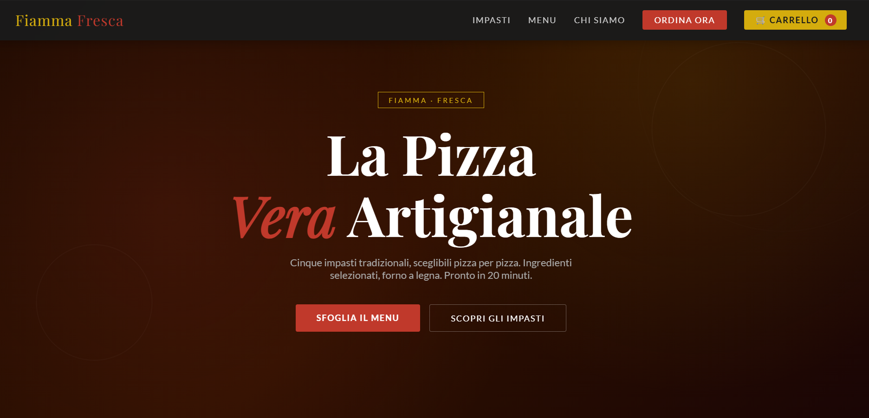

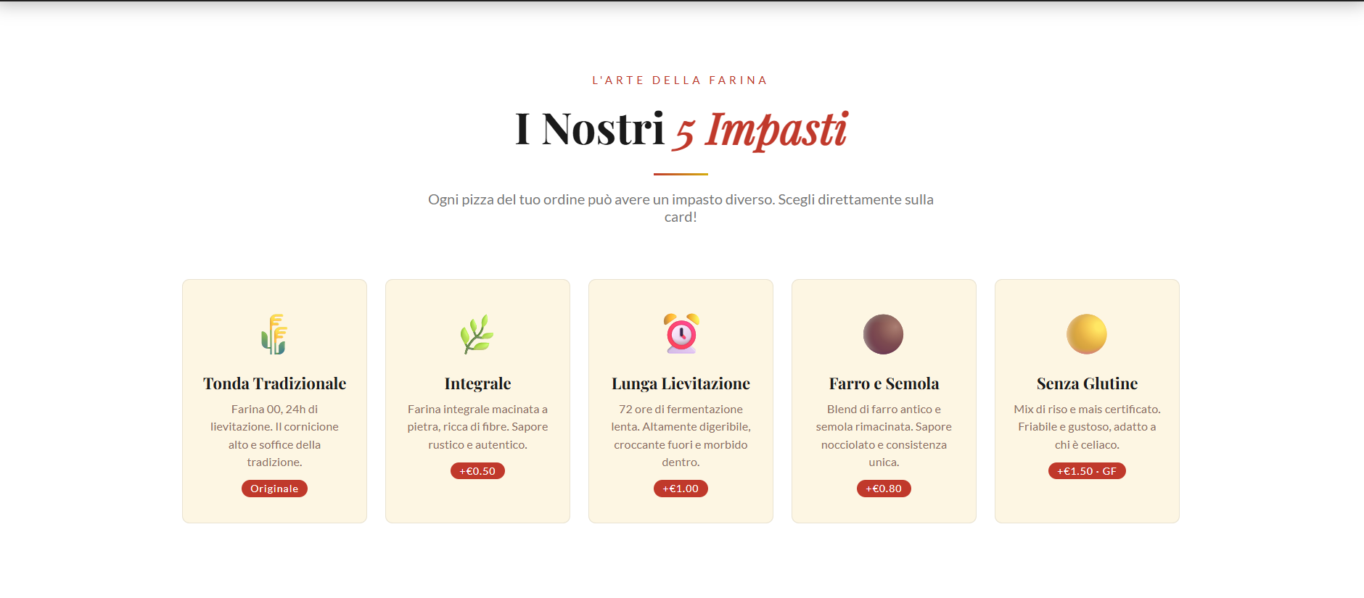

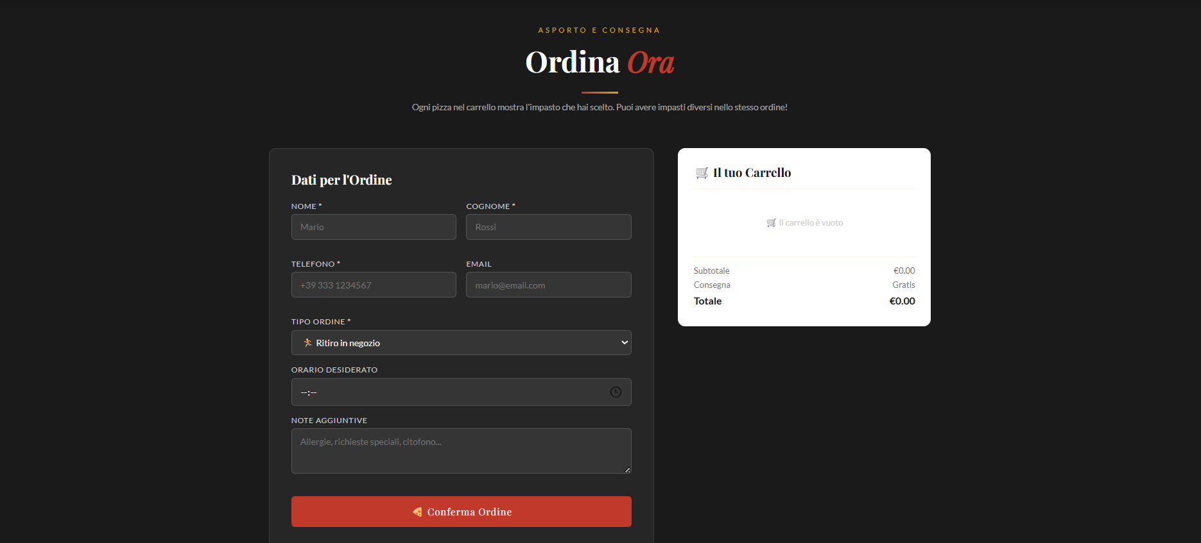
1. Business Plan
1.1 Executive Summary
The project involves the development of a dynamic website for 'Fiamma Fresca', a takeaway pizzeria. The site allows customers to browse the menu, select a specific dough type for each pizza in their order, and submit orders online. The project development spans from 09/03/2026 to 01/05/2026 (40 working days).
1.2 Key Product Features
- Responsive Website: Built with PHP 8, CSS3, and JavaScript ES6+.
- Individual Dough Selection: Customers can choose a specific dough for every single pizza added to the cart (the project’s core innovation).
- 5 Dough Options: Traditional Round, Whole Wheat, 72h Long Leavening, Spelt & Semolina, and Gluten-Free.
- Dynamic Cart: Each row displays the pizza type + chosen dough + quantity + price.
- MySQL Database: Structured with 6 tables; dough selection is stored for every order line item.
- Advanced Animations: Powered by GSAP 3 + ScrollTrigger across all website sections.
- Admin Panel: Dedicated interface to view and update real-time order status

1.3 Market Analysis
The food delivery market in Italy exceeds €1.6 billion annually, with pizzerias representing the dominant segment. Owning a proprietary website eliminates the 20-30% commissions charged by third-party platforms like JustEat or Deliveroo. Providing dough customization per individual pizza is a high-value differentiator that increases the average ticket size and improves customer loyalty.
1.4 Target Audience
- Local Customers: Regular clients within a 5 km radius of the shop.
- Families with Diverse Dietary Needs: Allows a family to order, for example, one Gluten-Free pizza and several traditional ones in a single checkout.
- Quality-Conscious Customers: Clients seeking a premium, personalized dining experience.
- Groups of Friends: People with different nutritional preferences ordering together.

1.5 SWOT Analysis
STRENGTHS | WEAKNESSES
+ Individual dough selection: unique in the local market.  + Zero commissions to third-party delivery platforms.  + Real-time admin panel for efficient order management. | - Annual hosting and domain costs.  - Slightly more complex UX due to dough selection steps.  - Requirement for staff training on the new digital system.

2. WBS — Work Breakdown Structure
Codice | Attivita' | Periodo | Durata
1 | PROJECT: Fiamma Fresca Websiteca
1.1 | PLANNING & SETUP
1.1.1 | Functional requirements analysis | 09/03 – 10/03 | 2 gg
1.1.2 | UX/UI Wireframing: Cart & dough selection flow | 10/03 – 11/03 | 2 gg
1.1.3 | ER Database Schema | 11/03 – 12/03 | 2 gg
1.2 | DATABASE DEVELOPMENT
1.2.1 | MySQL Database creation | 16/03 – 17/03 | 2 gg
1.2.2 | Schema creation: 6 tables | 18/03 – 18/03 | 1 gg
1.2.3 | Data Seeding: pizzas, categories, doughs | 19/03 – 19/03 | 1 gg
1.2.4 | Query testing & SQL Views | 20/03 – 20/03 | 1 gg
1.3 | BACKEND PHP & FRONTEND
1.3.1 | Backend: config.php & index.php | 23/03 – 25/03 | 3 gg
1.3.2 | Backend: order.php & admin.php | 26/03 – 31/03 | 4 gg
1.3.3 | Frontend: HTML & Core CSS | 23/03 – 27/03 | 5 gg
1.3.4 | Frontend: UI Components & Grid | 30/03 – 01/04 | 4 gg
1,3,5 | Frontend: Checkout UI | 03/04 – 03/04 | 1 gg
1.4 | JAVASCRIPT & ANIMATIONS
1.4.1 | GSAP Setup & Scroll animations | 06/04 – 08/04 | 3 gg
1.4.2 | Hero & Visual animations | 09/04 – 10/04 | 2 gg
1.4.3 | Logic: Dough selection & Cart | 13/04 – 15/04 | 3 gg
1.4.4 | AJAX: Order submission | 16/04 – 17/04 | 2 gg
1.4.5 | Filtering & Stats counter | 20/04 – 20/04 | 1 gg
1.5 | INTEGRATION & TESTING
1.5.1 | Full Frontend-Backend integration | 21/04 – 23/04 | 3 gg
1.5.2 | E2E Testing & Mobile Responsive | 24/04 – 27/04 | 2 gg
1.5.3 | Bug fixing & Optimization | 28/04 – 29/04 | 2 gg
1.5.4 | Final Deploy & Documentation | 01/05 – 01/05 | 1 gg

3. RBS — Resource Breakdown Structure
Codice | Risorsa | Dettaglio / Utilizzo
1 | TOTAL RESOURCES
1.1 | Human Resources
1.1.1 | Web Developer (Student) | Project Manager, Full-stack Developer, QA Tester
1.2 | Hardware Resources
1.2.1 | PC | Development, local server hosting, documentation
1.2.2 | Smartphone | UI/UX mobile responsiveness testing
1.3 | Software Resources
1.3.1 | XAMPP (v8.0+) | Local Stack: Apache, PHP 8, MySQL 8, phpMyAdmin
1.3.2 | Visual Studio Code | Primary IDE with PHP, JS, and CSS extensions
1.3.3 | GitHub | Versioning, remote backup, commit history tracking
1.3.4 | Browser DevTools | JS Debugging, Network/AJAX inspection, CSS Grid testing
1.3.5 | LibreOffice | Project reporting and final documentation
1.4 | Technological Stack
1.4.1 | PHP 8.x | Backend: Secure PDO connection, order management
1.4.2 | MySQL 8.x | RDBMS: 6 Tables, 2 Views, dough-specific field logic
1.4.3 | Semantic HTML5 | Accessible and SEO-friendly structural markup
1.4.4 | CSS3 (Flexbox + Grid) | Responsive layout, CSS variables, native animations
1.4.5 | JavaScript ES6+ | Cart logic, dough selection, AJAX, localStorage
1.4.6 | GSAP 3.12 + ScrollTrigger | Advanced scroll animations via Free CDN
1.5 | Informative Resources
1.5.4 | AI Assistants (Claude, GPT) | Support for code generation, logic review, and debugging

4. Gantt

Attivita' | GG | S1  09/03 | S2  16/03 | S3  23/03 | S4  06/04 | S5  21/04
Fase / Attivita' | lav | 13/03 | 20/03 | 03/04 | 20/04 | 01/05
Functional requirements analysis | 2
UX/UI Wireframing: Cart & dough selection flow | 2
ER Database Schema | 1
MySQL Database creation | 2
Schema creation: 6 tables | 1
Data Seeding: pizzas, categories, doughs | 1
Query testing & SQL Views | 1
Backend: config.php & index.php | 3
Backend: order.php & admin.php | 4
Frontend: HTML & Core CSS | 5
Frontend: UI Components & Grid | 4
Frontend: Checkout UI | 1
GSAP Setup & Scroll animations | 3
Hero & Visual animations | 2
Logic: Dough selection & Cart | 3
AJAX: Order submission | 2
Filtering & Stats counter | 1
Full Frontend-Backend integration | 3
E2E Testing & Mobile Responsive | 2
Bug fixing & Optimization | 2
Final Deploy & Documentation | 1

Phase colors legend
PLANNING & SETUP DATABASE DEVELOPMENT BACKEND & FRONTEND JAVASCRIPT & ANIMATIONS INTEGRATION & TESTING

5. Logical Schema of the Database
The database 'la_fornace' contains 6 tables connected through foreign keys. Below is the description of each table and the relationships.
Table: categories
Campo | Note
id_categoria (PK) | Chiave primaria
nome
descrizione
created_at

Table: doughs
Campo | Note
id_impasto (PK) | Chiave primaria
nome
descrizione
lievitazione
gluten_free
costo_extra
disponibile

Table: pizzas
Campo | Note
id_pizza (PK) | Chiave primaria
id_categoria (FK) | Chiave esterna
nome
descrizione
prezzo
disponibile
bestseller
created_at

Tabel: client
Campo | Note
id_cliente (PK) | Chiave primaria
nome
cognome
telefono (UNIQUE)
email
indirizzo
created_at

Table: orders
Campo | Note
id_ordine (PK) | Chiave primaria
id_cliente (FK) | Chiave esterna
tipo_ordine
indirizzo_consegna
orario_richiesto
impasto_scelto
note
totale
stato
created_at

Table: order_details
Campo | Note
id_dettaglio (PK) | Chiave primaria
id_ordine (FK) | Chiave esterna
nome_pizza
impasto
prezzo_unitario
quantita
subtotale (GENERATED)

6. Installation Guide
6.1 System Requirements
- XAMPP >= 8.0 (Apache + PHP 8.x + MySQL 8.x)
- Browser (Chrome, Firefox, Edge)
- Internet connection (to load GSAP and Google Fonts from CDN)
- Disk space: ~5 MB
6.2 File Structure
After extracting the archive, the folder structure should be:
la_fornace/
├── index.php ← Pagina principale
├── css/
│ └── style.css ← Tutti gli stili
├── js/
│ └── main.js ← Animazioni, carrello, AJAX
├── php/
│ ├── config.php ← Connessione PDO al database
│ ├── ordine.php ← Endpoint ricezione ordini
│ └── admin.php ← Pannello amministratore
└── sql/
└── la_fornace.sql ← Script creazione DB
6.3 Step 1 — Place the files
• Start XAMPP Control Panel → Start Apache and MySQL
• Copy the 'la_fornace' folder to: C:xampphtdocs (Windows)
6.4 Step 2 — Create the Database
- Open the browser and navigate to: http://localhost/phpmyadmin
- Click on 'Import' (top tab)
- Select the file: la_fornace/sql/la_fornace.sql
- Click 'Run' — the following will be created automatically: database, all 6 tables

6.5 Step 3 — Start the Website
- Open the browser and navigate to: http://localhost/la_fornace/
- The site will load the pizzas directly from the database

