User Study: Vibrotactile and Audio Feedback for Non-Visual Touchscreen Navigation
Project: HapticNavigation
Course: [course name and number]
Team: [names]
Date: [date]

1. Research Questions
Our project explores how well vibration helps visually impaired users navigate touchscreen interfaces when it is paired with audio cues. The study asks:
- RQ1: Does adding vibrotactile feedback to audio cues reduce the time needed to find and select a target button on a touchscreen without vision?
- RQ2: Does adding vibrotactile feedback reduce selection errors?
- RQ3: Does adding vibrotactile feedback change how comfortable users feel while navigating?
- RQ4: How does interface complexity (the number of buttons on screen) affect time, errors and comfort, and does the benefit of vibration grow as the interface becomes more complex?

2. Variables

Independent variables
Variable | Levels | Type
Feedback modality | (1) Haptic + Audio: the phone vibrates continuously while the finger is on a button, at an intensity specific to that button, and speaks the button’s name. (2) Audio only: the button’s name is spoken with no vibration. | Within-subject
Interface complexity | Level 1, 2, 3 or 4 buttons on screen | Within-subject

Dependent variables
Variable | Definition | How it is measured
Time to complete task | Seconds from the participant’s first touch to lifting the finger on the correct button | Logged automatically by the app (time_from_first_touch_s) with a high-resolution timer
Error rate | Wrong-button selections divided by all button selections (wrong + correct), per level | Logged automatically (wrong_selections, completed)
Comfort | “How comfortable was this level?”, rated 1 (very uncomfortable) to 5 (very comfortable) | Rated in the app after every level (comfort_rating)
Secondary measures, also logged automatically: completion rate (trials finished within 60 s), empty lifts (finger lifted on blank space), buttons entered (how much exploring was needed), and the target’s size, position and vibration intensity on every trial.

3. Hypotheses
 | Null hypothesis (H0) | Alternative hypothesis (H1) | Why we expect H1
H1 Time | Mean completion time is the same in both conditions: μ(H+A) = μ(A) | Completion time is lower with haptic feedback: μ(H+A) < μ(A) | Vibration starts the instant the finger crosses a button’s edge, while speech takes a moment to start and finish. Vibration also tells users they are on a button before the label is spoken.
H2 Errors | Error rate is the same in both conditions | Error rate is lower with haptic feedback | Continuous vibration confirms the finger is still on the button before lifting. Per-button intensities give a second cue to the button’s identity.
H3 Comfort | Comfort ratings are the same in both conditions | Comfort is higher with haptic feedback | Two confirming channels should reduce uncertainty while searching without vision.
H4 Complexity | Completion time is the same at all four levels | Completion time increases with the number of buttons | More buttons means more area to explore and more labels to listen to before finding the target.
H5 Interaction | The effect of feedback modality on time is the same at every level | The haptic advantage grows as the number of buttons increases | With one button the target is easy to find either way; with four, faster edge detection should save more time.

4. Method

4.1 Apparatus
- One Android smartphone, used for every participant: [phone model, Android version, screen size]. Using the same device for everyone controls vibration motor strength, screen size and audio quality.
- The HapticNavigation app (Kivy/Python). On each trial the app says “Find [target]”. The participant slides one finger across the screen. Entering a button speaks its name and, in the Haptic + Audio condition, vibrates continuously until the finger leaves the button. Lifting the finger on a button selects it.
- Buttons: Purchase, Add to Cart, Wishlist and Back, styled after an online-shopping interface. Each trial places every button at a random position, with a random size (20–45% of screen width, 8–22% of screen height) and no overlap, so positions can’t be memorized.
- Vibration intensity per button: Purchase 1.0, Add to Cart 0.7, Wishlist 0.45, Back 0.25.
- A blindfold or sleep mask, so sighted participants complete the task without vision.

4.2 Location
Sessions take place in a quiet, closed room on campus ([building/room]). One facilitator and one participant are present. The participant sits at a table with the phone in portrait orientation, flat on the table in front of them. The room, lighting, seating and phone position are the same for every session.

4.3 Participants
- Target: at least 10 participants, aiming for 12 so the two condition orders have equal groups (6 and 6).
- Population: university students aged 18 or older, with an even split of men and women where possible. Participants must have normal hearing and be able to feel phone vibrations. Anyone who uses a screen reader daily is recorded separately, since that experience could affect performance.
- Why students: students are readily available on campus, and the study tests a basic interaction technique (finding a target by touch) rather than a full assistive product. Using blindfolded sighted students for early-stage haptic interface studies is common; for example, Kokkonis et al. evaluated smartphone vibration patterns with 20 blindfolded university students. We acknowledge the limitation that blindfolded sighted users are not the same as people who are blind or visually impaired (see 4.9 Validity), and validating the design with visually impaired users is named as future work.

4.4 Recruitment
Participants are recruited through [class announcements, department email lists, flyers in campus buildings, and word of mouth]. The message describes a roughly 30-minute study about using a phone without looking at it. Participation is voluntary and unpaid [or: compensated with ___]. Volunteers pick a time slot through [a sign-up sheet or form].

4.5 Study design and counterbalancing
The study uses a 2 × 4 within-subject design (feedback modality × interface complexity): every participant completes both conditions at all four levels. A within-subject design suits a small sample (10–12 people), because each participant serves as their own control, which removes differences in skill and touch sensitivity between people.
- Counterbalancing of condition: half the participants start with Haptic + Audio and half start with Audio only, alternating by participant number (odd numbers start with Haptic + Audio, even numbers with Audio only). This balances learning and fatigue effects across the two conditions.
- Levels: levels always run from 1 to 4, so the interface grows gradually more complex, as it would in a real app. Because this order is fixed, practice could partly mix with the level effect. To reduce that, participants get a practice round before data collection, and layouts change randomly every trial, so participants can’t learn positions.
- Trials: 4 trials per level × 4 levels × 2 conditions = 32 measured trials per participant. Within each level, every button is the target equally often, in random order.

4.6 Controlled variables
Variable | How it is controlled
Device, screen size, vibration motor | Same phone for all participants
Speech voice, rate and volume | Same text-to-speech settings; volume fixed at [__]%
Vibration intensities | Fixed values for each button, the same for all participants
Phone position and grip | Portrait, flat on the table; dominant index finger only
Vision | Blindfold for every participant during all trials
Button labels and number of trials | Identical for every participant and condition
Button positions and sizes | Randomized every trial, to prevent memorization
Instructions | Read from the same script to every participant
Environment | Same quiet room, same time limit (60 s per trial), same break length

4.7 Procedure (about 30 minutes)
- Welcome and consent (3 min): explain the study, answer questions, and have the participant sign the consent form (Appendix C).
- Background questionnaire (3 min): on paper or [Google Forms] (Appendix A). The facilitator assigns a participant ID (P01, P02, …) and notes the condition order.
- Instructions and practice (3 min): the facilitator reads the script. The participant then does a short practice run without the blindfold, then with it. Practice sessions are excluded from the analysis.
- Condition 1 (about 5 min): the facilitator selects the condition on the start screen and puts on the participant’s blindfold. The participant completes levels 1–4. After each level, the app asks for a comfort rating; the participant says or chooses a number from 1 to 5.
- Post-condition questionnaire (3 min): with the blindfold off (Appendix B, Part 1). The facilitator writes down the session ID shown on the end screen.
- Break (2 min).
- Condition 2 (about 5 min): same as step 4 with the other condition.
- Post-condition and final questionnaires (5 min): Appendix B, Part 1 for condition 2, then Part 2, which compares the two conditions.
- Debrief (1 min): thank the participant, explain the hypotheses, and answer questions.

4.8 When and how the questionnaires are given
When | What | How
Before the experiment | Background questionnaire (Appendix A) | Paper or online form, no blindfold
After each level | Comfort rating, 1–5 | In the app: the question is spoken, and the participant slides to a number and lifts to choose it
After each condition | Post-condition questionnaire (Appendix B, Part 1) | Paper or online form, blindfold removed
At the end | Comparison questionnaire (Appendix B, Part 2) | Paper or online form

4.9 Validity
Internal validity
- Order and learning effects: condition order is counterbalanced, a practice round comes before the measured trials, and random layouts prevent learning positions.
- Fatigue: sessions are short (about 10 minutes of trials in total), with a break between conditions.
- Fixed level order: levels always increase from 1 to 4, so practice could add to the level effect; this is acknowledged as a limitation.
- Experimenter bias: scripted instructions; timing and errors are recorded by the app, not by the facilitator.
- Audible vibration: the vibration motor makes a faint sound, so participants may partly hear the vibration as well as feel it. This is noted as a limitation.
- Device differences: removed by using one phone.
External validity
- Population: blindfolded sighted students lack the touch skills, strategies and screen reader experience of people who are blind or visually impaired, so results may not transfer directly to that group.
- Task realism: the task uses 1–4 labelled buttons on an otherwise empty screen. Real apps have more elements, scrolling and text.
- Sample and device: a small student sample and one phone model limit how far the results generalize to other people and phones.

4.10 Measuring the dependent variables
- Time and errors: the app logs every trial to trials.csv on the phone: time from the first touch and from the spoken prompt, wrong selections, empty lifts, buttons entered, whether the trial was completed within 60 s, and the target’s position, size and vibration intensity.
- Comfort: stored in ratings.csv, one rating per level per condition.
- Questionnaires: typed into a spreadsheet by participant ID.
- Linking the data: the facilitator records the session IDs shown on the app’s end screen next to each participant ID.

5. Data Analysis
All analyses were run with a Python script (analyze_study.py, using pandas, SciPy and statsmodels) on the data logged by the app.
- Data cleaning. The researcher’s two pilot sessions from November 3 and one session that was quit after a single trial were excluded. That left 19 complete sessions of 16 trials each: 10 Haptic + Audio and 9 Audio only (304 trials and 76 comfort ratings).
- Unit of analysis. For each session and level, we computed the mean completion time of completed trials, the error rate and the comfort rating.
- Independent-groups comparison. The app’s sessions were not linked to participant IDs, so the two conditions were compared as independent groups of sessions rather than as paired within-subject data. This is a conservative choice: it ignores the fact that the same people contributed to both conditions, which makes differences harder, not easier, to detect.
- Descriptive statistics. Mean, median and standard deviation (SD) for every dependent variable, by condition and level.
- Completion time (H1). A Welch t-test on each session’s mean log-transformed time (completion times are right-skewed), with a Mann-Whitney U test as a non-parametric check. Effect sizes: Cohen’s d and rank-biserial r.
- Error rate (H2) and comfort (H3). These are bounded or ordinal, so we used Mann-Whitney U tests, overall and at each level, with Holm correction for the four per-level comparisons.
- Number of buttons (H4). Friedman tests across the four levels within each condition, with Kendall’s W as the effect size.
- Exploratory. Spearman correlations between target size and completion time, and between target vibration intensity and completion time.
- Sensitivity check. Session 20261106-043325 finished 16 trials in about 71 seconds (0.69 s per trial on average), which suggests random tapping. All analyses were repeated without it.
- Decision rule. α = .05. H0 is rejected when p < .05.
- Written feedback. Each participant’s written comment was coded for condition preference and recurring themes, and preference counts were compared with a two-sided sign test.

6. Pilot Test
A researcher completed one full Haptic + Audio session to test the app and the data pipeline. Mean completion times were 3.37 s (level 1), 2.98 s (level 2), 3.33 s (level 3) and 6.18 s (level 4), with no wrong selections. Pilot data is excluded from the analysis.

7. Results

7.1 Participants
Ten participants took part, and all ten signed the consent form. [Fill in from the background questionnaire: ___ women, ___ men; aged ___ to ___ (M = ___, SD = ___); ___ used a screen reader regularly.] After data cleaning, 19 complete sessions were analyzed: 10 Haptic + Audio and 9 Audio only.

7.2 Descriptive statistics
Table 1. Time to complete task (seconds), by condition and level
Level | H+A mean | H+A median | H+A SD | Audio mean | Audio median | Audio SD
1 | 10.01 | 8.12 | 6.68 | 11.22 | 8.94 | 8.00
2 | 7.18 | 6.70 | 5.04 | 9.16 | 6.45 | 7.12
3 | 8.11 | 6.58 | 6.62 | 10.19 | 9.71 | 4.47
4 | 8.21 | 6.41 | 6.15 | 7.31 | 7.43 | 3.66
Overall | 8.38 | 8.16 | 4.77 | 9.47 | 9.45 | 4.19
Table 2. Error rate (wrong selections ÷ all selections), by condition and level
Level | H+A mean | H+A median | H+A SD | Audio mean | Audio median | Audio SD
1 | 0.00 | 0.00 | 0.00 | 0.00 | 0.00 | 0.00
2 | 0.16 | 0.20 | 0.15 | 0.12 | 0.00 | 0.21
3 | 0.15 | 0.20 | 0.14 | 0.19 | 0.00 | 0.26
4 | 0.20 | 0.20 | 0.21 | 0.04 | 0.00 | 0.09
Overall | 0.13 | 0.14 | 0.11 | 0.09 | 0.08 | 0.09
Table 3. Comfort rating (1 = very uncomfortable, 5 = very comfortable), by condition and level
Level | H+A mean | H+A median | H+A SD | Audio mean | Audio median | Audio SD
1 | 4.30 | 4.0 | 0.68 | 2.78 | 3.0 | 0.83
2 | 3.70 | 4.0 | 0.95 | 2.33 | 2.0 | 0.71
3 | 3.70 | 4.0 | 0.95 | 2.00 | 2.0 | 0.87
4 | 3.90 | 4.0 | 0.74 | 2.00 | 2.0 | 1.00
Overall | 3.90 | 3.75 | 0.71 | 2.28 | 2.25 | 0.78
H+A = Haptic + Audio (n = 10 sessions); Audio = Audio only (n = 9 sessions). “Overall” is the mean of each session’s average across the four levels. Of the 304 trials, all but one were completed within the 60-second limit; the one timeout was in a Haptic + Audio session at level 3.
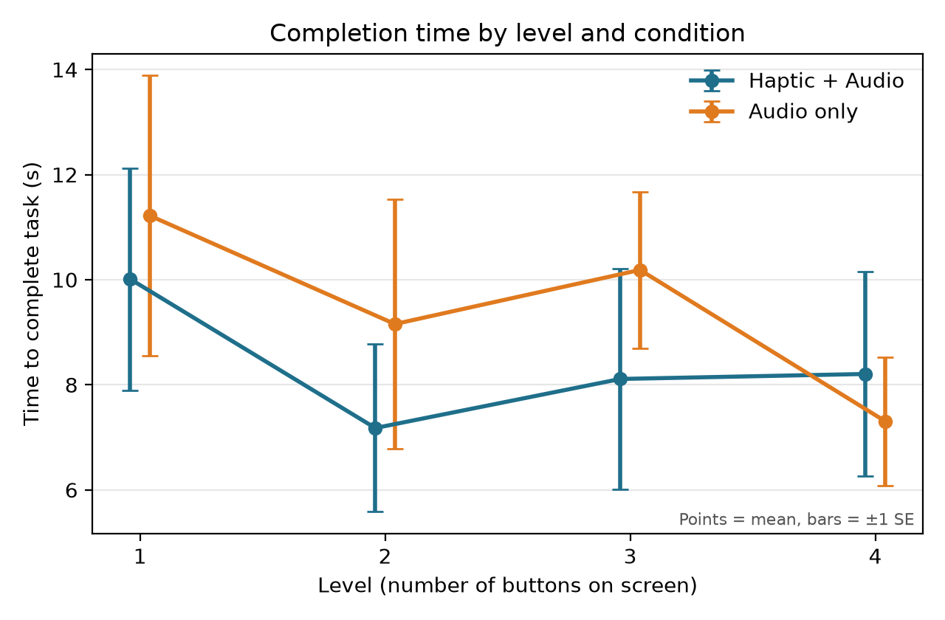
Figure 1. Completion time by level and condition (mean ± 1 SE)
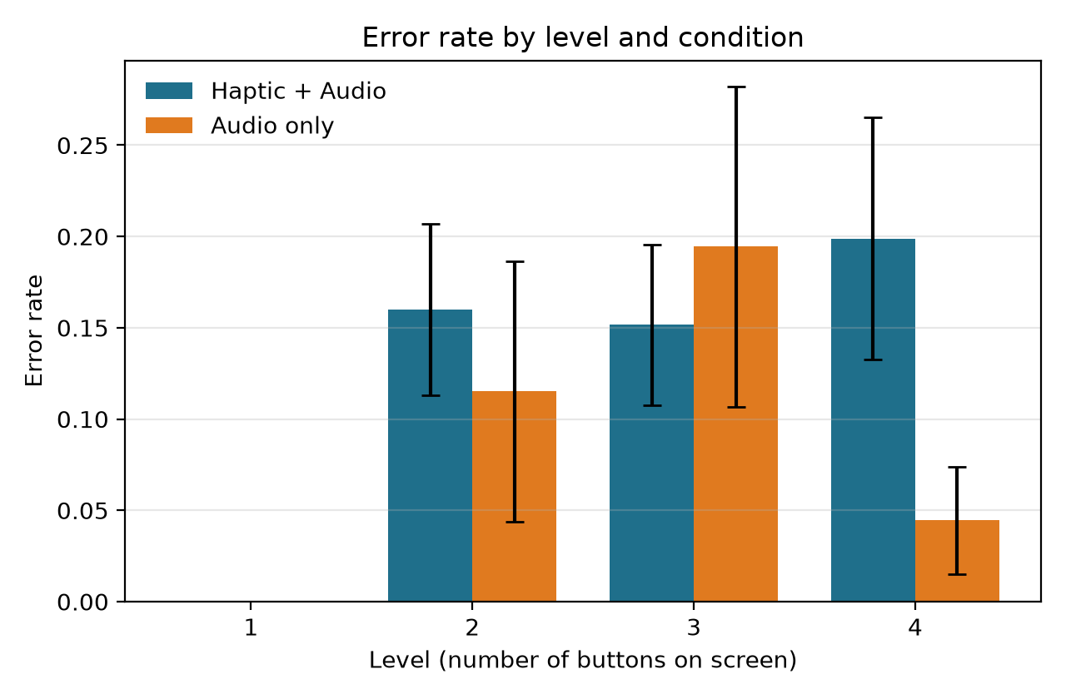
Figure 2. Error rate by level and condition (mean ± 1 SE)
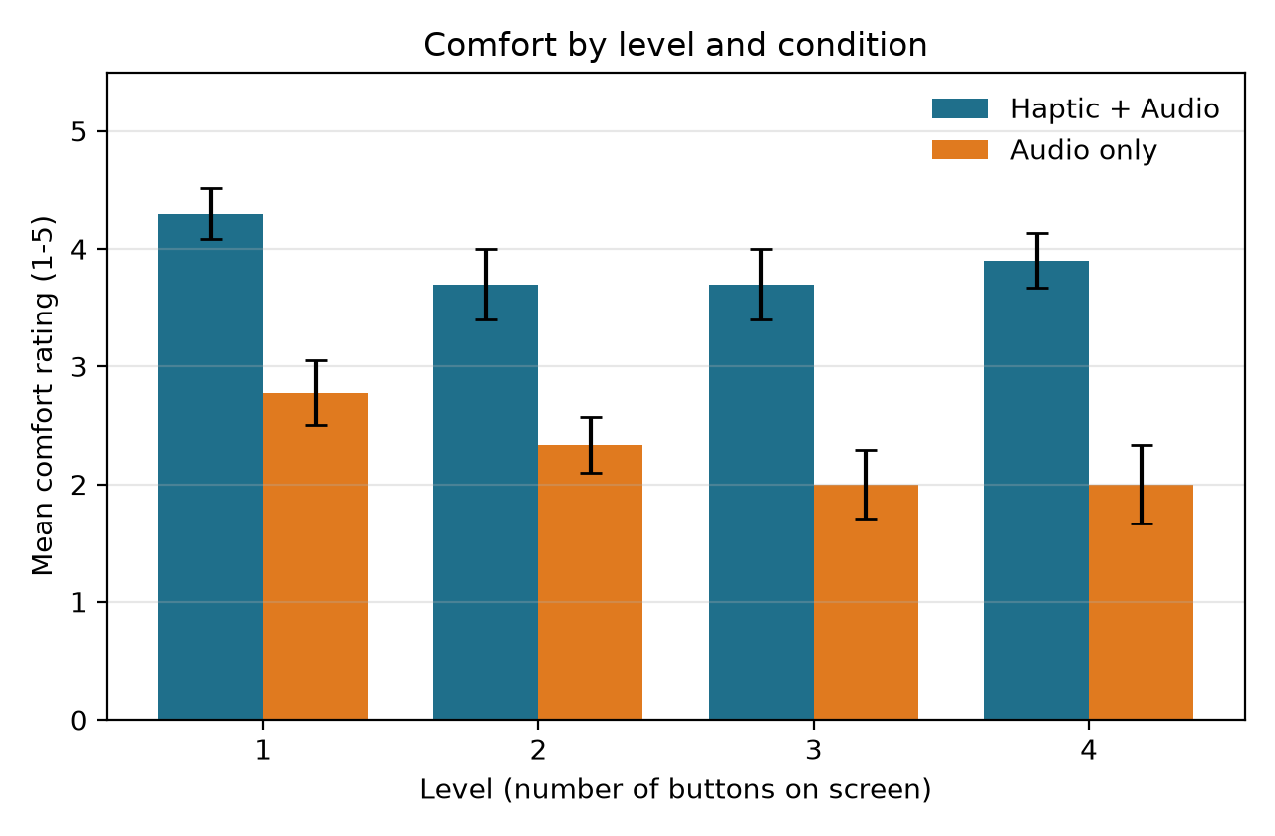
Figure 3. Comfort rating by level and condition (mean ± 1 SE)

7.3 Inferential statistics
Table 4. Haptic + Audio vs Audio only, overall
Measure | Test | Result | Effect size
Time (log) | Welch t-test | t(15.8) = −0.65, p = .522 | d = −0.30; H+A times 0.80× Audio only
Time | Mann-Whitney U | U = 41.0, p = .775 | r = −0.09
Error rate | Mann-Whitney U | U = 53.0, p = .534 | r = 0.18
Comfort | Mann-Whitney U | U = 84.5, p = .001 | r = 0.88
Positive r means higher values in Haptic + Audio.
Table 5. Haptic + Audio vs Audio only at each level (Mann-Whitney U, Holm-corrected p)
Level | Time p | Error rate p | Comfort p | Comfort median difference
1 | 1.000 | – (no errors) | .005 | +1.0
2 | 1.000 | .608 | .006 | +2.0
3 | .823 | .896 | .005 | +2.0
4 | 1.000 | .219 | .005 | +2.0
Table 6. Differences across the four levels within each condition (Friedman tests)
Measure | Haptic + Audio | Audio only
Time | χ²(3) = 2.28, p = .516, W = 0.08 | χ²(3) = 3.00, p = .392, W = 0.11
Error rate | χ²(3) = 11.79, p = .008, W = 0.39 | χ²(3) = 6.64, p = .084, W = 0.25
Comfort | χ²(3) = 7.00, p = .072, W = 0.23 | χ²(3) = 12.47, p = .006, W = 0.46
Exploratory. Larger target buttons were found faster (Spearman ρ = −0.20, p < .001; Figure 4). In Haptic + Audio trials, the target’s vibration intensity was unrelated to completion time (ρ = 0.01, p = .895).
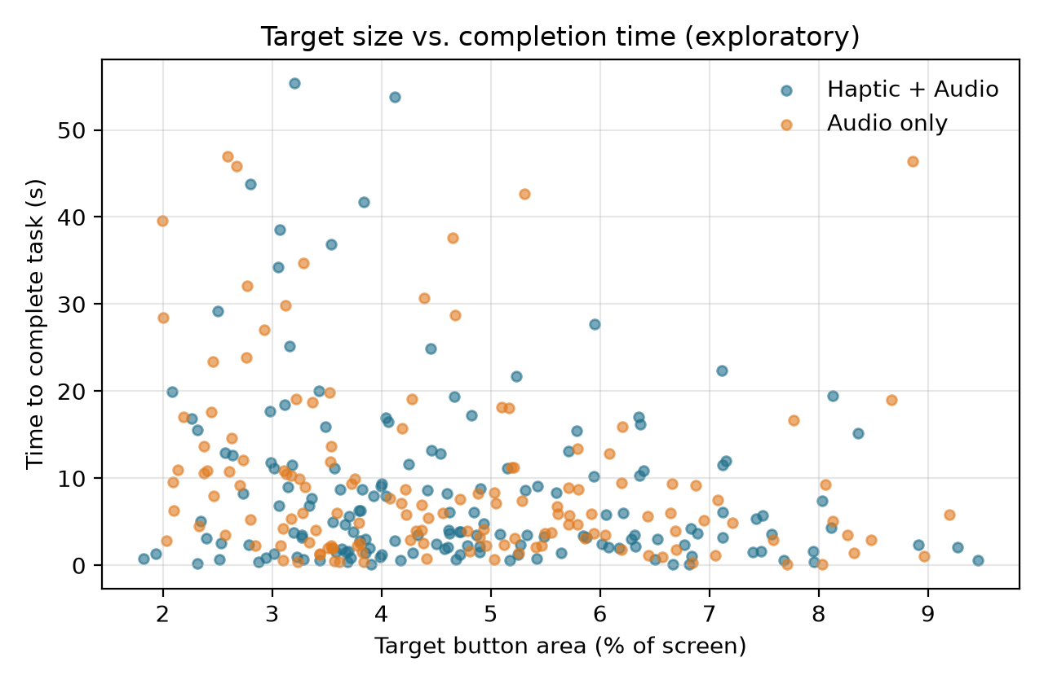
Figure 4. Target button area vs completion time, all completed trials
Sensitivity check. Without the likely random-tapping session (20261106-043325), the time difference disappeared (Welch t(15.0) = 0.08, p = .934; H+A times 1.02× Audio only). Error rates still did not differ (U = 51.5, p = .348), and comfort remained significantly higher with haptics (U = 75.5, p = .002, r = 0.86). The conclusions are therefore the same with or without this session.

7.4 Written feedback
Seven of the ten participants explicitly preferred Haptic + Audio or found Audio only harder, and none preferred Audio only (two-sided sign test, 7 vs 0, p = .016). Recurring themes:
- Haptics gave confidence and showed button boundaries (4 participants). For example: “with audio only I would slide over the button thinking I was on it still”, and “Audio only can’t tell you how big the box is.”
- Overlapping speech (2 participants). When the finger crossed two buttons quickly, the button names were spoken over each other and over the prompt.
- Selection and app feedback (2 participants). One participant accidentally closed the app several times without noticing and found it hard to tell when something was selected. Another suggested larger buttons for Audio only.
- Low engagement (1 participant). One participant disliked the task and reported clicking randomly to get through it. This may be the very fast session removed in the sensitivity check.

7.5 Can we reject the null hypotheses?
Hypothesis | Test | Result | Decision
H1 Time | Welch t-test (log time) | t(15.8) = −0.65, p = .522 | Fail to reject H0
H2 Errors | Mann-Whitney U | U = 53.0, p = .534 | Fail to reject H0
H3 Comfort | Mann-Whitney U | U = 84.5, p = .001, r = 0.88 | Reject H0
H4 Complexity (time) | Friedman, each condition | p = .516 (H+A), p = .392 (Audio) | Fail to reject H0
H5 Interaction | Per-level time comparisons | All Holm p ≥ .82 | Not supported

8. Discussion
Comfort (RQ3). The clearest finding is that vibration made non-visual navigation much more comfortable. Haptic + Audio sessions were rated 3.90 on average against 2.28 for Audio only, a large effect (r = 0.88) that was significant at every level and survived the sensitivity check. Comfort in Audio only also dropped as buttons were added (Friedman p = .006), while Haptic + Audio comfort stayed between 3.7 and 4.3 (p = .072). This suggests vibration helps people stay comfortable as interfaces get more complex. The written feedback agrees: seven of ten participants preferred haptics and none preferred audio only. Participants said vibration told them when they were on a button and how big it was, which speech alone could not.
Speed (RQ1). Haptic + Audio sessions were about 20% faster on average, but the difference was not statistically significant, and it disappeared entirely when the likely random-tapping session was removed. We therefore found no evidence that vibration makes finding a button faster. One explanation is that in both conditions participants still had to wait for the button’s name to be spoken before they could decide, so speech, not edge detection, set the pace.
Errors (RQ2). Error rates did not differ significantly. If anything, Haptic + Audio had slightly more wrong selections, rising with the number of buttons (Friedman p = .008). Continuous vibration confirms that the finger is on a button but not which one. Participants may have lifted their finger as soon as they felt vibration, before the label finished playing, trading accuracy for confidence. The per-button intensities were meant to help tell buttons apart, but intensity was unrelated to completion time, and 16 trials per condition were probably too few to learn four intensity levels.
Complexity (RQ4). Completion time did not increase with the number of buttons; it actually tended to fall from level 1 to level 4. Because the levels always ran in the same order, practice with the slide-and-listen technique likely outweighed the extra buttons. Target size mattered more than the number of buttons: larger targets were found faster (ρ = −0.20), consistent with Fitts’ law.
Limitations.
- Sessions were analyzed as independent groups because they were not linked to participant IDs. A paired, within-subject analysis would have more statistical power.
- Condition order should be checked against the facilitator sheet. If most participants did Haptic + Audio first, learning could favor the Audio only condition.
- The fixed level order mixes practice with complexity.
- Participants were blindfolded sighted students, a small sample on a single phone, so the results may not generalize to people who are blind or visually impaired.
- One participant reported random tapping, and overlapping speech made Audio only harder than it needed to be.
Future work.
- Link sessions to participants, so the within-subject design can be analyzed as paired data.
- Stop speech as soon as the finger leaves a button.
- Give participants more practice with the vibration intensities, or use distinct vibration patterns instead.
- Randomize the level order.
- Repeat the study with blind and visually impaired participants.

Appendix A – Background Questionnaire
Participant ID: ______ (filled in by the facilitator)
- Age: ______
- Gender: ☐ Woman ☐ Man ☐ Non-binary ☐ Prefer to self-describe: ______ ☐ Prefer not to say
- Current status: ☐ Undergraduate ☐ Graduate student ☐ Staff/Faculty ☐ Other: ______
- Field of study: ______
- Dominant hand: ☐ Right ☐ Left ☐ Both
- How would you describe your vision (with glasses or contacts if you wear them)? ☐ Normal ☐ Low vision ☐ Blind ☐ Prefer not to say
- Do you have any difficulty hearing speech from a phone speaker? ☐ No ☐ Yes
- Do you have any condition that reduces touch sensitivity in your fingers? ☐ No ☐ Yes ☐ Prefer not to say
- Which phone do you use most? ☐ Android ☐ iPhone ☐ Other ☐ None
- How many hours per day do you use a smartphone? ☐ Less than 1 ☐ 1–3 ☐ 3–5 ☐ More than 5
- How often have you used a screen reader (TalkBack, VoiceOver)? ☐ Never ☐ Tried once or twice ☐ Sometimes ☐ Daily
- How often do you play games or use apps that rely on vibration feedback? ☐ Never ☐ Rarely ☐ Sometimes ☐ Often
- How comfortable are you using a phone without looking at it? (1 = not at all, 5 = very) 1 ☐ 2 ☐ 3 ☐ 4 ☐ 5 ☐

Appendix B – Experiment Feedback Questionnaire

Part 1 – After each condition
Participant ID: ______ Condition: ☐ Haptic + Audio ☐ Audio only
Rate how much you agree (1 = strongly disagree, 5 = strongly agree):
Statement | 1 | 2 | 3 | 4 | 5
1. It was easy to find the button I was asked for. | ☐ | ☐ | ☐ | ☐ | ☐
2. I always knew when my finger was on a button. | ☐ | ☐ | ☐ | ☐ | ☐
3. I was confident I was selecting the correct button. | ☐ | ☐ | ☐ | ☐ | ☐
4. The feedback was fast enough. | ☐ | ☐ | ☐ | ☐ | ☐
5. The task required a lot of mental effort. | ☐ | ☐ | ☐ | ☐ | ☐
6. I felt comfortable using the app without seeing the screen. | ☐ | ☐ | ☐ | ☐ | ☐
7. The feedback was annoying or distracting. | ☐ | ☐ | ☐ | ☐ | ☐
8. (Haptic + Audio only) I could tell buttons apart by how strongly they vibrated. | ☐ | ☐ | ☐ | ☐ | ☐
- What made finding the buttons easier or harder in this condition? ____________________

Part 2 – At the end (comparing both conditions)
- Which condition did you prefer? ☐ Haptic + Audio ☐ Audio only ☐ No preference
- In which condition did you feel faster? ☐ Haptic + Audio ☐ Audio only ☐ No difference
- As more buttons appeared, which condition stayed easier? ☐ Haptic + Audio ☐ Audio only ☐ No difference
- Did you rely more on the vibration or on the speech when both were available? ☐ Mostly vibration ☐ Both equally ☐ Mostly speech
- Would you want vibration feedback like this in apps you use every day? ☐ Yes ☐ Maybe ☐ No
- What would you change about the vibration or audio feedback? ____________________
- Any other comments? ____________________

Appendix C – Consent Form
Study title: Vibrotactile and Audio Feedback for Non-Visual Touchscreen Navigation
Researchers: [names], [department], [university]. Contact: [email]
Supervisor: [instructor name], [email]
Purpose. This study tests whether phone vibration, combined with spoken audio, helps people find buttons on a touchscreen without looking. The results will be used in a course project report.
What you will do. You will fill in a short background questionnaire. Then, wearing a blindfold, you will slide your finger across a phone screen to find buttons named by the app, under two feedback conditions. After each part you will rate your comfort and answer a short questionnaire. The session takes about 30 minutes.
Risks and discomfort. Risks are minimal. You may find the blindfold or the vibration uncomfortable. You can remove the blindfold, take a break or stop at any time.
Benefits. There is no direct benefit to you. Your participation helps improve accessible interface design for people with visual impairments.
Voluntary participation. Taking part is voluntary. You may skip any question, and you may withdraw at any time without giving a reason and without any penalty. If you withdraw, your data will be deleted on request.
Confidentiality. You will be identified only by a participant ID (for example, P04). Your name appears only on this form, which is stored separately from the data. The app records touch timing, button selections and ratings. No audio, video, photos or personal data are recorded. Data are stored on [password-protected device/storage] and reported only as group results. Data will be deleted [at the end of the semester / date].
Compensation. [None / describe]
Questions. Contact [researcher email] or [instructor email]. [If required: questions about your rights as a participant can go to the university IRB at ___.]
By signing below, I confirm that I am at least 18 years old, have read and understood this form, have had the chance to ask questions, and agree to take part.
Participant name: ____________________ Signature: ____________________ Date: ________
Researcher name: ____________________ Signature: ____________________ Date: ________

Appendix D – Facilitator Session Sheet
Participant ID | Order | Session 1 ID | Session 2 ID | Notes
P01 | Haptic + Audio first
P02 | Audio only first
P03 | Haptic + Audio first
P04 | Audio only first
P05 | Haptic + Audio first
P06 | Audio only first
P07 | Haptic + Audio first
P08 | Audio only first
P09 | Haptic + Audio first
P10 | Audio only first
P11 | Haptic + Audio first
P12 | Audio only first
After the sessions, copy this into participants.csv with one row per session: participant_id,session_id,order.

Instruction script (read to every participant)
“In this study you’ll use a phone without looking at it. The phone will say ‘Find’ and then a button name, for example ‘Find Wishlist’. Keep one finger on the screen and slide it around. When your finger is on a button, you’ll hear its name, and in some rounds the phone will also vibrate. When you find the button you were asked for, lift your finger to select it. If you pick the wrong one, the phone will tell you, and you can keep searching. The buttons move and change size every time. Try to be quick and accurate. After each level, you’ll rate how comfortable it felt from 1 to 5. Any questions?”

