MANUAL
Music Box on Glass
Anri SALA

POWER ON
- Switch ON – Slide the switch inside - the Marseillaise Box (it's the master). It will start automatically.
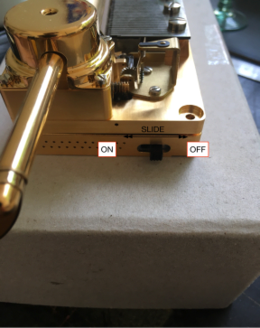
- Switch ON the International Box. It's the slave. After a few second, it will connect to the slave.
  - Wait for wifi connection
  - Wait for follow. The slave box need a little time to be near the master. During this time, the box can be very slow (waiting the master) or fast (catch up the master).
  - The 2 box are in sync. The sync happen every 10ms.

POWER OFF
Switch off the 2 box

CHARGE
- Power off the box you need to charge.
- Plug the charger inside the hole.
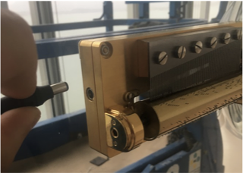
- Verify the LED on the charger :
  - Yellow blink slowly : pre-charge (during a few minute)
  - Green blink quickly : fast- charge
  - Fixed green : full battery
Keep always battery charged (in case of storage, charge battery before store) – Never keep mashine without battery !

FIRST INSTALLATION
check the function mode of the two set of boxes

FUNCTION MODE
To optimize battery (like daily usage and charge during night) there is 4 mode of function :
Infinite Loop
One Loop and 30 secondes break
One loop and 1 minute break
One loop every 5 minutes (the break time is 3m53s)
One loop every 1 minute (the break time is 56m27s

You can also click to play now if you want to play during the break. In this case, the countdown start again.

To change the mode, you need a computer or a smartphone.
- Power On the 2 box
- Connect your computer (or smartphone) to the wifi of the box. The wifi name is S2PBM, the password is Anri_Sala_8266
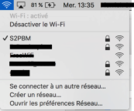
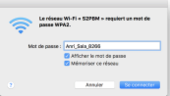
- Open your web browser (safari / firefox / internet explorer ….).
- Go to this address : 192.168.1.1 (type this address and press enter)
- You will see a webpage like bellow. Click start to chose the mode you want.
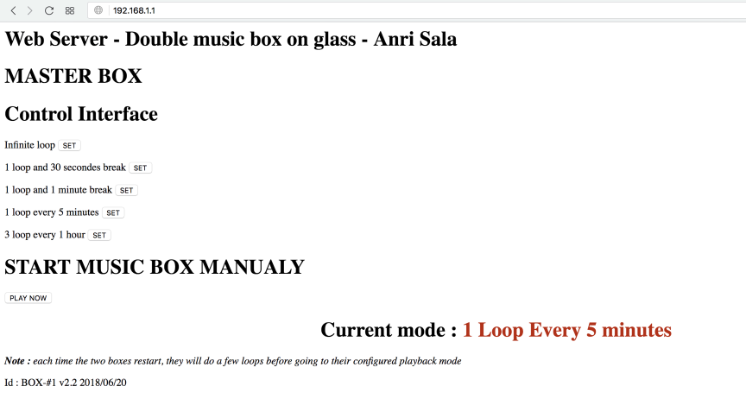
- Reboot the two box
You must do the same operation to the spare set of box.

INFORMATION :
The 5xAAA battery is rated for 5h of usage (5h@200mA → 1000mAh)

Battery life is 5h infinite loop
Battery life is 6h30 with 1 minute break
Battery life is 8h every 5'

Charging time is about 3h30
There is 2 set of boxes (4 boxes). You can only have one set working at each time never the 4 boxes in the same time.

If you connect the charger and keep on the music box, the music box will automatically stop (connecting the charger power OFF motor and electronic)

