ASSIGNEMENT 3

**31342 -** Introduction to Programmable Logic Controllers

João Ramiro

S182059@student.dtu.dk

# Hello World

Just as a first test to understand the basic functionality of PLCs an hello world program, where pressing a button would turn a light on. The FDB is the following:

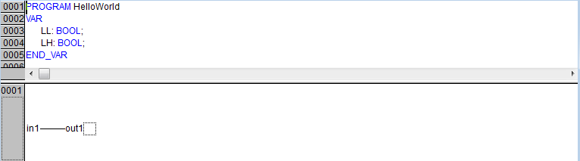

# Basic Logic Functions

The next step was to implement the following logic functions:

|  |  |
| --- | --- |
| AND | OR |
| NAND | NOR |
| XOR |  |

# Logic Function

After looking for a bit to the truth table, the following schematic was made, (an other alternative would be to make the Karnaugh map for every ouput)

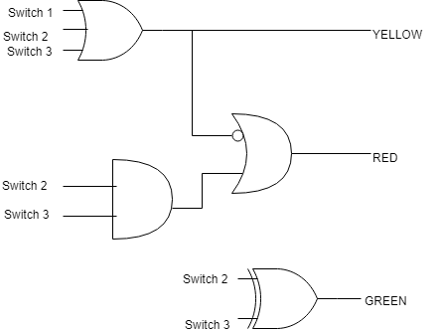

After that, this schematic was converted into this FBD

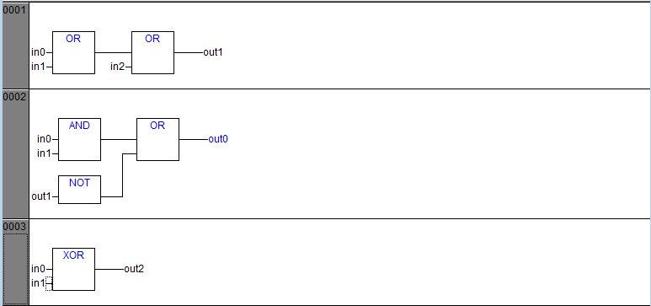

Where the mapping between the two schematics is the following:

|  |  |  |  |  |  |
| --- | --- | --- | --- | --- | --- |
| In0 | In1 | In2 | Out0 | Out1 | Out2 |
| Switch3 | Switch2 | Switch3 | Red | Yellow | Green |

Thus its concluded that the circuit can be made with just 6 Logic Gates.

# Latch

It was chosen the D Latch to be implemented:

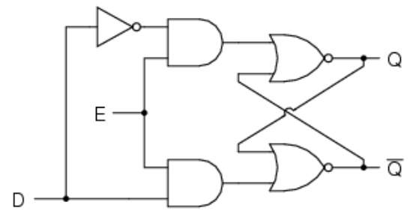

In this latch, when E is ON, the latch is ‘capturing’ to the value of D. As soon as E is turned off, the latch does not check the value of D anymore, instead its value Q is equal to the last value of D before turning off E.

This system was implemented in FBD in the following way:

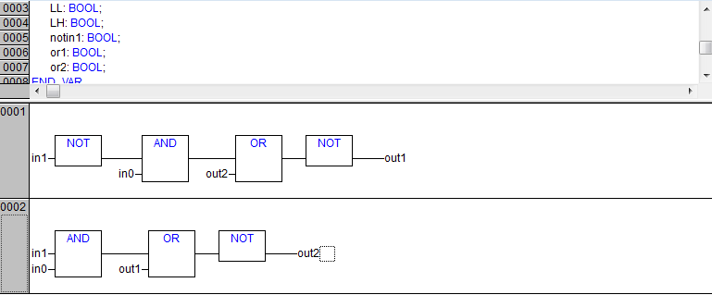

After testing it in the box it was confirmed that it was working as expected. (See Video in Attachment)

# Timers

Using the technique displayed in <http://aut.elektro.dtu.dk/staff/sh/plc/faq_q4.html>, for each interval that a certain light was ON, two timers were needed.

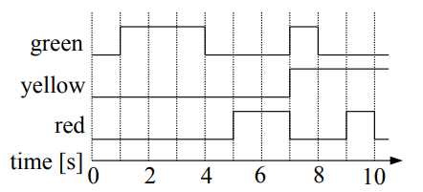

So, by looking at the image above we see that RED has 2 ON intervals, YELLOW is just a delayed step function, and GREEN has also 2 ON intervals:

So, for the RED is produced by the following networks:

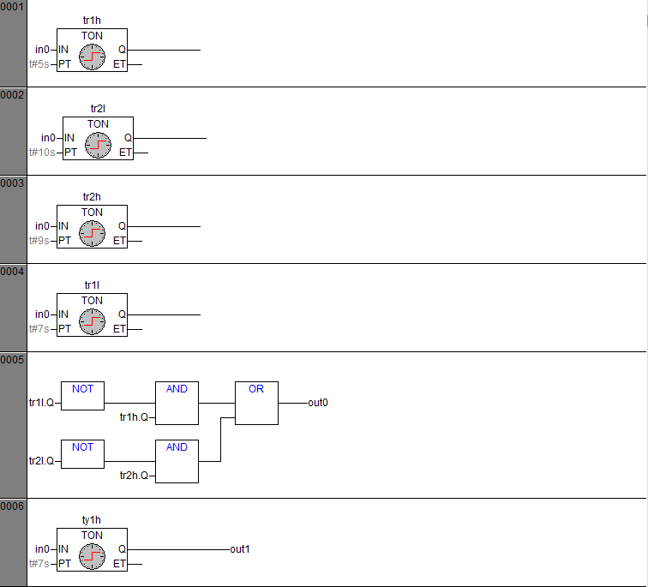

For YELLOW:



And for GREEN:

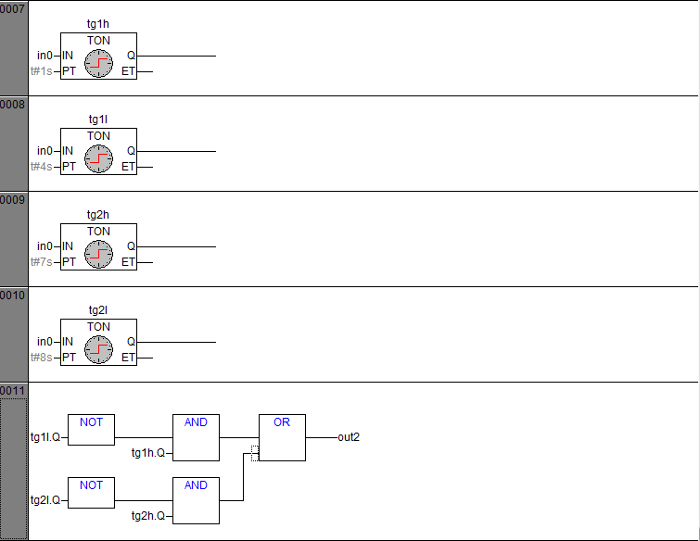

After implementing this nets it was confirmed that the system was working well. (See Video in Attachment)

# Attachment