# 

ASSIGNEMENT 5

**31342 -** Introduction to Programmable Logic Controllers

João Ramiro

[S182059@student.dtu.dk](mailto:S182059@student.dtu.dk)

# Part 1 – IL XOR

To implement the XOR without using the XOR logic gate, first a truth table must be build:

|  |  |  |
| --- | --- | --- |
| s1 | s3 | o2 |
| 0 | 0 | 0 |
| 0 | 1 | 1 |
| 1 | 0 | 1 |
| 1 | 1 | 0 |

This will translate to:

$$\overline{s_{1}}s_{3}+s_{1}\overline{s_{3}}$$

Which is easily converted to the following Instruction List:

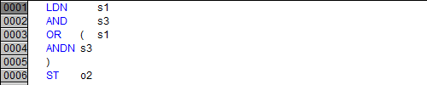

# Part 2 – Logic expression in ST

The table shown in the assignment is the same as the one on the last assignment, so the logic expressions will be the same:

$Red=S_{2}S_{3}+S_{1}S_{3}+\overline{S_{1}}\overline{S_{3}}\overline{S_{3}}$

$Yellow=\left(\overline{S_{1}}+\overline{S_{3}}\right)∙\left(S_{1}+S_{2}+S_{3}\right)$

$Green=(S_{1}+\overline{S_{2}})∙\left(\overline{S_{2}}+\overline{S_{3}}\right)(\overline{S_{1}}+S_{2}+S_{3})$

After having this, converting it into Structured Text is straight forward.

Since it was asked to make a function, the following function was built:

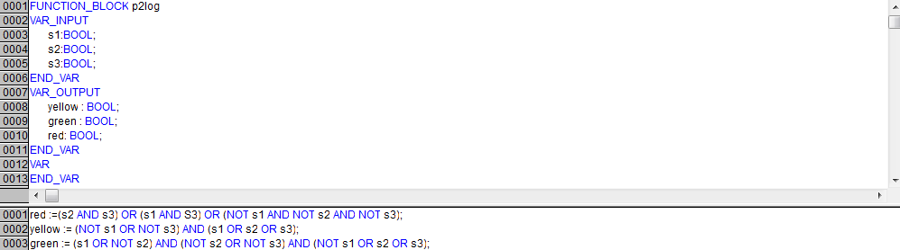

Then the function should be called with the following PLC program:

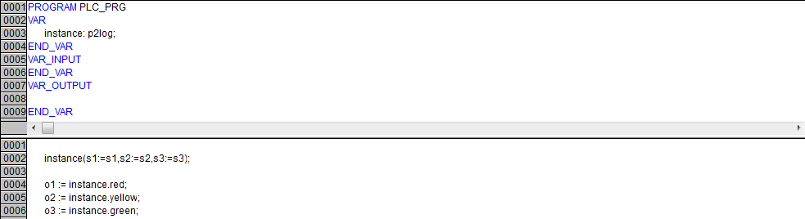

After this it was verified that the PLC worked correctly.

# Part 3 – Water Tank Sequence

Part 3 was implemented in SFC, and the transitions/states where implemented in structure text.

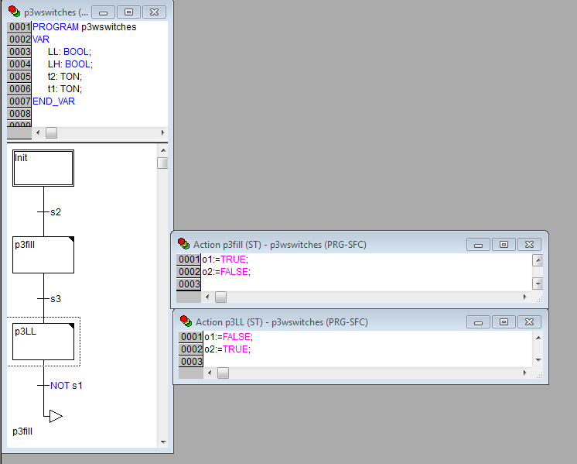

First there is the *Init* state, where nothing is done until the start button (*s2*) is pressed.

The on state *p3fill* the tank will start to fill (*v3* which corresponds to the *red* light(*o1*) is active). Then s1, which represents *LL* is pressed, followed by s3 which represents *HL*.

When the *High Level* is reached the PLC transitions onto the *P3LL* state where the *v2* opens and *v1* closes. This will happen while the water level is not below the low level (*LL*). When that finally happens, the PLC goes onto state p3fill where *v1* is closed and *v2*, repeating the whole process again.

(See Video in attachment)

# Part 3 Extra – Water Tank Sequence

To implement the same system but with timer, the previous PLC only needed a few changes, that consisted in TON timers that are started when the state is entered. After 3 seconds of filling up (only *v1* open) the PLC empties the tank during 3 seconds (only *v2* open):

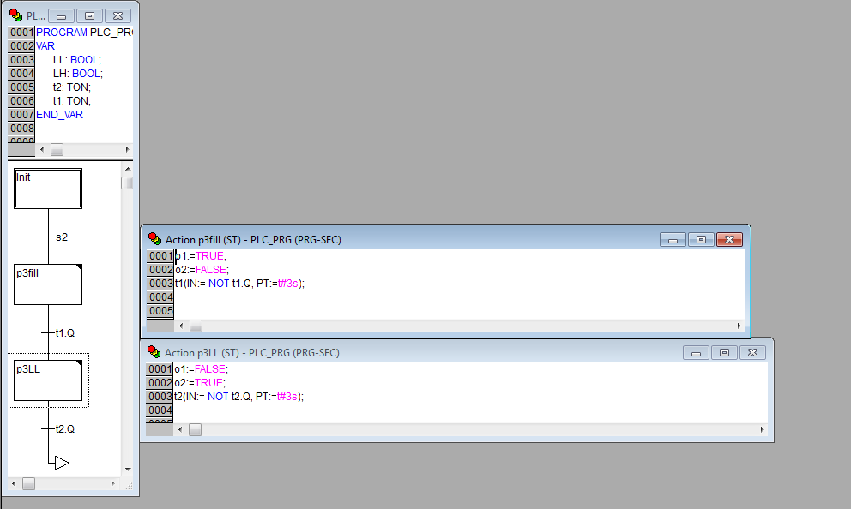

A video of this functionality can be seen in attachment.