Table of Contents
1
1
Use Case 1
Use Case 1
Use Case 1
Use Case 1
Use Case 1
Use Case: System Login 2
Use Case: Equipment Inventory 3
Use Case: Maintenance Tracker 6
Use Case: Maintenance Scheduler 8
Use Case: Maintenance History 10
Use Case: Maintenance Resources 12

Use Case: System Login

Author
Revision
  Version | Date | Notes
  Initial
Description

Actors
Includes
Extends
Pre-Condition
Post-Conditiion

Basic
Alternate
Exception

Use Case: Equipment Inventory

Author | Don Heuss
Revision
  Version | Date | Notes
  Initial | 06/23/2019
Description | Inventory and track all equipment managed by the PMI system.

Actors | User
Includes
Extends | Tracker
Pre-Condition
Post-Conditiion

Basic | User searches for available equipment  - Log into system.  - System displays list of owner equipment.  - Check the work status of equipment  - Generate report of equipment inventory
Alternate | Owner enters new equipment  - Log into system  - Select new item  - Enter new item  User updates equipment information  - Log into system  - Find Item to be updated  - Update information  Owner deletes equipment  - Log into system  - Find Item to delete  - Delete Item
Exception

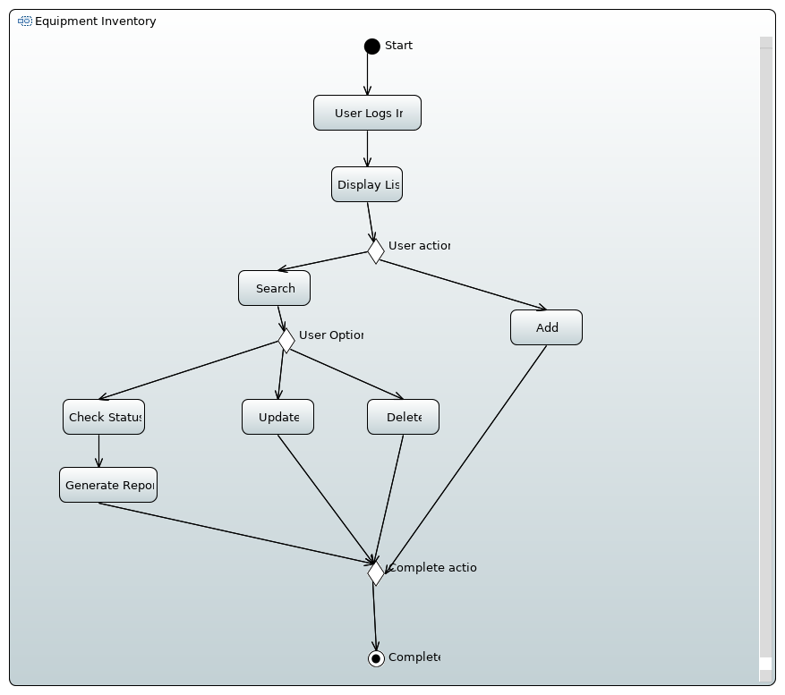

Use Case: Maintenance Tracker

Author
Revision
  Version | Date | Notes
  Initial
Description | Track inspections and periodic work that needs to be accomplished. Keep a history of all work that needs to be performed.

Actors
Includes | Scheduler, Resources
Extends
Pre-Condition
Post-Condition

Basic | - Technician logs into the system  - Search for the required equipment  - Search for the task to be accomplished  - Update completed work
Alternate | User generates a report of all tasks required to maintain an equipment item  User generates a report of all required maintenance for a specific period of time
Exception

Business Rules

Use Case: Maintenance Scheduler

Author
Revision
  Version | Date | Notes
  Initial
Description | Automatically schedule equipment maintenance based on tracking requirements.

Actors
Includes
Extends
Pre-Condition | Equipment information and PMI tasks have already been entered into the system.
Post-Condition | New PMI schedule is created.

Basic | On a monthly basis, report is ran to check the due dates of equipment task that are due for the coming month. This report is sent to the Customer and Technician from the maintenance tracker.  - On the 15th of the month, query the PMI requirements table for items due in the next month.  - Generate a report for each PMI monthly items  - Generate a report for each PMI item that has a required by date.  - Post report on the “Work coming Due” webpage.  - Email report to owner and technician
Alternate | Update the “Monthly PIM Report” that show work that is required for the current month  - On the 1st of the month, move the current open items in the “Monthly PMI Report” to the “Overdue Items Report”.  - Move the “Work Coming Due” data to the “Monthly PMI Report”  Update the work status  - Technician updates PMI Task status.  - Task change is shown on the “Monthly PMI Report”.
Exception | Overdue Items are sent to the Customer monthly by the Maintenance Tracker.  - “Overdue Item Report” is emailed to the owner and technician.

Business Rules

Use Case: Maintenance History

Author
Revision
  Version | Date | Notes
  Initial
Description | Maintains a history of maintenance actions.

Actors
Includes
Extends
Pre-Condition
Post-Condition

Basic | When a maintenance task has been completed, the completion date and work notes are recorded.  1. When a date complete action is committed  2. Create historical records
Alternate | Maintenance tracker can request a maintenance history on equipment as needed.  1. Search for equipment  2. Generate equipment historical report
Exception

Business Rules

Use Case: Maintenance Resources

Author
Revision
  Version | Date | Notes
  Initial
Description | An inventory of the skills, tools, technical information, and consumables needed to complete a maintenance task.

Actors
Includes
Extends
Pre-Condition | Equipment information and PMI tasks have already been entered into the system.
Post-Conditiion | Complete list of resources has been created

Basic | An inventory of the skills, tools, technical information, and consumables needed to complete a maintenance task.  - Technician select an equipment item  - Technician updates the skills  - Technician updates the tools  - Technician updates the technical information  - Technician updates the consumables
Alternate
Exception

