FPGA and FLASH Loading

1. Build the FPGA Code 1
2. Convert the .BIT file to an Intel Format .MCS File 1
3. Format a Header Record 2
4. Erase FLASH 5
5. Write the Header to the Flash 5

Build the FPGA Code

In Xilinx ISE, build the FPGA code – Synthesize, Implement Design, Generate Programming File – to produce a .BIT file. This step is preliminary to actually Loading it into FLASH, and I have not attempted to fully explain the Xilinx ISE build process here.

Convert the .BIT file to an Intel Format .MCS File

Run promgen.exe to convert the .BIT file to an Intel format .MCS file

C:\Xilinx_ISE_Design_Suite_13.1\ISE_DS\ISE\bin\nt\promgen.exe
-w –spi –p mcs –u 0 file[.bit] –o mcsfile

-w Overwrite existing output file(s).
-spi Disables bit swapping for compatibility with SPI flash devices.
-p <format> PROM format (mcs, exo, hex, tek, bin, ieee1532, or ufp)
-u <hexaddr> <file[.bit]>
Load .bit file(s) up from address. Multiple .bit files are
Daisy-chained to form a single PROM load.
<hexaddr> in our case is zero “0”
file[.bit] is full path and filename of .BIT programming file
-o <mcsfile> Output PROM file name (default matches first .bit file),
multiple names may be specified when splitting PROMs.
mcsfile is full path and filename for our destination MCS file.

Example:

C:\Xilinx_ISE_Design_Suite_13.1\ISE_DS\ISE\bin\nt\promgen.exe -w -spi -p mcs -u 0 S:\Xilinx_Prj_Tb3iomc_Fpga2\Rev_01.03.08_F2\Tb3iomc_Fpga2\tb3iomc_fpga2_top
-o S:\Xilinx_Prj_Tb3iomc_Fpga2\Rev_01.03.08_F2\Tb3iomc_Fpga2\tb3iomc_fpga2_top.MCS

Format a Header Record
Format a header record to be written at address 0 into the Flash memory. The header record is 256 bytes and contains info describing and identifying the FPGA program that will be loaded into the Flash memory. In my client, I come up with this information then format it as MCS (Intel Hex format) and write it into a text file, then later I read the text file and transmit it to the Test Station to write it into the Flash memory.

Header Record fixed length fields
offset | length | param
0 | 4 | Offset in FLASH to Bitstream (0x0000,0100)
4 | 4 | BitStream length in bytes
8 | 1 | xor hash of bytes 0-7
9 | 1 | Constant "A5"
A | 2 | CheckSum 16-Bit
C | 4 | reserved
0x10 | 0x20 | NCD Filename
0x30 | 0x10 | Date
0x40 | 0x10 | Time
0x50 | 0x20 | Revision
0x70 | 0x90 | reserved

The header record has a fixed length of 256 bytes, 0x100. It is loaded into Flash at offset 0x0000,0000. The DSP reads this header record out of the FLASH whenever it needs to load its program into an FPGA. The DSP also supports the general ability to read any block of data, such as the header record, and transmit it back to the PC, if for example the PC wants to see what program version is loaded into the FLASH.

Offset in FLASH to Bitstream
In each FLASH memory, we reserve the first 0x100 bytes for the Header Record, then Immediately following the header, at offset 0x0000,0100 is the start of the bit-stream load-image for the FPGA. So the value in the first 4 bytes of the header – “Offset in FLASH to Bitstream” – is 0x0000,0100.

BitStream length in bytes
The 2nd 4 bytes of the header is the length of the bit-stream image. For our Spartan 6 FPGAs this is a constant 0x0005327C bytes. The value can be found in the first 102-byte header of the Xilinx .bit file containing the Bit-Stream Image of the FPGA program. (See Parsing Data from the 102-Byte Header to the .BIT file below.)

Xor hash of bytes 0-7, Constant "A5"
Before The DSP loads an FPGA from Flash, it checks to make sure the Header Record is legitimate information, not random garbage, by verifying these 2 fields. Xor hash of bytes 0-7 should be equal to the value you get when you start with a zero accumulator and Xor in each of the first 8 bytes in the Header record. Constant "A5" should be just that: 0xA5.

CheckSum 16-Bit
In my PC Client, as we prepare a header record for an FPGA bit stream, the CheckSum-16 is calculated by reading the MCS file of the FPGA bit-stream, looking at it as a ROM image, and adding together all the 16-bit data words, mod 0x10000.

Although the CheckSum-16 field was conceived to be used to verify the integrity of the data as it moves from PC to Test Station to Flash and to FPGA, it is apparently not checked by the test station when receiving FPGA Bit-stream data to be loaded into FLASH. It is also apparently not used by the test station when reading FPGA bit-stream data out of the Flash and loading it into the FPGA. My conclusion is that the CheckSum-16 is probably not necessary

It turns out that the Xilinx .BIT bit-stream format includes a CRC which is checked as it loads into the FPGA. So we already do have that sort of error detection, without the CheckSum-16. This may explain why I never went to the trouble in the DSP code to verify the CheckSum-16.

NCD Filename
Date
Time
These values are for information only. They may be useful if you want to identify the code that is running in an FPGA, and you can read back the header record from the FLASH and examine these fields. In my PC client, I extract values for these fields from the 102-byte header of the Xilinx .bit file containing the Bit-Stream Image of the FPGA program.

Parsing Data from the 102-Byte Header to the .BIT file
At offset 14-bytes, find token "a" followed by 2-byte NCD_name_length (ms byte first).
Read the next (NCD_name_length) bytes as the Ncd_name in ascii, discard the trailing null.
Next character should be the token "b" followed by 2-byte Part_name_length.
Read the next (Part_name_length) bytes as the Part_name in ascii, discard the trailing null.
Next character should be the token "c" followed by 2-byte Date_length.
Read the next (Date_length) bytes as the Compile_Date in ascii, discard the trailing null.
Next character should be the token "d" followed by 2-byte Time_length.
Read the next (Time_length) bytes as the Compile_Time in ascii, discard the trailing null.
Next character should be the token "e" followed by 4-byte binary Bit_Stream_Length (ms byte first).
That’s the whole 102 byte header.
Next byte starts the Bit-Stream-image that can be fed into the FPGA to program it.

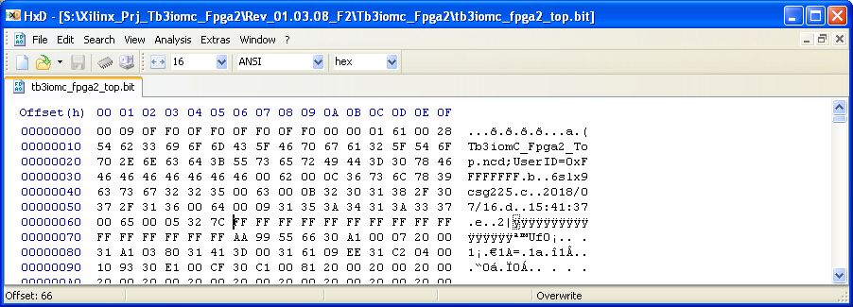

Revision
Again this is for information only. In my PC Client, I look in the folder containing the .BIT Bit-stream file, and I search all .V, Verilog source files in that folder looking for "FW_REVISION_VALUE” which identifies the location of the revision info coded in the source files. (See BFH_Find_Rev_Info() macro in TS3_CAN_Test.xls)

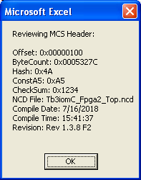
Format the Header Record as an MCS ROM Image.

Specifically, the .mcs format file produced by Xilinx ISE’s promgen utility is what’s called “Intel MCS-86 Hexadecimal” format. You can Google that and find good documentation on the specifics of that format. Here’s an example of a Header Record for storing an FPGA program in one of the TS3’s Flash memories.

Line # | MCS Records
1 | :10000000000001000005327C4AA512340000000007
2 | :10001000546233696F6D435F46706761325F546F3E
3 | :10002000702E6E63640000000000000000000000FD
4 | :10003000372F31362F3230313800000000000000F9
5 | :1000400031353A34313A3337000000000000000007
6 | :1000500052657620312E332E3820463200000000C3
7 | :100060000000000000000000000000000000000090
8 | :100070000000000000000000000000000000000080
9 | :100080000000000000000000000000000000000070
10 | :100090000000000000000000000000000000000060
11 | :1000A0000000000000000000000000000000000050
12 | :1000B0000000000000000000000000000000000040
13 | :1000C0000000000000000000000000000000000030
14 | :1000D0000000000000000000000000000000000020
15 | :1000E0000000000000000000000000000000000010
16 | :1000F0000000000000000000000000000000000000
17 | :00000001FF

Line # 1 -- :10000000000001000005327C4AA512340000000007

expanded :10 0000 00 00000100 0005327C 4A A5 1234 00000000 07
| | | | | | | |
| | | | | | | Mcs rec checksum
| | | | | | CheckSum 0x1234
| | | | | Hash 0x4A followed by ConstA5
| | | | ByteCount 0x0005,327C
| | | Offset 0x0000,0100
| | Mcs record type: 00 = Data Record
| Mcs hex address
# of 16-bit data words in MCS rec.

Erase FLASH

Select which Flash to erase. Send a value 1,2,or 3 to CAN index 0x204C, subindex 0x10, selecting the Flash associated with FPGA1 or FPGA2 on TB3IOM, or with FPGA3 on TB3PM.

Read from CAN index 0x204C, subindex 0x07, to receive a Bulk_Erase_Token. This is a 16-bit random value that you will need to supply to effect the erasure. This is a bit of security to try and avoid some situations where the Flash might be erased due to an error.

Write to CAN index 0x204C, subindex 0x07, sending the Bulk_Erase_Token received in the previous step. This starts the Flash performing it’s Bulk Erase operation.

From this point it takes a second or so for the Flash to complete its Bulk Erase operation. You can check the status by reading from CAN index 0x204C, subindex 0x02 which returns the Flash Status Register value as the LS 8 bits. See the Flash data sheet for an explanation of the full Flash Status Register. The LS bit of the Flash Status Register value indicates “Write In Progress”. So if that bit is 1, the erasure is still in progress. If that bit is 0 the erasure is complete.

Write the Header to the Flash

Loading an FPGA from Flash

