8/6/2018
Board Configuration / Loopback Commands in the TS3 Test Station

Self Test Loopback Circuitry on the TS3 Test Station’s TB3IOM module serves well at the purpose of allowing testing of most I/O circuits on the module. However it does NOT exactly replicate the Self Test Circuitry from the Classic Test Station’s TBIOM module. After much analysis, following is the functionality that will be implemented in the TS3 Test Station to respond to four CAN commands relating to board configuration and loopback. This provides substantial compatibility with the Classic Test Station (see “Board Configuration commands from the Classic Test Station” below.) Potential incompatibilities are noted.

TEST_MODE_ENABLE – CAN 0x202C.00

TS3 implementation of this command is 100% compatible with the Classic Test Station

Bit 0 tells whether to open or close all 8 SPST switches connecting each of the 8 Analog input pins to the Analog Input Circuitry.

Bit 1 tells whether or not to ENABLE all 8 of the analog loopback multiplexors.

TS3 has SPST switches on all 8 of its analog input pins and we can set them according to this command.
TS3 has ENABLE lines all 8 of its analog loopback multiplexors, and we can set them according to this command.

Bit 0: 1= AnlgMuxOut OFF, 0=AnlgMuxOut ON
Bit 1: 1=ioPin ON, 0= ioPin OFF

0x0000 -- anlg in ioPin ON, anlg mux output disabled
0x0001 -- anlg in ioPin OFF, anlg mux output disabled
0x0002 -- anlg in ioPin ON, anlg mux out enabled
0x0003 -- anlg in ioPin OFF, anlg mux out enabled

TEST_CONTROL_WORD – CAN 0x202B.00

The TS3 implementation of this command provides some compatibility with the Classic test station, possibly all we need. In the Classic Test Station, the command directs which signals are multiplexed into Analog Input and Digital Input circuitry, and most of that is replicated in the TS3 implementation. A table below describes the remaining incompatibilities.

Let’s separate this one into two commands – Bits 2:0 control Analog loopback mux, Bits 4:3 affect digital loopback:

TEST_CONTROL_WORD -- Bits 2:0

In the Classic test station, this selects one of 8 signals to rout through the analog loopback mux into the analog input circuitry (subject to the mux enable controlled by the TEST_MODE_ENABLE command):

The TS3 test station has 8 signals into its analog loopback mux – just not exactly the same signals as the Classic test station. To maximize compatibility in TS3, we need to determine for each value of bit 2:0, which signal to select as input to the mux, and what else, if anything we need to do.

Classic Command Connects  This Signal to Anlg In 1-8 | TS3 Mux | Comments | Compatible ?
..000 - +5V | 0 Self Test DC V | Self Test DC V choices are +10, -10, +2.5, 0V: use +10V | No  One road to compatibility *
..001 - -5V | 0 Self Test DC V | Self Test DC V choices are +10, -10, +2.5, 0V: use -10V | No  One road to compatibility *
..010 - Analog Out | 1 Analog Out |  | Yes
..011 - Gnd | 0 Self Test DC V | Self Test DC V choices are +10, -10, +2.5, 0V: use 0V | Yes
..100 - Digital Out A/B | 2 Digital Out A/B |  | Yes
..101 - Digital Out C/D | 3 Digital Out A/B |  | Yes
..110 - Digital Out E/F | 4 Digital Out A/B |  | Yes
..111 - Resolver  AnlgIn1 – RSLVR_REF  AnlgIn2 – RSLVR_SIN  AnlgIn3 – RSLVR_COS  AnlgIn4-8 – 0V | 5 Resolver  AnlgIn1 – RSLVR_SIN  AnlgIn2 – RSLVR_COS  AnlgIn3 – SSEnc_SIN  AnlgIn4 – SSEnc_COS  AnlgIn5 – SSEnc_2V5_1  AnlgIn6 – SSEnc_2V5_2  AnlgIn7 – ResVref_SinCos  AnlgIn8 – 0V | 1) Classic RSLVR_REF was generated internally in NYSTSYS. TS3 assumes it is supplied by the amp under test.  (2) Rslvr_Sin & Cos are looped back onto different Analog inputs from where they appeared in Classic Test Station. | No  One road to compatibility *

Resolver loopback: This may NEVER have been used in the classic test station. One road to compatibility is to detect whenever mux is configured to loop back resolver sin or cos or Vref, and have the DSP serve up appropriate anlg_in values. Eg: Serve TS3 AnlgIn2 – RSLVR_COS responding to request for classic AnlgIn3 – RSLVR_COS.

+5V / -5V loopback: -- One road to compatibility is to have TS3 loop back +10V, -10V Self Test DCV, and to detect that the mux is configured for +5V / -5V loop-back, and internally divide measured voltage by 2.
TEST_CONTROL_WORD -- Bits 4:3

Classic Command Connects  This Signal to Dig_In C/D | TS3
00... – Digital In I/O Pin | Have SPST switches to connect / disconnect I/O pin from Digital Input circuitry | When Classic test station selects this, it enforces connecting the Dig_In I/O pins to the circuits, and TS3 can mimic that. | Yes
01... – Test Square Wave | No easy way to do this. Hard way is to put a square wave on all analog outputs looped into digital inputs. Very Hard. | When Classic test station selects this, it enforces disconnecting the Dig_In I/O pins, and TS3 can mimic that. | No
10... – Anlg Output 1-8 | Have self-test switches to connect Anlg_Out circuits with Dig_In circuits. | When Classic test station selects this, it enforces disconnecting the Dig_In I/O pins, and TS3 can mimic that. | Yes
11..... – Gnd | No easy way to do this. | When Classic test station selects this, it enforces disconnecting the Dig_In I/O pins, and TS3 can mimic that. | No  One road to compatibility *

-Gnd: -- One road to compatibility is to have TS3 detect that the mux is configured for -Gnd, and internally report suitable hi/low states when PC reads digital output values.

TEST_CONTROL_WORD – Incompatible Features

Classic Features | Limitation in TS3
Connect +5V DC test voltage to Analog In Circuits | Self Test DC V choices are +10, -10, +2.5, 0V: use +10V
Connect -5V DC test voltage to Analog In Circuits | Self Test DC V choices are +10, -10, +2.5, 0V: use +10V
Connect Resolver Signals Analog In Circuits | TS3 Resolver loopback is different from the Classic Test Station. I doubt that Resolver loopback was ever used in the Classic Test Station. If in fact it was, and if there is a need for TS3 to be compatible, then it may be possible, in the DSP code, to make accommodations. See “One road to compatibility” above, in the discussion of resolver loopback.
Connect a test square wave to digital input circuits. | No easy way to do this. We will consider it if a need arises.
Connect Gnd to digital input circuits | No easy way to do this. We will consider it if a need arises

ANALOG_OUTPUT_ENABLE – CAN 0x202D.00

In the Clasic Test Station this controls 10 SPST switches connecting I/O pins to the 8 Anlg_Out circuits and to the Resolver Sin & Cos output.

In TS3 we have individual SPST switches on all 10 of those I/O pins, and we can easily emulate this 100%

Bit_0 – Anlg_Out_1 & 2
Bit_1 – Anlg_Out_3 & 4
Bit_2 – Anlg_Out_5 & 6
Bit_3 – Anlg_Out_7 & 8
Bit_4 – Resolver Sin & Cos

This turns on/off switches connecting anlg out circuits to anlg out pins.

0x0000 connects all outputs to all pins.
0x001F disconnects outputs from pins

INPUT_CHANNEL_USE – CAN 0x200D.00

This was a sophisticated feature built into the A to D hardware, and not used (mostly).

For the time being, the TS3 Test Station will send and receive this command value, but will not act on it, continuing to read all 8 Analog Input channels through the A-to-D converters. We can take a second look at this when the Bode Plot feature is ported into the TS3 firmware.

Ideally, each of the 8 bits controls whether or not one of the 8 Anlg_In signals is multiplexed into the A-to-D converter. In theory you can achieve better resolution of a single signal by not sharing the A-to-D converter with other inputs. In practice that was only ever used by the Bode Plot application, and that used other features not documented here. In practice, the Classic hardware does not support independent selection of all 8 channels, and the selection of 5 thru 8 mirrors the selection of 1 thru 4. In other words if you select Anlg_In_1, you always get Anlg_In_5 too. (Probably) to accommodate some ancient compatibility issue, the FPGA takes bits 5-8 and OR’s them with bits 0-4 and uses the resulting mask to select which Anlg_In signals are multiplexed into the A-to-D converters:

Bit 0 OR Bit 5: “1” selects Anlg_In _1 and Anlg_In 5 to be included in rotation of mux into D-to-A.
Bit 1 OR Bit 6: “1” selects Anlg_In _2 and Anlg_In 6 to be included in rotation of mux into D-to-A.
Bit 2 OR Bit 7: “1” selects Anlg_In _3 and Anlg_In 7 to be included in rotation of mux into D-to-A.
Bit 3 OR Bit 8: “1” selects Anlg_In _4 and Anlg_In 8 to be included in rotation of mux into D-to-A.

This actually controls the FPGA rather than switches on the I/O module.

0x00FF have a-to-d's read all 8 analog inputs

Background Material:
Board Configuration commands from the Classic Test Station

It is desirable to make the TS3 test station “Classic Compatible” – able to respond to all the CAN commands from the legacy PC client software. So the question is: what to do about the Classic CAN commands relating to Self Test Loopback Circuitry – the so called ‘board configuration’ commands. There are 4 of these commands, and in the Classic test station you write to these commands, and you can read back whatever the present command value is.

0x202B.00 | TEST_CONTROL_WORD  Control multiplexors that select what signal to switch into the Analog Input circuitry and the Digital Input Circuity.  ..000 - +5V to Anlg In 1-8  ..001 - -5V  ..010 - Analog Out  ..011 - Gnd  ..100 - Digital Out A/B  ..101 - Digital Out C/D  ..110 - Digital Out E/F  ..111 - Resolver  00... – Digital In I/O Pin to Dig In C/D  01... – Test Square Wave  10... – Anlg Output  11... – Gnd
0x202C.00 | TEST_MODE_ENABLE  Bit 0 controls SPST digital switches, connecting or disconnecting the analog-digital input circuitry from the input I/O. “0” connects, “1” disconnects.  Bit 1 controls the enable lines to the analog “loopback” multiplexors: enabling or disabling its output line to the analog input circuitry. “0” is mux disabled, “1” is mux enabled.
0x202D.00 | ANALOG_OUTPUT_ENABLE  Control SPST digital switches connecting analog output circuitry -- & resolver output – to I/O pins.  Bit 0 – Anlg Out 1 & 2 – 0 = connect, 1 = disconnect  Bit 1 – Anlg Out 3 & 4  Bit 2 – Anlg Out 5 & 6  Bit 3 – Anlg Out 7 & 8  Bit 4 -- Resolver
0x200D.00 | INPUT_CHANNEL_USE  Control FPGA Firmware selecting which Analog Input signals to measure in the A to D converters. Value 0x00FF tells FPGA to read all 8 analog inputs. The only place we diverged from using that value was in the Bode Plot code.

Calibration & Loop Back – in Classic Test Station (aka “New Test Board”)

From DSP_Functional_Spec.doc

Implementation Details
The New Test Board (2001) utilizes a number of digital switches and analog multiplexors to allow you to rout its output circuits back to its inputs. The following information was culled from the Tbiomb.1 schematic and the canindx.txt file and the Fpga_Mem.h file.
#define TEST_CONTROL_WORD CS_ADC_FPGA_ADDRESS(0x0010)
//
// +---+---+---+---+---+---+---+---+---+---+---+---+---+---+---+---+
// | | | | | | | | | | | | B | A |
// +---+---+---+---+---+---+---+---+---+---+---+---+---+---+---+---+
//
// A - Bits 2-1-0 (Analog Inputs)
//
// 000 +5v to all Analog Inputs
// 001 -5v to all Analog Inputs
// 010 Analog Outputs to all corresponding Analog Inputs
// 011 Ground to all Analog Inputs
// 100 Digital Outputs 01-08 to corresponding Analog Inputs
// 101 Digital Outputs 09-16 to corresponding Analog Inputs
// 110 Digital Outputs 17-24 to corresponding Analog Inputs
// 111 Resolver
//
// B - Bits 4-3 (Digital Inputs)
//
// 00 Input Signal
// 01 Test Frequency
// 10 Analog Out
// 11 Ground

The LS 3 bits of the TEST_CONTROL_WORD control the U82 multiplexor, selecting which of several outputs and reference signals is looped back into the analog inputs. Note that the diagram shows DIG_OUTA1 and ANLG_OUT_1 looped back to Anlg_Dgtl_In_1. Similarly, other digital and analog outputs are looped back to the corresponding analog-digital input. Likewise the three analog outputs from the resolver may be looped back to three of the analog-digital inputs.
Bits 3 and 4 of the TEST_CONTROL_WORD control the U36 multiplexor, selecting which of several outputs and reference signals is looped back into the “digital only”inputs.
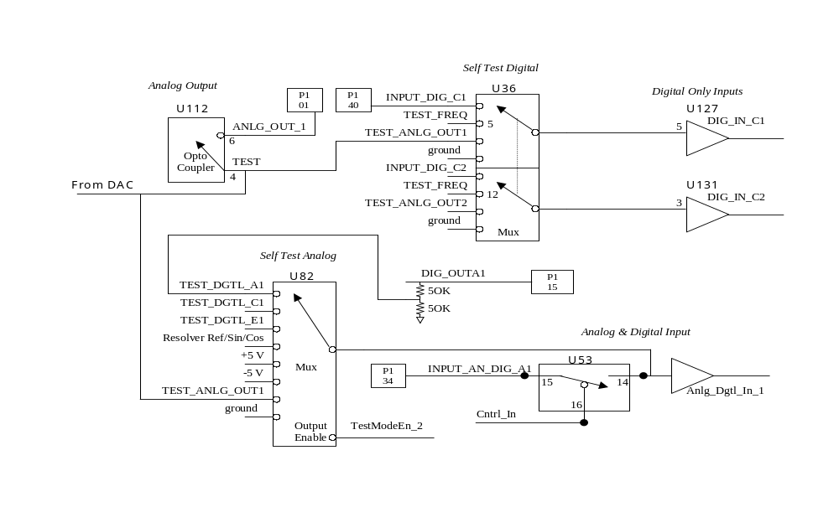
Relating the Test / Loop-Back circuits to the CANMan “Board Configuration” screen:

Test Control Word to Analog Inputs A1-B4 selects one of the test input signals to the U82 multiplexor
Test Mode Enable (bottom text box: “Test Signals Enabled” / “Disabled”) controls the Output Enable line on the U82 multiplexor
Test Mode Enable (upper text box: “Analog from Connector” / “Test Input”) controls the switch in U53
Test Control Word to Digital Inputs 09-16 selects one of the inputs to the U36 multiplexor.
Analog Output Enable switches control U12 opto coupler
Analog Input Channel Use controls FPGA firmware that multiplexes analog input signals into the A-to D converters used to read the analog inputs.

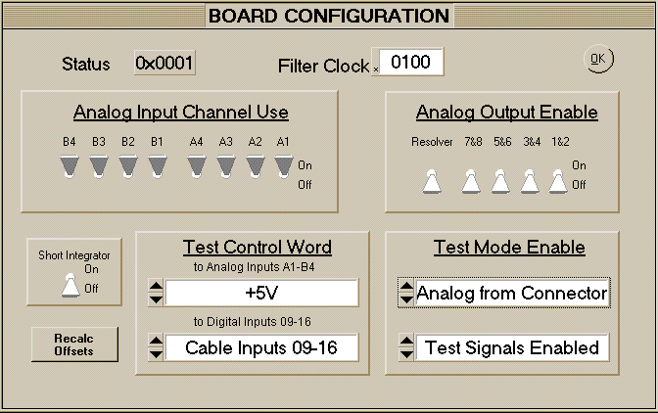

#define TEST_MODE_ENABLE CS_ADC_FPGA_ADDRESS(0x0011)//

// +---+---+---+---+---+---+---+---+---+---+---+---+---+---+---+---+
// | | | | | | | | | | | | | | | 1 | 0 |
// +---+---+---+---+---+---+---+---+---+---+---+---+---+---+---+---+
//
// Bit 0
// 0 - Analog from Connector
// 1 - Test Input
//
// Bit 1
// 0 - Test Signals (Analog) Disabled
// 1 - Test Signals (Analog) Enabled

Bit 0 of TEST_MODE_ENABLE controls the U53 digital switch, optionally connecting or disconnecting the analog-digital inputs from the input pins on the P1 and P2 connectors.
Bit 1 of TEST_MODE_ENABLE controls the enable line to the analog “loopback” multiplexors: enabling or disabling it’s output line to the analog input circuitry.
The Analog Input Channel Use switches in CANMan’s Board Configuration screen control logic in an FPGA which drives 4-way multiplexors on the analog inputs to the two A-to-D converters used to read the 8 analog inputs.

Connect Input or Output … | … To …
Analog Inputs 1-8 | Analog Outputs 1-8  +5 V  -5 V  Ground  Digital Outputs 1-8  Digital Outputs 9-16  Digital Outputs 17-24  Resolver
Digital Inputs 9-16 | Cable inputs INPUT_DIG_C1 – D4  Test Freq  Analog Out 1-8  Ground

