C2Prog_notes_on_using_it.doc

I’m trying to use CodeSkin’s C2Prog tool to program FLASH (code) in TB3CM’s F2812 DSP.

So our “Target:” is a “2812”

TB3CM uses a 30MHz crystal, and what they are asking for in the “Options:” selection is the crystal frequency, as opposed to the internal clock speed (TB3CM internal clock is 150MHz.) C2Prog “Options:” selection has a special selection for “30MHz-JTAG” and that’s the one we use when programming via the JTAG, (as opposed the plain “30MHz” selection.) Note that if you haven’t selected one of the “…MHz-JTAG” options, then C2Prog won’t let you select the “JTAG” radio button in the “Port:” selection at the bottom of the form.

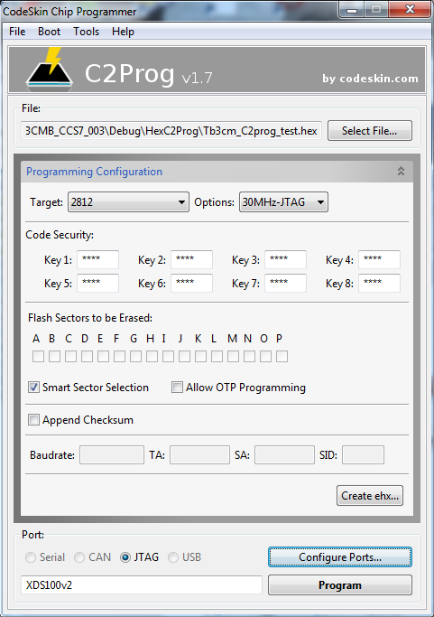

“Code security:” keys should be left to default to “FFFF” – that’s the default value behind the “****” Right now TB3CM DSP code is not using password protection. Additionally, I have explicitly include DSP218x_CSMPasswords.asm in my code with “FFFF” in password locations.

Click the “Configure Ports …” button to display the little “Port Configuration” window. Today I’m trying out a “TI / Spectrum Digital XDS100v2 emulator which connects to my PC vis a USB cable. Remember you have to selected one of the “…MHz-JTAG” options – next to the “Target:” selection at the top of the form – before C2Prog will let you select the “JTAG” radio button in the “Port:” selection at the bottom of the form.
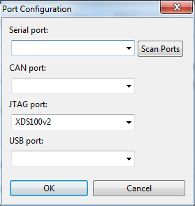

Here’s what I got when I finally clicked the “Program” button.
