Detecting Target species, and related taxa:
Dataset source: iNaturalist.
Filtered for genus Scelotes along the West Coast only.
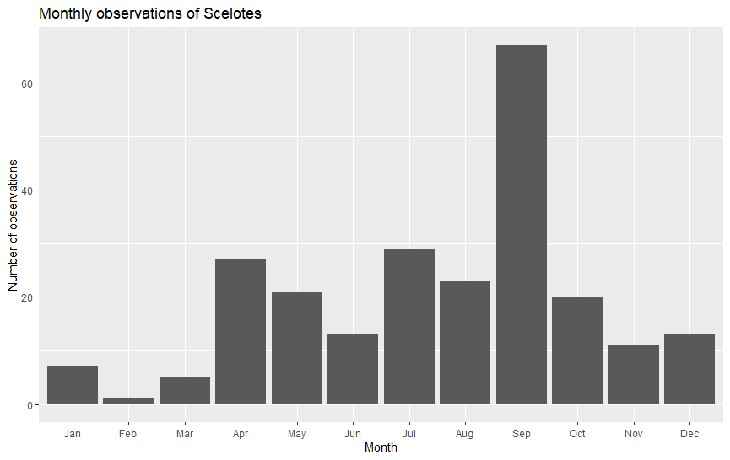git

Figure 1: Bar plot showing the number of Scelotes observations recorded in each month.
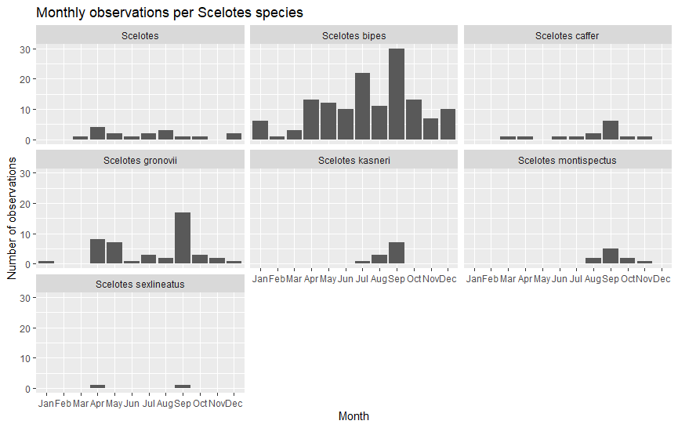
Figure 2: Monthly observation frequencies for each Scelotes species, shown in separate panels.
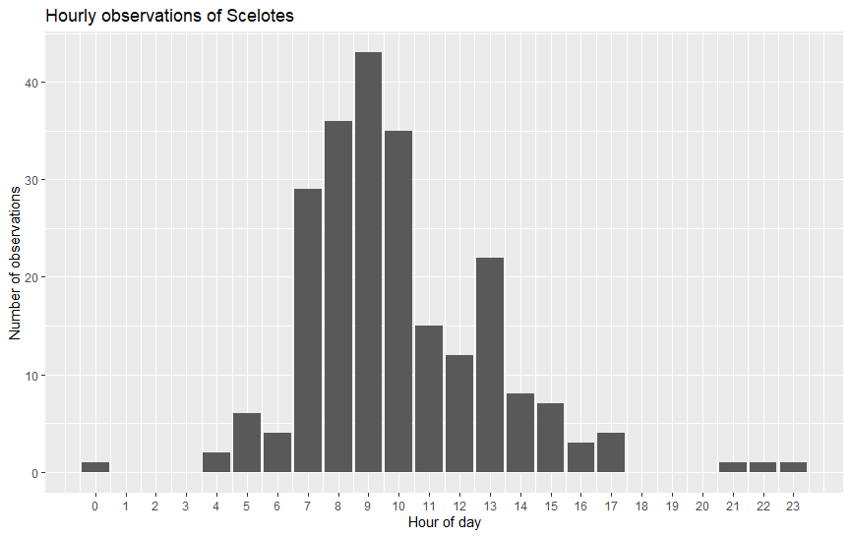
Figure 3: Hourly distribution of Scelotes observations across the day.

