Table of Contents

1. Purpose 2

1.1 Intended Audience………………………………………………………………………………………………………………..2

1.2 Intended Use.………………………………………………………………………………………………………………………..2

1.3 Scope ……………………………………………………………………………………………………………………………………2

1.4 Definitions and Acronyms……………………………………………………………………………………………………..2

2. Overall System Description………………………………………………………………………………………………………………….3

2.1 Use Case Diagram………………………………………………………………………………………………………………….3

2.2 System Architecture………………………………………………………………………………………………………………4

2.3 Functional Requirements………………………………………………………………………………………………………5

2.3.1 Start Up and Main Menu……………………………………………………………………………………….5

2.3.2 Function1………………………………………………………………………………………………………………6

2.3.3 Function2 and Flowchart…….…………………………………………………………………………………6

2.3.4 Remote Access………………………………………………………………………………………………………6

2.3.5 Authentication Services…………………………………………………………………………………………7

2.4 Non-Functional Requirements………………………………………………………………………………………………8

2.4.1 Power Management………………………………………………………………………………………………9

3. Software Architecture………………………………………………………………………………………………………………………….9

3.1 Static Software Architecture………………………………………………………………………………………….…….10

# 1. Purpose

1.1 Intended Audience

This SRS document describes the System Requirements and Software Design for Supermarket Self-Checkout System and the target audience are customers at a supermarket.

1.2 Intended Use

This SRS defines the overall System Architecture and Requirements as well as the Software Architecture and Design. This document also contains the definition of the System Requirements which shall be used as the input for System Test cases and Software Unit Test cases.

1.3 Scope

1.4 Definitions and Acronyms

2. Overall System Description

2.1 Use Case Diagram

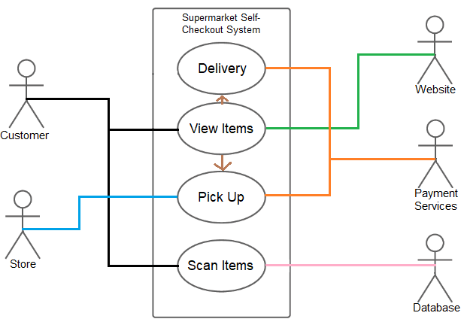

2.2 System Architecture



## Functional Requirements

### 2.3.1. Start Up and Main Menu

|  |  |
| --- | --- |
| **REQ_ID** | **Requirement** |
| REQ-01 | When the machine is turned on, the main menu will display  “Touch to Begin” or “start” |
| REQ-02 | Given the menu defined in REQ-01, if the option “Start” is selected, then the following text is displayed on the LCD screen  Line 1 = “Scan your groceries” |

2.3.2. In-store purchase

|  |  |
| --- | --- |
| **REQ_ID** | **Requirement** |
| REQ-03 | If the user presses start, the camera will be turned on and allow items to be scanned, which will follow the flowchart in Figure 1. |

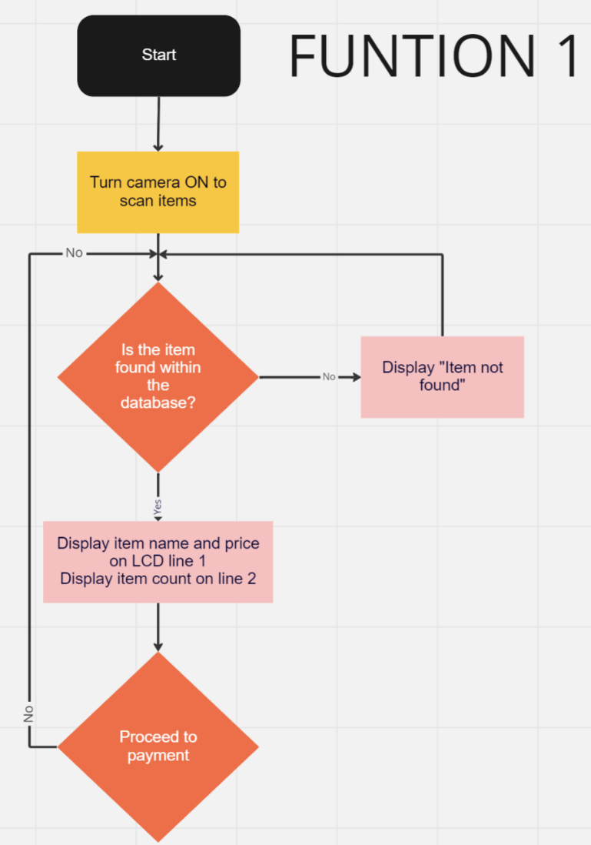

**Figure 1**

### 2.3.3. Payment method: paywave

|  |  |
| --- | --- |
| **REQ_ID** | **Requirement** |
| REQ-04 | After the user has finished scanning the items, they are able to proceed to payment and at that point, the user can select “1. PayWave” then it checks that the card is a valid card that has been tapped. If it is a display “payment successful”  Otherwise, it will return to “please tap card” |

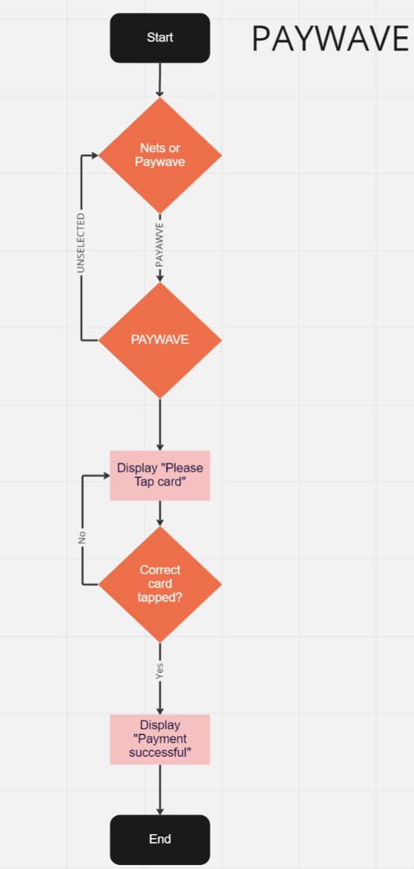

**Figure 2**

### Payment method: Nets

|  |  |
| --- | --- |
| **REQ_ID** | **Requirement** |
| REQ-05 | After the user has finished scanning the items, they are able to proceed to payment and at that point, the user can select “2. Nets” it checks that the card is a valid card that has been tapped after that they have to type in their pin thumber Otherwise, it will return to “please tap card” after 15s |

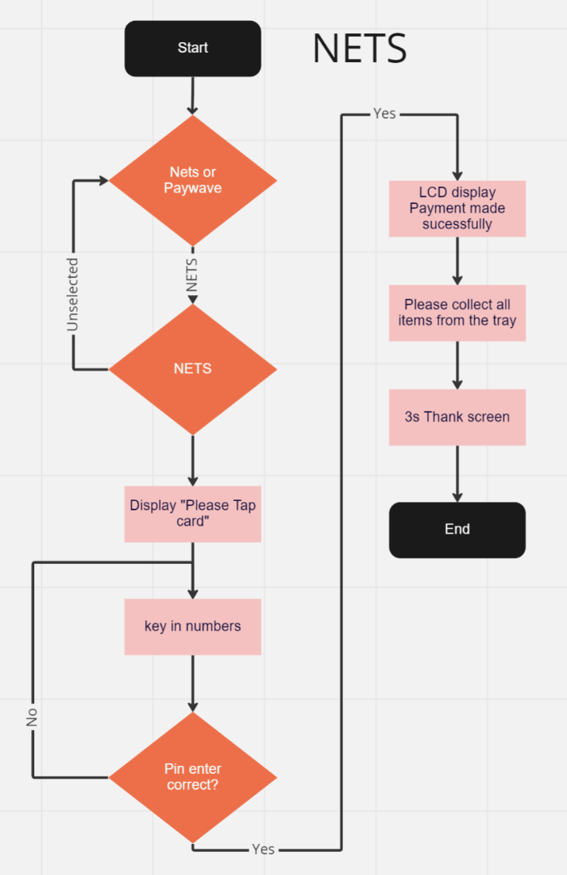

**Figure 2**

### Remote Access

The Coffee Maker supports “Remote Access” to monitor the coffee maker functions, set events and remote

|  |  |
| --- | --- |
| **REQ_ID** | **Requirement** |
| REQ-07 | The user shall be able to login to the IP address of the IoT Coffee Maker to view a web page |
| REQ-08 | The internal Web Server on the IoT Coffee Maker shall allow the user to monitor the following,     * Water Level using Moisture Sensor * Ambient Room Temperature |
| REQ-09 | The internal Web Server on the IoT Coffee Maker shall allow the user to control the following,     * View the Main Menu defined in REQ-01 * Trigger all functions in the main menu remotely |

### Authentication Services

For commercial variants of the coffee maker, an added feature is to authenticate the user log in to use the coffee maker via an NFC card reader before unlocking the functions on the coffee maker for the user.

|  |  |
| --- | --- |
| **REQ_ID** | **Requirement** |
| REQ-21 | For commercial variants of the IoT Coffer Maker with NFC reader, upon Power On the LCD shall display the following    Line 1 = “Tap card to unlock”  Line 2 = Display time “hh:mm:ss” |
| REQ-22 | If the NFC reader detects a NFC card that has been registered in the internal data base then the coffee maker shall display the main menu defined in REQ-01 |
| REQ-23 | If the NFC reader detects an unregistered NFC card, the following shall be implemented,     * LCD shall display the following.      * Buzzer shall be activated based on the timing diagram below     **500**  **ms**    **500**  **ms**    **500**  **ms**    **500**  **ms**    **Buzzer**    **ON**    **OFF** |

2.4. Non-Functional Requirements

2.4.1. Power Management

The IoT Coffee Maker has 2 Power Modes as defined in the State Machine diagram in Figure xx below. The transitions between the Low Power Mode and High Power Mode are triggered by the events labelled “evEnterLPM” and “evEnterHPM”.

Conditions for trigger the events are defined in the requirements below.

**Figure 3**



High Power Mode



Low Power Mode



evEnterLPM



evEnterHPM

|  |  |
| --- | --- |
| **REQ_ID** | **Requirement** |
| REQ-24 | **“evEnterLPM” Trigger Condition 1**    ▪ When the option “2. Power Off” is selected in the main menu |
| REQ-25 | **“evEnterHPM” Trigger Condition 2**    ▪ When the coffee maker has not dispensed any coffee for at least 1 minute |
| REQ-26 | **“evEnterHPM” Trigger Condition 1**    ▪ When the user presses any button on the key pad |
| REQ-27 | **“evEnterHPM” Trigger Condition 2**    ▪ When the Ultrasonic Distance Sensor detects an object is within 10 cm of the coffee maker |
| REQ-28 | **“evEnterHPM” Trigger Condition 3**    ▪ When the IR sensor detects that the coffee container has been removed |

1. Software Architecture

3.1. Static Software Architecture

The Software Architecture defines the various Software Components that are developed to realize the implementation of the system requirements.

