EGB240: Electronic Design

Assessment 2: Digital Voice Recorder

Don Misura Minduwara Kaluarachchi

N10496262

# Executive Summary

The aim of this project is to document the implementation of an input conditioning circuitry for a digital voice recorder on a Teensy 2.0 board. Due to real world limitations implementation of the analogue signal conditioning cannot be done therefore its process is documented.

A series of filters are designed in which the output of the microphone is passed through. The signal is first passed through a high pass filter was used it was then passed though the 6th order Chebyshev filter designed on MATLAB and ltspice.

Before implementation of the filter the components value and other parameters were calculated and simulated in MATLAB. These steps will be covered in more detail with in this design documentation

Table of Contents

Executive Summary 2

List of tables and figures 4

Introduction 5

Background/Literature review 6

About Human Speech 6

Analog and Digital signals 6

Op-amps 8

Filters 10

Chebyshev and Butterworth filters 10

Task 12

Input filter 12

13

LTspice simulation 14

Verification of simulation 16

Conclusion 17

References 17

Appendices 18

Appendix A – Excel sheets used 18

Appendix B - Extension 19

# List of tables and figures

Fig. 1 Development board………………………………………………………………………...5

Fig. 2 Human hearing……………………………………………………………………………..6

Fig. 3 Human speech………………………………………………………………………………6

Fig. 4 Differences between signals………………………………………………………………..7

Fig. 5 Comparing analogue and digital signals……………………………………………………7

Fig. 6 ADC sampling……………………………………………………………………………...8

Fig. 7 Operation amplifier…………………………………………………………………………8

Fig. 8 Operation amplifier…………………………………………………………………………8

Fig. 9 Inverting amplifier………………………………………………………………………….9

Fig. 10 Non-inverting amplifier…………………………………………………………………...9

Fig. 11 Unity gain follower………………………………………………………………………..9

Fig. 12 Butterworth filter response………………………………………………………………10

Fig. 13 Equation for frequency response of Butterworth filter…………………………………..10

Fig. 14 Chebyshev filter frequency response…………………………………………………….11

Fig. 15 Equation for frequency response of Chebyshev…………………………………………11

Fig. 16 Graph of different filter types……………………………………………………………11

Fig. 17 MATLAB simulations……………………………………………………………….12-13

Fig. 18 LTspice simulation………………………………………………………………………14

Fig. 19 LTspice simulation………………………………………………………………………14

Fig. 20 LTspice simulation………………………………………………………………………15

Fig. 21 LTspice simulation………………………………………………………………………15

Fig. 22 LTspice simulation………………………………………………………………………16

Fig. 22 LTspice simulation (output)……………………………………………………………..16

Fig. 23 LTspice simulation (stage 2)…………………………………………………………….16

Fig. 24 LTspice simulation (input)………………………………………………………………16

Fig. 24 LTspice simulation………………………………………………………………………16

# Introduction

This report Is a technical documentation of the design process, methodology and other research that took place to complete the designated task.

The task given was to simulate input analogue conditioning circuitry for the Digital Voice Recorder (DVR). The task is to be carried out on the Teensy 2.0 microcontroller board which is provided by QUT. The analogue input conditioning circuitry that is designed will be interfaced to the microcontroller via the analogue to digital converter (ADC) peripheral as shown below. [1] The analogue input condition circuitry is based on the TL974 operational amplifier which has also been provided.

Fig. 1 Development board [1]

# Background/Literature review

## About Human Speech

The general human hearing range is from 20 – 20kHz the female voice and male voice ranges however are between the ranges 350Hz to 17kHz and 100Hz to 8kHz respectively. Microphones are designed to measure frequencies from as low as 50Hz up to 20kHz. [2] The figures shown below show the characteristics of human hearing and human speech

Fig. 2 Human hearing [3]

Fig. 3 Human speech [6]

The human voice produces sound which is a form of energy and oscillates and vibrates which can be converted to voltages form using a microphone.

## Analog and Digital signals

Analog signals are varying amounts of information against time. These include audio, video and other forms of data. The characteristic of analog waves is that the signals are continuous [4]. Digital signals however are discrete in value and in time and are represented by binary numbers and consistent of different voltage values.

Fig. 4 Differences between signals [5]

Fig. 5 Comparing analogue and digital signals [5]

Fig. 6 ADC sampling [1]

## Op-amps

Operational amplifiers also known as op-amps are voltage amplifying devices [7]. It’s inputs consist of a non-inverting input with voltage (V+) and an inverting input with voltage (V−) as shown by the diagrams below.

Fig. 7 Operation amplifier [7] Fig. 8 Operation amplifier [1]

Operation amplifiers can be structed in a few ways such as inverting, non-inverting, summing, differential etc. The ones used in this task are mentioned below.

1. Inverting amplifier

* inverting amplifier inverts the input signal and produces a gain equal to –R2/R1 [1].

Fig. 9 Inverting amplifier [1]

1. A picture containing object, clock

   Description automatically generatedNon-inverting amplifier

* It amplifies the input signal without inverting the signal [1].

Fig. 10 Non-inverting amplifier [1]

1. Unity gain follower

* A picture containing clock

  Description automatically generatedUsed as a buffer because of its isolating properties [1].

Fig. 11 Unity gain follower [1]

## Filters

Filters can be categorised as

1. Active filters
2. Passive filters

Passive filters are made using passive components such as resistors, capacitors and inductors. These filters cannot amplify a signal. Active filters use active components such as transistors and op-amps and need a power supply so they can amplify the signal [1].

Filters can also be classified as low pass, high pass and band pass filters. For this task we are using an active low pass filter. Specifically, a Chebyshev filter.

## Chebyshev and Butterworth filters

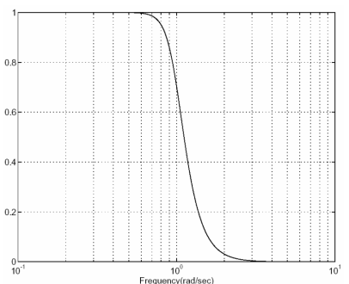Butterworths exhibit a flat passband with no ripple. The roll off is smooth and has a good phase response. Shown below is a diagram of a Butterworth filter [9].

Fig. 12 Butterworth filter response [9]

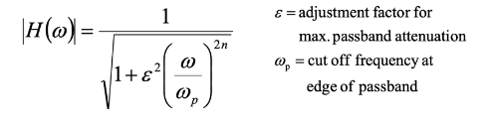The frequency response of a Butterworth filter can be calculated by the equation shown below.

Fig. 13 Equation for frequency response of Butterworth filter [1]

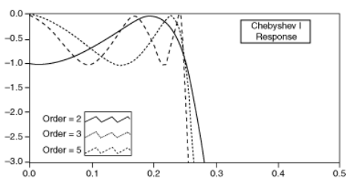Chebyshev filters are analog filters that has a faster roll-off by allowing ripple in the frequency response. As the ripple increases the roll-off becomes sharper. The con of using a Chebyshev is that they have poor phase response.

Fig. 14 Chebyshev filter frequency response [8]

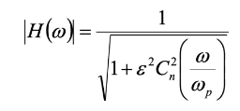The frequency response of a Chebyshev filter can be calculated by the equation below.

Fig. 15 Equation for frequency response of Chebyshev filter [1]

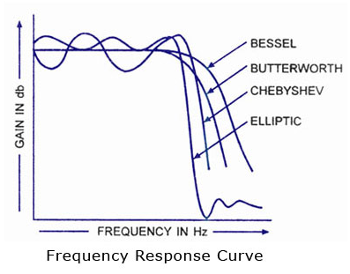Chebyshev filters produce better results than the Butterworth filter for this task because it has a step roll-off response than a Butterworth filter as shown in the diagram below.

Fig. 16 Graph of different filter types [9]

# Task

## Input filter

As mentioned above the use of a Chebyshev filter was considered over a Butterworth filter. Specifically, a 6th order filter. This filter was implemented in MATLAB to receive proper values. The equations shown below were used for the MATLAB calculations

Stop band frequency as per Shannon Nyquist theorem,

Maximum attenuation in the stop band

To find the coefficients to use for the spice simulation the function shown below was used in MATLAB.

Figs. 17 MATLAB simulations

As shown by the images above the cheby function was used to calculate the coefficients to be used with the filter along with the components values which were determined using the excel sheet found in appendix A.

## LTspice simulation

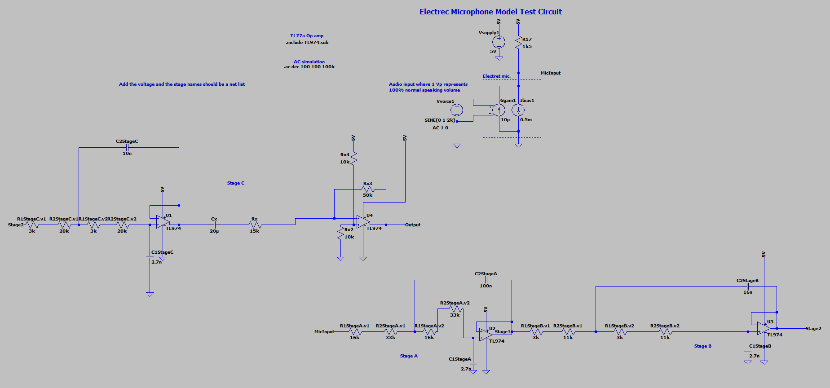The calculated component values were set up in the LT psice simulation abd shown in the figure below. The first figure shows an overview of the 6th order cheybshev filter and the following figures show it’s components in more detail.

Fig. 18 LTspice simulation

Stage A and Stage B

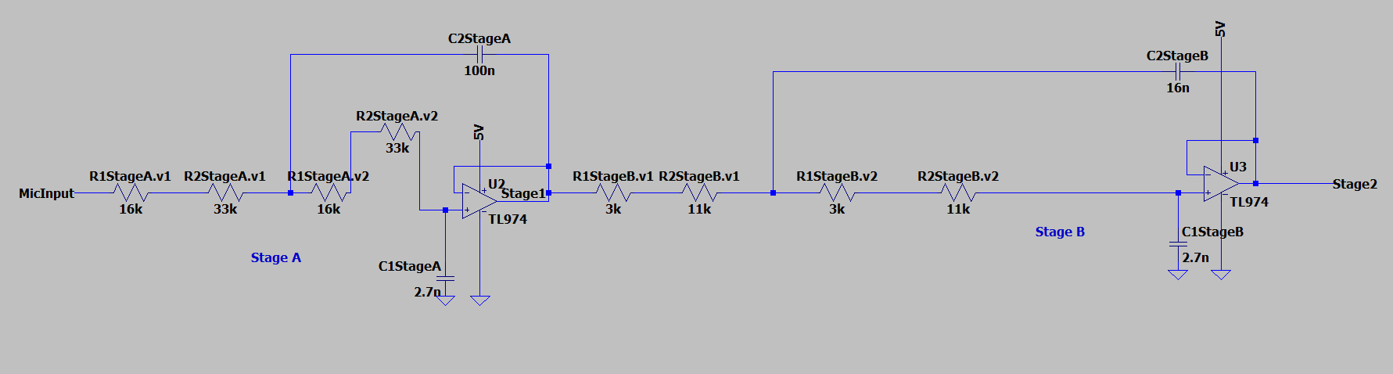

Fig. 19 LTspice simulation

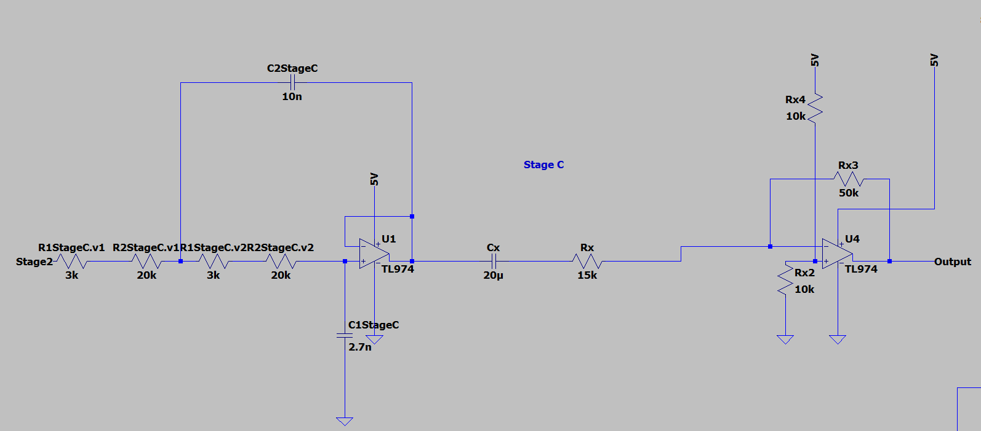Stage C

Fig. 20 LTspice simulation

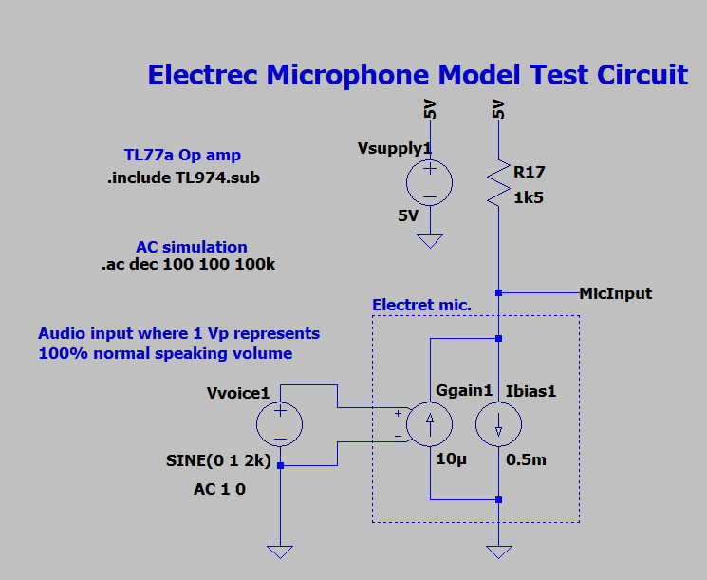Microphone

Fig. 21 LTspice simulation

## Verification of simulation

The simulations performed in LTspice are shown below for the output, stage 2, the input and a final graph of all waveforms.

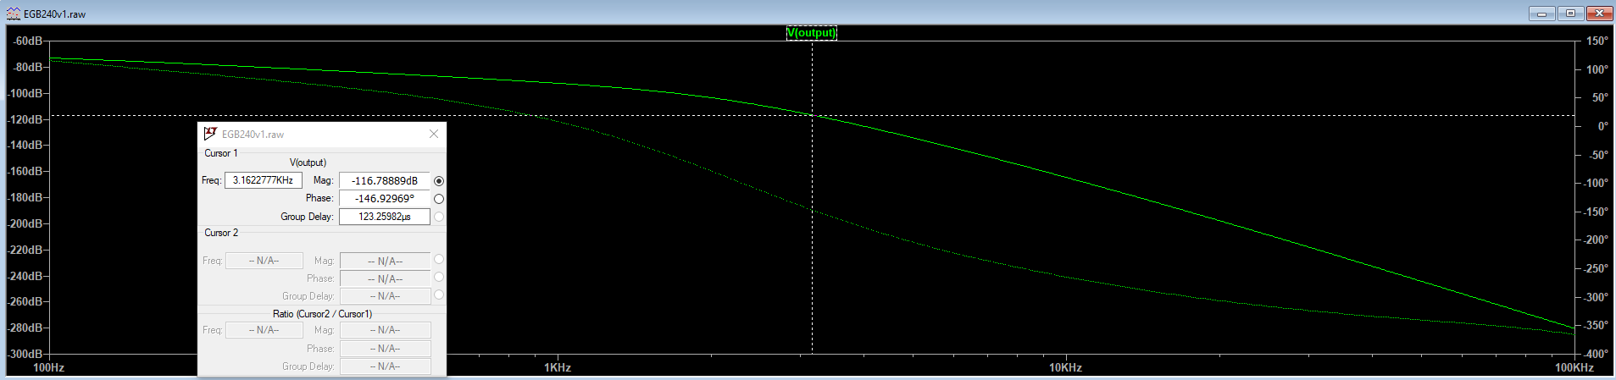As seen by the results the filter works as intended.

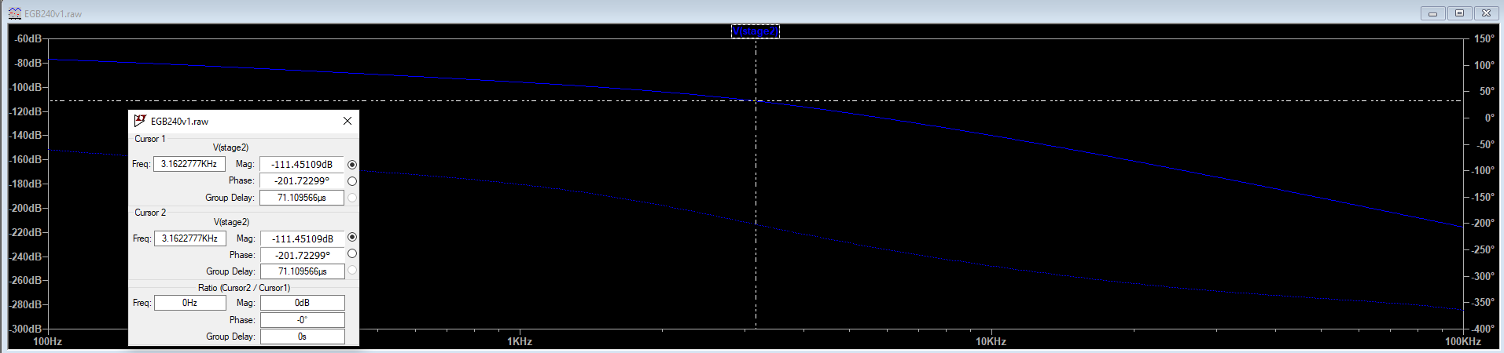Fig. 22 LTspice simulation (output)

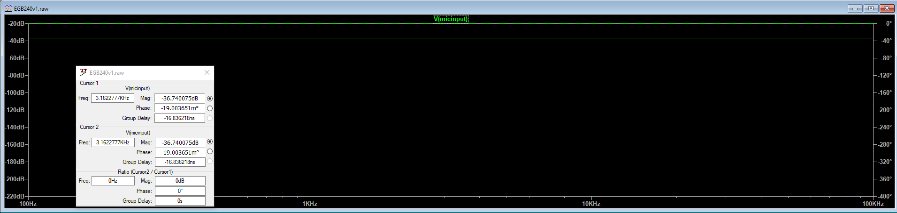Fig. 23 LTspice simulation (stage 2)

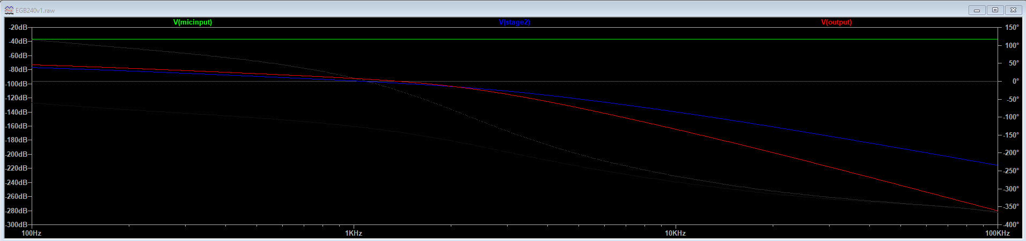Fig. 24 LTspice simulation (input)

Fig. 25 LTspice simulation

# Conclusion

The filter works as intended but for future projects the used of a butterworth filter or different order of Chebyshev can be explored and different set ups so that less error occur throughout the process.

# References

[1]*QUT Blackboard*, 2020. [Online]. Available: https://blackboard.qut.edu.au/bbcswebdav/pid-8450378-dt-content-rid-30612278_1/courses/EGB240_20se1/EGB240_Assessment2_2020_Rev1.pdf. [Accessed: 25- May- 2020].

[2]"Human Voice Frequency Range - Sound Engineering Academy", *Sound Engineering Academy*, 2020. [Online]. Available: https://www.seaindia.in/human-voice-frequency-range/. [Accessed: 26- May- 2020].

[3]"Human hearing andvoice", *Users.cs.cf.ac.uk*, 2020. [Online]. Available: https://users.cs.cf.ac.uk/Dave.Marshall/Multimedia/node271.html. [Accessed: 26- May- 2020].

[4]"Analog and Digital Signal Explained - Soundbridge", *SoundBridge*, 2020. [Online]. Available: https://soundbridge.io/analog-digital-signal-explained/#:~:text=In%20other%20words%2C%20Analog%20signals,of%20a%20continuously%20variable%20quantity.&text=This%20is%20what%20analog%20represents. [Accessed: 26- May- 2020].

[5]"Difference Between Analog And Digital Signal in Tabular Form | BYJU'S", *BYJUS*, 2020. [Online]. Available: https://byjus.com/physics/difference-between-analog-and-digital/. [Accessed: 26- May- 2020].

[6]*DPA*, 2020. [Online]. Available: https://www.dpamicrophones.com/mic-university/facts-about-speech-intelligibility. [Accessed: 27- May- 2020].

[7]"What is an Operational Amplifier? | Basics For Beginners", *Electronics For You*, 2020. [Online]. Available: https://www.electronicsforu.com/resources/learn-electronics/operational-amplifier-basics#:~:text=An%20Operational%20Amplifier%20or%20op,usually%20a%20single%2Dended%20output. [Accessed: 27- May- 2020].

[8]"Chebyshev Filter - Diffferent Types of Chebyshev Filters", *ElProCus - Electronic Projects for Engineering Students*, 2020. [Online]. Available: https://www.elprocus.com/types-of-chebyshev-filters/#:~:text=Chebyshev%20filters%20are%20nothing%20but,the%20actual%20and%20idealized%20filter. [Accessed: 02- Jun- 2020].

[9]*Ele.uri.edu*, 2020. [Online]. Available: https://www.ele.uri.edu/courses/ele314/handouts/YS06_Classicfilters.pdf. [Accessed: 02- Jun- 2020].

# Appendices

## A screenshot of a cell phone Description automatically generatedA screenshot of a cell phone Description automatically generatedA screenshot of a cell phone Description automatically generatedA screenshot of a cell phone Description automatically generatedAppendix A – Excel sheets used

## Appendix B – Extension

