Auditory Stimuli Reconstruction for Electroencephalography Data at Development Stage: A Topological Approach
Martín Alcántara, m.alcantara@uc.cl
November 28, 2025
2. Abstract
Recent studies aim to test neural entrainment for auditory stimuli on EEG data. Results for this vary, but they generally support the theory. However, there is a lack of study of the phenomenon for infant data, and if it were to hold, it could be used as an indicator for language acquisition at an early stage of development. To tackle this issue, we aim to generalize the standard linear approach, by introducing nonlinearity through the extraction of topological features present in the data. Multiple models were defined, with increasing level of complexity, as to iteratively build a notion for relevant structures and features that play a role on neural entrainment. In particular, these models aim to evaluate the performance that regression methods obtain when reconstructing auditory stimuli, and compare it with the reconstruction of a sped-up copy of the stimuli. The results are robust, and support the hypothesis that infants will have a lower degree of neural entrainment if the audio is played at a significantly higher speed, and we conclude this to be due to having a lower attention to a stimuli they don’t recognize as a speech directed to them.
3. Introduction
In the last few decades, there has been an increasing interest and research that links the neural activity with auditory and linguistic stimuli. The fact that the brain responds to external stimuli has been known for as long as it has been understood as an electric and excitatory system, that obeys the laws of electromagnetism. It is still, however, not understood precisely how this information is encoded and decoded. However, with the recent advancements in mathematical and computational tools, many researchers have decided to tackle this problem.
One such tool developed in the last decade is the Multivariate Temporal Response Function (mTRF), developed by Crosse et al. (2016). This tool, available as a MATLAB toolbox, has a central hypothesis. It claims that the brain activity, as measured by an electroencephalogram (EEG), can be described as a convolution; as a linear transformation of the original stimuli, or at the very least features extracted from it. In other words, the EEG synchronizes with the stimuli; phenomenon often referred to as Neural Entrainment.
Using the aforementioned methodology, PhD Marcela Peña proposed using mTRF to study early language acquisition and communicative abilities. In particular, it has been observed that there is a specific way, given by speech speed, rhythm, and pitch, with which infants become more attentive and interested (Endevelt-Shapira et al., 2024). Thus, Peña proposed that, as speech speed increases, the synchronization rate between EEG and stimuli should decrease. Therefore, an experiment was defined and data collected to test this hypothesis, with two stimuli categories: audios played at an adequate speed (slow), and a sped-up copy (fast).
The utilization of mTRF, whilst it has shown significant results, makes a nontrivial assumption. Numerous authors have stated that brain activity behaves nonlinearly with both internal and external stimuli (Qu et al., 2024; Akritas et al., 2024). That, however, does not imply that either Crosse’s or Peña’s hypothesis are entirely incorrect. In particular, there might be a linear operator that maps features extracted with nonlinear methods.
It is following this line where we propose using Topological Data Analysis (TDA) tools to extract features from both stimuli and response data, to later map them through different methods. We will be using the data collected by Peña and her team and will thus expect similar results. That is, we expect a higher level of similarity between slow stimuli and response pairs, over fast pairs. Additionally, we follow the backwards model as described by Crosse et al.; we aim to reconstruct the auditory structure, from features gathered from the EEG data. This is done in multiple ways, with escalating levels of complexity, as described further in this document.
4. Data Description
As mentioned before, the data comes from an experiment designed and led by researcher Marcela Peña, as per her funded project FONDECYT: 1241946. The stimuli consisted of 46 different auditory stimuli; 23 distinct audios played at an adequate speed for infants, and 23 copies of the same audio sped up by 60%. Over 80 subjects took part in the experiment, with ages around 4 months old, and having no record of learning disabilities, or physical impairments. Some metadata, such as their parent’s education and similar information was also collected. However, this was not shared publicly, nor would it affect the results in this report. It would be interesting, however, to add this data in order to cluster or classify different subjects based on their performance and make additional conclusions.
The original EEG data was recorded and saved as MATLAB .mat files, with a sampling frequency of 250Hz. As for the audios, they were saved as .auff files with a sampling frequency of 44100Hz. In a previous preprocessing stage, these files were cut and synchronized, being saved separately for each EEG/audio/speed tuple (or case from now onwards). Both EEG and audio files had the same time length (when taking into account sampling rate), but it changes through audio files and, clearly, through speed. The EEG data was recorded in 65 channels, but only 47 of them constituted real data, as the lowest 14 were not in the head, as the recording device was not suited for heads of 4 month babies.
The most common obstacle when dealing with EEG data is noise and artifacts. Every movement or perturbation while recording will be detected by the recording device, and such, denoising is a key part of dealing with such data. This is increasingly important when dealing with infant measurements, as they are more prone to sudden movements, and less tolerable to uncomfortable and tedious scenarios. Additionally, at such an early stage, the skull is not fully formed, and thus not only is the cranial impedance different from adults, having to then adapt most methodologies and pipelines, but it also cannot be assumed constant through participants, as even while having a similar age, they can be in widely different development stages of their skull.
5. Preprocessing
As mentioned above, denoising and artifact removal is key in any experiment dealing with EEG data. However, the data used throughout this document was already preprocessed before I started working with it. I know, however, this preprocessing was done using APICE, a general pipeline for this purpose on EEG data from infants. This pipeline both filters out artifacts to clean data or outright removes certain trials or even full subjects if they are deemed too noisy, usually related to outside factors such as an intervention of the study, or the subject being unwilling to continue (communicated in this case by crying).
After the above pipeline was finished, only 47 of the original subjects remained, with most having only a portion of their trials still available. Additionally, due to the nature of the hypothesis, every case that didn’t have both conditions (the slow and fast variants) was discarded. Even though this doesn’t cut any subjects, the number of trials for some subjects was severely reduced. That’s why the number of subjects considered was lowered, so more robust conclusions could be made from them, as few trials will only induce statistical uncertainty. After some work, it was clear that the procedures done were too computationally expensive, so having a high number of cases caused trouble when defining methods for testing. Dimension reduction was not heavily considered for this, however, since it meant losing interpretability of the results, mainly the spatial dependance given by the EEG channels. With both reasons in hand, we considered seven subjects. While low, this allowed splitting the data through subjects, with two subjects available for testing. The subjects were selected such that they had at least 40 trials (20 for each category).
After this, since multiple models were tested, additional preprocessing was done for each model. Across every model both signals were lowered to a sampling rate of 64Hz, and the analytical envelope was used as stimuli instead of the raw audio, following the methods done in a similar experiment (O’Sullivan et al., 2014). For later models, the data was also split for different frequency bands.
Additionally, in almost every model, the takens embedding was taken for the envelopes, as to capture the delay between EEG and audio signals. In some instances, this was also done per channel for the EEG. From the second model onwards, the EEG data was interpolated and projected to a sphere through spherical harmonics and used as the response signal, both as a raw sphere, and projecting its upper half back to a unit square, as it’s there where most channels are plotted. This was done to capture a sense of spatial dependance between each channel, since their standard location in space was defined in Peña’s research. With this spatial representation of the data, the persistence diagram was extracted for each time, utilizing Cubical Complex as the filtration method. For each persistence diagram obtained, either through Cubical Complex or Takens Embedding, multiple topological features were extracted, as discussed in the following section.
Figures 1-4 in the Appendix correspond to illustrative examples of the different data used, in specific cases.
6. Topological Data Analysis.
A total of 5 models were used, with increasing level of complexity, in order to extract topological information, later tested for stimuli reconstruction. They will be described and justified as follows. And finally, there will be a brief discussion on the computational dependencies used to compute them.
For the first and most basic model, the objective is to test if the EEG structure can be mapped straight into the audio structure. Therefore, a sliding window was employed to both EEG data, and audio data. The first parameters tested were a delay of 1 (i.e. without skipping points), and a window size of 2 and 3. On one hand, the delay of 1 was to emulate the procedure on mTRF, as it’s a convolutional model done with no delay. On the other hand, the window sizes were selected as they correspond to ~31ms and ~47ms respectively, which is around the time it takes the brain to detect and react to a general sound (Korzyukov, 2009; Woods, 1995). This was deemed too low, as results were too similar to the original data. Therefore, window sizes were set to values of 30, 50 or 64, as to encode longer windows of time. Additionally, a delay of 10 was also used, as to reduce the importance of overly local features. With this construction, the objective is to map the Takens Embedding for each channel to the embedding of the corresponding audio.
On the second model, the EEG data used was its spherical interpolation, considering a spatial distribution of the measured data. For this model, however, the procedure was the same as before. For each point in the sphere, a sliding window was employed, and they were later mapped to the same Takens Embedding as before. Additionally, from this model onwards, EEG data was separated in three frequency bands: theta frequencies (2-6Hz), alpha frequencies (6-9Hz), and beta frequencies (9-14Hz). This is because different frequency bands have been shown to be linked to different events of human cognition (Askarpour et al., 2024; Cuevas et al., 2022; Ericson et al., 2025; Gong et al., 2024; Grace, et al., 2023; He et al., 2025; Lundy et al., 2023; Ren et al., 2021; Saby & Marshal 2012; Sharma & Singh 2015), where the alpha band is linked to attentional processes. Thus, we expect better performance on these cases, over the other two bands. We also clarify that these ranges are higher for adults, and thus in the general literature. However, research with subjects in an early stage of development suggest that the equivalent frequency bands are much lower (Arioli et al., 2024; Marshal et al., 2002; Cornelissen et al., 2015).
The third model, however, is the first to introduce a more complex representation for the signals. Taking the spherical representation of the EEG data we either have arrays of dimensions (Tx128x64) representing the data on a unit sphere, or of dimensions (Tx50x50), where the data was projected back to the 2D plane, with the upper point on the origin, and the upper half of the sphere projected to the unit sphere. The data was cut on the unit square, each size discretized with N=50, and every point outside of the unit sphere was set to 0. This way, only the data of the upper half of the sphere was considered, where all electrodes are placed, and thus the interpolation is most accurate. Whichever the case was, we now have either S² or an object in R², with assigned values in R. Therefore, we can construct a Cubical Complex through a sublevel filtration. The reason why this is interesting is twofold. First, this methodology is quite robust to noisy data. This can be derived from a theorem discussed in class, where for every tame functions $f,g: X →R$ with $X$ triangulable, the persistence diagram obtained through a sublevel filtration given by these functions have bottleneck distance bounded by ${\left|\left|f-g\right|\right|}_{∞}$. Whilst the definition of tame functions and triangulable set escape the scope of this report, it suffices to know that every smooth compact manifold is triangulable (James, 1962; Chairns, 1935), which S² is, and ${\left[-1,1\right]}^{2}⊆R^{2}$ is a compact subset of one, and every analytical function from a compact triangulable set is tame (van den Dries, 2009; Edelsbrunner & Harer, 2010; Milnor, 1963). Therefore, any reasonable mapping between EEG and audio will satisfy these requirements. Thus, if we obtain functions from two different observations (and therefore assume their difference highly relates to noise and outside perturbations), we can reasonably expect the filtrations to be well behaved. All this to say, that this methodology will be robust to noisy data such as infant EEG. The second reason why Cubical Complex, as defined through a sublevel filtration, is interesting is through its interpretation. In particular, the first homology group H₀ will correspond to peaks in the image space, whilst the second homology group H₁ corresponds to valleys in the image space; more precisely, ones surrounded by peaks. This rough interpretation discussed during class is highly relevant when considering the context of the data. Since the output of the EEG is the voltage difference with some ground data, it maps to both negative and positive values. Furthermore, peaks and extended measurements of both highly negative and highly positive data have been linked to different aspects of human cognition and stimuli response, especially when the activity is concentrated in different regions of the measurement space. Thus, since H₀ represents regions with highly positive voltage differences, whilst H₁ roughly represents regions with highly negative differences, extracting information from these is of much interest. Circling back to the method at hand, the resulting data is a series of persistence diagrams. The idea of this method is simply mapping these PDs to the persistence diagram obtained from the audio stimuli (as before, in Takens Embedding form). In addition to this, we can obtain a time series of topological features associated with the respective complexes, and it is then natural to map them to the corresponding feature from the audio embedding. In particular, we obtain descriptors for H₀ and H₁, such as their average lifespan, the amount of components that do not die, peak values for $β_{0},β_{1},λ_{0},λ_{1}$, and other descriptors seen in class.
The fourth method further escalates the previous concept. Taking the feature time series generated in the previous method, the objective is to map these with the auditory embedding. That is, whilst the third method maps these to a vector (feature vector from audio embedding), the present method tries to map them to the audio embedding, and therefore mapping directly with the evolution through time of the audio signal. Taking it a step above, we can take a sliding window for each feature time series and map them into the audio embedding with the same parameters. This way, include the benefits of the Takens Embedding (i.e. robustness to noise, and signal dynamic preservation), and include them on the analysis by comparing these two. As a final metric, we can take some distance between the respective persistence diagrams, obtained by a simple Rips filtration.
The fifth and final method can be thought of the less traditional method, and is proposed by yours truly. The concept is to take obtain a time series of defined as the difference between different points, and is heavily inspired by Takens Embedding. When defining this method, I was unsure if this would lead to any significant findings, either by lacking a real interpretation, or by being redundant with method 4. However, since the methodology was fairly similar to the former, I decided to still pursue it, and test for myself if it would lead to anything substantial, and include it here regardless of the outcome. That being said, noting that Takens defines its time series as follows:
$$X(t) = [x(t), x(t - τ),...,x(t-(m-1)τ)]∈R^{m}$$
I aim to define a similar time series as:
$$X(t) = [0, x(t) - x(t - τ),...,x(t) - x(t-(m-1)τ)]∈R^{m}$$
Therefore, each window will be dynamically shifted by a time depending factor. The intuition behind why I find this interesting, is that it might encode better the local fluctuation on time. That is, the starting point of each window will have higher importance and influence over the window. A similar alternative can be defined as followed, although I regrettably did not implement this:
$$X(t) = [1, \frac{x(t - τ)}{x(t)},...,\frac{x(t-(m-1)τ)}{x(t)}]∈R^{m}$$
I lacked the tools and time to mathematically analyze the relevance of such constructions. I therefore decided to test the first definition, and pursue the latter if the former method concludes with significant results, especially if they are distinct from the fourth method.
Lastly, all the code used throughout this project was done in Python 3.12. The above described methods are made possible through different general numerical libraries, such as NumPy and SciPy, alongside ones specialized on Topological Data Analysis. In particular, Scikit-TDA submodules persim and ripser were used for plotting persistence diagrams, and generating Rips Complexes respectively, while GHUDI was used to generate Cubical Complexes. To extract topological features from persistence diagrams, as well as the sliding windows used for Takens Embeddings, custom code was used, either defined in class, or a modified version of it. Additionally, Scikit-Learn was used for general statistical analysis, model selection, and other methodologies described in the following section. Libraries such as JSON, Pickle, and Pandas were used at different stages to process and store data. Finally, apart from persistence diagrams, every figure was generated with MatplotLib.
7. Statistical Analysis
Before starting, it is important to reiterate our hypothesis, as the following section aims to define statistical methods for testing it. In the most general sense, we state that we can reconstruct the audio data or general structure with the EEG data. Even more, we state that such reconstruction will be more accurate in slow cases, than their fast counterpart. Thus, it is important to define what these statement truly mean, and how we will formally test them.
First, the aim is to map a multidimensional input (EEG) to a multidimensional output (audio). Any set of hypothesis must be a set of functions that can work with this I/O structure. We will be using four methods, or regressors, to make such predictions, all from the Scikit-Learn library. This Python package is used extensively throughout this section, and will be referred to as sklearn from now onwards. Firstly, we use the Ridge Regression model, as it’s the closest predictor to mTRF, since the MATLAB toolbox solves a Ridge Regression optimization problem. Secondly, we use a Kernel Ridge Regression, with a Gaussian kernel, as it’s the most natural nonlinear extension to the Ridge Regression. Thirdly, we also use PLSRegression, as its biggest strength is highly correlated data, which would be the case if the hypothesis were to be true. Finally, we will use the basic neural network MLPRegressor.
Second, the previously mentioned regressors have hyperparameters that need to be trained. For this, the data will be split with a roughly 70-30 split of the data. To train the hyperparameters, a k-fold leave-one-out regime was used, with k=5. That is, training data was further split in five segments, and each segment served to validate the hyperparameter sets. Therefore, for every hyperparameter candidate, there are five different performance instances, and the candidate with the best average performance is used as the testing model. The hyperparameters trained are: alpha, (alpha, gamma), n_components, and hidden_layer_sizes, respectively.
Third, while the dimensions of each might vary from method to method, there are three dimensions that we have direct control over, and with which we can define our study: subjects, trials, and time. The subjects will be our training variable. That is, we will split the data through subjects, where the first and last subjects will serve to test the functions, and the remaining subjects will serve to train the predictors’ hyperparameters. In particular, we leave 2 subjects for testing, which leads to roughly 70% of the data available for training. The trials will simply be observations for each subject, which just multiply the samples for both training and testing. That is, we will have around 45 cases for testing, and 105 for training. The final dimension, time, will just be the identification for each point, and the reference for the regression.
Fourth, we define the performance of each model and regression. In particular, following the classical work on mTRF, we will be using the Pearson Correlation Coefficient, whilst every regressor will use the Mean Squared Error as loss function. That is, when training, every case will result in a different Pearson coefficient, and we will use the average of them as the validation score. Then, for each fold, we take, the average of these values to select the best hyperparameter set. And finally, for testing, we obtain one pearson per case.
Fifth, to statistically test the hypothesis, multiple test can be employed. The most direct approach, is just averaging the pearson coefficient from all the test case reconstructions, and observing which condition has a higher score. However, we can do better. Instead of taking the average, we can take the binary comparison for each test case, and assigning a value of 1 if the slow outperforms the fast condition, and 0 otherwise, and perform a binomial hypothesis test, to check if, based on the data, the odds of the slow condition having a better performance is higher than 0.5. Even though we can obtain a statistically significant result with this approach, it fails to distinguish how much, or how little, one category outperforms the other. Thus, the next proposal is a pairwise t-Student test with equal variance. The aim of this is to test if, on average, the pearson correlation for the slow condition is greater than that of the fast condition. Additionally, the results can also be done through a repeated measure ANOVA, considering we have multiple conditions of the same case (frequency bands, embedding parameters, etcetera), and consider the False Discovery Rate correction, to avoid synthetically generated correlations, by the sheer number of comparisons taken.
Sixth, we will also compare the findings with another model; model 0 if one may. This consists in simply mapping the raw EEG signal with the envelope of the audio. This approach tries to emulate the methodology of mTRF, but with the proposed regressors. This way, we can not only define if the topological features of both EEG and auditory stimuli map between each other, but how that compares to the mapping of the raw values, and thus how valid is the employment of TDA techniques to test this, and possibly similar, hypothesis.
8. Results
In this section we present the most relevant results among the six analysis methods. The full list of results can be found in the Appendix figures, and tables in the supplementary material.
First, we present the results obtained through model 0. That is, mapping EEG data directly to the envelope of the stimuli. We also reiterate that performance of a model will be defined based on the Pearson Correlation Coefficient between true and predicted signals, since this is the standard for the classical case through mTRF. On one side, the best predictor was PLSRegressor, where it had a Pearson coefficient of around 0.2 for the slow. However, the Ridge Regressor had the highest proportion of accurately classified trials; trials with higher pearson for the slow reconstruction, with 0.61 and 0.64 respectively. The other two predictors, however, fail to attain similar reconstruction performance. The binomial distribution result shows significant evidence that the slow cases outperform the fast ones, with a p-value around 0.035.
Second, we present the results obtained through model 1, and the first using TDA. The reconstruction is worse here than in the original case. Even though the average pearson for slow cases (0.143) is higher than that of the fast cases (0.114), a binomial comparison gives a poor p-value of 0.332. However, since we are yet to define structures with precise links, this loss of accuracy is expected. Additionally, since we now have multiple categories (Sliding Window parameters), we can make t-tests to estimate these performances, and repeated ANOVAs to test these. For this model, the performance is quite poor, with only one case having a significant p-value, and a non-significant ANOVA. But these two methods will be more useful moving forward.
Third, we have the results from model 2. This results in the most statistically significant model, with only MLPRegressor having a non significant p-value of 0.2. Even more, less than 20% of the cases with alpha band had a better fast stimuli reconstruction, whilst the other bands lacked clear tendencies. In particular, alpha bands had a 51.9 ± 0.075% and 53.5 ± 0.07% success rates for subjects “01” and “79” respectively, whilst theta bands had a higher disparity with 59.7 ± 0.08% and 0.39 ± 0.06% respectively, and beta bands had a higher variation with 63.1 ± 0.1% and 54.8 ± 0.07% respectively. Additionally, when running repeated measures tests with a False Discovery Rate correction, we find statistical proof suggesting that both the bands and the different data type (S² and [-1,1]²) affect the score between speed categories. However, there’s no substantial proof suggesting that they determine the score behavior, with the sole exception of differentiating alpha bands from theta bands.
Fourth, there are the results from model 3. This model was separated in two parts. First, the sequence of persistence diagrams was directly mapped to the Takens’ Persistance Diagram from the Audio. These cases had a correlation coefficient really close to 1, and the only statistically significant result is the data type distinguishing correctly the different speeds, with p-value < 0.04. The second part corresponds to mapping the time series of topological descriptors towards the audio’s descriptors from the Takens Embedding. On one hand, on the first case there not only was a lack of evidence, but the data supported that fast cases overperformed the slow cases, with having higher proportions with fast over slow, and higher average pearsons. On the other hand, mapping to the feature vector yielded statistically sound results, with a p-values on the order of 10⁻²⁰ or lower.
Fifth, we present the results from model 4. This model generalizes the previous case, where a sliding window was applied to the topological feature vectors across time. That is, a comparison between two structures with the same dimensions, but with EEG having 21 times more observations, which is the size of the feature map, and mapping them into the audio Takens Embedding. First, however, we compare the feature series with the embedded audio, obtaining an average success rate is 42.9 ± 0.09% and 0.048 ± 0.12% for subjects “01” and “79” respectively, and a binomial test p-value of over 0.99. However, the highest difference comes from the beta band, with a proportion of 38.7%. If we ignore this case, the binomial p-values drop to 0.025. Additionally, upon obtaining the ANOVA tests, this model also separates fast from slow with a high degree of significance. Finally, window size and stride for the sliding windows both separate data with standard α-threshold, type of EEG data distinguish speeds with a p-value of 0.088, and bands have no statistical relevance when classifying the cases. Second, we repeat the procedure for the embedded features, and obtain accuracies of 46.9 ± 0.11% and 51.7 ± 0.13% respectively, and a binomial p-value of 0.055, barely not having statistical weight under standard α-thresholds. And for the corrected ANOVA tests, only type of data fails the statistical test with a p-value of 0.22.
Sixth, we can take a look at the results from model 5; the proposed model based on the difference from the Persistence Diagrams. This proposed structure is mapped to both the audio’s Takens Embedding, as well as the embedding generated with the same construction. For the first case, we obtain proportions of 43.9 ± 0.14% and 49.8 ± 0.14% respectively, with a p-value of 0.98 for the binomial test, and all categories distinguishing the speeds.
The full results can be found in the supplementary data, across four distinct csv files.
9. Discussion
Following the same structure as the results section, we start by discussing the standard case, noting that the results support our initial hypothesis, where a reconstruction done by some adequate function will have higher performance when trained on slow data, as opposed to when it deals with accelerated data. The fact that both “Ridge” and “PLSRegressor” significantly outperform “KRidge” and “MLPRegressor” indicate that, in fact, this mapping is linear by nature, and by introducing nonlinearities the performance drops. This, while not being in line with the nonlinear activity of the brain, does go in tandem with Crosse’s mTRF proposal.
The first proposed model also had a better slow reconstruction, but without the statistical guarantees. This makes sense since, in practice, it’s the same model as model 0, but taking a sliding window over each channel, and thus uniformly increasing the amount of data points without adding new information directly. This can lead to two issues: certain outliers or sudden peaks in the EEG data appear more times, and thus have a stronger effect on the regression, even when proportionally they appear on the same proportion; or more plausible, by increasing the amount of points, the model suffer from overfitting on the training subjects, and therefore generalize poorly to the test subjects in comparison.
The second proposed model has p-values on the orders of 10⁻²⁰ and thus distinguishes exceptionally well between the two conditions. This indicates a high level of spatial dependance of the EEG response under the Audio stimuli. This behavior holds across many of the parameters selected. Importantly, it holds for all bands, window sizes, stride, data type, and almost every model, with the exceptions being “KRidge” and “MLPRegressor”. Importantly, we note that the best performing frequency band corresponds to the alpha band, which has been linked to linguistic and auditory cognitive processes (Arioli et al., 2024; Grace et al., 2023). One cannot ignore that such low p-values might indicate artificially induced artifacts, or mistakes at some steps of the coding stage. These kinds of oversights, however, would perpetuate into following models, since they were constructed sequentially, utilizing structures and objects defined in previous models. Thus, it is justified to consider these values as valid with sufficient confidence.
The third proposed model had two variations, with opposite conclusions. This, however, arises from the fact that it’s the model most prone to overfitting. That is, considering the regression is directed to either one Persistence Diagram, or one vector of features, both being significantly less numerous than the EEG data. Therefore, most conclusions derived from this model need to be taken cautiously. The importance of this model, however, is less about the specific results, and more about setting a precedence for the next model.
The fourth proposed model is the most complex and rigorous model discussed so far. This is because it aims to map, in some sense or another, the evolution in time of the topological features and abstract geometry of the EEG data, into the evolution in time of the Audio stimuli, and thus is the most robust extension of the mTRF problem with TDA tools. For the first variation of the model, the p-value is almost 1, suggesting it is statistically irresponsible to make any conclusions. However, this behavior is dominated by the beta band, which as discussed previously has the least relevance to attentional processes. Therefore, we can ignore it, and are left with statistical support, given by a p-value of 0.025, that the slow cases, in fact, outperform the fast reconstructions. For the second variation, we observe a binomial p-value of 0.055, giving statistically strong arguments, albeit not as strong as we ideally would want, to support our hypothesis.
For the fifth and custom model, we similarly see the main deviation arise from the beta bands and ignoring it leads to significantly better results. In particular, the p-value drops from 0.98, down to $3.22⋅{10}^{-5}$, reiterating the perturbation this band produces, and further supporting our hypothesis. In one sense, the results between this and the previous model are quite similar. But at the same time, they differ enough such that I find believe the embedding construction defined on section 6 has sufficient merit to be further explored. This is illustrated on Figures 2.B and 2.C, where we can observe a different shape of the embedding generated by the two formulations. And finally, this performance is further improved when the custom embedding is also applied to the auditory stimuli, with the binomial p-value reaching $2.08⋅{10}^{-8}$.
10. Conclusion
The present document aimed to validate the hypothesis proposed by both Crosse et al., and Peña, introducing a Computational Topology approach. For this, different methodologies were defined and tested, to determine with which extent these propositions hold, and how relevant is the introduction of TDA tools for the study. First, the best performing frequency band was the alpha frequencies (6-9 Hz), followed by the theta frequencies (2-6 Hz), whilst the beta frequencies (9-14 Hz) had a poor performance that would contradict the hypothesis. This, however, is supported by numerous research that link attention for linguistic and auditory stimuli to alpha bands, whilst beta frequencies have little to relate with these. Second, the best performing predictor was the classical Ridge Regression, followed closely by PLSRegressor, suggesting that the mapping between EEG and audio is linear, as initially proposed by Crosse et al. Third, the performance of each model was statistically shown to depend on the parameters used to extract topological data, thus implying that the abstract geometry of the EEG data depends on the speed at which the stimuli is heard. Fourth, it is shown that, for the aforementioned cases of interest, slow stimuli tend to produce a better synchronization than their fast counterpart. By combining all these findings, we can confidently state that infants have a higher degree of neural entrainment for auditory stimuli played at normal speed, as opposed to when the speech gets accelerated. Since the best synchronization occurs on the alpha bands, this behavior can be interpreted as the newborns paying more attention if they realize they are being talked to, as the original audios were constructed to emulate mothering speech, hence validating Peña’s hypothesis. Additionally, sufficient evidence validated a linear mapping between topological features of the data, supporting and generalizing Crosse’s hypothesis for Topological data.
11. Reproducibility
All codes used for this project will be found in the following Github Repository: https://github.com/DonMarto/TDA_EEG_IMT3801. I must clarify these are not organized nor clean documents.
The data for training and testing models is not available currently, as it is over 500GB total. Any inquiries about the data or any of the codes, my contact details are in the front page of this document.
12. Bibliography
Akritas, M., Armstrong, A. G., Lebert, J. M., Meyer, A. F., Sahani, M., & Linden, J. F. (2024). Nonlinear sensitivity to acoustic context is a stable feature of neuronal responses to complex sounds in auditory cortex of awake mice. eLife Neuroscience. https://doi.org/10.7554/eLife.98415.1.
Arioli, M., Mattersberger, M., Hoehl, S., & Brzozowska, Alicja. (2024). Peak alpha frequency is linked to visual temporal attention in 6-month-olds. Scientific Reports. https://doi.org/10.1038/s41598-024-79129-0.
Askarpour, H., Mirzaee, F., Habibi, F., & Pourfridoni, M. (2024, October 17). Binaural Beats’ Effect on Brain Activity and Psychiatric Disorders: A Literature Review. The Open Public Health Journal. https://openpublichealthjournal.com/VOLUME/17/ELOCATOR/e18749445332258/FULLTEXT/.
Cairns, S. S. (1935, August). Triangulation of the manifold of class one. Bulletin of the American Mathematical Society. https://projecteuclid.org/journals/bulletin-of-the-american-mathematical-society-new-series/volume-41/issue-8/Triangulation-of-the-manifold-of-class-one/bams/1183498332.full?tab=ArticleLink.
Cornelissen, L., Kim, S.-E., Purdon, P. L., Brown, E. N., & Berde, C. B. (2015, June 23). Age-dependent electroencephalogram (EEG) patterns during sevoflurane general anesthesia in infants. ELife Computational and Systems Biology. https://doi.org/10.7554/eLife.06513.
Crosse, M. J., Di Liberto, G. M., Bendar, A., & Lalor, E. C. (2016, November 30). The Multivariate Temporal Response Function (mTRF) Toolbox: A MATLAB Toolbox for Relating Neural Signals to Continuous Stimuli. Frontiers in Neuroscience. https://doi.org/10.3389/fnhum.2016.00604.
Cuevas, K., & Ann Bell, M. (2022, September 21). EEG Frequency Development Across Infancy and Childhood. The Oxford Handbook of EEG Frequency. https://doi.org/10.1093/oxfordhb/9780192898340.013.13.
Edelsbrunner, H. & Harer, J. (2010). Computational Topology: An Introduction. American Mathematical Society. https://doi.org/10.1007/978-3-540-33259-6_7.
Endevelt-Shapira, Y., Bosseler, A. N., Mizrahi, J. C., Meltzoff, A. N., & Kuhl, P. K. (2024). Mother–infant social and language interactions at 3 months are associated with infants’ productive language development in the third year of life. Infant Behavior and Development. https://doi.org/10.1016/j.infbeh.2024.101929.
Ericson, J., Ruiz Ibáñez, N., Lundqvist, M., & Klingberg, T. (2025, June 25). Low frequency oscillations – neural correlates of stability and flexibility in cognition. Nature Communications. https://doi.org/10.1038/s41467-025-60821-2.
Gong, Z.-Q., & Zuo, X.-N. (2024, July 26). Activating Cognitive Processes in Human Cortex at Multiple Frequency Bands. BioRxiv. https://doi.org/10.1101/2024.07.26.605234.
Grace M. Clements, G. M., Gyurkovics, M., Low, K. A., Kramer, A. F., Beck, D. M., Fabiani, M., & Gratton, G. (2023, April 15). Dynamics of alpha suppression index both modality specific and general attention processes. NeuroImage. https://doi.org/10.1016/j.neuroimage.2023.119956.
He, J., Aximu, N., Yoshida, T., Isobe, Y., Sudo, Y., Matsumoto, K., Shimizu, E., & Hirano, Y. (2025, November). Exploring the correlation between frequency-dependent brain activity and cognitive function in social anxiety disorder. Brain Research Bulletin. https://doi.org/10.1016/j.brainresbull.2025.111603.
James, I. M. (1962). On C¹-Complexes. The Mathematical Works of J. H. C. Whitehead. https://doi.org/10.1016/B978-0-08-009870-8.50021-X.
Korzyukov, O., Asano, E., Gumenyuk, V., Juhász, C., Wagner, M., Rothermel, R. D., & Chugani, H. T. (2009, August 22). Intracranial Recording and Source Localization of Auditory Brain Responses Elicited at the 50 ms Latency in Three Children Aged from 3 to 16 Years. Brain Topography. https://doi.org/10.1007/s10548-009-0108-3.
Lundy, C., Boylan, G. B., Mathieson, S., Proietti, J., & O’Toole, J. M. (2023, October). Quantitative analysis of high-frequency activity in neonatal EEG. https://doi.org/10.1016/j.compbiomed.2023.107468.
Marshal, P. J., Bar-Haim, Y., & Fox, N. A. (2002, August). Development of the EEG from 5 months to 4 years of age. Clinical Neurophysiology. https://doi.org/10.1016/S1388-2457(02)00163-3.
Milnor, J. (1963). Morse Theory. Princeton University Press. https://webhomes.maths.ed.ac.uk/~v1ranick/papers/milnmors.pdf
O’Sullivan, J. A., Power, A. J., Mesgarani, N., Rajaram, S.,Foxe, J. J., Shinn-Cunningham, B. G., Slaney, M., Shamma, S. H., & Lalor, E. C. (2014, January 15). Attentional Selection in a Cocktail Party Environment Can Be Decoded from Single-Trial EEG. Cerebral Cortex. https://doi.org/10.1093/cercor/bht355.
Qu, S., Wu, X., Tang, Y., Zhang, Q., Huang, Cui, B., Jiao, S., Sung, Q., & Zeng, F. (2024). Analyzing brain-activation responses to auditory stimuli improves the diagnosis of a disorder of consciousness by non-linear dynamic analysis of the EEG. Nature Scientific Reports. https://doi.org/10.1038/s41598-024-67825-w.
Ren, F., Ma, W., Zong, W., Li, N., Li, X., Li, F., Wu, L., Li, H., Li, M., & Gao, F. (2021, July 13). Brain Frequency-Specific Changes in the Spontaneous Neural Activity Are Associated With Cognitive Impairment in Patients With Presbycusis. Frontiers in Aging Neuroscience. https://doi.org/10.3389/fnagi.2021.649874.
Saby, J. N., & Marshal, P. J. (2012, April). The Utility of EEG Band Power Analysis in the Study of Infancy and Early Childhood. Dev Neuropsychol. https://doi.org/10.1080/87565641.2011.614663.
Sharma, A., & Singh, M. (2015). Assessing alpha activity in attention and relaxed state: An EEG analysis. 2015 1st International Conference on Next Generation Computing Technologies (NGCT). https://doi.org/10.1109/NGCT.2015.7375171.
van den Dries, L. P. D. (2009, September). Tame Topology and O-minimal Structures. Cambridge University Press. https://doi.org/10.1017/CBO9780511525919.
Woods, D. L., Alain, C., Covarrubias, D., & Zaidel, O. (1995, May). Middle latency auditory evoked potentials to tones of different frequency. Hearing Research. https://doi.org/10.1016/0378-5955(95)00035-3.
Appendix
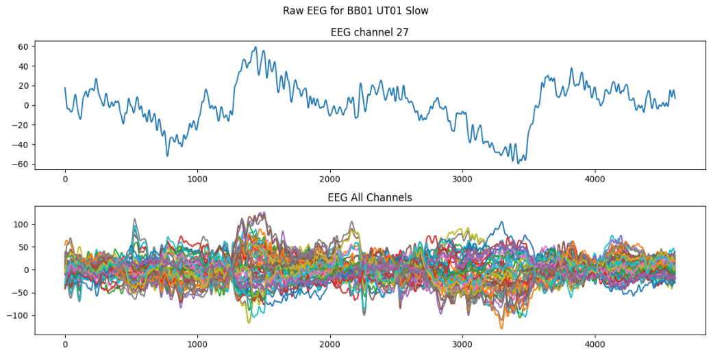
Figure 1.A: Example of raw EEG data. First plot corresponds to the recording of a single channel, whilst the second one corresponds to every channel.

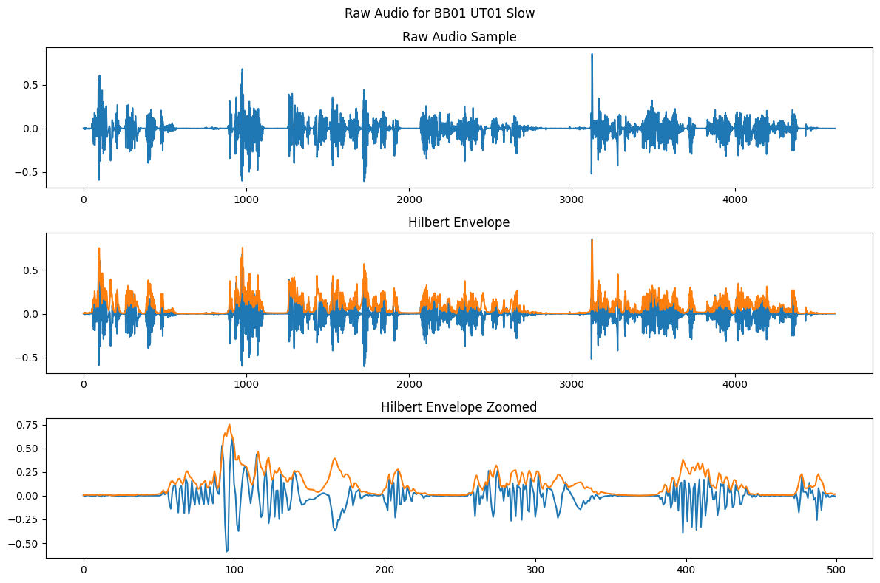
Figure 1.B: Example of Audio data on blue, with its analytic envelope on orange.
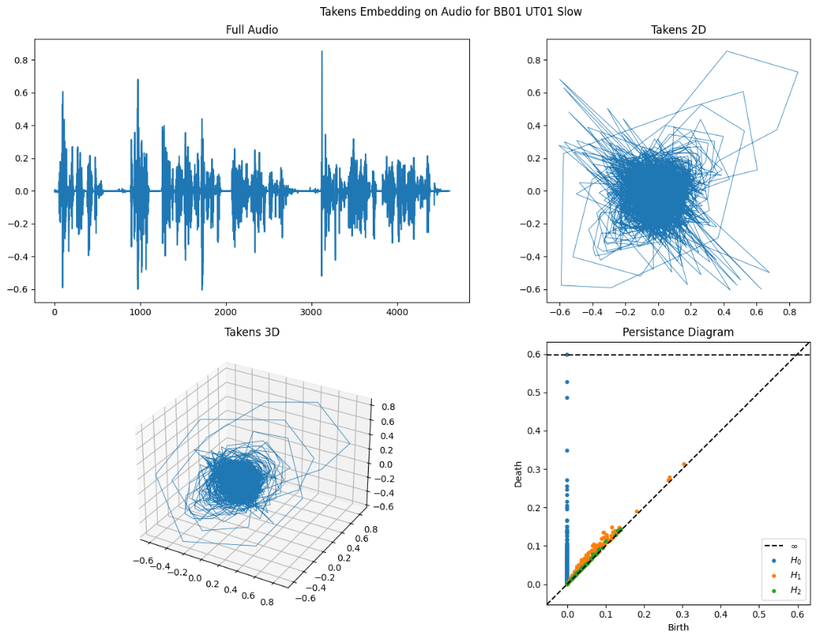
Figure 2.A: Takens Embedding for the Audio on 2 and 3 dimensions, alongside the Persistance Diagram of the 3D Takens.

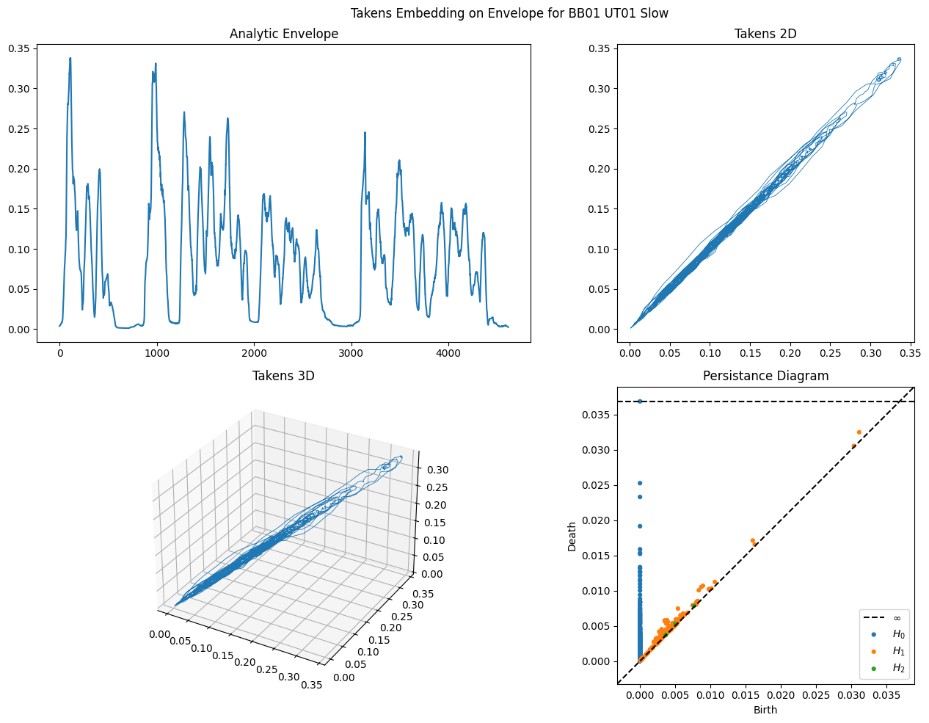
Figure 2.B: Takens Embedding for the Hilbert Envelope from the Audio on 2 and 3 dimensions, alongside the Persistance Diagram of the 3D Takens.

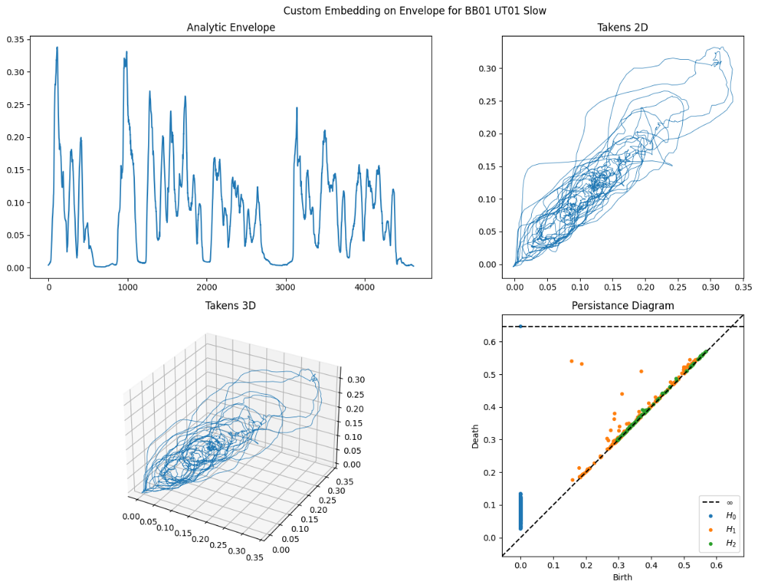
Figure 2.C: Custom Embedding for the Hilbert Envelope from the Audio 01 with window size 50 and stride 10, plotted on the first 2 and 3 dimensions, alongside the Persistance Diagram of the 3D Takens.

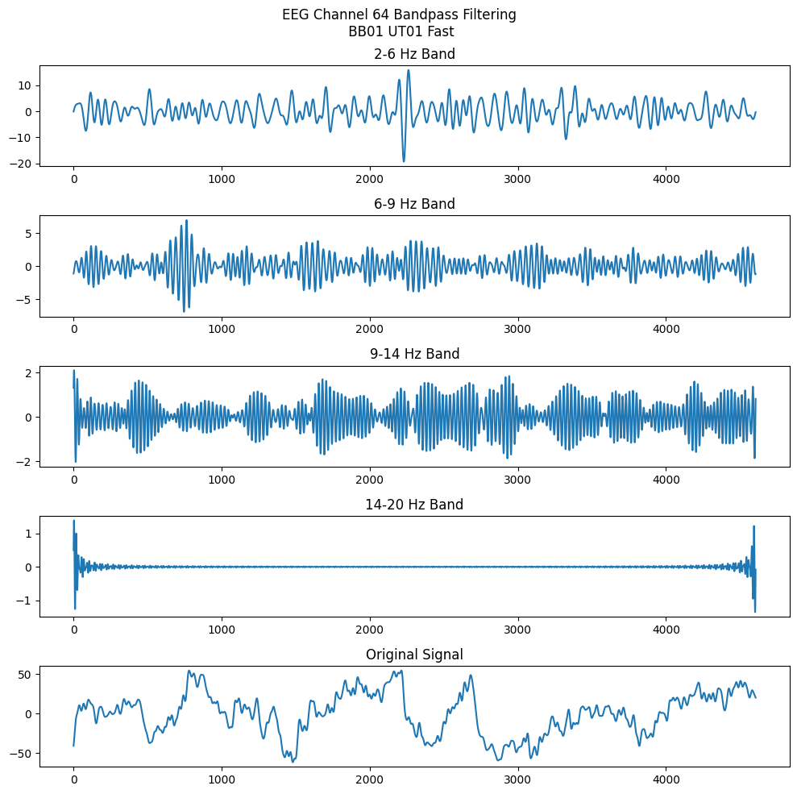
Figure 3.A: Separating EEG data on different Frequency Bands, including over the selected ranges, proving that it contains most of the relevant information.
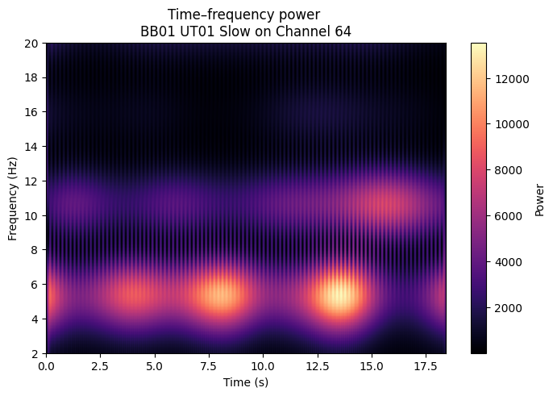
Figure 3.B: Time-Frequency Power for the EEG data over a specific case.
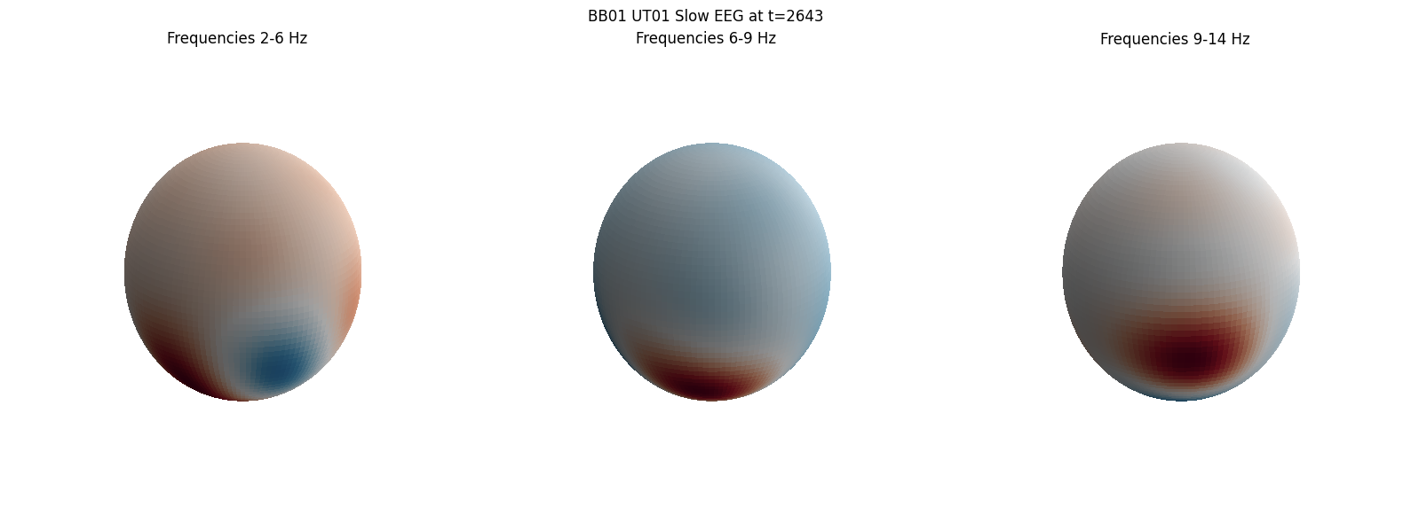
Figure 4.A: Spherical Interpolation of EEG data for every Frequency Band. Interpolation was done through Spherical Harmonics. Spheres are rotated by 100 degrees around the z axis, and 20 degrees of elevation, as to visualize the data “from the top back”.

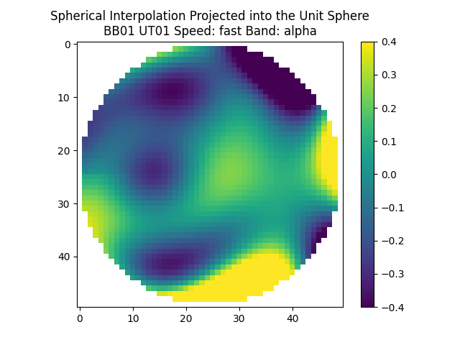
Figure 4.B: Projection back to the unit square of the interpolated data. This representation is often referred to as “Topomaps”, but it’s done with custom code.
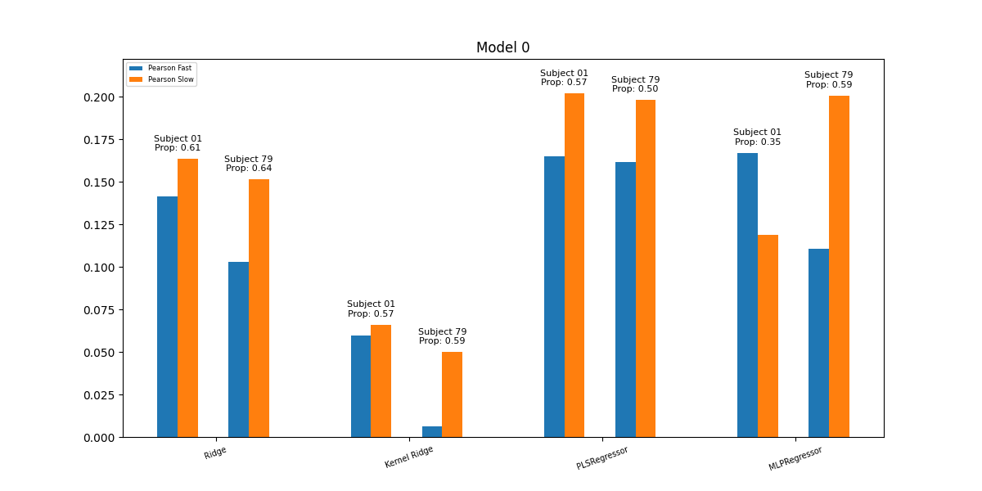
Figure 5.A: Performance of Model 0 for each Regressor used. Average Pearson across Trials for every Subject. Prop corresponds to the proportion of trials that had higher pearson for the slow condition.
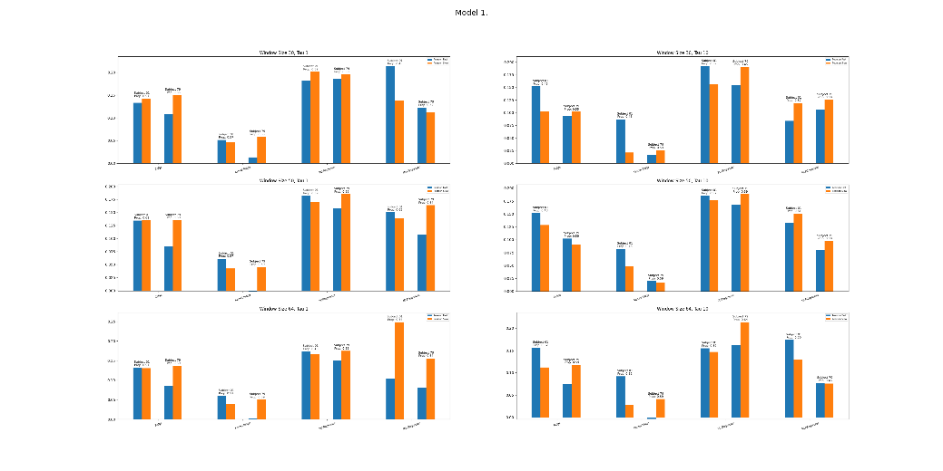
Figure 5.B: Performance of Model 1 for each Regressor used. Average Pearson across Trials for every Subject. Prop corresponds to the proportion of trials that had higher pearson for the slow condition. Row corresponds to Window Size, and Columns to Stride used on Audio’s Takens Embedding.

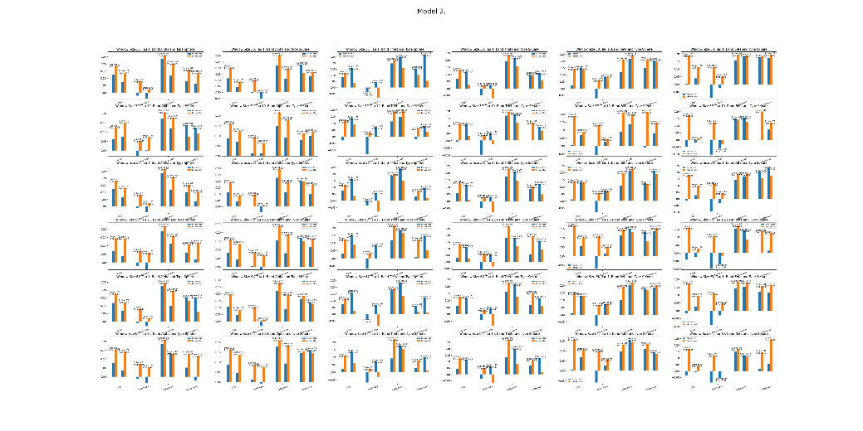
Figure 5.C: Performance of Model 2 for each Regressor used. Average Pearson across Trials for every Subject. Prop corresponds to the proportion of trials that had higher pearson for the slow condition. Rows correspond to parameters for the respective Sliding Windows, and each column to the type of data used as EEG; be it S² or projected to [-1,1]²; and frequency band selected.

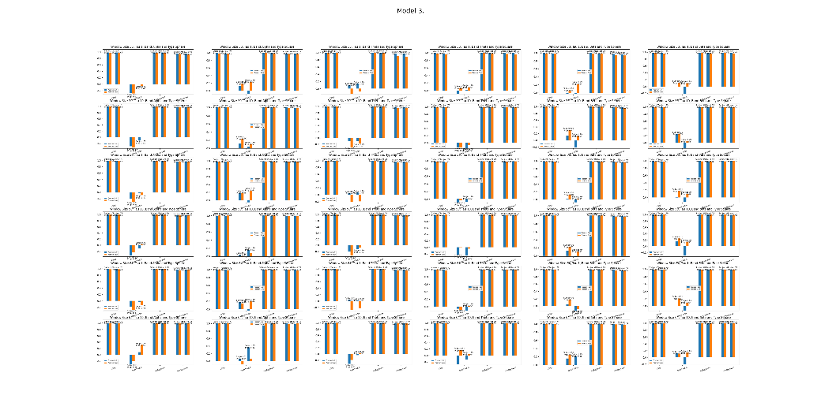
Figure 5.D: Performance of Model 2 for each Regressor used. Average Pearson across Trials for every Subject. Prop corresponds to the proportion of trials that had higher pearson for the slow condition. Rows correspond to parameters for the respective Sliding Windows, and each column to the type of data used as EEG; be it S² or projected to [-1,1]²; and frequency band selected.
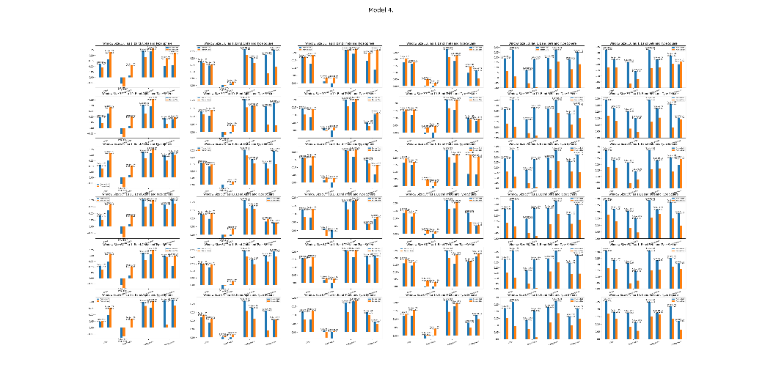
Figure 5.E: Performance of Model 2 for each Regressor used. Average Pearson across Trials for every Subject. Prop corresponds to the proportion of trials that had higher pearson for the slow condition. Rows correspond to parameters for the respective Sliding Windows, and each column to the type of data used as EEG; be it S² or projected to [-1,1]²; and frequency band selected.

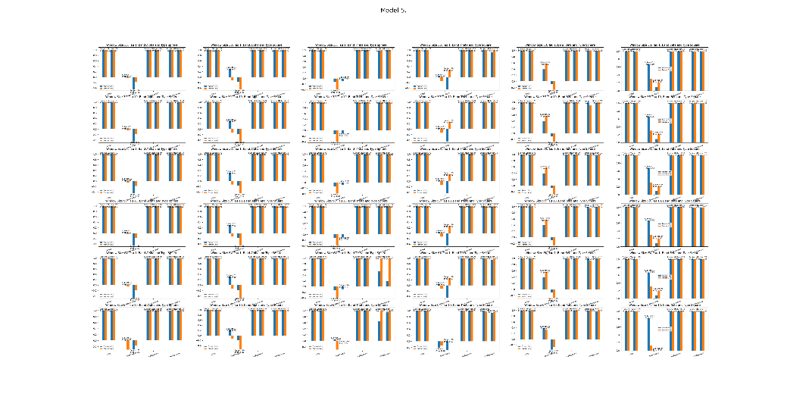
Figure 5.F: Performance of Model 2 for each Regressor used. Average Pearson across Trials for every Subject. Prop corresponds to the proportion of trials that had higher pearson for the slow condition. Rows correspond to parameters for the respective Sliding Windows, and each column to the type of data used as EEG; be it S² or projected to [-1,1]²; and frequency band selected.

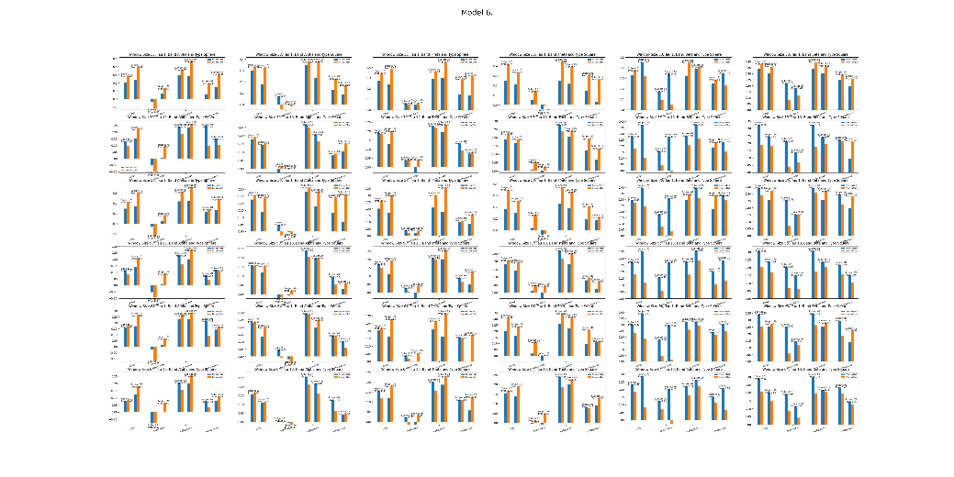
Figure 5.G: Performance of Model 2 for each Regressor used. Average Pearson across Trials for every Subject. Prop corresponds to the proportion of trials that had higher pearson for the slow condition. Rows correspond to parameters for the respective Sliding Windows, and each column to the type of data used as EEG; be it S² or projected to [-1,1]²; and frequency band selected.
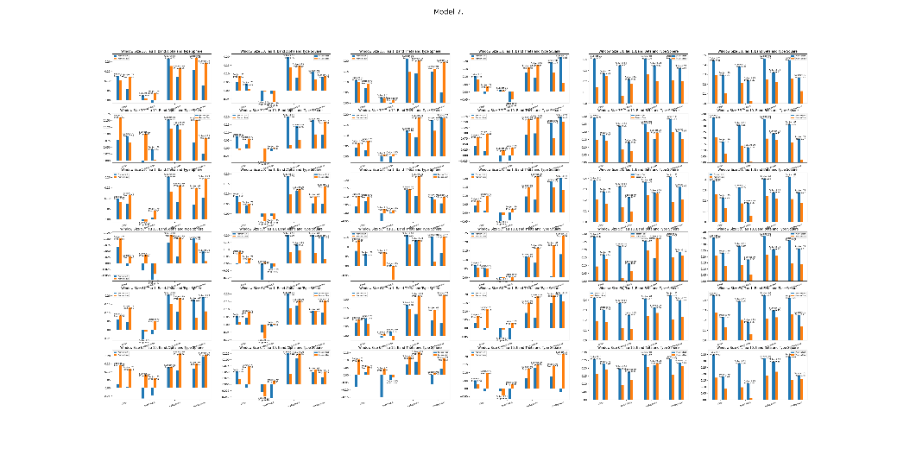
Figure 5.H: Performance of Model 2 for each Regressor used. Average Pearson across Trials for every Subject. Prop corresponds to the proportion of trials that had higher pearson for the slow condition. Rows correspond to parameters for the respective Sliding Windows, and each column to the type of data used as EEG; be it S² or projected to [-1,1]²; and frequency band selected.

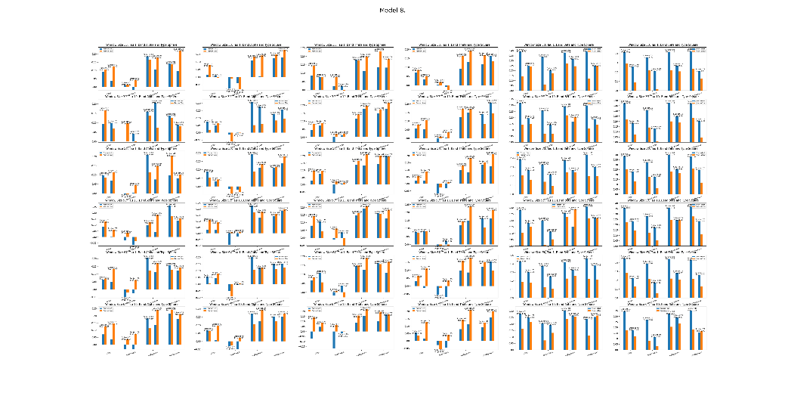
Figure 5.I: Performance of Model 2 for each Regressor used. Average Pearson across Trials for every Subject. Prop corresponds to the proportion of trials that had higher pearson for the slow condition. Rows correspond to parameters for the respective Sliding Windows, and each column to the type of data used as EEG; be it S² or projected to [-1,1]²; and frequency band selected.

