## Logo BW

**FACULTY OF COMPUTING**

**ANSWER SCHEME MID TERM TEST**

**COURSE : SOFTWARE ENGINEERING PRACTICES**

**COURSE CODE : BCS3133**

**LECTURER : MUHAMMAD ZUFLFAHMI TOH**

**DATE : 29 NOVEMBER 2021**

**DURATION : 2 HOURS**

**SESSION/SEMESTER : SESSION 2021/2022 SEMESTER** **I**

**PROGRAMME CODE : BCS**

**INSTRUCTIONS TO CANDIDATE:**

1. This question paper consists of **TWO** **(2)** questions. Answer **ALL** questions.
2. Write your answers in the question paper.
3. All calculations and assumptions must be clearly shown.

**EXAMINATION REQUIREMENTS:**

NONE

**NAME:** MUHAMMAD AFIF BIN AB RAHMAN

**MATRIC ID:** CB19007

**SECTION:** 01B

**DO NOT TURN THIS PAGE UNTIL YOU ARE TOLD TO DO SO**

This examination paper consists of **THREE (3)** printed pages including the front page.

Consider the following required functionality of a concert ticket selling service to answers **All** question.

Hujan is a famous music band in Malaysia, to celebrate 16 years of the band's history, they want to hold a concert for fans, however, the concert needs to be postponed to 2021 due to the covid pandemic. Since its establishment in 2005, it has gone through several changes regarding ticket selling for their concert, major changes are needed regarding ticket selling methods due to counterfeit and illegal selling of the ticket. The tickets have always been sold in a traditional way: through events agencies. The organizers decided to completely modernize the tickets selling system and created the following concept.

From this year on, the tickets will be sold only online: i.e. by the events agencies, in electronic format directly on the tapauTV and Prasarana website. All parties will have access to the same unique tickets database of the new system, to avoid double selling. A partnership with the Prasarana company needs to be set up, such that tapauTV and Prasarana can sell combi-tickets including both the concert admission fee and the train ride to the concert venue at reduced price, from anywhere in Kuala lumpur. This way, more music fans would have easier and cheaper access to Hujan 15 Years concert. Before the customer can purchase ticket, he or she need to register to the tapauTv membership. Since tickets will only be sold online, SecurePayment. will be contracted to provide and ensure the security of the online payment service. The Hujan 15 Years concert event manager will take care and negotiate all these details with the involved parties. Additionally, upon arrival at the concert venue at PJ Pac, each participant has to self-check in at a touch screen terminal, which scans the barcodes on his/her ticket and issues a bracelet with an electronic chip. This can be used to load money, such that whenever (s)he wants to purchase snacks or beverages, (s)he does not have to use cash anymore, thus reducing waiting time.

**QUESTION 1**

**From the case study above answers Question 1 which how to develop a requirement for the system.**

**[30 Marks]**

1. Create a UML Use Case Diagram for the Hujan 16 Years Ticketing System.

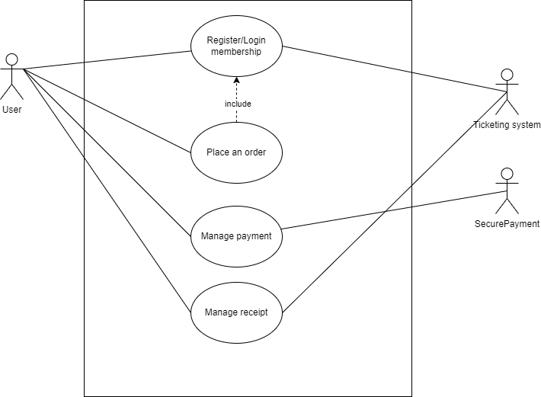

**[10 Marks]**

1. Based on your use case of “place an order”, develop structure language for basic flow.

|  |  |
| --- | --- |
| Use case | Place an order |
| Brief description | This use case allows the user to book and place an order to the concert ticket in then system. The user also can view the ticket details such as date, time, seat number and other information related |
| Actor | User |
| Pre-conditions | Users need to login into the system |
| Basic flow | 1. View ticket availability    1. Use case start when the user clicks “View ticket” button    2. System displays available ticket on the website    3. Use case end 2. View ticket information    1. Use case start when the user clicks “View detail” button    2. System displays the concert ticket information such as time, date, seat number and other information    3. Use case end 3. Place order    1. Use case start when user click “Book ticket” button    2. System redirect user to the booking page    3. Users fill in the personal information such as name, email, phone number and other information related    4. Users click on “Book now” button    5. System displays success message    6. Use case end |
| Alternative flow | None |
| Exception flow | None |
| Post-condition | System will redirect the user to the payment page |
| Rules | Users need to have the tapauTV membership |
| Constraint | None |

**[10 Mark]**

1. Construct a sequence diagram base on your basic flow in 4 (b). **Notes: No mark will be given if your basic flow is wrong.**

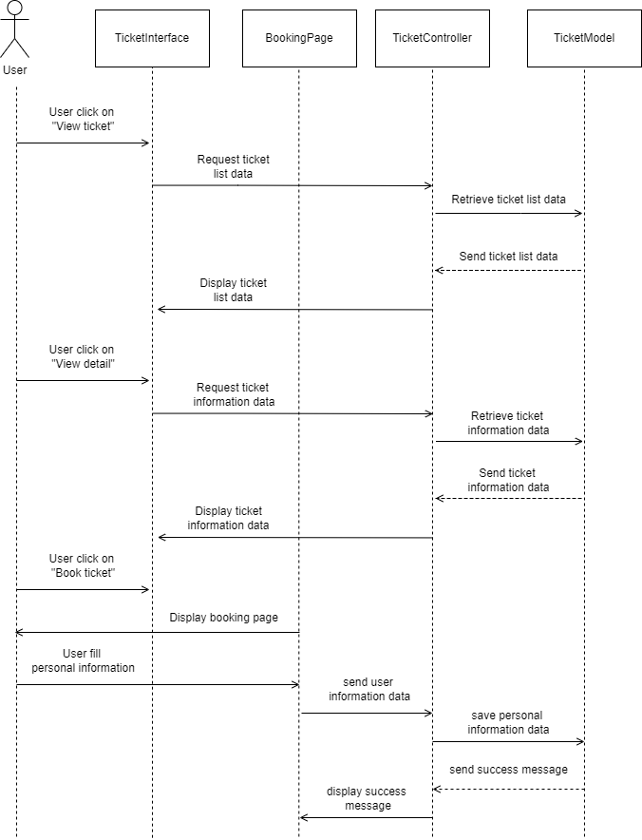

**[10 Mark]**

**QUESTION 2**

From the Answer from question **1 c** regarding your sequence diagram, purpose a design solution that consist **ONLY package and class diagram** design structure to solve the purchase ticket module.

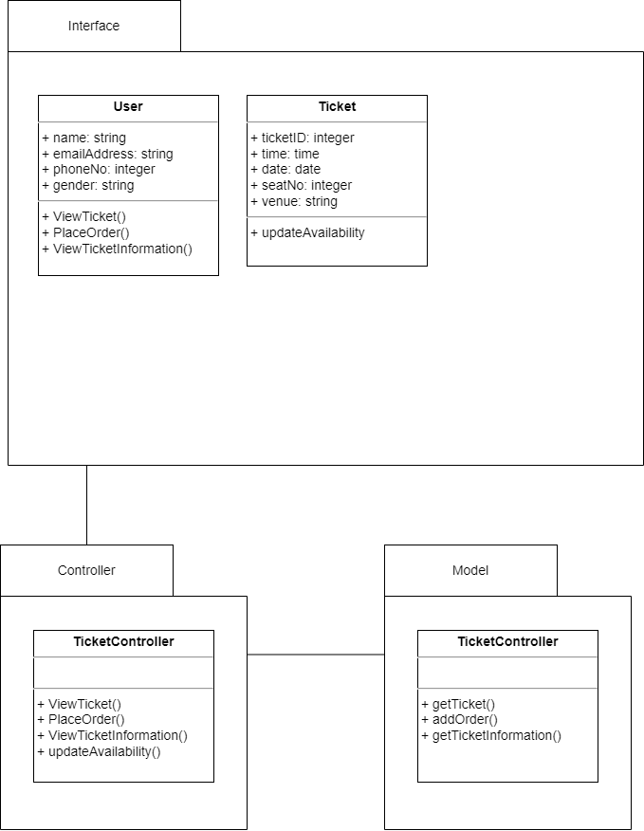

**[20 Marks]**