Project protocol

We configured our computational model to reproduce the microsaccadic rate modulation as a function of time as depicted in figure 1 (figure 3C in Engbert (2012, p. 8037)).
To obtain the time-varying threshold function from figure 3A in Engbert (2012, p. 8037), we had to square t in the argument of the exponential function in D(t) and set D(t < 180) = 1.
Before applying the time-varying potential functions we ran the model for 10000 iteration steps to avoid analyzing transient behavior. With a relaxation rate of γ = (1 - ε) = 0.999 we ran into the problem of a very quick saturation with a high constant microsacade rate. Therefore we lowered the relaxation rate γ to 0.94. Firstly, we modeled the effect of time-dependent microsaccadic inhibtion, by applying the time-varying potential function ap(t) to the potential field and thereby decreasing the potential. To replicate the properties of the graph in figure 1 we adjusted the amplitude by increasing the value of λ1 from 0.2 to 1.2. Secondly we modeled the time-dependent microsaccadic enhancement phase which is caused by a decrease of the time-varying threshold for microsaccade triggering hc(t). To fit figure 1 we had to stretch the peak horizontally. Hence, we stretched the parabolic function argument of the exponential decay of D(t) used in aA(t), by setting ρ2 = 0.00008. Furthermore, we needed to increase λ2 to 40.5 to adjust the amplitude of threshold function hc(t). This changes resulted in figure 2, reproducing the microsaccadic rate modulation of figure 1. For figure 2 we combined 1000 trials by applying a causal filter kernel. We stayed with the original timing values τ p = 150 and τ A = 30.
With the mentioned parameter changes in the model proposed by Engbert (2012), it is possible to reproduce empirical measurements of microsaccade rates for different participants as depicted in figure 3. The length of the microsaccadic inhibtion/enhancement phase can be easily adapted by varying ρ1/ρ2. The amplitude can be changed by altering λ1/λ2. Finally, the temporal occurrence of the phases can be adjusted by changing τp and τA.

Figure 1

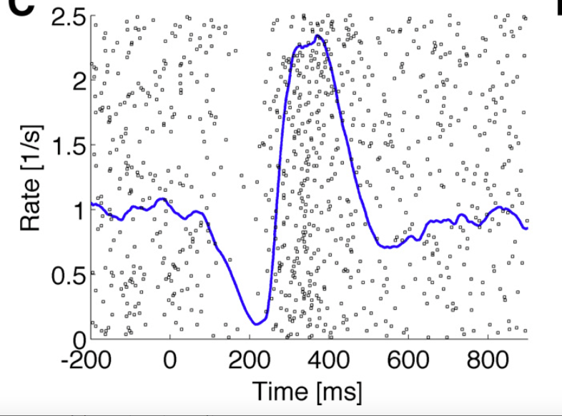
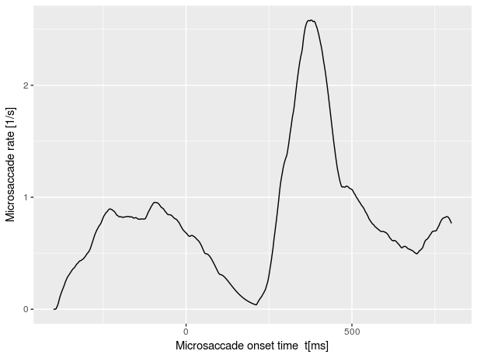
Figure 2
Figure 3

