We configured our computational model to reproduce the microsaccadic rate modulation as a function of time as depicted in figure 1 (figure 3C in the article (Rolf Engbert, 2012)).
Before applying the potential functions we ran the model for 10000 iteration steps to avoid analyzing transient behavior. With a relaxation rate of gamma=(1-epsilon)=0.999 we ran into the problem of a very quick saturation with a high constant miccrosacade rate. Therefore we lowered the relaxation rate to gamma=0.94. Firstly, we modeled the effect of microsaccadic inhibtion, by applying the potential function a_p(t) to the potential field and thereby decreasing the potential. To replicate the properties of the graph in figure 1 we adjusted the amplitude by increasing the value of lambda_1 from lambda_1= 0.2 to lambda_1=1.2 . Secondly we modeled the microsaccadic enhancement phase which is caused by a decrease of the threshold for microsaccade triggering h_c(t). To fit figure 1 we had to stretch the peak horizontally. Hence, we stretched the parabolic function argument of the exponential decay of D(t) used in a_A(t), by setting rho_2=0.00008. Furthermore we needed to increase lambda2 to lambda2=40.5 to adjust the amplitude of threshold function h_c(t). This changes resulted in figure 2, reproducing the microsaccadic rate modulation of figure 1. For figure 2 we combined 1000 trials by applying a causal filter kernel. We stayed with the original timing values tau_p = 150 and tau_A = 30.
With the mentioned parameter changes in the model proposed by (Rolf Engbert, 2012), it is possible to reproduce empirical measurements of microsaccade rates for different participants as depicted in figure 3. The length of the microsaccadic inhibtion/enhancement phase can be easily adapted by varying rho_1/rho_2. The amplitude can be changed by altering lambda_1/lambda2. Finally, the temporal occurrence of the phases can be adjusted by changing tau_p and tau_A.

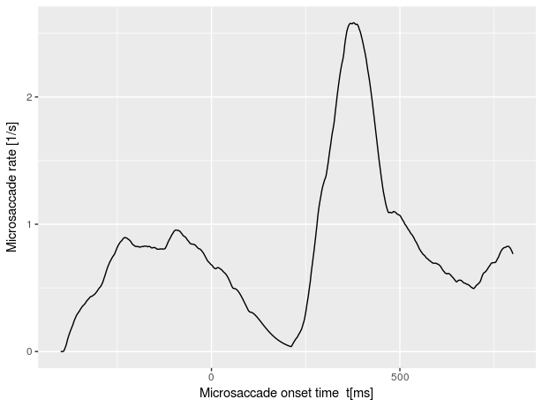
Figure 1
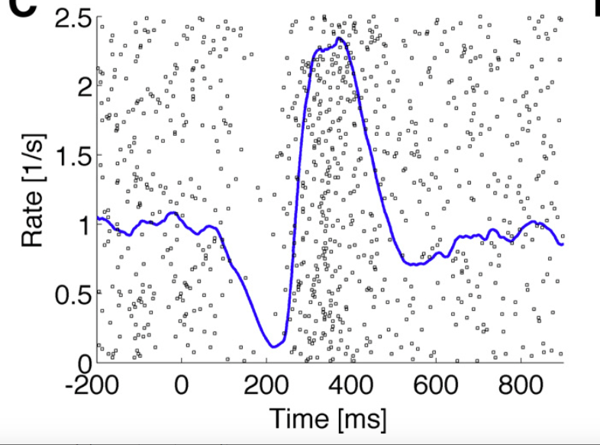
Figure 2

Figure 3

