Final Project Development 4

1. Review the guidelines for user-based and user-controlled navigation systems, and then specify the individual elements of a user-based and user-controlled navigation system for your website.

The navbar which will be incorporated into the layout for every page (except entry page) will provide all of the user-controlled navigation. This navbar will collapse when screen sizes reach a small size.

2. Using what you have learned about page layout and wireframing, create a sketch or blueprint of the layout of page elements.

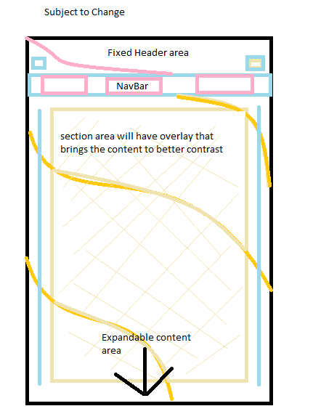

3. Define your website’s color scheme by using a web design template or color- matching software.

Cool, easy, relaxing and warm

4. Create a plan for testing, publishing, and maintaining your website.

Obtain images for use → MVP (minimal viable product) → enhance design from MVP →
→ Bring in addition want pages and features → polish → produce and maintain with updated content.

