COMPREHENSIVE PRACTICE PROJECT REPORT
ImageFileProcessing System
C/C++ BMP Image Processing with EasyX GUI

Course | Computing and Intelligent Programming
Project Type | Comprehensive Practice
Project Title | ImageFileProcessing
Student Name | HANAN OSSAMA
Student ID | 2025130323
Semester | Spring Semester, 2026
Lab Type | Comprehensive Design
Programming Language | C/C++
IDE / Library | Visual Studio / EasyX
Operating System | Windows
Input Image Format | 24-bit BMP

Final Submission-Ready Report
Report Completion Date: June 19, 2026

Abstract
This comprehensive practice project presents the design and implementation of an image-processing system named ImageFileProcessing. The system was developed using C/C++ in Visual Studio with the EasyX graphics library. The main purpose of the project is to read, display, process, and save 24-bit BMP images through a graphical user interface.
The program supports six main operations: reading a BMP image, converting the image to grayscale, performing Sobel edge detection, sharpening the image, adding salt-and-pepper noise, and removing noise using median filtering. Each operation can be selected through a button in the graphical interface. The processed image is displayed in the preview area and saved as a BMP output file.
In addition to implementing image-processing algorithms, the project focuses on modular programming, file processing, memory management, image data representation, user interface design, and debugging. The final interface uses a modern dark photo-editor style with a subtle futuristic and space-inspired visual design. It includes an image preview area, a right-side control panel, operation buttons, a status display area, and automatic image preview scaling so large images fit inside the program window.
Through this project, I improved my understanding of BMP file structure, BGR color order, row alignment, convolution-based image processing, EasyX GUI programming, and practical C/C++ development.

1. Objectives
The objective of this project is to build a complete C/C++ BMP image-processing program using the EasyX graphics library. The system reads and displays a 24-bit BMP image, applies several image-processing algorithms, saves the processing results, and provides a graphical interface for user interaction.
- Understand the structure of 24-bit BMP image files, including BMP headers, pixel data, color storage order, and row alignment.
- Implement file reading and saving functions for BMP images.
- Convert a 24-bit color image into an 8-bit grayscale image.
- Implement Sobel edge detection using 3x3 convolution kernels.
- Sharpen an image using a 3x3 convolution kernel.
- Add salt-and-pepper noise to an image and remove it using median filtering.
- Design a user-friendly graphical interface using EasyX.
- Apply modular programming to improve readability, maintainability, and reusability.
- Improve debugging ability by solving file path, BMP validation, BGR order, row alignment, and scaling problems.

2. Development Environment
Item | Description
Operating System | Windows
Programming Language | C/C++
IDE | Visual Studio
External Library | EasyX
Image Format | 24-bit BMP
Main Input File Path Used During Testing | C:\CP3\test.bmp
Output Files | gray.bmp, edge.bmp, sharpen.bmp, noise.bmp, median.bmp

The EasyX library was used to create the graphical user interface, draw buttons, display image pixels, and manage mouse-click interaction. Visual Studio was used as the main development environment for writing, compiling, debugging, and running the program.

3. Lab Project Content

3.1 Required Project Content
The selected project is ImageFileProcessing. The program performs basic image-processing operations on a 24-bit BMP image. The following required functions were implemented:
- Read a 24-bit BMP image.
- Display the original BMP image.
- Convert the image to grayscale.
- Save the grayscale result as gray.bmp.
- Perform Sobel edge detection.
- Save the edge detection result as edge.bmp.
- Sharpen the image using a 3x3 convolution kernel.
- Save the sharpened result as sharpen.bmp.
- Add salt-and-pepper noise.
- Save the noisy image as noise.bmp.
- Apply median filtering to reduce noise.
- Save the filtered result as median.bmp.
- Provide a graphical interface with buttons and an image preview area.
The final program contains six main operation buttons:
Read BMP
Gray Image
Edge Detect
Sharpen
Add Noise
Median Filter

4. Added or Improved Features
Modern dark photo-editor style UI: The final program interface was redesigned into a modern dark-style layout. Compared with a simple console program or a basic EasyX window, the final interface looks more professional and is easier to use.
Subtle futuristic and space-inspired visual design: The interface uses a clean dark dashboard style with a subtle futuristic feeling. This gives the program an attractive visual appearance while keeping the layout functional.
Automatic image preview scaling: Large images may exceed the EasyX window size. To solve this problem, showImage24Fit() and showImage8Fit() were implemented so the full image can fit inside the preview area.
Status display area: Instead of using many pop-up message boxes, the program includes a status display area inside the interface. This area shows whether the image was loaded, processed, or saved successfully.
Modular function design: The program is divided into independent functions and modules, which improves readability, maintainability, and debugging efficiency.
Output BMP saving for every operation: Each processing operation saves the result as a BMP file, making it easier to verify results and include them in the report.
Error checking: The program checks BMP format, bit depth, compression type, file opening, and memory allocation to improve robustness.

5. System Functional Design and Program Implementation
The ImageFileProcessing system is designed as an interactive graphical image-processing application. The user interacts with the system by clicking buttons in the EasyX window. Each button calls a specific image-processing function. The system displays the result in the preview area, saves the output BMP file, and updates the status display area.
The main implementation idea is to separate the image-processing algorithms from the user interface. This means the Sobel edge detection function does not handle button drawing, and the UI drawing function does not perform image convolution. This separation improves program structure and makes the project easier to debug and extend.

5.1 General Program Workflow
Start program
|
Initialize EasyX window
|
Draw graphical user interface
|
Wait for mouse click
|
Check selected button
|
Call corresponding image-processing function
|
Display processed image in preview area
|
Save output BMP file
|
Update status display area
|
Continue waiting for user operation

5.2 Final UI Screenshot
The final interface follows a modern dark photo-editor layout with a preview area, control panel, operation buttons, and status display area.
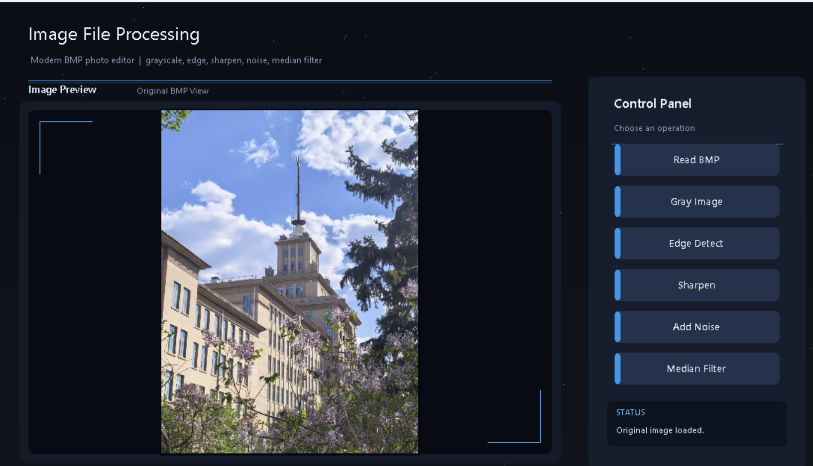
Figure 7. Final modern user interface.

6. System Functional Module Decomposition
The system is divided into nine main modules. Each module is responsible for a clear part of the program. This top-down decomposition improves readability, maintainability, and reusability.
- GUI module
- BMP file reading module
- BMP file saving module
- Grayscale conversion module
- Sobel edge detection module
- Image sharpening module
- Salt-and-pepper noise module
- Median filtering module
- Image display scaling module

6.1 System Module Diagram
ImageFileProcessing System
|
+-- GUI Module
| +-- Draw background
| +-- Draw title
| +-- Draw preview area
| +-- Draw control panel
| +-- Draw buttons
| +-- Handle mouse clicks
|
+-- BMP File Module
| +-- read_bmp()
| +-- save_bmp_8bit()
| +-- save_bmp_24bit()
|
+-- Image Processing Module
| +-- convert_24bit_to_gray()
| +-- edge_detection()
| +-- image_sharpening()
| +-- addSaltPepperNoise()
| +-- medianFiltering()
|
+-- Display Module
+-- showImage24Fit()
+-- showImage8Fit()

Note: The diagram uses ASCII line characters to ensure reliable rendering in both DOCX and PDF formats while preserving the same logical structure as the requested module diagram.

6.2 Module Descriptions
GUI Module: Draws the interface, including the background, title, preview area, control panel, buttons, and status display area. It also handles mouse clicks and determines which operation the user selected.
BMP File Reading Module: Opens the BMP image file in binary mode, reads the file header and information header, validates the image format, calculates row stride, allocates memory, and reads pixel data.
BMP File Saving Module: Saves processed image data into BMP files. It supports both 8-bit grayscale BMP images and 24-bit color BMP images.
Grayscale Conversion Module: Converts the original 24-bit BGR image into an 8-bit grayscale image using the weighted grayscale formula.
Sobel Edge Detection Module: Performs edge detection on the grayscale image using Sobel horizontal and vertical convolution kernels.
Image Sharpening Module: Sharpens the image using a 3x3 convolution kernel. It enhances image details by strengthening the center pixel and subtracting neighboring pixels.
Salt-and-Pepper Noise Module: Randomly changes some pixels to black or white to simulate salt-and-pepper noise.
Median Filtering Module: Removes salt-and-pepper noise using a 3x3 median filter.
Image Display Scaling Module: Displays large images inside the preview area by automatically scaling them while preserving the image aspect ratio.

7. Function Specifications and Interface Design
This system contains several custom functions. The main functions and interfaces are listed in the following table.
No. | Function Name | Function Description | Parameters | Return Value
1 | calculate_stride() | Calculates the number of bytes in each BMP row after 4-byte alignment. | width, bit_count | int row stride
2 | read_bmp() | Reads a 24-bit BMP file, validates the format, and loads pixel data into memory. | file path, BMP headers, image buffer pointer | bool success/failure
3 | save_bmp_8bit() | Saves an 8-bit grayscale image as a BMP file with a 256-level grayscale palette. | output path, gray buffer, width, height | bool success/failure
4 | save_bmp_24bit() | Saves a 24-bit color image as a BMP file. | output path, color buffer, width, height | bool success/failure
5 | convert_24bit_to_gray() | Converts a 24-bit BGR image into an 8-bit grayscale image. | source buffer, gray buffer, width, height | void
6 | edge_detection() | Performs Sobel edge detection on the grayscale image. | gray buffer, edge buffer, width, height | void
7 | image_sharpening() | Sharpens a color image using a 3x3 convolution kernel. | source buffer, destination buffer, width, height | void
8 | addSaltPepperNoise() | Adds random black and white pixels to simulate noise. | source buffer, destination buffer, width, height, noise ratio | void
9 | medianFiltering() | Removes noise using a 3x3 median filter. | source buffer, destination buffer, width, height | void
10 | showImage24Fit() | Displays a 24-bit color image scaled to fit the preview area. | image buffer, width, height, preview area information | void
11 | showImage8Fit() | Displays an 8-bit grayscale image scaled to fit the preview area. | gray buffer, width, height, preview area information | void
12 | drawUI() | Draws the full graphical interface. | UI state or status text | void

7.1 Function Calling Relationship
main()
|
+-- Initialize EasyX window
+-- drawUI()
| +-- Draw background
| +-- Draw title
| +-- Draw preview area
| +-- Draw control panel
| +-- Draw buttons
| +-- Draw status display area
|
+-- Mouse event loop
| |
| +-- Read BMP
| | +-- read_bmp()
| | +-- showImage24Fit()
| |
| +-- Gray Image
| | +-- convert_24bit_to_gray()
| | +-- save_bmp_8bit()
| | +-- showImage8Fit()
| |
| +-- Edge Detect
| | +-- edge_detection()
| | +-- save_bmp_8bit()
| | +-- showImage8Fit()
| |
| +-- Sharpen
| | +-- image_sharpening()
| | +-- save_bmp_24bit()
| | +-- showImage24Fit()
| |
| +-- Add Noise
| | +-- addSaltPepperNoise()
| | +-- save_bmp_24bit()
| | +-- showImage24Fit()
| |
| +-- Median Filter
| +-- medianFiltering()
| +-- save_bmp_24bit()
| +-- showImage24Fit()
|
+-- Close EasyX window

8. Data Structure Design

8.1 struct MyBITMAPFILEHEADER
MyBITMAPFILEHEADER stores basic BMP file information. It identifies the file type and locates the pixel data.
bfType : Identifies the BMP file type. Correct BMP files use 0x4D42.
bfSize : Total size of the BMP file.
bfReserved1 : Reserved field.
bfReserved2 : Reserved field.
bfOffBits : Offset from the beginning of the file to the pixel data.

8.2 struct MyBITMAPINFOHEADER
MyBITMAPINFOHEADER stores detailed information about the image, including image width, height, bit depth, compression type, and pixel data size.
biWidth : Image width in pixels.
biHeight : Image height in pixels.
biBitCount : Number of bits per pixel. The project supports 24-bit BMP.
biCompression : Compression type. The project supports uncompressed BMP.
biSizeImage : Size of image data.

8.3 struct MyRGBQUAD
MyRGBQUAD is used for the color palette of 8-bit grayscale BMP images. A grayscale BMP file needs a palette containing 256 gray levels. In a grayscale palette, the red, green, and blue components have the same value.

8.4 struct Button
The Button structure represents buttons in the graphical interface. It stores the position, size, and label of each button. Using this structure makes the UI easier to manage and simplifies mouse-click detection.

8.5 Image Buffers
The program uses unsigned char* buffers to store image data dynamically in memory.
Buffer | Purpose
imageData | Stores the original 24-bit BMP image data.
grayData | Stores the 8-bit grayscale image data.
edgeData | Stores the Sobel edge detection result.
sharpenData | Stores the sharpened color image.
noiseData | Stores the image after adding salt-and-pepper noise.
medianData | Stores the image after median filtering.

BMP images store pixels in BGR order, not RGB order. Therefore, when reading a 24-bit BMP pixel, the order is Blue, Green, Red. When displaying the pixel with EasyX, the program should use RGB(R, G, B).
BMP image rows must be aligned to 4 bytes. Therefore, the actual number of bytes in each row may be larger than width * 3. The stride calculation function is:
int calculate_stride(int width, int bit_count)
{
return ((width * bit_count + 31) / 32) * 4;
}

9. Algorithm Design

9.1 BMP Reading Algorithm
The BMP reading algorithm is responsible for loading the image from disk into memory. The main steps are shown below:
1. Open the file in binary mode.
2. Read the BMP file header.
3. Check whether bfType == 0x4D42.
4. Read the BMP information header.
5. Check whether the image is 24-bit.
6. Check whether the image is uncompressed.
7. Calculate row stride.
8. Allocate memory.
9. Read pixel data.
10. Display the image.
The validation steps prevent the program from reading unsupported or invalid files. For example, if the file is not a real BMP image or if it is compressed, the program stops reading and updates the status message.

9.2 Grayscale Conversion Algorithm
The grayscale conversion algorithm converts a 24-bit color image into an 8-bit grayscale image. The 24-bit BGR pixel is converted into one 8-bit grayscale value using the following formula:
Gray = 0.299R + 0.587G + 0.114B

This formula uses different weights for red, green, and blue because human vision is more sensitive to green. The grayscale result is saved as gray.bmp with a 256-level grayscale palette.

9.3 Sobel Edge Detection Algorithm
Sobel edge detection detects edges and contours in an image. The image is first converted to grayscale. Then two 3x3 kernels are used to calculate horizontal and vertical gradients.
int sobel_x[3][3] = {
{-1, 0, 1},
{-2, 0, 2},
{-1, 0, 1}
};
int sobel_y[3][3] = {
{-1, -2, -1},
{ 0, 0, 0},
{ 1, 2, 1}
};

The algorithm calculates the horizontal gradient Gx and the vertical gradient Gy. Then the gradient magnitude is calculated:
G = sqrt(Gx^2 + Gy^2)

If G is greater than the threshold, the output pixel becomes white. Otherwise, the output pixel becomes black. This produces a binary edge image where the main contours are white and the background is black.

9.4 Image Sharpening Algorithm
Image sharpening enhances details and edges. The project uses the following 3x3 sharpening kernel:
int kernel[3][3] = {
{-1, -1, -1},
{-1, 9, -1},
{-1, -1, -1}
};

The center pixel is multiplied by 9, while the surrounding pixels are subtracted. This increases local contrast and makes details clearer. For color images, the B, G, and R channels are processed separately. After convolution, each channel value is clamped to the range 0 to 255.

9.5 Salt-and-Pepper Noise Algorithm
Salt-and-pepper noise randomly changes some pixels into black or white. Black pixels represent pepper noise, and white pixels represent salt noise. The algorithm traverses all pixels, generates a random value, and changes a pixel if the random value is inside the noise probability range.

9.6 Median Filtering Algorithm
Median filtering is effective for removing salt-and-pepper noise. The algorithm uses a 3x3 window around each pixel, collects the 9 neighboring values, sorts them, and replaces the center pixel with the median value. For color images, the B, G, and R channels are processed separately.

10. Problems Encountered During the Project and Their Solutions

Problem 1: BMP file could not be opened
Symptom: The program failed to load the input image.
Cause: The file path was wrong, or the image was not placed in the expected folder.
Solution: I used the absolute path C:\CP3\test.bmp to confirm the file location and avoid path confusion during testing.

Problem 2: File was not a real BMP image
Symptom: The program detected that the file was invalid even though the file name ended with .bmp.
Cause: The image was renamed from JPG or PNG to BMP without real conversion. Changing the file extension does not change the actual image format.
Solution: I opened the image in Microsoft Paint and used Save as -> BMP picture. After saving it as a real BMP image, the program could read the file successfully.

Problem 3: Image was too large for the EasyX window
Symptom: Only part of the image was visible in the preview area.
Cause: The original image size was larger than the EasyX window or preview frame.
Solution: I implemented showImage24Fit() and showImage8Fit() to scale the image automatically so the full image fits inside the preview area.

Problem 4: Wrong color display
Symptom: The image colors were incorrect. Red and blue appeared swapped.
Cause: BMP stores pixels in BGR order, not RGB order.
Solution: I read the pixel data as B, G, and R, then displayed it using RGB(R, G, B). This corrected the color display.

Problem 5: Row alignment problem
Symptom: The image appeared distorted, or some rows seemed shifted.
Cause: BMP rows are aligned to multiples of 4 bytes. Using only width * 3 as the row size ignores padding bytes.
Solution: I used calculate_stride() to calculate the correct row size including padding.

Problem 6: UI was not professional
Symptom: The first interface looked too simple and was not suitable for a polished project demonstration.
Cause: The early version focused mainly on algorithm implementation and used basic buttons and a simple background.
Solution: I redesigned the interface as a modern dark photo-editor style UI with a preview area, right-side control panel, clear operation buttons, status display area, and automatic preview scaling.

11. Test Cases and System Test Results
Testing was conducted after the program compiled and ran correctly. The testing method was functional testing. Each button was tested separately to check whether the corresponding function worked correctly, whether the image result was displayed, and whether the output BMP file was saved.
The following screenshots show the actual results obtained by running the final ImageFileProcessing program. Each operation was tested through the graphical interface, and the corresponding output file was generated successfully.

Test Case 1: Read BMP
Item | Description
Purpose | Verify the program can read and display the original BMP image.
Input | C:\CP3\test.bmp
Operation | Click the Read BMP button.
Expected Result | Original image appears in the preview area.
Output File | None
Result | Passed


Figure 1. Original BMP image loaded in the program.

Test Case 2: Gray Image
Item | Description
Purpose | Verify grayscale conversion.
Input | Loaded 24-bit BMP image.
Operation | Click the Gray Image button.
Expected Result | Image becomes grayscale and gray.bmp is saved.
Output File | gray.bmp
Result | Passed

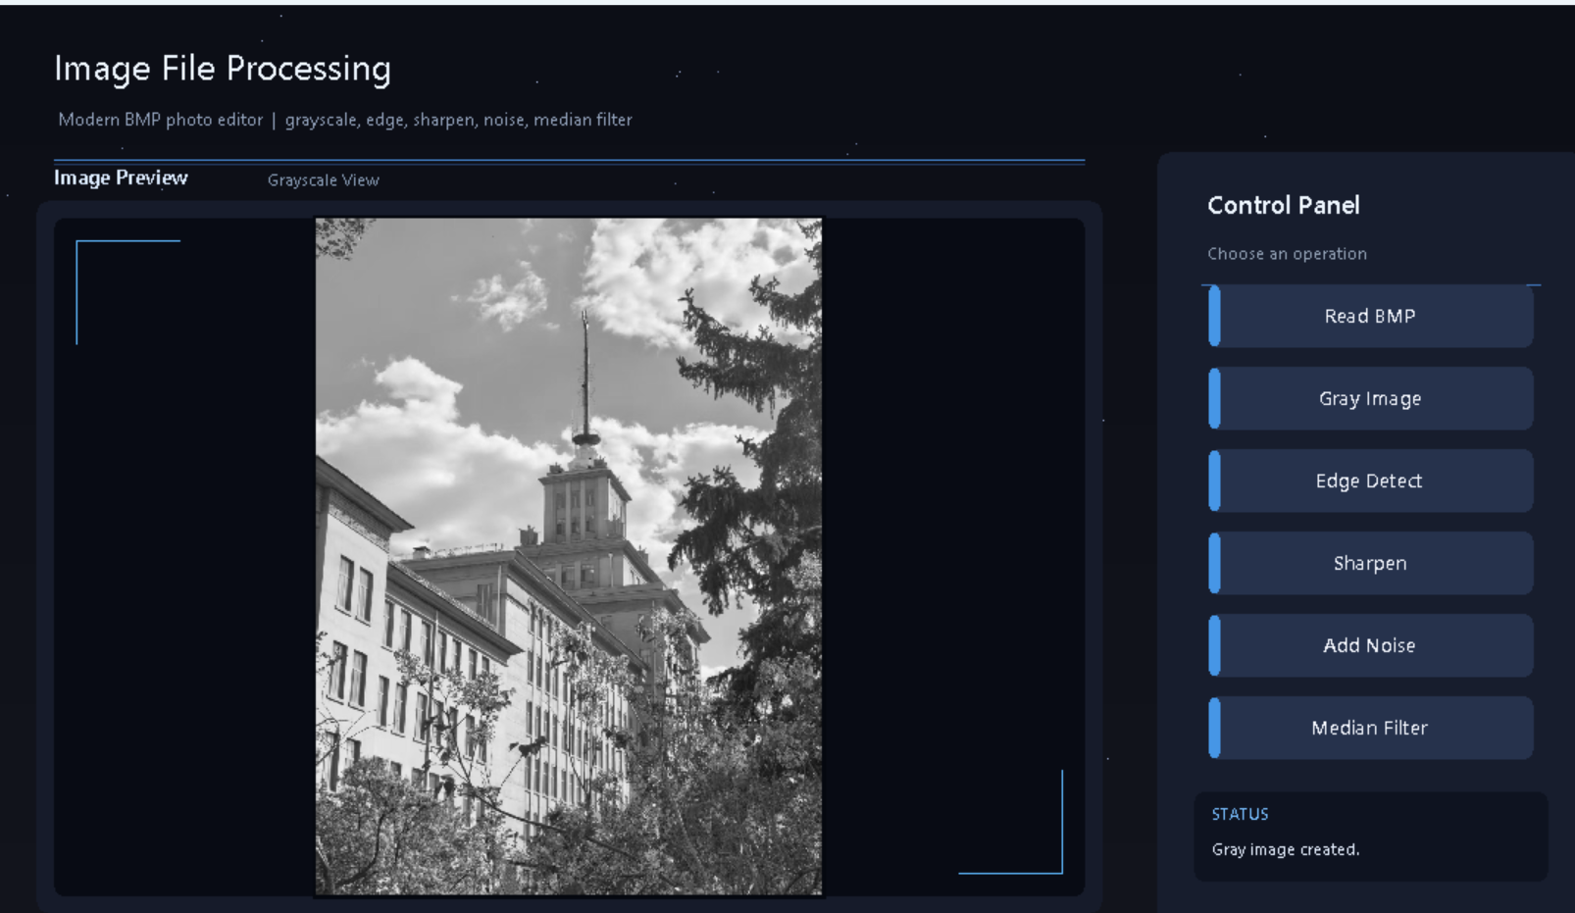
Figure 2. Grayscale conversion result.

Test Case 3: Edge Detect
Item | Description
Purpose | Verify Sobel edge detection.
Input | Grayscale image data.
Operation | Click the Edge Detect button.
Expected Result | Main contours are extracted and edge.bmp is saved.
Output File | edge.bmp
Result | Passed

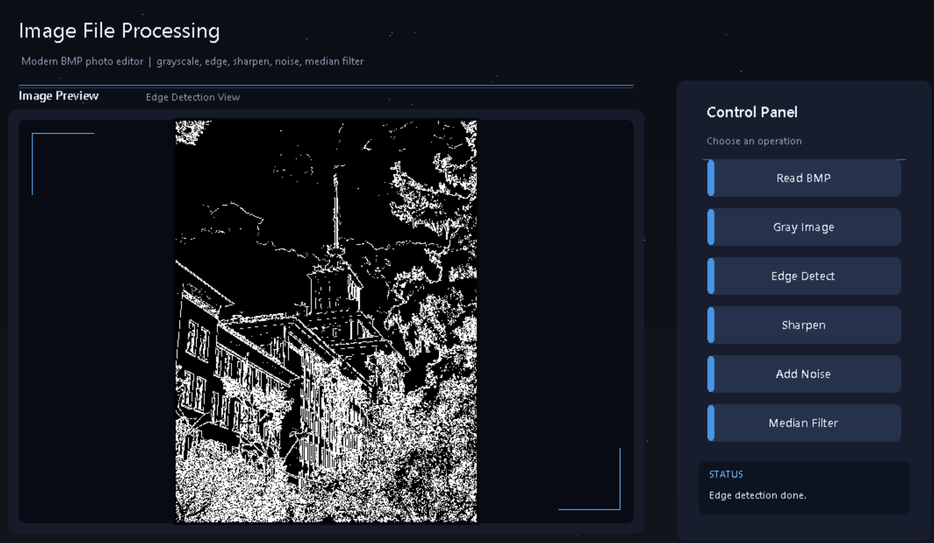
Figure 3. Sobel edge detection result.

Test Case 4: Sharpen
Item | Description
Purpose | Verify image sharpening.
Input | Loaded 24-bit BMP image.
Operation | Click the Sharpen button.
Expected Result | Image details become clearer and sharpen.bmp is saved.
Output File | sharpen.bmp
Result | Passed

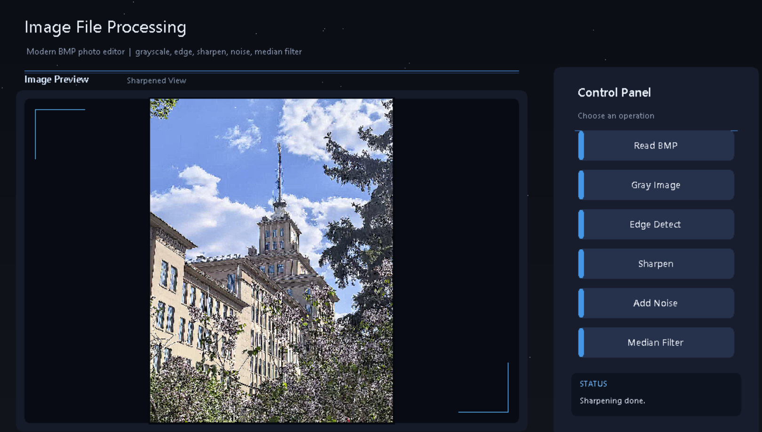
Figure 4. Image sharpening result.

Test Case 5: Add Noise
Item | Description
Purpose | Verify salt-and-pepper noise generation.
Input | Loaded 24-bit BMP image.
Operation | Click the Add Noise button.
Expected Result | Random black and white noise appears and noise.bmp is saved.
Output File | noise.bmp
Result | Passed

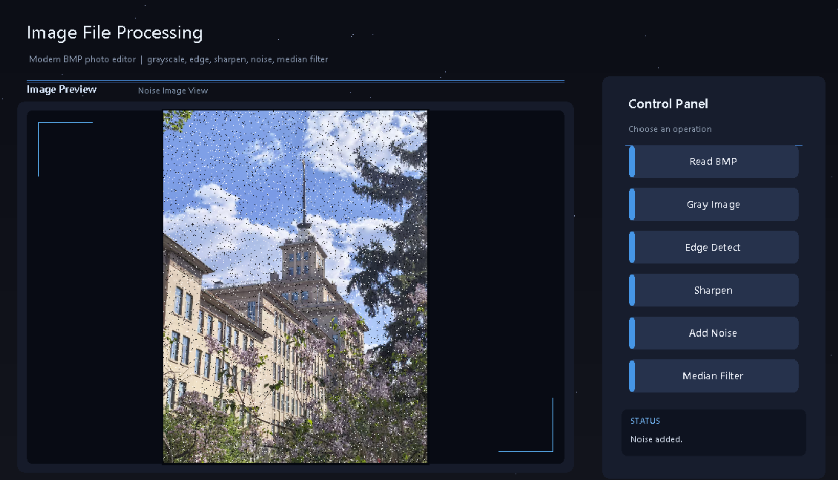
Figure 5. Salt-and-pepper noise result.

Test Case 6: Median Filter
Item | Description
Purpose | Verify median filtering.
Input | Image with salt-and-pepper noise.
Operation | Click the Median Filter button.
Expected Result | Noise is reduced and median.bmp is saved.
Output File | median.bmp
Result | Passed

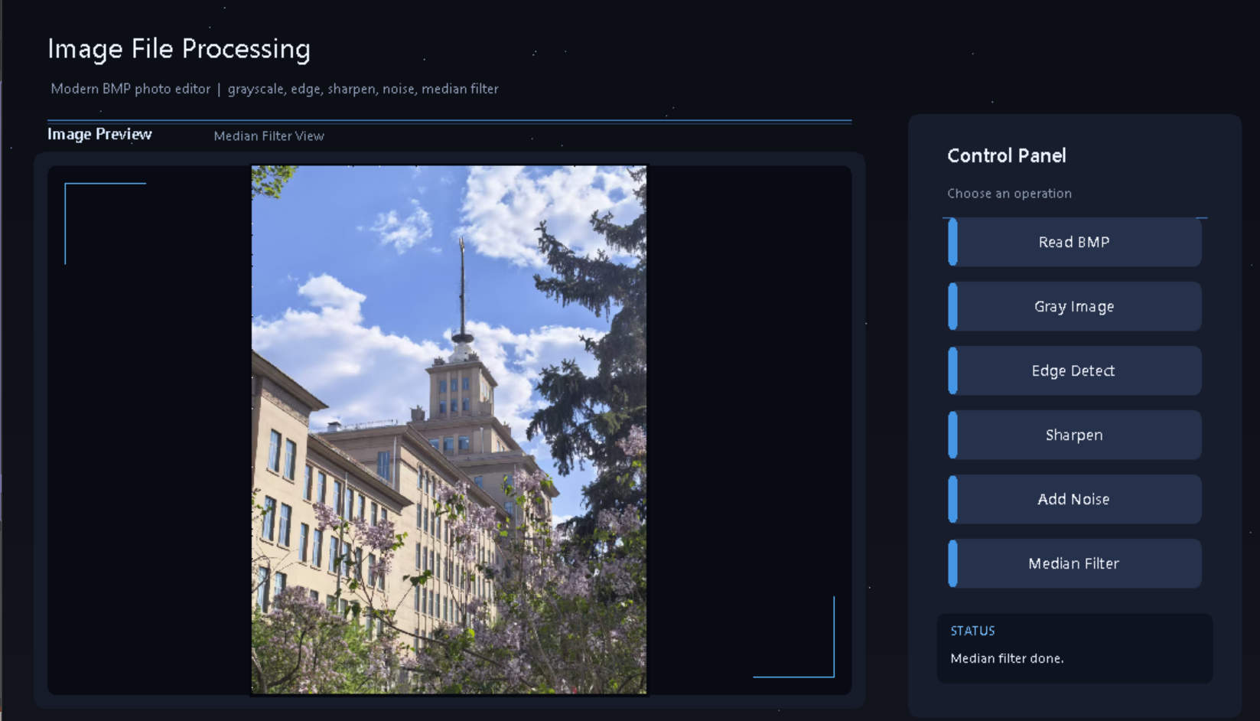
Figure 6. Median filtering result.

12. Program Core Code
The following snippets show the key implementation logic. The complete source code is included in the SourceCode folder. The snippets are presented as core logic excerpts rather than the full program, and they use the final function names used by the project.

12.1 calculate_stride()
BMP rows must be aligned to 4 bytes. This function calculates the actual row size.
int calculate_stride(int width, int bit_count)
{
// BMP rows are aligned to 4-byte boundaries.
return ((width * bit_count + 31) / 32) * 4;
}

12.2 BMP validation in read_bmp()
This snippet checks whether the input file is a valid 24-bit uncompressed BMP image and reads its pixel data.
bool read_bmp(const char* filename,
MyBITMAPFILEHEADER& fileHeader,
MyBITMAPINFOHEADER& infoHeader,
unsigned char*& imageData)
{
FILE* fp = fopen(filename, "rb");
if (fp == NULL) return false;
fread(&fileHeader, sizeof(MyBITMAPFILEHEADER), 1, fp);
if (fileHeader.bfType != 0x4D42)
{
fclose(fp);
return false;
}
fread(&infoHeader, sizeof(MyBITMAPINFOHEADER), 1, fp);
if (infoHeader.biBitCount != 24 || infoHeader.biCompression != 0)
{
fclose(fp);
return false;
}
int width = infoHeader.biWidth;
int height = abs(infoHeader.biHeight);
int stride = calculate_stride(width, 24);
imageData = new unsigned char[stride * height];
if (imageData == NULL)
{
fclose(fp);
return false;
}
fseek(fp, fileHeader.bfOffBits, SEEK_SET);
fread(imageData, 1, stride * height, fp);
fclose(fp);
return true;
}

12.3 convert_24bit_to_gray()
This function converts each BGR pixel into one grayscale value using the standard weighted formula.
void convert_24bit_to_gray(unsigned char* src,
unsigned char* gray,
int width,
int height)
{
int stride = calculate_stride(width, 24);
for (int y = 0; y < height; y++)
{
for (int x = 0; x < width; x++)
{
int index = y * stride + x * 3;
// BMP stores pixels in BGR order.
unsigned char B = src[index];
unsigned char G = src[index + 1];
unsigned char R = src[index + 2];
gray[y * width + x] =
(unsigned char)(0.299 * R + 0.587 * G + 0.114 * B);
}
}
}

12.4 edge_detection()
Sobel edge detection calculates horizontal and vertical gradients, then applies a threshold to produce a binary edge image.
int sobel_x[3][3] = {
{-1, 0, 1},
{-2, 0, 2},
{-1, 0, 1}
};
int sobel_y[3][3] = {
{-1, -2, -1},
{ 0, 0, 0},
{ 1, 2, 1}
};
// For each non-border pixel:
// 1. Apply 3x3 convolution with sobel_x to obtain Gx.
// 2. Apply 3x3 convolution with sobel_y to obtain Gy.
// 3. Calculate G = sqrt(Gx * Gx + Gy * Gy).
// 4. If G > threshold, output 255; otherwise output 0.

12.5 image_sharpening()
The sharpening operation uses a 3x3 convolution kernel and processes B, G, and R channels separately.
int kernel[3][3] = {
{-1, -1, -1},
{-1, 9, -1},
{-1, -1, -1}
};
// For each pixel and each color channel:
// 1. Multiply the 3x3 neighborhood by the kernel.
// 2. Add all products to produce a new channel value.
// 3. Clamp the value to the range 0-255.

12.6 addSaltPepperNoise()
This logic randomly changes selected pixels to black or white.
void addSaltPepperNoise(unsigned char* src,
unsigned char* dst,
int width,
int height,
double noiseRatio)
{
int stride = calculate_stride(width, 24);
memcpy(dst, src, stride * height);
for (int y = 0; y < height; y++)
{
for (int x = 0; x < width; x++)
{
double r = (double)rand() / RAND_MAX;
if (r < noiseRatio)
{
int index = y * stride + x * 3;
unsigned char value = (rand() % 2 == 0) ? 0 : 255;
dst[index] = value;
dst[index + 1] = value;
dst[index + 2] = value;
}
}
}
}

12.7 medianFiltering()
Median filtering removes salt-and-pepper noise by replacing each channel value with the median value in its 3x3 neighborhood.
// For each non-border pixel and each B, G, R channel:
// 1. Collect the 9 values in the 3x3 neighborhood.
// 2. Sort the 9 values.
// 3. Select the middle value values[4].
// 4. Use this value as the filtered output pixel channel.

12.8 showImage24Fit() and showImage8Fit()
The display scaling functions calculate the smaller scaling ratio so the full image fits inside the preview area.
double scaleX = (double)previewW / width;
double scaleY = (double)previewH / height;
double scale = (scaleX < scaleY) ? scaleX : scaleY;
int displayW = (int)(width * scale);
int displayH = (int)(height * scale);
int startX = previewX + (previewW - displayW) / 2;
int startY = previewY + (previewH - displayH) / 2;
// The image is drawn at the scaled size and centered in the preview frame.

13. Analysis, Summary, and Reflections

13.1 Novel and Creative Aspects
- Modern dark photo-editor UI.
- Subtle futuristic and space-inspired design.
- Integrated multiple image-processing algorithms in one system.
- Automatic image preview scaling.
- Output saving for every operation.
- Modular program structure.

13.2 Areas for Improvement
- Add a file selection dialog instead of using a fixed file path.
- Add adjustable Sobel threshold.
- Add adjustable noise ratio.
- Support more image formats, such as JPG and PNG.
- Add a side-by-side before/after comparison view.
- Improve processing speed for very large images.
- Add undo and reset functions.
- Add more image-processing operations, such as blur, brightness adjustment, and contrast adjustment.

13.3 Gains and Reflections
Through this project, I gained practical experience in C/C++ programming and image processing. I learned how BMP image files are structured and how image data is stored in memory. Before this project, I only had a basic understanding of images as visual files, but this project helped me understand that images are stored as pixel data with specific formats and rules.
One important concept I learned is that BMP images store color pixels in BGR order, not RGB order. This caused incorrect color display at first, but after analyzing the problem, I corrected the display by reading the data as B, G, and R, then using RGB(R, G, B) in EasyX.
I also learned about BMP row alignment. BMP rows must be aligned to 4 bytes, so the actual row size is not always equal to width * 3. This problem helped me understand why low-level file processing requires careful attention to data format details.
In terms of algorithms, I learned how grayscale conversion works using a weighted formula, how Sobel edge detection uses convolution kernels to calculate gradients, how sharpening enhances image details, how salt-and-pepper noise is generated, and how median filtering removes noise by replacing a pixel with the median value of its neighborhood.
This project also improved my GUI programming ability. By using EasyX, I practiced drawing a window, buttons, preview area, control panel, and status bar. I learned that a good program should not only implement correct algorithms but also provide a clear and friendly user interface.
During debugging, I solved several practical problems, including wrong file paths, invalid BMP files, incorrect color order, row alignment errors, large image display problems, and basic UI design issues. These problems improved my independent problem-solving ability.
Overall, this project helped me connect programming theory with practical system development. It also strengthened my understanding of modular programming, file processing, memory management, image-processing algorithms, and user interface design.

14. Self-Assessment
The following self-assessment summarizes the completion status of the project according to the course requirements.
Question | Yes | No
Was the program running without bugs? | Yes
Did you watch the instructional videos in the smart course before working on the project and writing the report? | Yes
Was the code compliant with coding standards, including indentation, alignment, and necessary comments? | Yes
Was modular design implemented? | Yes
Was AI-assisted tooling used? | Yes

15. Final Message to the Instructor
Thank you for reviewing my project. Through this comprehensive practice project, I improved my understanding of C/C++ programming, BMP image file structure, pixel-level image processing algorithms, and EasyX graphical interface design. I will continue improving this project by adding more interactive features, adjustable parameters, and support for additional image formats.

16. Report Completion Date
June 19, 2026

17. Appendix

17.1 Final Submission Folder Structure
HANANOSSAMA_2025130323_ImageFileProcessing/
|
+-- SourceCode/
| +-- task1.cpp
| +-- task2.cpp
| +-- task3.cpp
| +-- task4.cpp
| +-- task5_final.cpp
|
+-- Executable/
| +-- task5_final.exe
|
+-- Resources/
| +-- test.bmp
| +-- gray.bmp
| +-- edge.bmp
| +-- sharpen.bmp
| +-- noise.bmp
| +-- median.bmp
|
+-- Screenshots/
| +-- 01_original.png
| +-- 02_grayscale.png
| +-- 03_edge_detection.png
| +-- 04_sharpen.png
| +-- 05_noise.png
| +-- 06_median_filter.png
| +-- final_modern_ui.png
|
+-- DemoVideo/
| +-- demo.mp4
|
+-- report_for_comprehensive_practice_project.docx

17.2 Screenshot Checklist
Screenshot File | Status | Required Figure
01_original.png | Included | Figure 1. Original BMP image loaded in the program.
02_grayscale.png | Included | Figure 2. Grayscale conversion result.
03_edge_detection.png | Included | Figure 3. Sobel edge detection result.
04_sharpen.png | Included | Figure 4. Image sharpening result.
05_noise.png | Included | Figure 5. Salt-and-pepper noise result.
06_median_filter.png | Included | Figure 6. Median filtering result.
final_modern_ui.png | Included | Figure 7. Final modern user interface.

17.3 Output File List
Output File | Description
gray.bmp | Grayscale image result.
edge.bmp | Sobel edge detection result.
sharpen.bmp | Sharpened image result.
noise.bmp | Image with salt-and-pepper noise.
median.bmp | Median filtering result.

