

# Information Management CA2

## **Major CA2**

# Ericsson

## Don Valino – X00112730

Contents

Appendix A - Introduction to the organisation 3

Company facts 4

Financial facts 4

Number of employees worldwide 5

Gender breakdown (Dec 31, 2015): 5

Appendix B - Element of the organisation that I intend examining: 5

Reason for selecting this organisation: 6

Appendix C - Analysis for the organisation 6

Fig 1.1 – Traditional OSS / BSS Architecture 7

Appendix D - Stakeholder analysis for the organisation 7

Employees: 7

Customers: 8

Competitors: 8

Appendix E - Research/ background document 8

1. Organisation Structure: 8

2. Its own vision / goals: 9

3. Its own IT structure and approach to IT: 9

Appendix F - Overview of current amount of resources devoted to IT 10

Fig 1.2 – Split Radio-Access Architecture (Improves redundancy with two nodes – ensures uptime of a network) 11

Fig 1.3 - New ICT Site Floor Plan in Sweden Key Facts 12

Appendix G - Risk Review 12

1. The three key risk issues for the organisation: 12

• Centralisation of servers in the ICT Centre in Sweden: 13

• Key knowledge lost due to employee departure: 13

• Scalability due to growing number of interconnected entities: 14

2. Metrics / Actions / Measures / Suggestions to improve management of these risks. 14

• Centralisation of servers in the ICT Centre in Sweden: 14

• Key knowledge lost due to employee departure: 14

• Scalability due to growing number of interconnected entities: 15

Appendix H - Strategic Recommendations 16

References: 16

## Introduction to the organisation

Ericsson is a telecommunication, multinational networking, and mobile service provider in over 180 countries around the world. Some examples of Ericsson’s customer include Vodafone Ireland as well as their biggest customer, AT&T in the USA. It is also the leading mobile service provider in many countries such as in the USA and it employs more than one hundred forty thousand employees worldwide. 40% of world’s mobile traffic are carried over Ericsson network and Ericsson is concerned with the **Network Society** in which everyone and everything is connected in real time - enabling new ways to collaborate, share and get informed. The Network Society can include calling, texting, watching news, twittering etc. on all sorts of devices and location. To achieve this, Ericsson uses two platforms. These platforms are **Operational Support System (OSS) & Business Support System (BSS).**

Fig 1.0 – About Ericsson

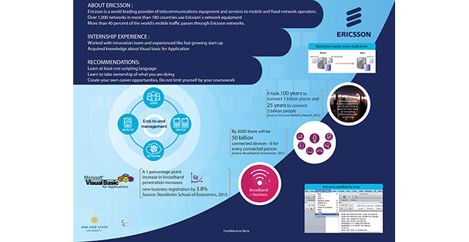

## Company facts

Ericsson is a world leader in the rapidly changing environment of communications technology – providing equipment, software and services to enable transformation through mobility.

**Founded:** 1876  
**Parent company:** Telefonaktiebolaget LM Ericsson (publ)  
**Company registration number:** 556016-0680  
**Global headquarters:** Stockholm, Sweden  
**President and CEO:** Jan Frykhammar  
**Chairman of The Board:** Leif Johansson

## Financial facts

**Net sales, Q3 2016**: SEK 51.1 billion  
**Operating income Q3 2016**: SEK 0.3 billion  
**Net sales full year 2015:**SEK 246.9 billion  
**Operating income full year 2015:**SEK 21.8 billion

**Listed:**NASDAQ OMX Stockholm and NASDAQ New York

## Number of employees worldwide

North America: 12,229  
Latin America: 9,592  
Northern Europe & Central Asia: 19,759*  
Western & Central Europe: 13,574  
Mediterranean: 13,110  
Middle East: 3,479  
Sub Saharan Africa: 2,167  
India: 22,340  
North East Asia: 13,434  
South East Asia & Oceania: 4,113

**Total 113,797**

* of which Sweden:15,872

(figures from latest interim report)

Gender breakdown (Dec 31, 2015):  
Female 22%  
Male 78%

## Element of the organisation that I intend examining:

**To analyse a report that will explore its:**

* + - 1. Stakeholders
      2. Strategies
      3. Risk
* Objectives:
  + 1. To study how it’s **strategies** and **stakeholders** affect their business operation and continuation.
    2. Use the knowledge obtained from objective 1 to a analyse a report representing possible flaws on its operation and advocate applicable solutions.
    3. Identify possible **risk** types (e.g. Architecture, Environment) and suggest suitable solutions.
    4. Examine how Ericsson plans to mitigate the scalability issues that surface them in the near future. **– 50 billion devices expected to be connected around the world by 2020.**

## Reason for selecting this organisation:

The reason that I initially selected this organisation is because this is a company in which I did my internship with for 6 months. I am therefore familiar with their operations and the technologies that they use to deliver the development of products and services to their customer.

From being an intern in Ericsson, I have realised the issue that they are facing especially concerned with scalability. I have also witnessed the actions and investments that they have created to mitigate these issues. Therefore, I think it it’s a good area to explore or investigate how those investments had impacted the organization that stands today (i.e. explore the return).

## Analysis for the organisation

As anOperators, Ericsson needs to control cost, find new sources of revenue, and provide a better customer experience to make their business a success. From Over 130 years, Ericsson has learned that telecom is always evolving. Working with OSS and BSS means always adapting, changing, fine-tuning, improving and updating. Ericsson challenges knowledge of discovering exactly what’s going on from one end to another through all the network element. These include not just the mobile networks but all the parts: **fixed and mobile** that makes up the **Network Society**.

A network needs to be planned to work at its best. It may need to cover mountains, forest, lakes, small town, and big cities to reach every customer. Then the network needs to be built. Even after the network has been built, there is still always constant optimization to the network to ensure its integrity and enable services to its customers. This is practiced to achieve fulfilment. If there are hindrance to the network such as sky scrapers or if a base station goes down, the people at the **Network Operation Centre** can pick up the slightest disturbance in the network. Their role in the chain of operation is called ‘**Assurance**’. These are all related to **Operational Support System** **(OSS)**.

Operators also needs revenue management. To look after their customer whether they are post-paid subscriber or with prepaid card, there must be mechanism for billing and charging in place. These ensure that each customer pays the correct rate, for different services, at different locations and at different times. If customers need to contact the operators to change details on their account, ask questions or report a fault, they need to enquire with the customer support. The applications to handle this dialog is called **Customer Relationship Management**. All these systems that looks after the business are referred to as **Business Support System** **(BSS)**.

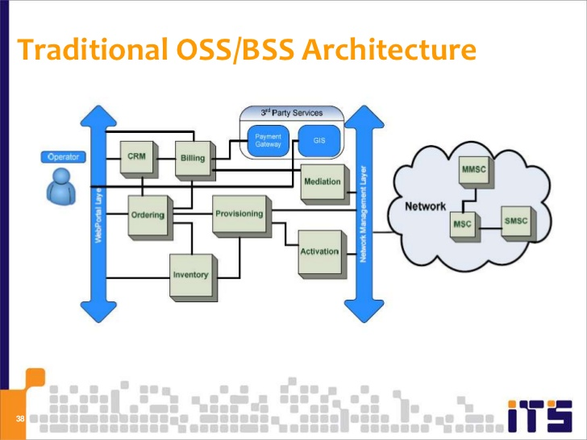

## Fig 1.1 – Traditional OSS / BSS Architecture

## Stakeholder analysis for the organisation

## Employees:

One of Ericsson’s Stakeholder is its enormous number of employees that provides the skills required to deliver the business continuation of Ericsson. Employees are primarily affected as stakeholders in terms of their economic well-being. Employees share a common concern regarding how much and how often Ericsson pays them. The decisions of management that affect these concerns are especially important for these stakeholders. Whether Ericsson decides to offer benefits and other compensatory packages to employees also affects employees in this sense. Therefore, the continued economic health of the company is of utmost importance to the employee. The decisions that Ericsson executes may also affect the job security of its employees. If Ericsson executes risky business decisions that harm the essential point of the company, this may be putting the job security of the employees at risk. This could cause employees to take an interest in those decisions and possibly jump ship if they sense that it will hurt the company overall. Employees need long-term job security and stability to thrive, in most cases.

## Customers:

Ericsson is a global company supporting more than 500 operator customers and an increasing number of non-operator customers. The Company has been present in many countries, such as China, Brazil and India, for more than 100 years. The ten largest customers, half of which are multinational, account for 47% of Ericsson’s net sales. Without customers, the company cannot survive so in almost all situations the customer needs must come first. The customer want the business to provide high-quality goods and services at an affordable cost. If these opportunities are present in another organization, they can always to choose to take his business to a competitor. Therefore, it is essential that Ericsson continue to innovate and offer good products and services for its customers.

## Competitors:

The top competitors for Ericsson are:

1. Alcatel-Lucent
2. Huawei Investment & Holdings Co., Ltd.
3. Nokia Solutions and Networks B.V.

Competitors also fit the definition of a stakeholder (i.e. Negative Stakeholder). This is because Ericsson’s operations impact them. However, the effects are typically more indirect. All companies that are in the same industry as Ericsson are impacted by the way Ericsson conduct business. Competitors also have a strong interest in your business when you target the same types of customers.

## Research/ background document

## Organisation Structure:

Ericsson contains two platforms: **OSS** and **BSS** that contains a separate organisational structure. As an intern in Ericsson, I was fortunate enough to be exposed to the OSS platform. The **OSS or Operational Support System** operates mostly in Sweden and Ireland. Here in Ireland, Ericsson LMI’s site in Athlone is there main development site in which their products are developed. The Athlone site is also considered to be the largest Java development site in Ireland. For the platform of OSS. Ericsson uses **Scrum** and **Kanban** with **Agile development**. In Agile development, there is always active user involvement from the beginning. The teams in Ericsson are empowered to make / suggest their decision. Everyone is treated equally regardless of their positions. While in development, the timescale of development for a project is fixed. This is usually estimated on the units of work (i.e. the velocity of the team). The requirements are captured at a high level and development is executed in small portions. There are frequent incremental release and iteration is necessary for improvement. Ericsson’s focus is on the delivery of quality products. Therefore, each feature is completed before implementing the next one. Testing is also integrated towards the lifecycle and collaboration / cooperative with stakeholders is present.

The OSS maintains its own customer support department which are allocated in the countries of Ireland, Mexico, and India. The customer support department is structured into tiers depending on the skills of the engineers that provides the support and the escalation level of the **Customer Service Request (CSR)**. A customer of Ericsson creates a CSR to report a fault to a product belonging to Ericsson. Ireland is the highest tier which is tier 3. CSR with a high escalation level (e.g. Emergency) that are sometimes associated with revenue are usually handled here. Since Ireland is the top tier, this is the last country that the CSR reaches. Mexico is the second level of the tier. They would usually handle CSR with mid-level escalation or CSRs that are passed to them from India. India is level 1 of the tier. They are usually first to receive CSRs regardless of its severity / escalation level. If the CSR that arrived is with a low-level severity, they usually handle it. However, if it is associated with a mid-high level severity, they can redirect the CSR to Mexico or even to Ireland.

## Its own vision / goals:

The aims of Ericsson are to connect 50 billion devices by 2020. However, with this many interconnect devices, they are faced with scalability issues which they must address. Ericsson has invested in the development of a new platform that are strongly based on the Operational Support System. This platform will be more scalable and will reduce OSS’s current downtime by over 15% (i.e. ensuring an uptime of 99.99%). This platform will be called **Ericsson Network Manager (ENM)**. ENM ‘s main aim is to provide a single management solution for all network technologies for mobility and IP. It also aims to support full network management capabilities – to set up, run and assure the best network performance. It is designed with the best-in-class usability and workflow management for improved operational efficiency in service delivery. The service delivery for the customer support department is also aimed to be improved with the introduction of **Flow Optimization**, along ENM. With Flow Optimization, a CSR is redirected efficiently to the correct CSR handler with the necessary skills required to handle the issues associated with the CSR.

## Its own IT structure and approach to IT:

Ericsson centralise most of its datacentre in Sweden. Their main reason for this is to reduce cost, energy usage and the development of 5G network. Ericsson decided that they were going to build a 20,000-square meter Global ICT Centre in Sweden to drive innovation. The centre supports engineering on virtual platforms with global test labs and IT hubs connected via a single virtual environment. This will support Ericsson to host 5G development under one site. Ericsson’s cloud solutions power the site, enabling over 20,000 R&D engineers globally to accelerate innovation cycles, reduce cost and better support Ericsson's customers. Ericsson estimates a 40 percent reduction in energy usage compared to 2014 test lab energy baseline.

Rosersberg was selected as a location due to numerous benefits that include its proximity to Ericsson's R&D hub in Kista, Sweden. A direct fibre cable between Rosersberg and Kista will optimize connectivity speed, reliability, and security. The Rosersberg site, which covers 20,000 square meters, is the first purpose-built Ericsson Global ICT Centre to be inaugurated in Sweden. Ericsson's Global ICT Centres are an important step toward achieving the company's sustainability goals. The innovative design of the centres, combined with modular and scalable construction, secures efficient use of energy and space.

## Overview of current amount of resources devoted to IT

As more people are becoming subscribers, more things are becoming connected and more applications are running constantly. Therefore, Ericsson’s developers of new technologies are working hard to enhance responsiveness by reducing latency, a key performance parameter. The capability to determine what functions can be virtualized to maximize ideal placement in the network and ensure low latency is one of the primary driving factors behind a proposed split of radio-access architecture.

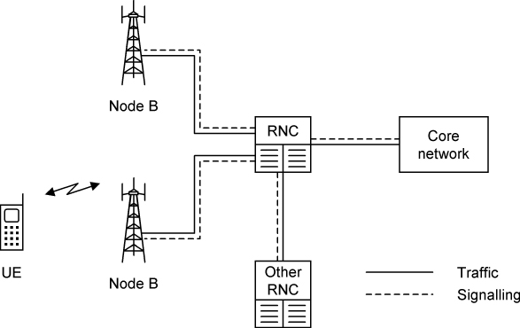

## Fig 1.2 – Split Radio-Access Architecture (Improves redundancy with two nodes – ensures uptime of a network)

Today, 2d video is the most advanced form of communication people use to connect with each other. In the future, people will be able to participate in distant business meetings or attend a family gathering by sending an augmented 3d selfie. Since Many people are looking forward to the day this will be Ericsson is motivated in investing in this technology along with the development of 5g network. Emerging technologies in the fields of the tactile internet, virtual reality, and augmented reality – supported by 5g network evolution – are showing signs that the ability to experience an event virtually is no longer science fiction, but a feasible reality, and indicate a giant step forward in innovation.

Fig 1.3 - [Ericsson](https://twitter.com/ericsson) unveils Piero augmented reality graphics for sports broadcasting



With a goal to drive innovation and to improve facilities, Ericsson has recently opened a new 20,000 square meter Global ICT Centre in Sweden. The Global ICT Centres allow Ericsson to emulate an operator's mobile network and to test new solutions as if they were running on a live network. Soon, Ericsson's customers will be able to connect remotely for interoperability testing, trials, early access, and innovation on new offerings from any location. These services will be provided through ten Business-Near Centres, to be announced in 2017, which are connected to the Global ICT Centre. The Global ICT Centres are set to be powered by Ericsson's cloud solutions and will host a substantial part of the company's product portfolio. Because of this extensive rationalization and virtualization effort, Ericsson will be able to shorten innovation cycles and increase global collaboration while also reducing R&D costs. Currently, the company's test environments are spread across more than 50 locations worldwide.

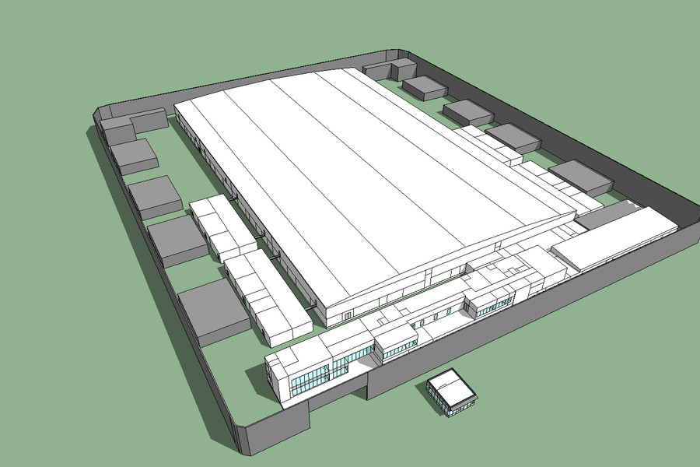

### Fig 1.3 - New ICT Site Floor Plan in Sweden **Key Facts**

#### **Cost Saving**

* 44%

#### **Energy Saving**

* 21.6%

#### **LEED credits**

* 6

#### **Area**

* 20,000 m2

Over the past three years, Ericsson has also invested approximately SEK 100 billion in research and development. Ericsson holds over 37,000 granted patents, including more standard-essential patents for mobile communication than any other company. Innovation is the foundation of Ericsson's technology and services leadership, and supports the company's position as an enabler of the Networked Society.

## Risk Review

## The three-key risk issues for the organisation:

The three types of risk that I have identified over my research about Ericsson are:

1. Centralisation of servers in the ICT Centre in Sweden – **Operations Risk**
2. Key knowledge lost due to employee departure – **Project Risk**
3. Scalability due to growing number of interconnected entities – **Opportunity Risk**

## Centralisation of servers in the ICT Centre in Sweden:

While the innovation behind Sweden’s ICT centre has some advantages, it can also effects developments in sites of other countries such as Ireland. In Ireland, Ericsson’s Network Manager which is intended to replace its ‘Operational Support System’ platform is being developed. However, since the servers are centralised in Sweden (including test servers), this can sometime increase the development time if a bug or a configuration error occurs in the server. As past intern of Ericsson, I have personally experienced this first-hand when we had to deploy a new version of a program in which I was a software developer in. The deployment crashed due to a minor issue associated with the war file size of Tomcat’s live server. While we knew how to solve the issue, we were not able to configure it due to restrictions allocated to the engineers of Ireland. We therefore needed to create a ticket into Ericsson’s JIRA system and the ticket took five working days to be addressed. Comparing this scenario back to when the live Tomcat server was still located in Dublin, Ireland, the issue could have been solved within the same day by simply contacting an engineer in Dublin.

## Key knowledge lost due to employee departure:

Ericsson has had to lay off thousands of workers this year in the face of a [stagnant market](http://fortune.com/2016/04/21/ericsson-earnings-report/) for its products, and last week said it is still looking to drastically cut costs. Its [biggest problem](http://fortune.com/2016/07/19/5g-wireless-ericsson-troubles/) is that most operators are done rolling out the current generation of mobile broadband networks, known as 4G or LTE. The next generation, so-called 5G, doesn’t exist yet—everyone agrees that it’s supposed to be faster and more reliable, and there’s a general hope for a roll-out around 2020, but the underlying technical standards have not been established, so no-one can build anything yet.

Just recently in a media report, Telecoms equipment maker Ericsson has confirmed that it will cut 3,000 jobs in Sweden, including in production, research, and development. The 3,000 job cuts will affect around 1,000 positions in production, 800 in research and development (R&D), and some 1,200 in other operations. Ericsson said it planned to reduce the number of administrative positions in R&D, but needed new competence in new technologies and would therefore hire around 1,000 engineers in Sweden, primarily from universities, over the next three years. Ericsson also said it would make "general cost reductions and take out external costs, primarily by reducing the number of consultants in Sweden by 900.

We can remember that this summer, Ericsson had also cut 4,000 jobs due to a down-turn of sales. Also, they have recently laid off their CEO, Hans Vestberg who led the Swedish firm for seven years, and is replaced by chief financial officer Jan Frykhammar for the short term.

All of this would constitute to the key knowledge lost due to employee departure. Departing employees leave with more than what they know; they also take with them critical knowledge about who they know. That information needs to be a part of any knowledge-retention strategy. When employees leave a job, of their own volition or not, employers lose the institutional knowledge or history that they take with them, and many organizations lack sufficient transfer programs to stem the loss. Ericsson must have plans in place to ensure continuity.

## Scalability due to growing number of interconnected entities:

40% of world’s mobile traffic carried over Ericsson network. Ericsson is Concerned with the **Network Society** where everyone and everything is connected in real time - enabling new ways to collaborate, share and get informed. The Network Society can include calling, texting, watching news, twittering etc. on all sorts of devices and location. With the concept of the Network Society, Ericsson is faced with a new challenge concerning scalability. This is because more devices whether fixed or mobile are expected to be connect soon. **50 billion devices expected to be connected around the world by 2020.**

## Metrics / Actions / Measures / Suggestions to improve management of these risks.

## Centralisation of servers in the ICT Centre in Sweden:

To prevent affecting the development timescale of engineers in sites of other countries like Ireland, they can allow administrative rights / access to contents or configurations to engineers with the right skills and position. This can prove to be beneficial as it would alleviate the need to create a ticket into Ericsson’s JIRA system just to report an incident or issue relating to the servers which is centralised into Sweden’s ICT centre. While creating a ticket is useful, the ticket can take up to 5 -10 working days to be addressed. This can delay a release and affect the deadline of a project. With the access rights to alter configuration, engineers can use Putty to SSH or FileZilla to FTP remotely into the server and execute commands / transfer appropriate files to resolve an issue. They can then remotely restart the server to commit the changes.

## Key knowledge lost due to employee departure:

To prevent losing knowledge due to an employee departure, the information that Ericsson employees know can be a part of any knowledge-retention strategy. The type of knowledge may be lost, the organizational consequences of losing that knowledge and the action to be executed to retain that knowledge needs to be taken into consideration. The first part of knowledge-retention strategy is to understand your risk factor. This can involve the age of an employee, the focus on knowledge capture, difficulty to locate knowledge and informal communication in the organization. The knowledge then needs to be classified and the most critical knowledge needs to be understood.

Knowledge retention consists of a wide range of tools. One of those tools is **‘*Personalization and codification’****.* Personalization refers to connecting people and includes tools such as mentoring, job rotation, knowledge fairs, communities, and so on, while codification includes tools like after action reviews, various knowledge repositories, lessons learned systems, etc. Another tool **‘*Bidirectional knowledge flow’.*** This involvesestablishing a two-way system of knowledge capture, where knowledge is not only passed down from the senior employee to the junior employee, but also vice versa. Ericsson can also bring back important retirees in various capacities. This includes rehire programs, consultancy, part-time work or temporary jobs.

Despite cutting 3,000 jobs in Sweden, including in production, research, and development, the company said that it however also planned to hire 1,000 people in research and development over the next three years, as the company undergoes a "large transformation". According to Chief Executive Jan Frykhammar, "We continue to have a strong focus on research and development, and since many years, most Ericsson employees work in software development and services, rather than hardware production. The measures are necessary to secure Ericsson's long-term competitiveness as well as technology and services leadership".

## Scalability due to growing number of interconnected entities:

To improve scalability, everything in Ericsson today everything is all automated. The systems and applications are being constantly optimised to handle problems in the networks. The focus of Ericsson’s **Service Operation centre** is the actual service passing through the network. Customers calling for support don’t want to wait for answers on why something isn’t working or how much data they can download etc. The operators of Ericsson have complete end-to-end overviews and control of the information in real time. They have answers ready before customer even calls customer support.

Ericsson has also taken on several projects to improve scalability. One of these projects is the development of a new platform called **Ericsson Network Manager** (ENM). ENM based on one of Ericsson’s current platform called Operational Support System that is used for the development and maintenance of products belonging to Ericsson. ENM is a single management solution for all network technologies for mobility and IP. It has full network management capabilities. Also, it integrates comprehensive SON capability for network automation. With Ericsson Network Manager, unified management is possible from access all the way through to core, including our 4GIP networks. This saves time, getting more out of network assets, and delivering more agile and better performing networks and services.

## Strategic Recommendations

My analysis of Ericsson indicates that the company possesses major strengths in mobile technologies such as **3g / 4g** **network** that can be used to effectively address opportunities in IoT and the Network Society. The company can also use these strengths to exploit the opportunity to expand its distribution network. This is proven with the opening of their ICT site in Sweden with the aim of will hosting a substantial part of the company's product portfolio. In addition, Ericsson can use its strong brand image as the world-leading provider of communications networks and rapidly use innovation processes to successfully develop and launch new product lines. Currently, Ericsson is developing the **5g** which is the next chapter of telecom networks designed to meet ever-more advanced and complex sets of performance requirements. 5G will enable organizations to move into new markets and build new revenue streams with radically new business models and use cases, including Internet of Things (IoT) applications. This will also enhance scalability with the challenge of connecting 50 billion devices by 2020.

 However, the organization faces the significant threats of aggressive competition (i.e. with the likes of **Alcatel-Lucent** and **Huawei Investment & Holdings Co., Ltd**.**.**) and imitation, which are major challenges affecting players in the industry. Ericsson’s competition also use rapid innovation. Because of the aggressive behaviours of other competing organization, it is necessary to have strong fundamentals for maintaining competitive advantage. A suitable course of action is to address these threats through a stronger patent portfolio, along with continuous innovation to ensure the competitive advantage of Ericsson’s products.

## Indexes

2

20 billion devices 8

3

**3g**  15

4

4G 12

5

**50 billion devices** 5, 13, 15

5G 9, 12, 15

A

Agile development 8

Assurance 6

B

***Bidirectional knowledge flow*** 14

BSS 2, 3, 6, 8

**Business Support System** 3

C

Company facts 2, 4, 17

Competitors 2, 7, 18

**CSR** 8, 9

**Customer Relationship Management** 6

**Customer Service Request** 8

customers 6, 7, 9, 11

Customers 2, 7, 14

D

development 5, 8, 9, 10, 11, 12, 13, 14

E

Employees 2, 7

ENM 8, 14

Ericsson Network Manager 8, 14

F

FileZilla 13

Financial facts 2, 4

**fixed** 6, 8, 13

FTP 13

G

Gender breakdown 2, 4

I

ICT Centre 2, 9, 11, 12, 13

Internet of Things 15

investments 5

IoT 15

Ireland 3, 8, 12, 13

J

JIRA 12, 13

K

Kanban 8

knowledge 2, 5, 12, 13, 14, 18

knowledge-retention strategy 13, 14

M

**mobile** 3, 6, 11, 12, 13, 15

N

**Network Operation Centre** 6

network Society 6

**Network Society** 3, 13, 15

Number of employees worldwide 2, 4

O

**Operational Support System** 3, 8, 12, 14

Operators 6

OSS 2, 3, 6, 8

P

***Personalization and codification*** 14

Putty 13

R

R&D engineers 9

**risk** 2, 5, 7, 12, 14

Risk 2, 5, 12

S

Scrum 8

SSH 13

stakeholder 7

Stakeholders 5

Strategies 5

Sweden 2, 4, 8, 9, 11, 12, 13, 14, 15, 18

T

Testing 8

## References:

* 2016 (2016) *About Ericsson - corporate information*. Available at: https://www.ericsson.com/about-us (Accessed: 10 November 2016).

**In-line Citation:**(2016, 2016).

* AB, E. (2016) *Company facts*. Available at: https://www.ericsson.com/about-us/company-facts (Accessed: 17 December 2016).

**In-line Citation:(**AB, 2016)

* Hoovers Inc. (2016) *Top Competitors for ERICSSON INC.* Available at: http://www.hoovers.com/company-information/cs/competition.ericsson_inc.2a8b644bddee0429.html (Accessed: 17 December 2016).

**In-line Citation:**(Hoovers Inc., 2016)

* Ericsson (2016) *Network manager*. Available at: https://www.ericsson.com/ourportfolio/products/networmanager?nav=productcategory005%7Cfgb_101_0382 (Accessed: 17 December 2016).

**In-line Citation:**(Ericsson, 2016)

* Ericsson (2016) *Ericsson opens 20, 000 square meter global ICT center in Sweden to drive innovation*. Available at: https://www.ericsson.com/news/1981806 (Accessed: 17 December 2016).

**In-line Citation:**(Ericsson, 2016)

* Limited, I.E.S. (2011) Ericsson global ICT center Rosersberg - energy services project. Available at: https://iesve.com/consulting/projects/projectdetail?building=Ericsson-Global-ICT-Center-Rosersberg&id=5662 (Accessed: 18 December 2016).

**In-line Citation:**(Limited, 2011)

* Ltd, R.C.E. (2016) *Ericsson to cut 3, 000 jobs in Sweden*. Available at: http://www.rte.ie/news/business/2016/1004/821278-ericsson-to-cut-3-000-jobs-in-sweden/ (Accessed: 18 December 2016).

**In-line Citation:**(Ltd, 2016)

* Frost, A. (no date) *Knowledge retention*. Available at: http://www.knowledge-management-tools.net/kr.html (Accessed: 18 December 2016).

**In-line Citation:**(Frost, no date)