**Normalisation**

**1NF**

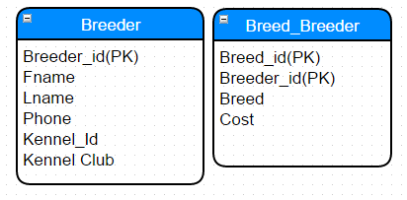

In 1NF, we remove the repeating groups (i.e. attributes which can have multiple values) from the table and place it into a new table. We then set the appropriate Primary Keys on the new table we created and in the old table.

**2NF**

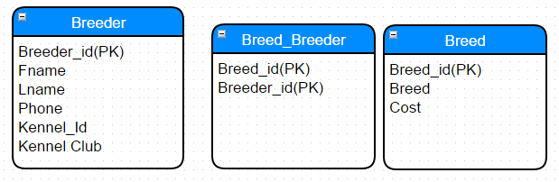

In 2NF we will focus on removing the partial dependencies among the attributes in the table. Based on the data produced in 1NF, I have observed that the table “Breed_Breeder” contained partial dependencies as the attribute “Breed” and “Cost” are only dependent on one of the composite key “Breed_id”. We therefore, remove these attributes and place them into a new relation, setting the appropriate Primary key in each table.

**3NF**

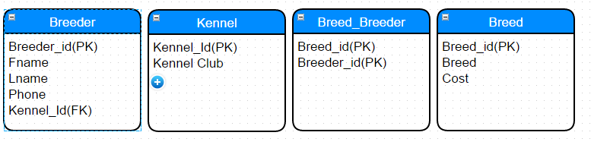

In 3NF, we will focus on removing the transient dependencies among the attributes . Data from 2NF suggest to me that the table “Breeder” contained transient dependencies as the attribute “Kennel Club” is only dependent on the none-key “Kennel_ID” of the 2NF “Breeder” table. We therefore remove these attributes and place them into a new table. To conclude we placed the primary key of “Kennel table” to be a foreign key of “Breeder” table.