**Lab4**

(3.) (a) Microsoft Windows 8.1 Enterprise

(b) 

(c) 

(d) 

(e) 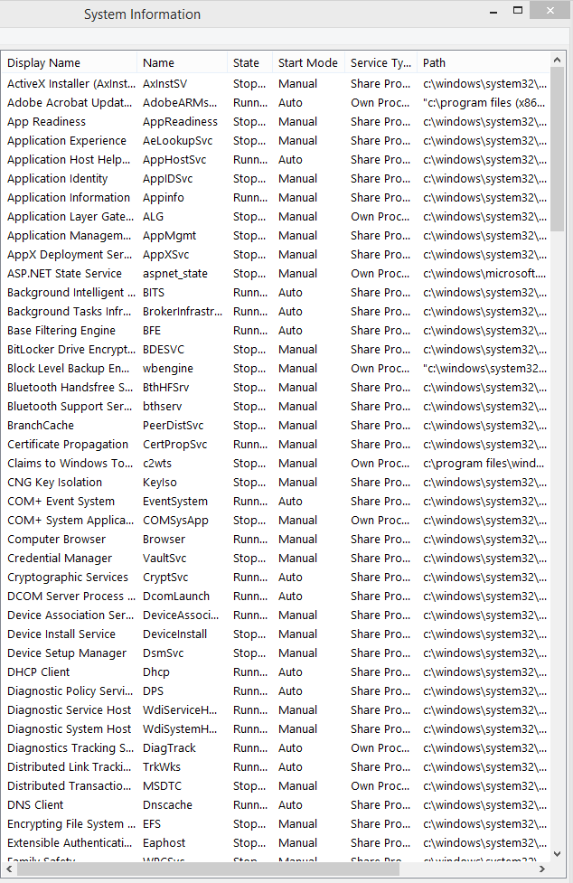

4.

(a) 8 apps. 32 back-ground process

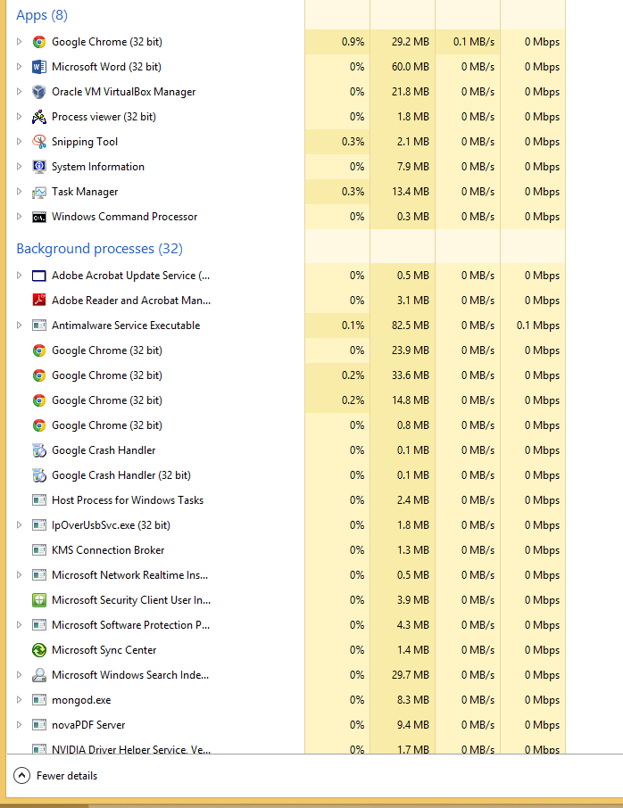

(b) **Idle Process** contains one or more kernel threads which run when no other runnable thread can be scheduled on a CPU.

(c)

