B.Sc in Computing - Semester 6
Adv Operating Systems

Deadlock Avoidance

1. Consider the following states:

State A
 | Current Loan | Maximum Need
User 1 | 1 | 4
User 2 | 4 | 7
User 3 | 1 | 4
User 4 | 0 | 3
Available | 2

State B
 | Current Loan | Maximum Need
User 1 | 4 | 6
User 2 | 1 | 5
User 3 | 5 | 8
Available | 2

In the context of the Banker’s Algorithm, are each of these states safe or unsafe? If safe, show how all processes can finish. If unsafe, show how deadlock could occur.
State A - Unsafe
State B - Safe

2. Does the existence of an unsafe state mean that the system will eventually deadlock? If no, show how processes in an unsafe state might complete successfully.
No. If 1 of the process in an unsafe state finishes, this will free up some other resource which might be requested by other resources to finish.

3. In the context of deadlock avoidance, if the first three conditions for deadlock (mutual exclusion, wait-for, and no pre-emption) are allowed to hold, will the following strategy prevent deadlock from occurring? Give all processes a unique priority. When more than one process is waiting for a resource and it becomes available, allocate it to the one with the highest priority.

No this strategy will not prevent deadlock from occurring just because priority is allocated from the beginning because the resource demand can increase.

4. If processes hold all resources until they complete, does an unsafe state eventually lead to deadlock?
Deadlock is possible in processes in unsafe state. If a process hold all resources until they complete, other process might be waiting for that resource. However when the process holding those resources completes, it will free up the resources for other process to use to finish. It does this again iteratively to free up the resources for the next process until all process had finished.

5. All resources are identical, and can be acquired and released one at a time. Suppose a process never needs more than two resources. State whether deadlock can occur in each of the following systems. If deadlock can occur, show a Resource Allocation Graph depicting the deadlock.

 | No. of Processes | No of Resources
A | 1 | 2
B | 2 | 2
C | 2 | 3
D | 3 | 3
E | 3 | 4

Even if a process never needs more than two resources, in this case a dead lock can still occur. A dead lock can still occur because if one of the processes (e.g. B) request the 2 resources and another process request another 2 resources, there might not be enough resources causing a dead lock. The process in A will not cause a dead lock but the processes in B,C,D and E will.
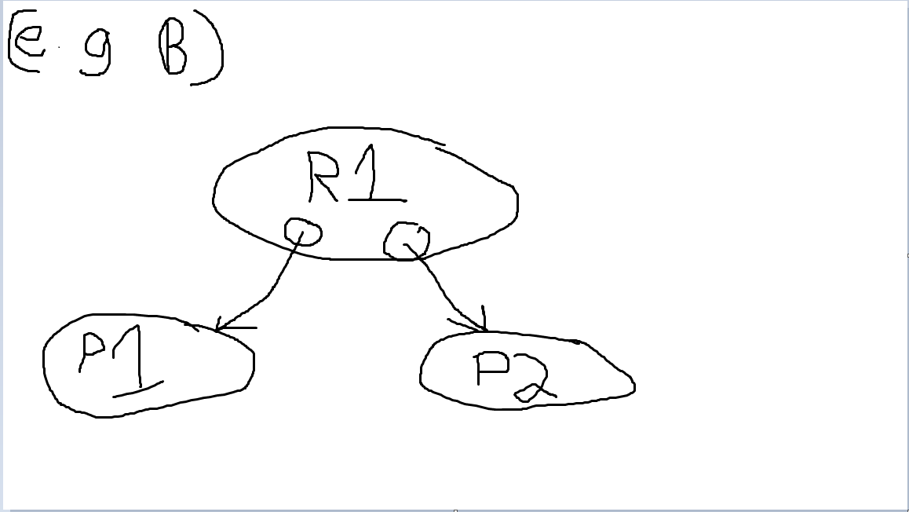

- Consider an OS in which three processes P1, P2, and P3 are requesting resources of types R1, R2, R3, and R4. There is one resource of type R1, 4 of type R2, 2 of type R3, 3 of type R4, and 3 of type R5. The processes issue the following sequence of requests:

P2 requests a resource of type R1
P1 requests a resource of type R2
P1 requests a resource of type R3
P3 requests a resource of type R5
P2 requests a resource of type R5
P3 requests a resource of type R4
P3 requests a resource of type R4
P1 requests a resource of type R4
P1 requests a resource of type R1
P2 requests a resource of type R3
P2 requests a resource of type R4
P3 requests a resource of type R2

Draw the resource allocation graph for this sequence of requests. Is the system deadlocked?

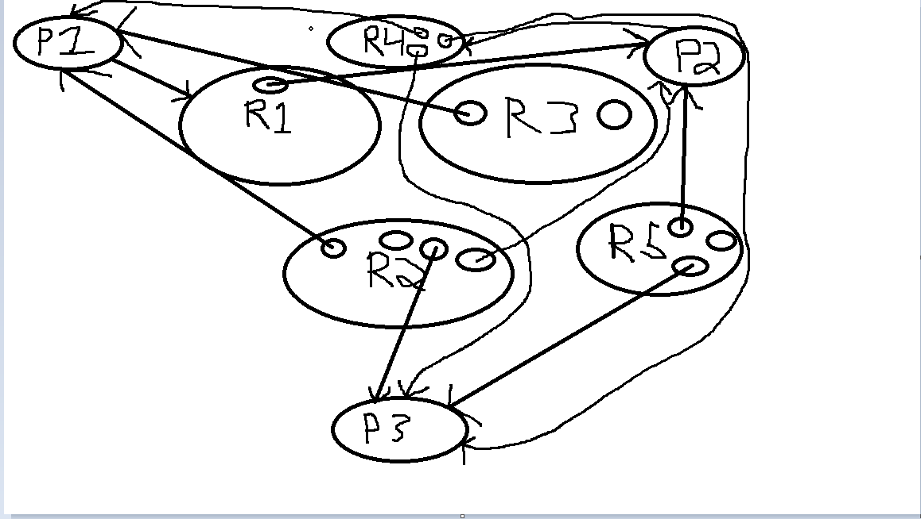

The system will not be deadlocked becaue process P3 is able to finish, freeing up resourceses to other processes, allowing them to finish.

