Project VGrabber

Description
The application offers the possibility to grab information from one of public sites called www.makler.md and stores it to local database. The grabbed info then is processed and shown in different views.
Folder /bin contain project binaries use java –jar VGrabber.jar in order to run application.
Folder /src contain project sources, use NetBeans 5.0 or newer version to open the VGrabber project.

Deployment

In order to run this application, the following environment and configurations are required:

Environment:

- JRE 1.5 installed on desktop machine (machine on which application should run).
- MSSQL2K (SP4) installed on desktop machine or network machine.
- Desktop machine should have access to the internet, (at list from desktop machine telnet www.makler.md:80 should be ok)

Configurations:

- Ensure you have rights to access MSSQL as system administrator
- Using MSSQL Enterprise manager create a database, just create an empty database
- Run application (/bin/VGrabber.jar) and open configuration tab, fill in the server name, database name (you just created), username and password (you may enter you user name or you may created a special user but if creating special user don’t forget to make it database owner), also check “Create Database Objects” if you access for first time the Database, see the screen below to be more clear.

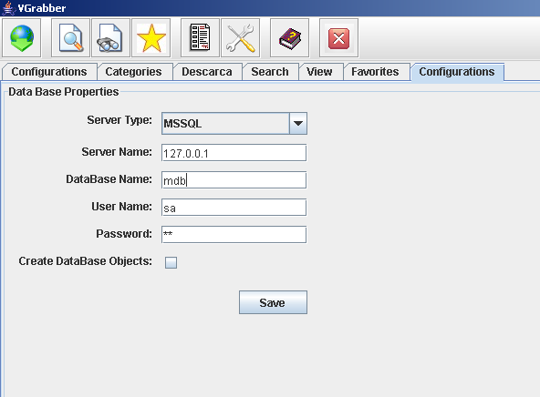

Functionalities

Categories to download:

Before download there is mandatory option you have to do, you have to choose which categories to download otherwise nothing will be downloaded, to do this click on the Categories button in menu the screen as bellow one will be shown.

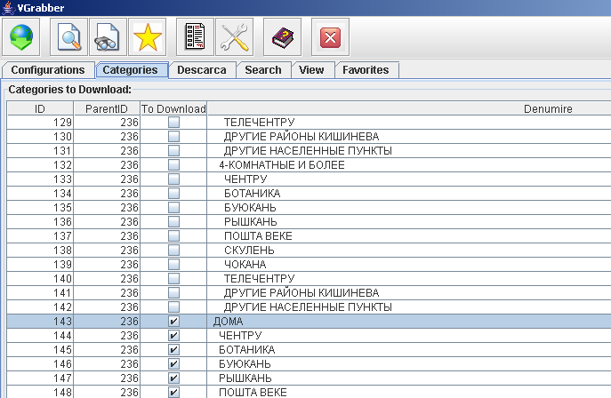

Download:

In order to start downloading select Download from menu. A screen like the below one you should see. The first grid shows the list of editions available for download from web. You may choose an edition or more and then select “Download” button, the process may take a while and a “Wait” window appear. After download finishes the downloaded editions will appear in the grid below. Then the downloaded editions you may remove, select the desired edition(s) and select “Remove” button.

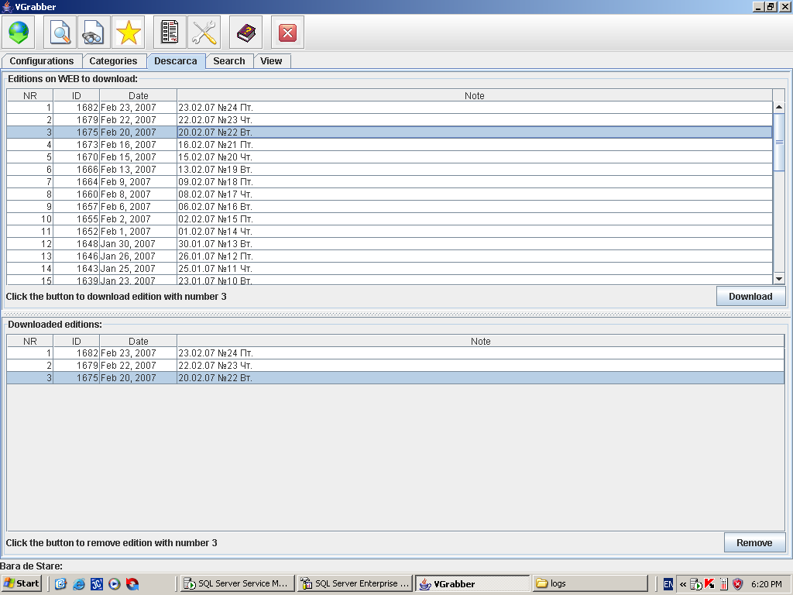

View News

Select “View” from menu to see offers which are new comparing with what is downloaded currently, see form below.

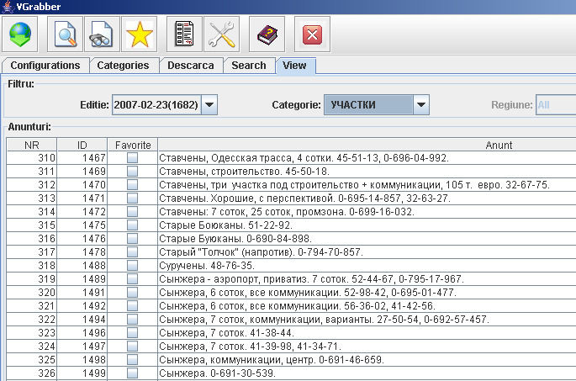

View History

Select “View History/Search” in order to see more offers on the contact/person which posted offer. See for example form below.

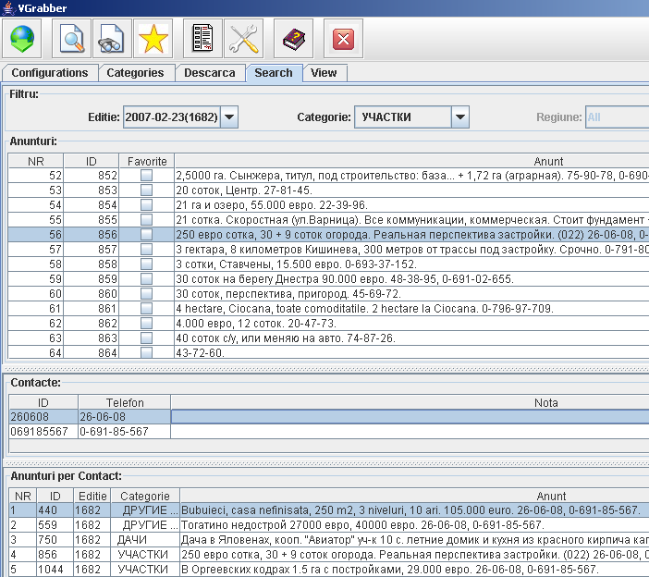

Favorites

During offers visualization you may put offer in favorites, you may see favorites by choosing Favorites from menu, you’ll see a form like the one below.

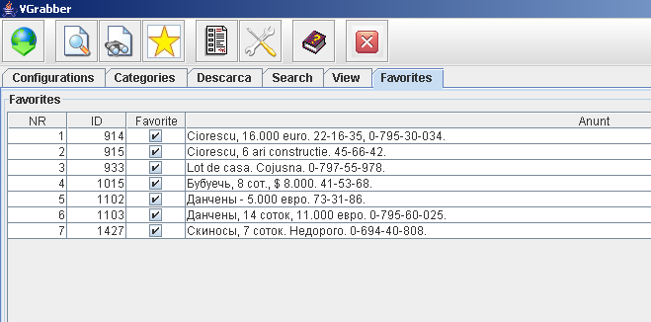

Architecture

Database

Database consists of the following tables:

editie – table stores data about editions like edition id, edition date, edition note
categorie - table stores data about categories like category id, category parent, category name, toupdate flag which means download this category or not.
contact – table stores data about contact/person like contact id, phone, note
anunt – table stores data about offers, data like offer id, edition id it belongs to, category id it belongs to, offer text, offer date (may be deprecated as it may be taken from edition), interested field which show that offer was interested the user.
contact_anunt – this table stores the relation between contact and offer.

Database diagram see below:

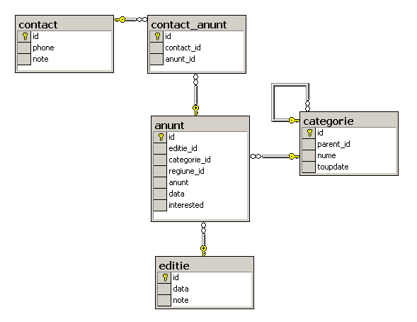

Implementation

Following describes application structure and in more detail some of application functionalities.

Application structure consists of following packages:

vgrabber – contains Main class with main method which starts application.
vgrabber.client - contains all classes related to application gui.
vgrabber.common – contains application basic classes like: Edition class, Category class, Message class, Contact class
vgrabber.config – contains classes to manage with configuration data stored in config file
vgrabber.db – contains classes to manage with db data
vgrabber.grabber - contains classes for grabbing data from web
vgrabber.logger - contains classes to manage with logs

Data download – following code grabs data from the web

public static ArrayList<vgrabber.common.Message> GrabEdition(Edition edition){

ArrayList<vgrabber.common.Message> messages=new ArrayList<vgrabber.common.Message>();
//Check if edition is added already
if (vgrabber.db.EditionManager.GetEditionById(edition.getId())==null){
vgrabber.db.EditionManager.AddEdition(edition);
}
for (Category category:vgrabber.db.CategoryManager.getCategoriesToDownload(edition)){
int page=0;
while(true){
page++;
try {
URL url=new URL("http://makler.md/rubrview.php?edition=1&rubric="+category.getId()+"&issue="+edition.getId()+"&ads_pp=500&p="+page);
HttpURLConnection con=(HttpURLConnection)url.openConnection();
con.setRequestMethod("GET");
con.setRequestProperty("User-Agent","Mozilla/4.0 (compatible; MSIE 6.0; Windows NT 5.1; SV1; .NET CLR 2.0.50727; .NET CLR 1.1.4322)");
con.connect();

//If Server response code is different from 200
//then break the while and go to next category
if (con.getResponseCode()!=con.HTTP_OK){
break;
}

String value="";
java.io.InputStream is;
java.io.ByteArrayOutputStream bStrim;
is=con.getInputStream();
bStrim=new java.io.ByteArrayOutputStream();
int ch;
while ((ch = is.read()) != -1) {
bStrim.write(ch);
}
is.close();
value=new String(bStrim.toByteArray(),"windows-1251");

Pattern pattern = Pattern.compile("<TD width=95%>.*?</TD>");
Matcher matcher = pattern.matcher(value);

boolean hasMessages=false;
while (matcher.find()) {
hasMessages=true;
messages.add(new vgrabber.common.Message(matcher.group().replace("<TD width=95%>","").replace("</TD>",""),edition.getId(),category.getId()));
}
//Check if the current page has no messages then this
//is empty page and previous page was the last
//So if hasMessages is false is better to break the cycle on this
//category and go the next
if (!hasMessages){
break;
}

} catch (IOException ex1) {
vgrabber.logger.Logger.getLogger().info(ex1.toString());
}
}
}
//Save to DB
for(vgrabber.common.Message msg:messages){
vgrabber.db.MessageManager.AddMessage(msg);
}
return messages;
}

Database connection – following code shows implementation of db connection creation:

package vgrabber.db;

import java.util.*;
import java.sql.*;
import vgrabber.logger.*;
import java.sql.*;

public class Connection {
private static java.sql.Connection connection;
public Connection() {
}
public static java.sql.Connection getConnection() {
//check if there already connection created
if (connection==null){
//read conection details from config file
vgrabber.common.Config cnf=vgrabber.config.ConfigManager.geConfig();
//connection string
String url = "jdbc:microsoft:sqlserver://"+cnf.getServerName()+":1433;DatabaseName="+cnf.getDatabase();
//connection properties
Properties props = new Properties();
props.put("user", cnf.getUserName());
props.put("password", cnf.getPassword());
try {
Class.forName("com.microsoft.jdbc.sqlserver.SQLServerDriver");
connection = DriverManager.getConnection(url, props);
} catch(ClassNotFoundException ex1) {
Logger.getLogger().info(ex1.toString());
} catch (java.sql.SQLException ex2) {
Logger.getLogger().info(ex2.toString());
}
}
return connection;
}
}

Database Write – insert of the message/offer to DB

public static Message AddMessage(Message message){
try{
String sql="INSERT INTO anunt (editie_id, categorie_id, anunt) VALUES (?, ?, ?)";
java.sql.PreparedStatement psMessage=vgrabber.db.Connection.getConnection().prepareStatement(sql);
psMessage.setInt(1,message.getEdition_id());
psMessage.setInt(2,message.getCategory_id());
psMessage.setString(3,message.getAnunt());
psMessage.execute();
sql="select top 1 id from anunt order by id desc";
java.sql.PreparedStatement psMessageLastId=vgrabber.db.Connection.getConnection().prepareStatement(sql);
psMessageLastId.execute();
java.sql.ResultSet rsMessageLastId=psMessageLastId.getResultSet();
while (rsMessageLastId.next()){
message.setId(rsMessageLastId.getInt("id"));
}

// Add Message Contacts
for (Contact contact:message.getContacts()){
if (!vgrabber.db.ContactManager.ContactExists(contact))
vgrabber.db.ContactManager.AddContact(contact);
sql="INSERT INTO contact_anunt (contact_id, anunt_id) VALUES (?,?)";
java.sql.PreparedStatement psContact=vgrabber.db.Connection.getConnection().prepareStatement(sql);
psContact.setString(1,contact.getId());
psContact.setInt(2,message.getId());
psContact.execute();
}

}
catch (java.sql.SQLException ex){
System.out.println(ex.toString());
}
return message;
}

Database read – select of favorite messages

public static ArrayList<Message> GetFavoriteMessages(){
ArrayList<Message> messages=new ArrayList<Message>();
try{
String sql="SELECT id, editie_id, categorie_id, anunt,interested FROM anunt WHERE interested = 1";
java.sql.PreparedStatement psMessages=vgrabber.db.Connection.getConnection().prepareStatement(sql);
psMessages.execute();
java.sql.ResultSet rsMessages=psMessages.getResultSet();
while (rsMessages.next()){
Message message=new Message(rsMessages.getInt("id"),rsMessages.getString("anunt"),rsMessages.getInt("editie_id"),rsMessages.getInt("categorie_id"),rsMessages.getBoolean("interested"));
messages.add(message);
}
}
catch (java.sql.SQLException ex){
System.out.println(ex.toString());
}
return messages;
}

Application Logging – read logging configuration

package vgrabber.logger;
import java.io.*;
public class Logger {
private static java.util.logging.Logger logger=null;
public static java.util.logging.Logger getLogger(){
if (logger==null){
try {
java.util.logging.LogManager lm=java.util.logging.LogManager.getLogManager();
java.io.FileInputStream fis=new java.io.FileInputStream("logs/logsconfig.properties");
lm.readConfiguration(fis);
} catch (java.io.IOException ex1){
System.out.println(ex1);
}
logger=java.util.logging.Logger.getAnonymousLogger();
}
return logger;
}
}

Application Logging – write to logs

vgrabber.logger.Logger.getLogger().info(“message”);

Multithreading – execution of long taks in separate threads, for example data download:

public void actionPerformed(java.awt.event.ActionEvent e) {
if(javax.swing.JOptionPane.showConfirmDialog(null,"Are you sure you want to Download selected edition(s) ?", "Download",javax.swing.JOptionPane.YES_NO_OPTION)==0){
SwingWorker worker = new SwingWorker() {
Wait wd;
public Object construct() {
wd =new Wait((JFrame)DownloadPanel.this.mf);
wd.setVisible(true);

for (int i=dep.editionstodownloadmin;i<=dep.editionstodownloadmax;i++ ){
if (vgrabber.grabber.Grabber.GrabEdition(dep.editionstodownload.get(i))!=null){
System.out.println("Edition "+dep.editionstodownload.get(i).getId()+" was downloaded");
} else {
System.out.println("No messages where dlownloaded for Edition "+dep.editionstodownload.get(i).getId());
}
}
dep.fillEditionsTable();
return null;
}
public void finished() {
wd.dispose();
}
};

}
}

Regular Expression – extract phone numbers from message/offer

package vgrabber.common;
import java.util.*;
import java.util.regex.Pattern;
import java.util.regex.Matcher;

public class Message {
private int id;
private String message;
private int edition_id;
private int category_id;
private boolean interested;

public Message(String message, int edition_id, int category_id){
this.id=0;
this.message=message;
this.edition_id=edition_id;
this.category_id=category_id;
this.interested=false;
}
public Message(int id, String message, int edition_id, int category_id, boolean interested){
this.id=id;
this.message=message;
this.edition_id=edition_id;
this.category_id=category_id;
this.interested=interested;
}

public int getId(){
return this.id;
}
public void setId(int id){
this.id=id;
}
public String getAnunt(){
return this.message;
}
public void setAnunt(String message){
this.message=message;
}
public int getEdition_id(){
return this.edition_id;
}
public void setEdition_id(int edition_id){
this.edition_id=edition_id;
}

public int getCategory_id(){
return this.category_id;
}
public void setCategory_id(int category_id){
this.category_id=category_id;
}
public boolean getInterested(){
return this.interested;
}
public void setInterested(boolean interested){
this.interested=interested;
}
public ArrayList<Contact> getContacts(){
ArrayList<Contact> contacts=new ArrayList<Contact>();
Pattern pattern = Pattern.compile("([\\d]{1,3})(\\-[\\d]{1,3}){1,4}([\\d]{1,10})");
Matcher matcher = pattern.matcher(this.message);
while (matcher.find()){
if (matcher.group().replace("-","").length()>4)
contacts.add(new Contact(matcher.group()));
}
return contacts;
}
}

