Step by Step description of the experiment

A flow cell will be heated by heating coils, remotely controlled via an Eurotherm EPC3004 controller. Temperatures of up to 600 °C will be reached. H2, He and CO2 as gases will be used. To guarantee gas tightness the following safety concept exists.

For all gas connections, gas-tight Swagelok fittings are used, as well as steel capillaries. The dosing system of the gas mixture consists of three Bronkhorst 200-CV-002-RGD-33-V mass flow controller (will probably be replaced by newer models of the same company), which are monitored and controlled via a FLOW BUS system on a PC. A maximum gas flow of 20 mL/min will be used under a pressure of 1 atm. A temperature resistant quartz capillary as a sample container will be used. Capillaries will come prepared with the catalyst held by quartz wool plugs. This capillary is connected with gas-tight Swagelok fittings. The whole setup will be screwed on the sample stage.

Prior to the experiment, the flow cell will be purged with helium for approximately 10 minutes. This will be controlled with a gas sensor and mass spectrometer. When the flow cell is gas tight, dosing with hydrogen can be started and another leaktest with H2 sensor is done. The exhaust gas will end in an exhaust pipe in safe distance to the heating coils.

For the time of the experiment a sign for heat hazard will be placed in front of the cell. The pipe going to the mass spectrometer will be heated by a heating ribbon (80°C), which is controlled with a Eurotherm 903P temperature controller.

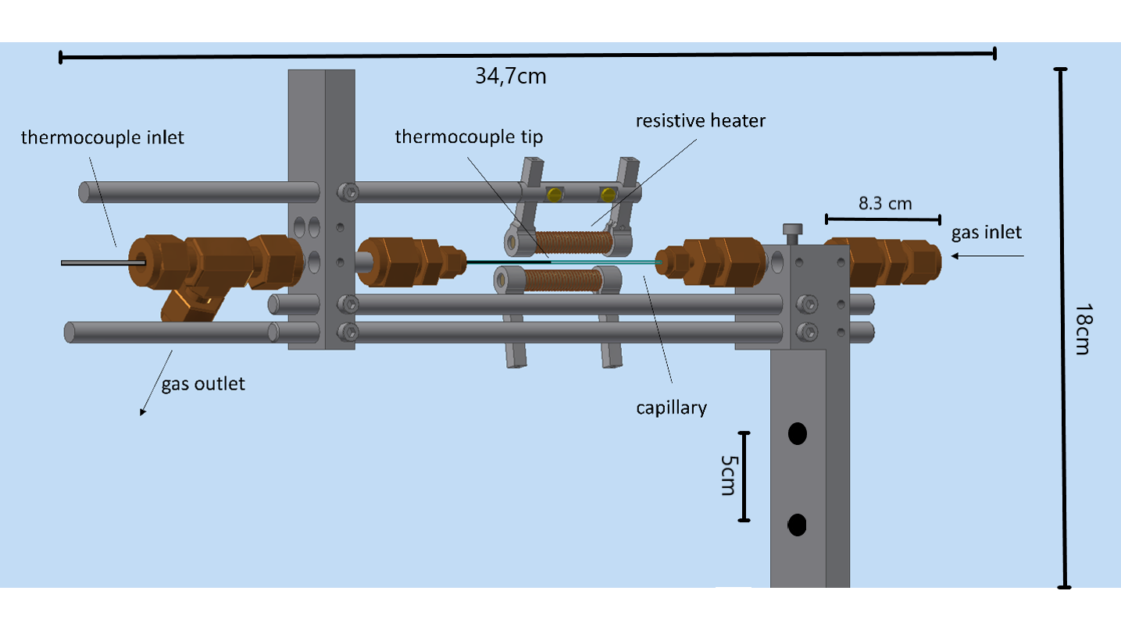

Figure 1 Schematic structure of the gas cell with dimensions

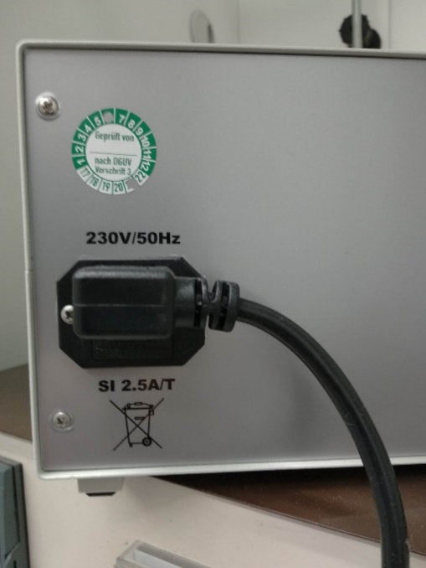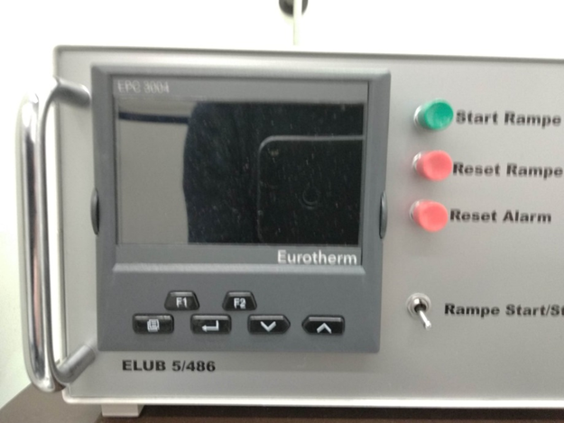

Figure Temperature controller Eurotherm EPC3004

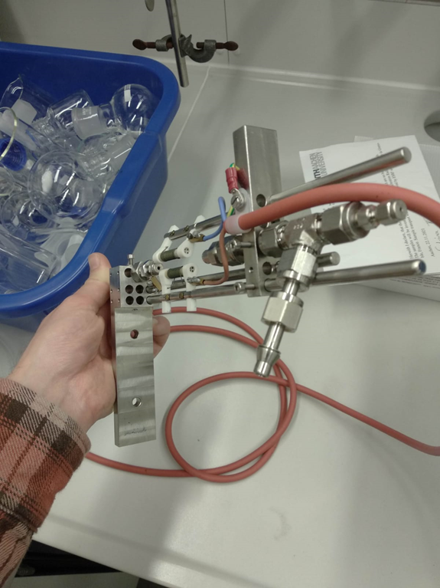

Figure Gas flow cell