**SQL Query Report – Super Store Sales**

## 1.Total Adjusted Sales

*SELECT SUM(CAST(REPLACE(Adjusted_sales, '$', '') AS FLOAT)) AS Total_Sales  
FROM super_store;*

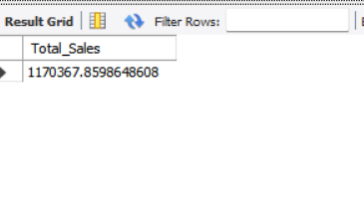

## 2.Average Order Value

*SELECT   
 SUM(CAST(REPLACE(Sales, '$', '') AS FLOAT)) / COUNT(DISTINCT Order_ID) AS Avg_Order_Value  
FROM super_store;*

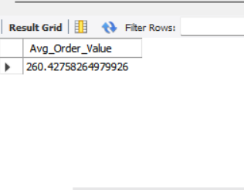

## 3.Total Discount

*SELECT SUM(CAST(Discount AS FLOAT)) AS Total_Discount  
FROM super_store;*

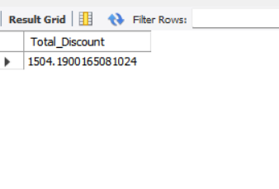

## 4.Total Orders

*SELECT COUNT(DISTINCT Order_ID) AS Total_Orders  
FROM super_store;*

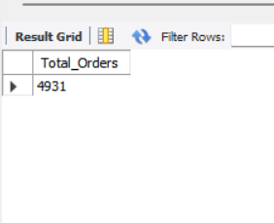

## 5.Sales & Discount by Category

*SELECT   
 Category,  
 SUM(CAST(REPLACE(Adjusted_sales, '$', '') AS FLOAT)) AS Total_Adjusted_Sales,  
 SUM(CAST(Discount AS FLOAT)) AS Total_Discount  
FROM super_store  
GROUP BY Category;*

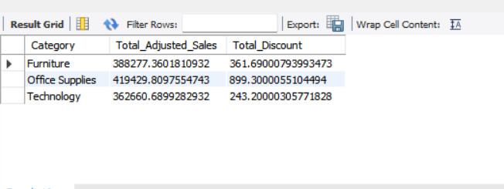

## 6.Sales by Ship Mode

*SELECT   
 Ship_Mode,  
 SUM(CAST(REPLACE(Sales, '$', '') AS FLOAT)) AS Total_Sales  
FROM super_store  
GROUP BY Ship_Mode;*

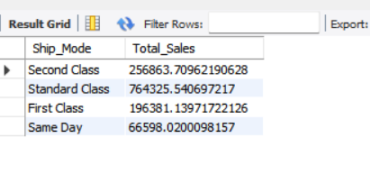

## 7.Sales by Segment

*SELECT   
 Segment,  
 SUM(CAST(REPLACE(Sales, '$', '') AS FLOAT)) AS Total_Sales  
FROM super_store  
GROUP BY Segment;*

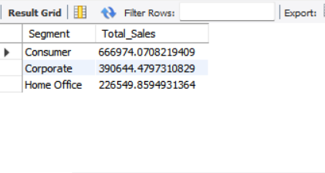

## 8.Sub-Category Sales and Quantity

*SELECT   
 Category,  
 Sub_Category,  
 SUM(CAST(REPLACE(Sales, '$', '') AS FLOAT)) AS Total_Sales,  
 SUM(Quantity) AS Total_Quantity  
FROM super_store  
GROUP BY Category, Sub_Category  
ORDER BY Category, Total_Sales DESC;*

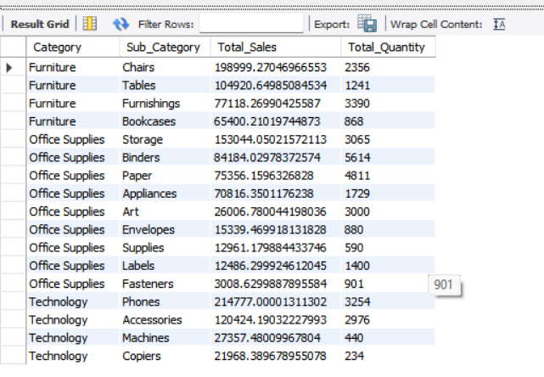

## 9.Region-Wise Sales and Profit

*SELECT   
 Region,  
 SUM(CAST(REPLACE(Sales, '$', '') AS FLOAT)) AS Total_Sales,  
 SUM(CAST(REPLACE(Profit, '$', '') AS FLOAT)) AS Total_Profit  
FROM super_store  
GROUP BY Region  
ORDER BY Total_Sales DESC;*

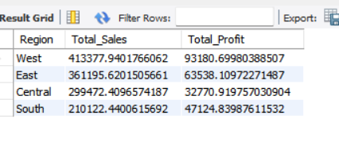

## 10.Profit by Category

*SELECT   
 Category,  
 SUM(CAST(REPLACE(Profit, '$', '') AS FLOAT)) AS Profit_By_Category  
FROM super_store  
GROUP BY Category  
ORDER BY Profit_By_Category DESC;*

