# 1. Dataset Overview

**DESCRIPTIVE STATISTICAL ANALYSIS-SHOPIFY PROJECT**

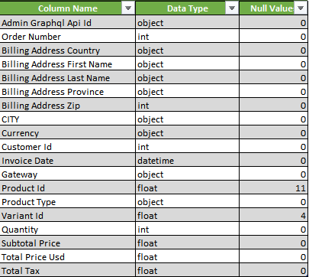

# 2. Revenue & Customer Insights

|  |  |
| --- | --- |
| **Metric** | **Value** |
| Total Quantity | 7,534 |
| Subtotal Revenue | $41,80,873.52 |
| Total Revenue | $45,98,960.87 |
| Total Tax | $4,18,087.35 |
| Average Order Price | $618.89 |
| Unique Customers | 2392 |
| Repeated Customers | 2039 |
| Total Customers | 4431 |

# 3. Quantity Summary

|  |  |
| --- | --- |
| **Statistic** | **Value** |
| Mean | 1.0139 |
| Median | 1 |
| Mode | 1 |
| Standard Deviation | 0.1493 |
| Minimum | 1 |
| Maximum | 7 |
| Range | 6 |
| Kurtosis | 497.77 |
| Skewness | 17.97 |
| Count | 7,431 |
| Sum | 7,534 |
| Confidence Level (95%) | 0.0034 |

=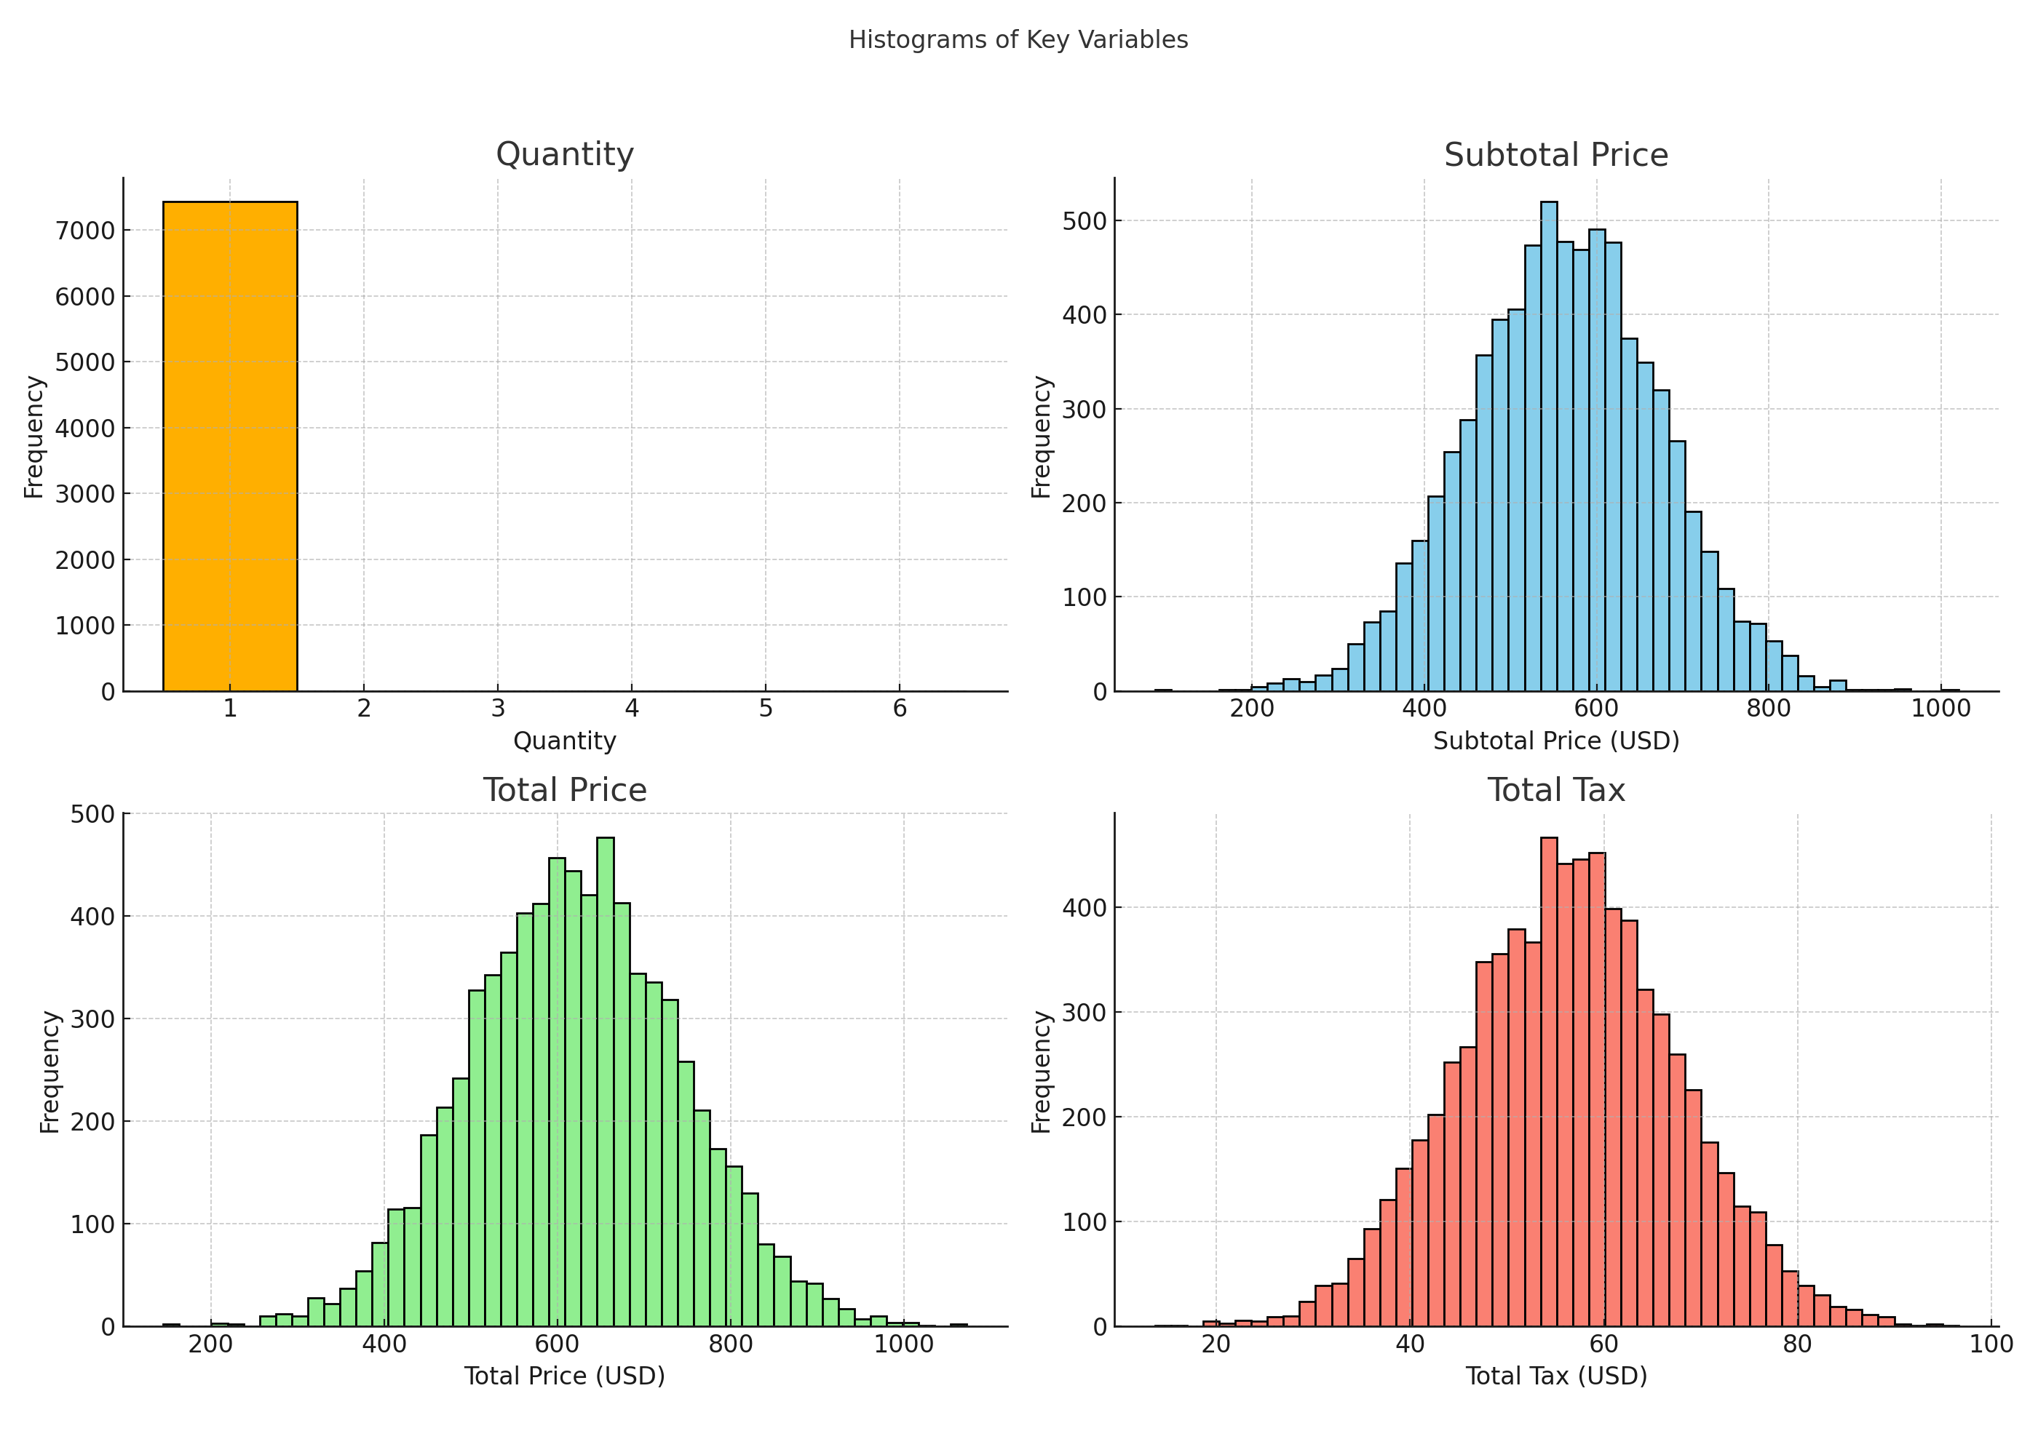

**CONCLUSION**

* The histogram and statistics **both confirm** that:
* **Most transactions involve a quantity of 1**.
* Larger quantities (e.g., 2 to 7) are **rare**, which is why you don’t see many other bars.
* **High kurtosis** and **skewness** values reinforce that the distribution is:
* **Heavily peaked** at 1.
* **Right-skewed**, meaning a few transactions have higher quantities but are not frequent enough to appear visibly in the chart.

# 4. Subtotal Price Summary

|  |  |
| --- | --- |
| **Statistic** | **Value** |
| Mean | $562.63 |
| Median | $537.13 |
| Mode | $537.13 |
| Standard Deviation | $110.39 |
| Minimum | $439.13 |
| Maximum | $6,319.13 |
| Range | $5,880.00 |
| Kurtosis | 10,000.08 |
| Skewness | 20.51 |
| Count | 7,431 |
| Sum | $41,80,873.52 |
| Confidence Level (95%) | $2.51 |



**CONCLUSION**

* The **majority of transactions are tightly clustered** around $537.
* A **few transactions with very high subtotals** (up to $6,319.13) are **rare but significantly influence** the overall average and distribution shape.
* This is confirmed by the **high skewness and kurtosis**, even though the histogram appears normal at first glance.
* The **distribution is not truly normal** — it's **right-skewed with heavy outliers**.

# 5. Total Price Summary

|  |  |
| --- | --- |
| **Statistic** | **Value** |
| Mean | $618.89 |
| Median | $590.84 |
| Mode | $590.84 |
| Standard Deviation | $121.43 |
| Minimum | $483.04 |
| Maximum | $6,951.04 |
| Range | $6,468.00 |
| Kurtosis | 1,000.08 |
| Skewness | 20.51 |
| Count | 7,431 |
| Sum | $45,98,960.87 |
| Confidence Level (95%) | $2.76 |



**CONCLUSION**

* The average total price is about $618.89, slightly higher than the subtotal due to tax.
* The data shows a similar distribution to the subtotal, with most values between $480 and $700, and a few high values causing a slight right skew.

# 6. Total Tax Summary

|  |  |
| --- | --- |
| **Statistic** | **Value** |
| Mean | $56.26 |
| Median | $53.71 |
| Mode | $53.71 |
| Standard Deviation | $11.04 |
| Minimum | $43.91 |
| Maximum | $631.91 |
| Range | $588.00 |
| Kurtosis | 1,000.08 |
| Skewness | 20.51 |
| Count | 7,431 |
| Sum | $4,18,087.35 |
| Confidence Level (95%) | $0.25 |



**CONCLUSION**

* The total tax values are mostly between **$45 and $70**, with an average of **$56.26**.
* The data is **mostly consistent**, but there are a few **very high tax values** that increase the overall range and skew the distribution slightly to the right.
* Despite this, the majority of values are close to the average, showing that tax amounts are generally stable.