BIDDINGDB
USERS GUIDE
WEB APPLICATION

INTRODUCTION

The BiddingDB is a web application that enables the users to keep track of the various details and dates concerning the numerous ongoing bids in the University of the Philippines.

MAIN FEATURES

- Dashboard
- Bid listing
- Calendar View
- Bid archives
- Administration Panel
  - User Management
  - List of Mode of Procurement

GETTING STARTED

Access the website through the URL bidding.up-ovpd.ph where you will be greeted with a login screen.

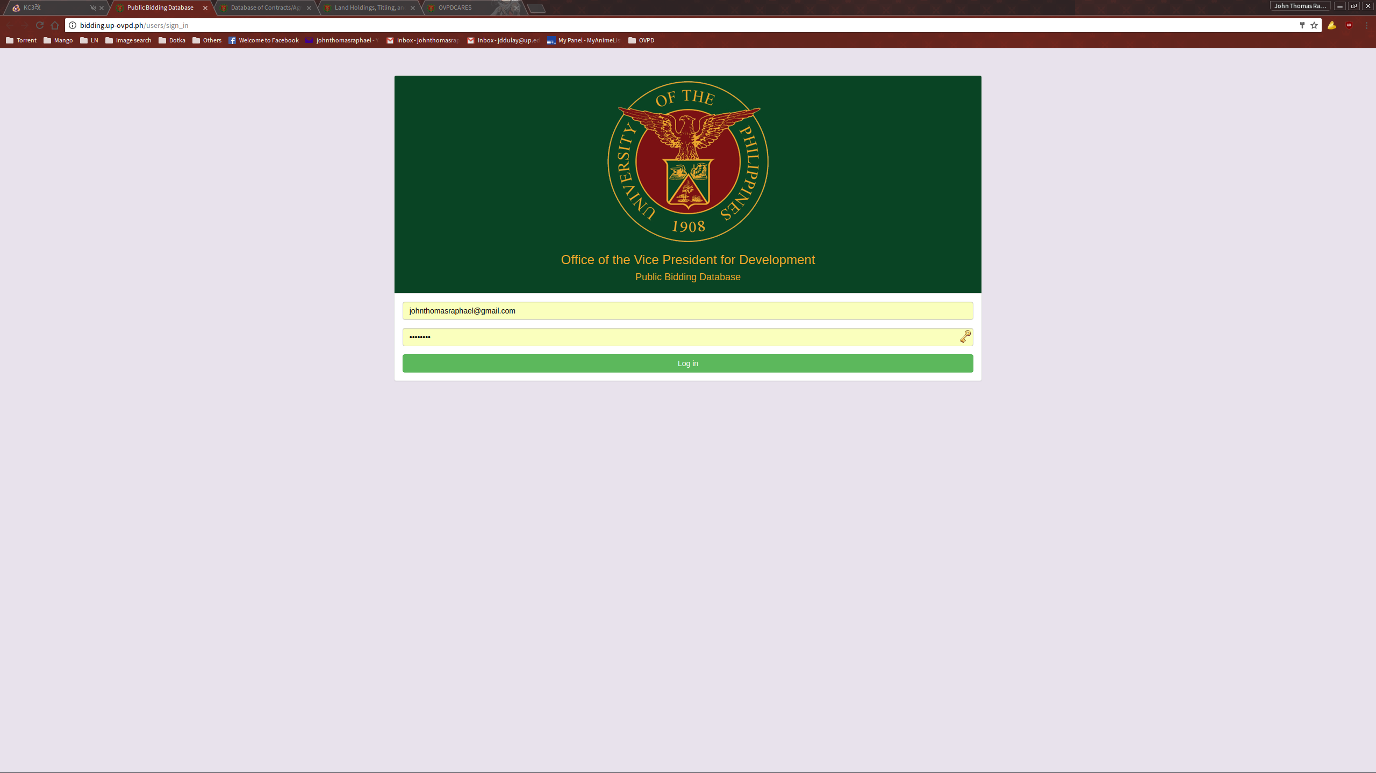
Input your access credentials to get to the dashboard.

DASHBOARD

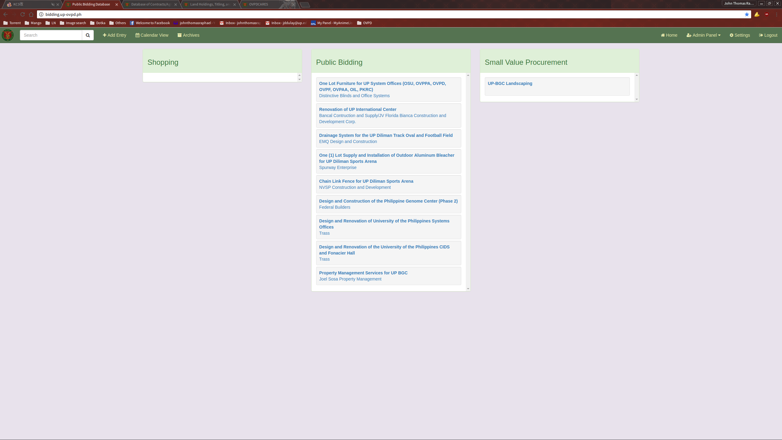
Upon a successful login, the user will be greeted with the dashboard. Most of the available functions can be access through here. Note that administration functions cannot be seen and used by non-admin users. The list can be filtered with the Search funtion accessible from the top left of the navigation bar.

ADDING A BID ENTRY

To add a new bid entry, click the link “Add Entry” located on the top left of the navigation bar. This will take you to the “New Bid” page where you can input the needed information.

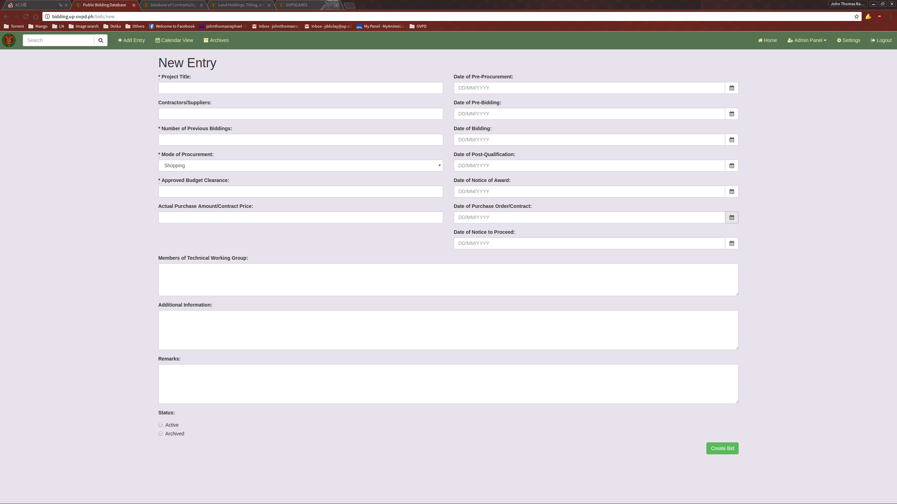
Once all relevant information has been filled up, click the “Create Bid” button to submit the data to created.

VIEW A BID ENTRY

From the dashboard, you can click on one of the entries on the list to show a modal that contains its details.

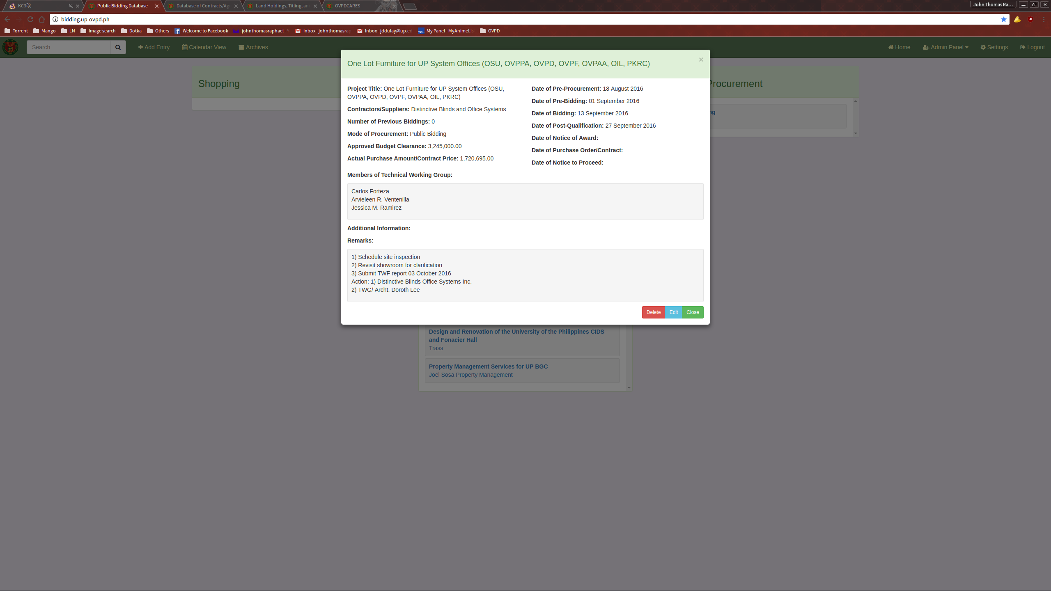
From here, the user can choose to edit or delete the chosen entry.

EDITING A BID ENTRY

From the View Entry modal, click on the “Edit” button. This will bring you to the Edit Entry page.

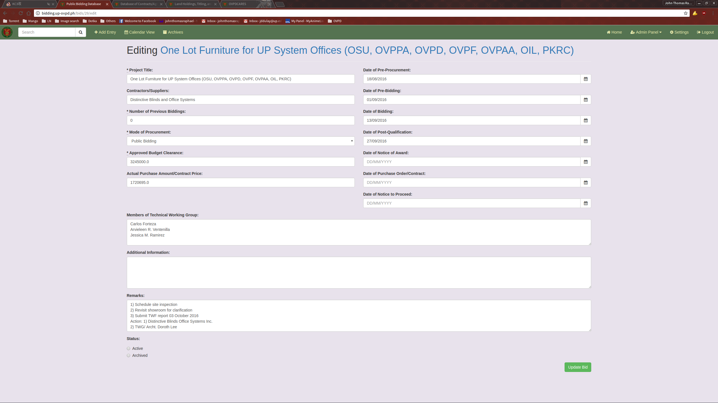
Update the necessary fields and click the “Update bid” button to submit.

CALENDAR VIEW

The Calendar view provides the user an easy way to view the important days for bidding requirements. It also shows how many entries there are for a given day and what those entries are.

To use the Calendar view, click the “Calendar View” link located on the top left of the navigation bar. This will bring you to the Calendar View page.

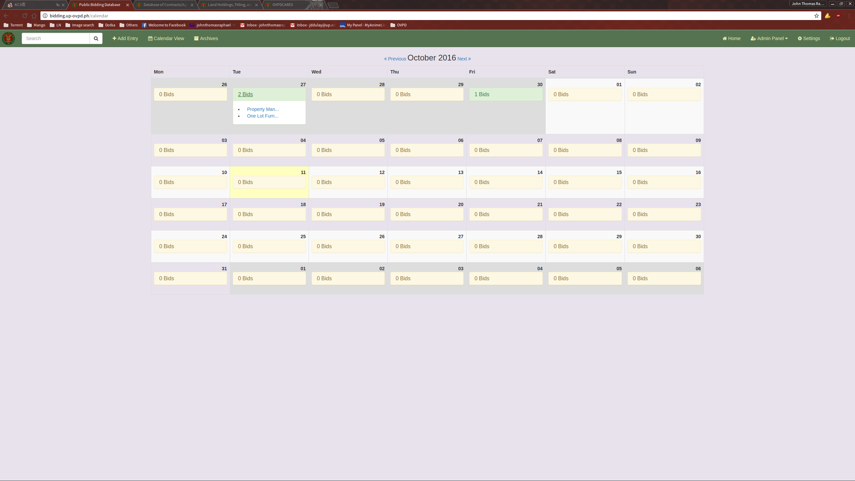
The Calendar View page show a month view of the current month, as well as the bids for any given day. Navigation to other months is done by clicking the “previous” and “next” links provided.
ARCHIVES

To access the archives, click the “Archives” link on the navigation bar. This will bring you to the Archives page.

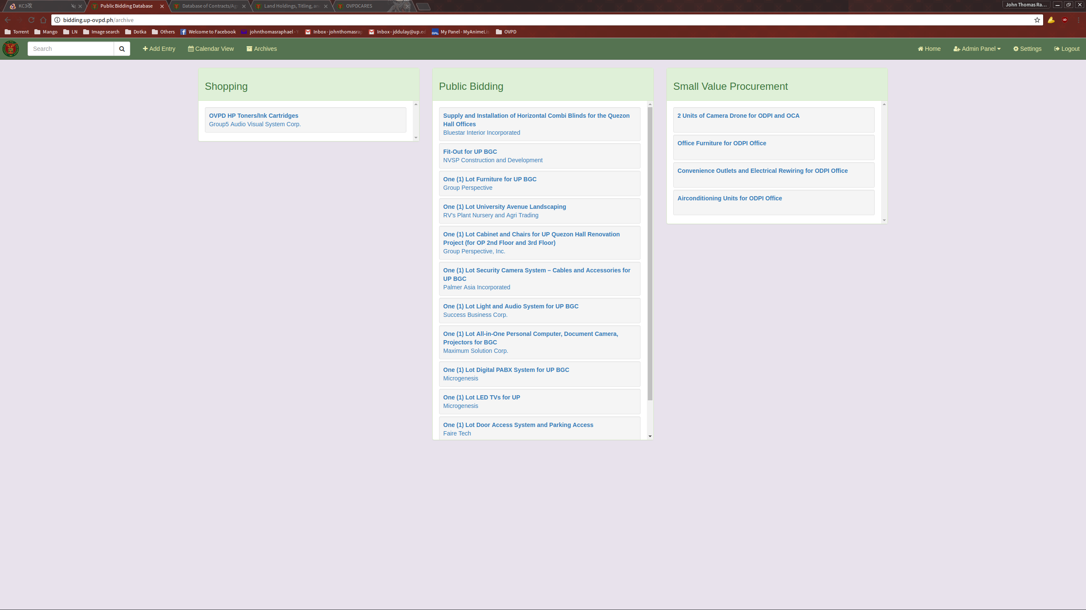
The Archives page functions exactly like the dashboard, with the exception that only bids tagged as archived are displayed here. Likewise, the dashboard only displays bids that are tagged as active.

ADMINISTRATION PANEL

The administration panel can be accessed on the top right of the navigation bar. Note that this option is invisible and unaccessible to non-admin users.

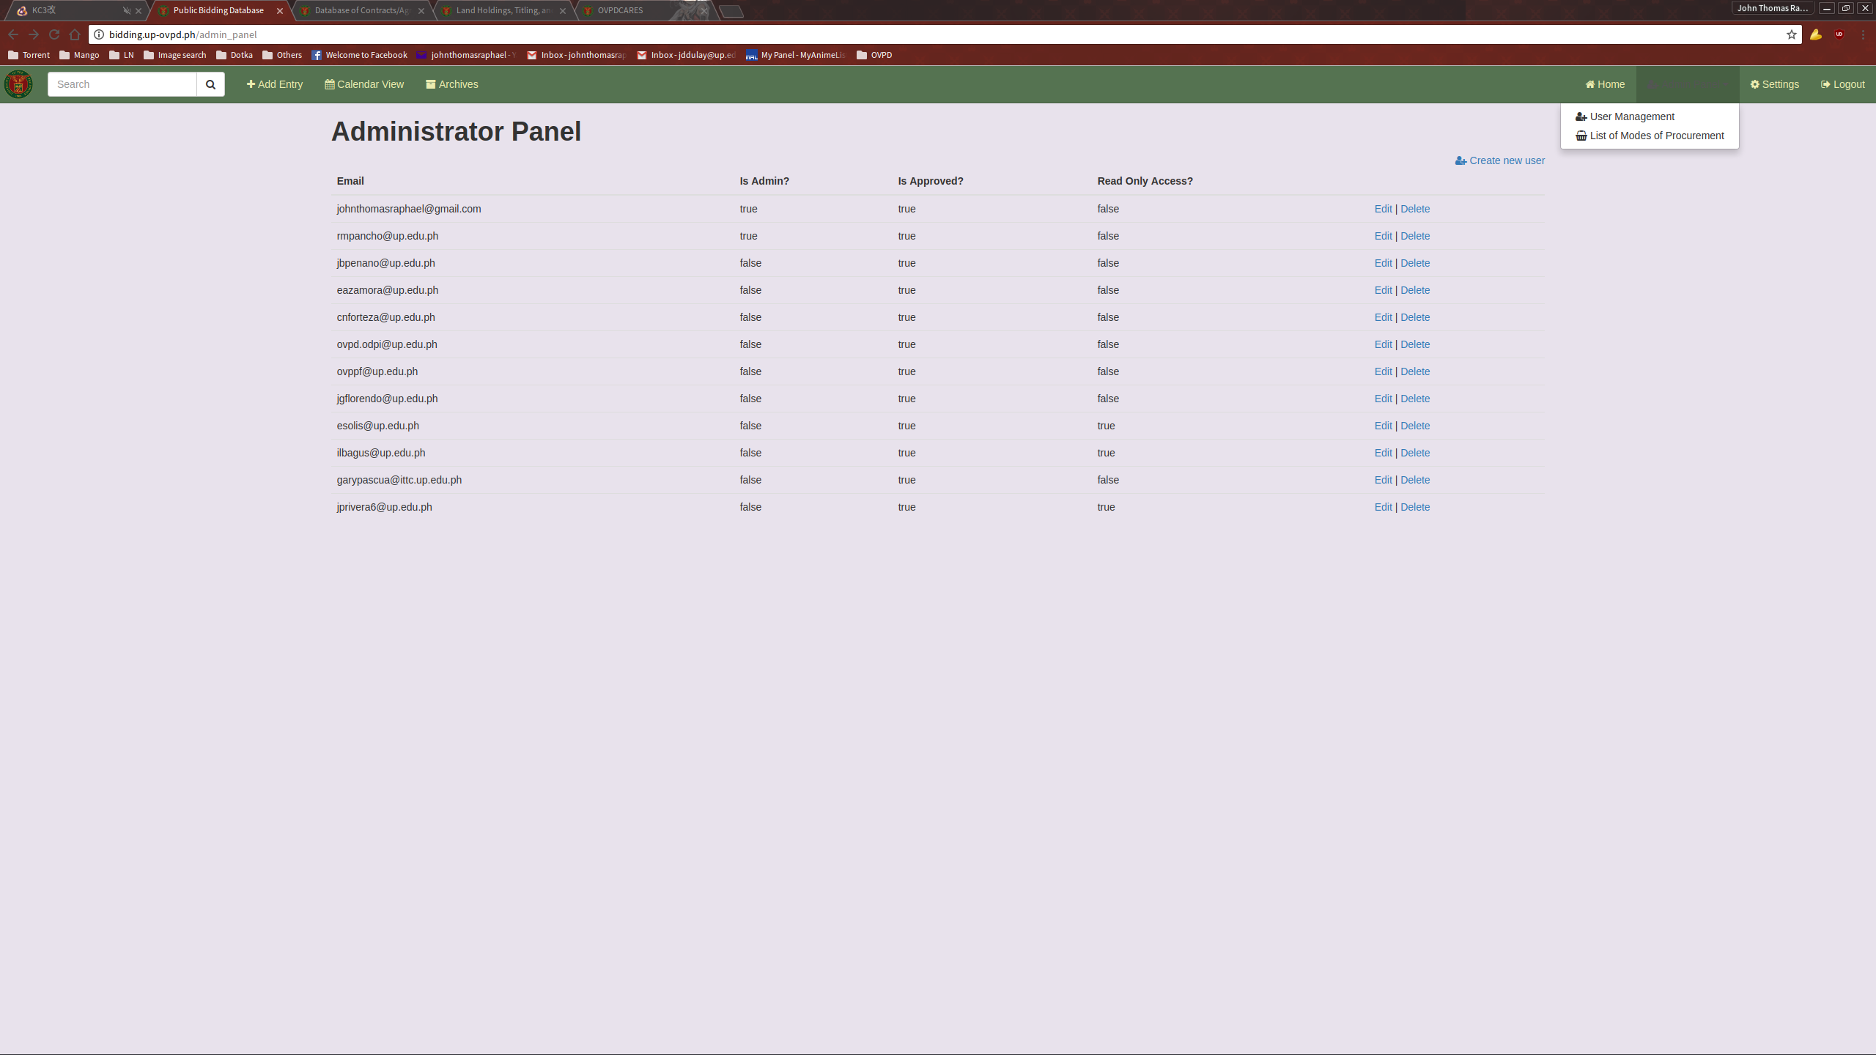
From here the admin user can select the User Management module or add another entry for Modes of Procurement.

USER MANAGEMENT

Using the User Management page, the admin user can view, create, edit, and delete users.

ADDING A NEW USER

To add a new user, click the “Create new user” link located on the top right of the user list.

This will bring you to the New User page where you can submit the necessary information for your new user.
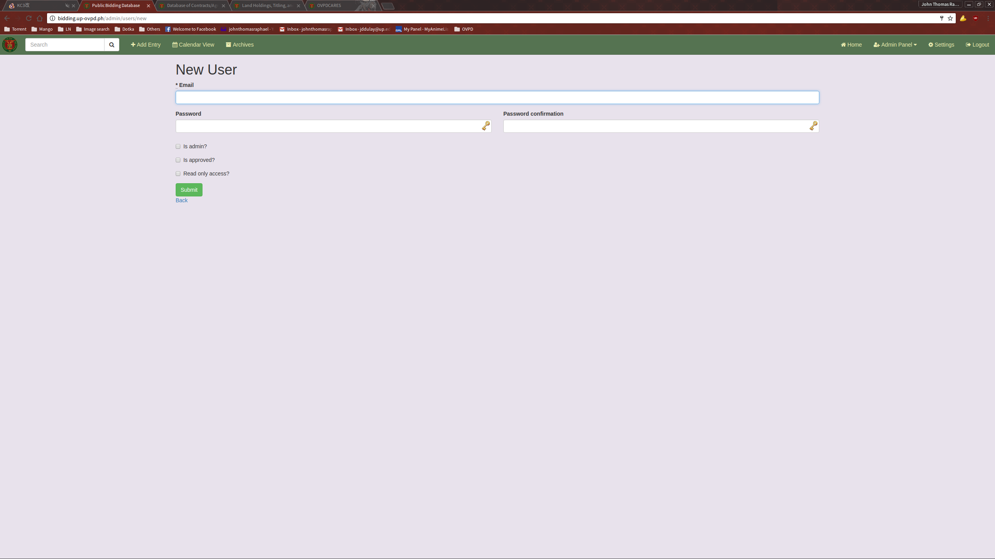
Fill up with the necessary information and submit.
EDITING A USER

To edit a user, simply click the “Edit” link provided on the User List.

This will bring you to the Edit User page.

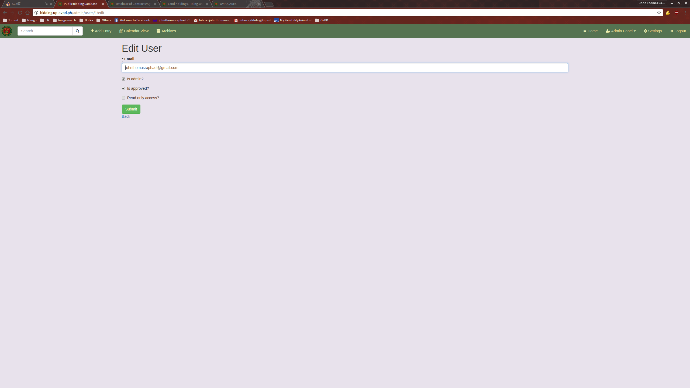
Fill up with the necessary information and submit.
LIST OF MODES OF PROCUREMENT

With the List of Modes of Procurement module, you can view, add, edit, and delete the list of Modes of Procurement that is used in the forms when creating or editing a bid entry.

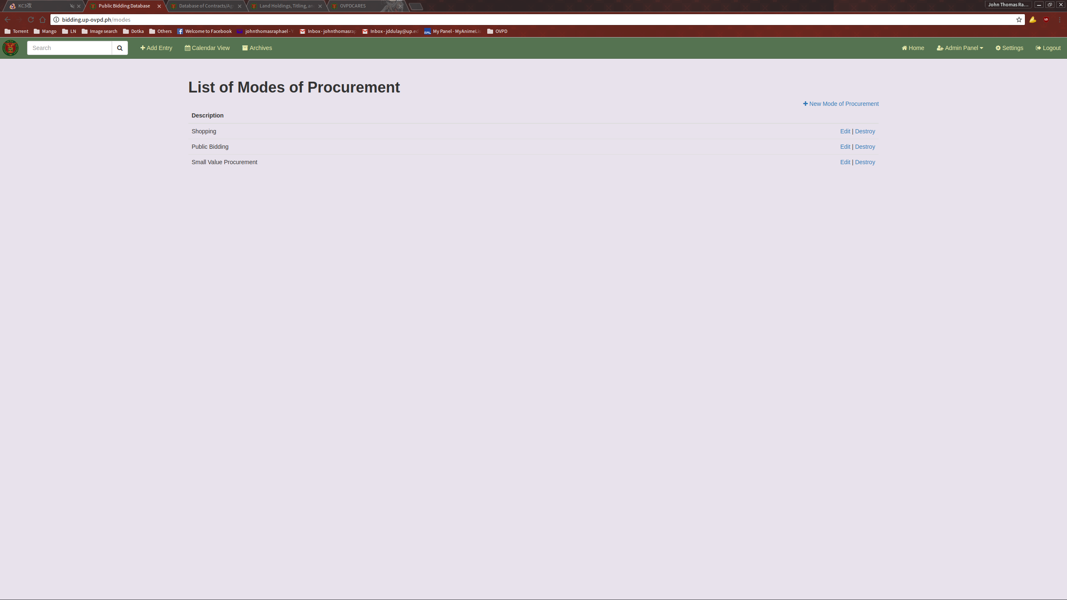

ADDING A NEW MODE OF PROCUREMENT

To add a new Mode of Procurement, click the “Add Mode of Procurement” link on the top right of the list.

This will bring you to the New Mode of Procurement Page.
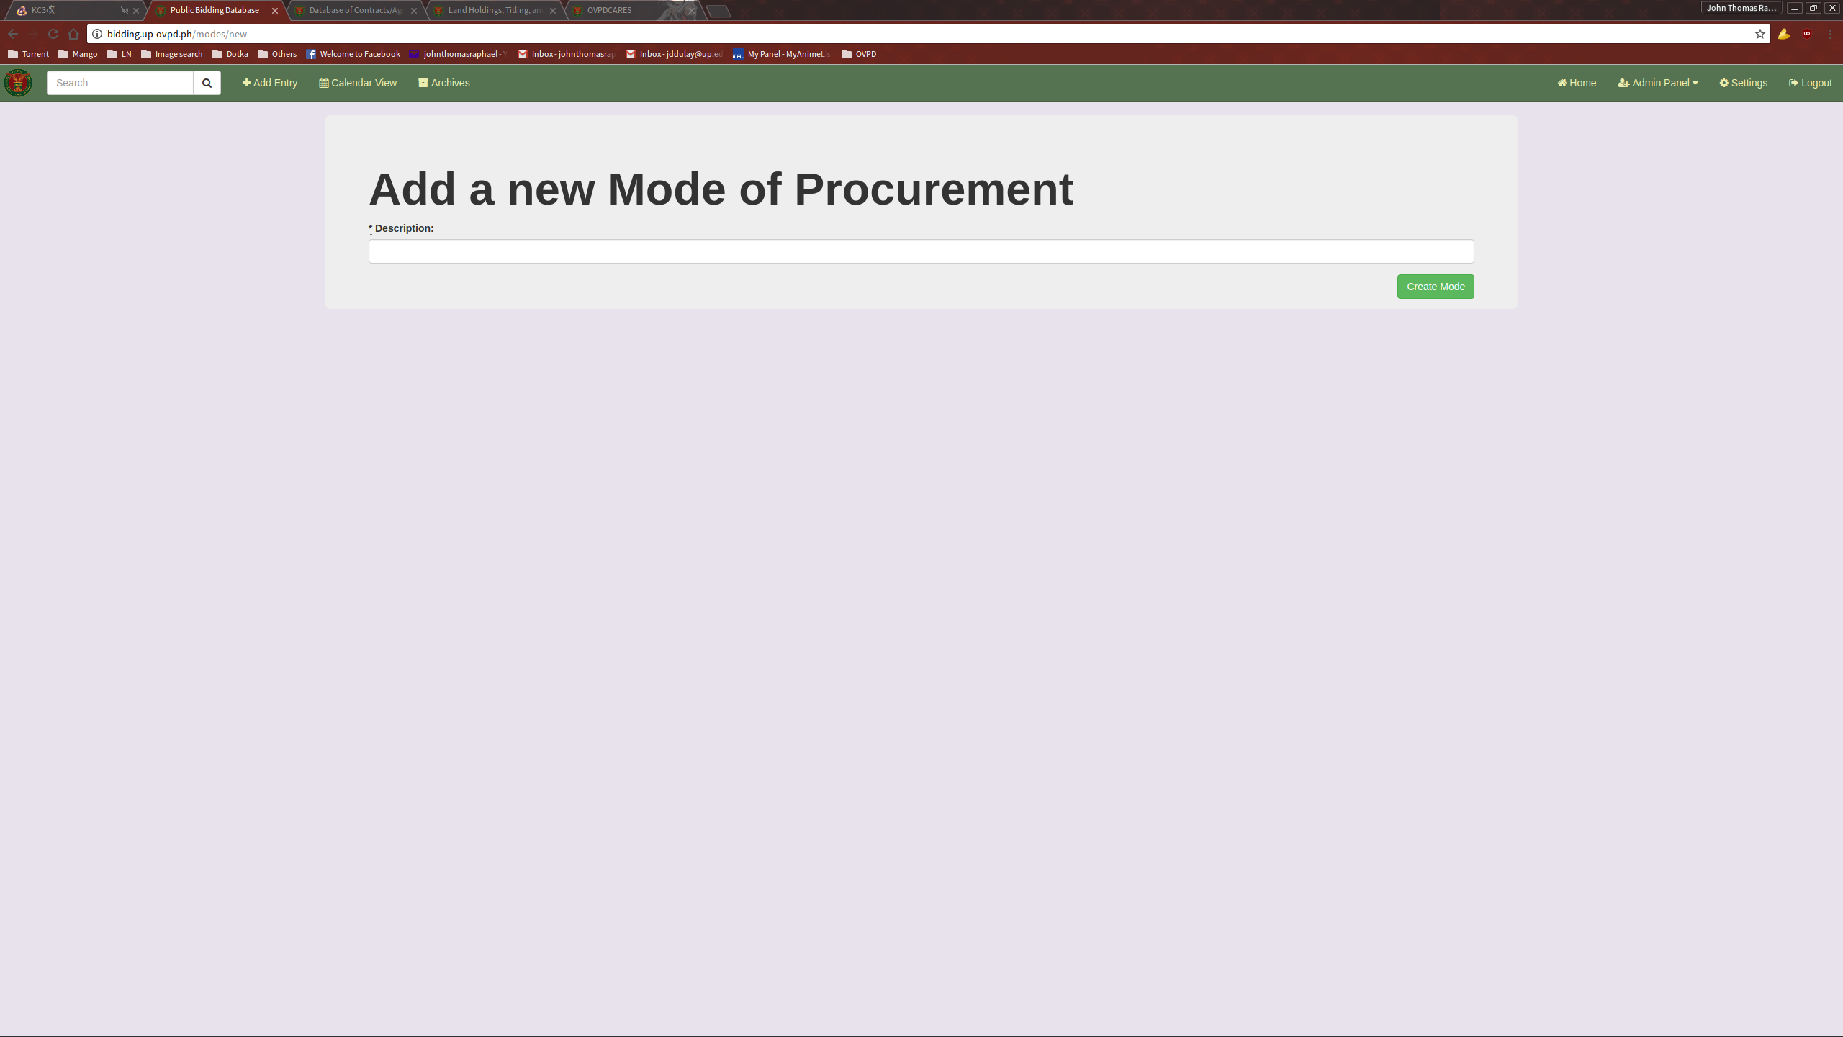
Fill it up the necessary information and submit.
EDITING A MODE OF PROCUREMENT

To edit a Mode of Procurement, click the “Edit” link on the list.

This will bring you to the Edit Mode of Procurement Page.

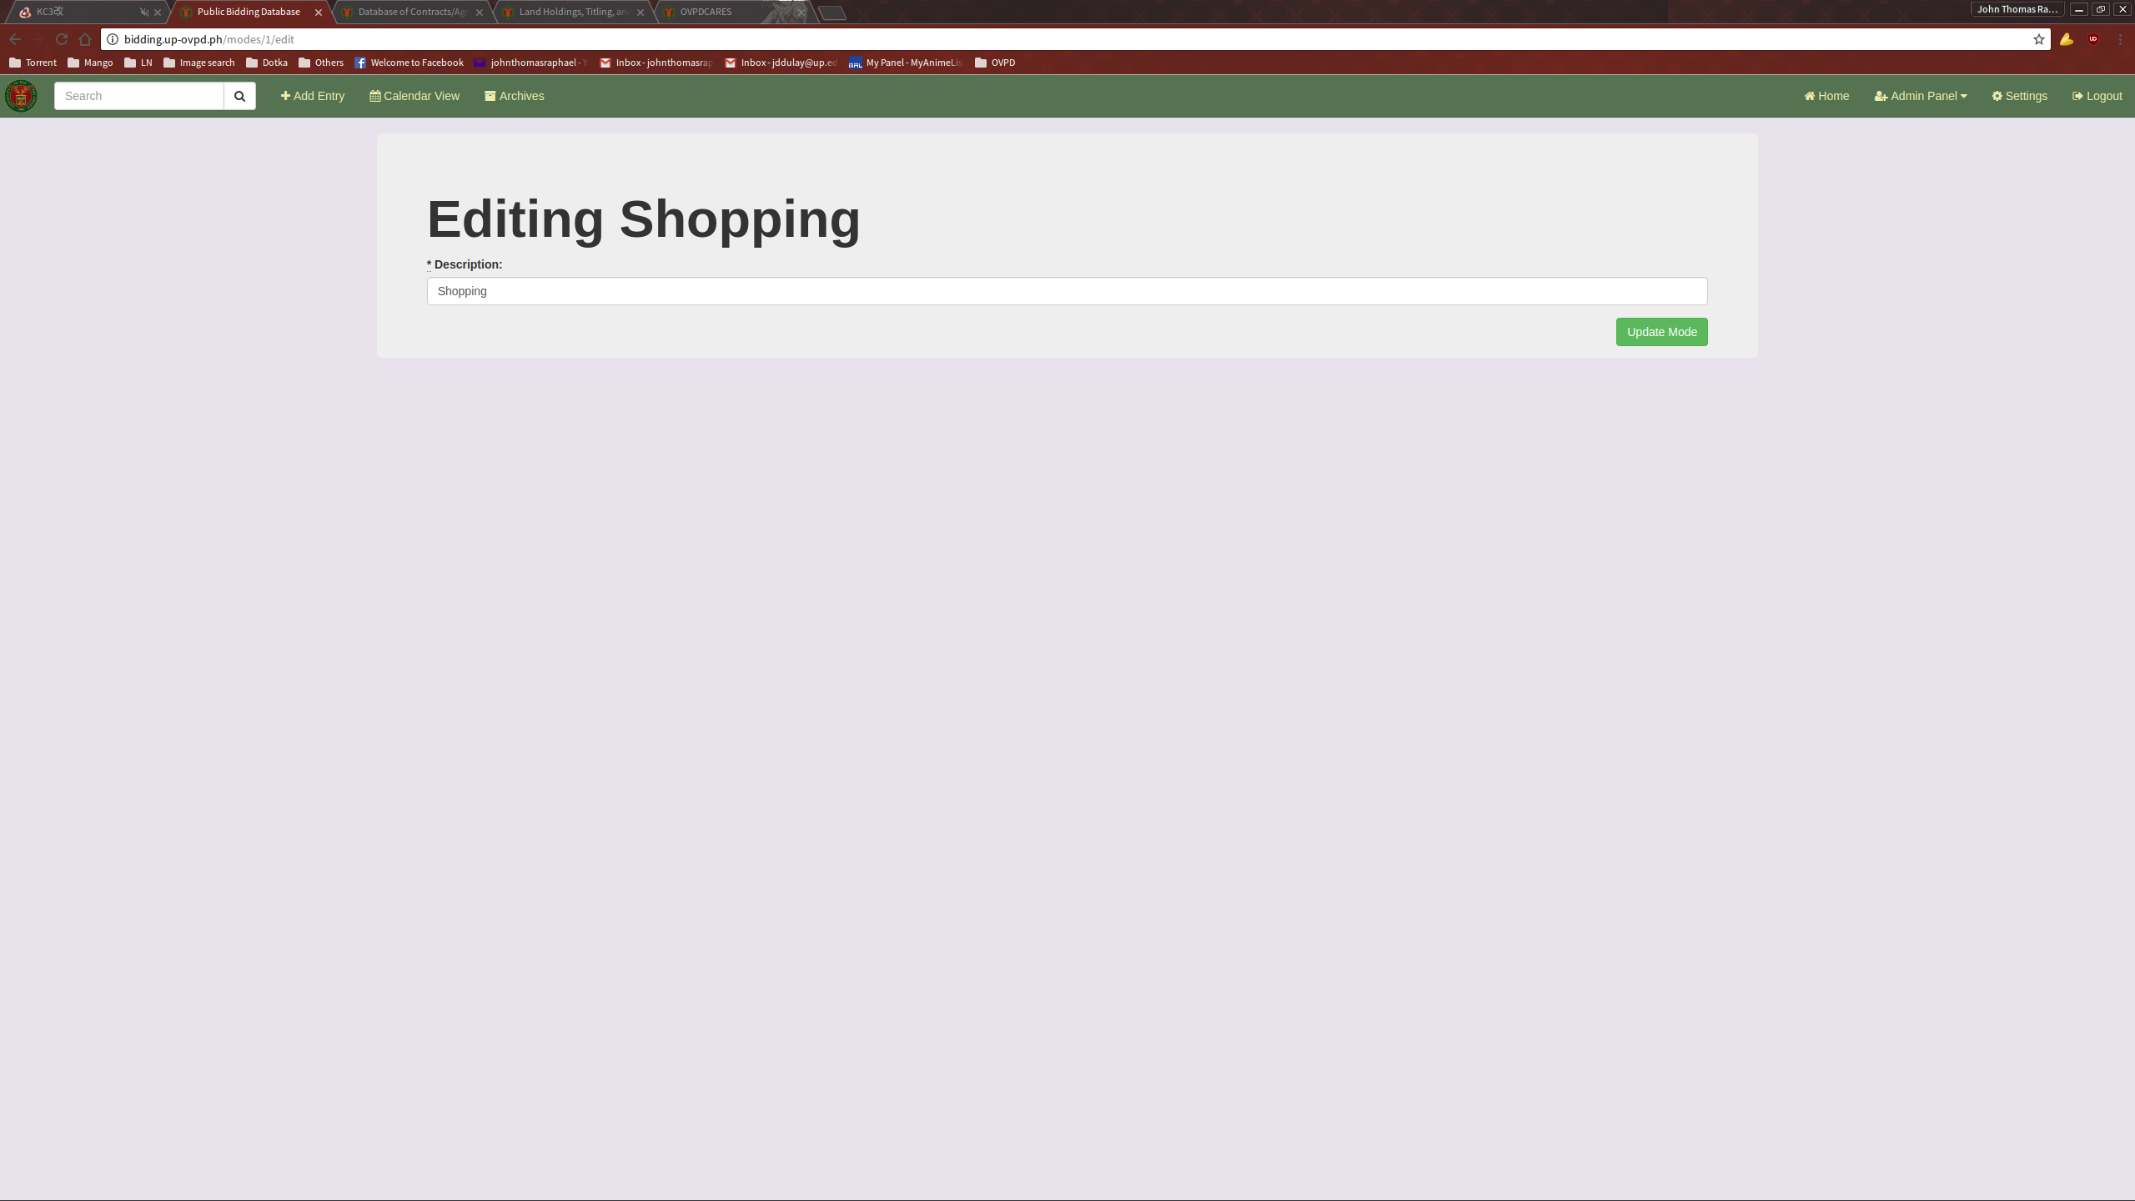
Fill it up with the necessary information and submit.

BIDDINGDB
USERS GUIDE
ANDROID APPLICATION

INTRODUCTION

The Mobile-BiddingDB is a readonly android application that enables the users to keep track of the various details and dates concerning the numerous ongoing bids in the University of the Philippines using their Android phones.

MAIN FEATURES

- Bid listing
- Calendar View
- Bid archives
GETTING STARTED

Open the BiddingDB application installed on your phone. This will lead you to a login page.

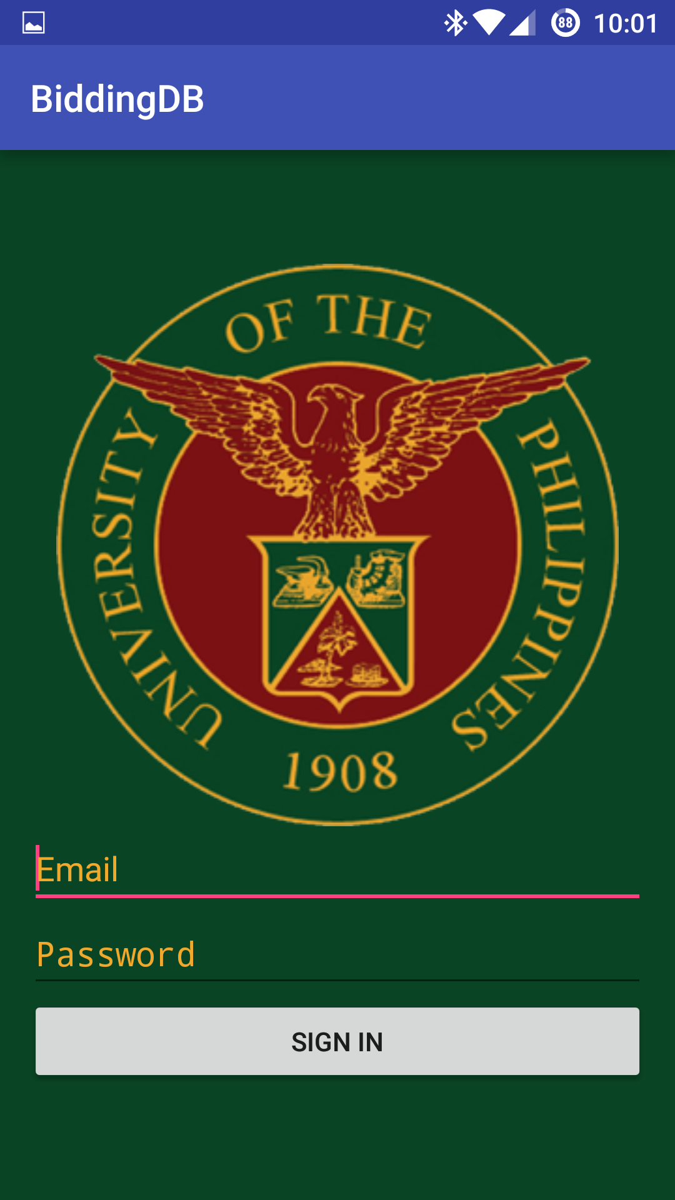

Enter your access credentials to login.
BIDDING LIST

Upon a successful login, you will you the list of active bids that are saved on the system. Use the tabs above the list to view the bids under other bidding categories.

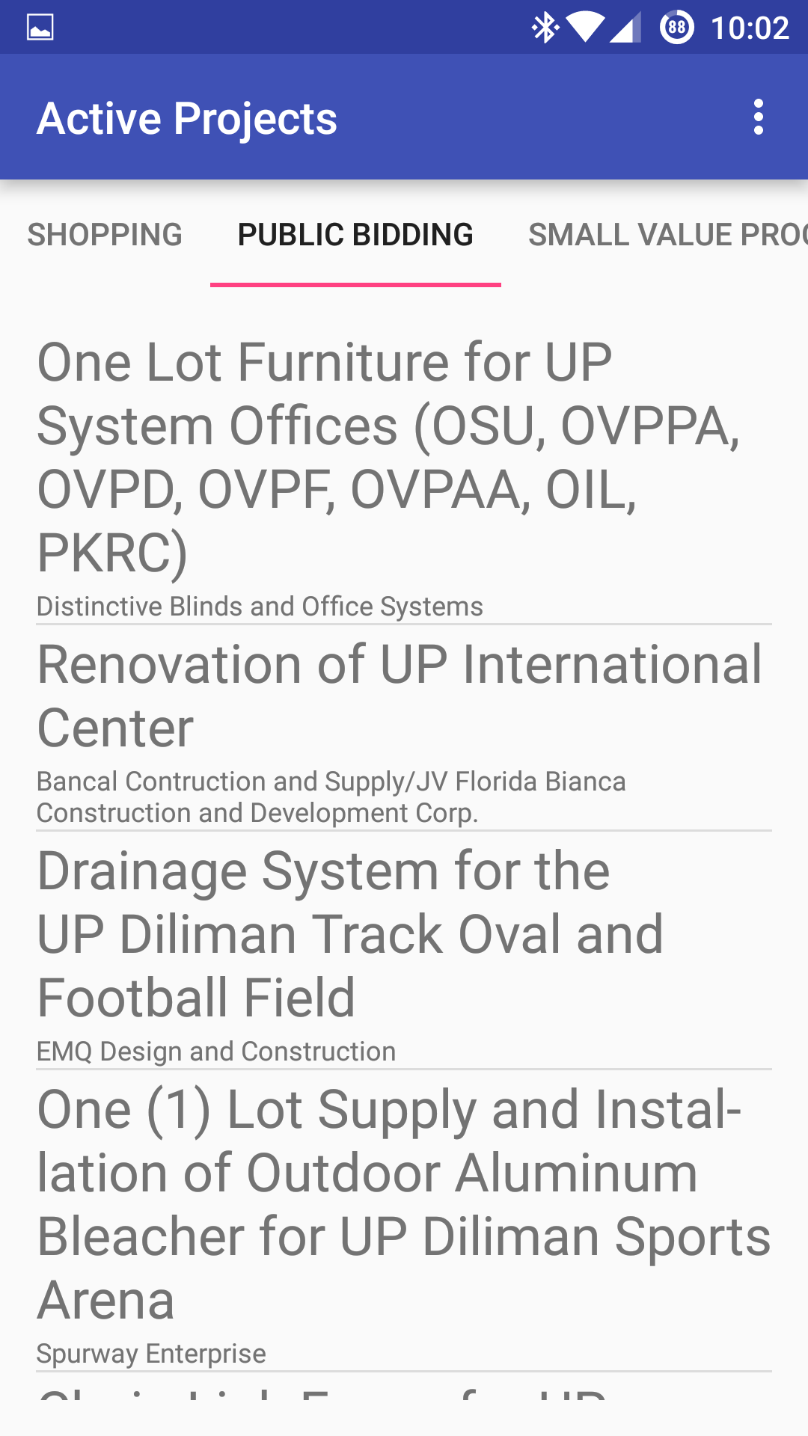
VIEWING A BID ENTRY

To view a Bid Entry, simply click on a entry on the list. This will send you to a page where you will be able to see the details of the selected entry.

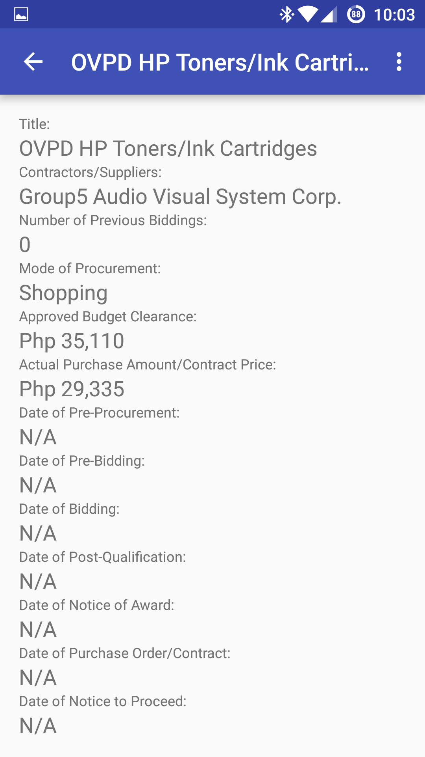
ARCHIVED BIDS

The Archived Bids page allows the user to view all the bids that have been marked as archived on the system.

To view the Archived views, open up the menu(this can differ across different phones) and click on the Archived Projects link. This will direct you to the Archived Projects page.

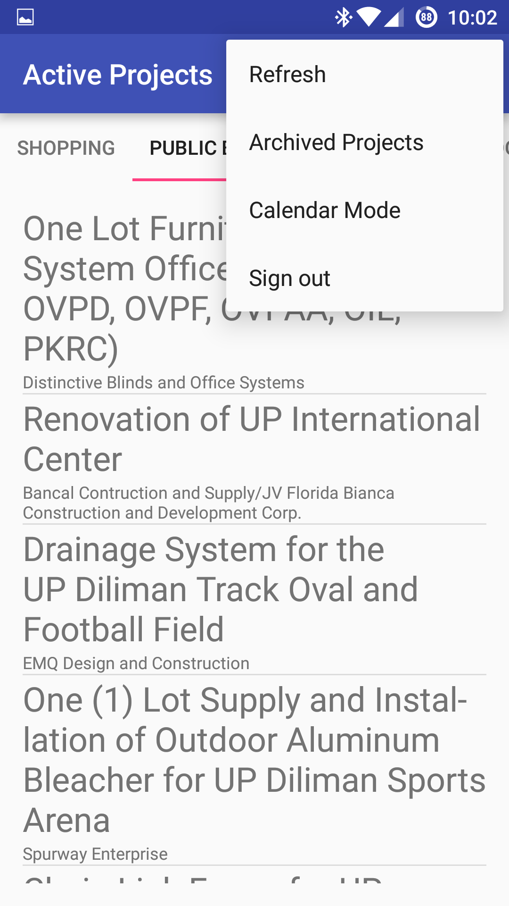
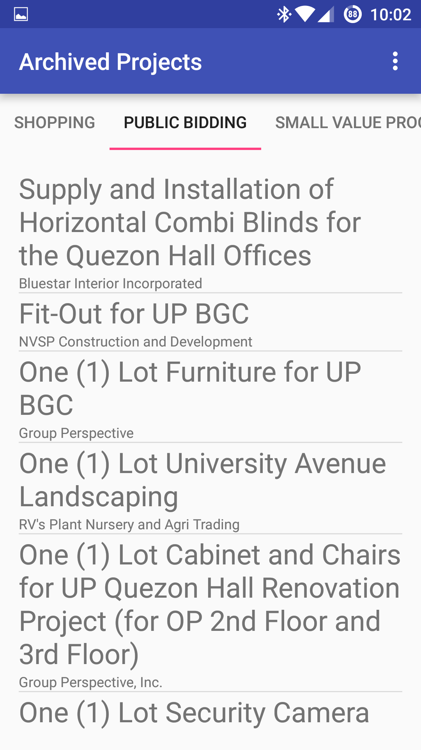
The Archived Projects page functions exactly the same as the Bid List page.
CALENDAR VIEW

The Calendar view allows the user to see the numerous bidding dates using a calendar.

To access the Calendar View, open the menu and click on the Calendar Mode link. This will bring you to the Calendar Mode page.

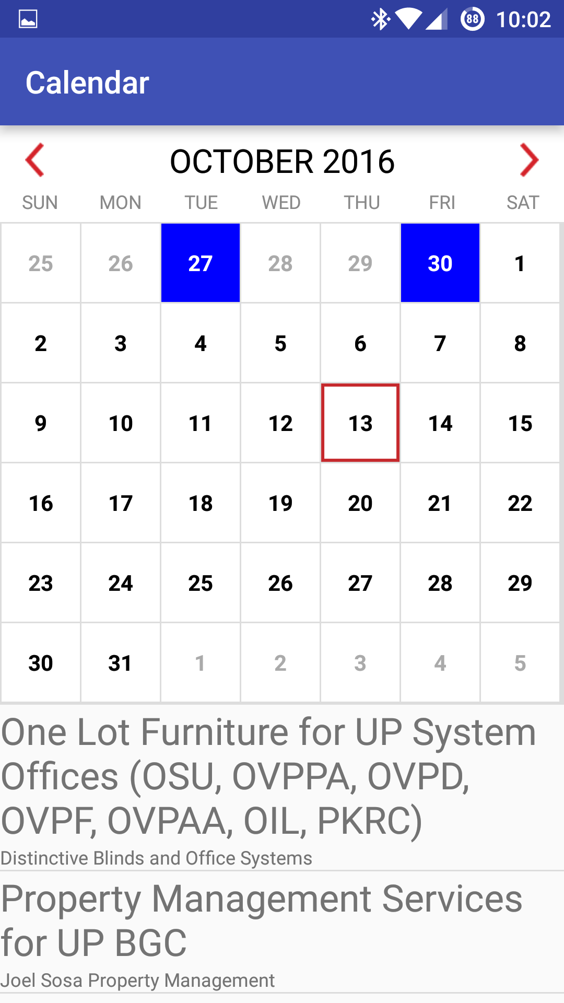
From here you can you can see which dates are important to bidding. These dates are highlighted with a colored background for ease of use. Clicking on the highlighted dates show what bids happen on that day.

