CONTACTSDB
USERS MANUAL
WEB APPLICATION

INTRODUCTION

The ContactsDB is a web application that enables the users to create and search for contacts with ease from anywhere.

MAIN FEATURES

- Dashboard

GETTING STARTED

Access the website through the URL contacts.up-ovpd.ph. This will bring you immediately to the dashboard.

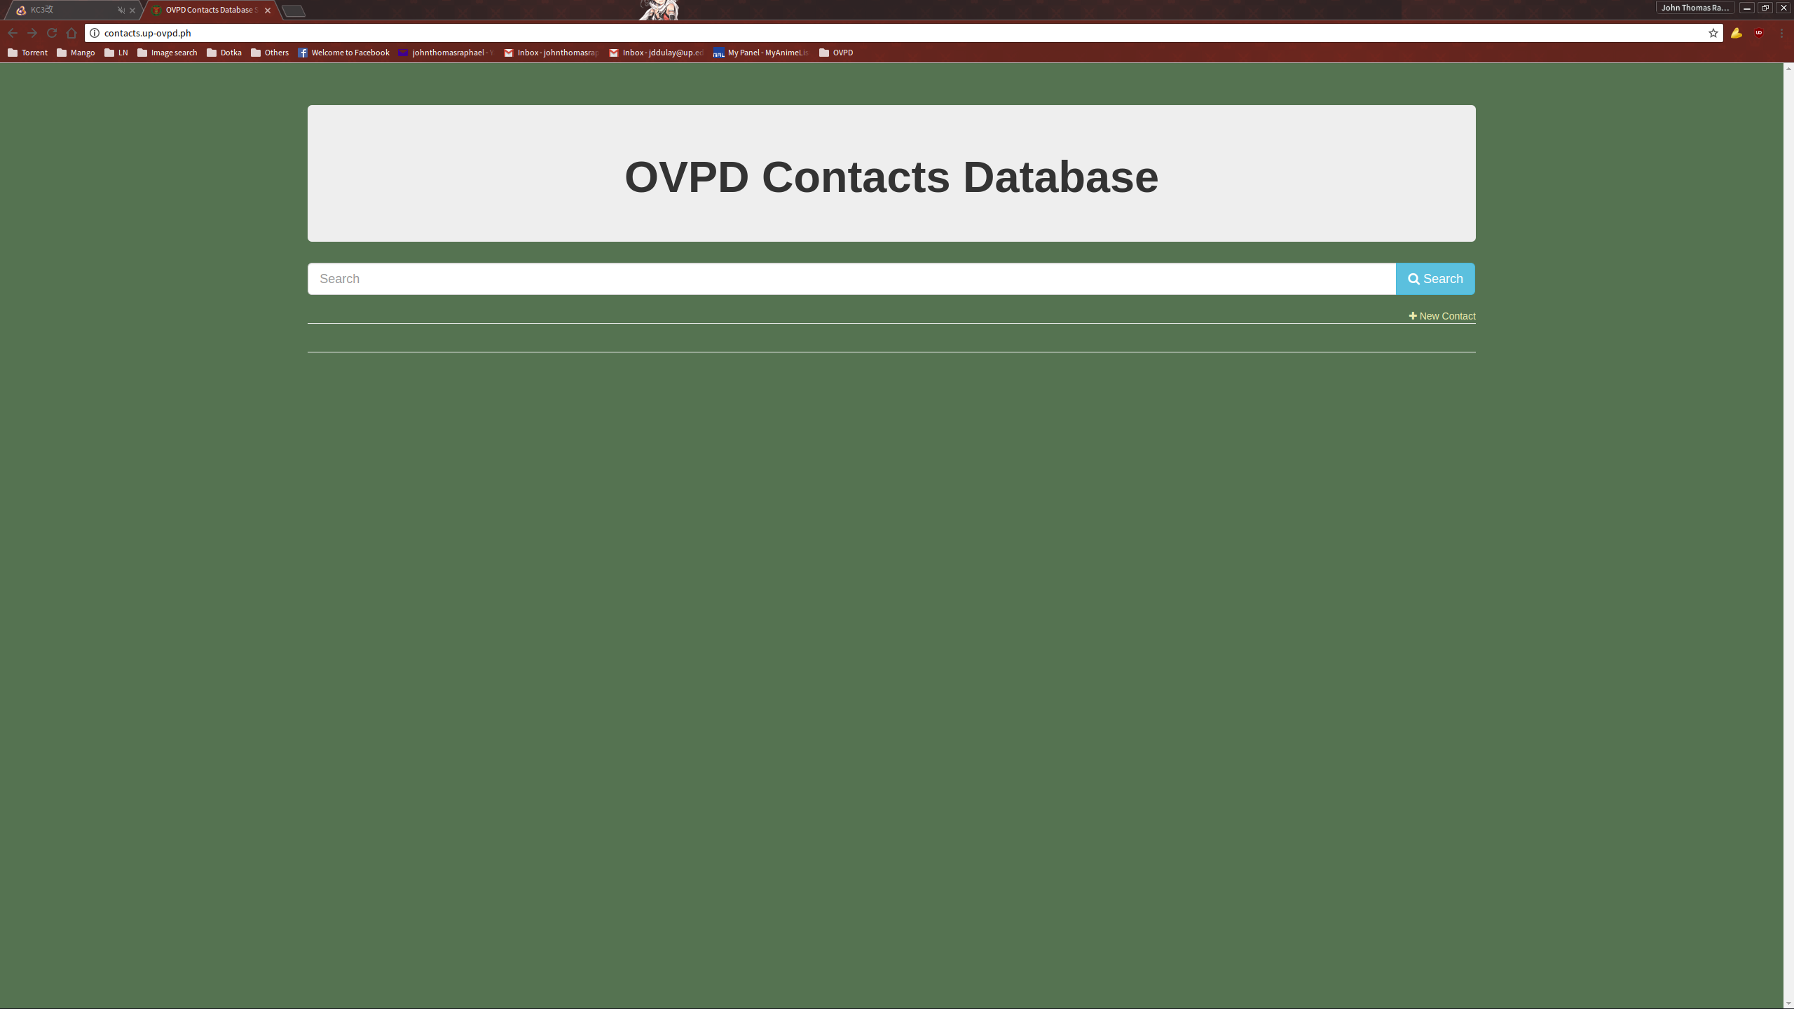
From here, the user can either search for the desired contact or create one of their own.
SEARCHING FOR A CONTACT

To search for a contacts, type in the desired keywords on the search bar and submit.

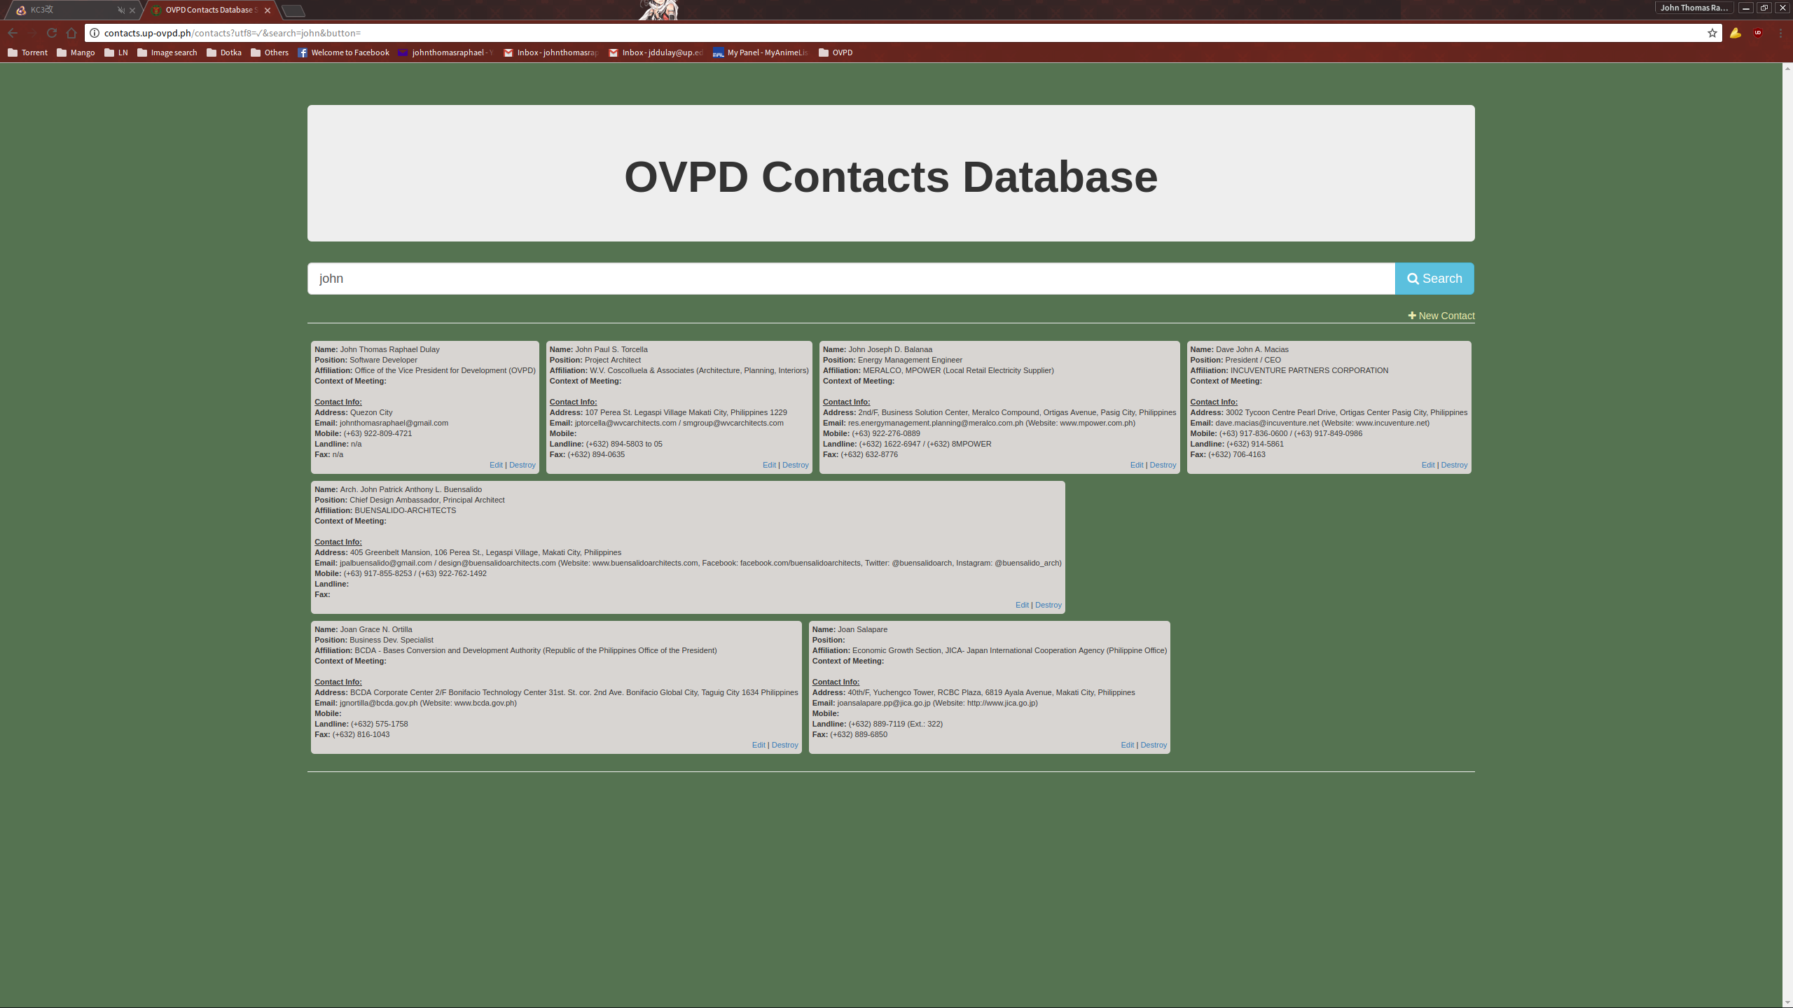
This will return a list in the form of cards that match the submitted keywords.
ADDING A NEW CONTACT

To add a new contact, click on the “New Contact” link below the search bar. This will direct you to the New Contact page.

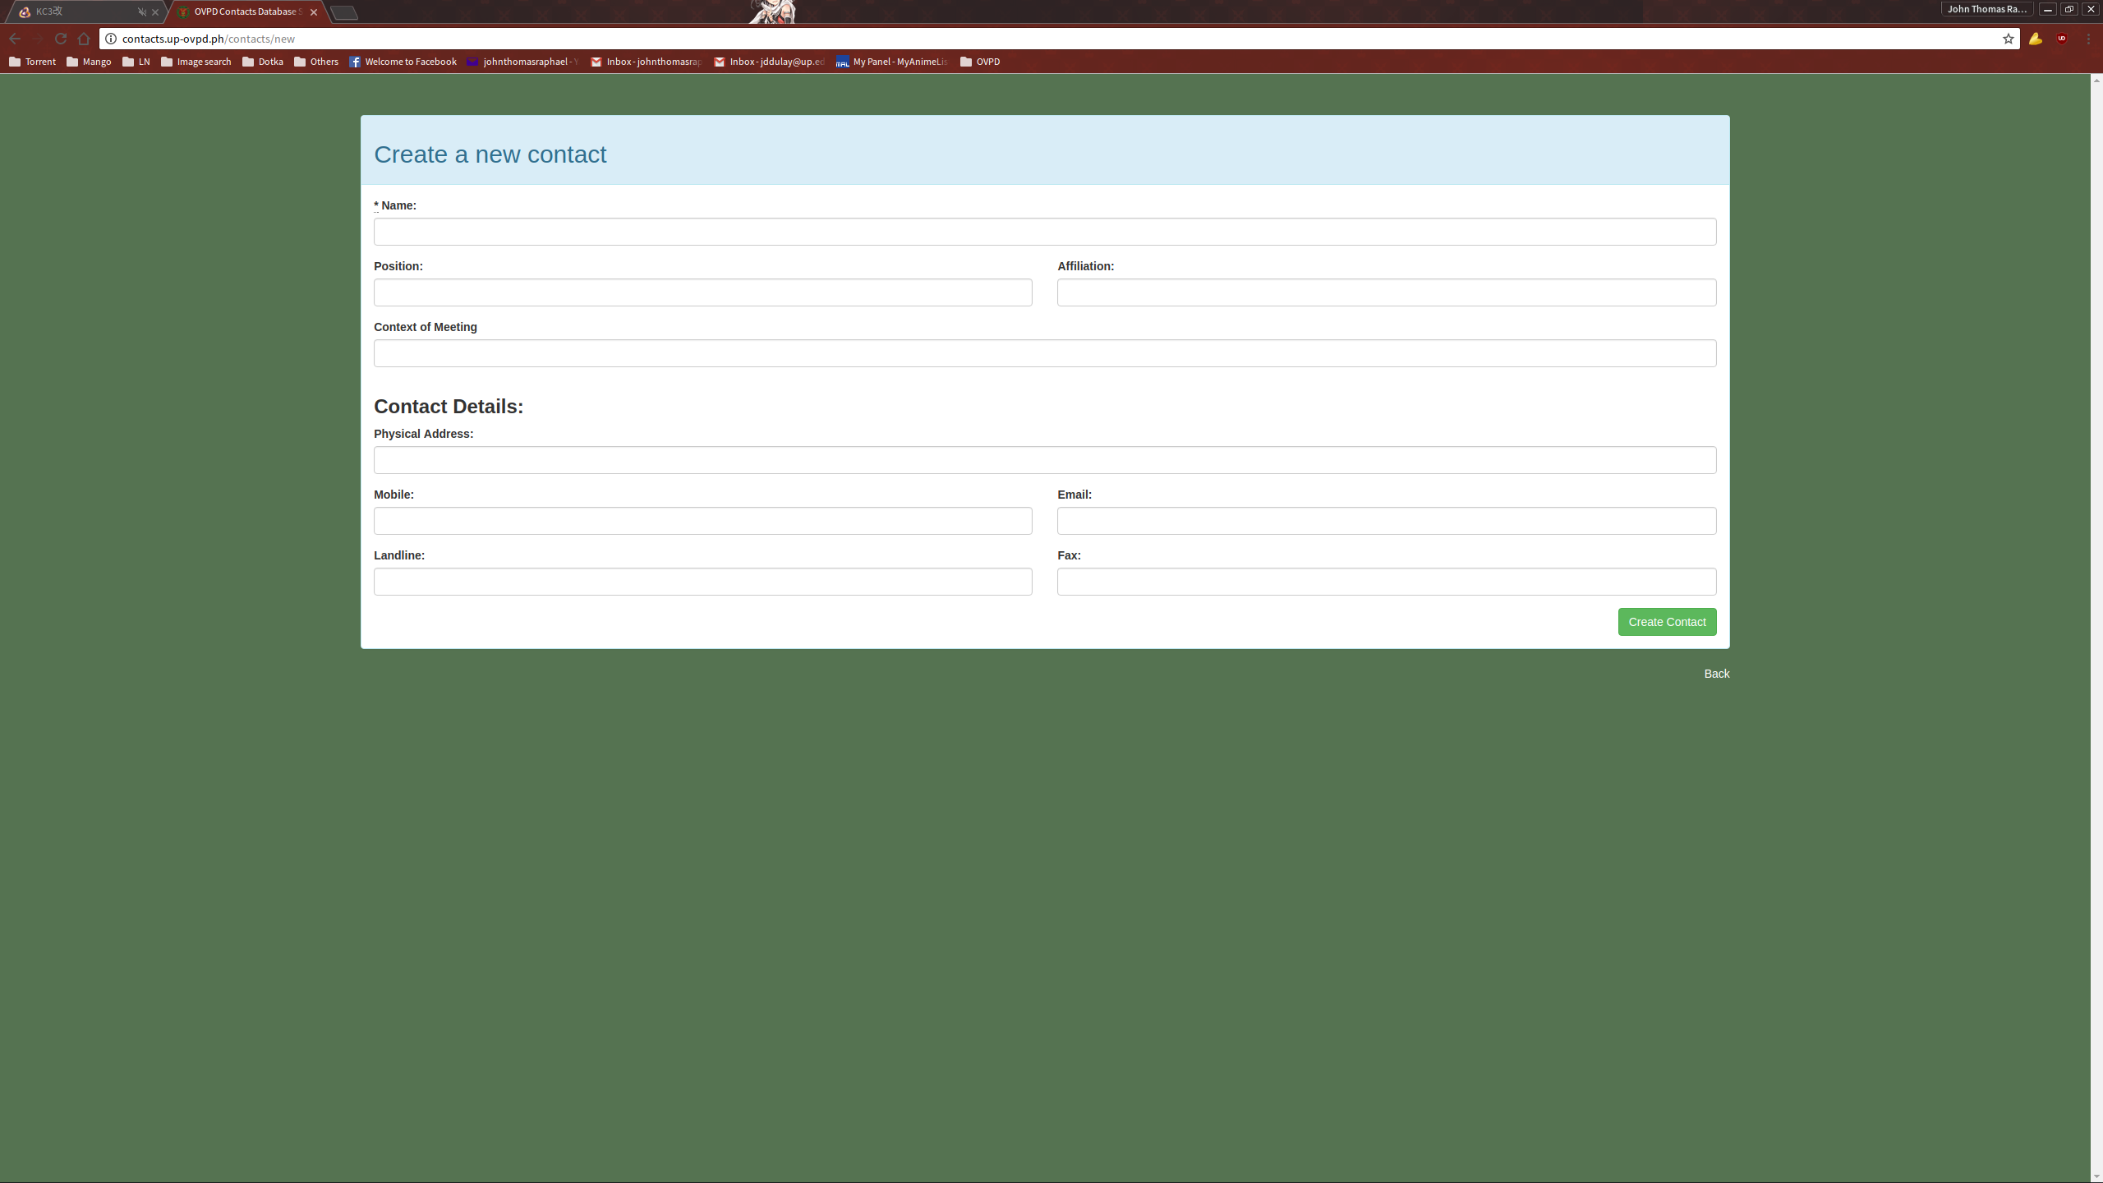
Fill it up the necessary information and submit.

