CONTRACTSDB
USERS MANUAL
WEB APPLICATION
INTRODUCTION

The ContractsDB is a web application that enables the users to keep track of the various details concerning the numerous ongoing contracts in the University of the Philippines.

MAIN FEATURES

- Dashboard
- Administration Panel
  - User Management
  - List of Mode of Procurement

GETTING STARTED

Access the website through the URL contracts.up-ovpd.ph where you will be greeted with a login screen.

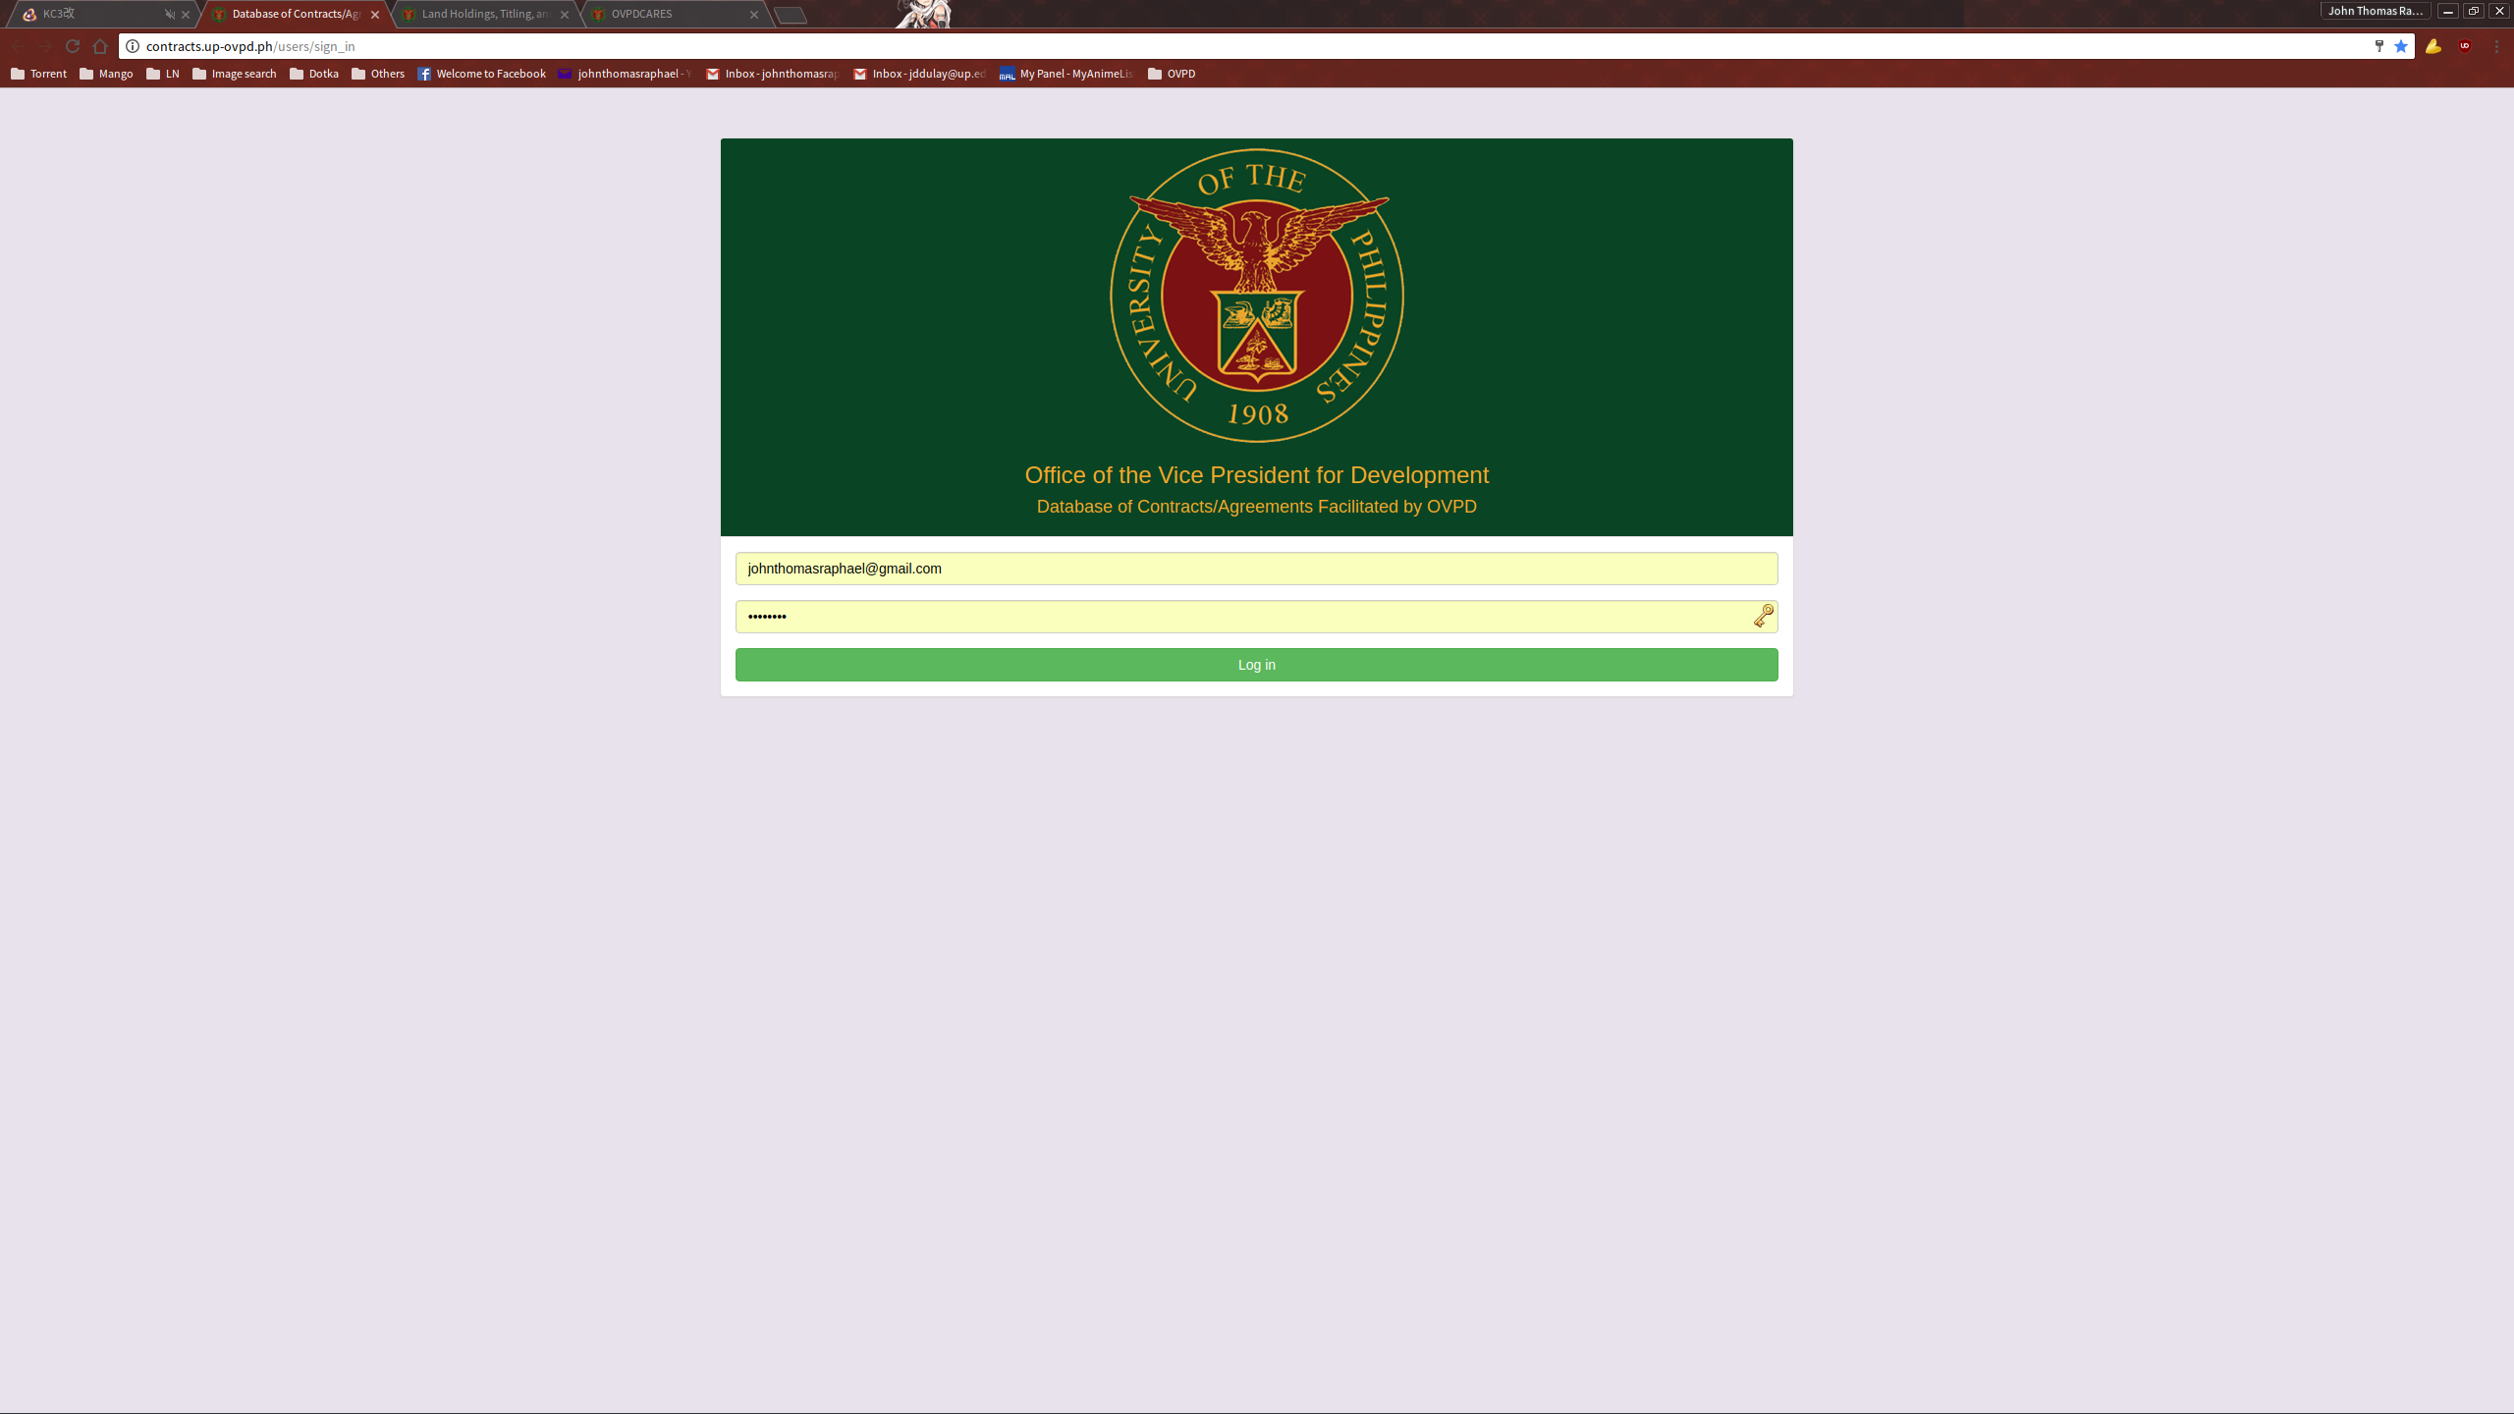
Input your access credentials to get to the dashboard.

DASHBOARD

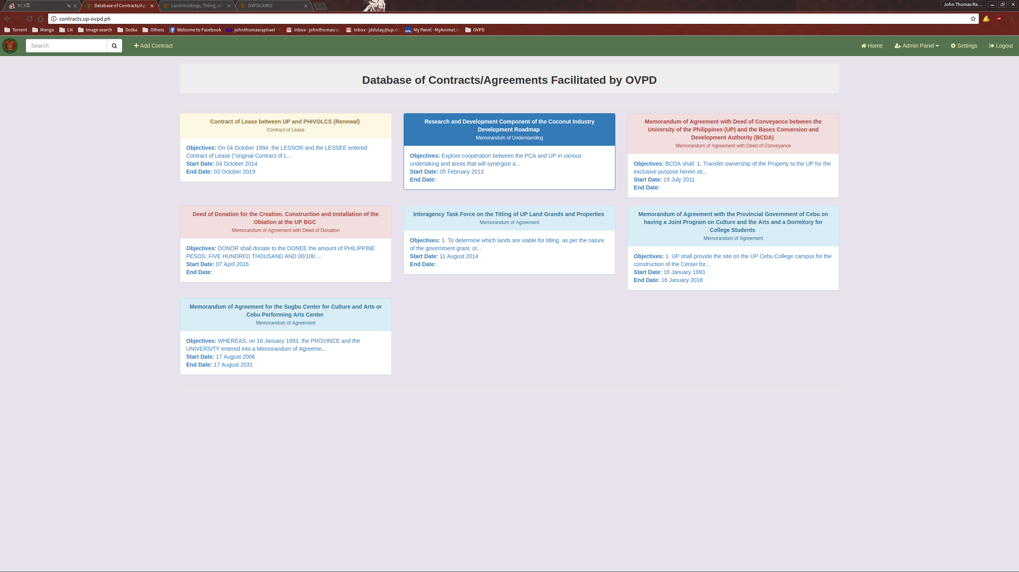
Upon a successful login, the user will be greeted with the dashboard. Most of the available functions can be access through here. Note that administration functions cannot be seen and used by non-admin users. The list can be filtered with the Search funtion accessible from the top left of the navigation bar.

ADDING A CONTRACT ENTRY

To add a new bid entry, click the link “Add Contract” located on the top left of the navigation bar. This will take you to the “New Contract” page where you can input the needed information.

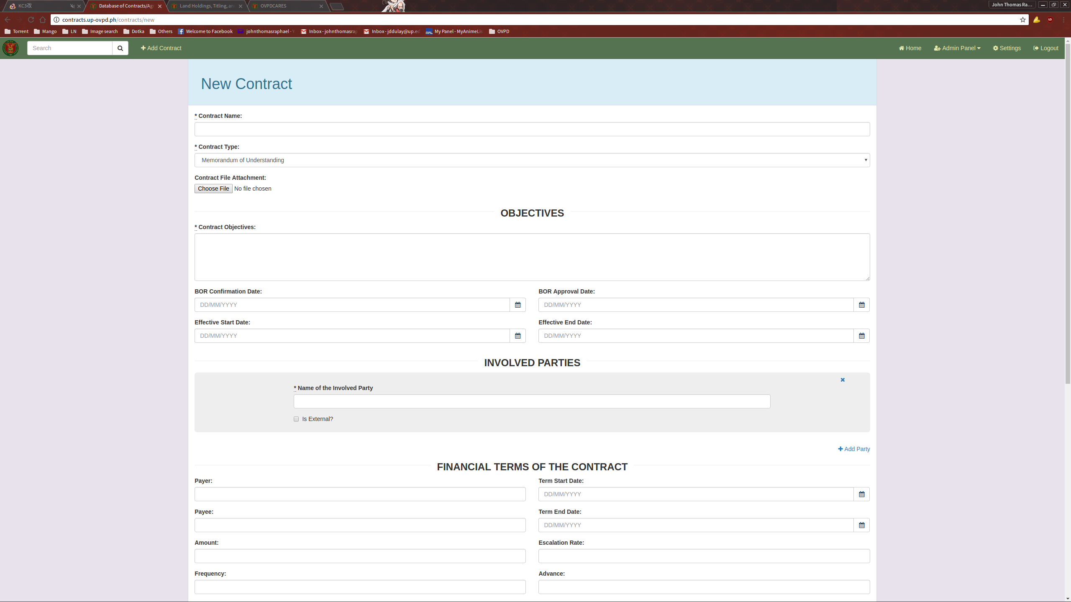
Once all relevant information has been filled up, click the “Create Bid” button to submit the data to created.

VIEW A CONTRACT ENTRY

To view a Contract entry, click one of the panels from the Dashboard. This will direct you to the Show Contract page for the selected entry.

On the Show Contracts page, you can see the details involving the selected entry. You can also download the Contract file from this page.

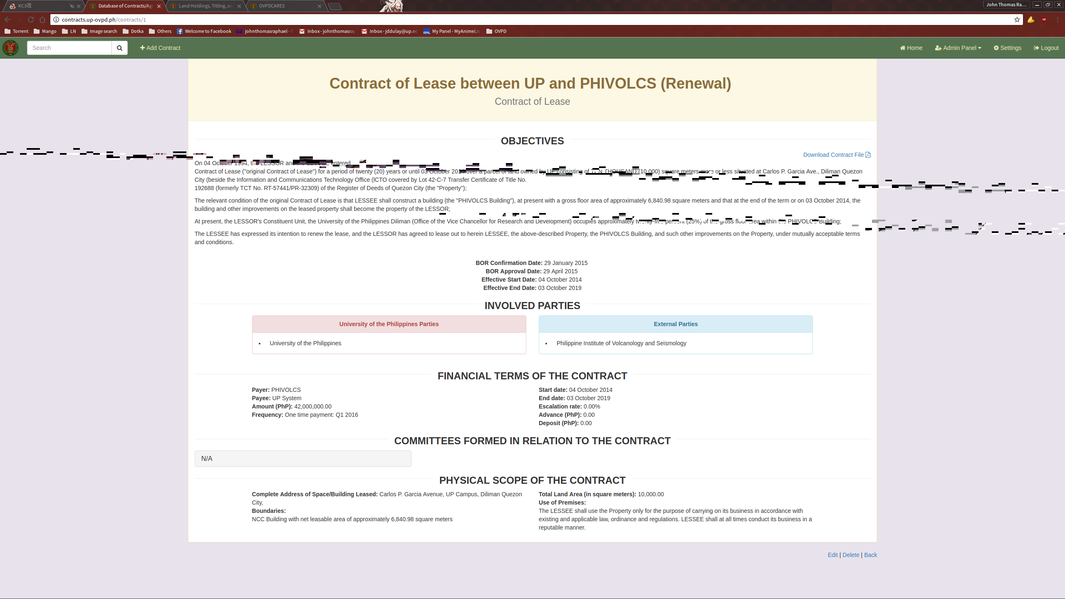

EDITING A CONTRACT ENTRY

To edit a contract entry, click on the Edit link located on the bottom part of the Show Contract page.

This will direct you to the Edit Contract page.
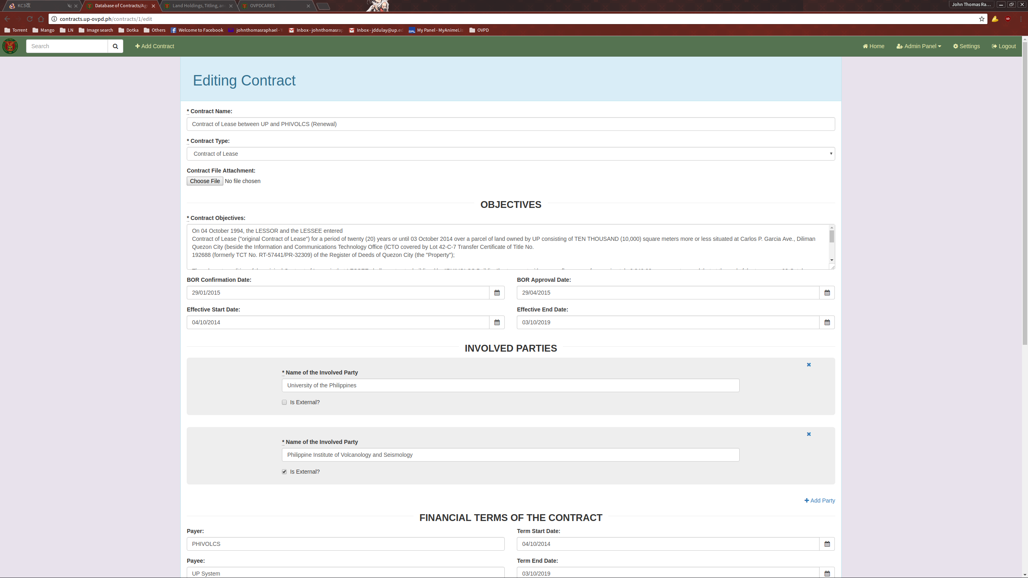
Fill up the necessary fields and click the “Update contract” button when done to submit.

ADMINISTRATION PANEL

The administration panel can be accessed on the top right of the navigation bar. Note that this option is invisible and unaccessible to non-admin users. From here the admin user can select the User Management module or add another entry for Contract Types.

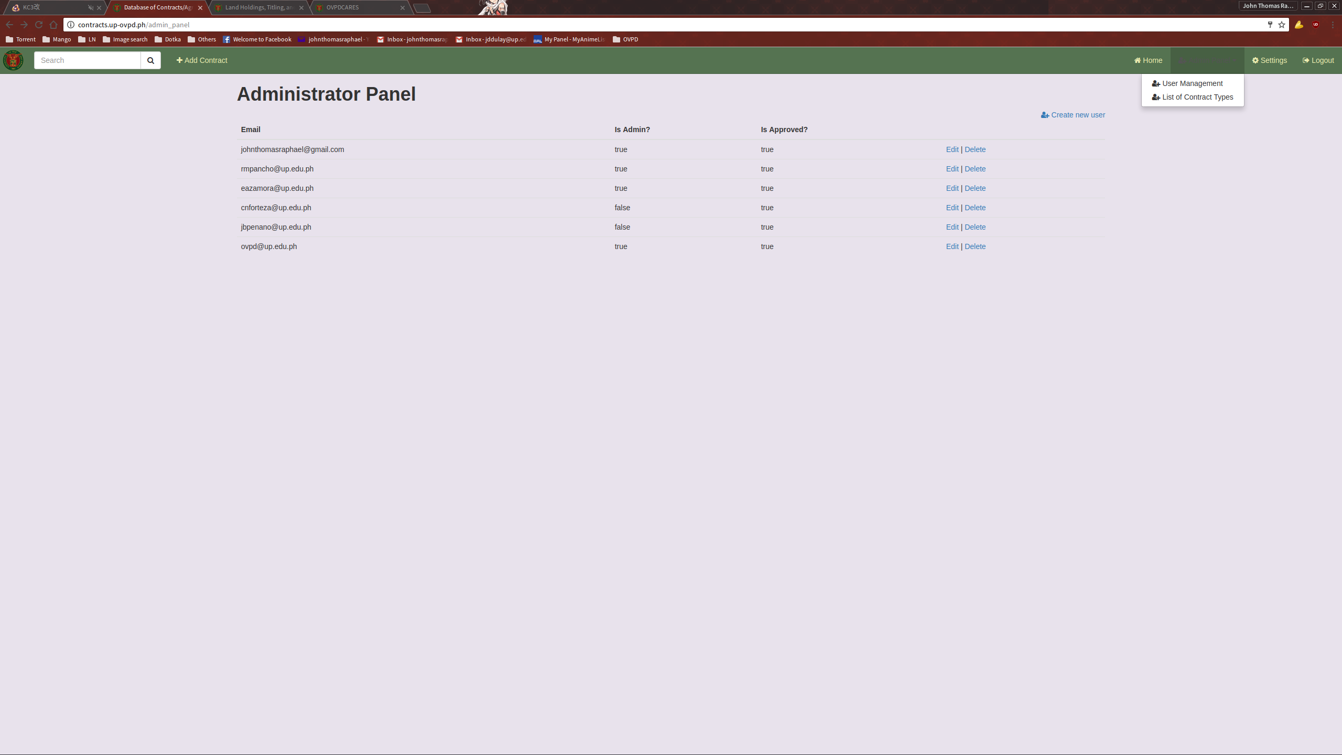

USER MANAGEMENT

Using the User Management page, the admin user can view, create, edit, and delete users.

ADDING A NEW USER

To create a new user, click the “Create new user” link on the top right of the user list.

This will direct you the New User page.
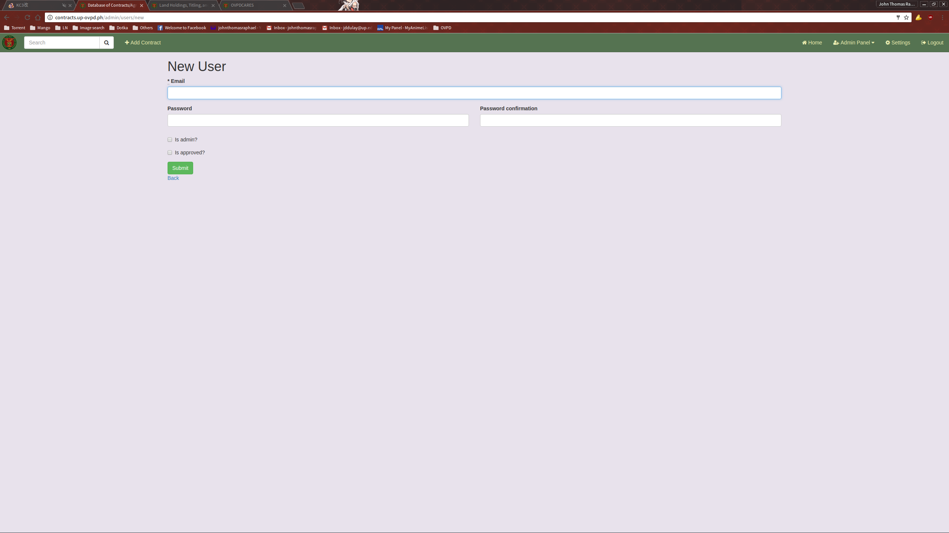
Fill up with the necessary information and submit.

EDITING A USER

To edit a User, click the Edit link located on the User List.

This will direct you to the Edit User page.
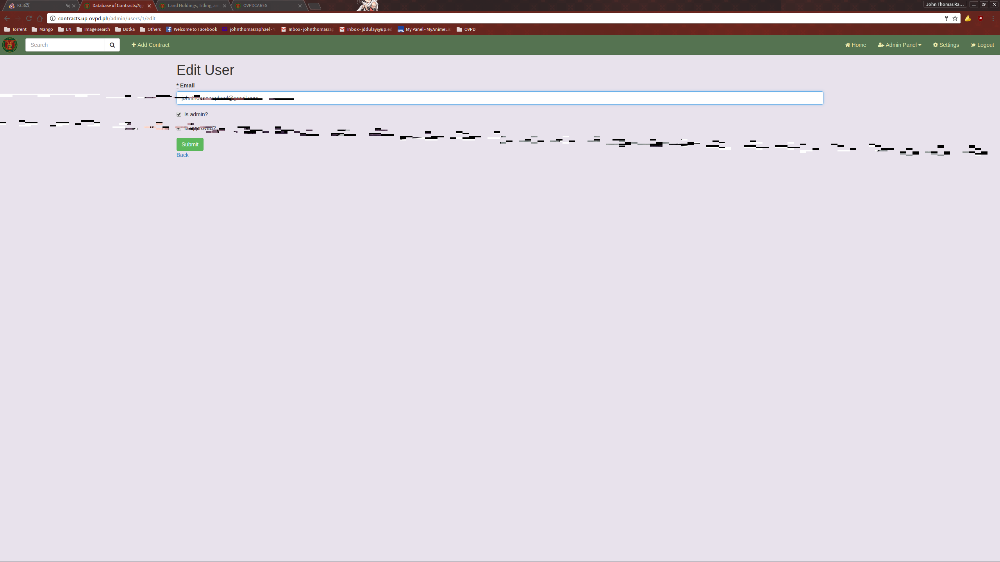
Fill it up with the necessary information and submit.
LIST OF CONTRACT TYPES

The List of Contract Types page contains all the Contract types used when creating or updating a Contract entry. You can access this page by clicking on the List of Contract Types link located in the Admin Panel dropdown.

With the List of Contract Types module, you can view, add, edit, and delete the entries of the Contract Types.
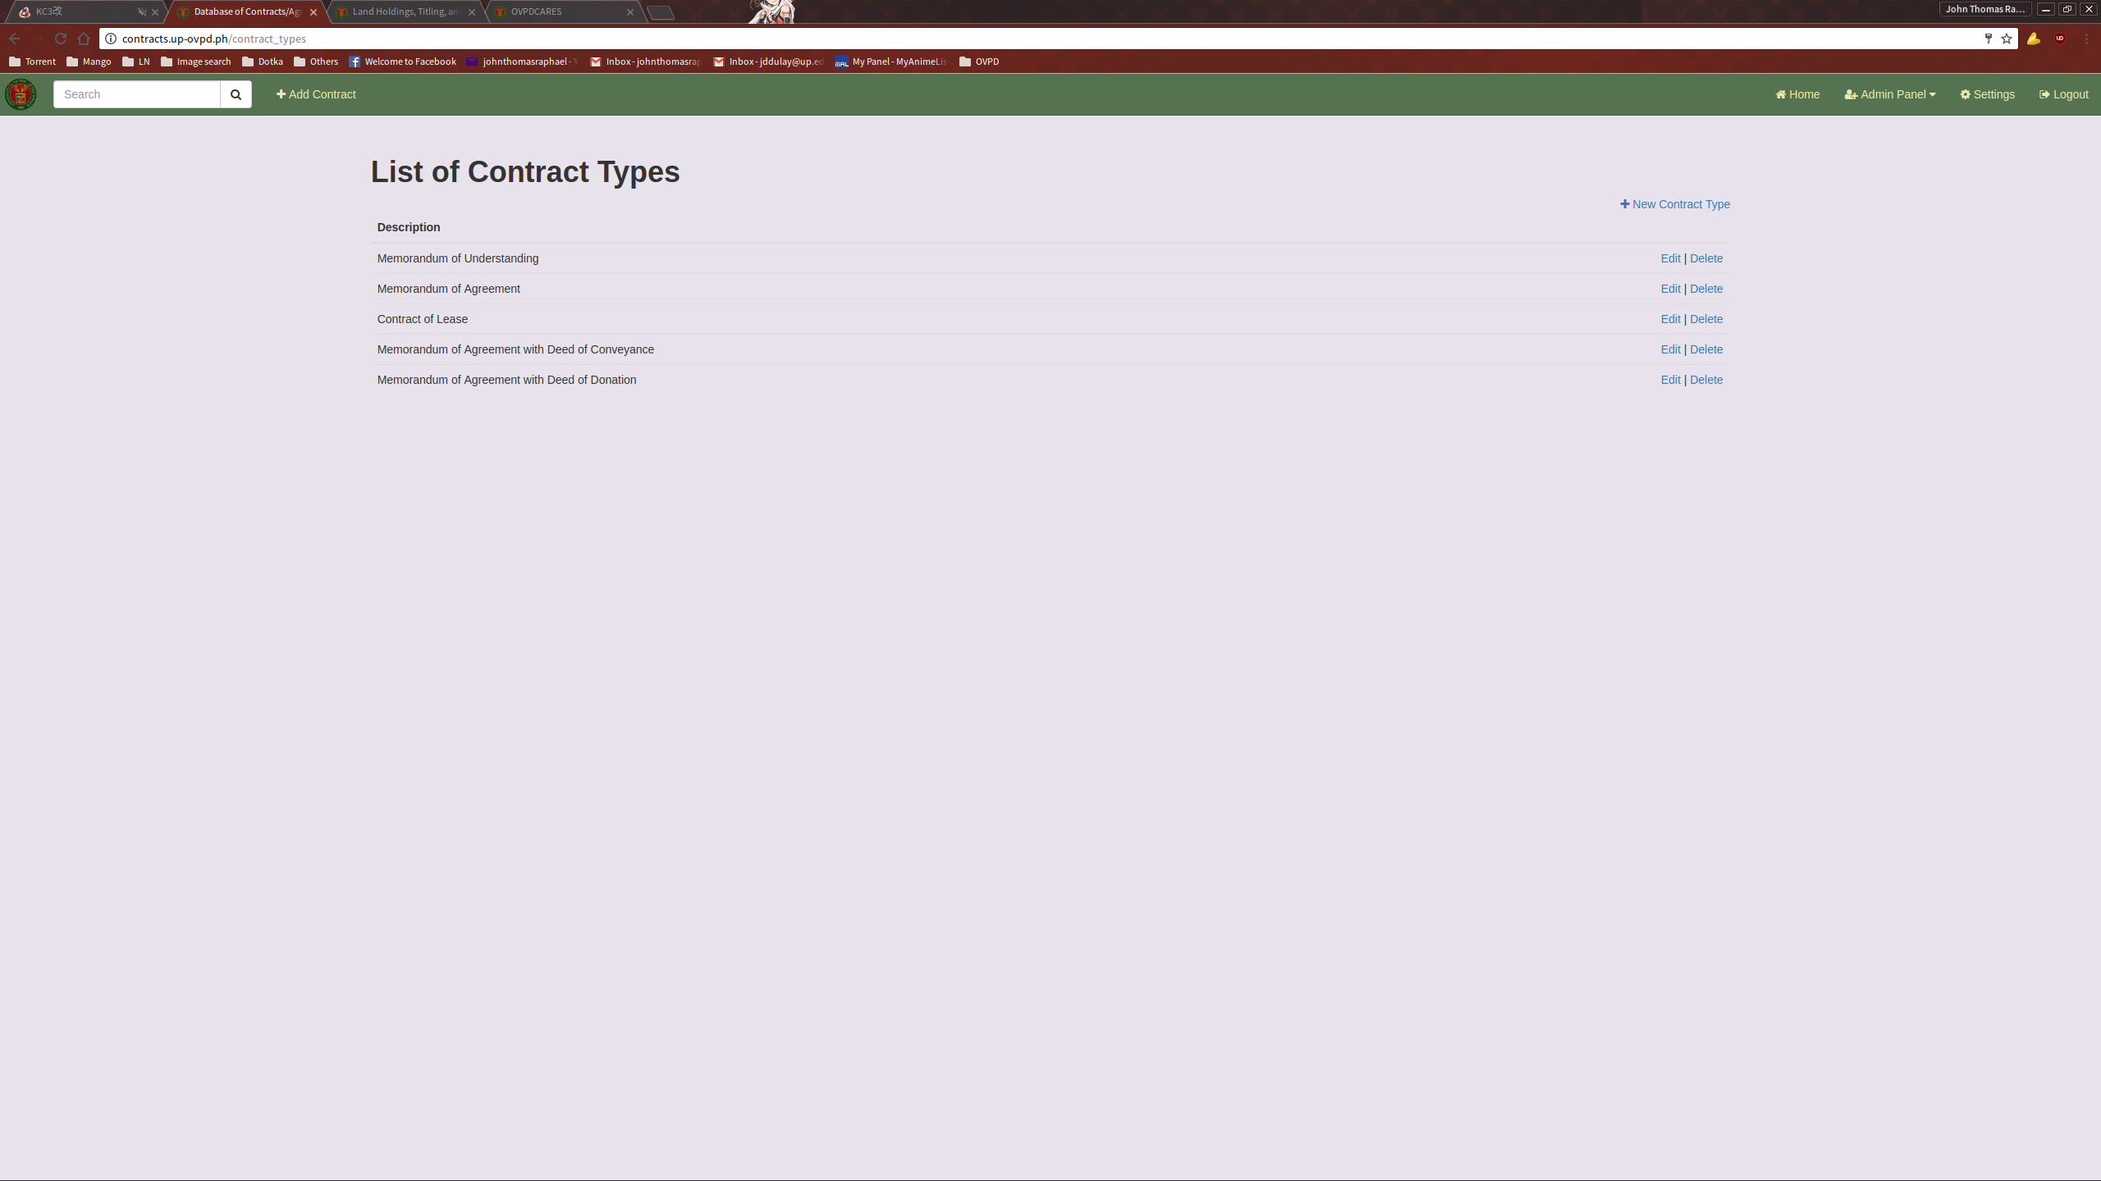

ADDING A NEW CONTRACT TYPE

To add a new Contract Type, click the “New Contract Type” link on the top right of the list.
This will direct you to the New Contract Type page.

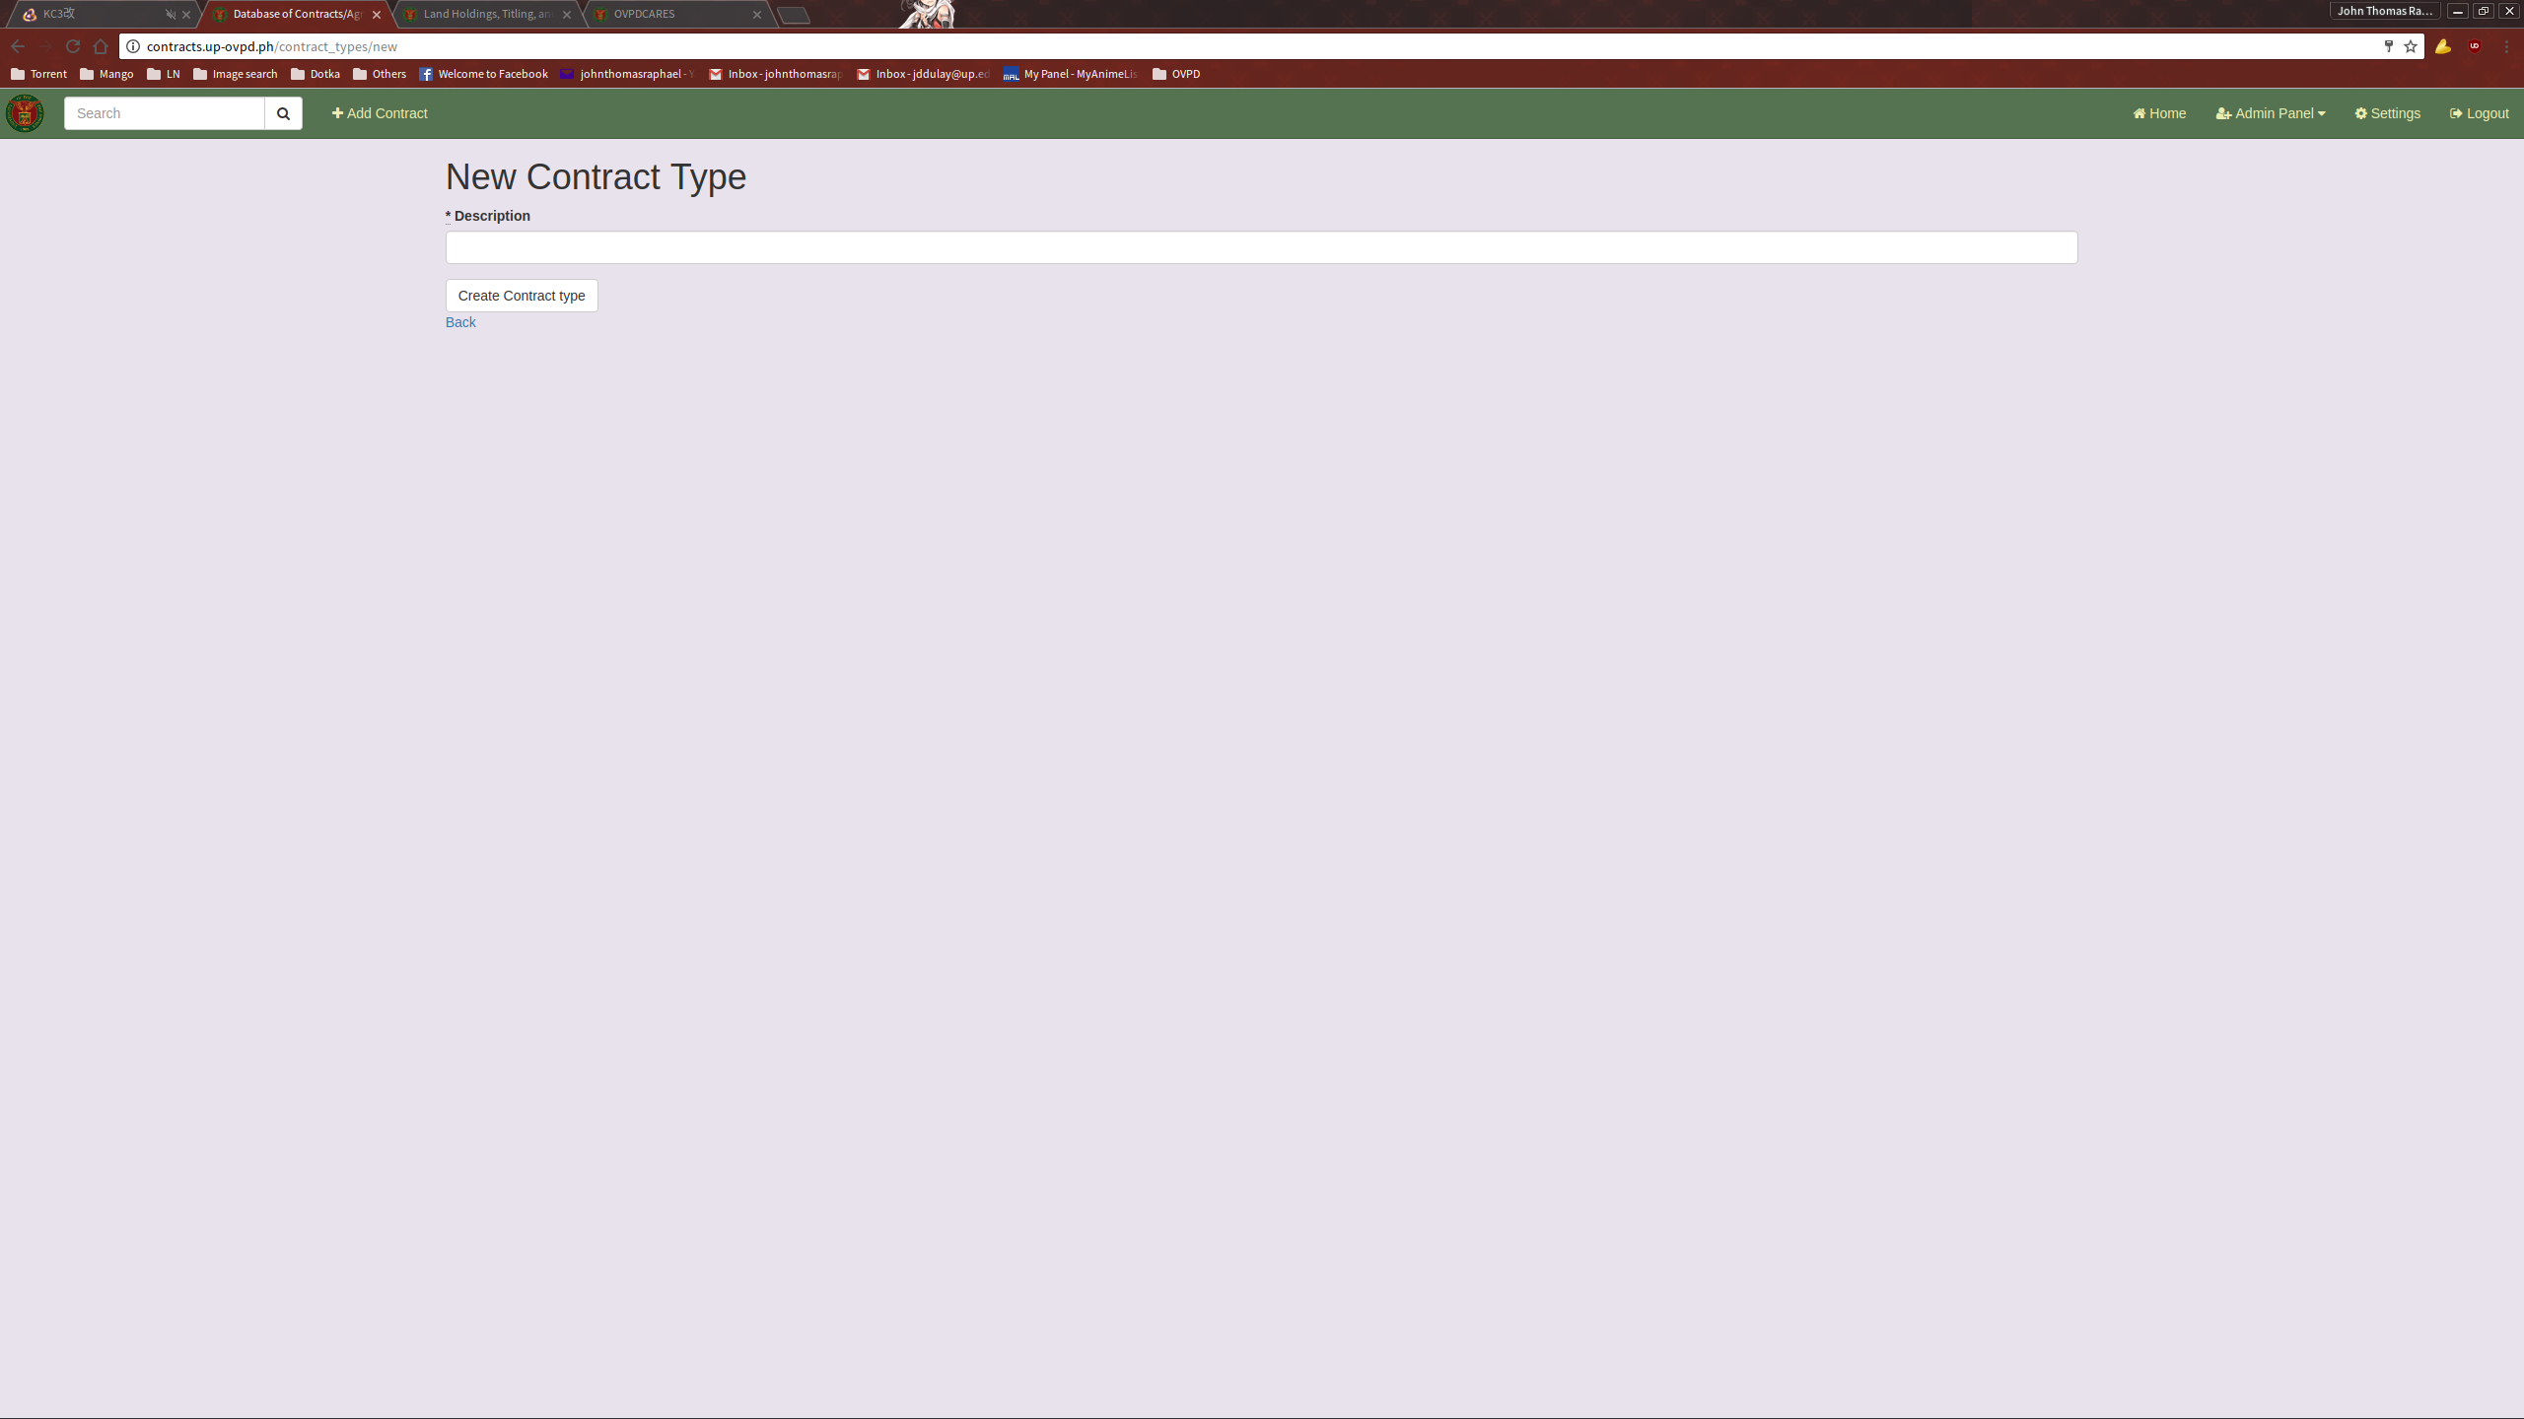
Fill up the necessary information and submit.

EDITING A CONTRACT TYPE

To edit a Contract Type, click on the Edit link located on the Contractt Types List.
This will direct you to the Edit Contract Type page.
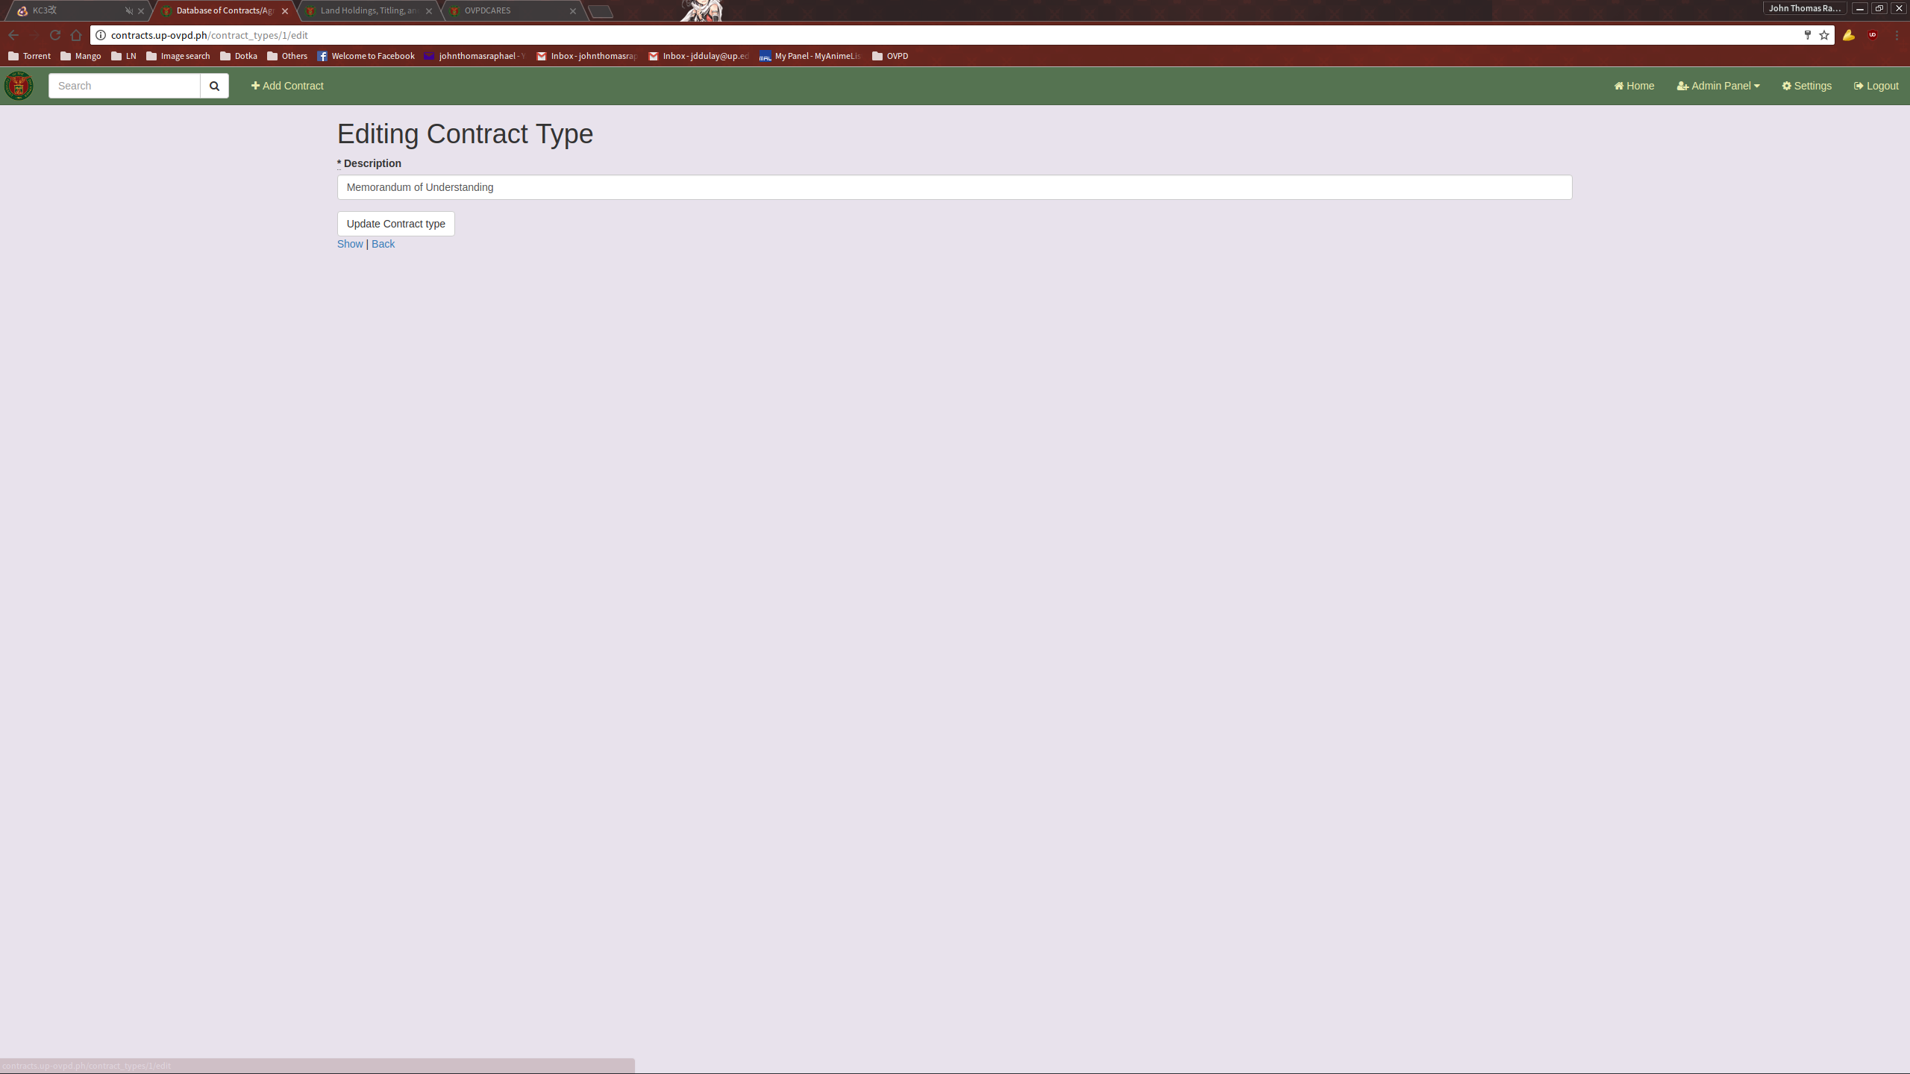
Fill it up with the necessary information and submit.

