DCARESV2
USERS MANUAL
WEB APPLICATION

INTRODUCTION

The DCARESV2 is a web application that enables the users to view the various Infrastructure projects held by the University of the Philippines.

MAIN FEATURES

- Dashboard
- University Project List
- Infrastructure Project per University
  - Project Components
  - Project Images
  - Export to Excel
- Report Generation
- Analytics
- Administration Panel
  - List of Universities
  - Recent Updates
  - List of Project Classifications
  - List of Project Statuses
  - List of Fund Sources
  - User Management

GETTING STARTED

Access the website through the URL dcares.up-ovpd.ph where you will be greeted with a login screen.
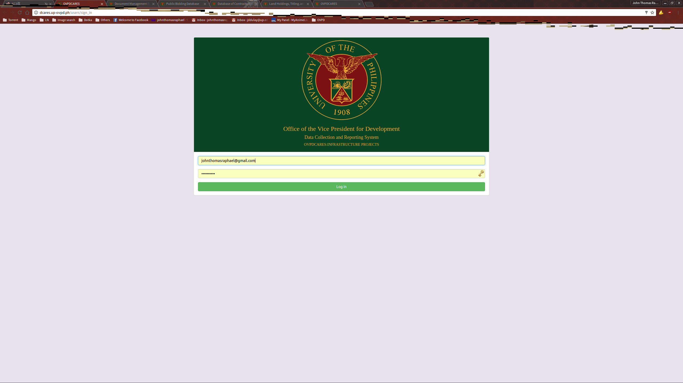
Input your access credentials to get to the dashboard.

DASHBOARD

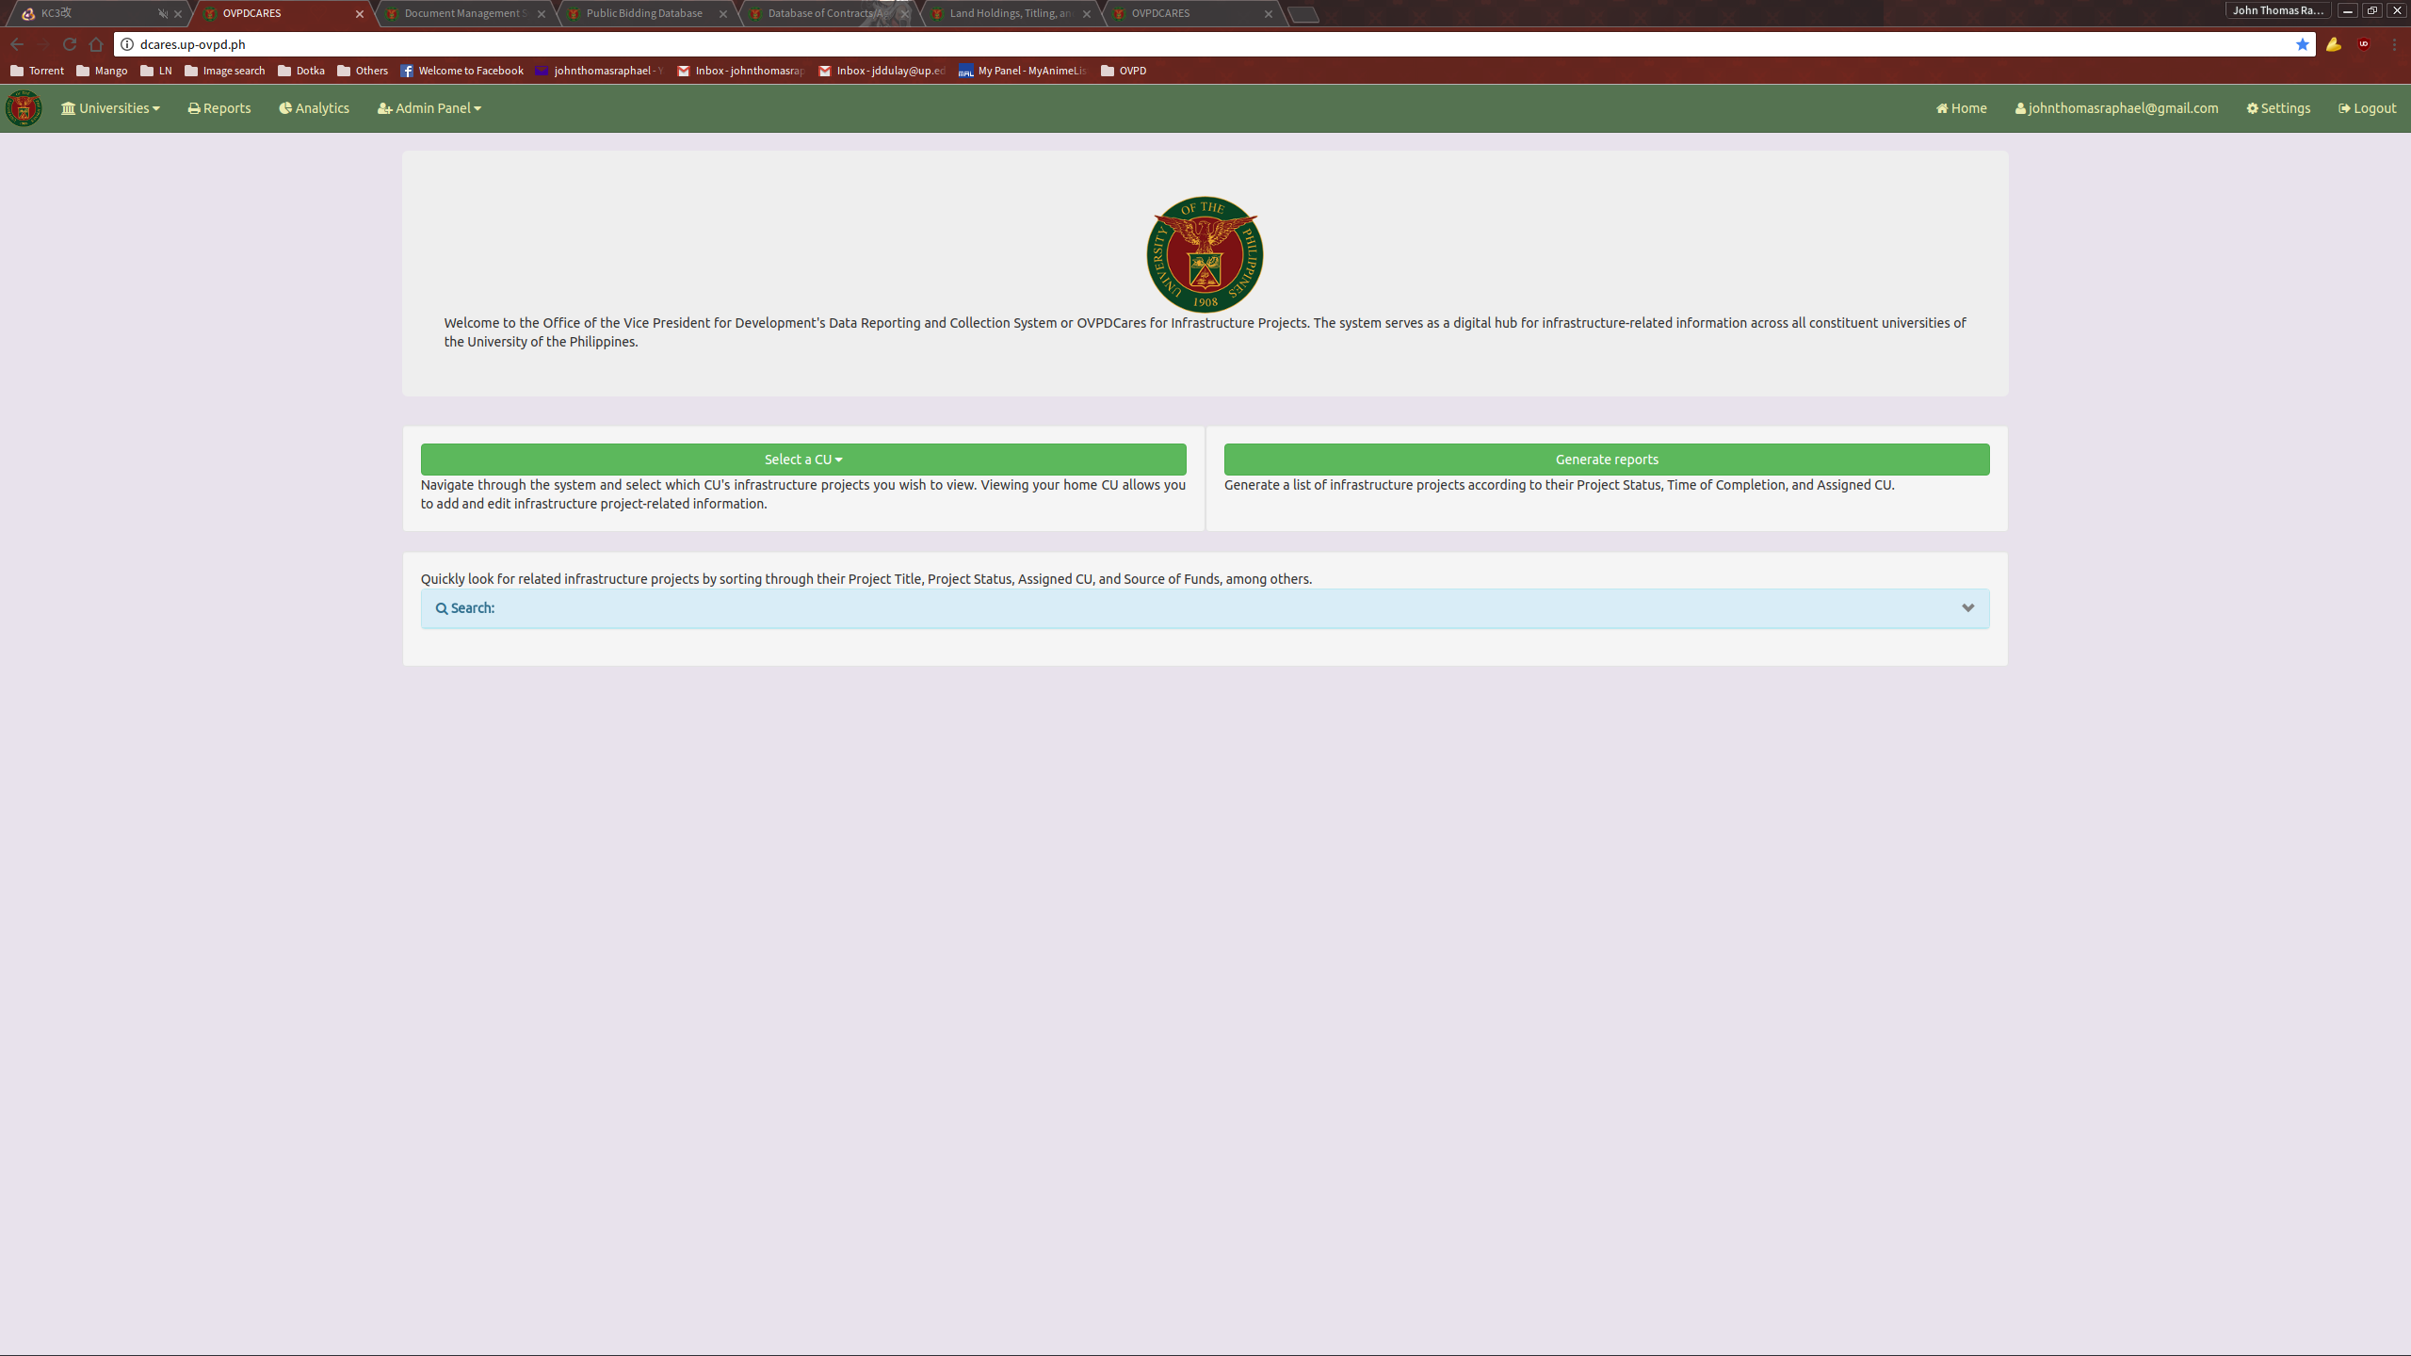
Upon a successful login, the user will be greeted with the dashboard. Most of the available functions can be access through here. Note that administration functions cannot be seen and used by non-admin users. The search function can be found below the University list and Generate Report buttons. Click on its panel heading to expand.
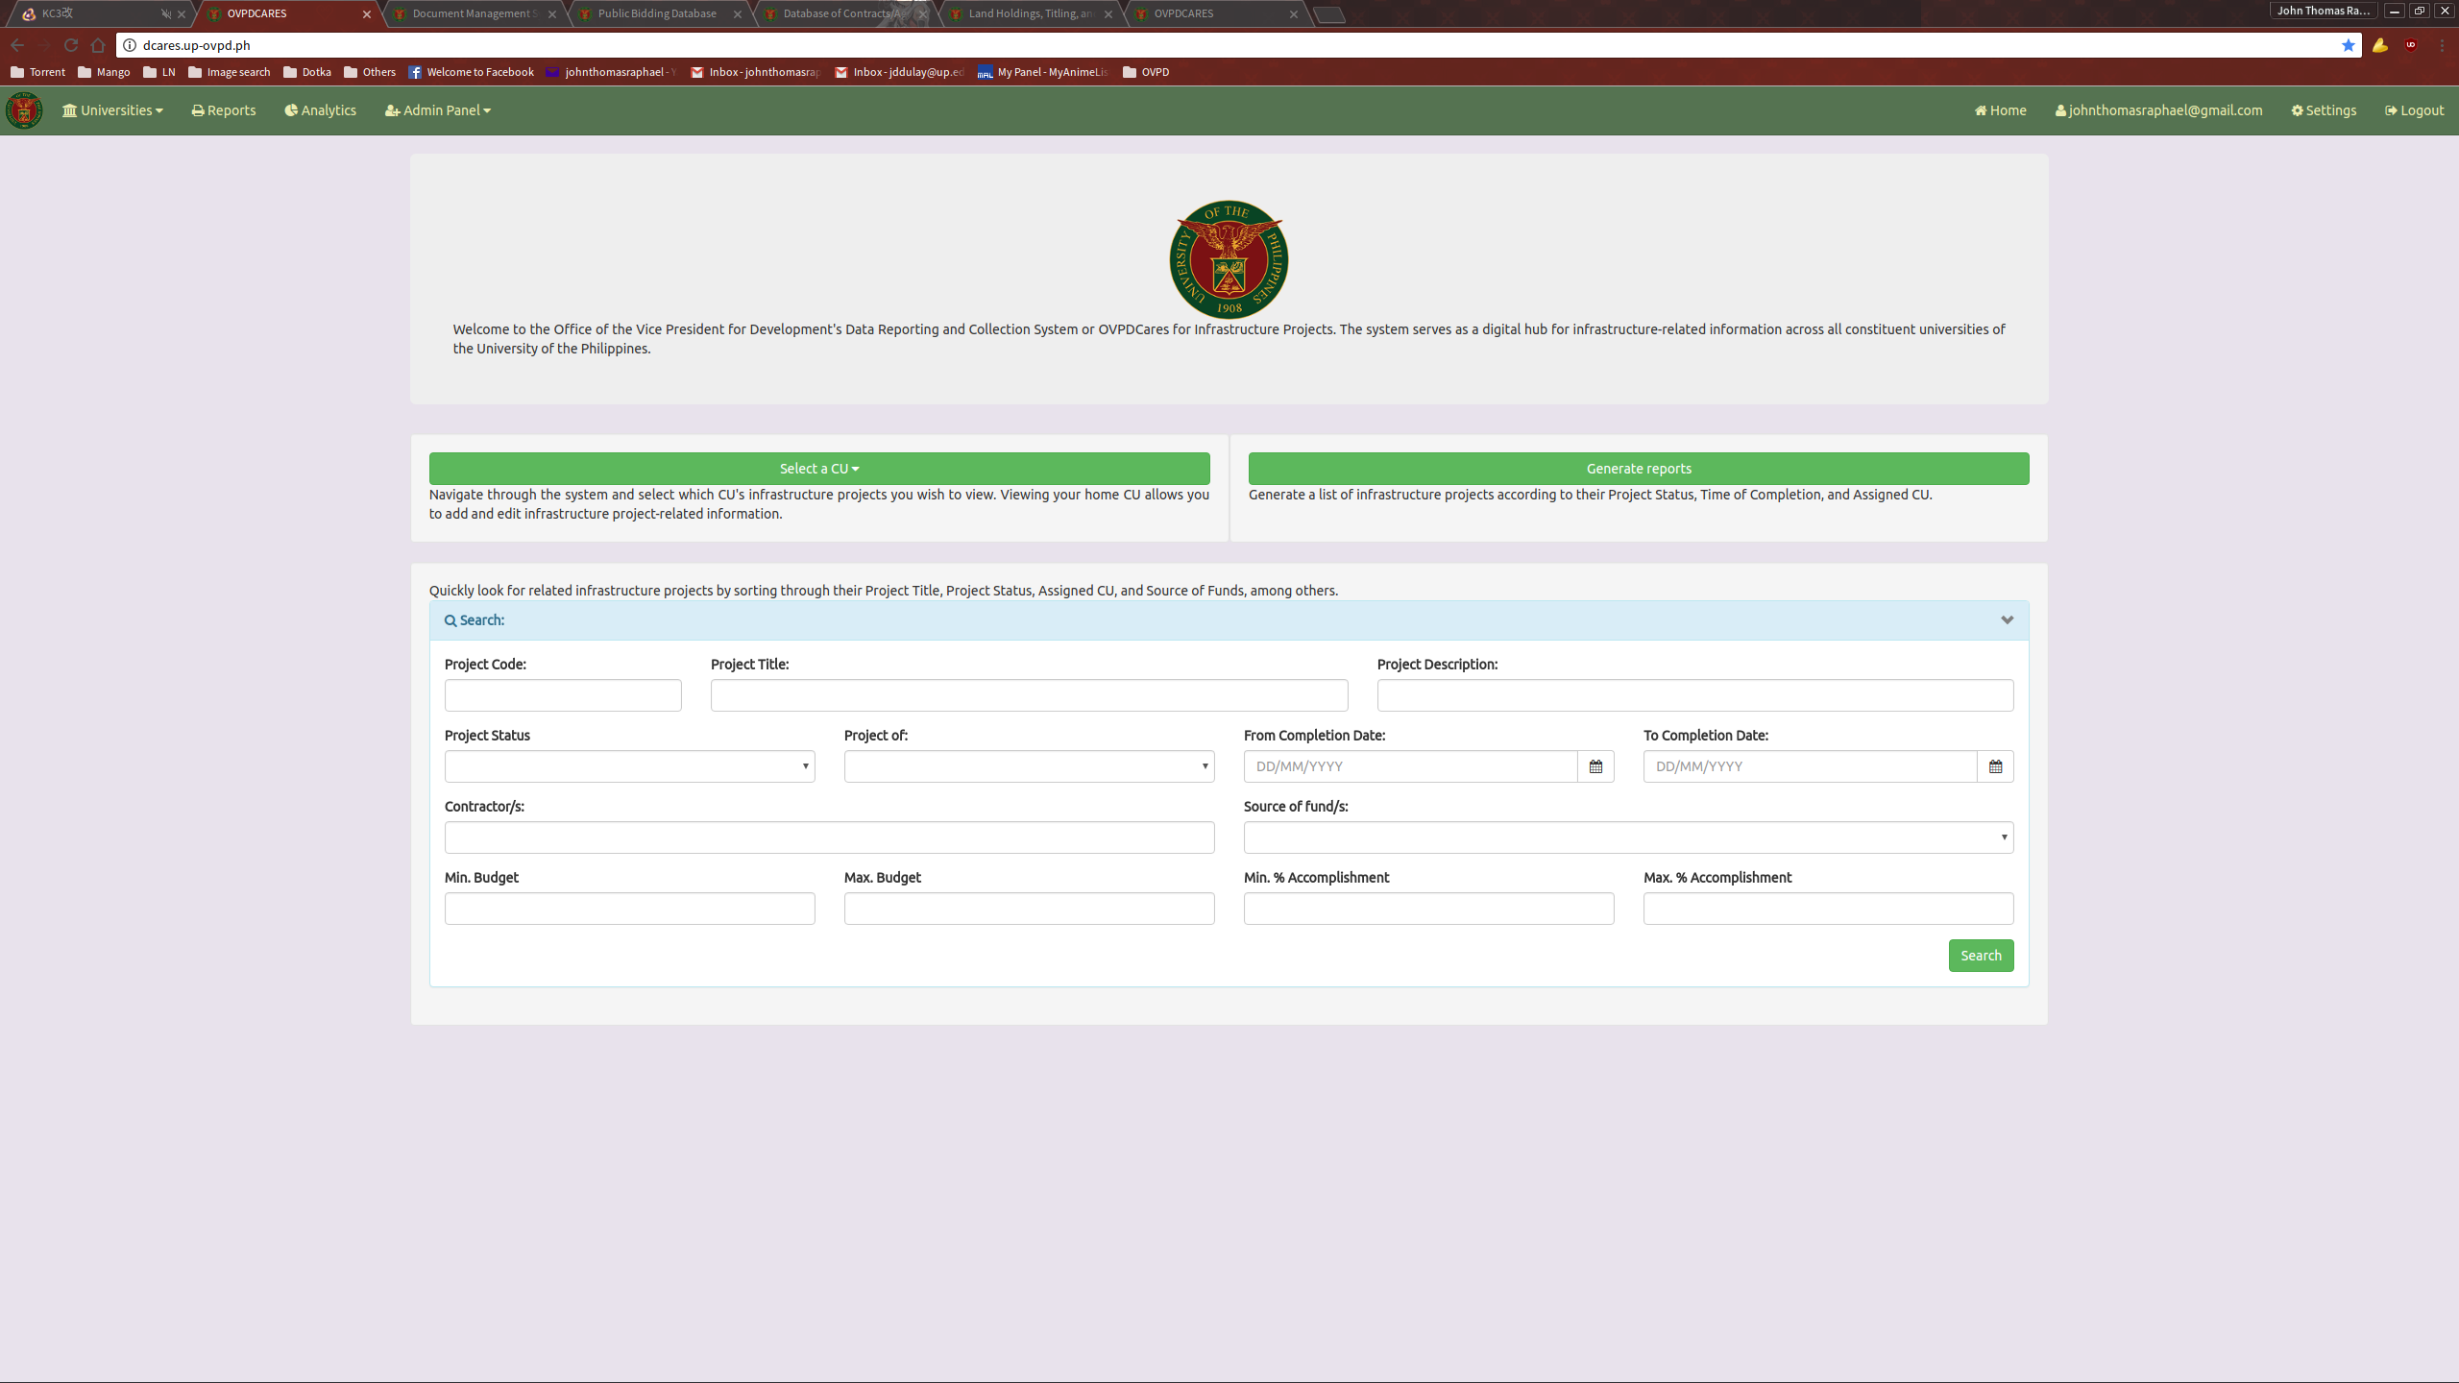
UNIVERSITY PROJECT LIST

The University Project List contains the Infrastructure Projects managed by the selected University.

To access the University List, select a university from either the dropdown from the dashboard or the navigation bar.

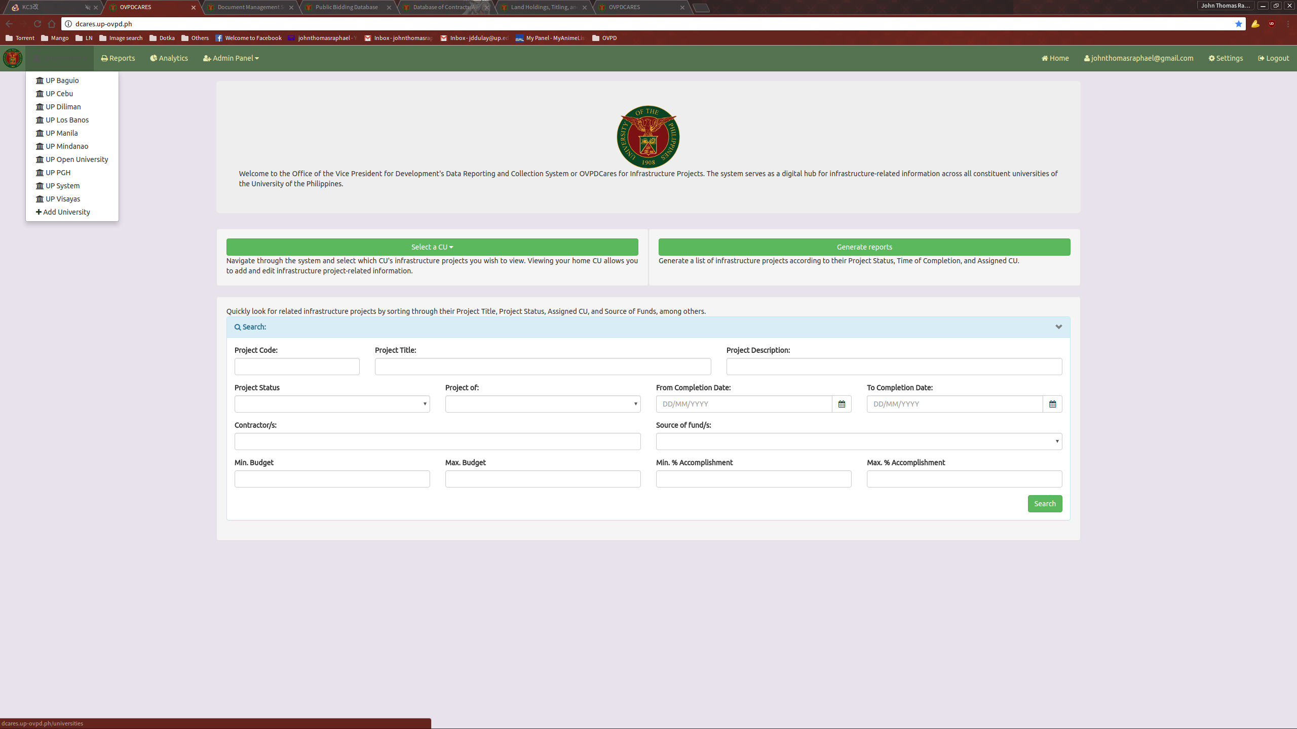

This will direct you to the University Projects page. Here you can see the list of projects the selected university manages, as well as the option to export the list to a downloadable Excel file by following the Export to Excel link.

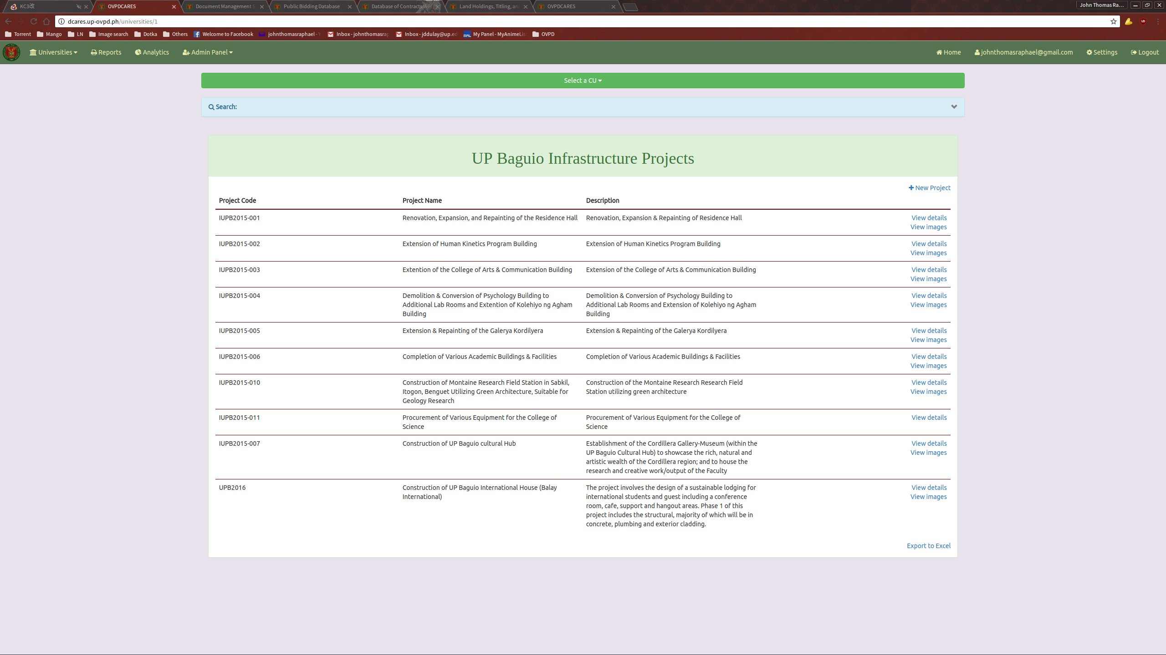

ADDING A NEW PROJECT

To add a new title entry, click the link “New Projects” located on the top right of the Projects list.

This will take you to the “New Project” page.

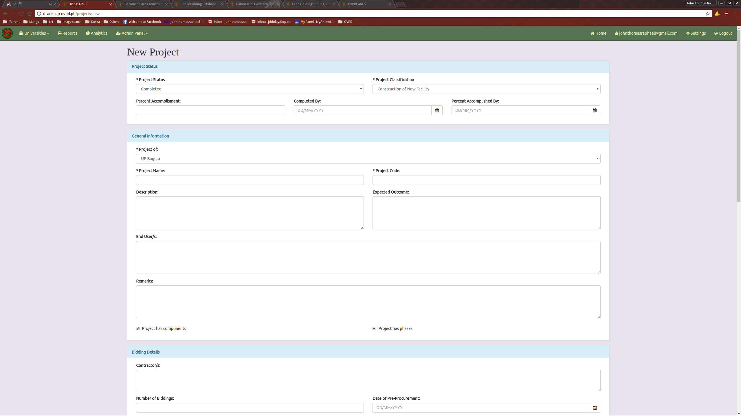
Fill it up with the necessary information and submit.
VIEW A PROJECT ENTRY

To view a Project Entry, click on the View Details link provided in the Project List on the University Project List Page.
This will direct you to the Show Project Entry page.
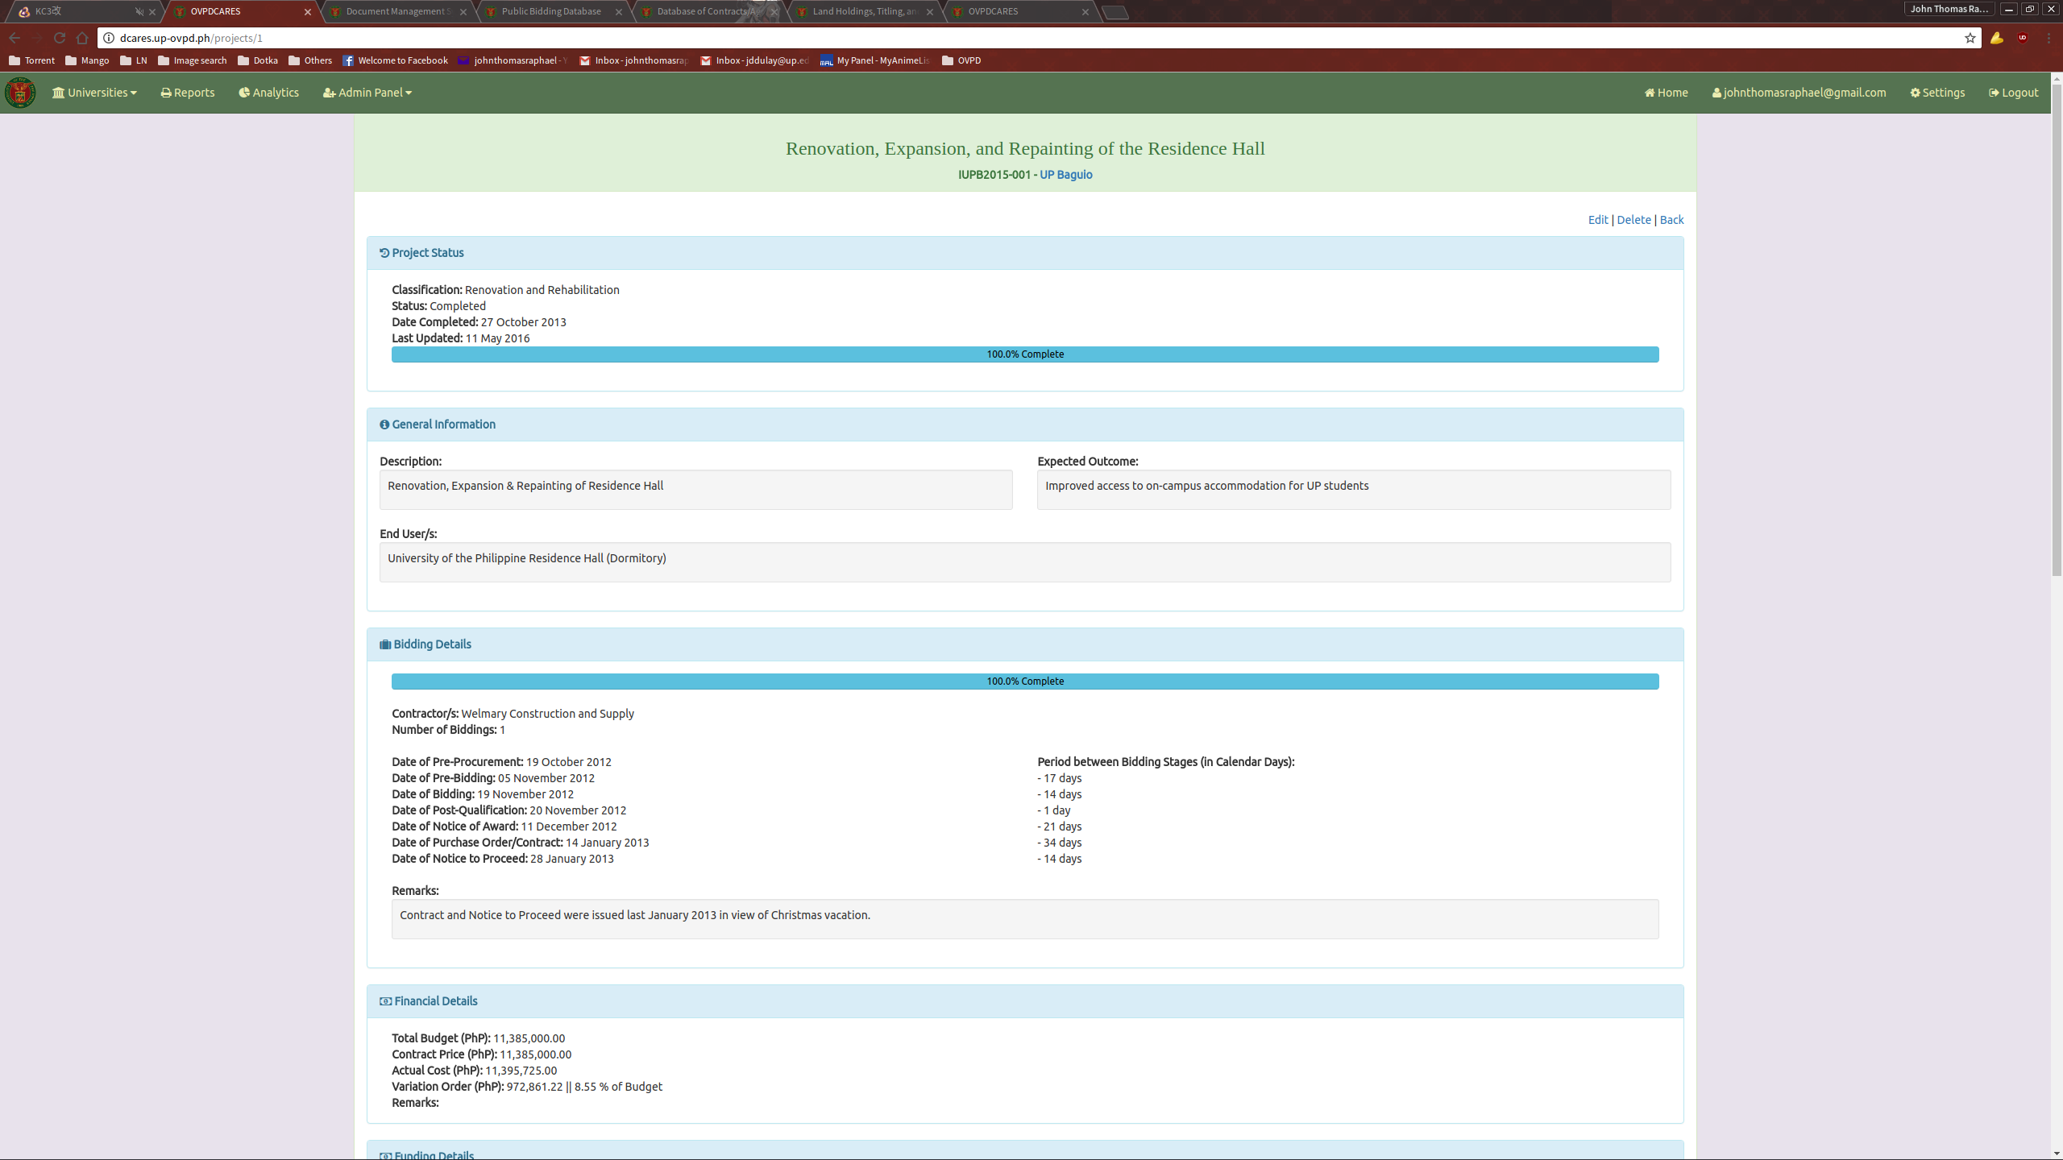
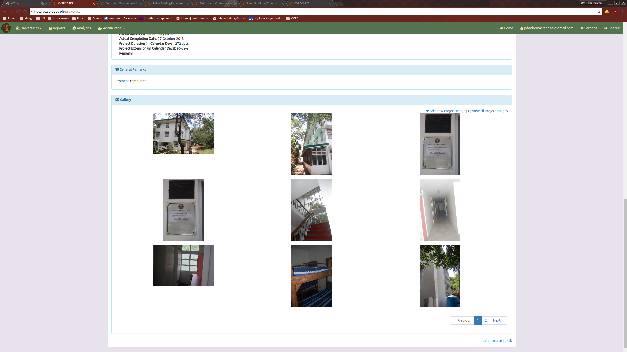

EDIT A PROJECT ENTRY

To edit a Project entry, follow the Edit link located on the bottom part of the Show Project Entry page.

This will direct you to the Edit Project page.
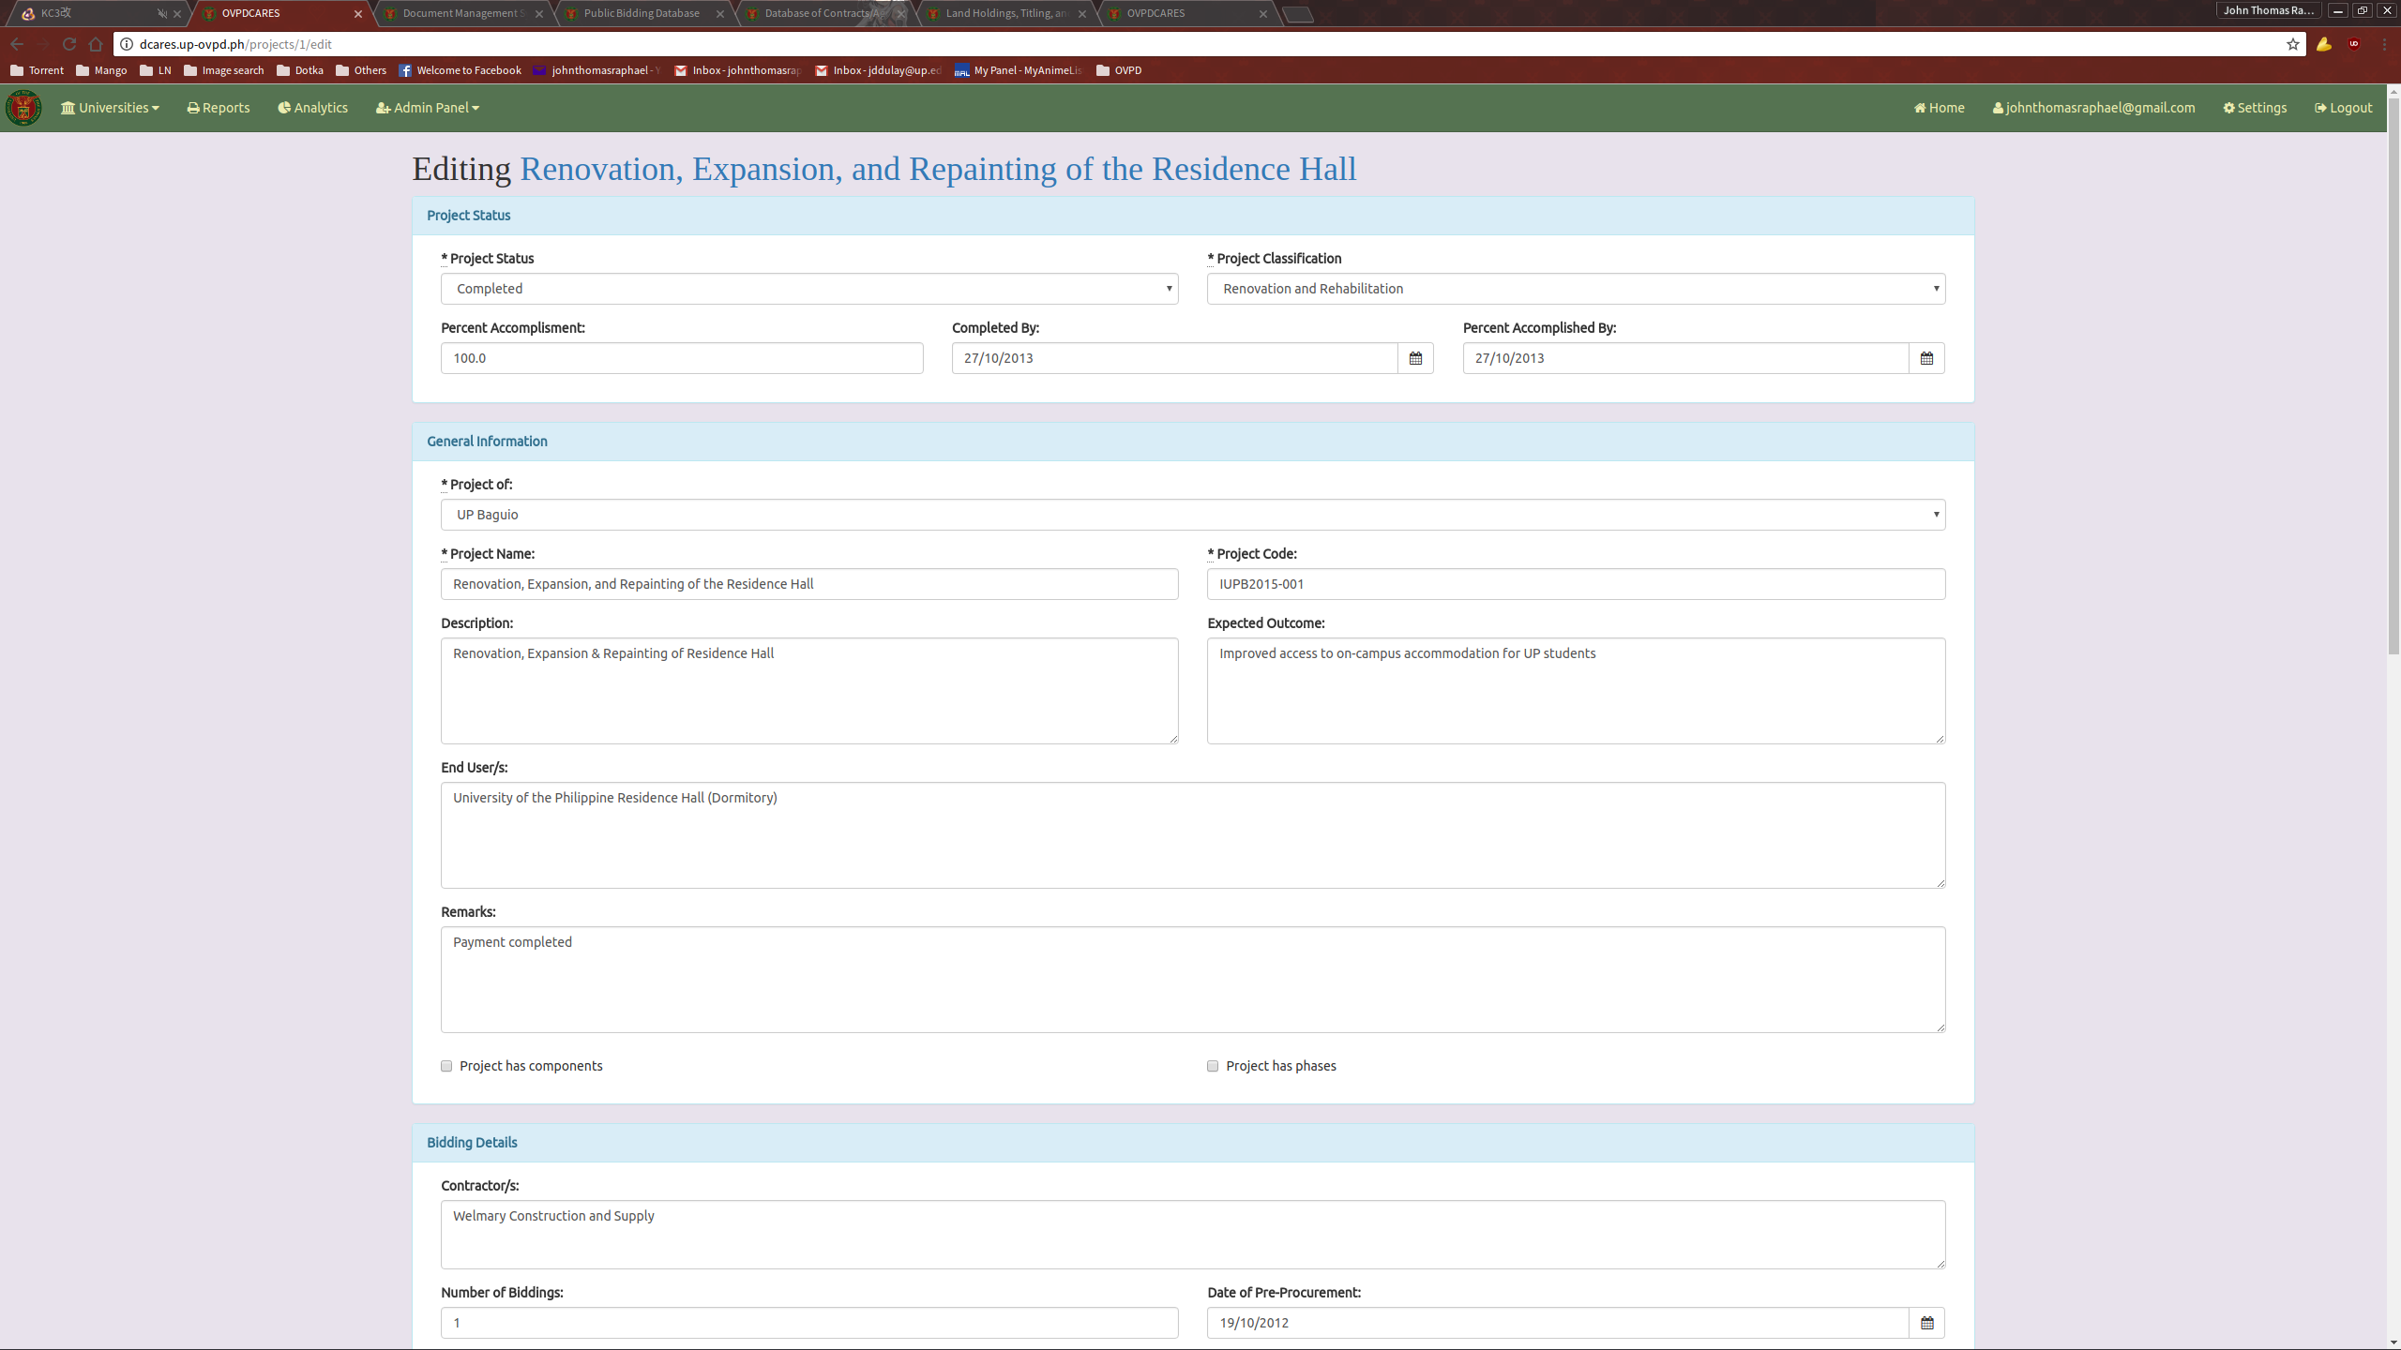
Update the necessary fields and click the “Update document” button when done to submit.

ADDING AN IMAGE TO A PROJECT

To add an image to an Infrastructure project, you can either follow the “Add new Project Image” link on the details page or go to the Gallery section of the Edit page. Upload your desired image. Note that an image can’t be bigger than 2MB in size and a Project can only have a maximum of 15 images at a time.

ADDING A COMPONENT TO A PROJECT

To add a Project Component to an Infrastructure Project, first ensure that the “Project has components” field is ticked in its edit page.
This will make the Project Components panel visible in the Project details page. From here, click on the “Add new Project Component” link.
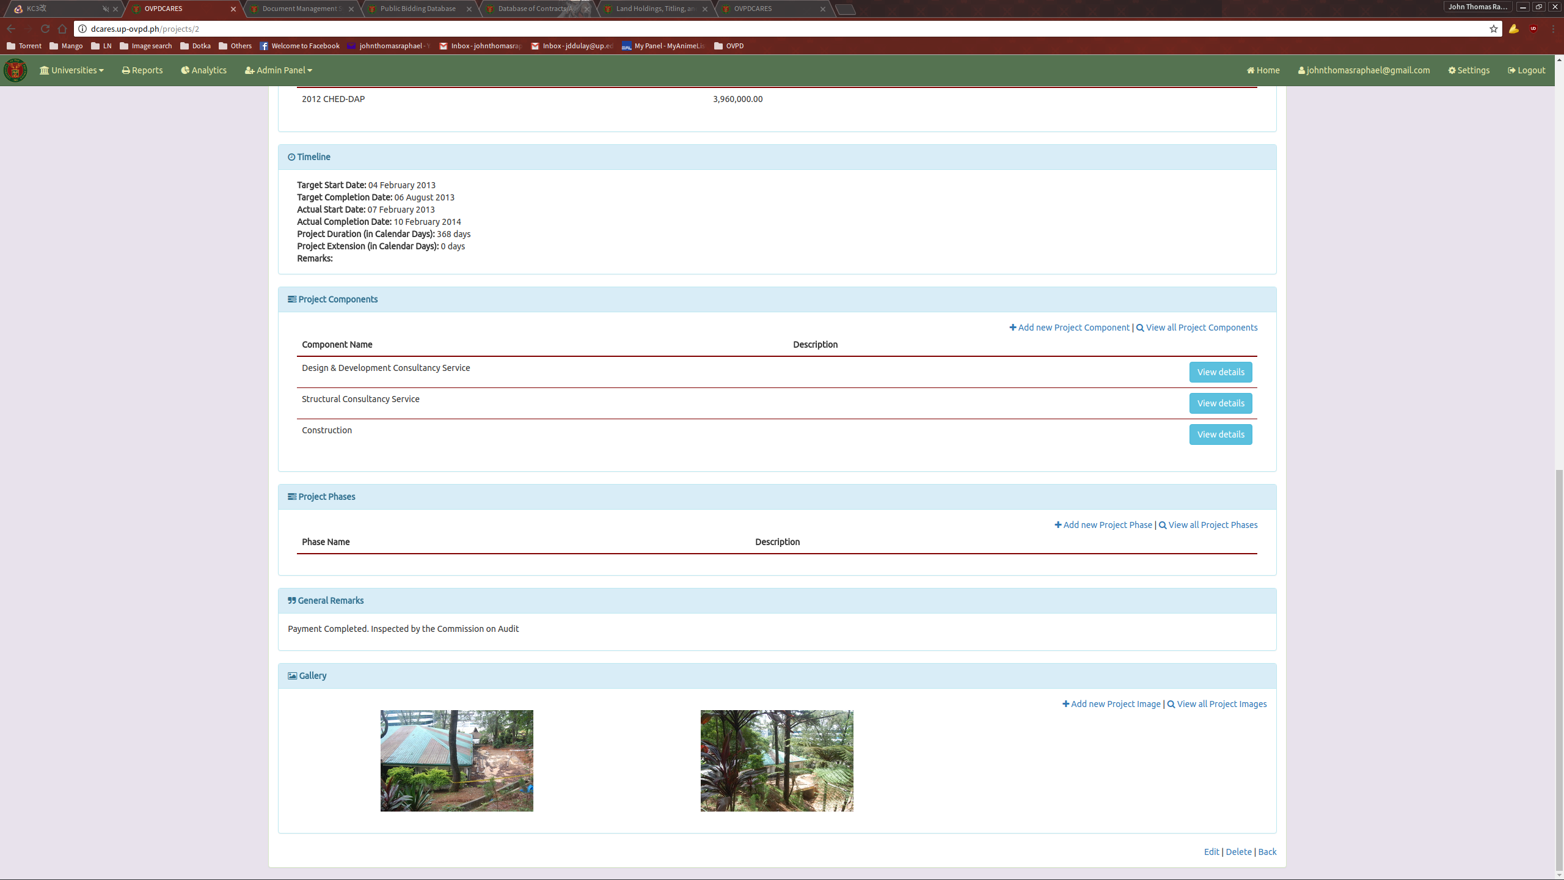
This will direct you to the New Project Component page.

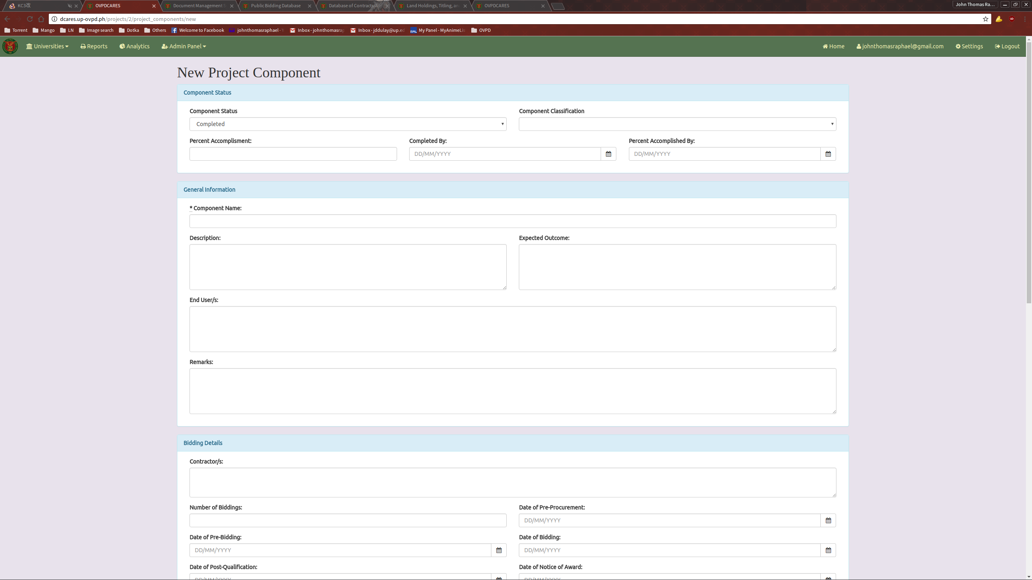
Fill it up with the necessary information and submit.

VIEWING A SPECIFIC PROJECT COMPONENT

To view a Project Component, click on the “View Details” button assigned to it on its parent Project Detail Page.
This will direct you to the Project Component Detail page.
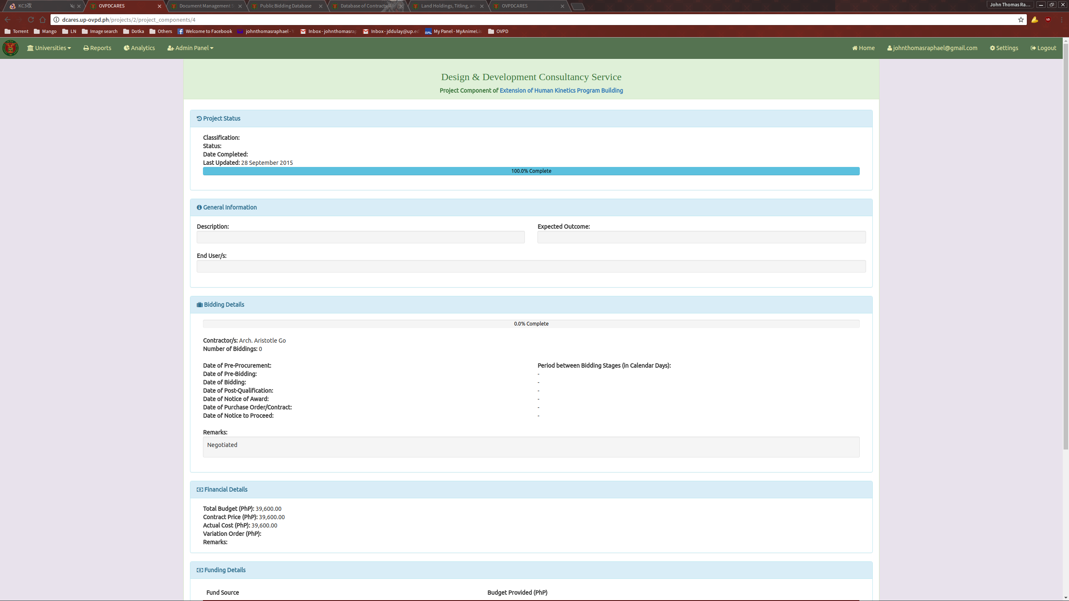
To edit a Project Component, follow the same steps as if editing a Project.
GENERATING A REPORT

To generate a report, follow the “Reports” link located in the navigation bar. This will bring you to the Reports Generation Module.
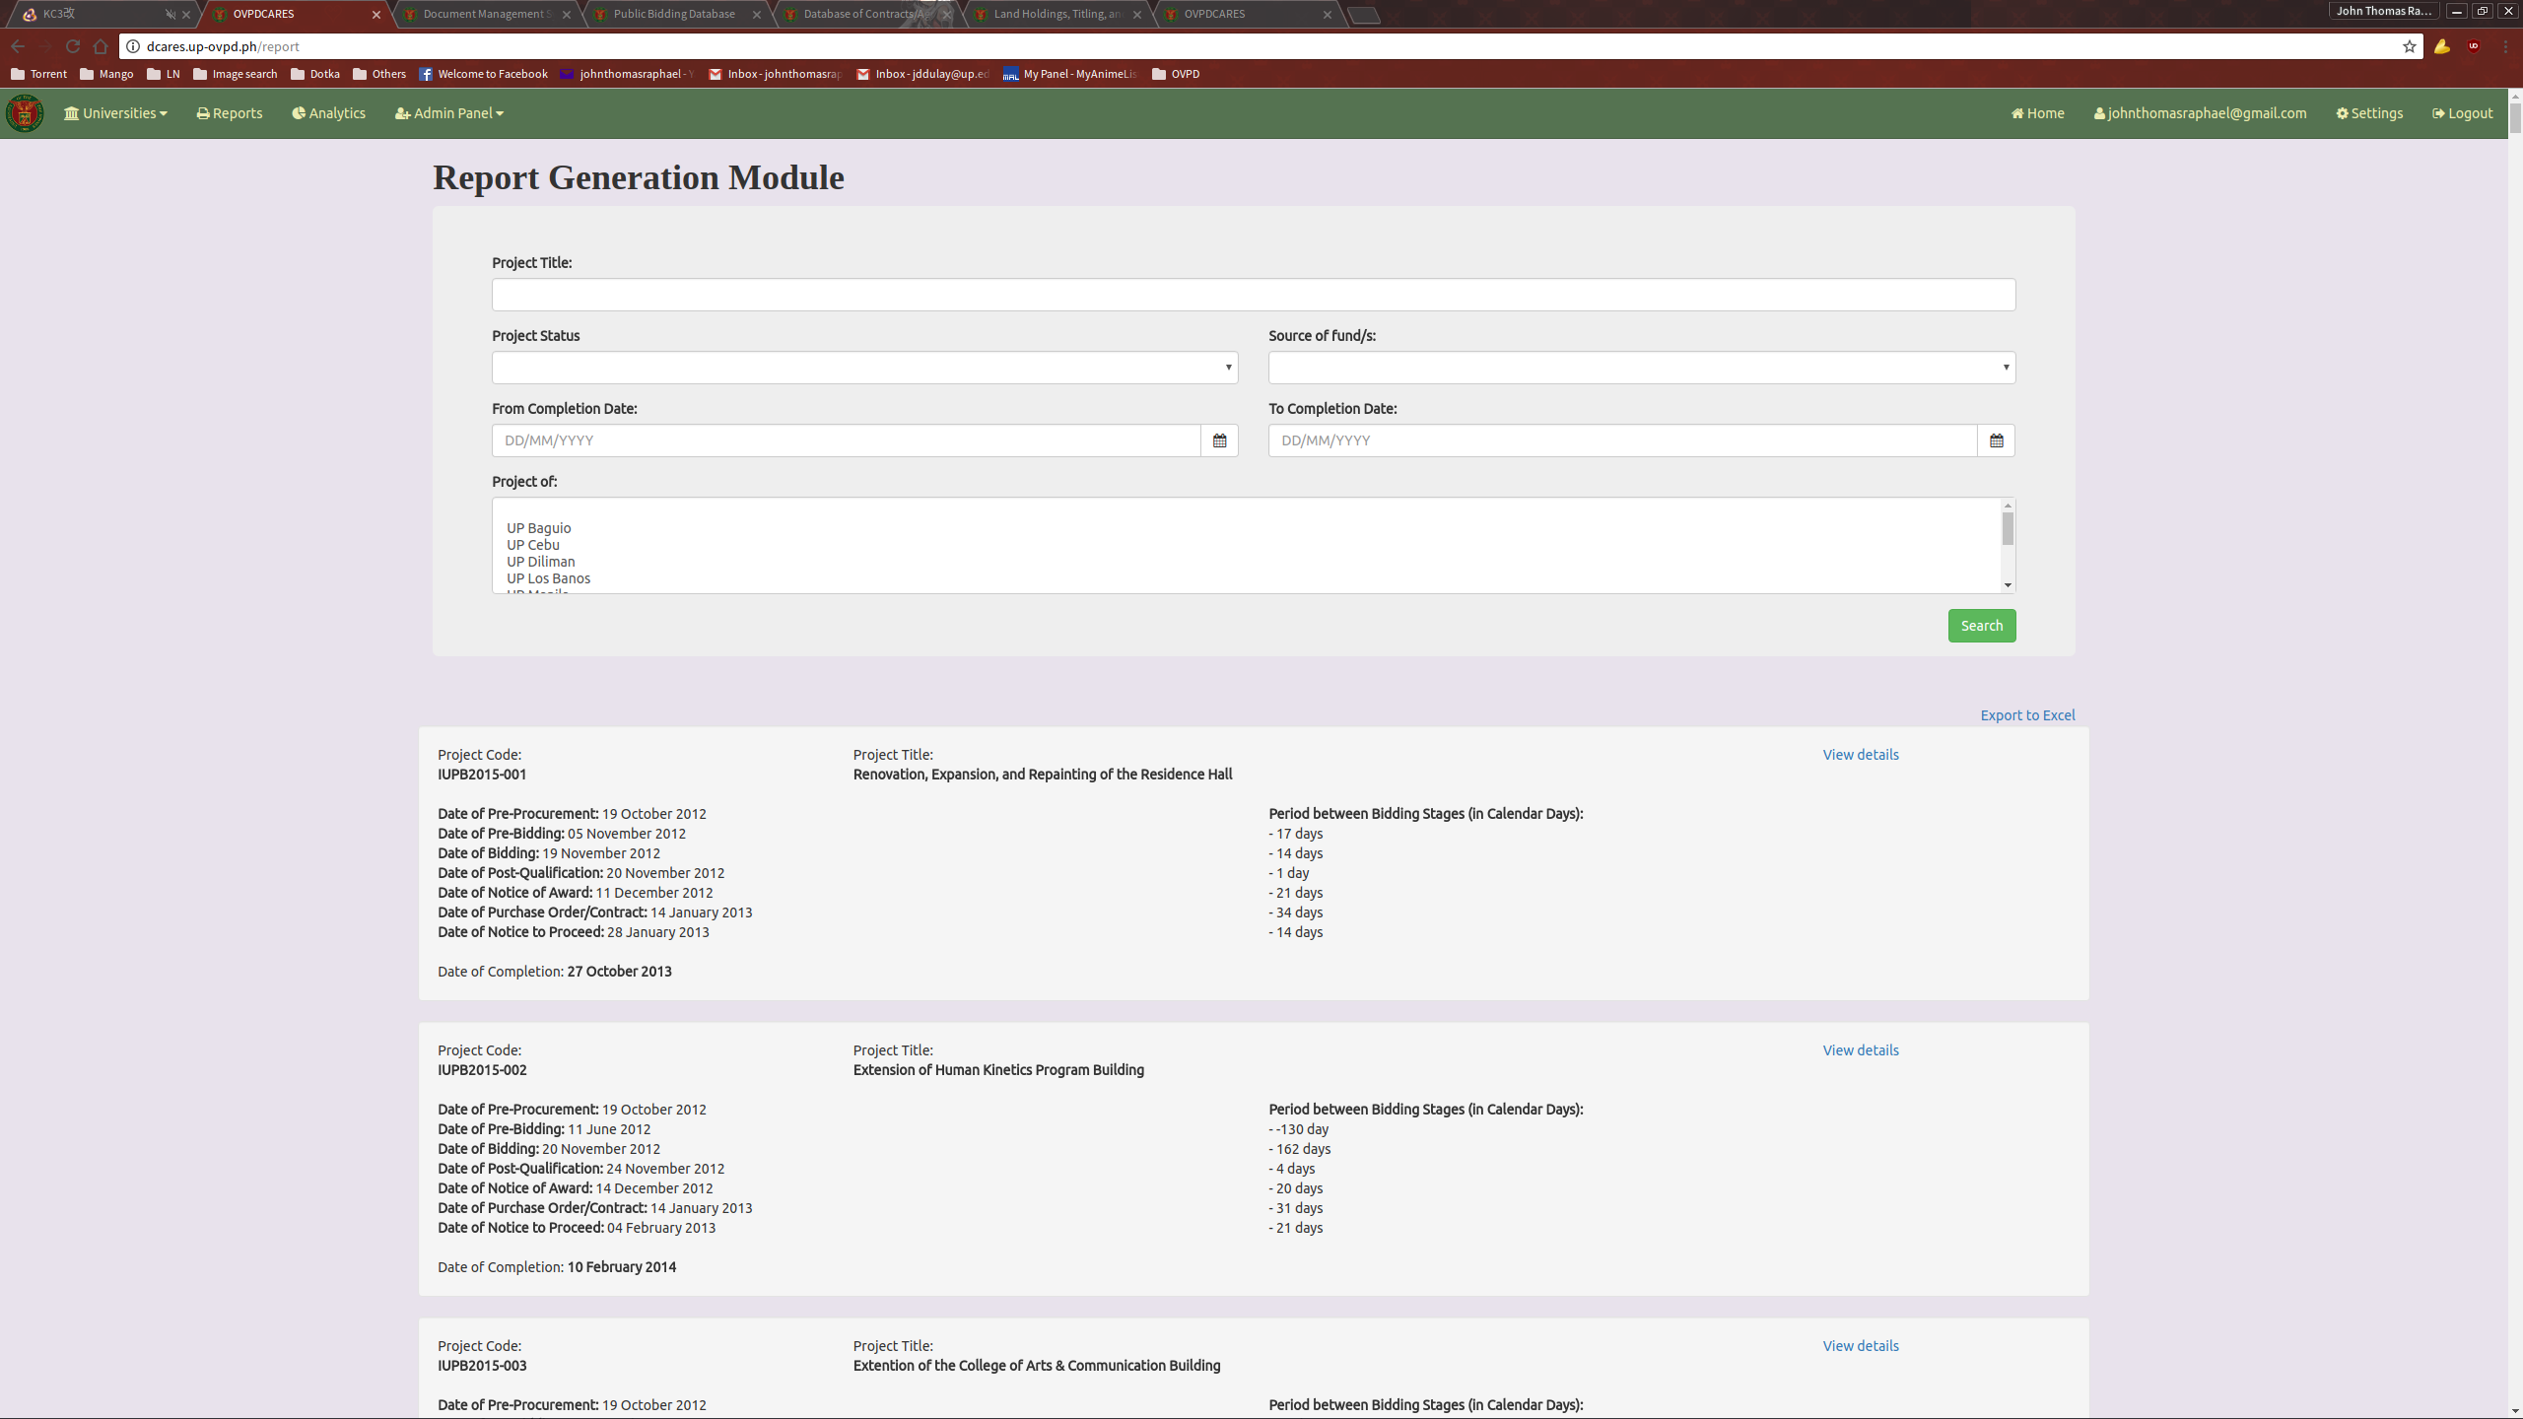
To use the module, simply use the form provided to filter the list to the desired values. The output can also be exported to an Excel file using the “Export to Excel” link found on the top right of the results list.

GENERATING ANALYTICS

To generate analytics, follow the “Analytics” link provided in the navigation bar. This will lead you to the Analytics module.
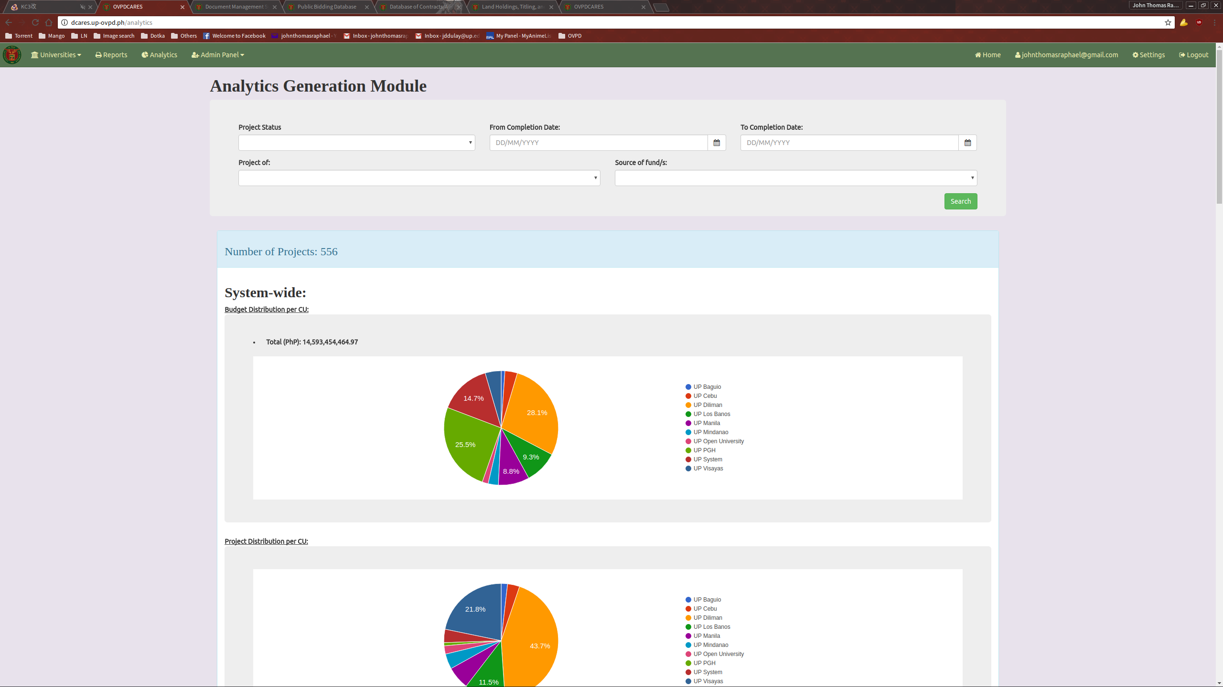
As with the Reports module, simply filter out the projects using the provided form. After submitting, the module will generate analytical graphs from the selection provided.
ADMINISTRATION PANEL

The administration panel can be accessed on the top left of the navigation bar. Note that this option is invisible and unaccessible to non-admin users.
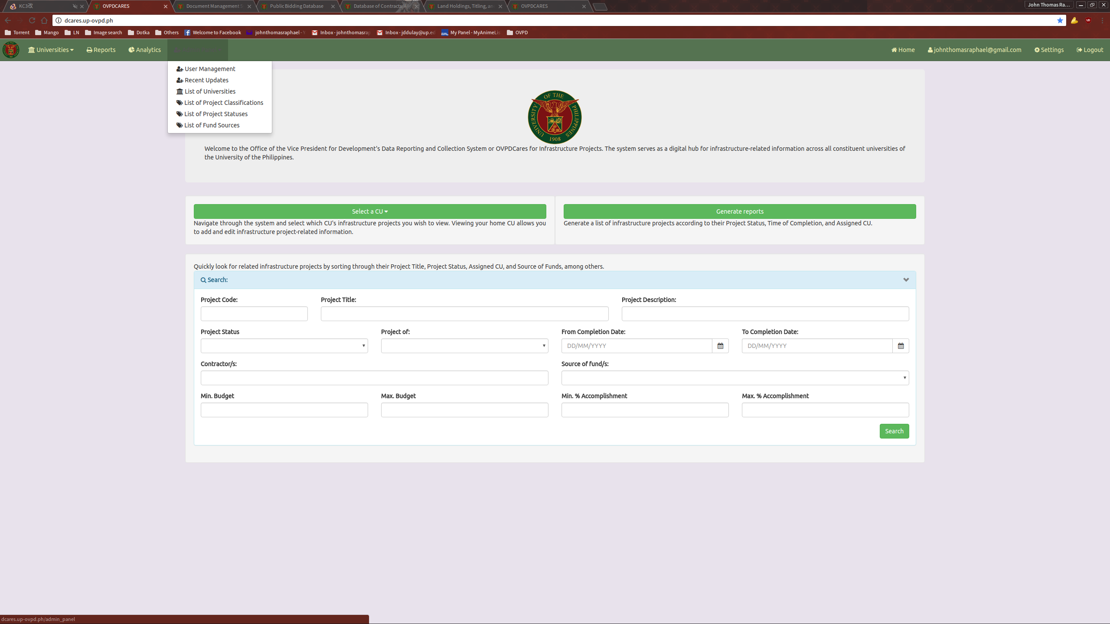
From here the admin user can select the User Management module, view Recent Updates, or view and modify the various lists used on the forms for creating and updating project entries.

USER MANAGEMENT

Using the User Management page, the admin user can view, create, edit, and delete users.
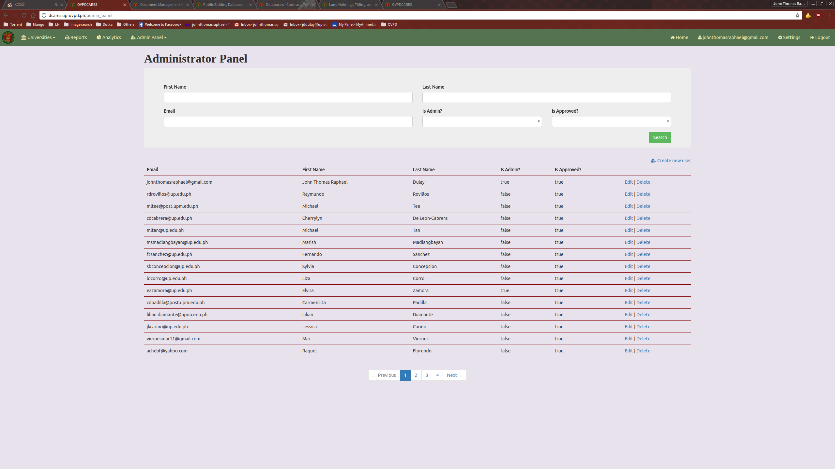

ADDING A NEW USER

To add a new user, click the “Create new user” link on the top right of the user list.
This will direct you to the New User page.
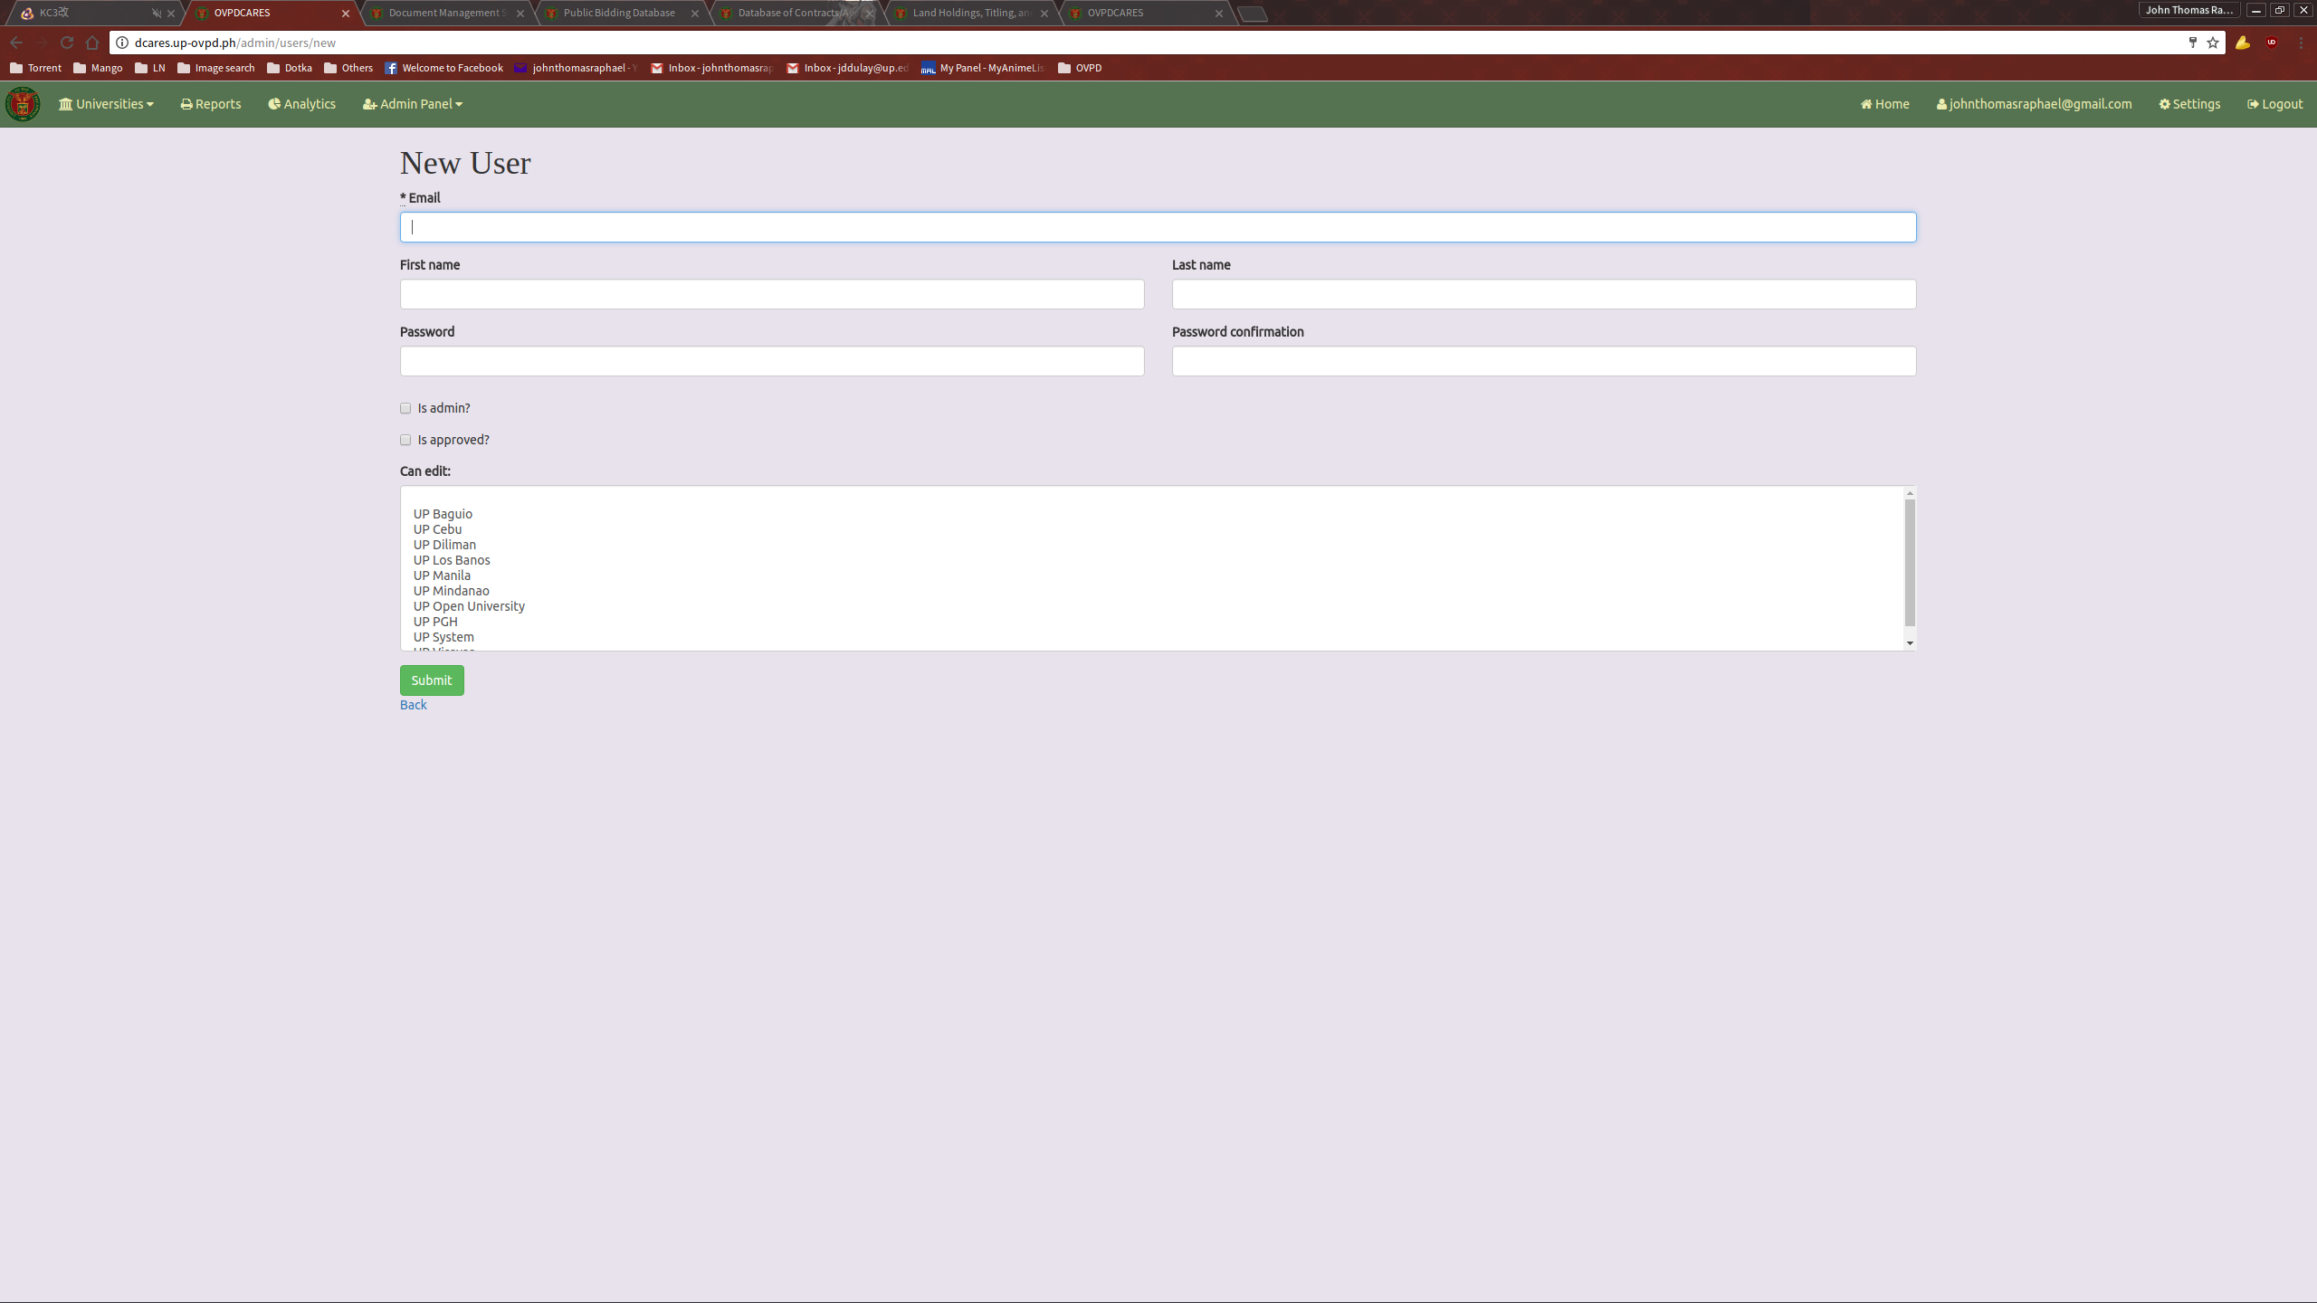
Fill it up with the necessary option and submit.
EDITING A USER

To edit a user, click the Edit link provided in the User List.
This will direct you to the Edit User page.
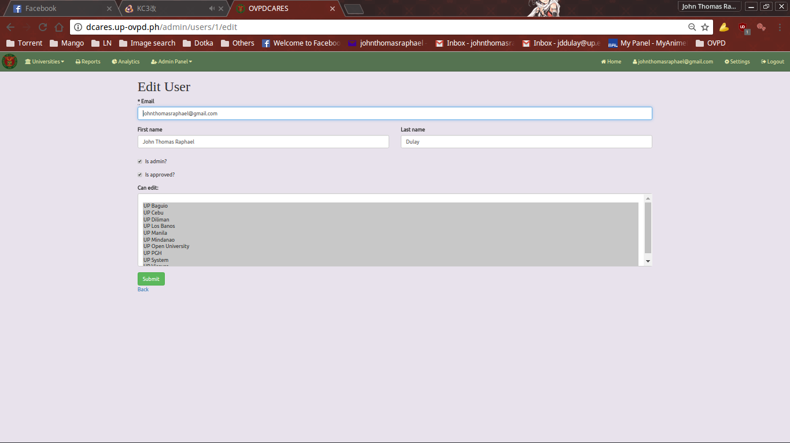
Fill it up with the updated information and submit.
VIEWING RECENT UPDATES

To view recent changes to the project entries, follow the “Recent updates” link under the administration panel dropdown. Here, the admin user can see whether projects have been added, updated, or deleted by a user as well as a timestamp for when the event took place.

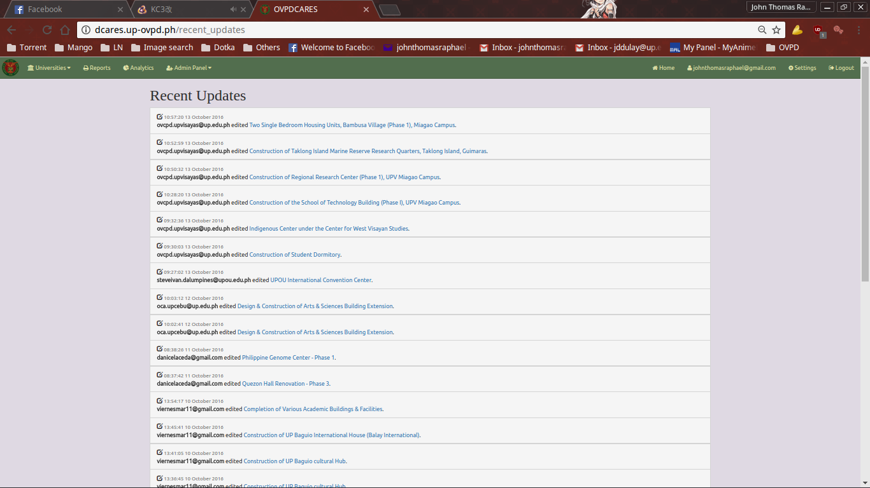

LISTS

Note: The lists under the Admin Panel function virtually in the exact way. For the sake of brevity, we will only look at the List of Project Statuses. The operations and processes done here can be applied to the other lists.

The List of Project Statuses contains the values that are used during the creation or update of Project entries. To access the list, click the List of Project Statuses link located under the Admin Panel dropdown on the navigation bar.

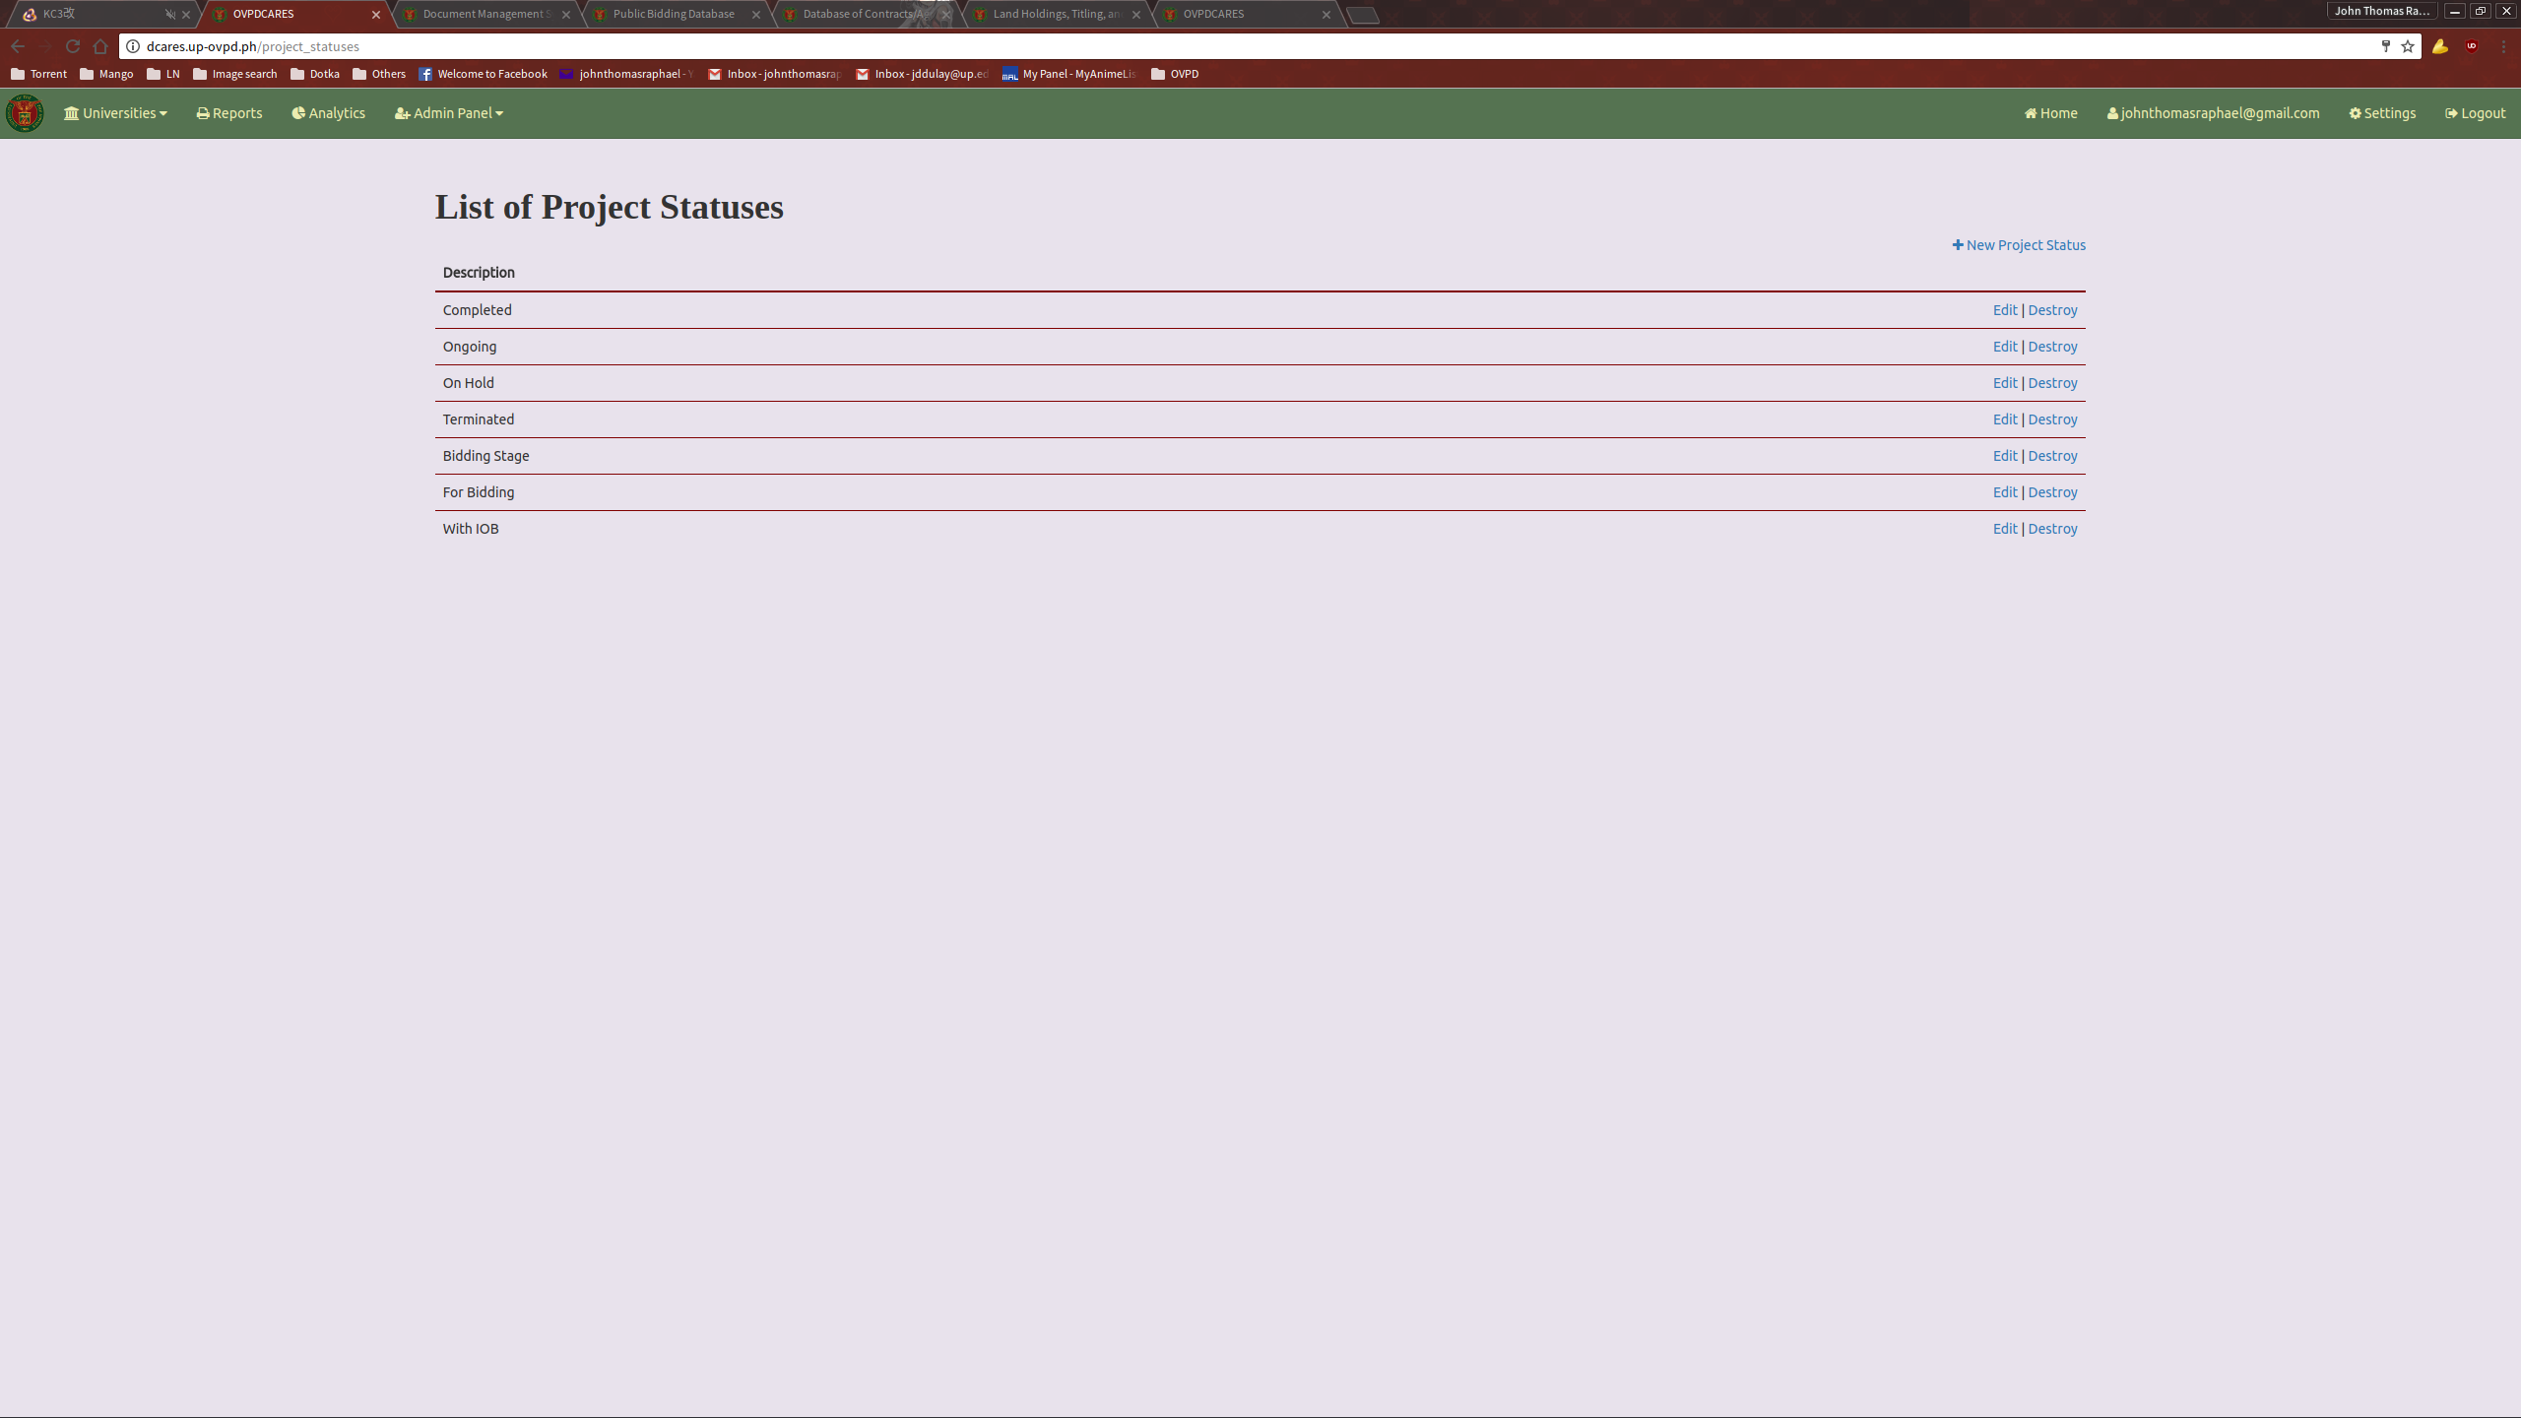

ADDING A NEW PROJECT STATUS

To add a new Project Status, click the New Project Status link located on the top right of the Project Status list.
This will direct you to the New Project Status page.
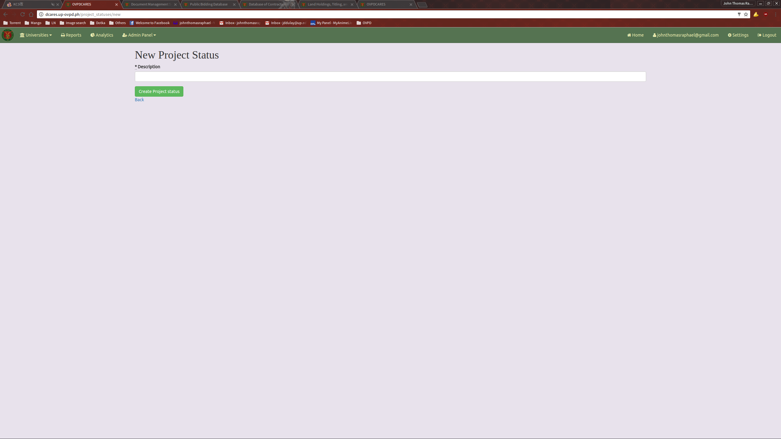
Fill it up with the necessary information and submit.
EDITING A PROJECT STATUS

To edit a Project Status, click the Edit link provided in the Project Status list.
This will direct you to the Edit Project Status page.
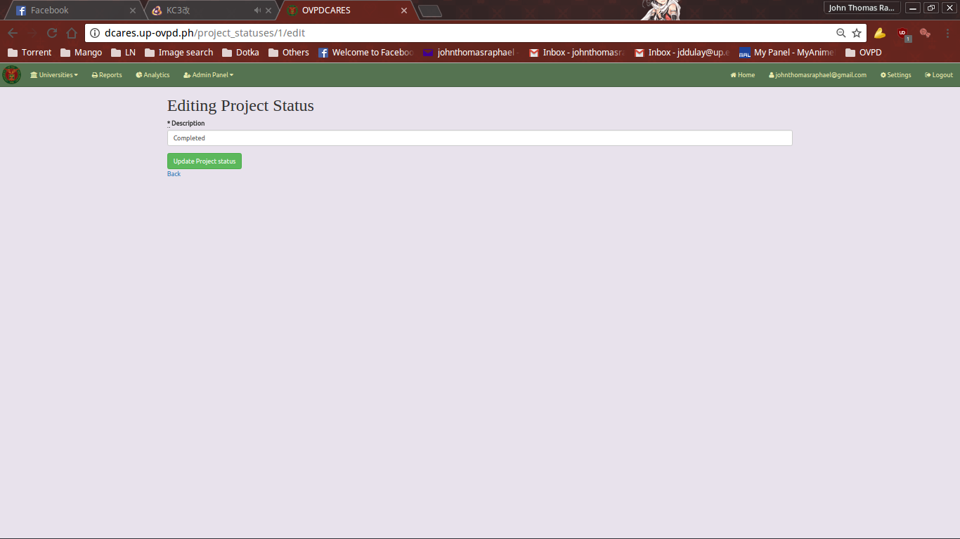
Fill it up with the necessary information and submit.

DCARESV2
USERS MANUAL
ANDROID APPLICATION

INTRODUCTION

The OVPDCARES is a readonly android application that enables the users to keep track of the various details and dates concerning the numerous ongoing bids in the University of the Philippines using their Android phones.

MAIN FEATURES

- Infrastructure Project listing
GETTING STARTED

Open the OVPDCARES application installed on your phone. This will lead you to a login page.

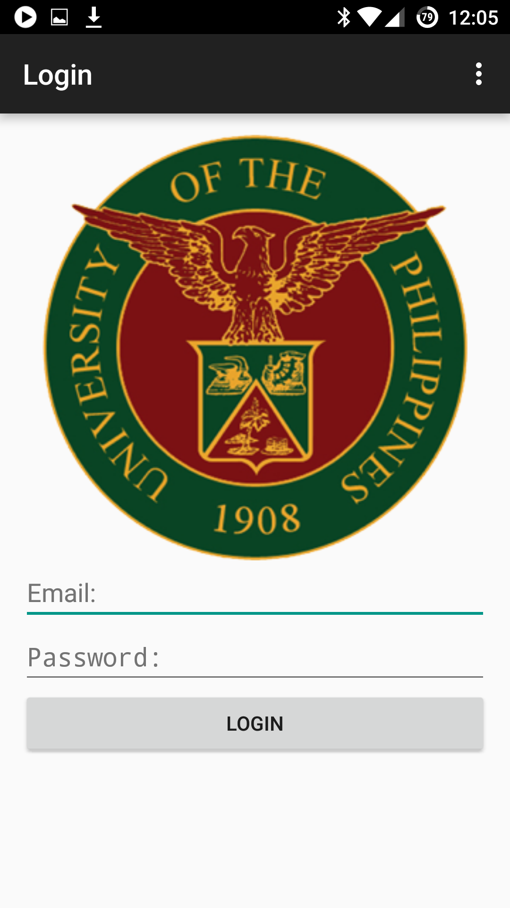

Enter your access credentials to login.
UNIVERSITY LIST

Upon a successful login, you will you the list of universities that are saved on the system. Select a university to view the Infrastructure Projects that it manages.

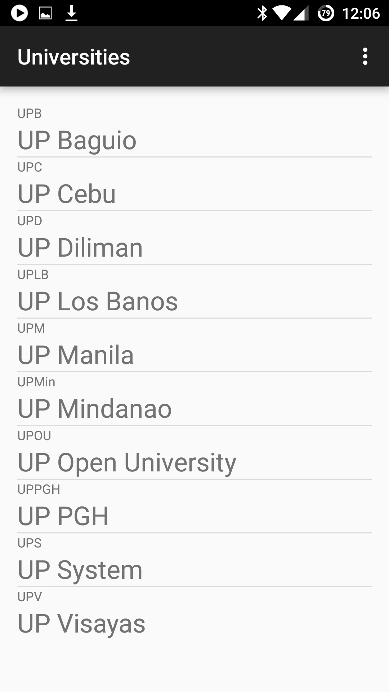
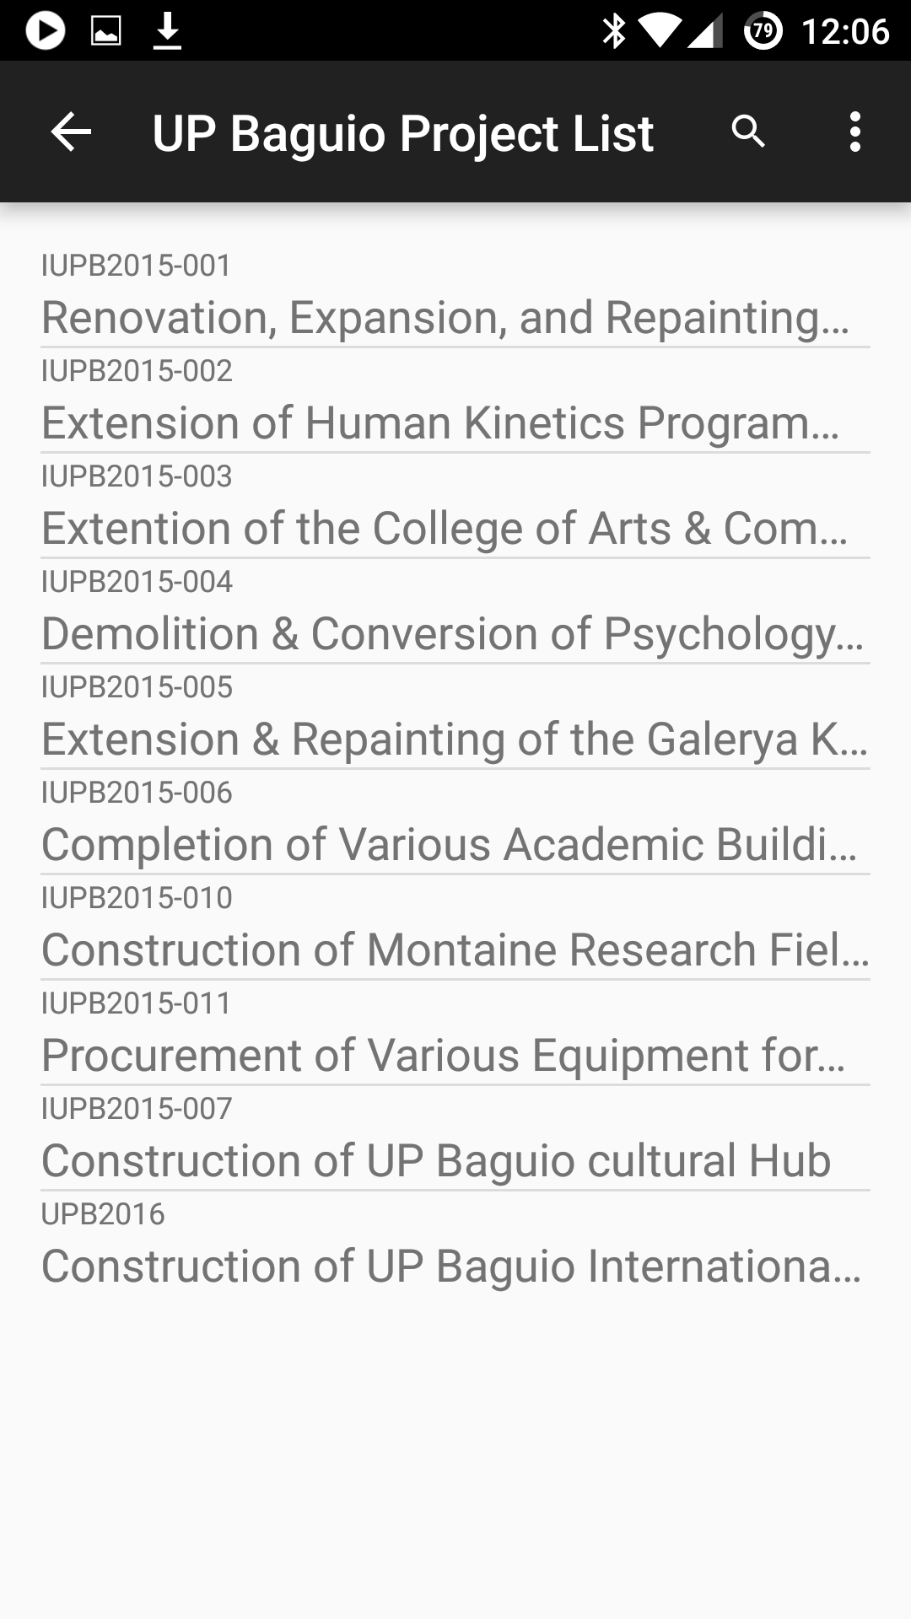
VIEWING A PROJECT ENTRY

To view a Project entry, click on the project entry located in the Project List. This will open the page that contains the details of the selected Project entry.

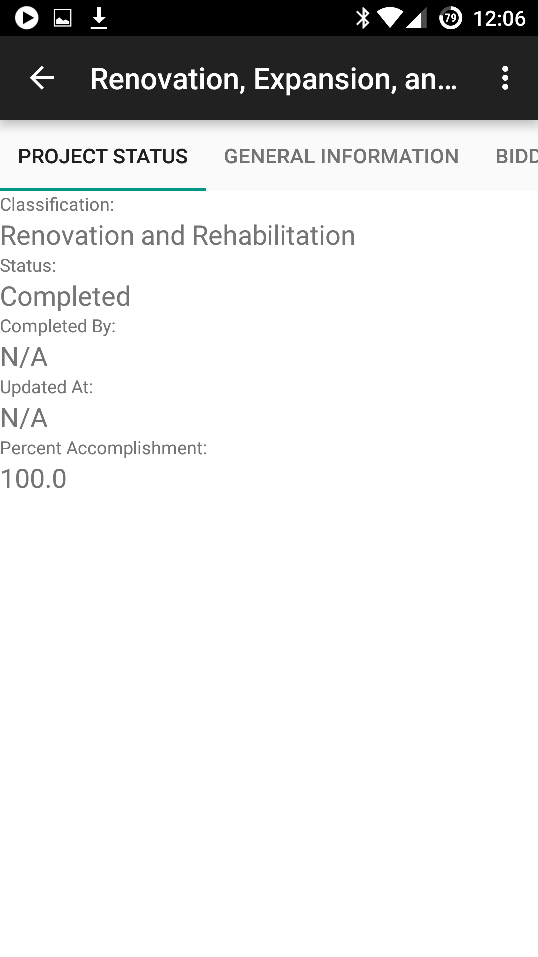
Use the tabs to navigate to the different sections available.



