DOCUDB
USERS GUIDE
WEB APPLICATION

INTRODUCTION

The DocuDB is a web application that enables the users to keep track of the various files and document used by the University of the Philippines Office of the Vice President for Development.

MAIN FEATURES

- Dashboard
- Export to Excel
- Document archives
- Administration Panel
  - User Management
  - List of Offices

GETTING STARTED

Access the website through the URL dms.up-ovpd.ph where you will be greeted with a login screen.
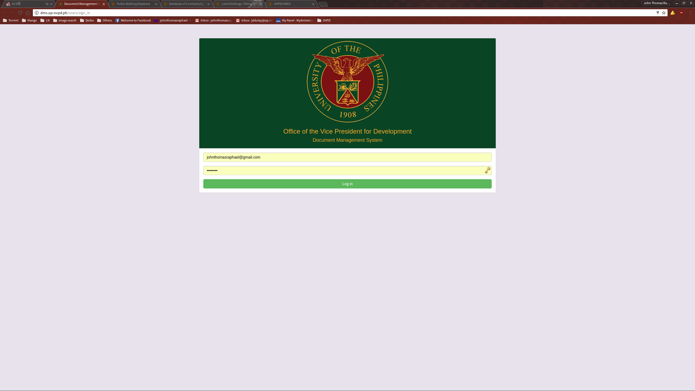
Input your access credentials to get to the dashboard.

DASHBOARD
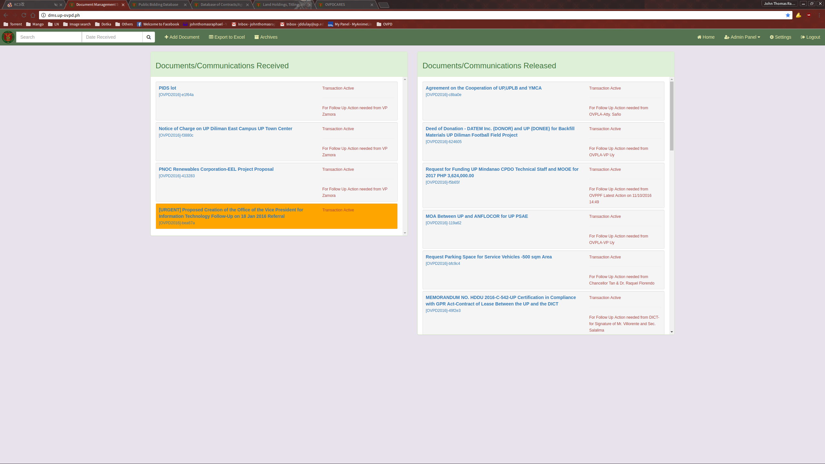
Upon a successful login, the user will be greeted with the dashboard. Most of the available functions can be access through here. Note that administration functions cannot be seen and used by non-admin users. The list can be filtered with the Search funtion accessible from the top left of the navigation bar.

ADDING A NEW DOCUMENT

To add a new bid entry, click the link “Add Document” located on the top left of the navigation bar. This will take you to the “New Document” page where you can input the needed information.

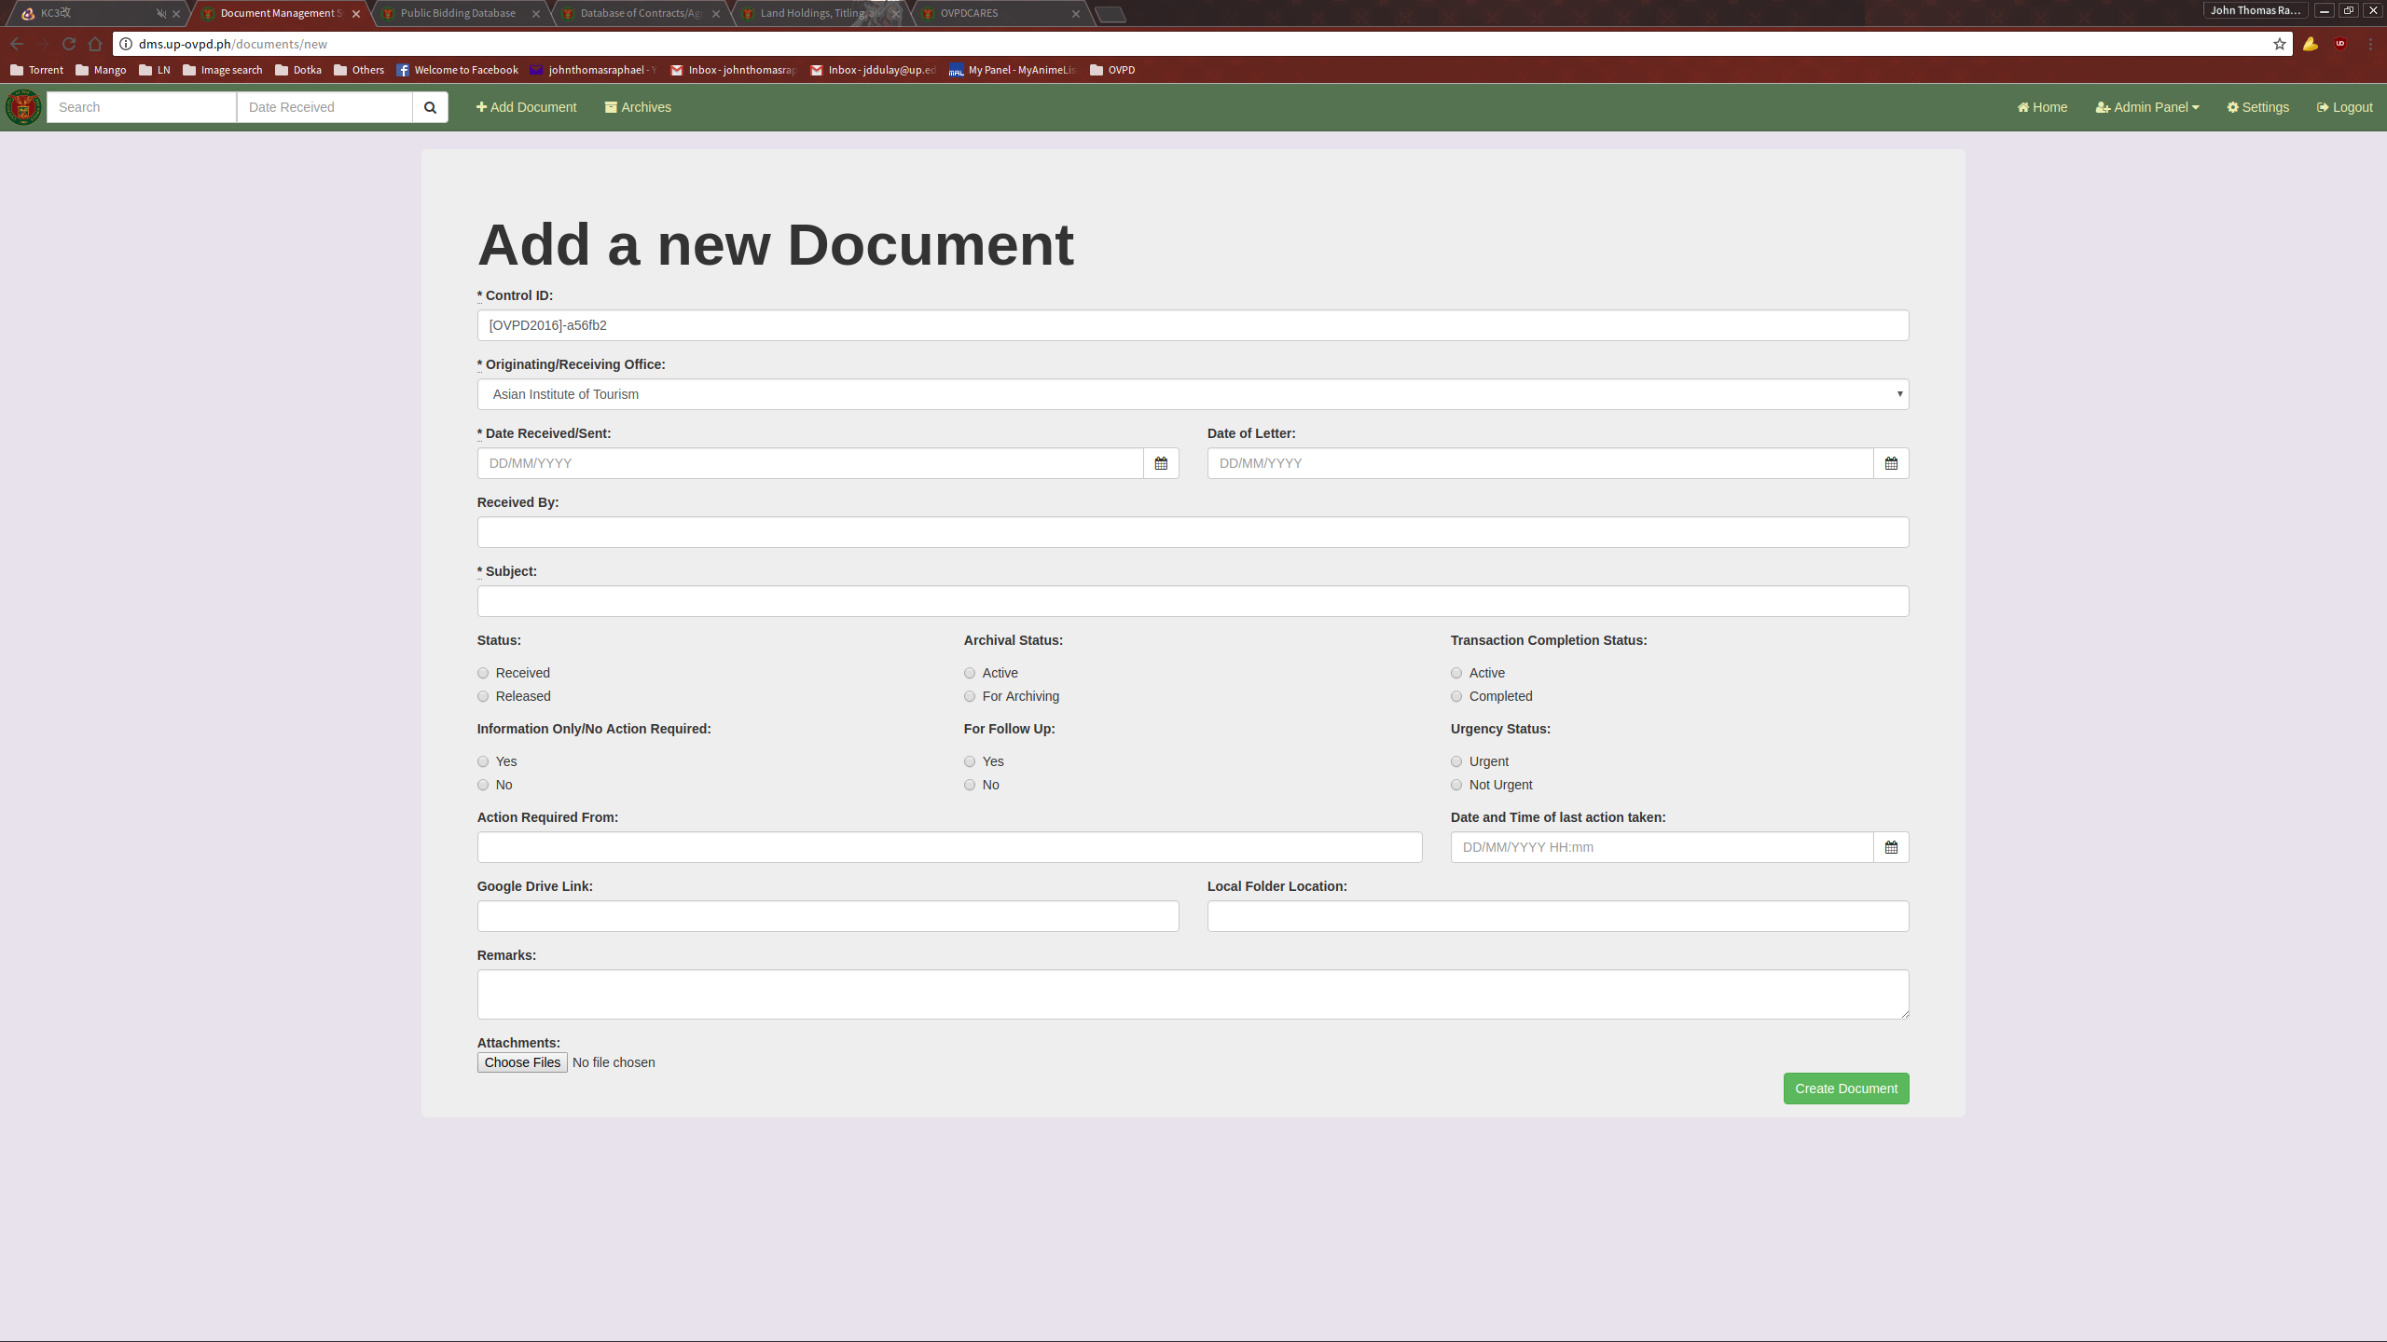
Once all relevant information has been filled up, click the “Create Document” button to submit the data to created.

VIEW A DOCUMENT ENTRY

From the dashboard, you can click on one of the entries on the list to show a modal that contains its details. From here, the user can choose to edit or delete the chosen entry.
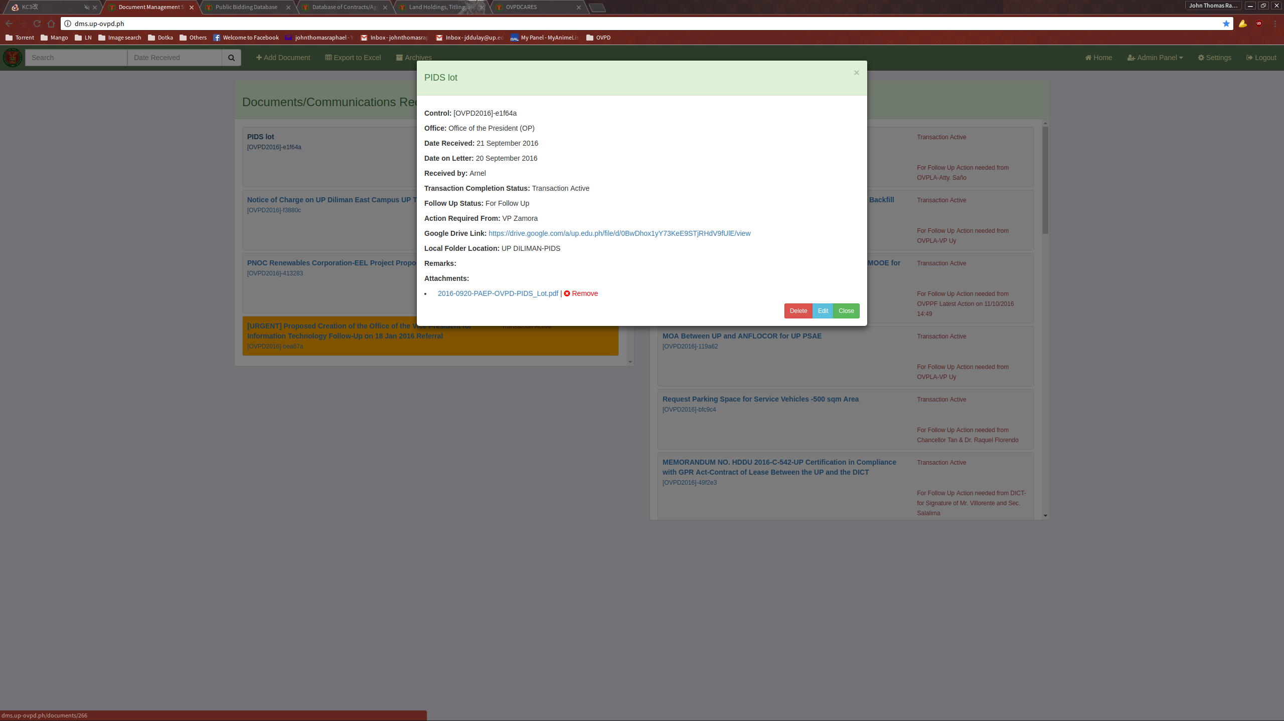

EDITING A DOCUMENT ENTRY

To edit a Document entry, click the Edit button found on the bottom of the View Document modal. This will direct you to the Edit Document Page.
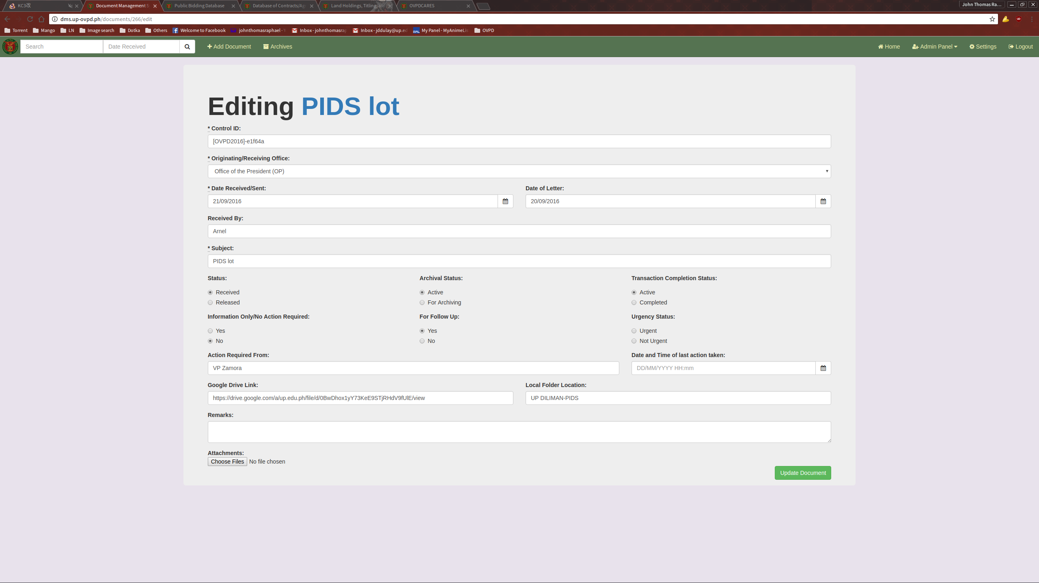
Update the necessary fields and click the “Update document” button when done to submit.

EXPORT TO EXCEL

To use the Export to Excel module, click the “Export to Excel” link located on the top left of the navigation bar. This will prompt a download of the entries in Excel format.
ARCHIVES
To access the archives, click the “Archives” link on the navigation bar. This will bring you to the Archives page.

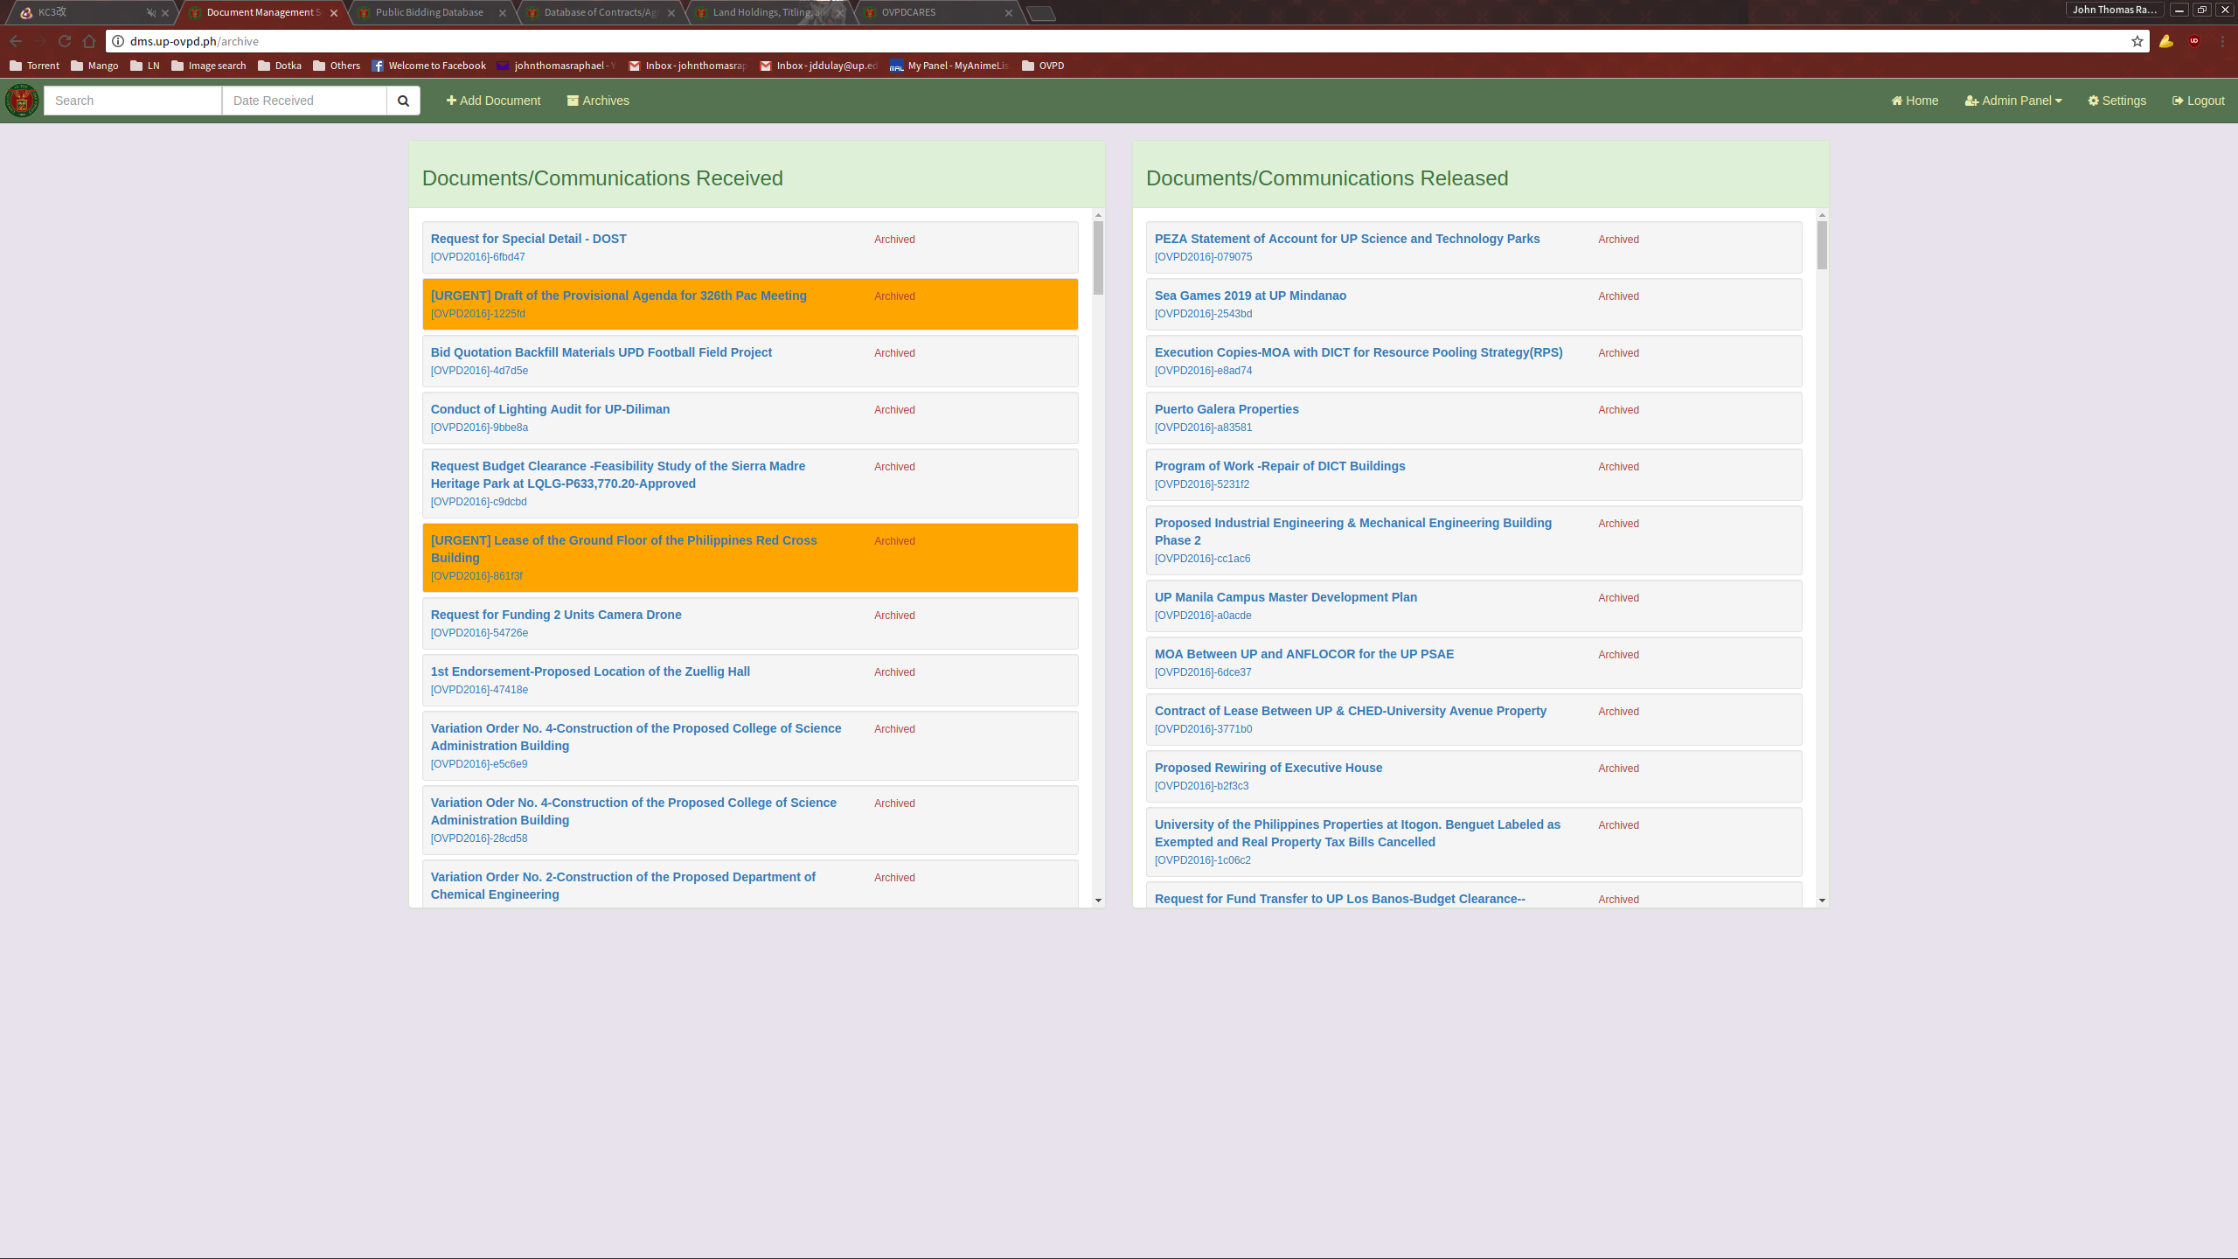
The Archives page functions exactly like the dashboard, with the exception that only documents tagged as archived are displayed here. Likewise, the dashboard only displays documents that are tagged as active.

ADMINISTRATION PANEL

The administration panel can be accessed on the top right of the navigation bar. Note that this option is invisible and unaccessible to non-admin users.
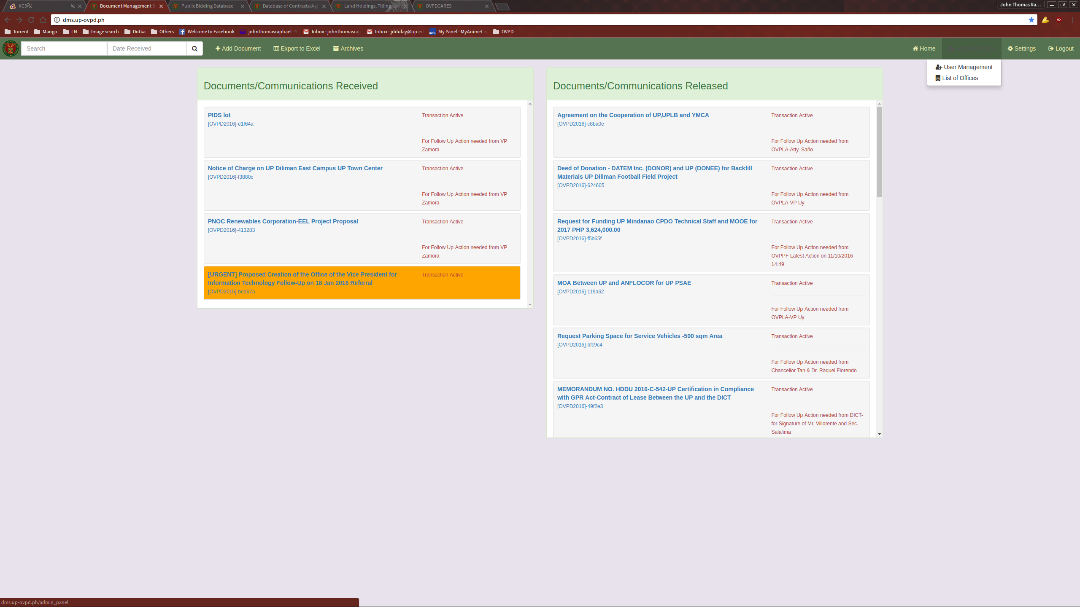
From here the admin user can select the User Management module or add another entry for Offices.

USER MANAGEMENT

Using the User Management page, the admin user can view, create, edit, and delete users.
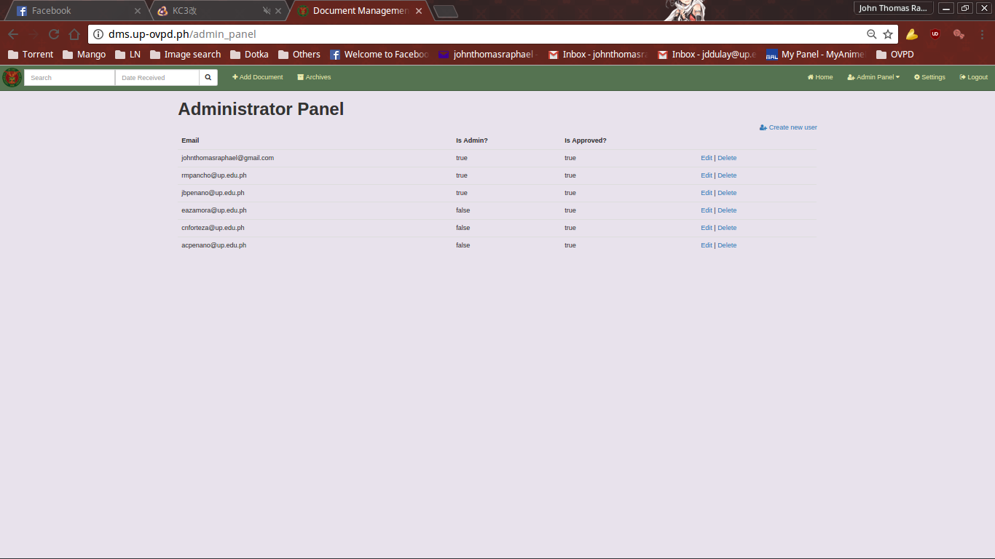

ADDING A NEW USER

To add a new user, click the “Create new user” link on the top right of the user list.
This will direct you to the New User page.
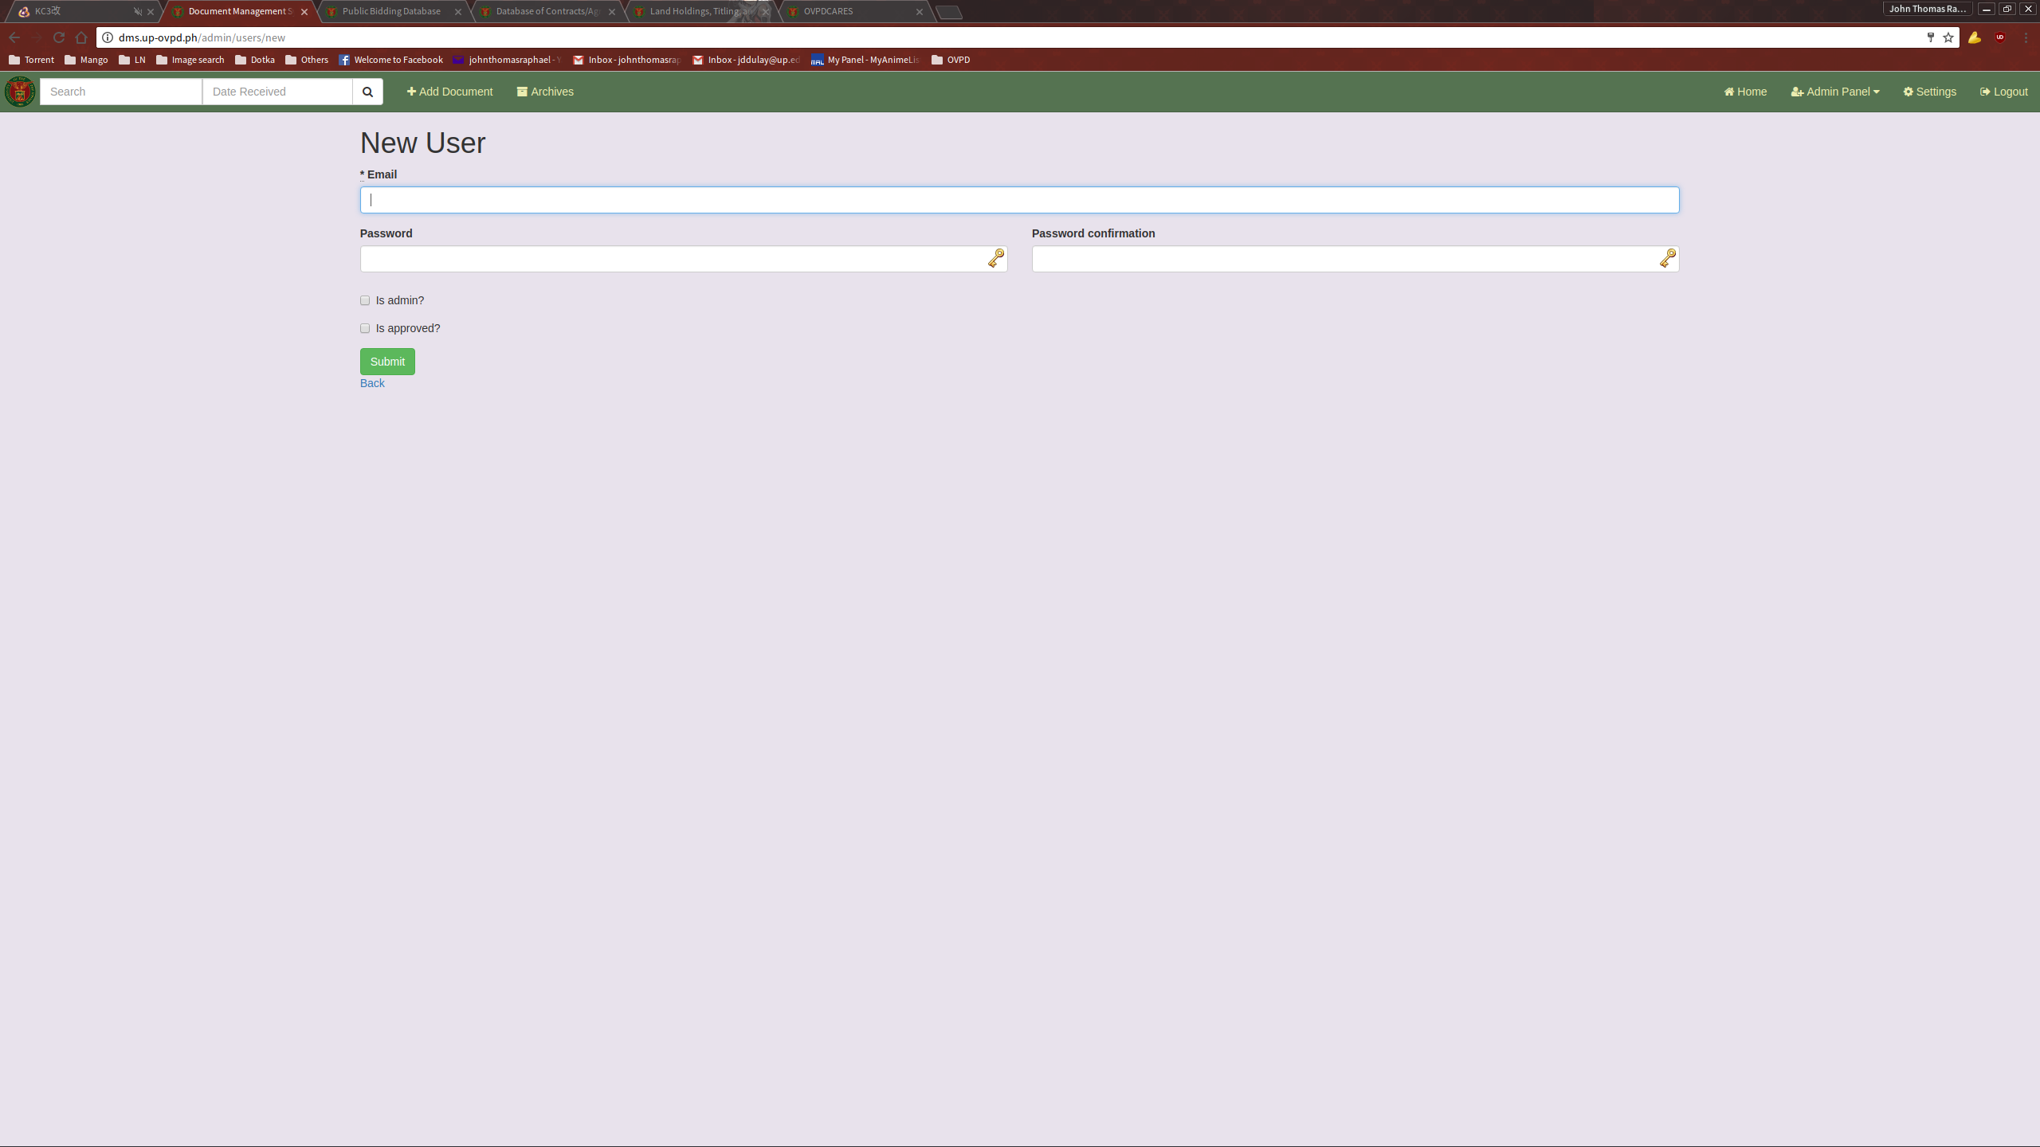
Fill it up with the necessary information and submit.

EDITING A USER

To edit a User, click the Edit link located in the Users List.
This will direct you to the Edit User page.
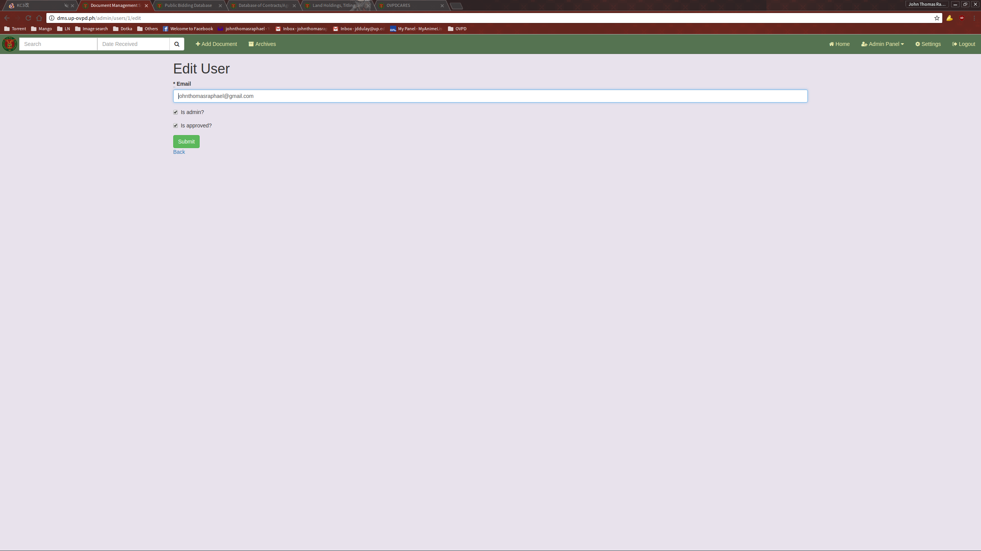
Fill it up with the necessary information and submit.
LIST OF OFFICES

With the List of Offices module, you can view, add, edit, and delete the list of Offices that is used in the forms when creating or editing a document entry.
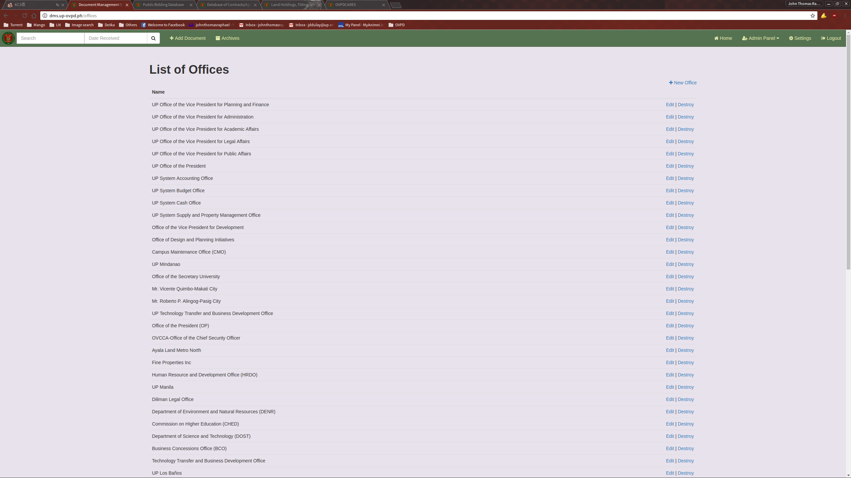

ADDING A NEW OFFICE

To add a new Office, click the “New Office” link on the top right of the Offices list.
This will direct you to the New Office page.
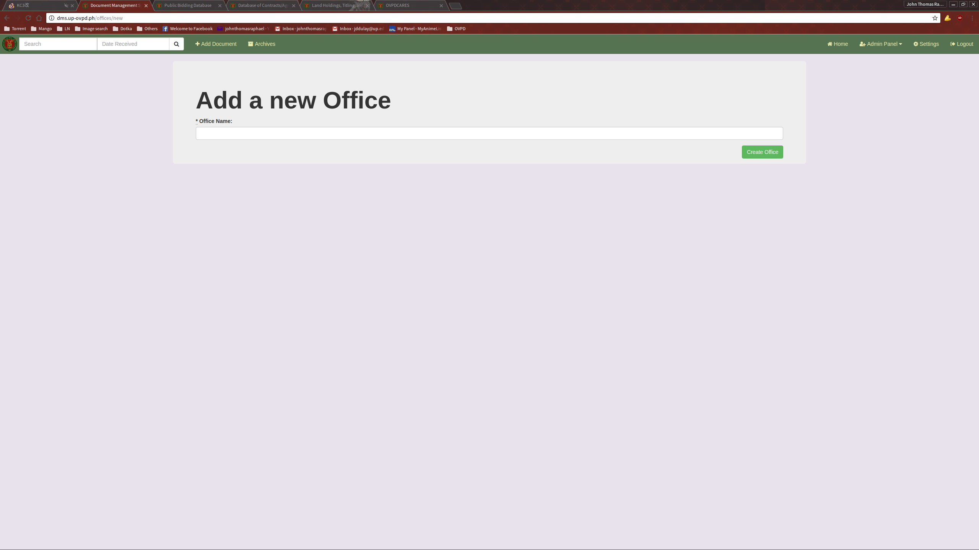
Fill it up the necessary information and submit.
EDITING AN OFFICE

To edit an Office entry, click the Edit link located in the Offices list.
This will direct you to the Edit Office page.
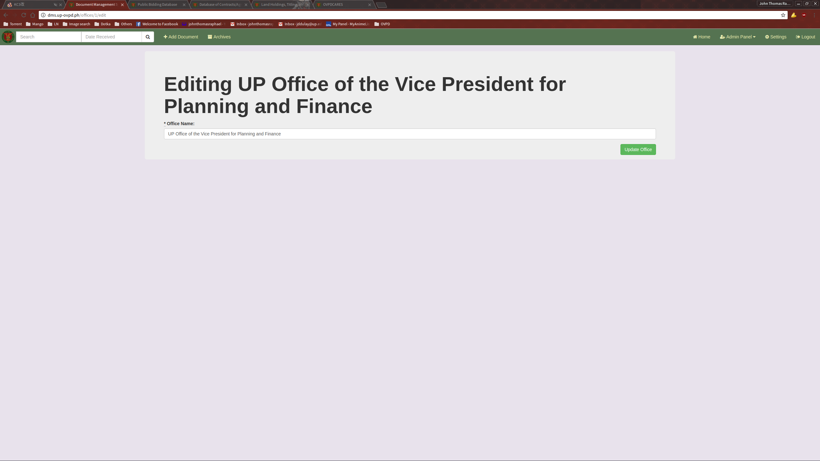
Fill it up with the necessary information and submit.

