IAP2M-CONFERENCE
USERS MANUAL

INTRODUCTION

The IAP2M-Conference is a simple web application for the upcomng IAP2M conference.

GETTING STARTED

Access the website through the URL iap2m-conference.up-ovpd.ph.
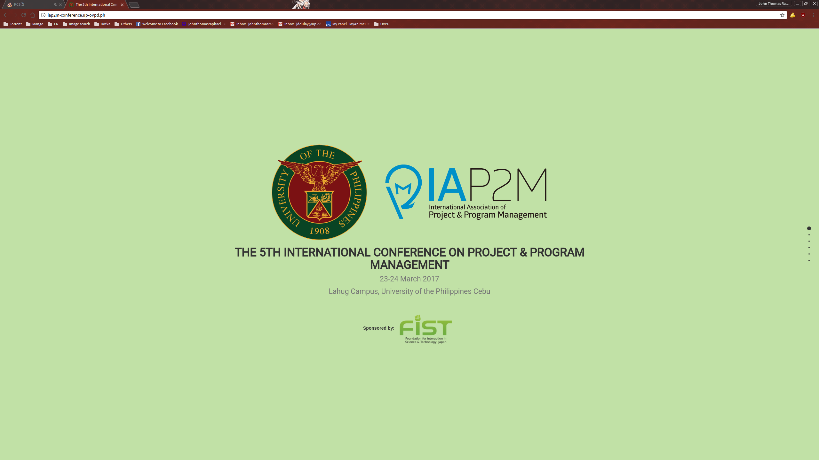
Scroll down using your mouse, or the directional buttons on your keyboard to view the other sections.

