ITDC_ACCOUNTS
USERS MANUAL
WEB APPLICATION

INTRODUCTION

The DCARESV3 is a web application that enables the users to view the various Infrastructure projects held by the University of the Philippines.

MAIN FEATURES

- Dashboard
- University List
- Infrastructure Project per University
  - Project Components
  - Project Images
  - Export to Excel
- Administration Panel
  - Recent Updates
  - List of Project Classifications
  - List of Project Statuses
  - List of Fund Sources
  - List of Bidding Statuses
  - User Management

GETTING STARTED

Access the website through the URL cares.up-ovpd.ph where you will be greeted with a login screen.
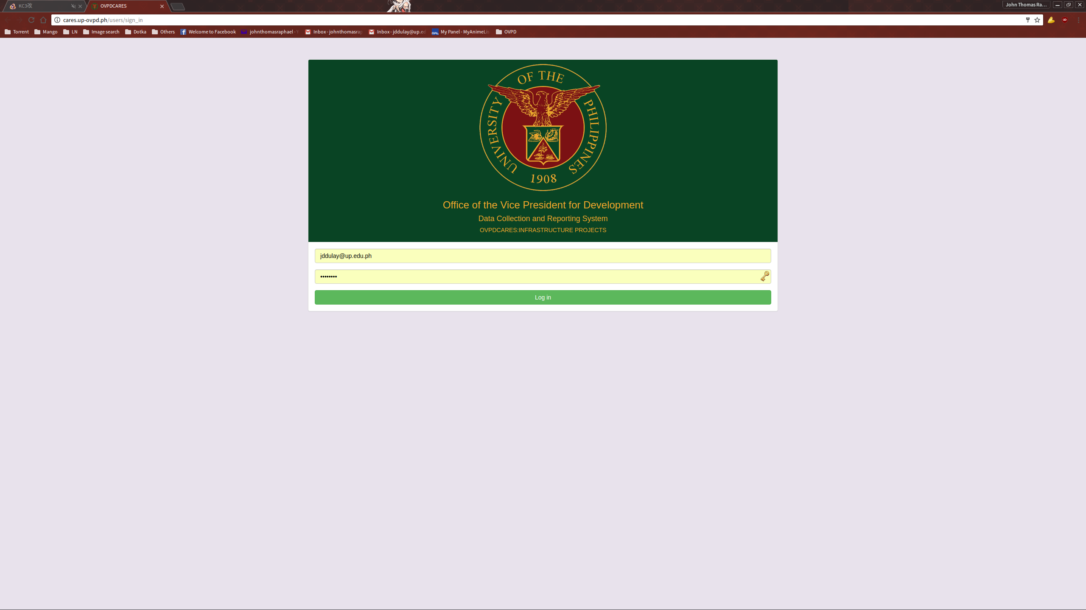
Input your access credentials to get to the dashboard.

DASHBOARD

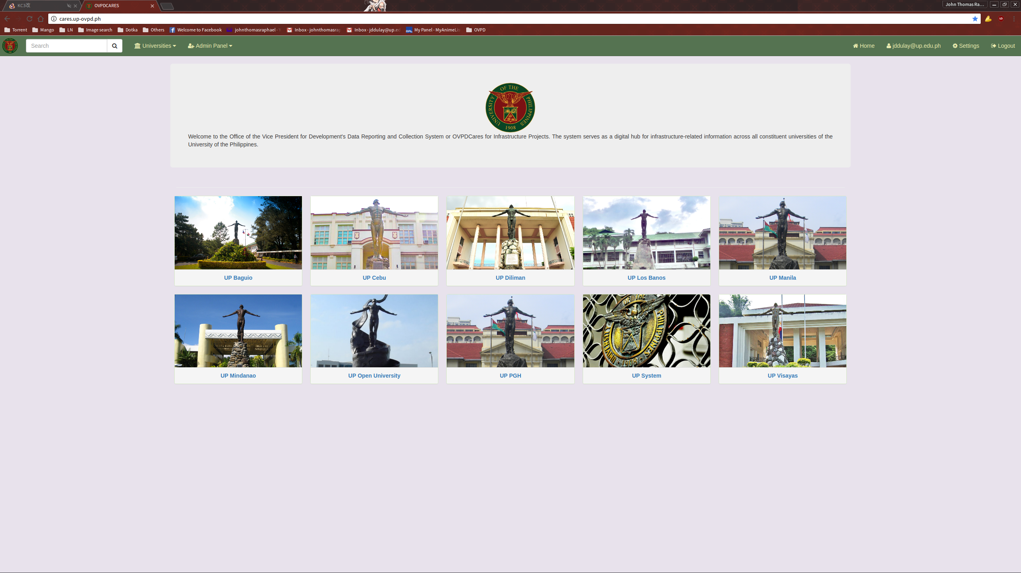
Upon a successful login, the user will be greeted with the dashboard. Most of the available functions can be access through here. Note that administration functions cannot be seen and used by non-admin users. The search function can be accessed on the left side of the navigation bar.

LIST OF UNIVERSITIES

The List of Universities can be accessed either from the dashboard or via dropdown list on the navigation bar.
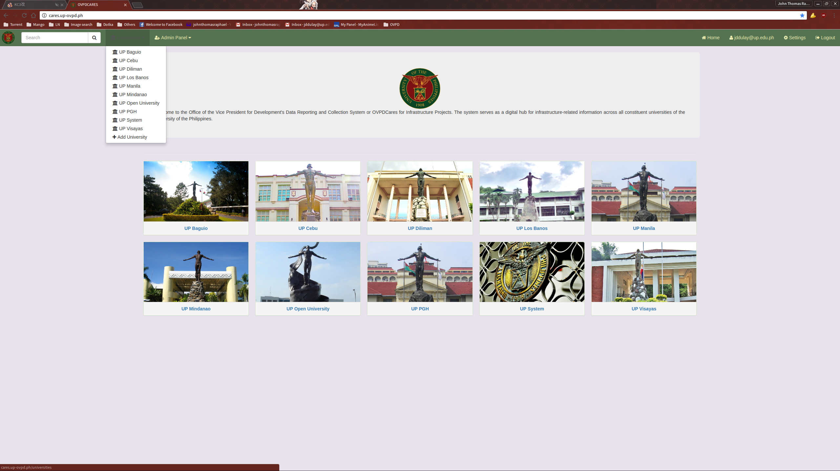

Selecting a university will show you the list of projects the selected university possesses.
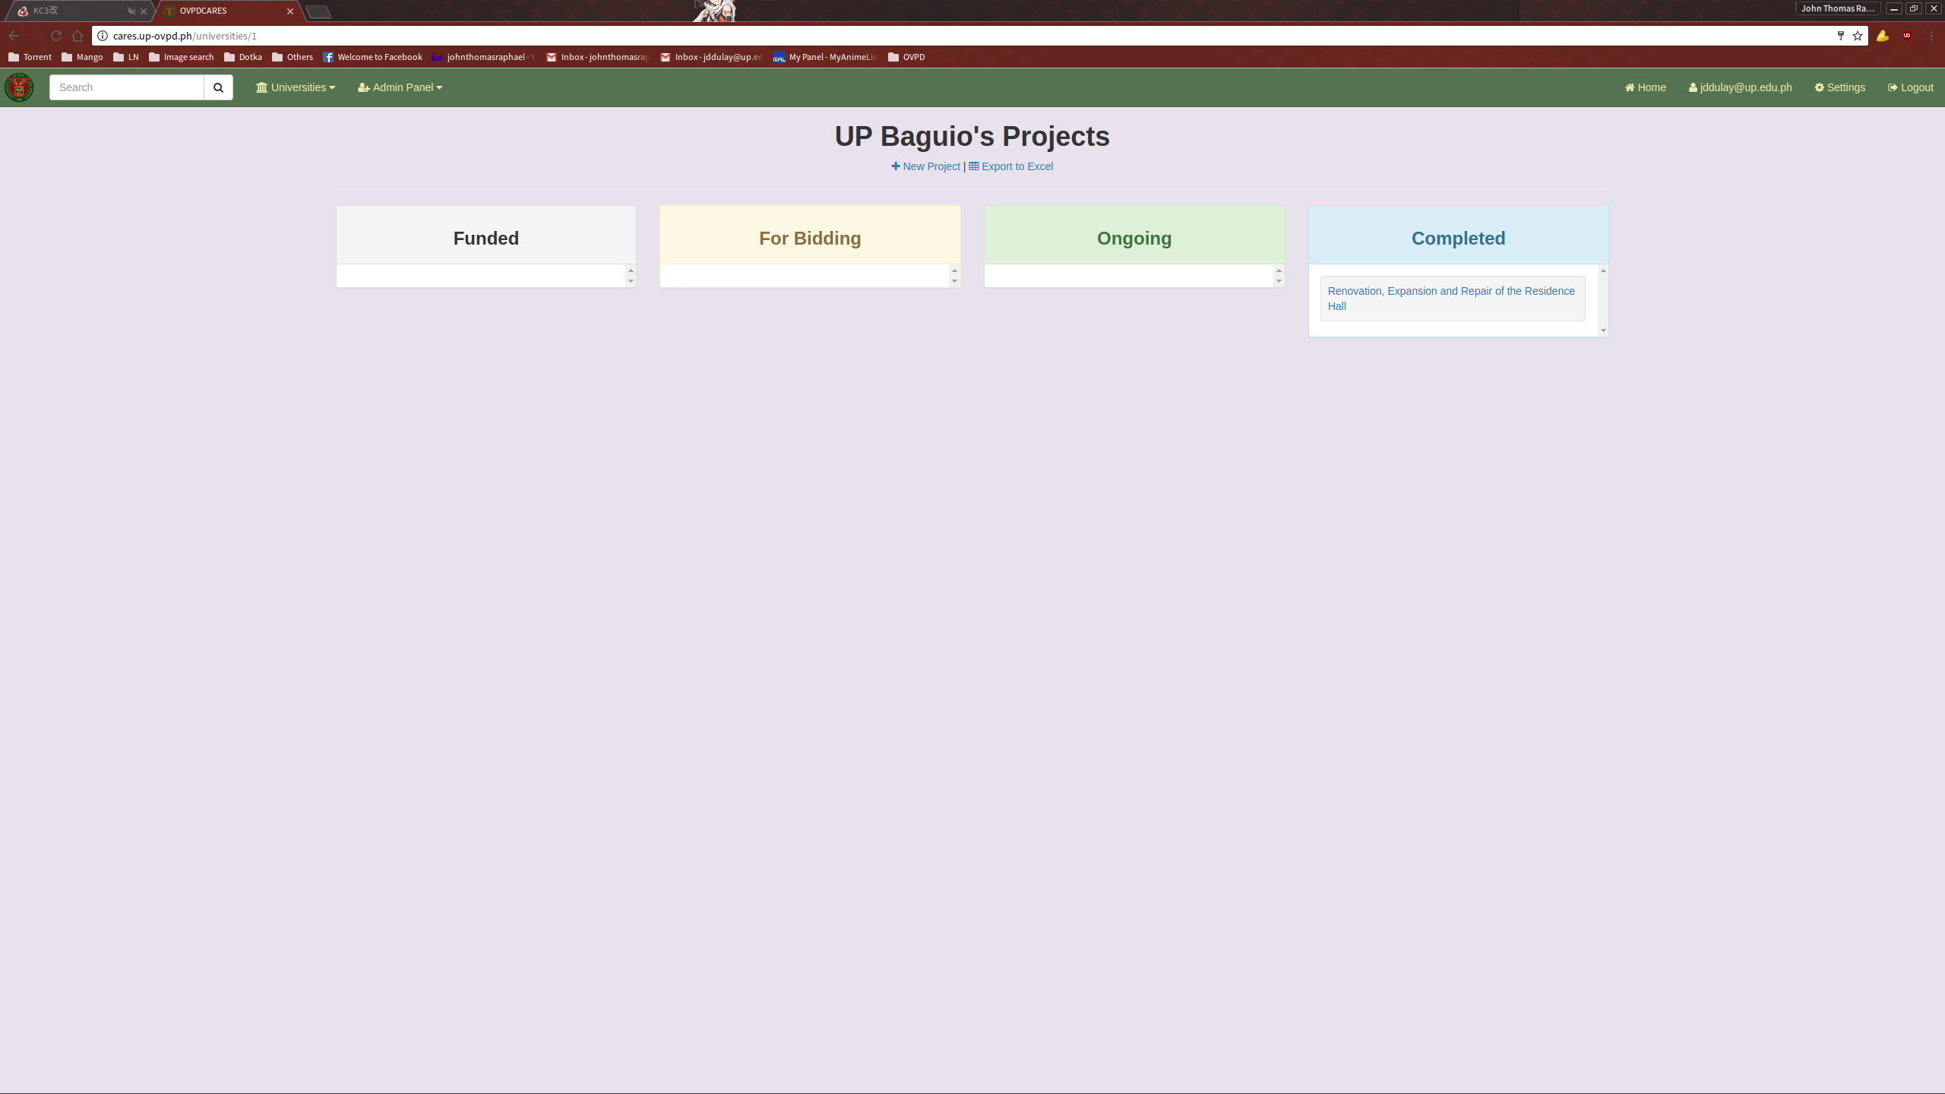
Clicking the “Export to Excel” will prompt a download of the list in Excel format.
ADDING A NEW PROJECT

To add a new title entry, click the link “New Projects” located above the Projects list.
This will take you to the “New Project” page.

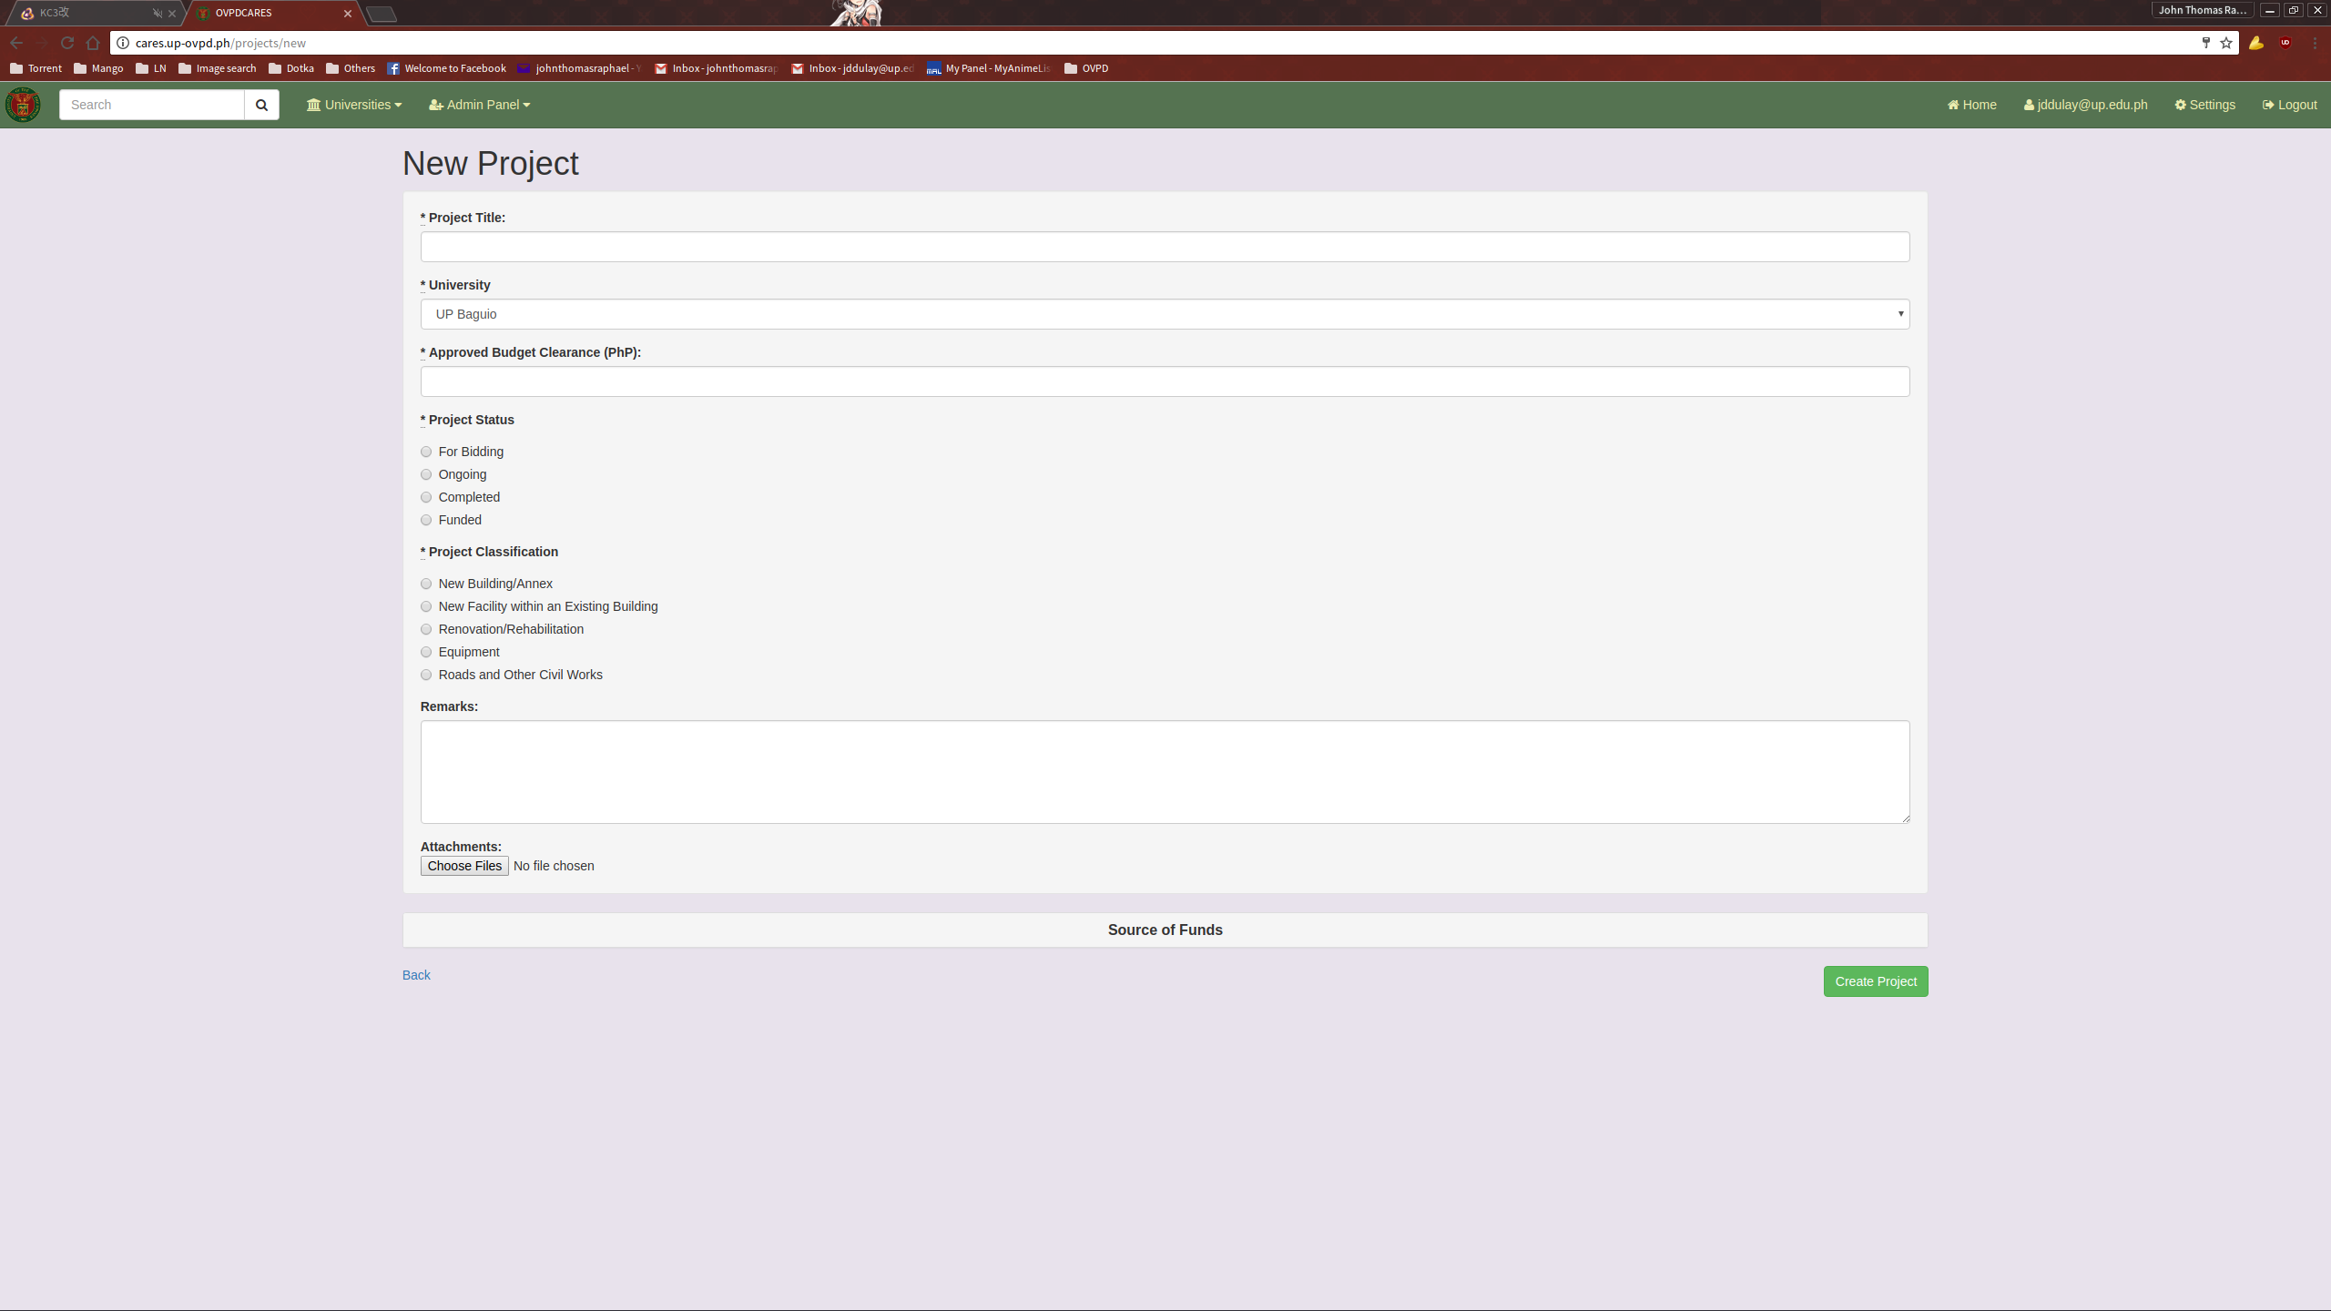
Depending on the Project Status selected, a different set of fields need to be filled up.

For Bidding:
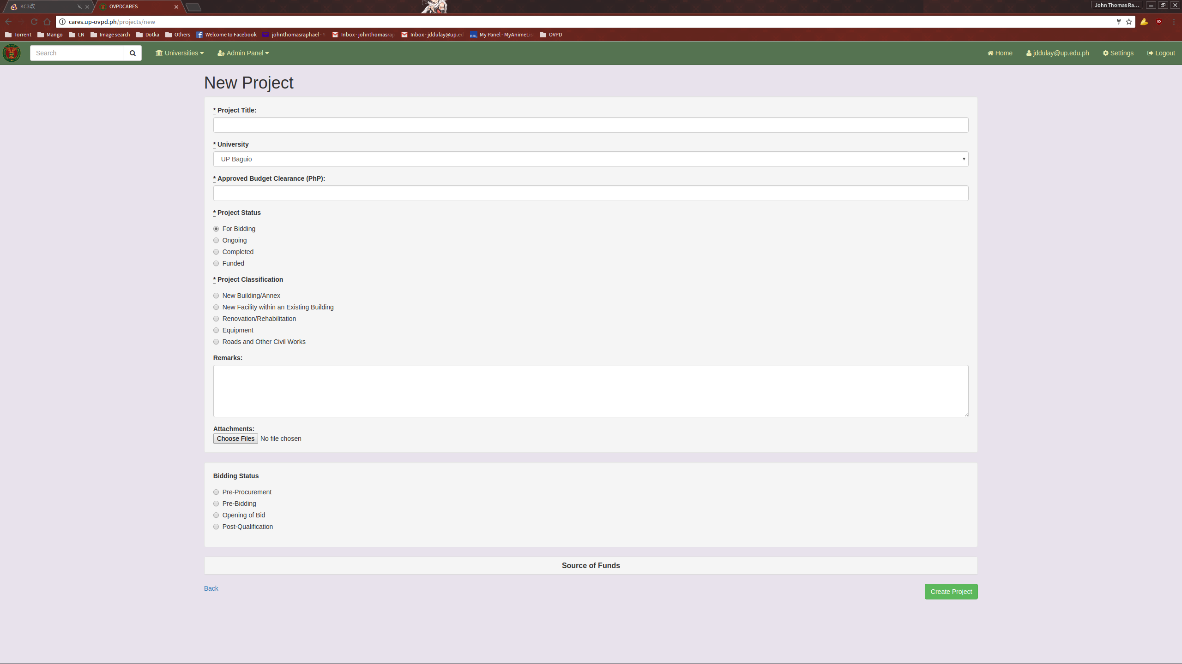

Ongoing:
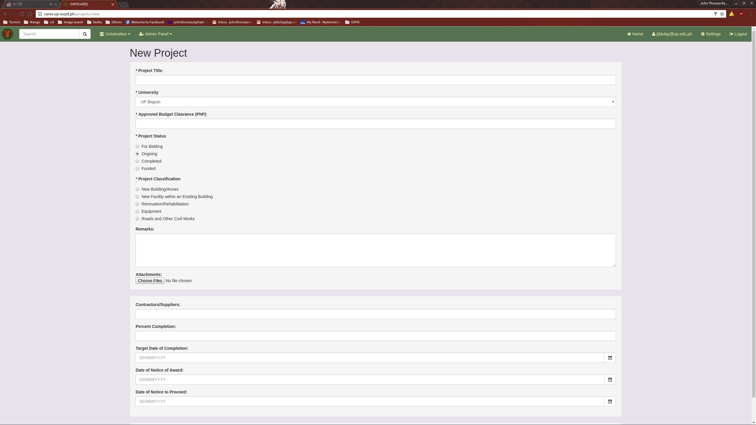

Completed:
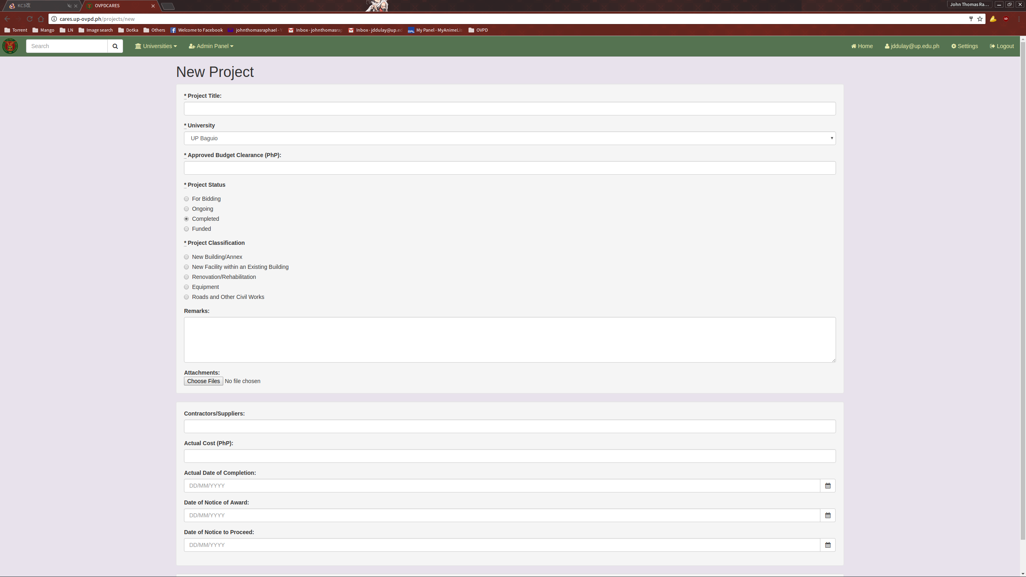
Funded:
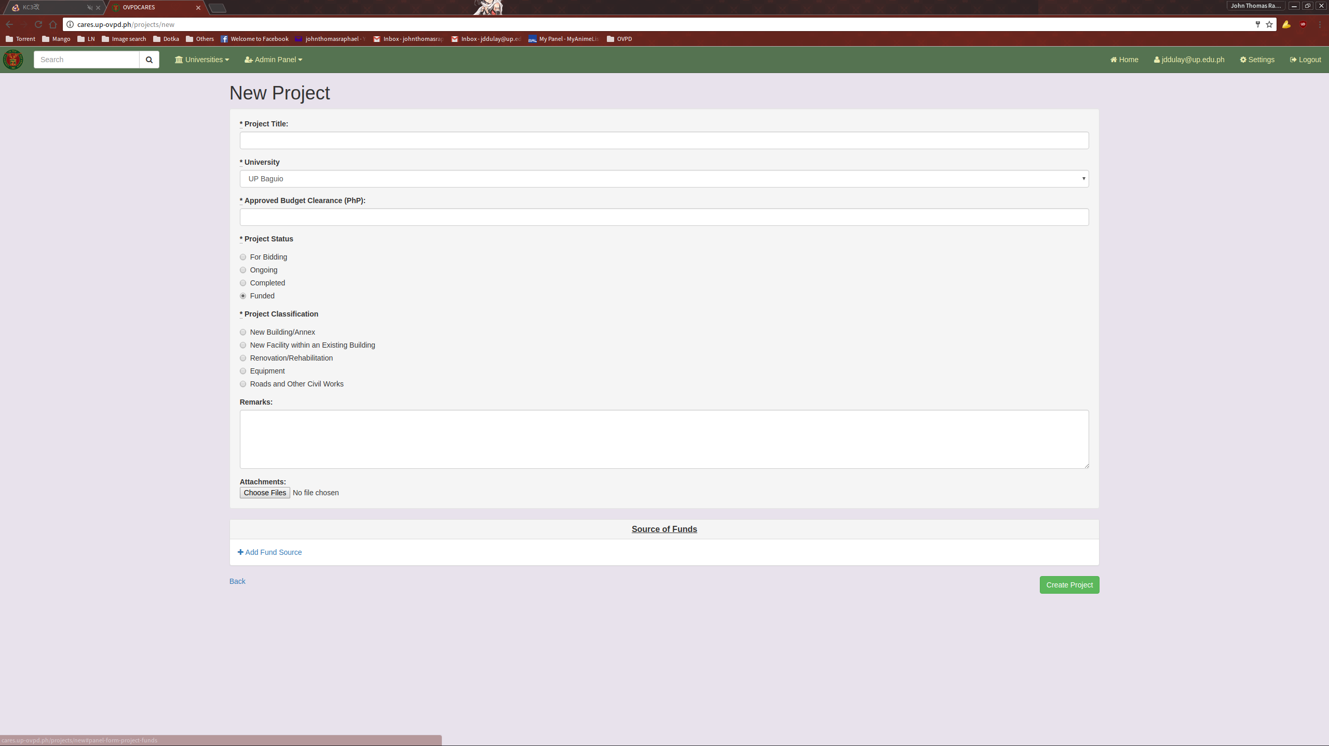

Clicking the panel heading labelled “Source of Funds” will show the hidden field that allows the user to input multiple sources of funds for the entry.

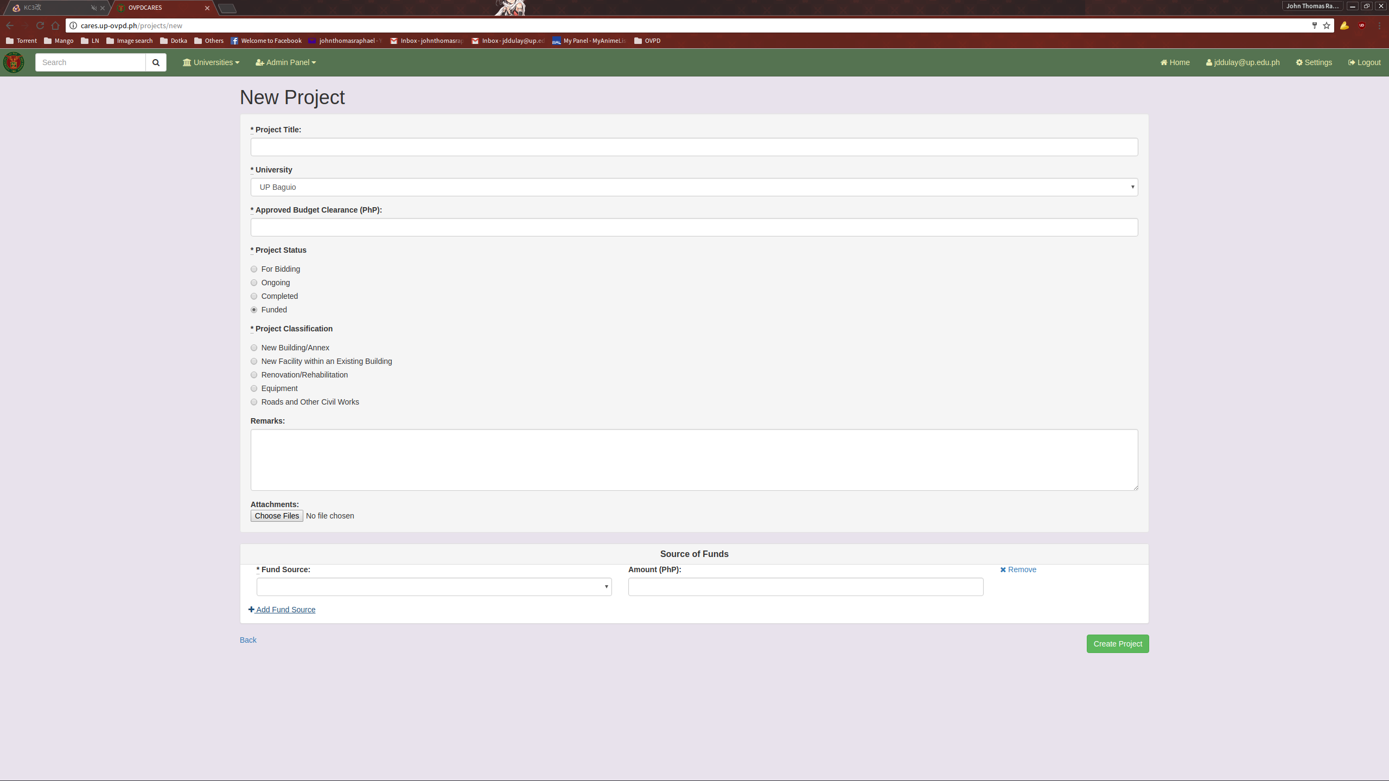
Once all relevant information has been filled up, click the “Create Project” button to submit the data to created.

VIEW A PROJECT ENTRY

To view a Project entry, select an entry from the Projects List.
This will direct you to the Show Project page. Here you can see the various details concerning the selected entry.
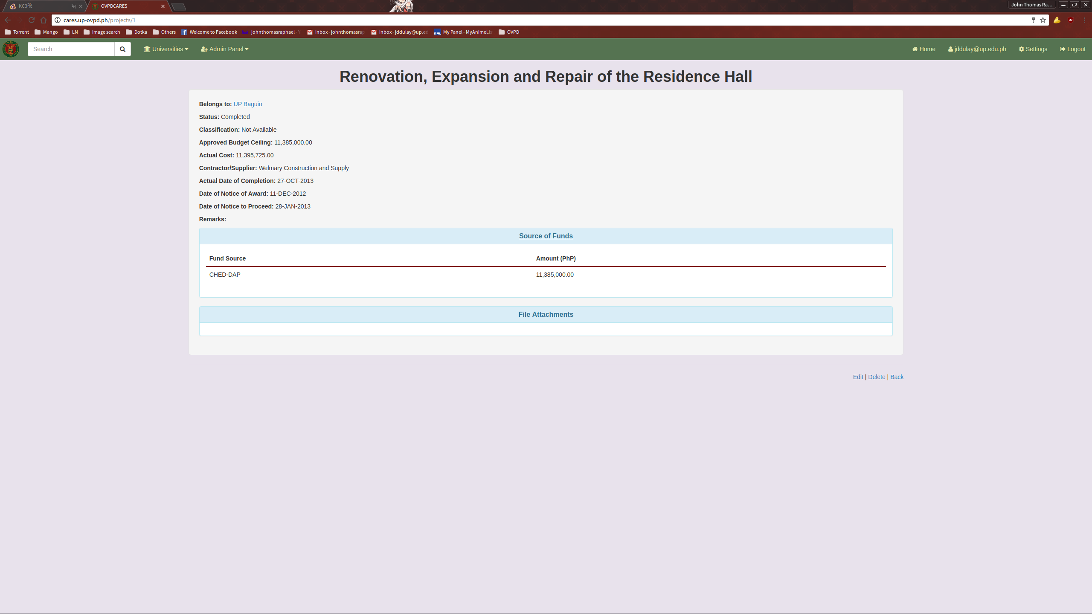

EDITING A PROJECT ENTRY

To edit a Project entry, click the Edit link located on the bottom of the Show Project page.
This will direct you to the Edit Project Page.
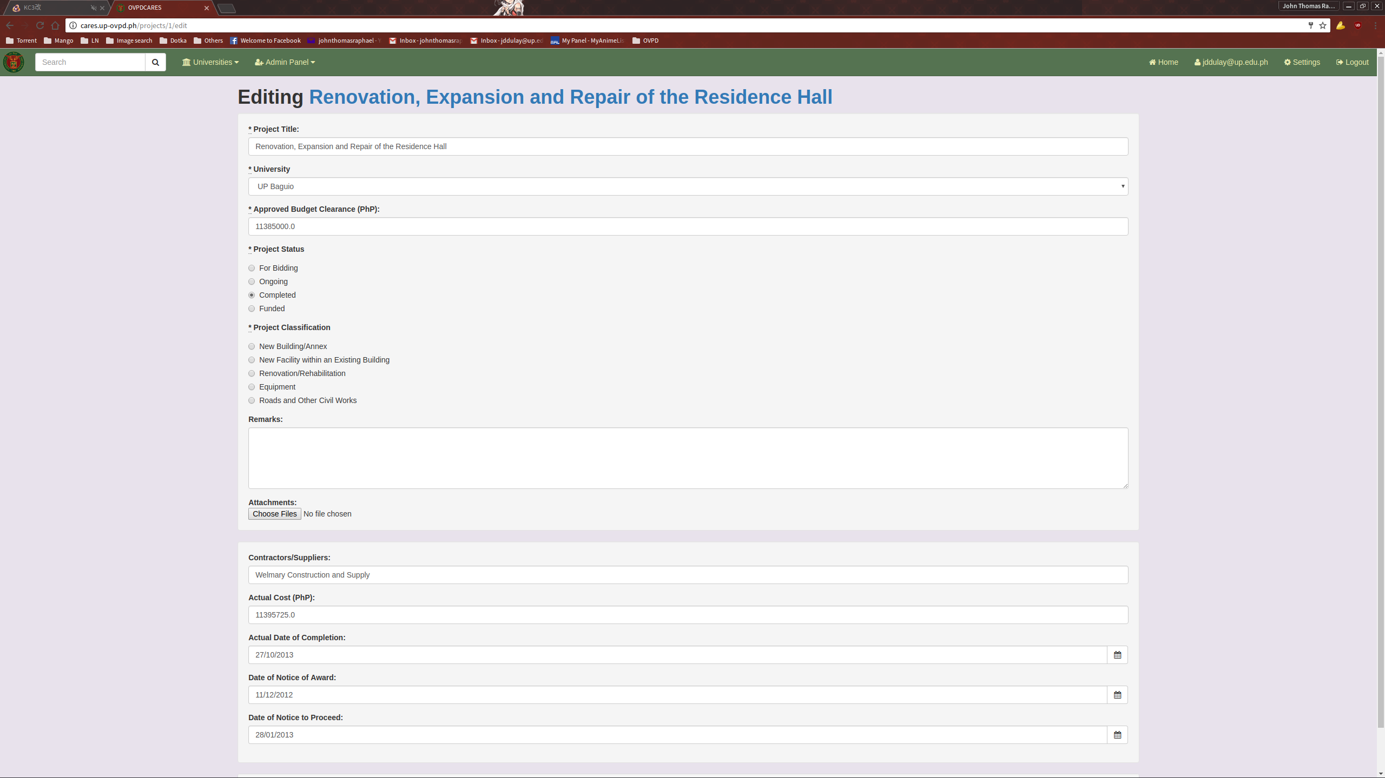
Update the necessary fields and click the “Update document” button when done to submit.

VIEW PROJECT COMPONENTS LIST

To view the Project Components of a selected Project entry, first ensure that its Status is set to Ongoing.
This will show the hidden Components panel in the Show Projects page.
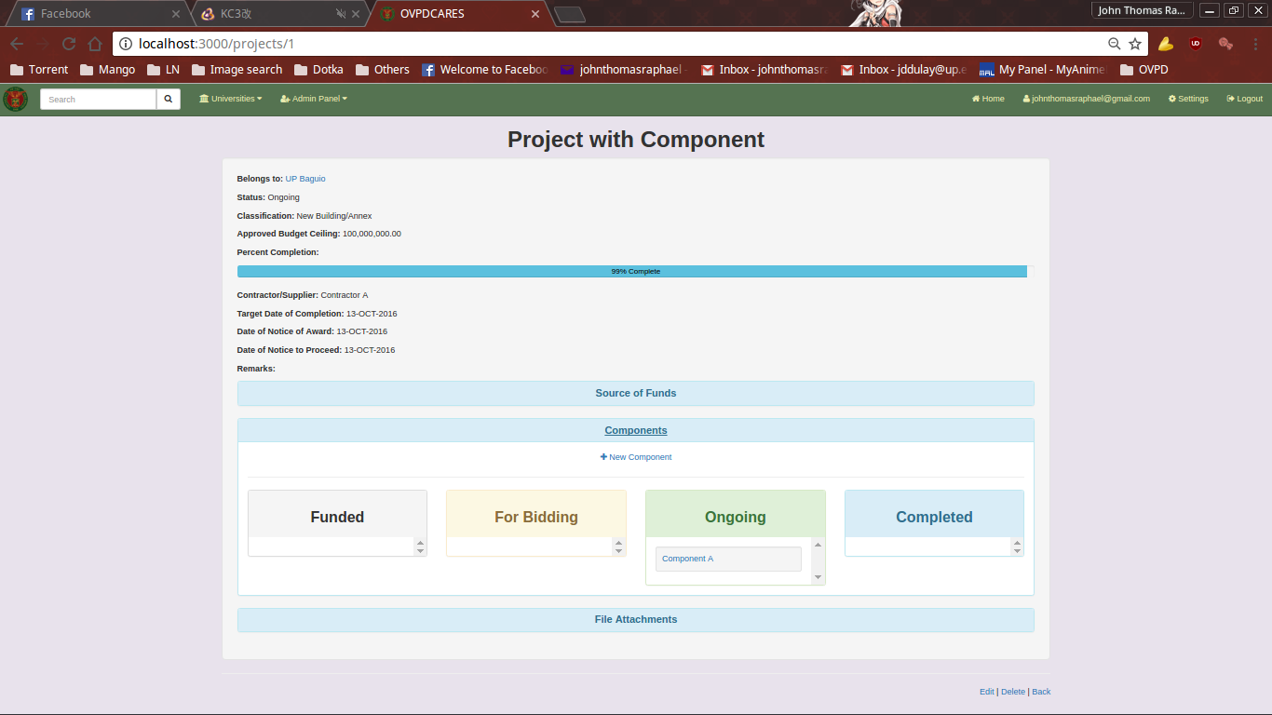
ADDING A NEW PROJECT COMPONENT

To add a new Project Component to a Project entry, click on the New Component link under the Components panel.
This will direct you to the New Components page.
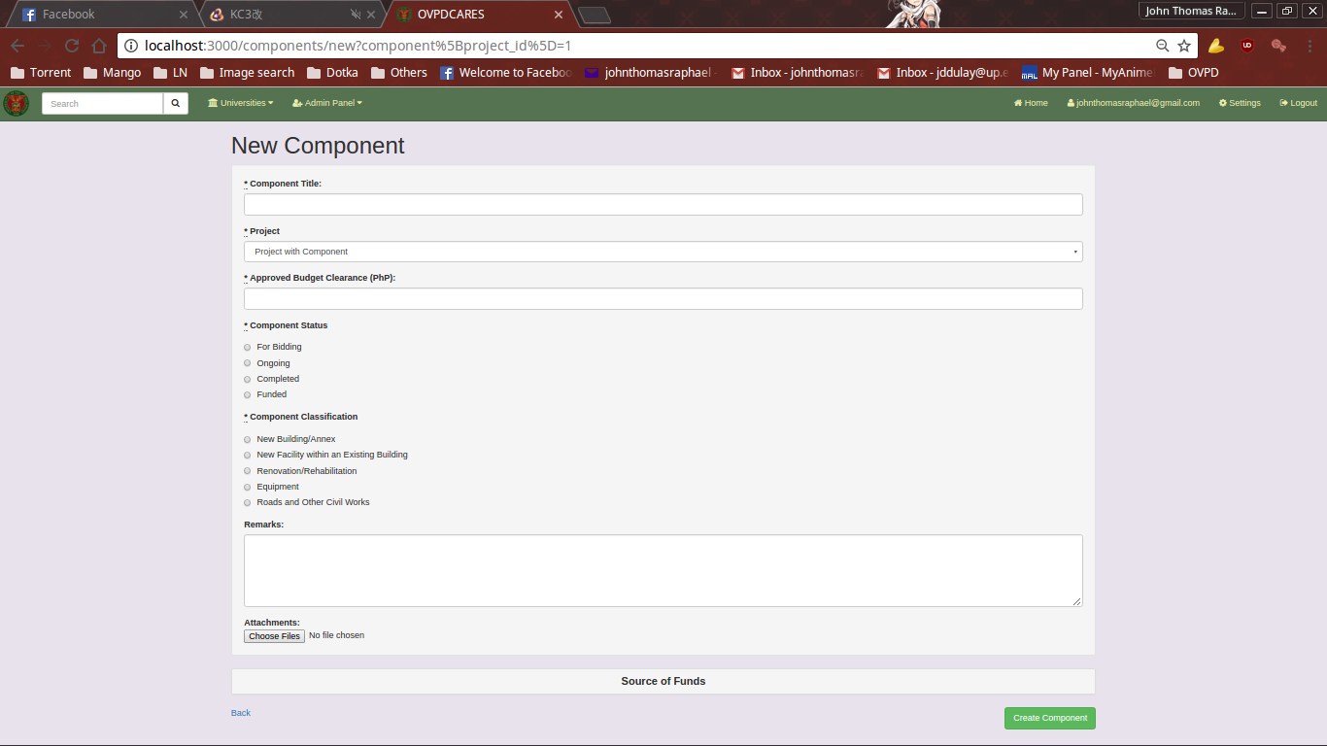
Fill up the necessary information and submit.

VIEW A PROJECT COMPONENT

To view a Project Component entry, click on its Component Name under the Components panel.
This will direct you to the Show Project Component Page.
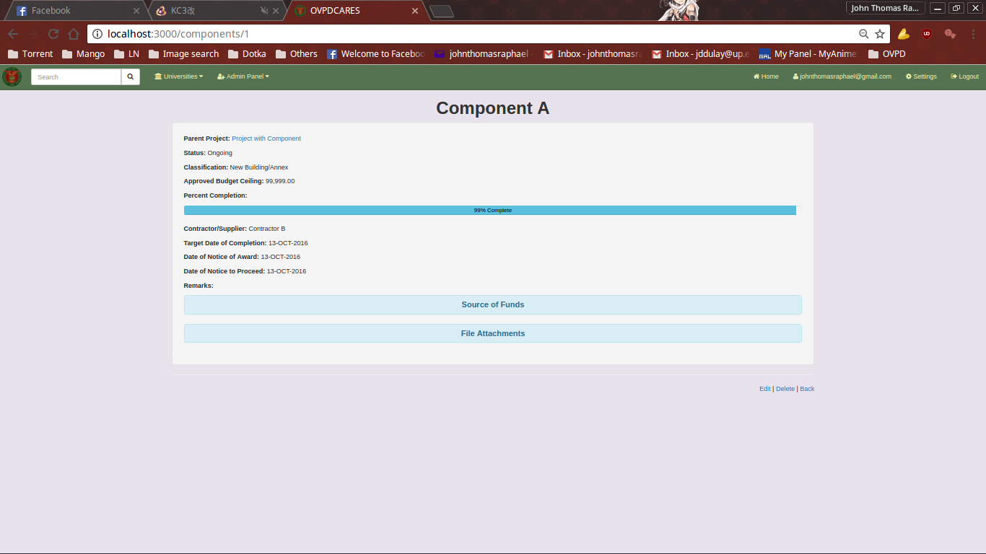
This page contains the various details about the selected Project Component.

EDITING A PROJECT COMPONENT

To edit a Project Component, click on the Edit link located on the bottom of the Show Project Component page.
This will direct you to the Edit Project Component page.
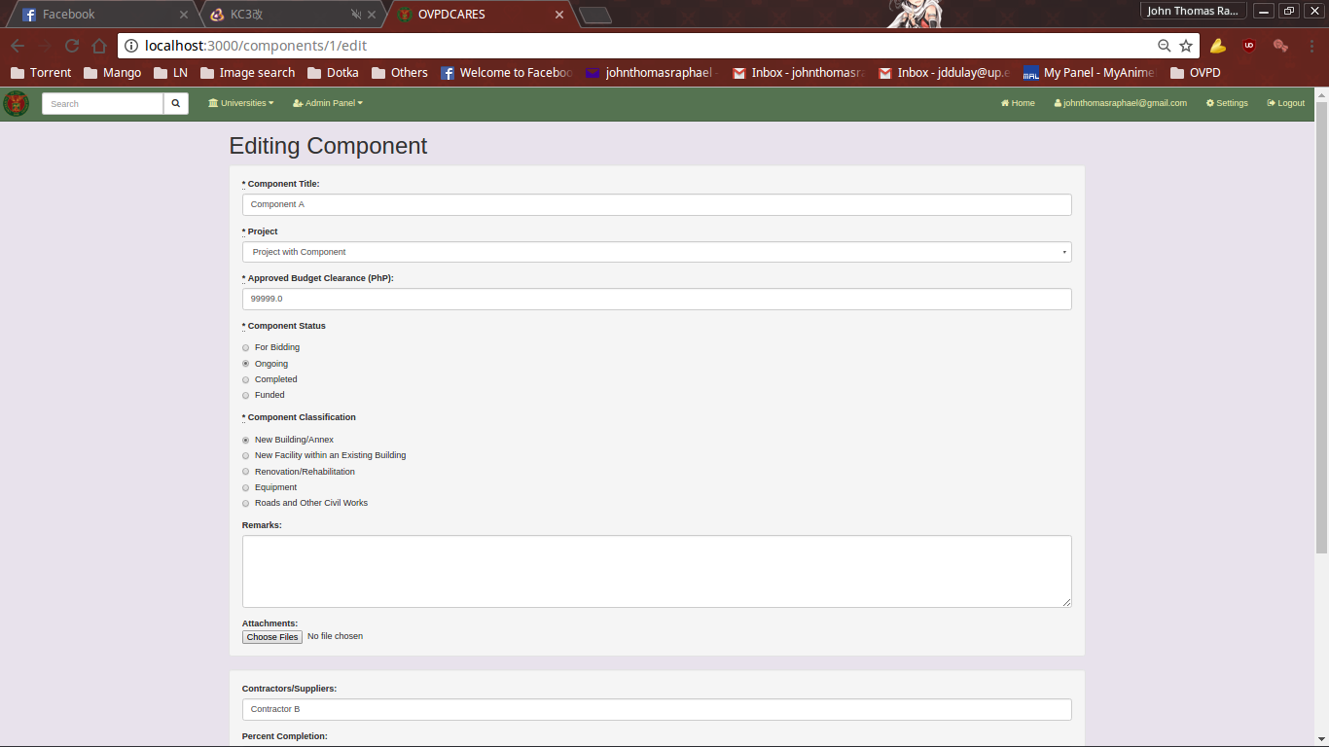
Fill it up with the necessary information and submit.
ADMINISTRATION PANEL

The administration panel can be accessed on the top left of the navigation bar. Note that this option is invisible and unaccessible to non-admin users.
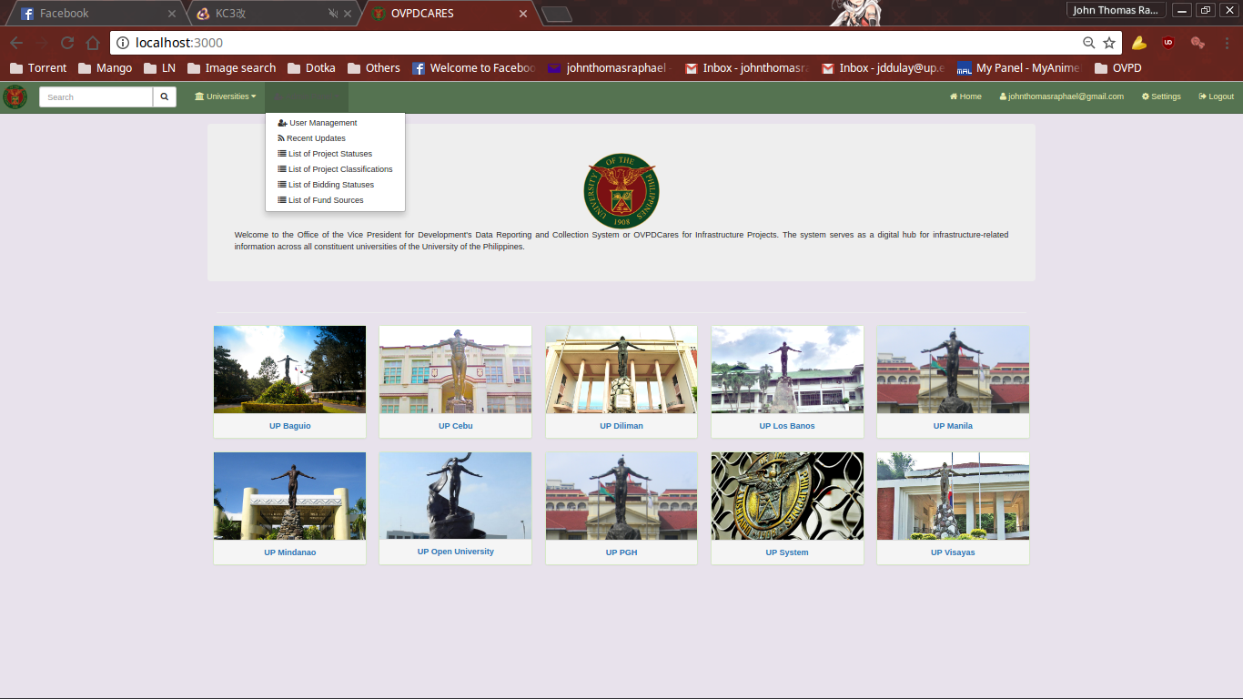
From here the admin user can select the User Management module, view Recent Updates, or view and modify the various lists used on the forms for creating and updating project entries.

USER MANAGEMENT

Using the User Management page, the admin user can view, create, edit, and delete users.
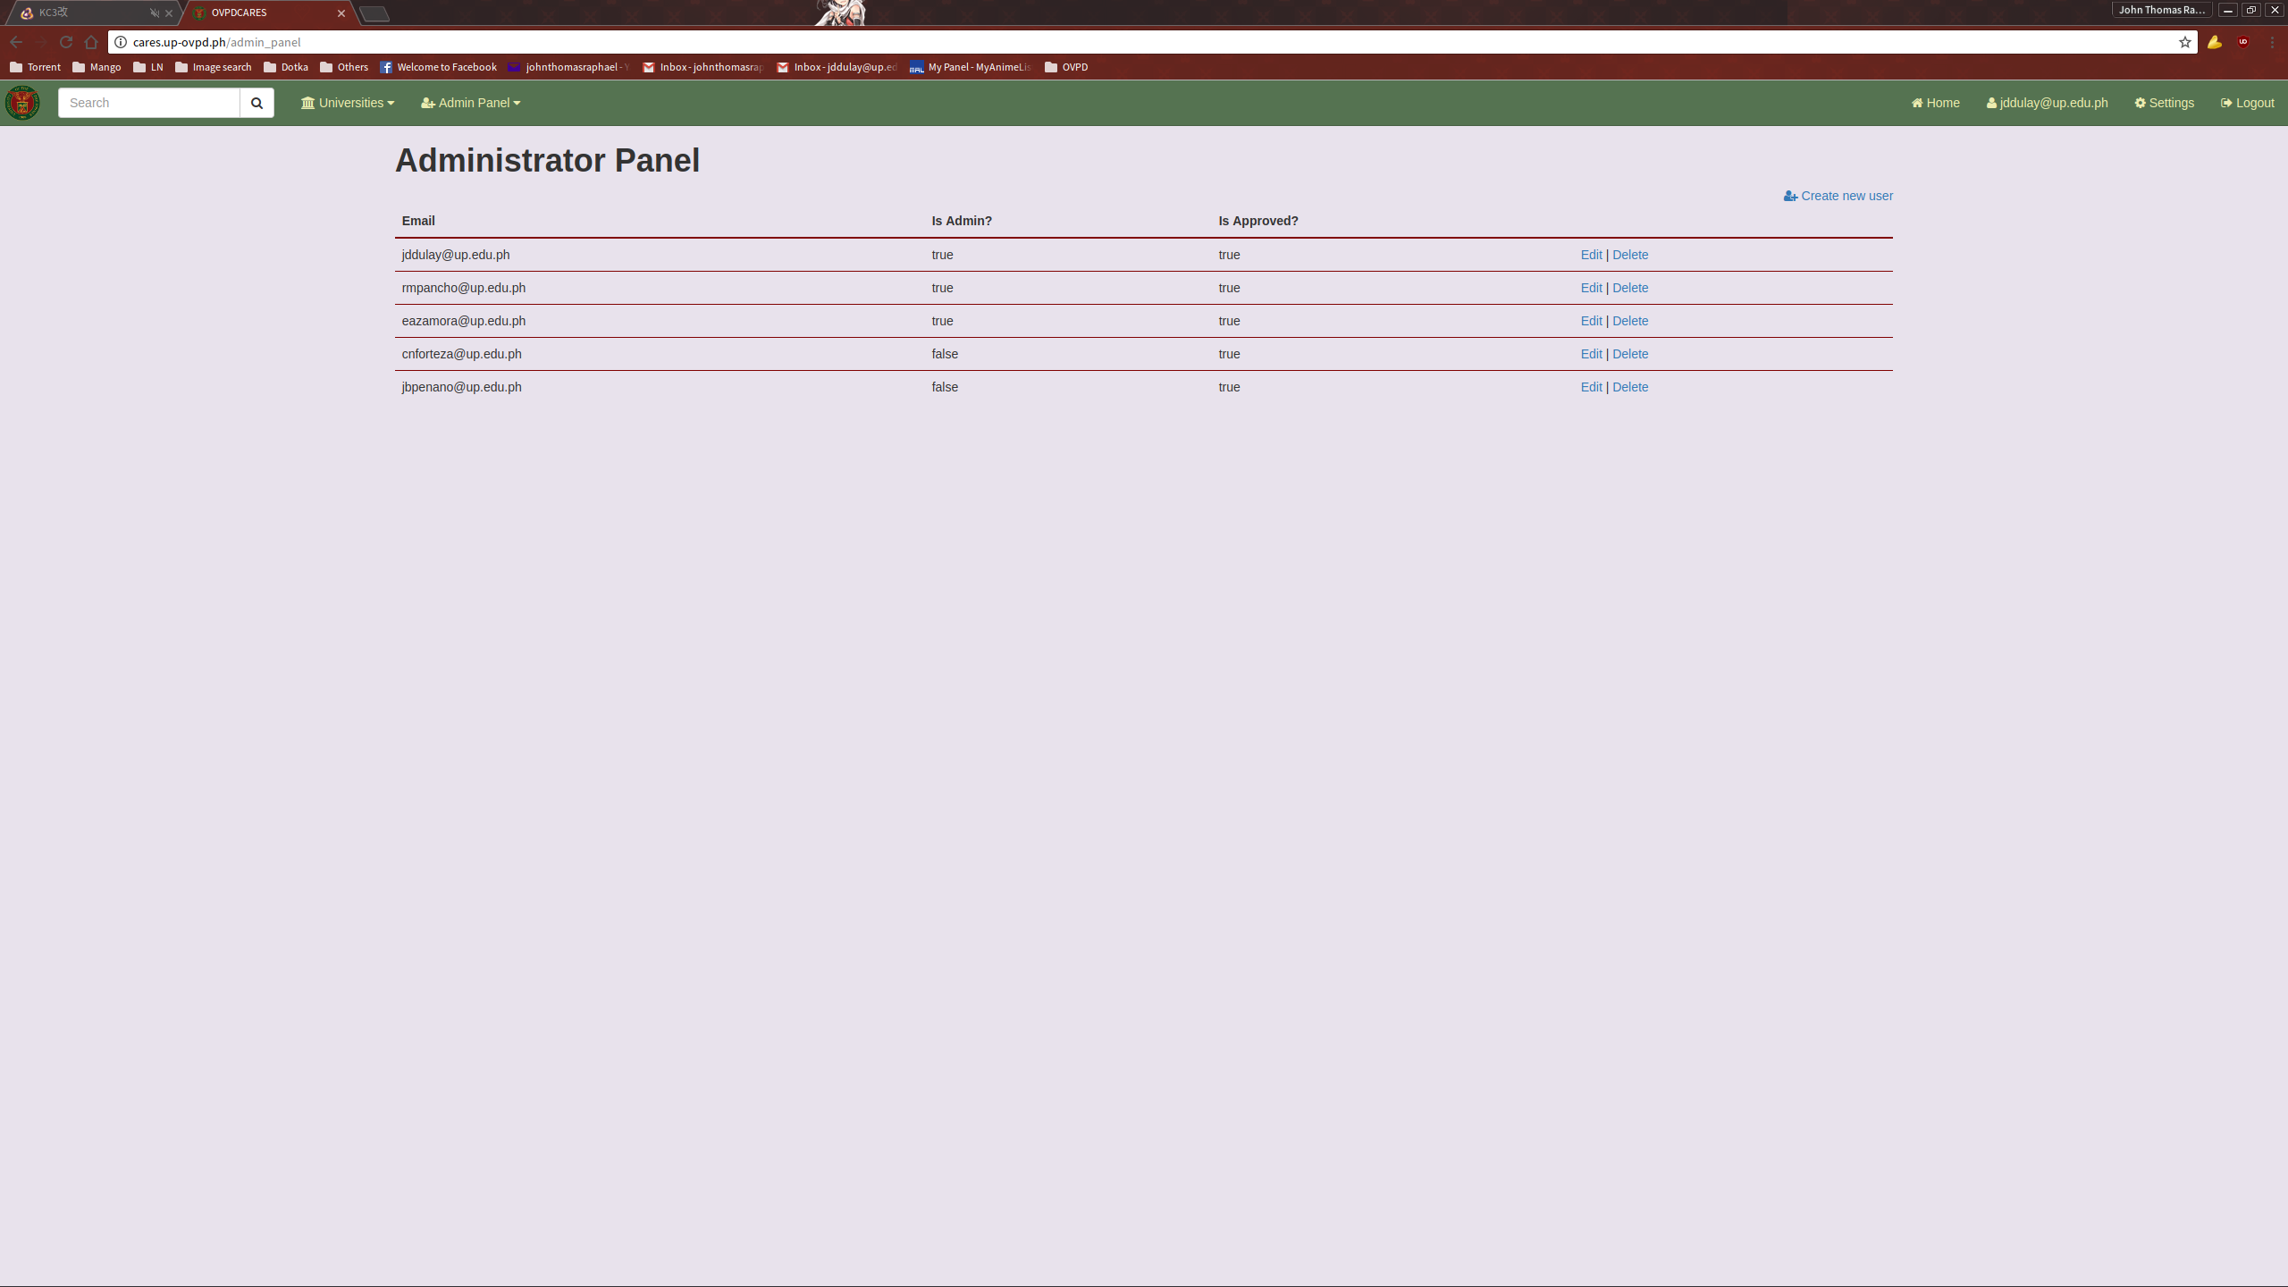

ADDING A NEW USER

To add a new user, click the “Create new user” link on the top right of the user list. This will direct you to the New User page.
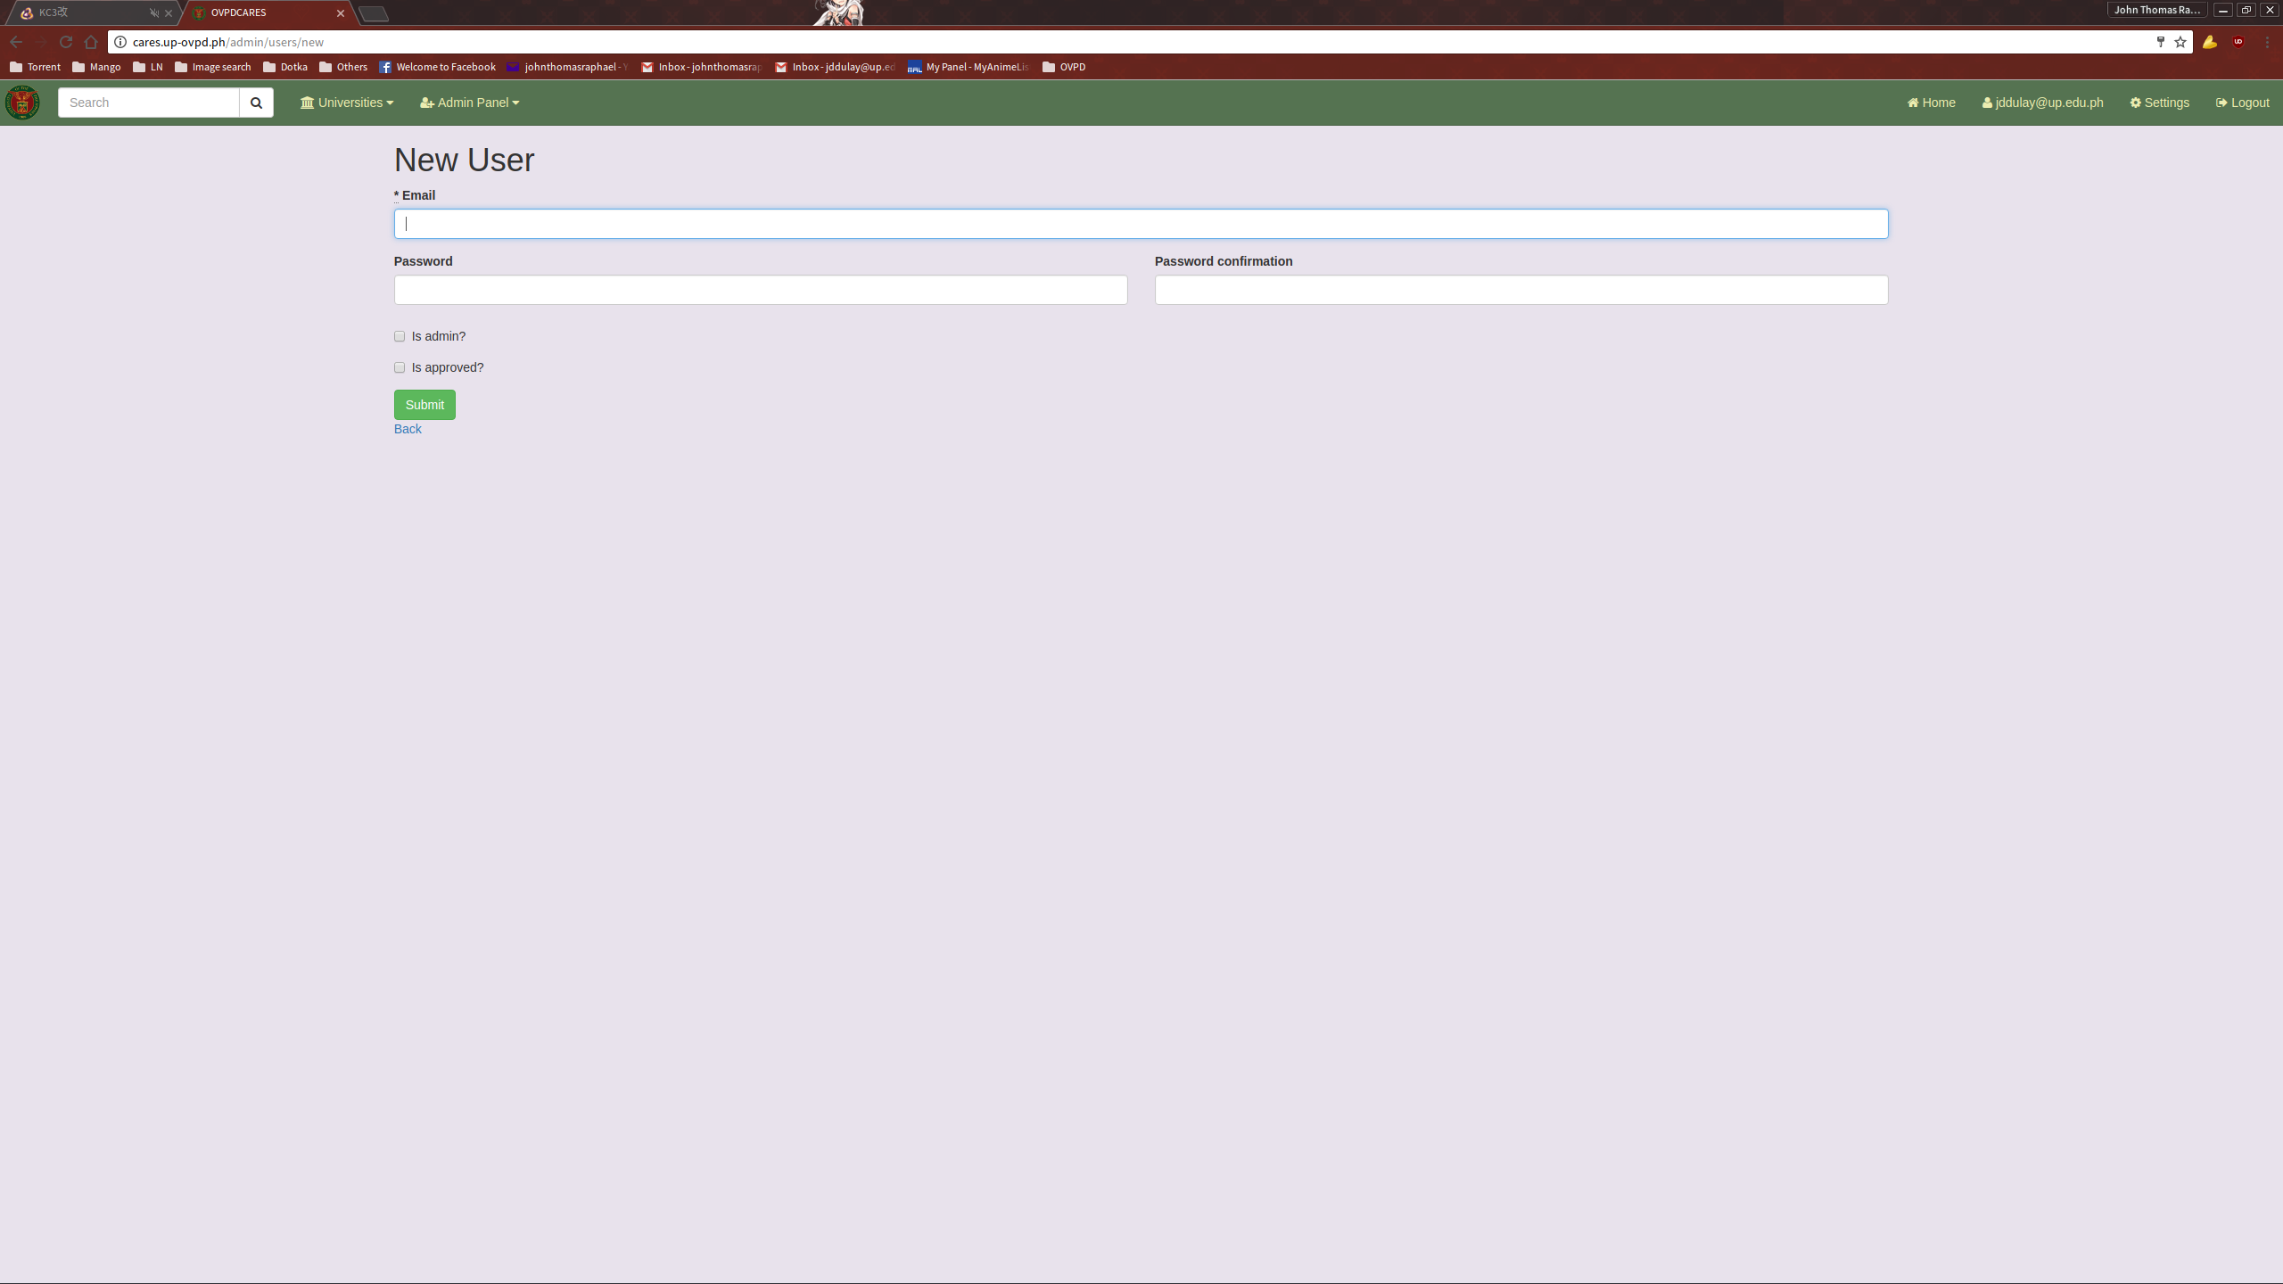
Fill up with the necessary information and submit.

EDITING A USER

To edit a user, click the Edit link provided in the Users List.
This will direct you to the Edit User page.
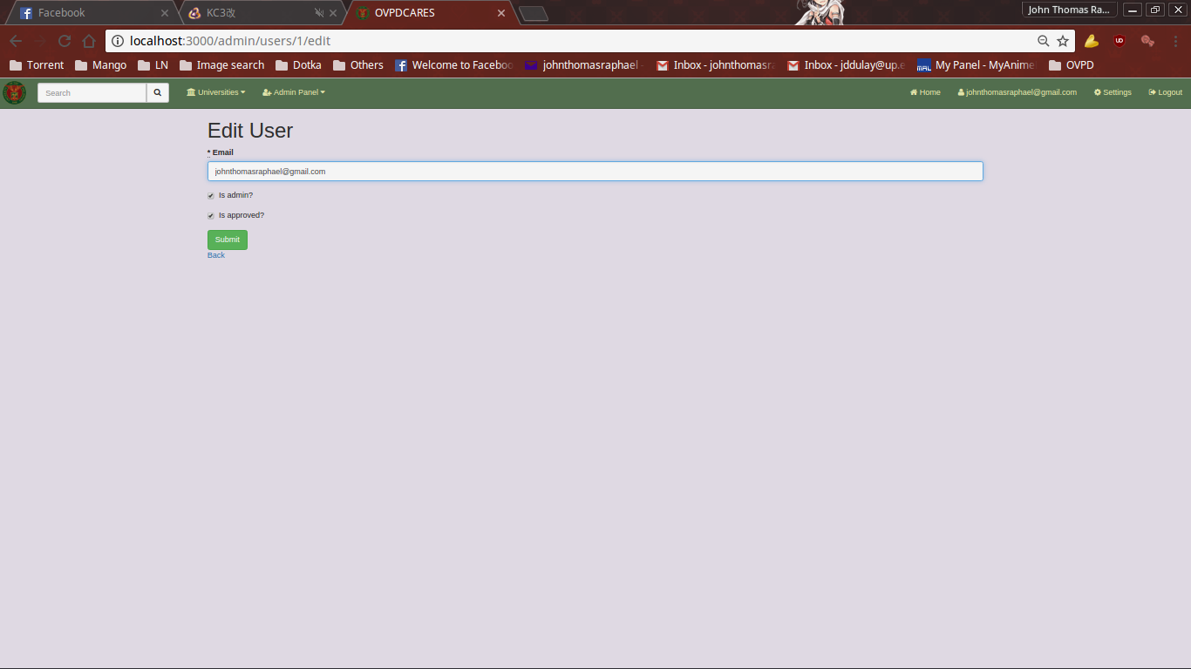
Fill it up with the necessary information and submit.

VIEWING RECENT UPDATES

To view recent changes to the project entries, follow the “Recent updates” link under the administration panel dropdown. Here, the admin user can see whether projects have been added, updated, or deleted by a user as well as a timestamp for when the event took place.

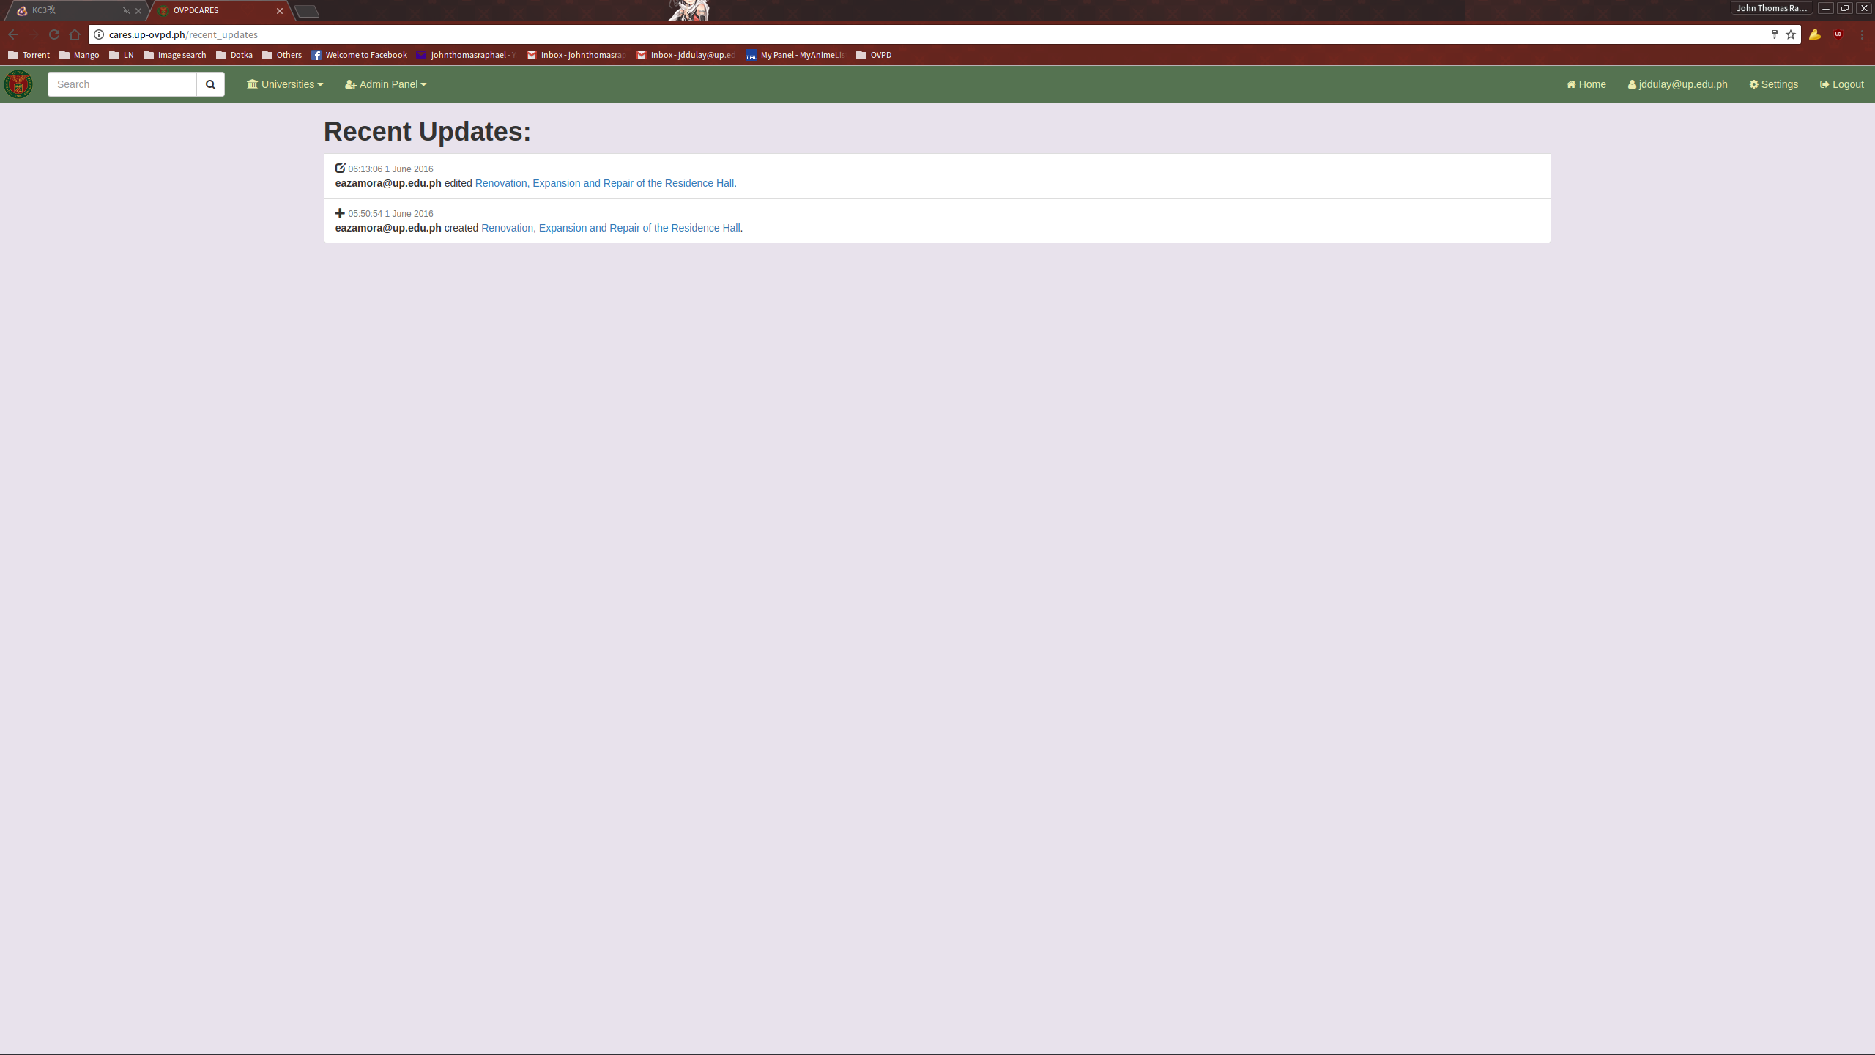

LISTS

Note: The lists under the Admin Panel function virtually in the exact way. For the sake of brevity, we will only look at the List of Project Statuses. The operations and processes done here can be applied to the other lists.

The List of Project Statuses contains the values that are used during the creation or update of Project entries. To access the list, click the List of Project Statuses link located under the Admin Panel dropdown on the navigation bar.

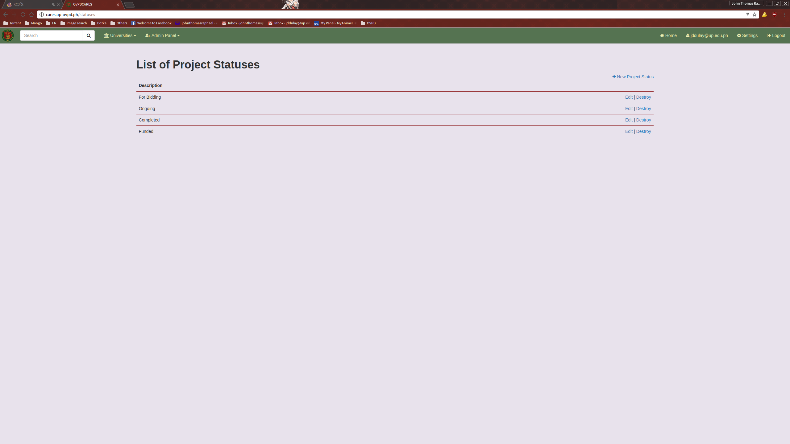
ADDING A NEW PROJECT STATUS

To add a new Project Status, click the New Project Status link located on the top right of the Project Status list.

This will direct you to the New Project Status page.
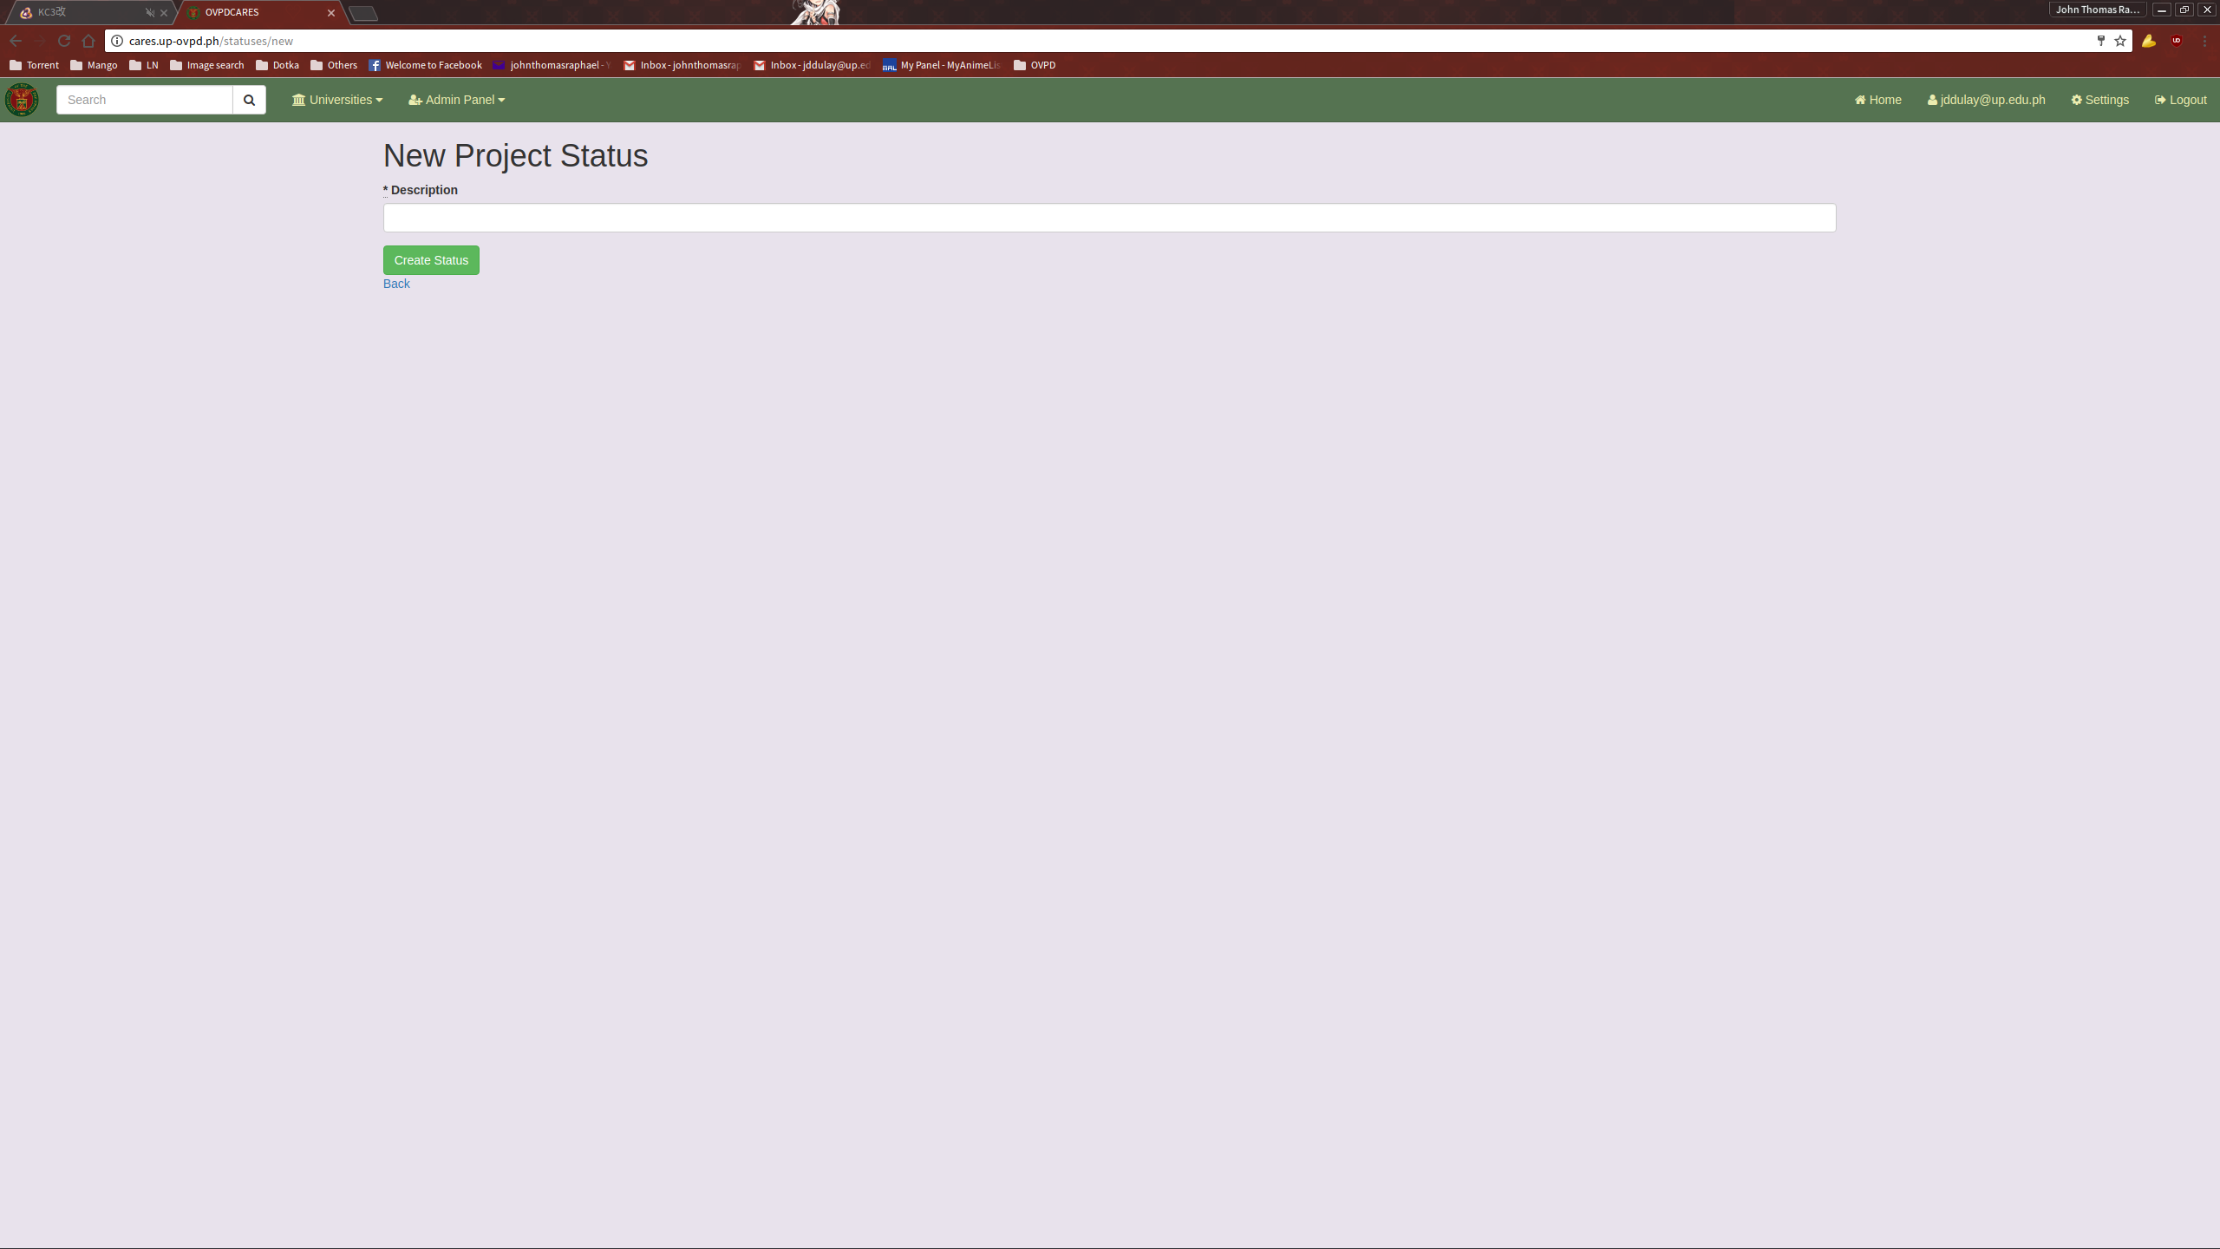
Fill it up with the necessary information and submit.
EDITING A PROJECT STATUS

To edit a Project Status, click the Edit link provided in the Project Status list.

This will direct you to the Edit Project Status page.

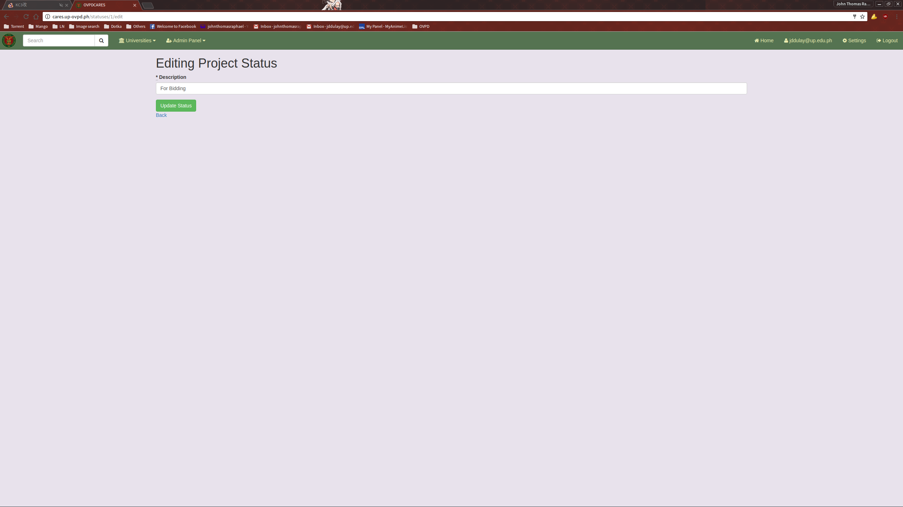
Fill it up with the necessary information and submit.

