TITLINGDB
INSTALLATION GUIDE
WEB APPLICATION

INTRODUCTION

The TitlingDB is a web application that enables the users to view the various Landholdings and titles held by the University of the Philippines.

MAIN FEATURES

- Dashboard
- University List
- Landholding List per University
- Administration Panel
  - User Management

GETTING STARTED

Access the website through the URL titling.up-ovpd.ph where you will be greeted with a login screen.
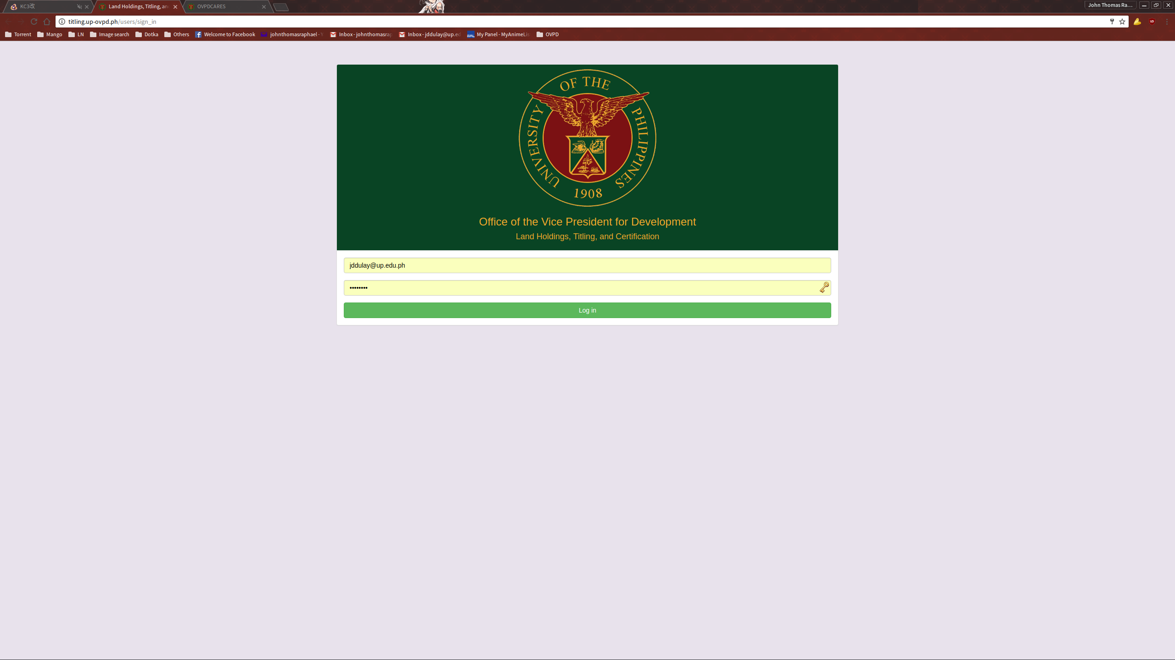
Input your access credentials to get to the dashboard.

DASHBOARD
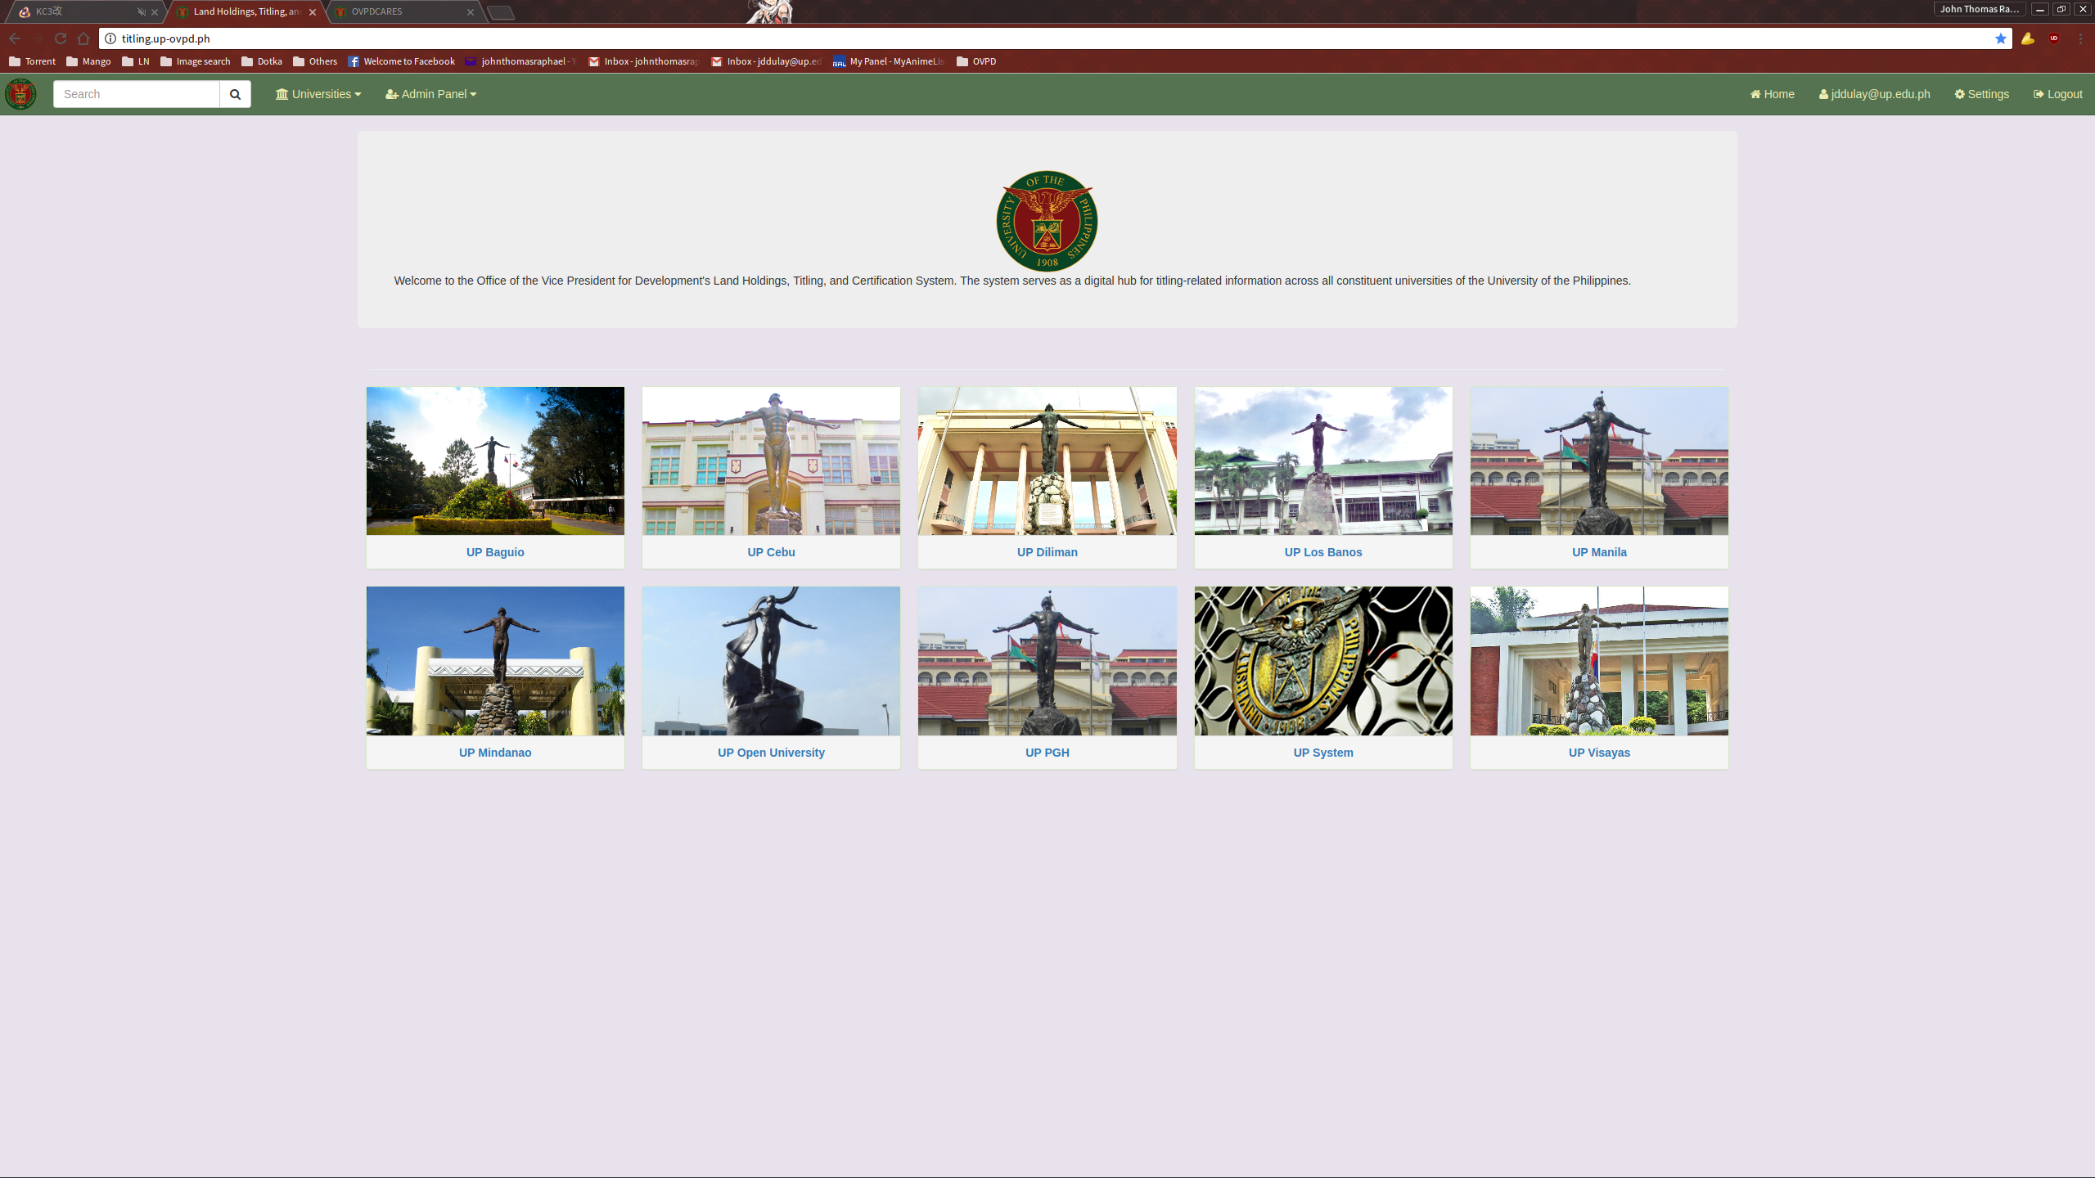
Upon a successful login, the user will be greeted with the dashboard. Most of the available functions can be access through here. Note that administration functions cannot be seen and used by non-admin users. The list can be filtered with the Search funtion accessible from the top left of the navigation bar.
LIST OF UNIVERSITIES

The List of Universities can be accessed either by clicking their respective images on the dashboard or via a dropdown list on the navigation bar.
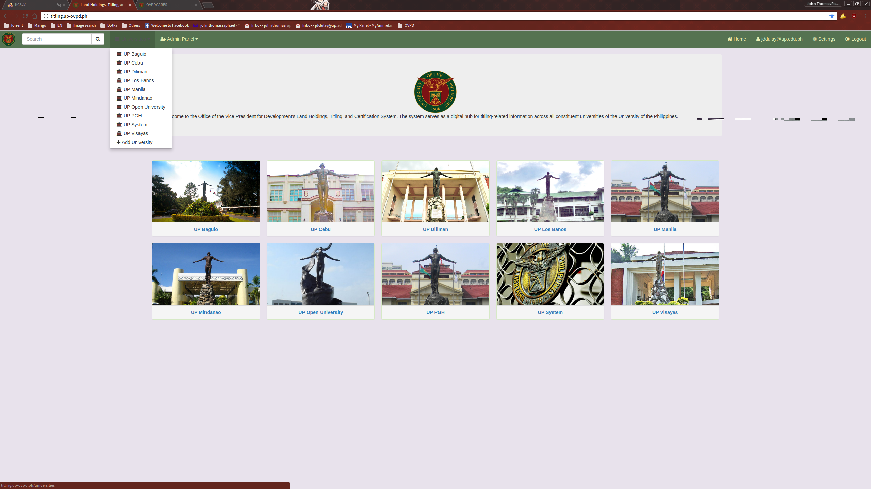

Selecting a university will show you the list of Landholdings the selected university possesses.
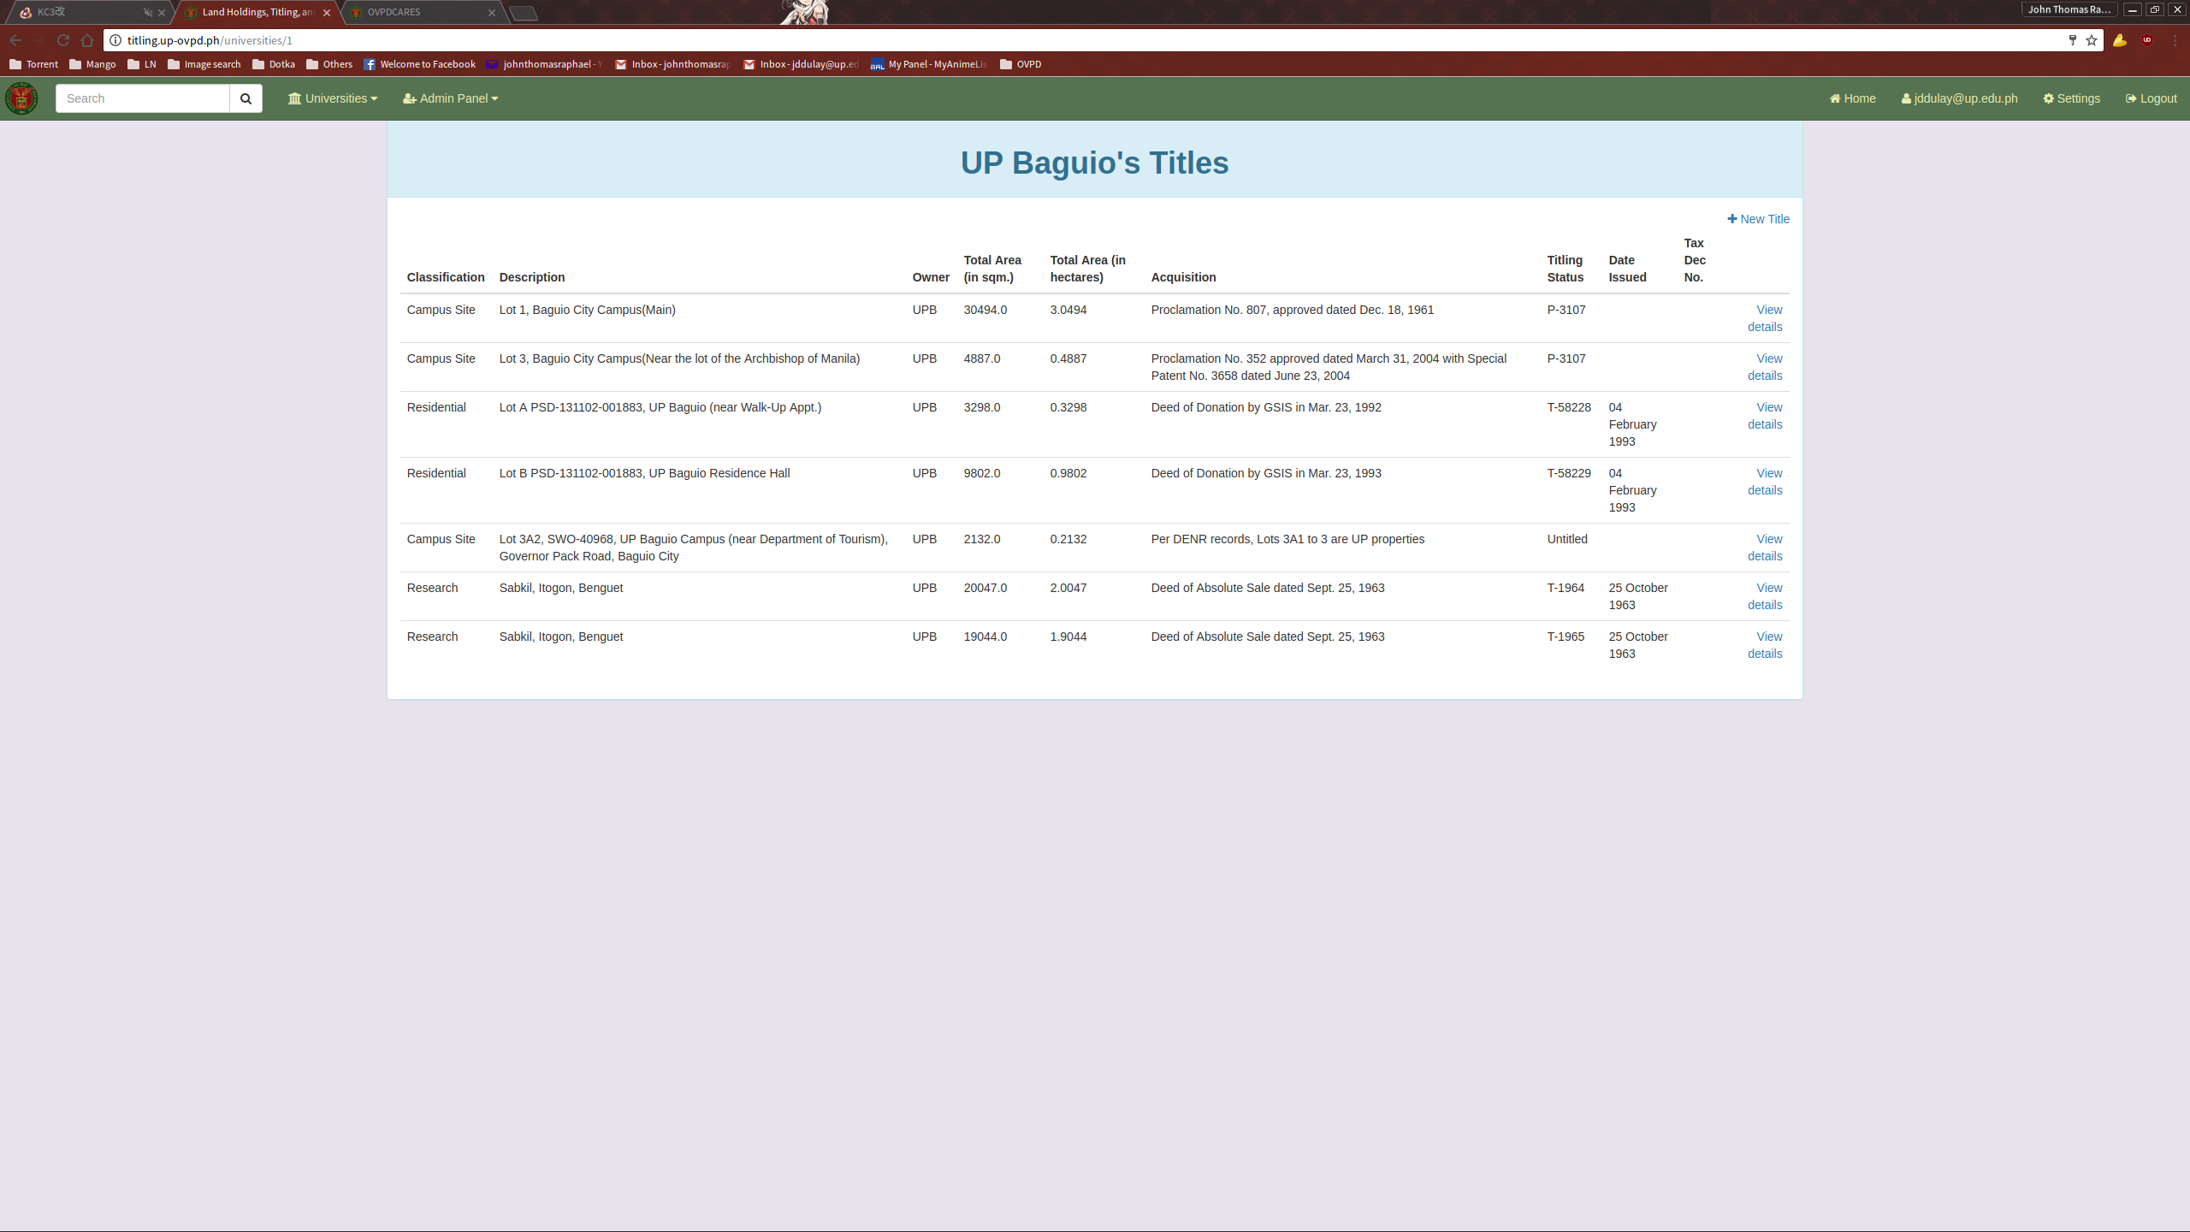
ADDING A NEW TITLE

To add a new title entry, click the link “New Title” located on the top right of the Titles list. This will take you to the “New Title” page where you can input the needed information.

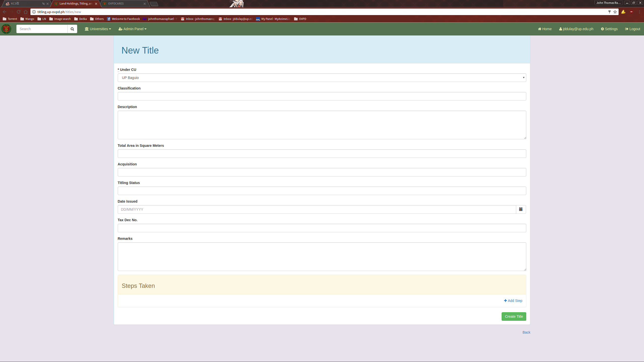
Once all relevant information has been filled up, click the “Create Title” button to submit the data to created.

VIEW A TITLE ENTRY

To view a Title entry, click on the View details link provided in the Titles list.
This will direct you to the Show Title page.
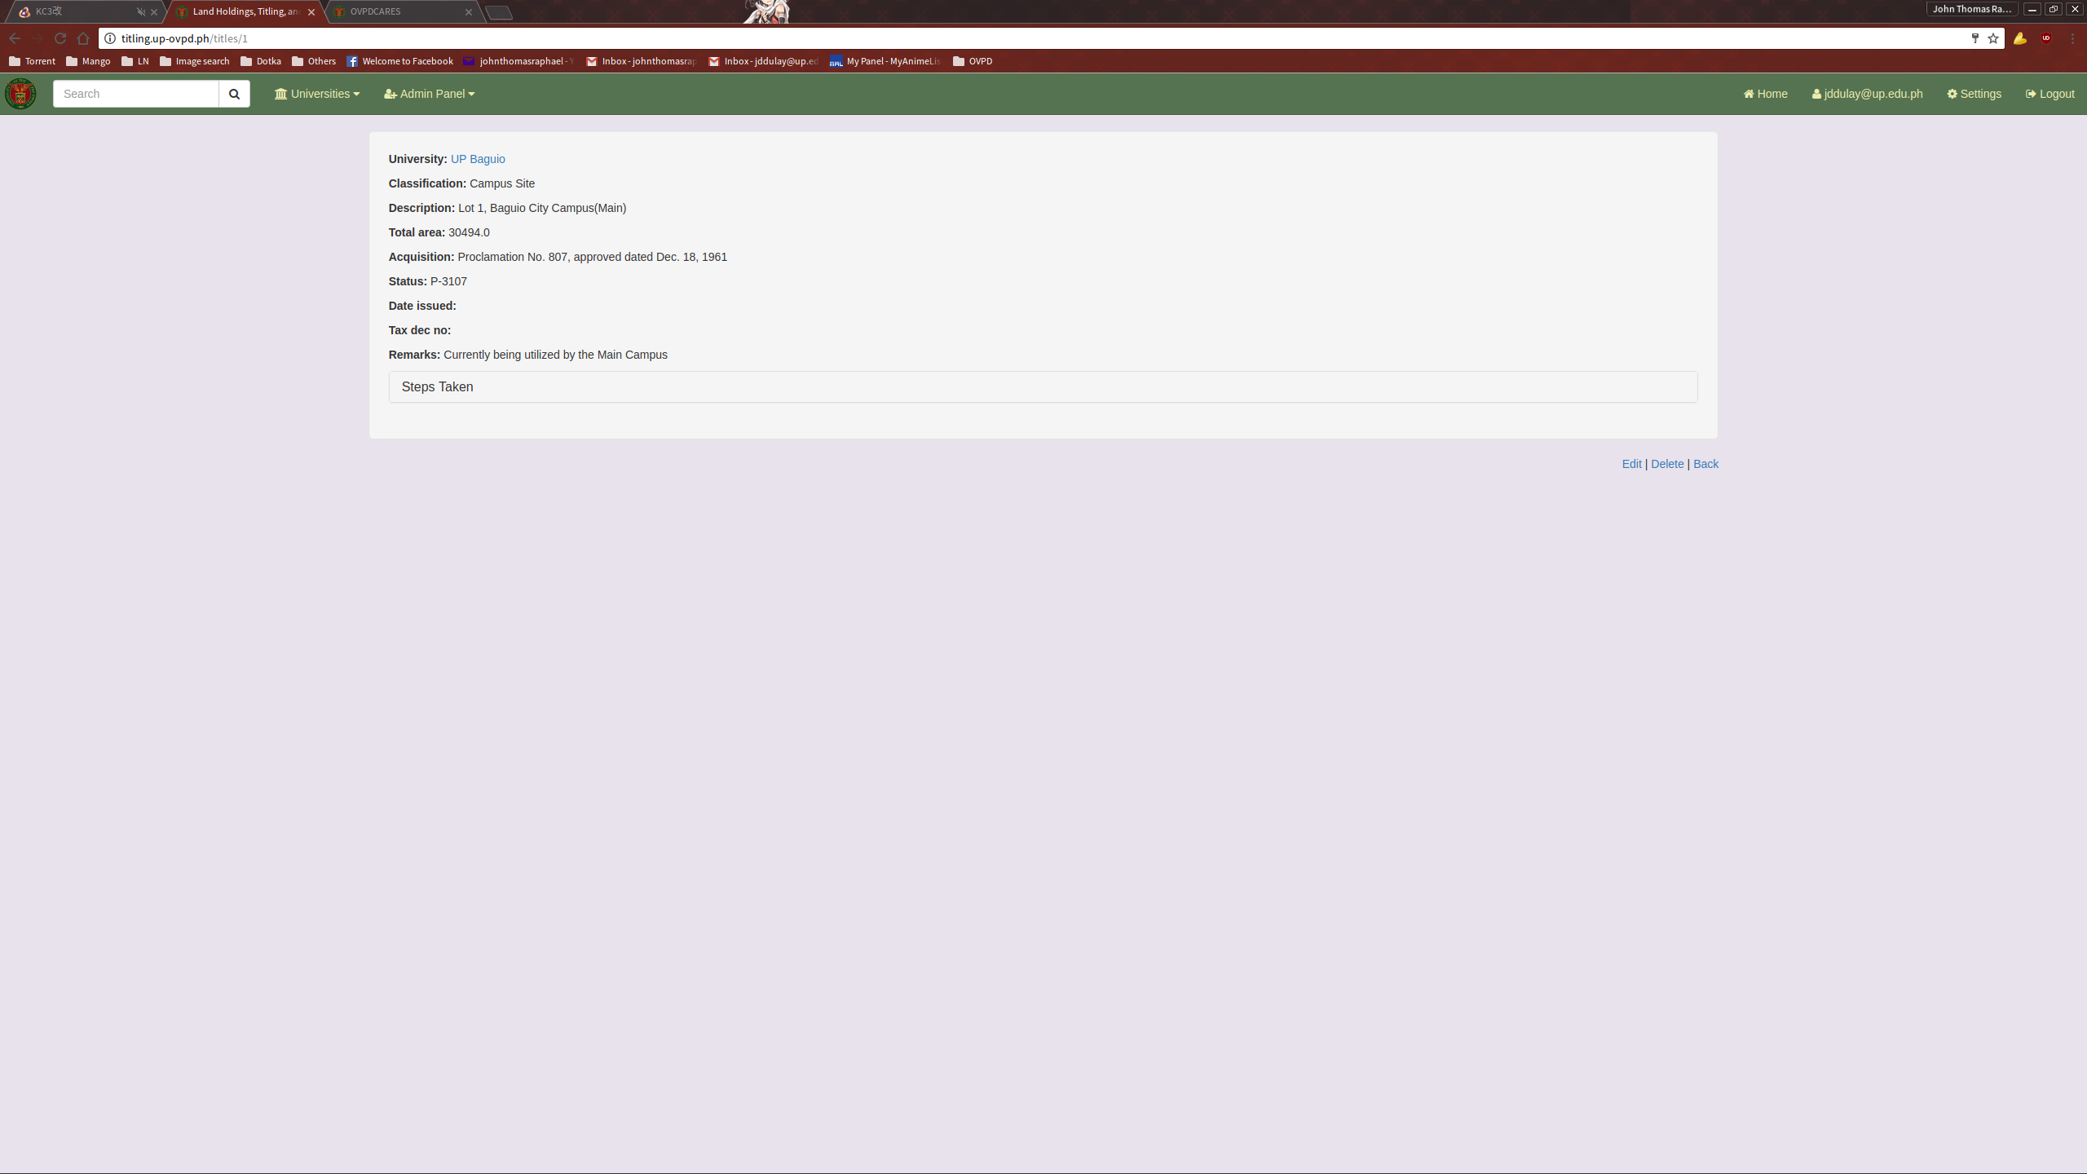
This page contains the various information about the selected entry.
EDITING A TITLE

To edit a Title, click on the Edit link located on the bottom of the Show Title page.
This will direct you to the Edit Title page.
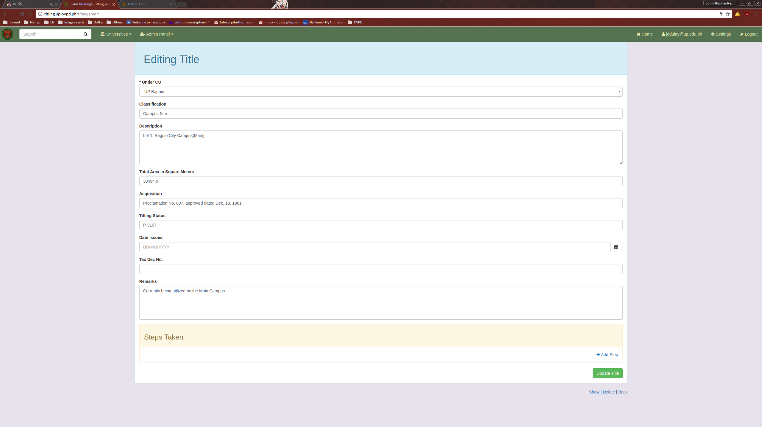
Update the necessary fields and click the “Update document” button when done to submit.
ADMINISTRATION PANEL

The administration panel can be accessed on the top left of the navigation bar. Note that this option is invisible and unaccessible to non-admin users.
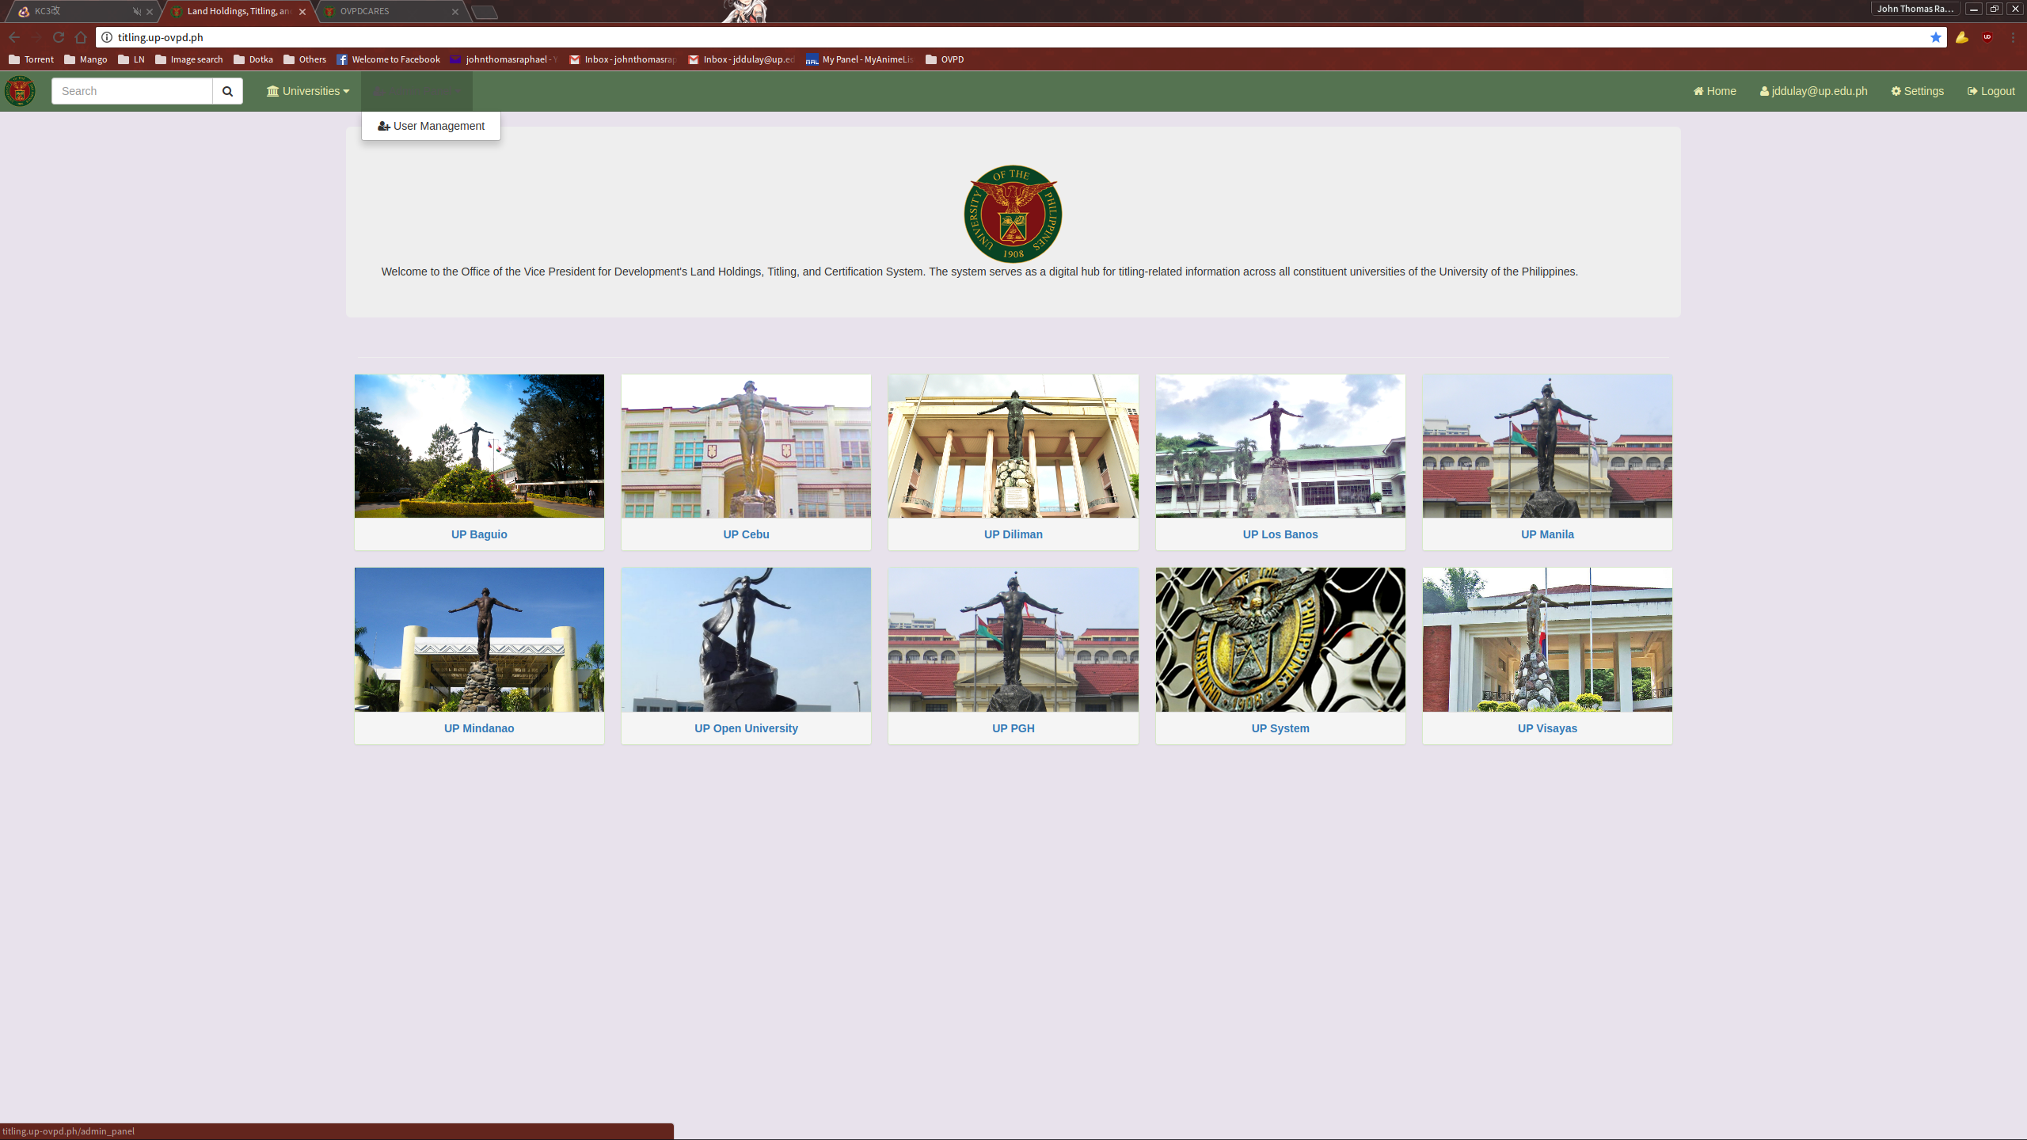

USER MANAGEMENT

Using the User Management page, the admin user can view, create, edit, and delete users.
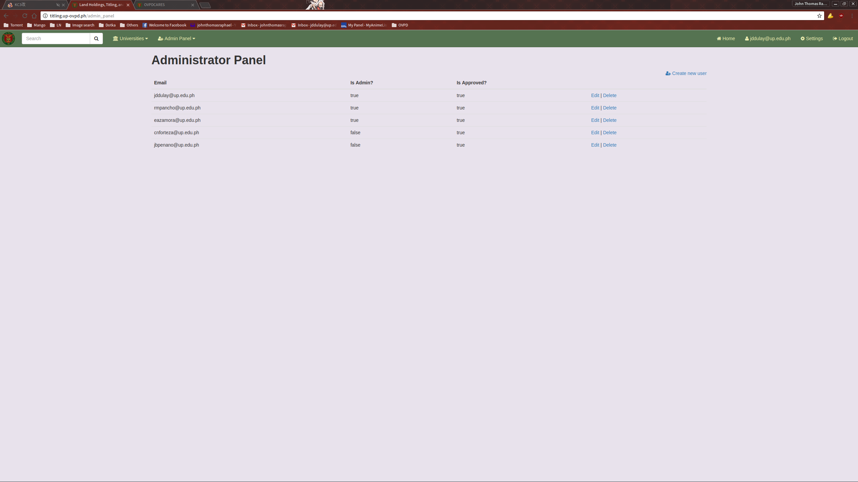

ADDING A NEW USER

To add a new user, click the “Create new user” link on the top right of the user list.
This will direct you to the New User page.
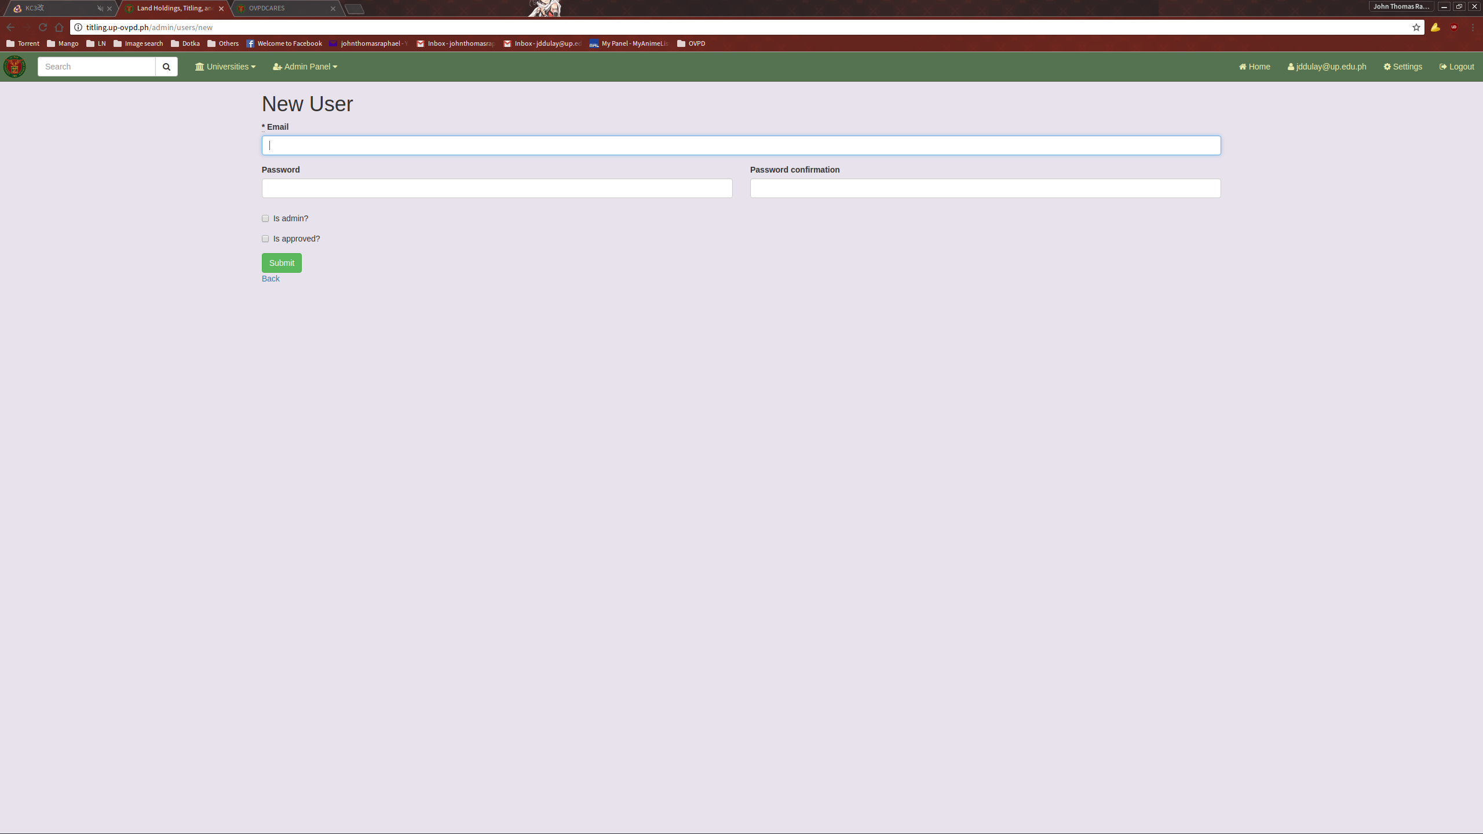
Fill it up with the necessary information and submit.

EDITING A USER

To edit a user, click the Edit link located in the Users list.
This will direct you to the Edit User page.
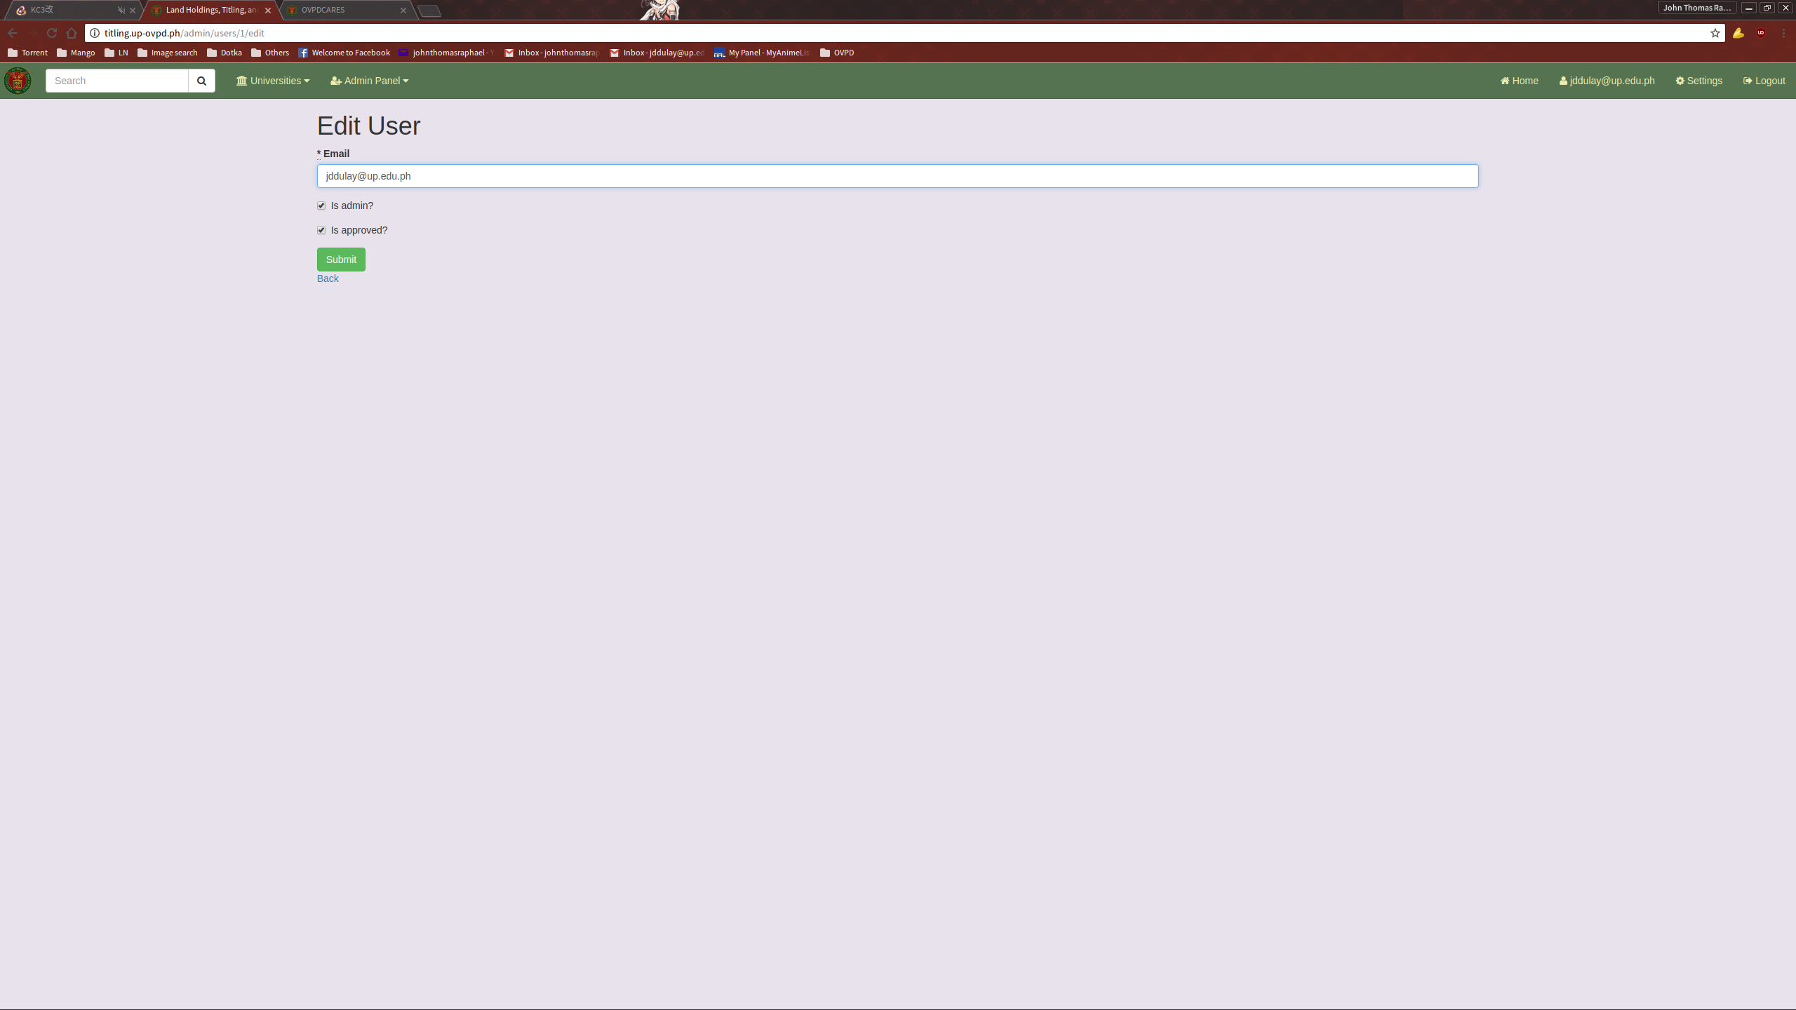
Fill it up with the necessary information and submit.

