The first analysis using pipeline_task.ipynb
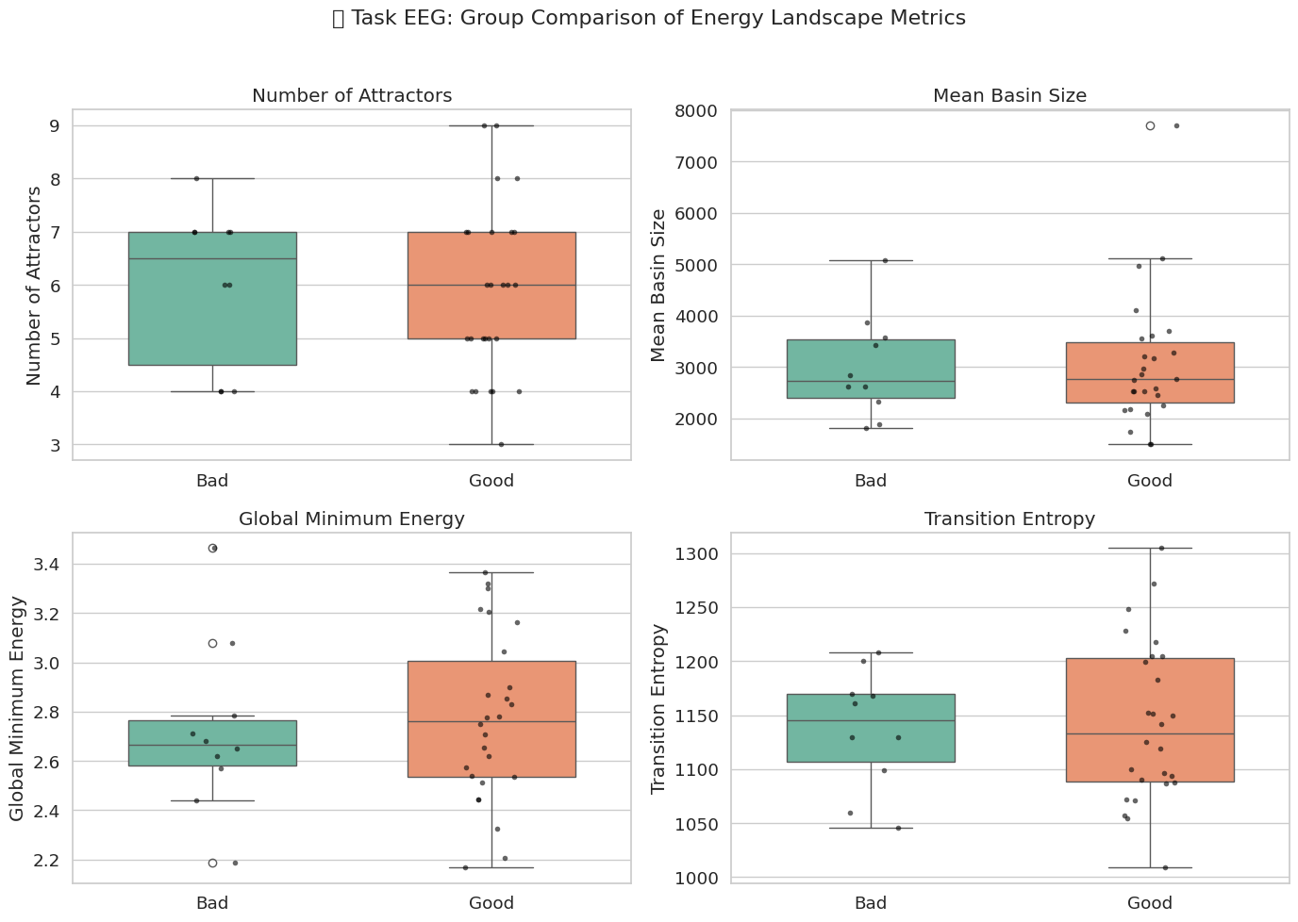
………..

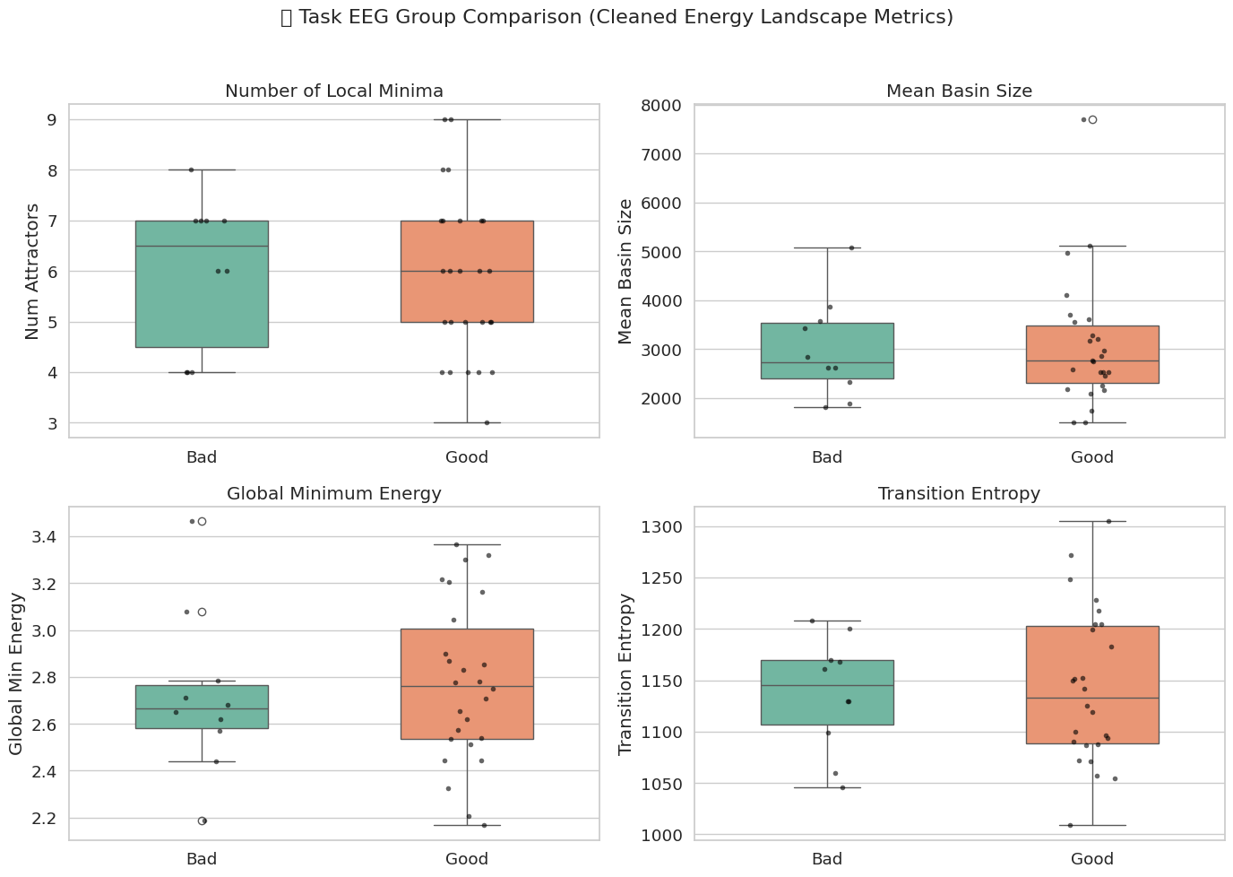
………
📈 Statistical Group Comparison (Task EEG):
Number of Local Minima: p = 0.7897
Mean Basin Size: p = 0.8779
Global Minimum Energy: p = 0.6775
Transition Entropy: p = 0.7927

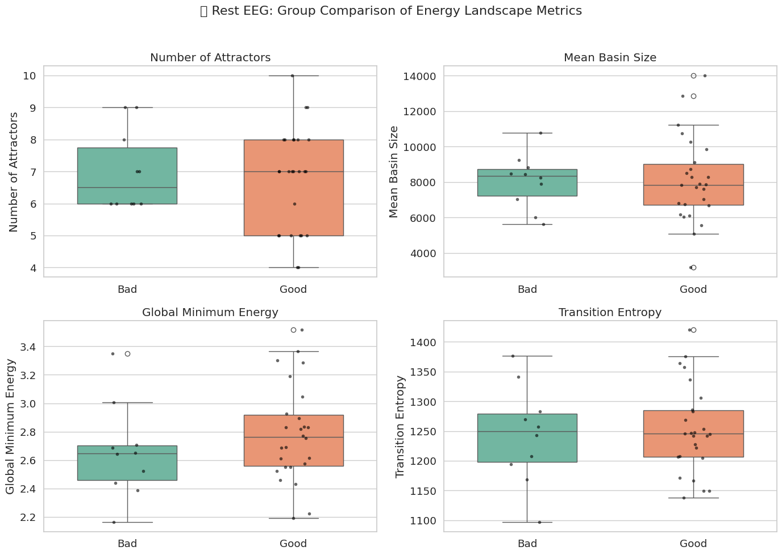
…………
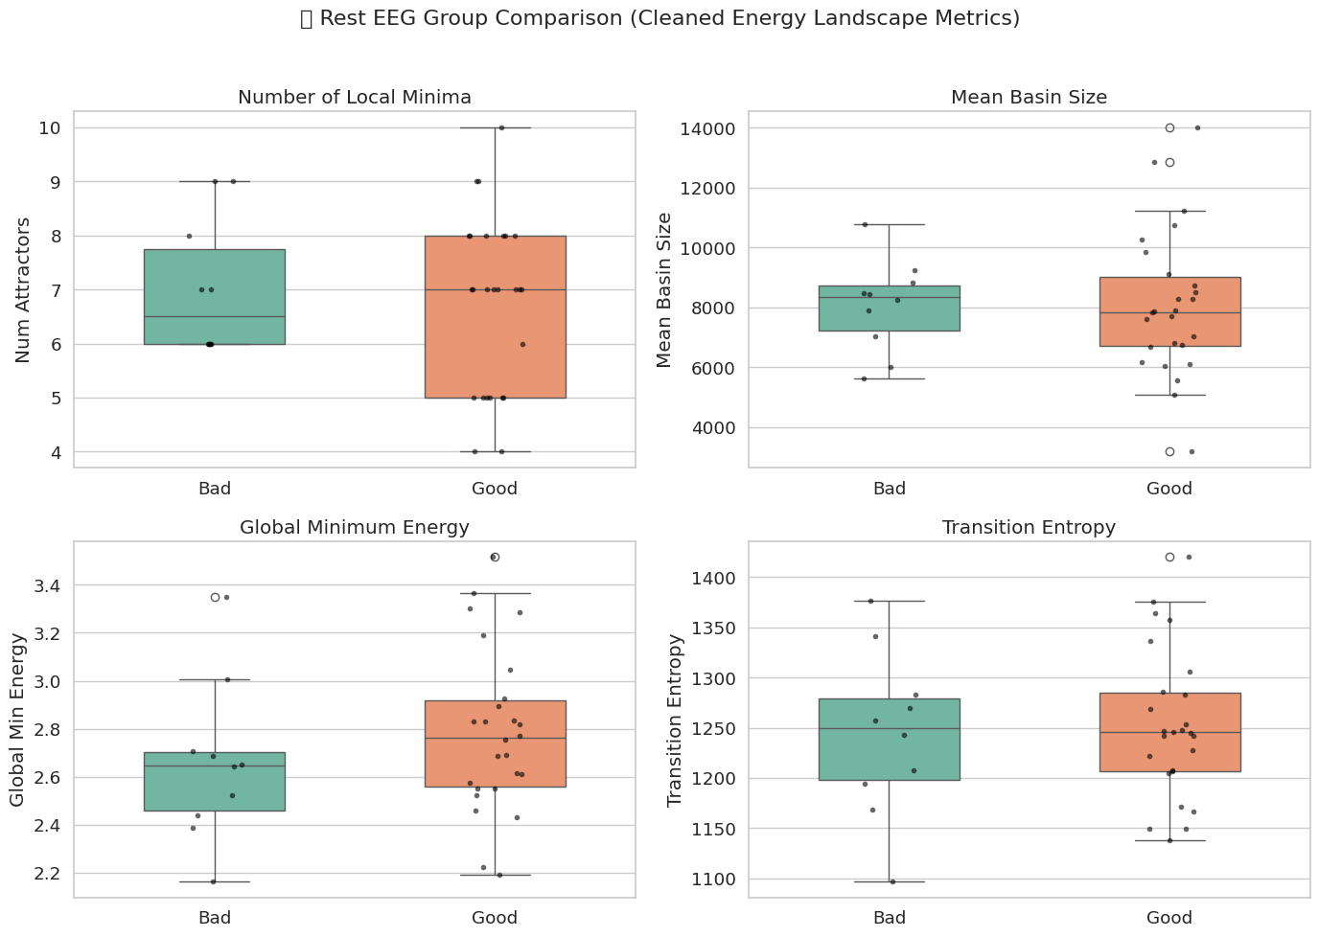
📈 Statistical Group Comparison (Rest EEG):
Number of Local Minima: p = 0.6523
Mean Basin Size: p = 0.9639
Global Minimum Energy: p = 0.3039
Transition Entropy: p = 0.7740

