Teicneolafochta an Oirdheiscirt



South East Technological Universit

Project description

The project is a comparison between different types of guided and non- guided pathfinding algorithms against Dstar Lite a dynamic incremental heuristic pathfinding algorithm the project compares the algorithms under various different types of comparisons such as speed of algorithm, how they react under changes in path, changes in grid size, and how difficult the algorithms were to implement.

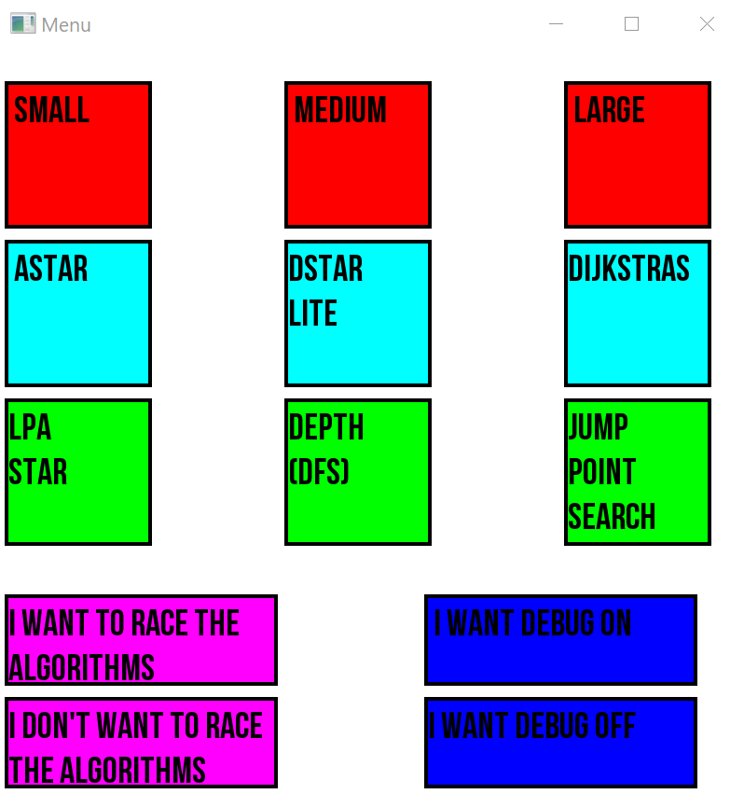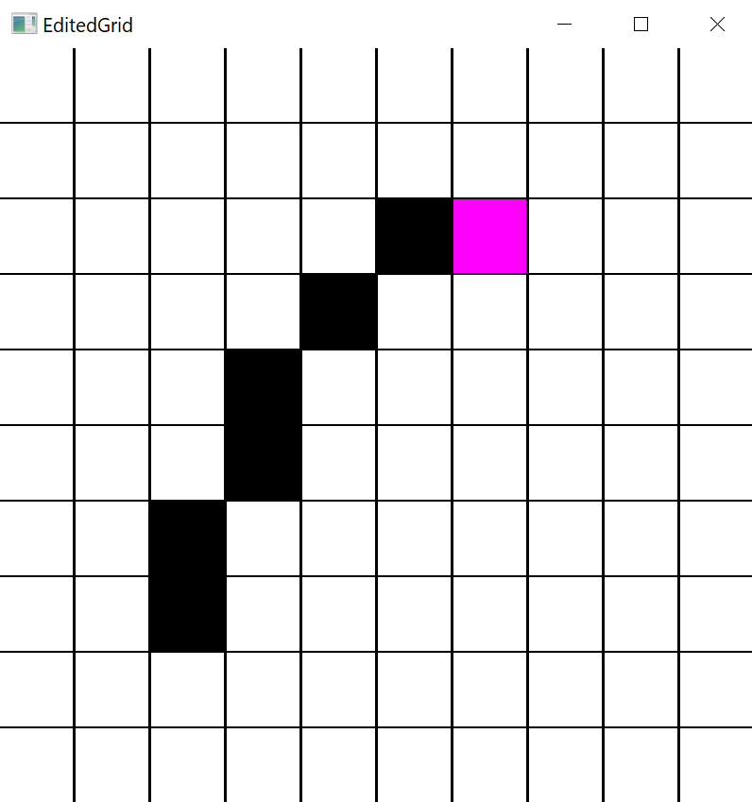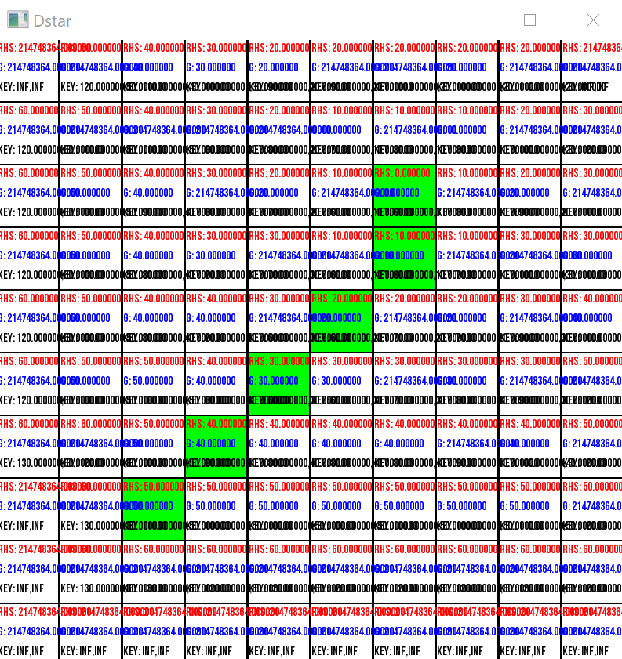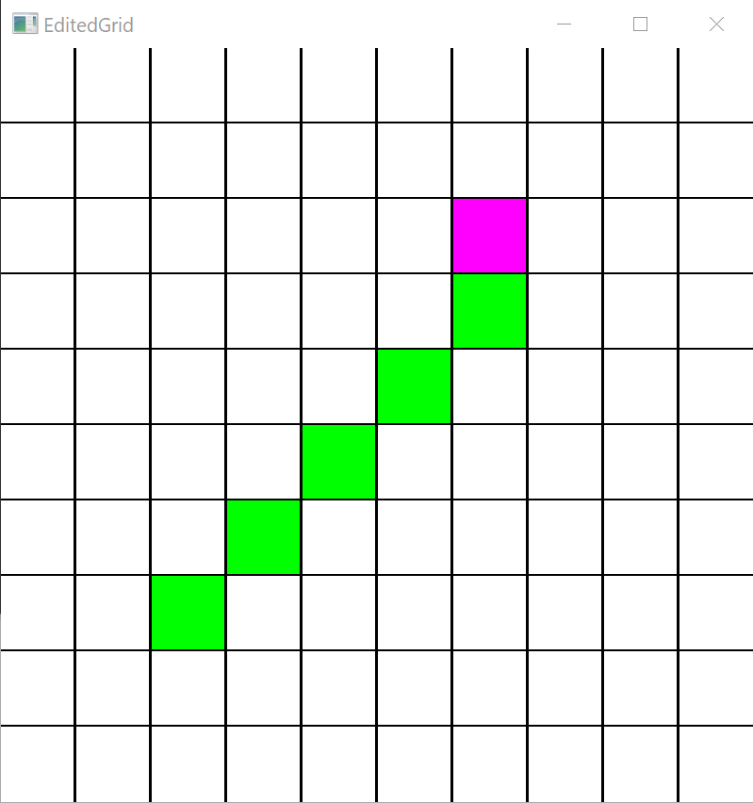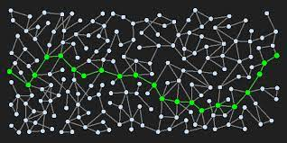

Project methodology

The project was conducted by constructing a 2D grid and running the various algorithms on it with various differing scenarios’ from the length of the path, the number of obstacles on the path obstructing it and on different grid sizes to stress test the algorithms under varying conditions.

Each algorithm was made with the same data structures where possible and tested the same way to ensure the same equality of outcome

Contact Details:

Phone number: 083 839 4315

Email: donaldevhowe@outlook.com

LinkedIn: https://www.linkedin.com/in/donalpeterhowe/

Github: https://github.com/DonalHowe