

Computer Games Development SE607

Technical Design Document

Year IV

|  |  |
| --- | --- |
| Donal Howe  C00249662 | [Student Name]  [Student Number] |
| [Date of Submission] | |

[Declaration form to be attached]

Contents

Technical Design 2

References 2

# 

**Introduction**

The objective of this project is to hopefully explain the benefits to both A star and Dstar and then go on to show the differences between the two and hopefully supply the reader with enough information and test cases for them to decide which algorithm is most suitable for use inside of their, game or application.

# Technical Design

The purpose of this document is to communicate effectively the technical details and design decisions of the system/algorithm to the readers.

It could include software architecture, algorithm design, class specifications, pseudo code, etc. with tools such as UML, Class Diagram, CRC Cards.

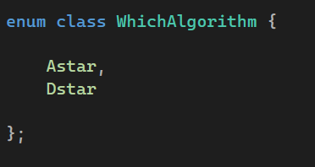 the enum class which controls the states of the game with each algorithm in use at a certain time

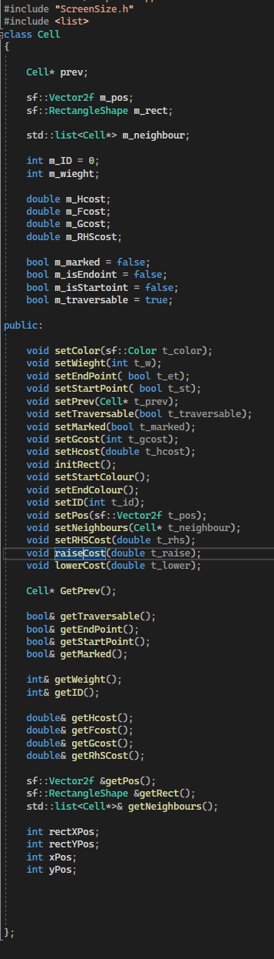 the header file for the Cell(node) which has all the current functions in use

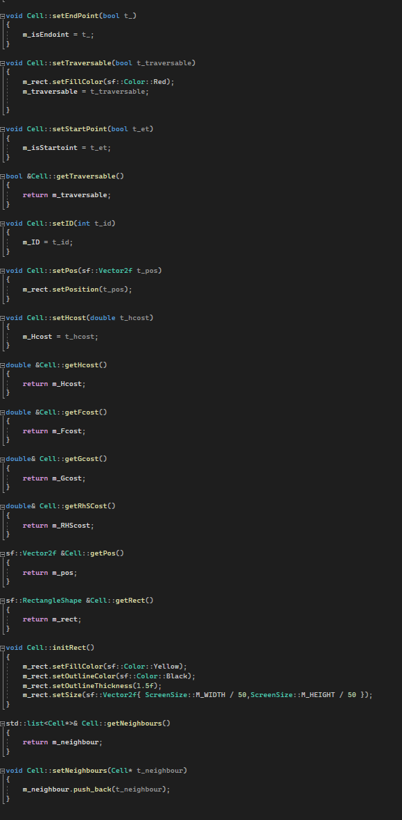the implementation for each function inside of the cell class

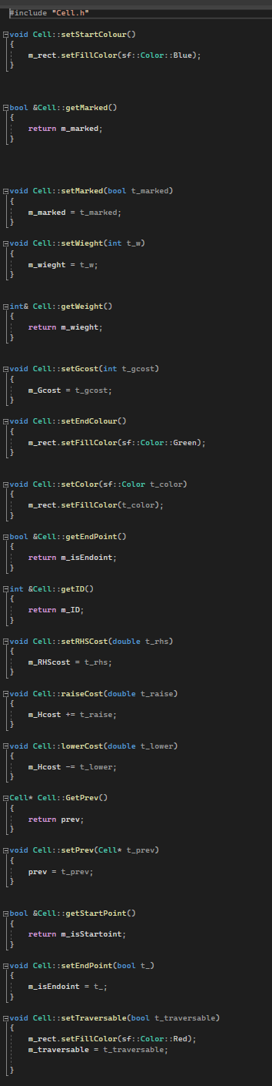 the implementation for each function inside of the cell

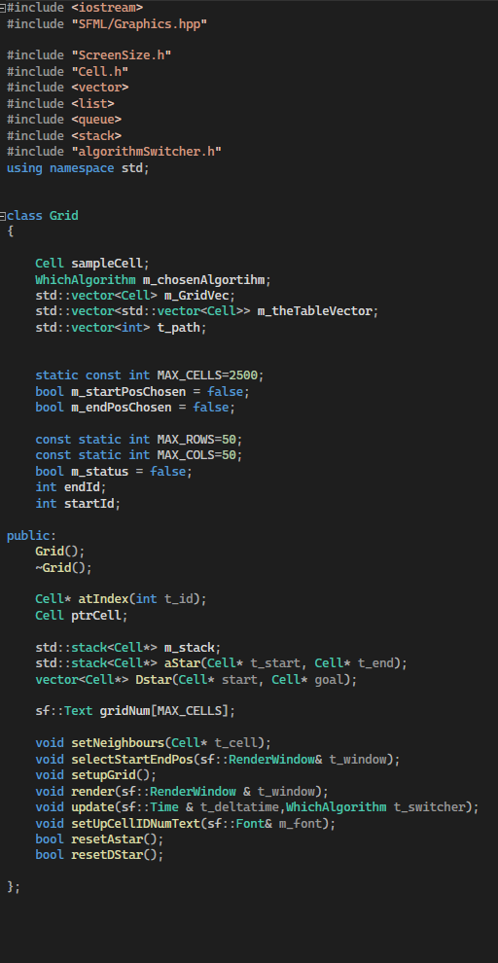 the header file for the grid which has all the current functions in use

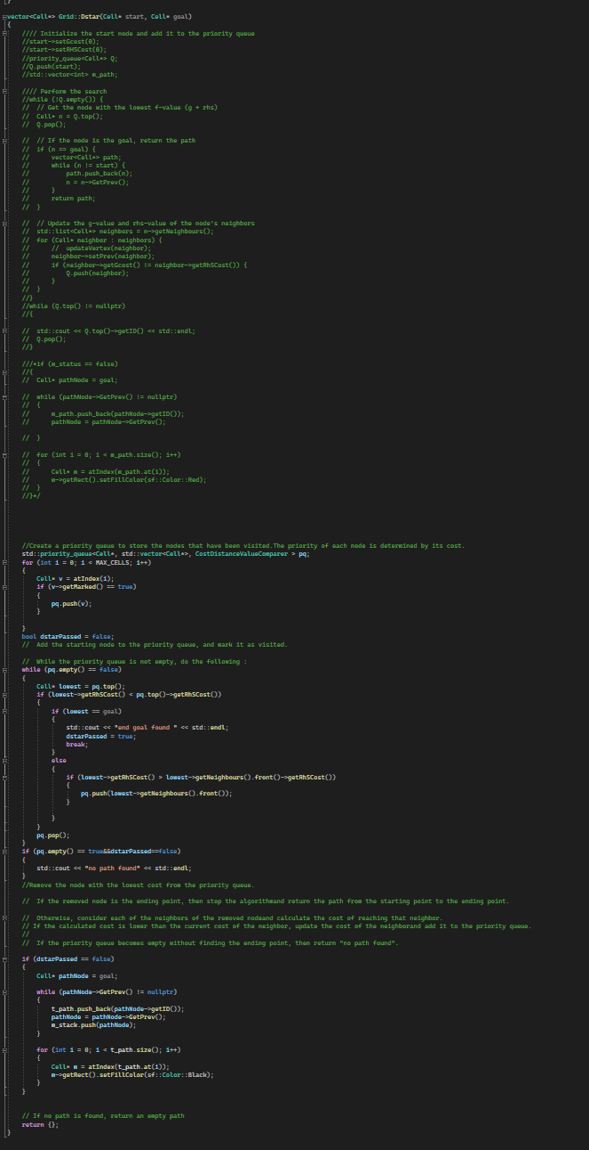 my attempts at Dstar

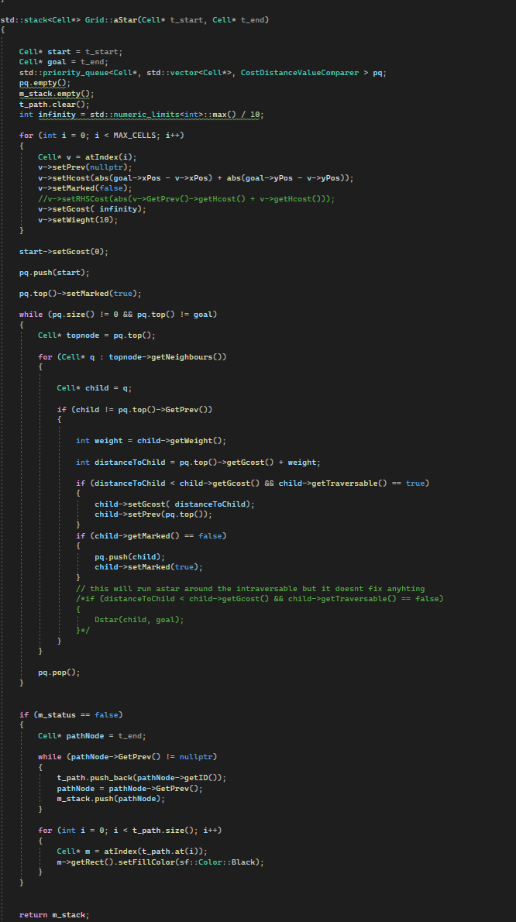 A star function

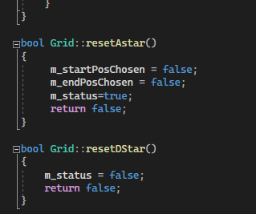 Function to reset Astar and Dstar

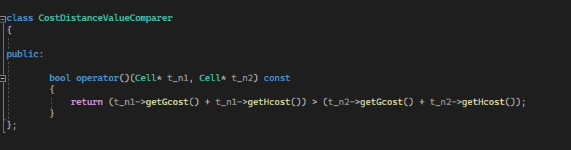

The functor which compares the Fcost of each node this is called in the priority queue for each node

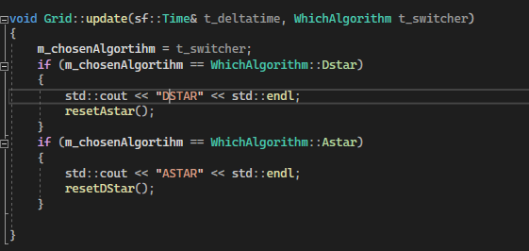

The switching between Astar and Dstar

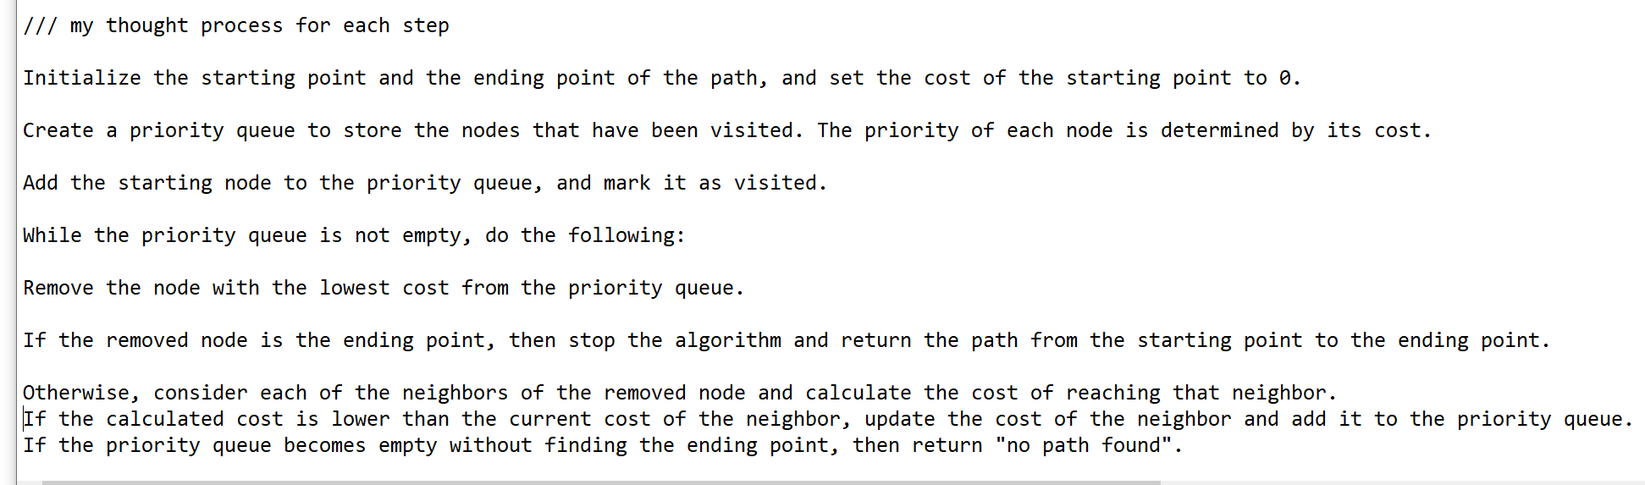

My thought process for the steps involved inside of Dstar

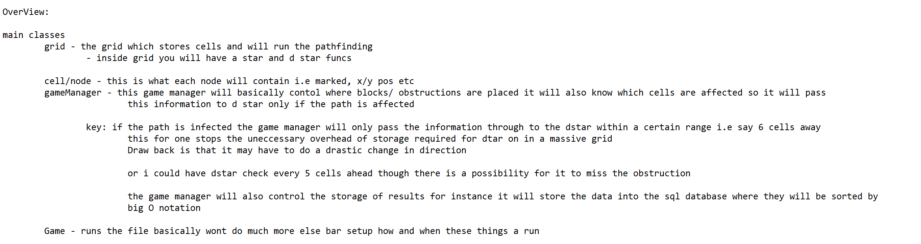

An overview of the classes involved in the application

# References

<https://core.ac.uk/download/pdf/235050716.pdf> - Path Planning Algorithm using D* Heuristic Method Based on PSO in Dynamic Environment Firas A. Raheema *, Umniah I. Hameedb

<https://medium.com/@nicholas.w.swift/easy-a-star-pathfinding-7e6689c7f7b2> -Nicholas Swift Feb 27 2017

<http://www.cs.cmu.edu/~ggordon/likhachev-etal.anytime-dstar.pdf> - Maxim Likhachev† , Dave Ferguson† , Geoff Gordon† , Anthony Stentz† , and Sebastian Thrun‡

<https://www.ri.cmu.edu/pub_files/pub3/stentz_anthony__tony__1994_2/stentz_anthony__tony__1994_2.pdf> -Anthony Stentz