1. Suppose you play the game of shooting. You shoot 6 times, each time to a different enemy, and each shot has a 10% chance of success.

1. What's the probability of killing two enemies out of six? =9.84%

Probability of success =p=0.1

Number of attempts=n=6

Number of successes =x=2#

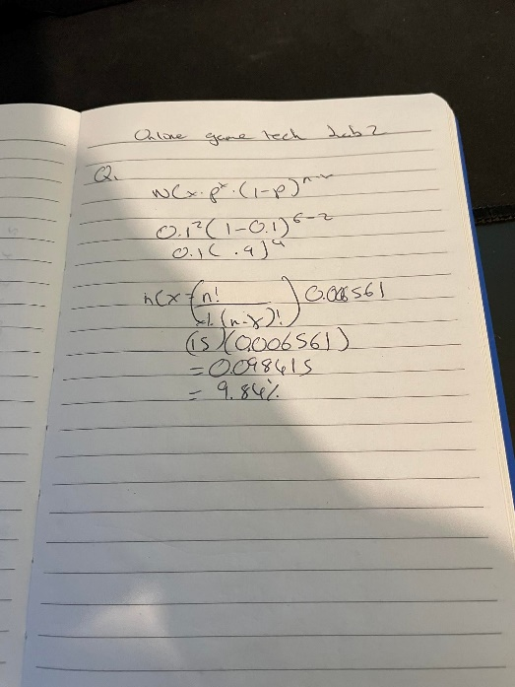

1. What's the probability of killing at most three enemies out of six?

Probability of success = p = 0.1

Number of Attempts = n= 6

Number of Successes at most = x=3

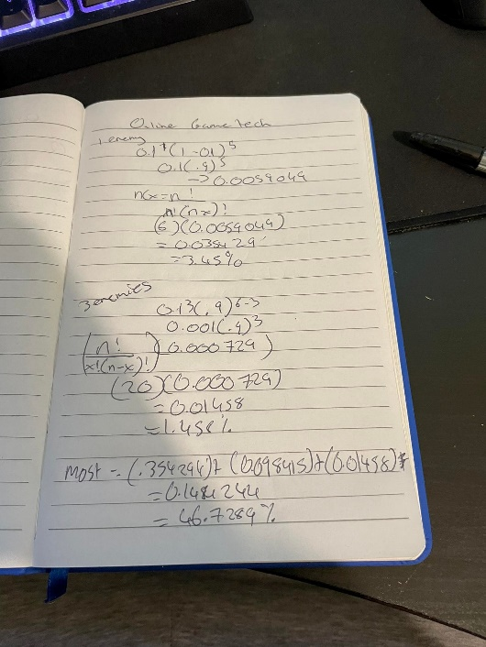

Pribability of 1 = 0.354294

Probability of 2 = 0.098415 - from 1

Probability of 3 = 0.01458

1. What's the maximum number of enemies we can kill with 90% probability? 1.72

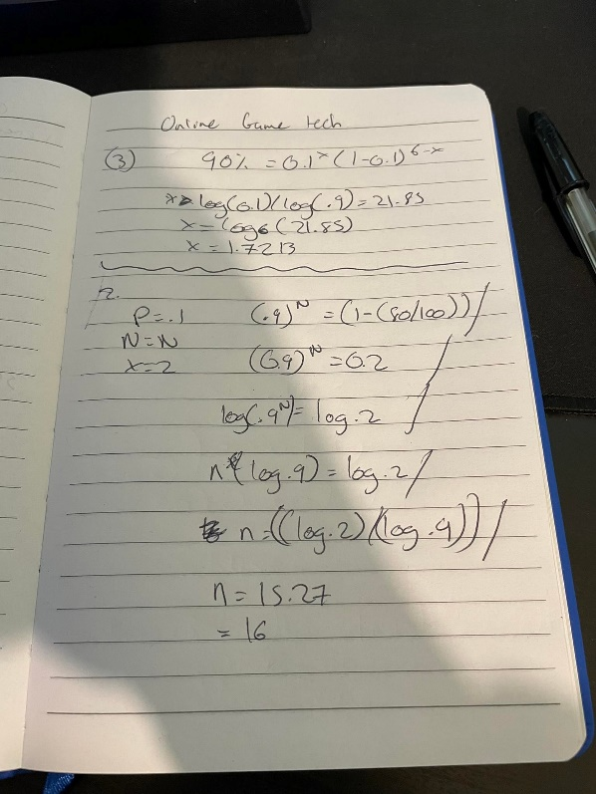

2. Suppose there is only one enemy and two success shots can kill the enemy. Each shot has a 10% chance of success. How many times do you need to shoot to kill the enemy with 80% probability? 16

