**Topics: Normal distribution, Functions of Random Variables**

1. The time required for servicing transmissions is normally distributed with *μ* = 45 minutes and *σ* = 8 minutes. The service manager plans to have work begin on the transmission of a customer’s car 10 minutes after the car is dropped off and the customer is told that the car will be ready within 1 hour from drop-off. What is the probability that the service manager cannot meet his commitment?
2. 0.3875
3. 0.2676
4. 0.5
5. 0.6987

**Ans**: Normal Distribution with µ= 45 and SD = 8. Let X be the time taken to complete the repair, hence, the probability of repair to be complete in one hour is P (X ≤ 50). The question asks us to find the probability of not being able to complete in one hour is P (X > 50).

P(X>50) = 1 – P(X≤50)

Z = (X - µ) / SD

= (50 – 45) / 8

= 0.625

P (X ≤ 50) = P (Z ≤ 0.625) = 0.7324

P (X > 50) = P (Z > 0.625) = 1 – P (Z ≤ 0.625)

= 1 – 0.7324

= 0.2676

**B. 0.2676**

1. The current age (in years) of 400 clerical employees at an insurance claims processing center is normally distributed with mean *μ* = 38 and Standard deviation *σ* =6. For each statement below, please specify True/False. If false, briefly explain why.
2. More employees at the processing center are older than 44 than between 38 and 44.

**Ans:** µ = 38 and SD = 6

The probability of more employees being older than 44 is P (X > 44) = 1 - P (X ≤ 44)

Z = (X - µ)/ SD

= (44 – 38)/ 6

= 1

P (X ≤ 44) = P (Z ≤ 1) = 0.8413 = 84.13%

P (X > 44) = P (Z > 1) = 1 - P (X ≤ 1)

= 100 – 83.14%

= 16.86%

The probability of employees being between 38 and 44 is P (X < 44) - 0.5

= 0.8314 - 0.5 = 0.3413 = 34.13%

Hence, the statement is false.

1. A training program for employees under the age of 30 at the center would be expected to attract about 36 employees.

**Ans:** µ = 38 and SD = 6

Z = (X - µ)/ SD

Z = (30 – 38)/ 6

= - 1.3333

P (X ≤ 30) = P (X ≤ - 1.3333) = 0.0918

Number of employees under the age of 30 = 0.0918 * 400 = 36.72 (approx. 36 employees).

Hence, the statement is true.

1. If *X1* ~ *N*(μ, σ2) and *X*2 ~ *N*(μ, σ2) are *iid* normal random variables, then what is the difference between 2 *X*1 and *X*1 + *X*2? Discuss both their distributions and parameters.

**Ans:**

**(a) .**2X1 is twice of random variable of X1. If X1 is normally distributed the 2X1 is also normally distributed.

**(b).** X1 and X2 is normally distributed, hence, the associated sums and sample along with their parameters are also normal.

1. Let X ~ N(100, 202). Find two values, *a* and *b*, symmetric about the mean, such that the probability of the random variable taking a value between them is 0.99.
2. 90.5, 105.9
3. 80.2, 119.8
4. 22, 78
5. 48.5, 151.5
6. 90.1, 109.9

**Ans:** The value of a and b is symmetric about mean and lie within the probability random variable between 0.99

The probability of going wrong, or probability of a and b being outside the area is 0.01

The probability towards the left for a = 0.01/2 = -0.005

The probability towards the right for b = 0.01/2 = +0.005

For calculating the Standard Normal Variable Z (Z value), we can find X value

Z = (X - µ)/ SD

For probability of 0.005 the Z value is –2.57 (from Z table)

Z * SD + µ = X

(-2.57) * 20 + 100 = 48.6

(2.57) * 20 + 100 = 151.4

**D. 48.5, 151.5**

1. Consider a company that has two different divisions. The annual profits from the two divisions are independent and have distributions Profit1 ~ N(5, 32) and Profit2 ~ N(7, 42) respectively. Both the profits are in $ Million. Answer the following questions about the total profit of the company in Rupees. Assume that $1 = Rs. 45
2. Specify a Rupee range (centered on the mean) such that it contains 95% probability for the annual profit of the company.

**Ans:** The value of a and b is symmetric about mean and lie within the probability random variable between 0.99

The probability of going wrong, or probability of a and b being outside the area is 0.01

The probability towards the left for a = 0.01/2 = -0.005

The probability towards the right for b = 0.01/2 = +0.005

For calculating the Standard Normal Variable Z (Z value), we can find X value

Z = (X - µ)/ SD

For probability of 0.005 the Z value is –2.57 (from Z table)

Z * SD + µ = X

(-2.57) * 20 + 100 = 48.6

(2.57) * 20 + 100 = 151.4

**D. 48.5, 151.5**

1. Specify the 5th percentile of profit (in Rupees) for the company

**Ans:** The formula used to compute percentiles of a normal distribution is

X = µ + Z(SD)

Where, µ = 540 and SD = 225 of the variable X and Z value of 5th percentile = -1.645

X = 540 + (-1.645) * (225)

= 169.875 = 170 (approx.)

1. Which of the two divisions has a larger probability of making a loss in a given year?

**Ans:**

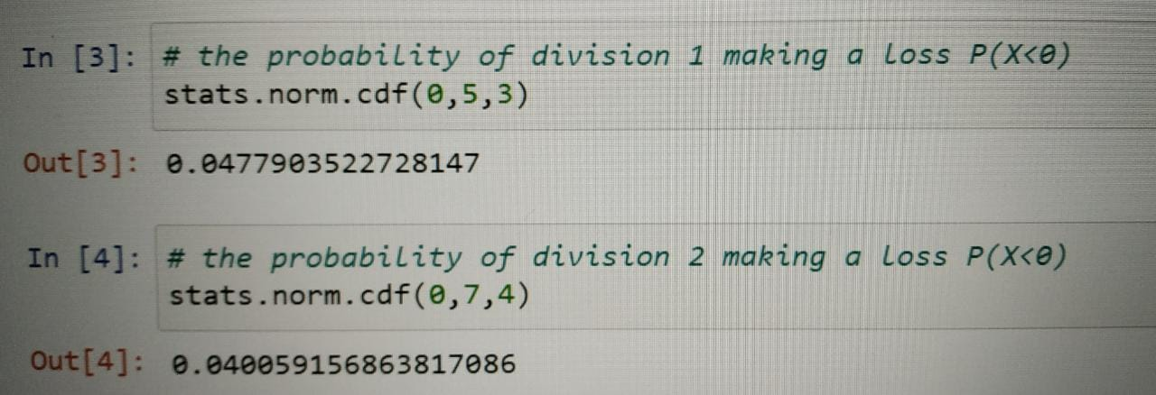

Therefore, the probability of division 1 making a loss in a year is more than division 2.