Exploring Window Behaviors

We use the SimpleListWindows.exe program to examine top-level window attributes as we investigate different use cases.

# Quiet System

***List Top Level Windows***

Active Window : 0

Focus Window : 0

Foreground Window : 0x504d4

Desk Top Window : 0x504d4

Console Window: 0x504d4

Window Type Codes

----------------------

V : Visible

A : Active

F : Focus

G : Foreground

C : Console

E : Enabled

----------------------

1. V--GCE 0x504d4 --> Simple List Windows – command window,

launched from ICON, that generates this list.

2. V----E 0x1048a --> Alienware Command Center

3. V----E 0x1046e --> Alienware Command Center

4. V----E 0x10398 --> Microsoft Text Input Application

5. V----E 0x10370 --> NVIDIA GeForce Overlay

6. V----E 0x10186 --> Program Manager

Done with 6 visible windows and 210 hidden windows, with 5 visible windows having no title.

Press any key to continue . . .

# Open MS Word for this document

***List Top Level Windows***

Active Window : 0

Focus Window : 0

Foreground Window : 0xf078c

Desk Top Window : 0xf078c

Console Window: 0xf078c

Window Type Codes

----------------------

V : Visible

A : Active

F : Focus

G : Foreground

C : Console

E : Enabled

----------------------

1. V--GCE 0xf078c --> Simple List Windows

***2. V----E 0x7065e --> ExploringWindows.docx - Word***

3. V----E 0x1048a --> Alienware Command Center

4. V----E 0x1046e --> Alienware Command Center

5. V----E 0x10398 --> Microsoft Text Input Application

6. V----E 0x10370 --> NVIDIA GeForce Overlay

7. V----E 0x10186 --> Program Manager

Done with 7 visible windows and 210 hidden windows, with 9 visible windows having no title.

Press any key to continue . . .

# Save File over Another File

## Screen shot:

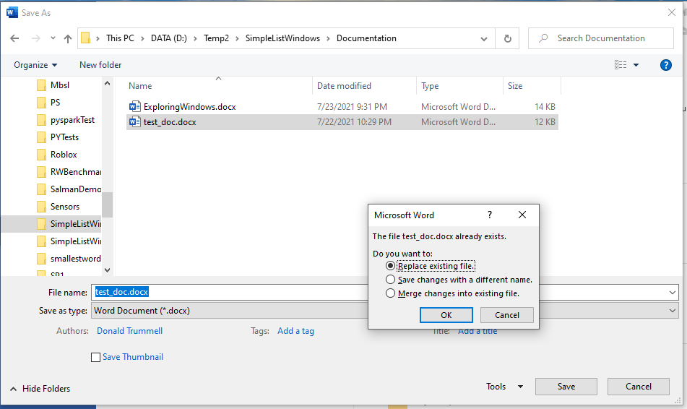

## Window Summary:

Window Type Codes

----------------------

V : Visible

A : Active

F : Focus

G : Foreground

C : Console

E : Enabled

----------------------

1. V--GCE 0xa0762 --> Simple List Windows

2. V----E 0x805aa --> Microsoft Word *** NOT TOP LEVEL WINDOW ***

3. V----- 0x60592 --> Save As *** NOT TOP LEVEL WINDOW ***

. . . V----E 0xd0744 --> Save Thumbnail *** NOT TOP LEVEL WINDOW ***

. . . V----E 0x505e8 --> Namespace Tree Control *** NOT TOP LEVEL WINDOW ***

. . . V----E 0x40656 --> Tree View *** NOT TOP LEVEL WINDOW ***

. . . V----E 0x330170 --> ShellView *** NOT TOP LEVEL WINDOW ***

. . . V----E 0x3700c6 --> Too&ls *** NOT TOP LEVEL WINDOW ***

. . . V----E 0xd0638 --> &Save *** NOT TOP LEVEL WINDOW ***

. . . V----E 0xf04d4 --> Cancel *** NOT TOP LEVEL WINDOW ***

. . . V----E 0x370108 --> Navigation buttons *** NOT TOP LEVEL WINDOW ***

. . . V----E 0x705be --> Up band toolbar *** NOT TOP LEVEL WINDOW ***

. . . V----E 0x704c2 --> Address: D:\Temp2\SimpleListWindows\Documentation *** NOT TOP LEVEL WINDOW ***

. . . V----E 0x80598 --> Address band toolbar *** NOT TOP LEVEL WINDOW ***

. . . V----E 0x90634 --> SearchEditBox *** NOT TOP LEVEL WINDOW ***

--- Popup Window ---

= = = V----- 0x60592 --> Save As *** NOT TOP LEVEL WINDOW ***

--------------------

***4. V----- 0x7065e --> ExploringWindows.docx - Word***

--- Popup Window ---

= = = V----- 0x7065e --> ExploringWindows.docx - Word

--------------------

5. V----E 0x1048a --> Alienware Command Center

6. V----E 0x1046e --> Alienware Command Center

7. V----E 0x10398 --> Microsoft Text Input Application

8. V----E 0x10370 --> NVIDIA GeForce Overlay

9. V----E 0x10186 --> Program Manager

Done with 9 visible windows and 228 hidden windows, with 9 visible windows having no title.

Press any key to continue . . .

# Dismiss Save – Back to main window

***List Top Level Windows***

Active Window : 0

Focus Window : 0

Foreground Window : 0x1007dc

Desk Top Window : 0x1007dc

Console Window: 0x1007dc

Window Type Codes

----------------------

V : Visible

A : Active

F : Focus

G : Foreground

C : Console

E : Enabled

----------------------

1. V--GCE 0x1007dc --> Simple List Windows

***2. V----E 0x7065e --> ExploringWindows.docx - Word***

3. V----E 0x1048a --> Alienware Command Center

4. V----E 0x1046e --> Alienware Command Center

5. V----E 0x10398 --> Microsoft Text Input Application

6. V----E 0x10370 --> NVIDIA GeForce Overlay

7. V----E 0x10186 --> Program Manager

Done with 7 visible windows and 213 hidden windows, with 9 visible windows having no title.

Press any key to continue . . .

# Save and Close Word

***List Top Level Windows***

Active Window : 0

Focus Window : 0

Foreground Window : 0xe07b0

Desk Top Window : 0xe07b0

Console Window: 0xe07b0

Window Type Codes

----------------------

V : Visible

A : Active

F : Focus

G : Foreground

C : Console

E : Enabled

----------------------

1. V--GCE 0xe07b0 --> Simple List Windows

2. V----E 0x1048a --> Alienware Command Center

3. V----E 0x1046e --> Alienware Command Center

4. V----E 0x10398 --> Microsoft Text Input Application

5. V----E 0x10370 --> NVIDIA GeForce Overlay

6. V----E 0x10186 --> Program Manager

Done with 6 visible windows and 196 hidden windows, with 5 visible windows having no title.

Press any key to continue . . .

**Done**