FED provided raw NASDAQ Composite Index Values
URL: https://fred.stlouisfed.org/series/NASDAQCOM
Data Source:
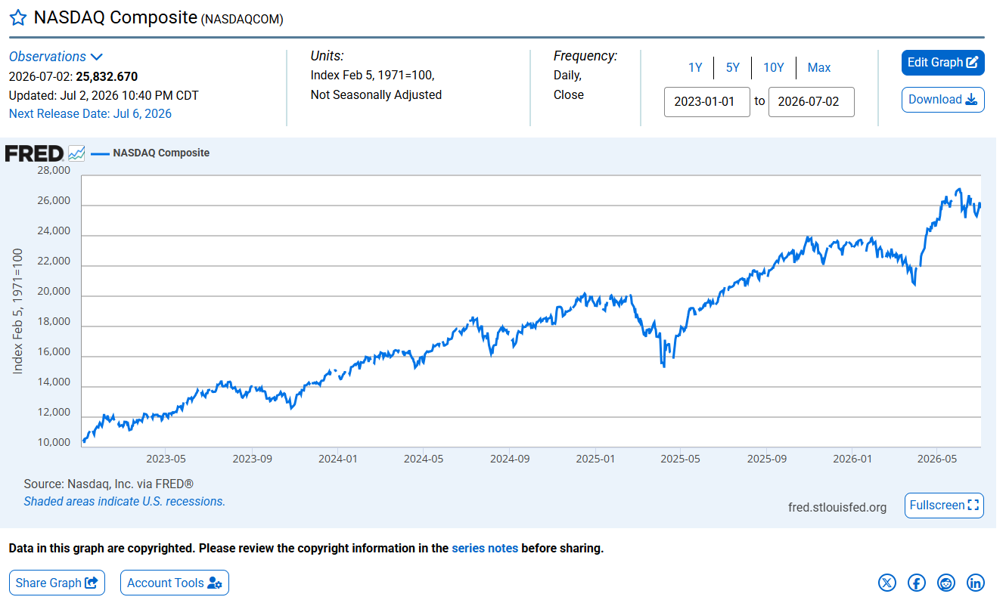

NASDAQ Notes
Source: Nasdaq, Inc.
Release: Nasdaq Daily Index Data
Units: Index Feb 5, 1971=100, Not Seasonally Adjusted
Frequency: Daily, Close
Notes:
The observations for the NASDAQ Composite Index represent the daily index value at market close. The market typically closes at 4 PM ET, except for holidays when it sometimes closes early.
The NASDAQ Composite Index is a market capitalization weighted index with more than 3000 common equities listed on the NASDAQ Stock Market. The types of securities in the index include American depositary receipts (ADRs), common stocks, real estate investment trusts (REITs), and tracking stocks. The index includes all NASDAQ listed stocks that are not derivatives, preferred shares, funds, exchange-traded funds (ETFs) or debentures.
Copyright Â© 2016, NASDAQ OMX Group, Inc.
Suggested Citation:
Nasdaq, Inc., NASDAQ Composite [NASDAQCOM], retrieved from FRED, Federal Reserve Bank of St. Louis; https://fred.stlouisfed.org/series/NASDAQCOM, July 4, 2026.

Volatility Values
URL: https://fred.stlouisfed.org/series/VIXCLS



